Data Processing for Battery Data

Looking at the discharge pulse at each SOC step use The following formulas find V0 and R0.

Equations:

V0=OCV= highest voltage value before the discharge pulse.

Tables to be filled out (the lowest and highest temp can change to the actual lowest and highest you can get):

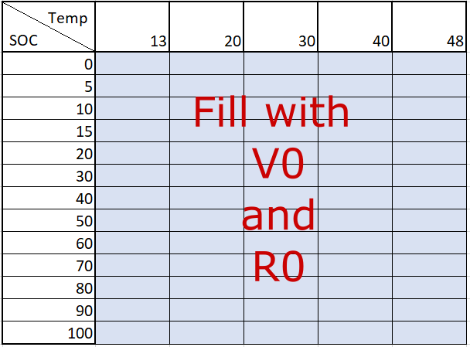

Perform a standard full discharge at each temp and fill out the table below.

|  |  |  |  |  |  |
| --- | --- | --- | --- | --- | --- |
| Temp | 13 | 20 | 30 | 40 | 48 |
| Capacity |  |  |  |  |  |