In-Situ Event Camera Imaging for Quality Classification of Dissimilar Metal Laser Welds in Battery Tab Welding

General Outline: Battery tab welding is essential to the performance and long-term reliability of lithium-ion battery packs (Rapp). Inadequate weld quality can reduce battery efficiency and thermal performance while introducing safety risks, including thermal runaway (Yao). Poor welds also increase manufacturing costs through scrap and rework. As demand for advanced battery systems in electric vehicles, consumer electronics, and energy storage continues to grow, improving the reliability and consistency of battery tab welding is increasingly important. To address these challenges, this project is developing a custom platform that integrates event camera and optical camera imaging into a laser-welding setup. The goal of this project is to use in-situ monitoring methods, coupled with statistical analysis, to predict welded battery-tab quality.
Task #1: Initial groundwork has focused on hardware development for the cover and software development for event-camera control. The project uses an Aconity MIDI, an open-architecture LPBFAM printer, accessed through Dr. Lang Yuan at USC (Figure 1). Because thermal runaway could damage the machine, the initial experiments use representative materials rather than complete batteries. The project also includes consultation and data-processing support from researchers in St. Louis. The printer’s open design allows users to modify the system and integrate external equipment as needed. The custom cover consists of an aluminum plate with red, 3D-printed PLA components that form the structure and laser shroud (Figure 2). Laser safety is essential because the printer uses a Class 4, 1000 W laser. The cover also includes two lighting sets for post-weld imaging with the optical camera. National Instruments LabVIEW will serve as the central data-acquisition and control platform for both cameras. The software is available through the university and my research mentor’s laboratory. Both cameras are controlled through Ethernet and powered by Power over Ethernet (PoE). The LabVIEW program acts as a wrapper for a Python script that controls the event camera, while the optical camera is controlled directly through LabVIEW’s GigE Vision acquisition software. Current experiments focus on welding a steel block because early event-camera acquisition issues delayed battery-tab trials. Advice from the researchers in St. Louis was instrumental in diagnosing these problems. As a result, the event camera is equipped with several light filters to reduce the amount of light entering the sensor. Although the camera has a high dynamic range, that range is finite; therefore, limiting the incoming light remains necessary. The results we are looking to get are similar to the image in Figure 3. Deliverable for Task 1 is a fully intgrated in-situ monitoring system, including the event/optical camera setup. Success will be measured by 100% fucntionality of both camera setups, alignment accuracy within ±0.1 mm, and 10 consecutive test runs without failure. Milestones include completing cover fabrication in Q1, integrating hardware into the LPBFAM machine by Q2, and conducting data aquisition and sample welding tests by the end of Q2.
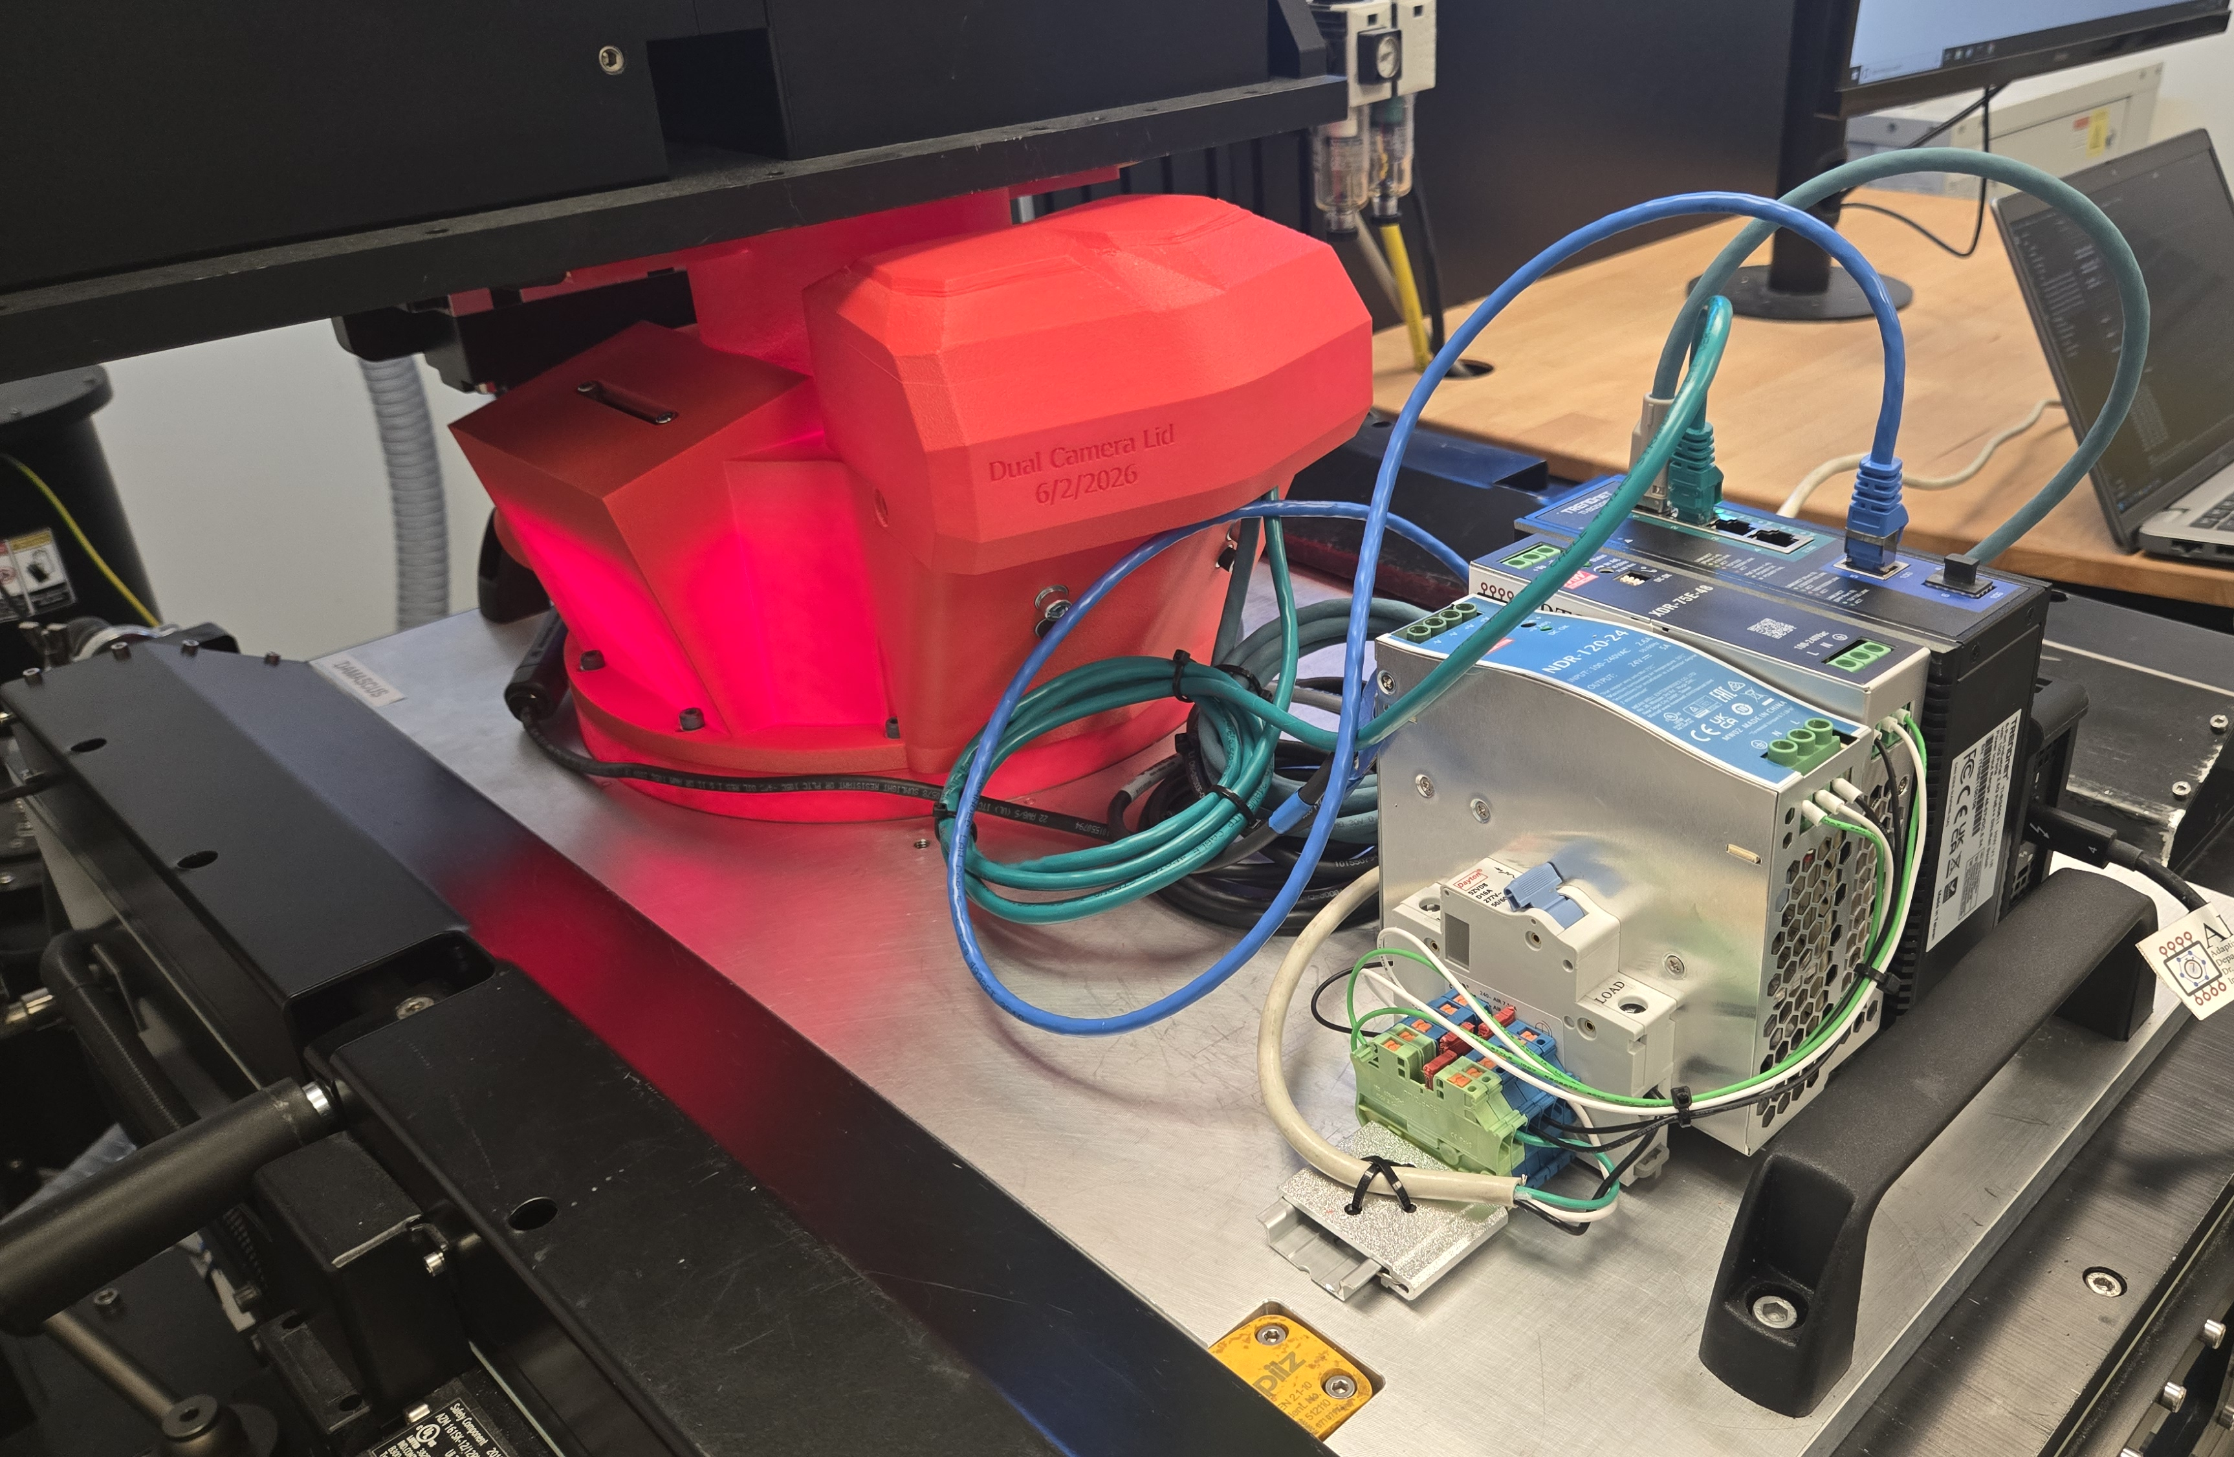
Fig 2. The custom aluminum cover features the event camera, optical camera, and lights
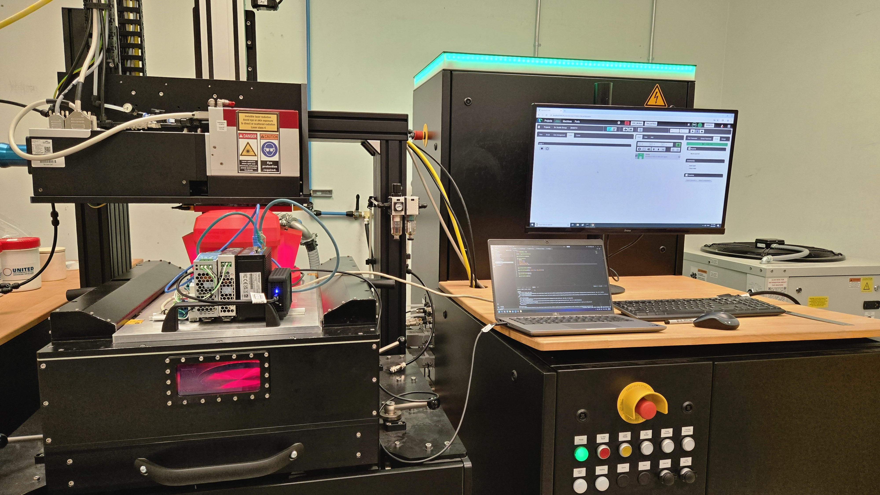
Fig 1. Test setup includes the Aconity MIDI printer and the custom cover.
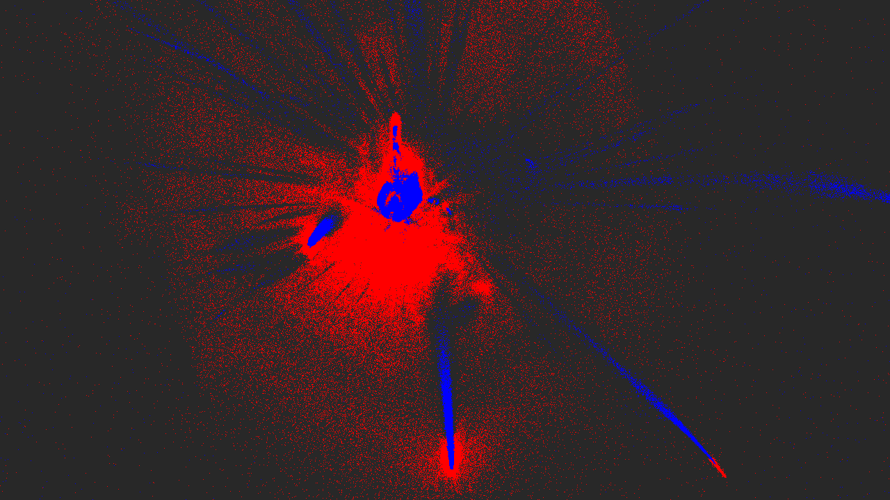
Fig 3. Sample event data captured.

Task #2: Using the hardware setup (shown in Fig 2.), testing and data collection with both cameras will begin. Remaining data-acquisition issues will be resolved, acquisition settings and weld parameters finalized, and tab-weld trials performed. Each test will join a nickel-plated strip placed over a stainless-steel strip. A sample will be mounted, aligned using the printer’s onboard laser, and welded while the event camera records data. An optical camera will capture a post-weld image. The sample will then be recovered for later analysis before repeating the cycle at progressively higher weld speeds. The dataset will be evaluated for trends associated with weld failure, including burn-through, poor fusion, melt-pool behavior, and spatter. Follow-on nondestructive and destructive testing will include microscope profilometry and tensile testing. Results will support future conference presentations and further research. Deliverables include a comprehensive event/optical dataset and tensile-test results for sample welds. Milestones are data-acquisition-system development in Q1, initial data collection in Q2, and preliminary defect reports by the end of Q2.

Timeline:
Project Timeline
 | December | January | February | March | April | May
Set-up
Testing
Analysis
Reporting

Relevance to NASA: Robust and reliable battery-tab welds are critical electrical and mechnical connections in battery packs used for spacecraft, rovers, and other NASA systems. Such technology are important to support future NASA missions such as the Artemis lunar surface missions. Additionally, real-time quality monitoring reduces dependence on destructive testing, especially when hardware is expensive, liminted in quanitiy, or mission critical. Recently, NASA unvieled their Lunar Terrain Vehicle (LTV), a rover astronauts will use to traval to and conduct science around the lunar south pole. Its battery packs need reliable tab welds because a bad weld can create high electrical resistance, localized heating, or loss of power. In-situ monitoring during battery manufacture would catch weld defects before the pack is installed in an LTV.

References:
1. Rapp, S., Optimising tab welding in lithium-ion battery manufacturing: on the advantages of laser welding
over ultrasonic welding, Master’s thesis, KTH, Production engineering (2024).
2. Yao, X.-Y. and Pecht, M. G., “Tab design and failures in cylindrical Li-ion batteries,” IEEE Access 7,
24082–24095 (2019).

