**Java**

***Enumeration, Type***

***Wrappers and Autoboxing***

Enumeration

* An enumeration is a list of named constants
* Java enumerations is similar to enumerations in other languages with some differences
* In Java, an enumeration defines a class type
* In Java, an enumeration can have constructors, methods, and instance variables
* ***Example****: EnumDemo.java*

Prepared by - Rifat Shahriyar 2

Enumeration

* All enumerations automatically contain two predefined methods:

***public static enum-type [ ] values( )***

– Returns an array that contains a list of the enumeration constants

***public static enum-type valueOf(String s)***

– Returns the enumeration constant whose value corresponds to the string passed in s

* ***Example****: EnumDemo2.java*

Prepared by - Rifat Shahriyar 3

Enumeration

* Java enumeration is a class type

– Although you can’t instantiate an enum using new

* Enumeration can have constructors, instance variables and methods

– Each enumeration constant is an object of its enumeration type

– The constructor is called when each enumeration constant is created

– Each enumeration constant has its own copy of any instance variables defined by the enumeration

* ***Example****: EnumDemo3.java*

Prepared by - Rifat Shahriyar 4

Type Wrappers

* Despite the performance benefit offered by the primitive types, there are times when you will need an object representation

– you can’t pass a primitive type by reference to a method

– many of the standard data structures implemented by Java operate on objects, which means that you can’t use these data structures to store primitive types

Prepared by - Rifat Shahriyar 5

Type Wrappers

* Java provides ***type wrappers***

– classes that encapsulate a primitive type within an object

* The type wrappers are:

– Character

– Boolean

– Double, Float, Long, Integer, Short, Byte

Prepared by - Rifat Shahriyar 6

Type Wrappers

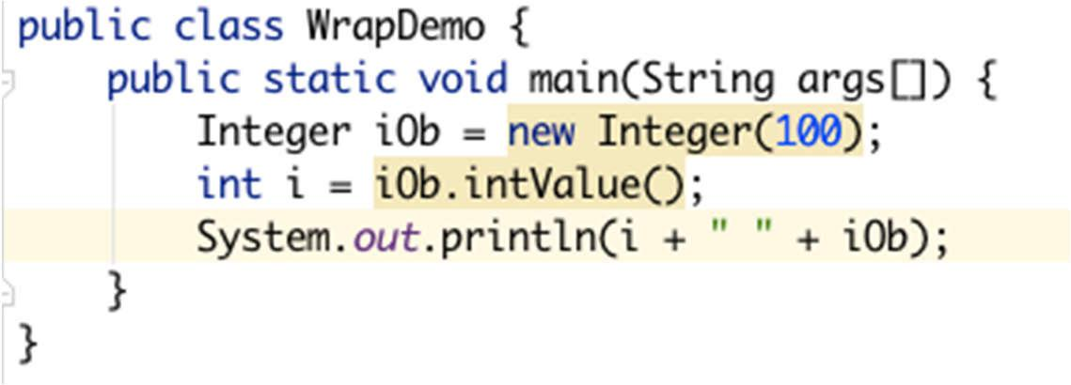

* The process of encapsulating a value within an object is called ***boxing***

*Integer iOb = new Integer(100);*

* The process of extracting a value from a type wrapper is called ***unboxing***

*int i = iOb.intValue();*

Prepared by - Rifat Shahriyar 7

Auto (boxing/unboxing)

* ***Autoboxing***

– the process by which a primitive type is automatically encapsulated into its equivalent type wrapper whenever an object of that type is needed

– There is no need to explicitly construct an object

* ***Auto-unboxing***

– the process by which the value of a boxed object is automatically extracted from a type wrapper when its value is needed

– There is no need to call a method such as intValue() or doubleValue()

Prepared by - Rifat Shahriyar 8

Autoboxing

* With autoboxing, it is no longer necessary to manually construct an object in order to wrap a primitive type
* You need only assign that value to a type-wrapper reference
* Java automatically constructs the object for you

|  |  |
| --- | --- |
| ***Integer iOb = 100; // autobox an int*** | ***100*** |

* Notice that the object is not explicitly created through the use of new. Java handles this for you, automatically

Prepared by - Rifat Shahriyar 9

Auto-unboxing

* To unbox an object, simply assign that object reference to a primitive-type variable

***int i = iOb; // auto-unbox***

* Java handles the details for you
* ***Example****: AutoBoxingUnboxingDemo.java*

Prepared by - Rifat Shahriyar 10