**Java**

***Introduction***

History of Java

* Java was originally developed by Sun Microsystems starting in 1991

– James Gosling

– Patrick Naughton

– Chris Warth

– Ed Frank

– Mike Sheridan

* This language was initially called ***Oak***
* Renamed ***Java*** in 1995

2

What is Java

* A simple, object‐oriented, distributed, interpreted, robust, secure, architecture neutral, portable, high‐performance, multithreaded, and dynamic language ‐‐ **Sun Microsystems**
* **Object‐Oriented**

– No free functions

– All code belong to some class

– Classes are in turn arranged in a hierarchy or package structure

3

What is Java

* **Distributed**

– Fully supports IPv4, with structures to support IPv6

– Includes support for Applets: small programs embedded in HTML documents

* **Interpreted**

– The program are compiled into Java Virtual Machine (JVM) code called bytecode

– Each bytecode instruction is translated into machine code at the time of execution

4

What is Java

* **Robust**

– Java is simple – no pointers/stack concerns

– Exception handling – try/catch/finally series allows for simplified error recovery

– Strongly typed language – many errors caught during compilation

5

Java – The Most Popular

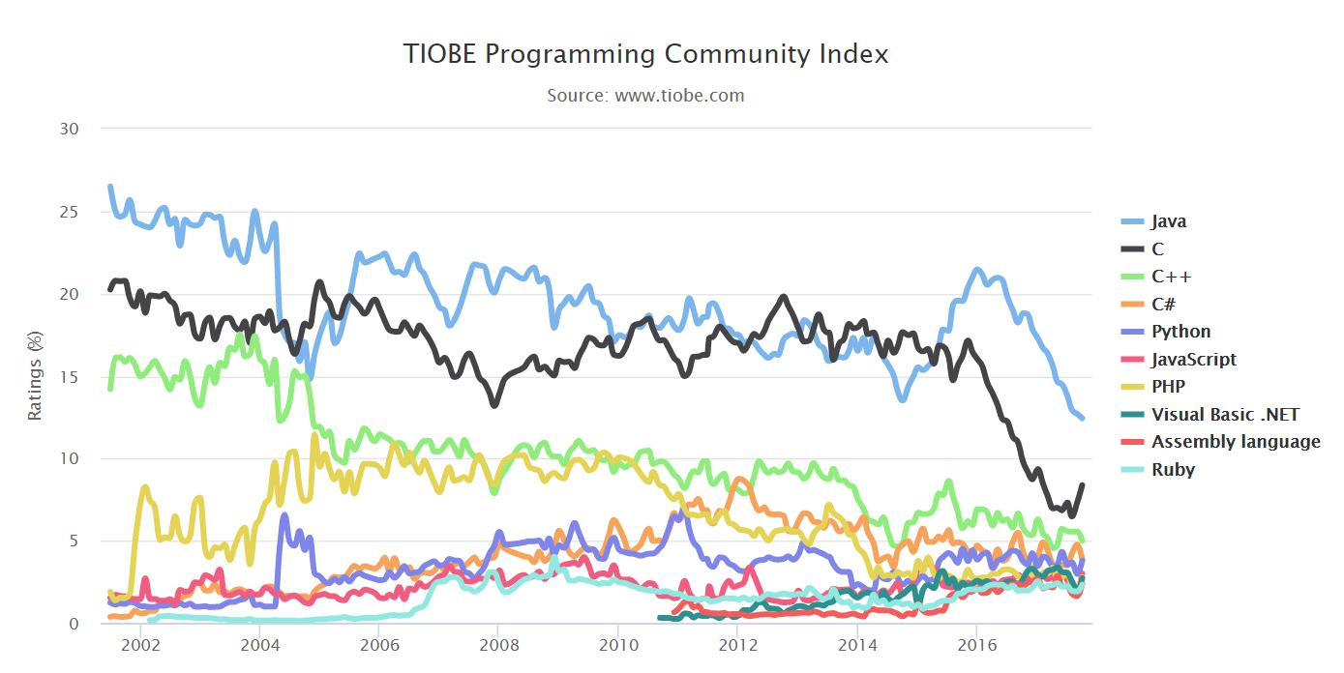

6

Java Editions

* Java 2 Platform, Standard Edition (J2SE)

– Used for developing Desktop based application and networking applications

* Java 2 Platform, Enterprise Edition (J2EE)

– Used for developing large‐scale, distributed networking applications and Web‐based applications

* Java 2 Platform, Micro Edition (J2ME)

– Used for developing applications for small memory‐constrained devices, such as cell phones, pagers and PDAs

7

Java platform

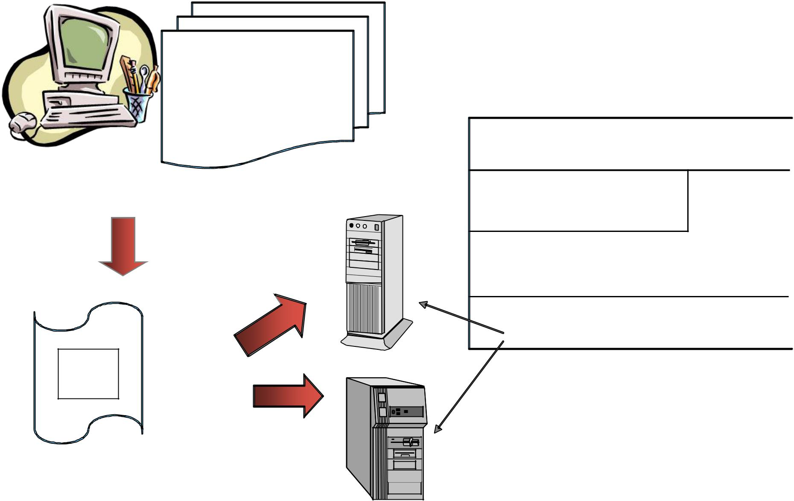

public class HelloWorld

{

public static void main( String [] args )

{

System.out.println(“hello”);

}

|  |  |  |  |  |
| --- | --- | --- | --- | --- |
|  | } |  | Java Program ( Class File ) |  |
|  |  |  |  |
| HelloWorld.java | | Windows NT | Java API |  |
| Compile | **Java** |  | Java Virtual Machine |  |
| **javac** |  |  |
| Interpreter | |  |  |
|  |  |  |
|  |  |  | Hardware-Based Platform |  |
| 2387D47803 | Java |  |  |  |
| A96C16A484 |  |  |  |
| 54B646F541 | Bytecode |  |  |  |
| 06515EE464 |  |  |  |

**Java**

Interpreter

HelloWorld.class

Power Macintosh

|  |
| --- |
| Java Platform |

8

Java Development Environment

* Edit

– Create/edit the source code

* Compile

– Compile the source code

* Load

– Load the compiled code

* Verify

– Check against security restrictions

* Execute

– Execute the compiled

9

Phase 1: Creating a Program

* Any text editor or Java IDE (Integrated Development Environment) can be used to develop Java programs
* Java source‐code file names must end with the ***.java*** extension
* Some popular Java IDEs are

– NetBeans

– Eclipse

– JCreator

– **IntelliJ**

10

Phase 2: Compiling a Java Program

* ***javac Welcome.java***

– Searches the file in the current directory

– Compiles the source file

– Transforms the Java source code into bytecodes

– Places the bytecodes in a file named **Welcome.class**

11

Bytecodes

* They are not machine language binary code
* They are independent of any particular microprocessor or hardware platform
* They are platform‐independent instructions
* Another entity (interpreter) is required to convert the bytecodes into machine codes that the underlying microprocessor understands
* This is the job of the **JVM** (Java Virtual Machine)

12

JVM (Java Virtual Machine)

* It is a part of the JDK and the foundation of the Java platform
* It can be installed separately or with JDK
* A virtual machine (VM) is a software application that simulates a computer, but hides the underlying operating system and hardware from the programs that interact with the VM
* It is the JVM that makes Java a portable language

13

JVM (Java Virtual Machine)

* The same bytecodes can be executed on any platform containing a compatible JVM
* The JVM is invoked by the java command

– ***java Welcome***

* It searches the class Welcome in the current directory and executes the main method of class Welcome
* It issues an error if it cannot find the class Welcome or if class Welcome does not contain a method called main with proper signature

14

Phase 3: Loading a Program

* One of the components of the JVM is the class loader
* The class loader takes the .class files containing the programs bytecodes and transfers them to RAM
* The class loader also loads any of the .class files provided by Java that our program uses

15

Phase 4: Bytecode Verification

* Another component of the JVM is the bytecode verifier
* Its job is to ensure that bytecodes are valid and do not violate Java’s security restrictions
* This feature helps to prevent Java programs arriving over the network from damaging our system

16

Phase 5: Execution

* Now the actual execution of the program begins
* Bytecodes are converted to machine language suitable for the underlying OS and hardware
* Java programs actually go through two compilation phases

– Source code ‐> Bytecodes

– Bytecodes ‐> Machine language

17

Editing a Java Program

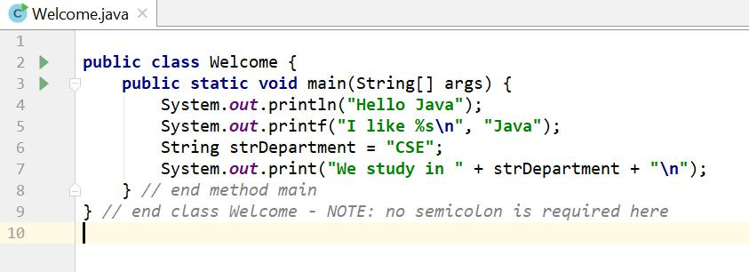

18

Examining Welcome.java

* A Java source file can contain multiple classes, but only one class can be a public class
* Typically Java classes are grouped into packages (similar to namespaces in C++)
* A public class is accessible across packages
* The source file name must match the name of the public class defined in the file with the .java extension

19

Examining Welcome.java

* In Java, there is no provision to declare a class, and then define the member functions outside the class
* Body of every member function of a class (called method in Java) must be written when the method is declared
* Java methods can be written in any order in the source file
* A method defined earlier in the source file can call a method defined later

20

Examining Welcome.java

* ***public static void main(String[] args)***

– **main** is the starting point of every Java application

– **public** is used to make the method accessible by all

– **static** is used to make main a static method of class Welcome. Static methods can be called without using any object; just using the class name. JVM call main using the **ClassName.methodName** (*Welcome.main*) notation

– **void** means main does not return anything

– **String args[ ]** represents an array of String objects that holds the command line arguments passed to the application. *Where is the length of args array?*

21

Examining Welcome.java

* Think of JVM as a outside Java entity who tries to access the main method of class Welcome

– main must be declared as a public member of class Welcome

* JVM wants to access main without creating an object of class Welcome

– main must be declared as static

* JVM wants to pass an array of String objects containing the command line arguments

– main must take an array of String as parameter

22

Examining Welcome.java

* ***System.out.println()***

– Used to print a line of text followed by a new line

– **System** is a class inside the Java API

– **out** is a public static member of class System

– **out** is an object of another class of the Java API

– **out** represents the standard output (similar to stdout or cout)

– **println** is a public method of the class of which out is an object

23

Examining Welcome.java

* **System.out.print()** is similar to **System.out.println()**,but does not print a new line automatically
* **System.out.printf()** is used to print formatted outputlike printf() in C
* In Java, characters enclosed by double quotes ("") represents a String object, where String is a class of the Java API
* We can use the plus operator (+) to concatenate multiple String objects and create a new String object

24

Compiling a Java Program

* Place the .java file in the bin directory of your Java installation

– ***C:\Program Files\Java\jdk1.8.0_144\bin***

* Open a command prompt window and go to the bin directory
* Execute the following command

– ***javac Welcome.java***

* If the source code is ok, then javac (the Java compiler) will produce a file called Welcome.class in the current directory

25

Compiling a Java Program

* If the source file contains multiple classes then javac will produce separate .class files for each class
* Every compiled class in Java will have their own .class file
* .class files contain the bytecodes of each class
* So, a .class file in Java contains the bytecodes of a single class only

26

Executing a Java Program

* After successful compilation execute the following command

– ***java Welcome***

– *Note that we have omitted the .class extension here*

* The JVM will look for the class file *Welcome.class* and search for a *public static void main(String args[* *])* method inside the class
* If the JVM finds the above two, it will execute the body of the main method, otherwise it will generate an error and will exit immediately

27

Another Java Program

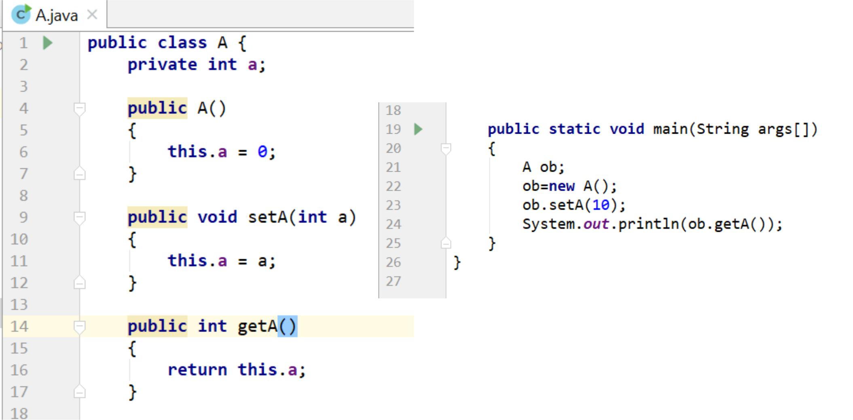

28

Examining A.java

* The variable of a class type is called a reference

– *ob* is a reference to A object

* Declaring a class reference is not enough, we have to use new to create an object
* Every Java object has to be instantiated using keyword **new**
* We access a public member of a class using the dot operator (.)

– Dot (.) is the only member access operator in Java.

– Java does not have **::, ->, &** and **\***



29

Primitive (built‐in) Data types

* Integers

– byte8‐bit integer (new)

– short16‐bit integer

– int 32‐bit signed integer

– long64‐bit signed integer

* Real Numbers

– float32‐bit floating‐point number

– double 64‐bit floating‐point number

* Other types

– char16‐bit, Unicode 2.1 character

– boolean true or false, *false is not 0 in Java*

30

Boolean Type

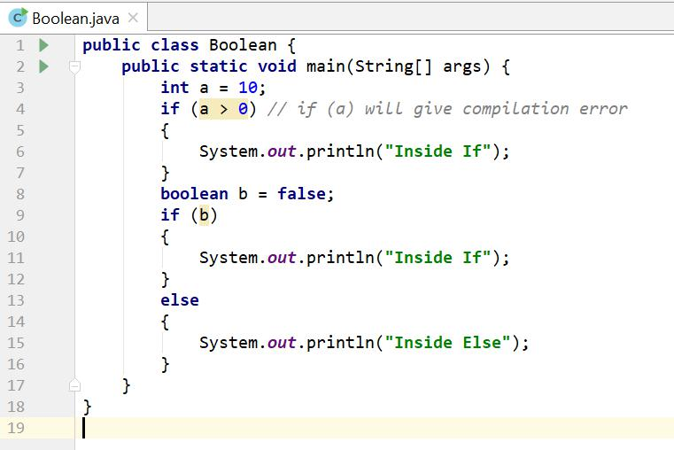

31

Non‐primitive Data types

* The non‐primitive data types in java are

– Objects

– Array

* Non‐primitive types are also called reference types

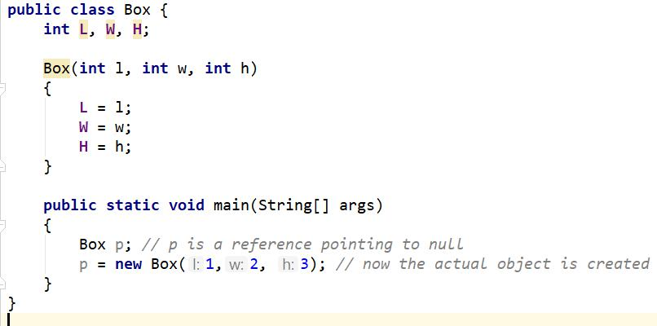

32

Primitive vs. Non‐primitive type

* Primitive types are handled by value – the actual primitive values are stored in variable and passed to methods

***int x = 10;***

***public MyPrimitive(int x) { }***

* Non‐primitive data types (objects and arrays) are handled by reference – the reference is stored in variable and passed to methods

***Box b = new Box(1,2,3);***

***public MyNonPrimitive(Box x) { }***

33

Java References

* Java references are used to point to Java objects created by new
* Java objects are **always** passed **by reference** to other functions, ***never by value***
* Java references act as pointers but does not allow pointer arithmetic
* We cannot read the value of a reference and hence cannot find the address of a Java object
* We cannot take the address of a Java reference

34

Java References

* We can make a Java reference point to a new object

– By copying one reference to another

***ClassName ref2 = ref1; // Here ref1 is declared earlier***

– By creating a new object and assign it to the reference

***ClassName ref1 = new ClassName();***

* We cannot place arbitrary values to a reference except the special value **null** which means that the reference is pointing to nothing

***ClassName ref1 = 100; // compiler error ClassName ref2 = null; // no problem***

35

Java References

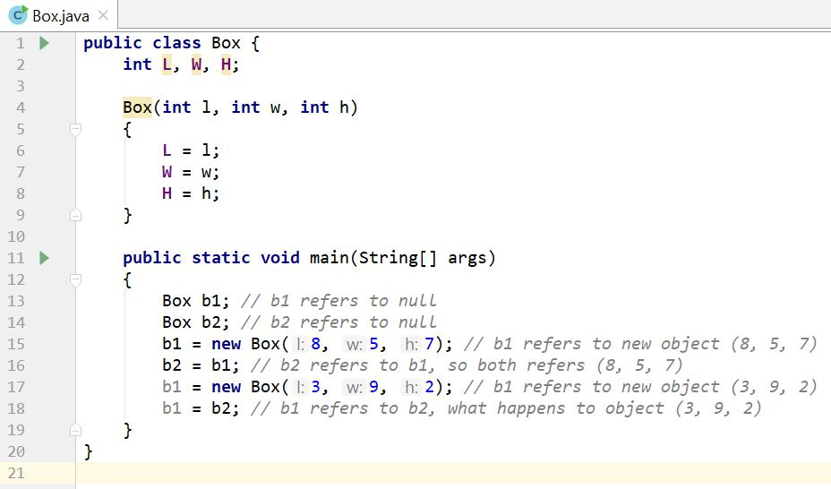

36

Textbook

* We will mostly follow Java 8, if time permits will see the new features of Java 9
* Books

– Java: The Complete Reference, 9th Edition by Herbert Schildt

– Effective Java, 2nd edition by Joshua Bloch

* Web

[– http://rifatshahriyar.github.io/CSE107.html](http://rifatshahriyar.github.io/CSE107.html)

37