**Java**

***Networking***

TCP

* TCP stands for Transmission Control Protocol
* TCP is connection‐oriented
* It provides reliability
* What is Server and Client?

– A server is a piece of software which advertises and then provides some service on request

– A client is a piece of software (usually on a different machine) which makes use of some service

Prepared By ‐ Rifat Shahriyar 2

TCP Sockets

* Two types of TCP Sockets
* ***ServerSocket***

– ServerSocket is used by servers so that they can accept incoming connections from client

* ***Socket***

– Socket is used by clients who wish to establish a connection to a (remote) server

Prepared By ‐ Rifat Shahriyar 3

Scenario

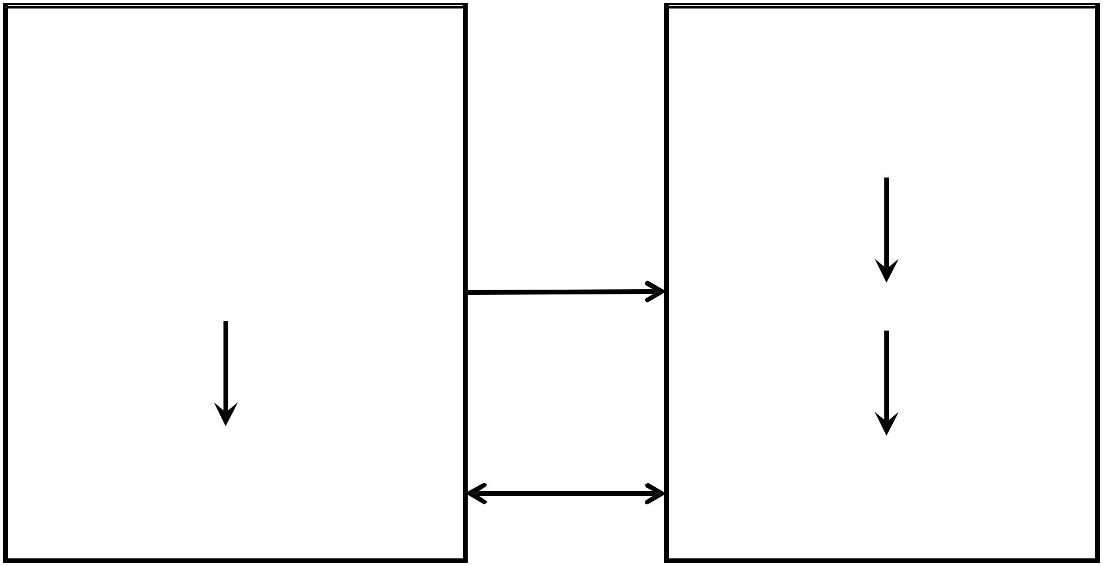

**Client**

*Socket s = new Socket (“192.168.0.63”, 22222);*

*s.getInputStream();*

*s.getOuputStream();*

**Server (192.168.0.63)**

*ServerSocket ss=new*

*ServerSocket(22222);*

*Socket cs = ss.accept();*

*cs.getInputStream(); cs.getOuputStream();*

Prepared By ‐ Rifat Shahriyar 4

TCP Sockets

* ***Packages****:*

– ***tcpsimple*** *(no threading)*

– ***tcpstring*** *(multithreading, string* *send and receive)*

– ***tcpobject*** *(multithreading, object* *send and receive)*

– ***tcpdiff*** *(multithreading, multiple* *clients simultaneously)*

* ***Sources****:*

– *Server.java*

– *Client.java*

– *ReadThread.java*

– *WriteThread.java*

– *NetworkUtil.java*

– *Data.java*

Prepared By ‐ Rifat Shahriyar 5

UDP

* UDP stands for User Datagram Protocol
* UDP is not connection‐oriented
* It does not provide reliability
* It sends and receives packets known as Datagram

Prepared By ‐ Rifat Shahriyar 6

Datagram Packet & Socket

* One type of Packet and one type of Socket
* ***DatagramPacket***

– Used to encapsulate Datagram

* ***DatagramSocket***

– DatagramSocket is used by both server and client to receive DatagramPacket

* ***Example****: DatagramServer.java, DatagramClient.java*

Prepared By ‐ Rifat Shahriyar 7

InetAddress

* Java has a class ***java.net.InetAddress*** which abstracts network addresses
* Major methods

– getLocalHost()

– getByAddress()

– getByName()

* ***Example****: HostInfo.java, AddressGenerator.java, Resolver.java*

Prepared By ‐ Rifat Shahriyar 8

HttpURLConnection

* Java provides a class ***java.net.HttpURLConnection*** that provides support for HTTP connections
* You can obtain HttpURLConnection by calling openConnection( ) on URL object
* You must cast the result to HttpURLConnection
* You can then read/write from/to the connection
* ***Example****: TestHttpURL.java*

Prepared By ‐ Rifat Shahriyar 9