

Foundations of Programming

Assignment No.: 07
Lab Assignment No. : 07
ARUL MITTAL
DIV 1 1262251948
PROBLEM STATEMENT: Write a C program to accept student details and display their result using an array of structures.

OBJECTIVE:

- To understand the concept of structures in C.
- To learn how to store multiple records using an array of structures.
- To accept and process student details such as name, roll number, and marks.
- To calculate total and percentage and display the result.

THEORY:
In C programming, a structure is a user-defined data type that allows grouping of variables of different data types under a single name. When multiple records such as student details need to be stored, an array of structures is used. This allows efficient storage and processing of student information like roll number, name, and marks in different subjects. The program can compute total marks and percentage and display the result for each student.
PLATFORM: Linux

INPUT: Student roll number, name, and marks in three subjects.
#include <stdio.h>

struct Student {
int roll_no;
char name[50];
int marks[3];
int total;
float percentage;
};

int main() {
int n, i, j;

printf("Enter number of students: ");
scanf("%d", &n);

struct Student students[50];

for (i = 0; i < n; i++) {
printf("Roll Number: ");
scanf("%d", &students[i].roll_no);
printf("Name: ");
scanf("%s", students[i].name);
printf("Marks in 3 subjects: ");
students[i].total = 0;
for (j = 0; j < 3; j++) {
scanf("%d", &students[i].marks[j]);
students[i].total += students[i].marks[j];
}
students[i].percentage = students[i].total / 3.0;
}

printf("\nStudent Result:\n");
for (i = 0; i < n; i++) {
printf("Roll No: %d\n", students[i].roll_no);
printf("Name: %s\n", students[i].name);
printf("Total Marks: %d\n", students[i].total);
printf("Percentage: %.2f%%\n\n", students[i].percentage);
}

return 0;
}

OUTPUT:
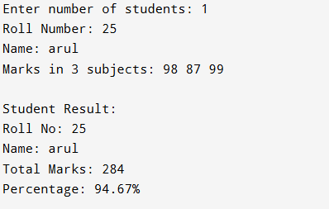

SAMPLE INPUT:
Enter number of students: 1
Roll Number: 101
Name: Rahul
Marks in 3 subjects: 80 75 90

SAMPLE OUTPUT:
Student Result:
Roll No: 101
Name: Rahul
Total Marks: 245
Percentage: 81.67%
CONCLUSION: Thus, the C program successfully accepts student details using an array of structures and displays the calculated result including total marks and percentage.

FAQs:
- What is a structure in C?
- What is a structure in C is an important programming concept because it supports clear problem solving, structured logic, and correct implementation. Understanding it helps in writing programs that are easier to develop, test, and maintain.
- What is the difference between a structure and a union in C?
- What is the difference between a structure and a union in C is an important programming concept because it supports clear problem solving, structured logic, and correct implementation. Understanding it helps in writing programs that are easier to develop, test, and maintain.
- What is an array of structures?
- What is an array of structures is an important programming concept because it supports clear problem solving, structured logic, and correct implementation. Understanding it helps in writing programs that are easier to develop, test, and maintain.
- Why are structures used in C programming?
- Why are structures used in C programming is an important programming concept because it supports clear problem solving, structured logic, and correct implementation. Understanding it helps in writing programs that are easier to develop, test, and maintain.
- What is the advantage of using an array of structures?
- What is the advantage of using an array of structures is an important programming concept because it supports clear problem solving, structured logic, and correct implementation. Understanding it helps in writing programs that are easier to develop, test, and maintain.

