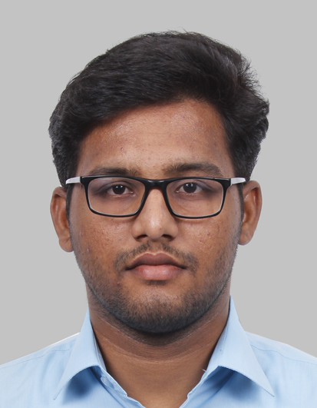
ARUN PRAKASH GANAPATHY

Address Schillerstrasse 12, Freiberg 09599, Germany
Date of birth 26/10/1995
Nationality Indian
Contact +4917677171806
arunprakash.fns@gmail.com
linkedin.com/in/arun-prakash-g-97a451b2

Education

September Masters in Computational Materials Science
2018–Now Technical university of Freiberg, Germany

2013-2017 Bachelors degree in Mechanical Engineering
Velammal Engineering College

2011-2013 High School
Dr. V.G.N Hr.sec School

Practical Experience

April 2015 Inplant Training at TNPL Factory, Karur, India
August 2017 Inplant Training at RAMCO Cements PVT Ltd, India

Projects

October Static analysis of Beam Structures using Refined beam models
2019-Now
- Developing a finite element solver which analyses beam structures based on Carrera Unified Formulation (CUF)
- Programming Language: Python

May 2019 Non-Linear Finite element analysis
- Developing a finite element solver for Spherosymmetric elastic-plastic problem from scratch
- Programming Language: Python

January 2019 Programming GUI for Raw data analysis
- Developing a GUI for analyzing the raw data based on Least Square method
- Programming Language: MATLAB

January 2017 Bachelor Thesis
- Investigation of addition of Canola seed oil methyl ester to CI engine fueled with blends of Higher branched alcohols and diesel

Technical Skills

Programming Languages Python
MATLAB
C
Softwares Abaqus
CATIA
Other softwares git, Linux(shell scripting), Arduino programming

Languages

- Tamil Mother Tongue
- English C1
- German B1

Hobbies

- Arduino Programming
- Reading books and cycling

