LAB EXAM 2

# Network Topology Configuration Using RIP and OSPF in Cisco Packet Tracer

**Objective:**

The objective of this lab is to design and configure a network topology using RIP and OSPF routing protocols in Cisco Packet Tracer. The network consists of two LANs connected through routers, each configured with different routing protocols to ensure proper

communication. IP addresses are assigned to computers using the last three digits of the student’s roll number.

# Procedure:

1. **Network Topology Design:**

# Devices Used:

* + - Two routers
    - Two switches
    - 10 computers (5 in each LAN)
    - WAN link connecting both routers

# Topology Structure:

* + - Two LANs connected via routers
    - LAN 1 consists of 5 PCs connected to a switch, which is linked to Router 1.
    - LAN 2 consists of 5 PCs connected to another switch, which is linked to Router 2.
    - Both routers are connected via a WAN link.

# Naming Convention:

* + - Each PC is named using the format PC_<RollNumber>. Example: PC_123

1. **IP Address Configuration:**

# Subnet Allocation:

o LAN 1: 192.168.1.0/24

o LAN 2: 192.168.2.0/24

# IP Assignment:

* + - Example:
      * PC_123 in LAN 1 is assigned IP: 192.168.1.123
      * PC_123 in LAN 2 is assigned IP: 192.168.2.123

1. **Routing Protocols Configuration:**

# Router 1 (RIP v1 Configuration):

* + After setting up the network devices, access Router 1's configuration terminal via the CLI (Command Line Interface).
  + RIP (Routing Information Protocol) is a distance-vector routing protocol used for smaller networks. In this lab, we configure Router 1 to use RIP v1 to handle routing within the LAN and the WAN connection to Router 2.
  + Ensure that the correct network addresses are advertised by the router to enable

communication within its local network and to the external network via the WAN.

# Router 2 (OSPF Configuration):

* + Access Router 2’s configuration terminal through the CLI.
  + OSPF (Open Shortest Path First) is a link-state routing protocol widely used for larger and more complex networks, providing more efficient and accurate routing than RIP.
  + Configure OSPF on Router 2 to manage the routes within LAN 2 and handle the

WAN link to Router 1. This will allow Router 2 to participate in exchanging routing information and ensure the correct routes are learned for inter-network

communication.

* + OSPF also provides faster convergence and is scalable, which is why it's used for Router 2 to enhance the network's efficiency.

1. **Packet Tracer Configuration Steps:**

# Add Devices:

* + - In Cisco Packet Tracer, add the required devices (PCs, routers, and switches).
    - Create connections between PCs and switches and between switches and routers.
    - Use the WAN link to connect the two routers.

# IP Configuration:

* + - Configure IP addresses for each PC in its respective LAN.
    - Assign IP addresses to router interfaces (LAN and WAN).

# Routing Configuration:

* + - On Router 1, enable RIP for its LAN and WAN interface.
    - On Router 2, enable OSPF for its LAN and WAN interface.

# Routing Verification:

* + - Use the ping command in simulation mode to test connectivity between PCs on different LANs.

1. **Simulation:**

# Testing Message Transmission:

* + - Switch Cisco Packet Tracer to simulation mode.
    - From a PC in LAN 1, send a message (ping) to a PC in LAN 2.
    - Ensure successful message transmission.

**Documentation and Submission:**

* Procedure Documentation: Create a step-by-step procedure that includes:
* Network design.
* IP address assignment.
* Routing protocol configuration.
* Screenshots: Capture the topology and successful message transmission.
* Packet Tracer File: Save the .pkt file with your completed configuration.
* GitHub Submission: Upload all files (procedure document, screenshots, and .pkt file) to a GitHub repository named with Lab 2 exam.
* Submit the repository link to the instructor.

# Output Screenshots:

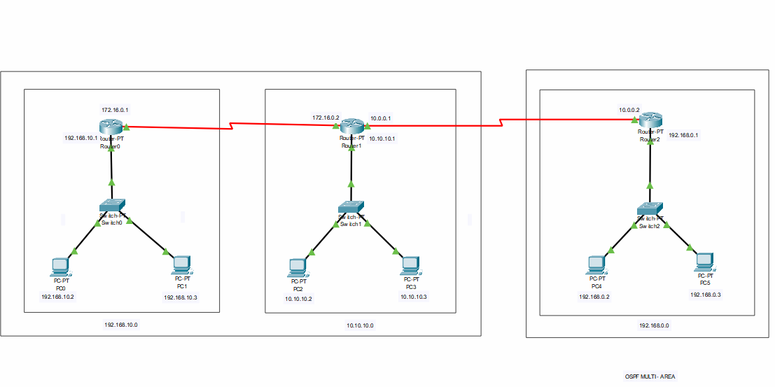

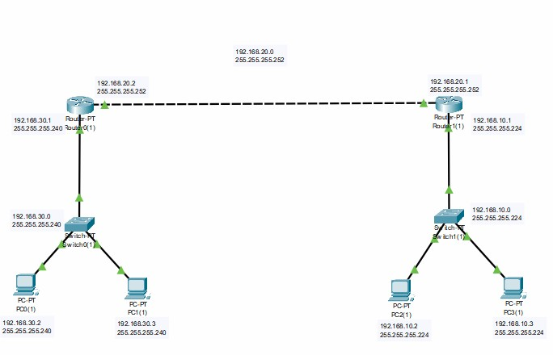

**Result:**

Network Creation and IP Address Assignment:

* + The network topology was successfully created with two LANs, two routers, and appropriate switches.
  + IP addresses were assigned correctly using the specified format based on the last three digits of the roll number.

Routing Protocol Configuration (RIP/OSPF):

* + Router 1 was correctly configured with RIP v1, and Router 2 was configured with OSPF.
  + The routing protocols were implemented on the respective routers, ensuring proper communication between the LANs.

Message Transmission Simulation:

* + The simulation mode in Cisco Packet Tracer was used to verify communication.
  + Messages were successfully transmitted between PCs on different LANs, confirming the functionality of the routing protocols.

Documentation (Procedure and Screenshots):

* + A detailed procedure was provided, including all steps for setting up the network and configuring IP addresses and routing protocols.
  + Screenshots of the topology and successful message transmission were included.

Uploading to GitHub:

* + All required files, including the procedure document, screenshots, and .pkt file, were successfully uploaded to the GitHub repository as instructed.

**Github Link : https://github.com/ARUN-PRASATH18/RA2211003050041**

Name : ArunPrasath.C

Reg. No.RA2211003050041

CSE B