Topic Covered
6/12/25
Linux Bootup steps
1: Power ON
2: BIOS
3: Detect External Device
4: Choose Boot Device
5: MBR
6: GRUB
7: Kernel
8: Init
9: Runlevels
10: User Login Prompt

BIOS: (Integrity Check)
When Power ON BIOS Firmware Loaded from ROM(Non-volatile)
Execute POST (Power ON Self-Test)
POST detects the devices connected to the system, including CPU, RAM, and storage.
If something goes wrong (for example: broken GPU), POST will abort the booting process and signal the user with a series of beeps or error codes.
Choose Bootable Device.
BIOS search BootLoader Program in MBR,if found loaded into Memory .

MBR:
MBR present in 1st sector of Bootable device
The MBR also contains information about GRUB.

GRUB: (Grand Unified Bootloader)
In the Linux boot process that initializes the system by loading the Linux kernel and passing necessary boot parameters
The GRUB splash screen is often the first thing you see when you boot your computer.
It has a simple menu where you can select some options.
If you have multiple kernel images installed, you can use your keyboard to select the one you want your system to boot with. By default, the latest kernel image is selected.
The splash screen will wait a few seconds for you to select and option. If you don't, it will load the default kernel image.
In many systems you can find the GRUB configuration file at /boot/grub/grub.conf or /etc/grub.conf.

Here's an example of a simple grub.conf file:
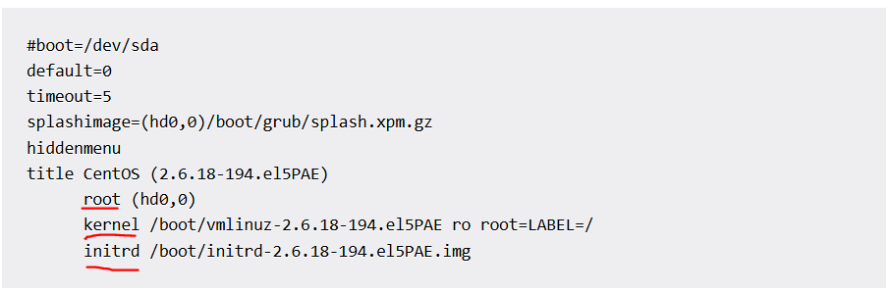

KERNEL :
In this stage of the boot process, the kernel that was selected by GRUB first mounts the root file system that's specified in the grub.conf file.
Then it executes the /sbin/init program, which is always the first program to be executed. You can confirm this with its process id (PID), which should always be 1.
The kernel then establishes a temporary root file system using Initial RAM Disk (initrd) until the real file system is mounted.

INIT : (SysVinit, Upstart, systemd)
Anyone is there (SysVinit, Upstart, systemd) in Linux System .
Looks at the /etc/inittab file to decide the Linux run level.
Following are the available run levels
  - 0 – halt
  - 1 – Single user mode
  - 2 – Multiuser, without NFS
  - 3 – Full multiuser mode
  - 4 – unused
  - 5 – X11
  - 6 – reboot
Init identifies the default initlevel from /etc/inittab and uses that to load all appropriate program.
Execute ‘grep initdefault /etc/inittab’ on your system to identify the default run level
If you want to get into trouble, you can set the default run level to 0 or 6. Since you know what 0 and 6 means, probably you might not do that.
Typically you would set the default run level to either 3 or 5.

RUN LEVELS :
Depending on your default init level setting, the system will execute the programs from one of the following directories.
Run level 0 – /etc/rc0.d/ → Shutdown
Run level 1 – /etc/rc1.d/ → Single-user mode
Run level 2 – /etc/rc2.d/ → Multi-user mode (without networking)
Run level 3 – /etc/rc3.d/ → Full multi-user mode
Run level 4 – /etc/rc4.d/ → User-defined/custom runlevel
Run level 5 – /etc/rc5.d/ → Multi-user with GUI
Run level 6 – /etc/rc6.d/ → System reboot
Please note that there are also symbolic links available for these directory under /etc directly. So, /etc/rc0.d is linked to /etc/rc.d/rc0.d.

Runlevel Programs are executed from /etc/rc.d/rc*.d/
Under the /etc/rc.d/rc*.d/ directories, you would see programs that start with S and K.
Programs starts with S are used during startup. S for startup.
Programs starts with K are used during shutdown. K for kill.
There are numbers right next to S and K in the program names. Those are the sequence number in which the programs should be started or killed.
For example, S12syslog is to start the syslog deamon, which has the sequence number of 12. S80sendmail is to start the sendmail daemon, which has the sequence number of 80. So, syslog program will be started before sendmail.

USER LOGIN:
After all the system services are loaded, the last part of the Linux boot phase is reached, which is displaying the user login prompt.

