**Additional Summary of Business Analyst Data Set**

**Q1. Top 5 Job Titles in New York**

**Code:**

r3 <- data %>%

filter(Location =="New York, NY") %>%

group_by(Job.Title) %>%

summarise(jobcount=n())

top5 <- r3 %>%

top_n(5, jobcount) %>%

arrange(desc(jobcount))

View(top5)

library(ggplot2)

ggplot(top5, aes(x = reorder(Job.Title, -jobcount), y = jobcount)) + geom_bar(stat = "identity", fill = "steelblue") + labs(x = "Job Title", y = "Number of Jobs", title = "Top 5 Job Titles in New York") +

theme(axis.text.x = element_text(angle = 90, hjust = 0.5, vjust = 0.5), axis.title.x = element_blank()) + coord_flip()

**Output:**

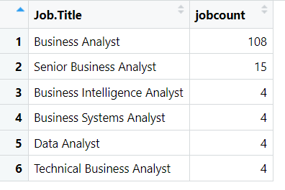

**Chart:**

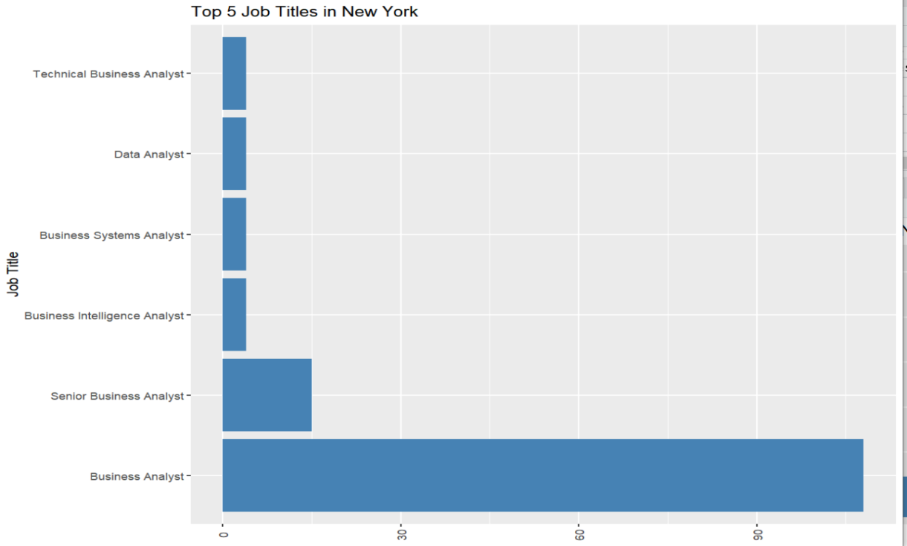

**Q2. Top 5 Job Titles in BurBank**

**Code:**

Burbank <- data %>%

filter(Location =="Burbank, CA") %>%

group_by(Job.Title) %>%

summarise(jobcountburbank=n())

top5Burbank <- Burbank %>%

top_n(5, jobcountburbank) %>%

arrange(desc(jobcountburbank))

View(top5Burbank)

ggplot(top5Burbank, aes(x = reorder(Job.Title, -jobcountburbank), y = jobcountburbank)) + geom_bar(stat = "identity", fill = "steelblue") +

labs(x = "Job Title", y = "Number of Jobs", title = "Top 5 Job Titles in BurBank") +

theme(axis.text.x = element_text(angle = 90, hjust = 0.5, vjust = 0.5), axis.title.x = element_blank()) + coord_flip()

**Output:**

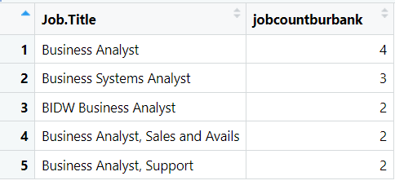

**Chart:**

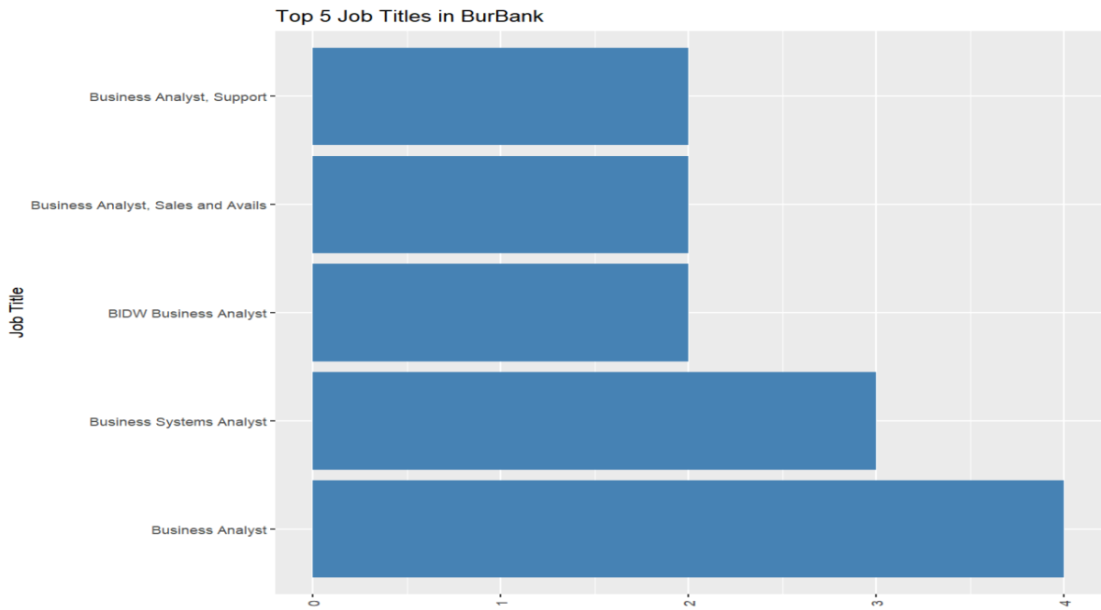

**Q3. Top 5 Job Titles in Dallas TX**

**Code:**

dallas<- data %>%

filter(Location =="Dallas, TX") %>%

group_by(Job.Title) %>%

summarise(jobcountdallas=n())

top5dallas <- dallas %>%

top_n(5, jobcountdallas) %>%

arrange(desc(jobcountdallas))

View(top5dallas)

ggplot(top5dallas, aes(x = reorder(Job.Title, -jobcountdallas), y = jobcountdallas)) +

geom_bar(stat = "identity", fill = "steelblue") + labs(x = "Job Title", y = "Number of Jobs", title = "Top 5 Job Titles in Dallas, TX") + theme(axis.text.x = element_text(angle = 90, hjust = 0.5, vjust = 0.5), axis.title.x = element_blank()) +

coord_flip()

**Output:**

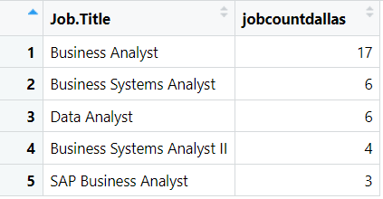

**Chart:**

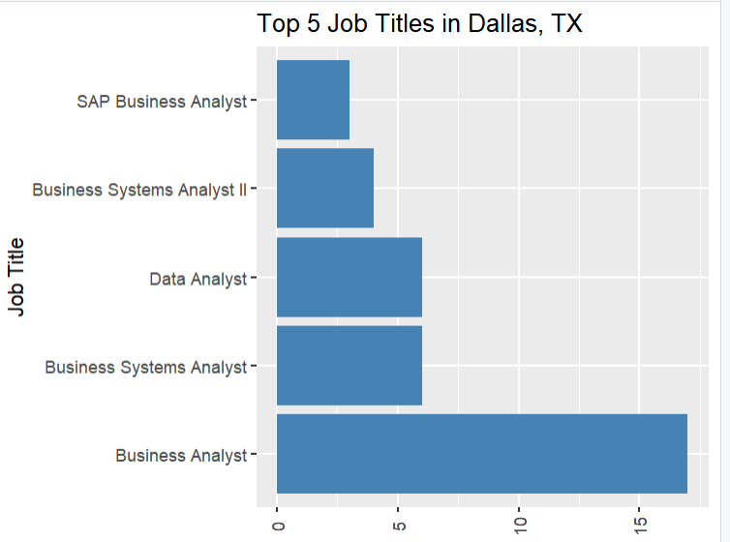

**Q4. Top 5 Job Titles in Austin, TX**

**Code:**

Austin<- data %>%

filter(Location =="Austin, TX") %>%

group_by(Job.Title) %>%

summarise(jobcountaustin=n())

top5austin <- Austin %>%

top_n(5, jobcountaustin) %>%

arrange(desc(jobcountaustin))

m1 <- top5austin %>%

arrange(desc(jobcountaustin)) %>%

distinct(Job.Title, jobcountaustin) %>%

head(5)

ggplot(m1, aes(x = reorder(Job.Title, -jobcountaustin), y = jobcountaustin)) +

geom_bar(stat = "identity", fill = "steelblue") + labs(x = "Job Title", y = "Number of Jobs", title = "Top 5 Job Titles in Austin Tx") + theme(axis.text.x = element_text (angle = 90, hjust = 0.5, vjust = 0.5), axis.title.x = element_blank()) +

coord_flip()

**Output:**

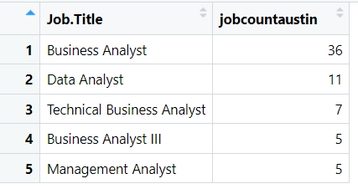

**Chart:**

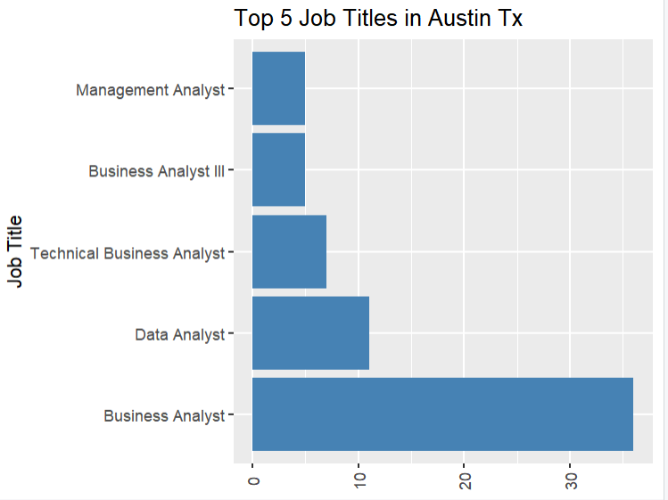

**Q5. Top 5 Job Titles in Los Angeles, CA**

**Code:**

LosAngels<- data %>%

filter(Location =="Los Angeles, CA") %>%

group_by(Job.Title) %>%

summarise(jobcountlosangels=n())

top5losangels <- LosAngels %>%

top_n(5, jobcountlosangels) %>%

arrange(desc(jobcountlosangels))

ggplot(top5losangels, aes(x = reorder(Job.Title, -jobcountlosangels), y = jobcountlosangels)) + geom_bar(stat = "identity", fill = "steelblue") + labs(x = "Job Title", y = "Number of Jobs", title = "Top 5 Job Titles in Los Angeles, CA") +

theme(axis.text.x = element_text(angle = 90, hjust = 0.5, vjust = 0.5), axis.title.x = element_blank()) + coord_flip()

**Output:**

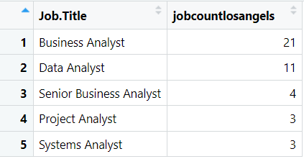

**Charts:**

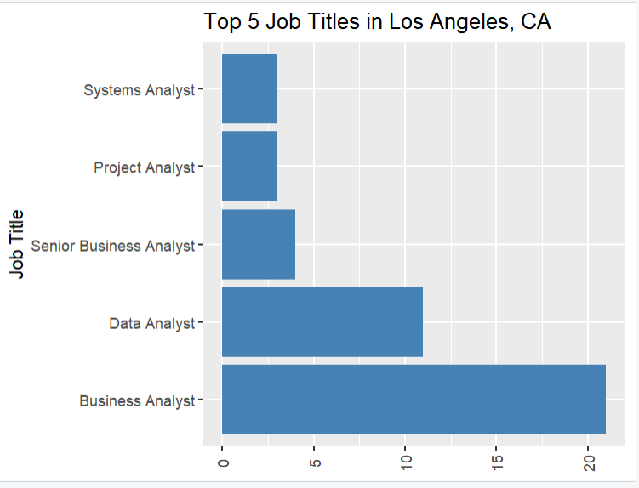

**Q6. Top 5 Job Titles in Houseton TX**

**Code:**

Houseton<- data %>%

filter(Location =="Houston, TX") %>%

group_by(Job.Title) %>%

summarise(jobcounthouseton=n())

top5houseton <- Houseton %>%

top_n(5, jobcounthouseton) %>%

arrange(desc(jobcounthouseton))

m2 <- top5houseton %>%

arrange(desc(jobcounthouseton)) %>%

distinct(Job.Title, jobcounthouseton) %>%

head(5)

ggplot(m2, aes(x = Job.Title, y = jobcounthouseton, size = jobcounthouseton, color = Job.Title)) + geom_point(alpha = 0.7) + scale_size(range = c(3, 10)) + labs (x = "Job Title", y = "Job Count", title = "Top 5 Job Counts in Housetone (Bubble Chart)") +

theme_minimal()

**Output:**

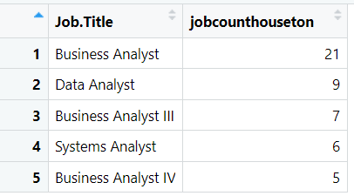

**Chart:**

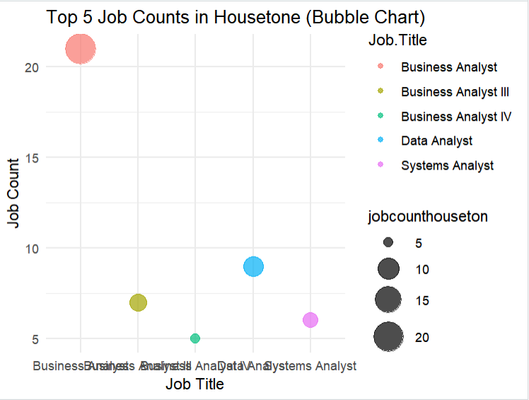

**Q7. Top 5 Job Titles in Phoenix, AZ**

**Code:**

Phoenix<- data %>%

filter(Location =="Phoenix, AZ") %>%

group_by(Job.Title) %>%

summarise(jobcountPhoenix=n())

m3 <- top5Phoenix %>%

arrange(desc(jobcountPhoenix)) %>%

distinct(Job.Title, jobcountPhoenix) %>%

head(5)

ggplot(m3, aes(x = Job.Title, y = jobcountPhoenix, size = jobcountPhoenix, color = Job.Title)) + geom_point(alpha = 0.7) + scale_size(range = c(3, 10)) +

labs(x = "Job Title", y = "Job Count", title = "Top 5 Job Counts in Phoenix, AZ (Bubble Chart)") + theme_minimal()

**Output:**

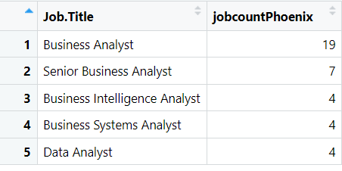

**Chart:**

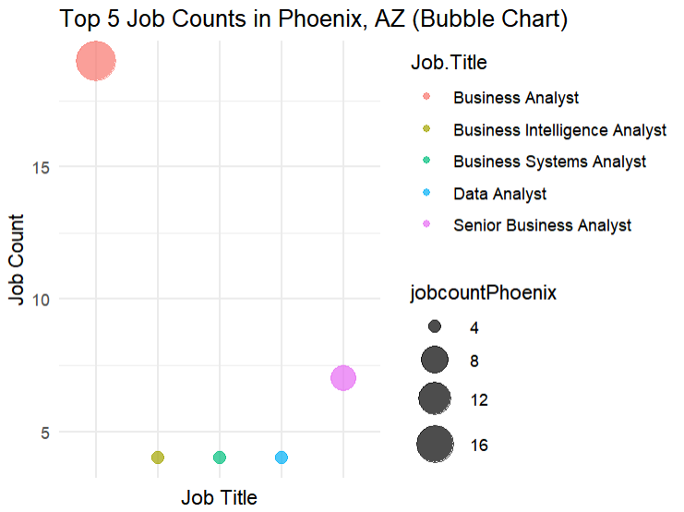

**Q8. Top 5 Job Titles in Tempe, AZ**

**Code:**

Tempe<- data %>%

filter(Location =="Tempe, AZ") %>%

group_by(Job.Title) %>%

summarise(jobcountTempe=n())

m4 <- Tempe %>%

arrange(desc(jobcountTempe)) %>%

distinct(Job.Title, jobcountTempe) %>%

head(5)

ggplot(m4, aes(x = Job.Title, y = jobcountTempe, size = jobcountTempe, color = Job.Title)) + geom_point(alpha = 0.7) + scale_size(range = c(3, 10)) +

labs(x = "Job Title", y = "Job Count", title = "Top 5 Job Counts in Tempe, AZ (Bubble Chart)") + theme_minimal()+ theme(axis.text.x = element_blank())

**Output:**

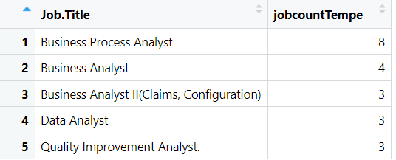

**Chart:**

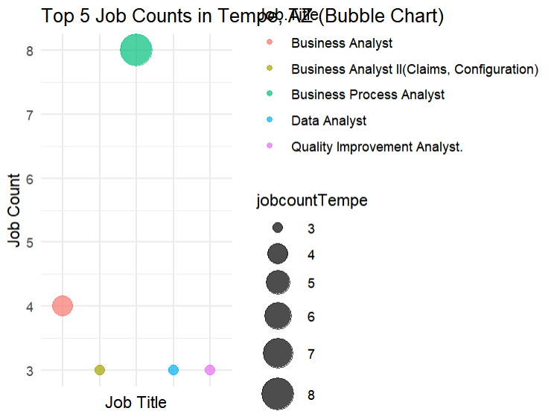

**Q8. Top 5 Job Titles in Tempe, AZ**

**Code:**

Philadelphia<- data %>%

filter(Location =="Philadelphia, PA") %>%

group_by(Job.Title) %>%

summarise(jobcountPhiladelphia=n())

m5 <- Philadelphia %>%

arrange(desc(jobcountPhiladelphia)) %>%

distinct(Job.Title, jobcountPhiladelphia) %>%

head(5)

ggplot(m5, aes(x = Job.Title, y = jobcountPhiladelphia, size = jobcountPhiladelphia, color = Job.Title)) + geom_point(alpha = 0.7) + scale_size(range = c(3, 10)) +

labs(x = "Job Title", y = "Job Count", title = "Top 5 Job Counts in Philadelphia, PA (Bubble Chart)") + theme_minimal()+ theme(axis.text.x = element_blank())

**Output:**

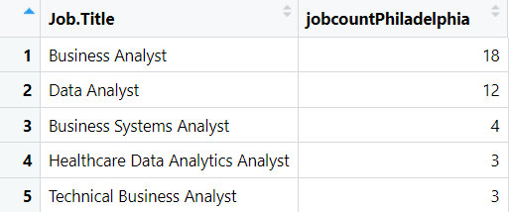

**Chart:**

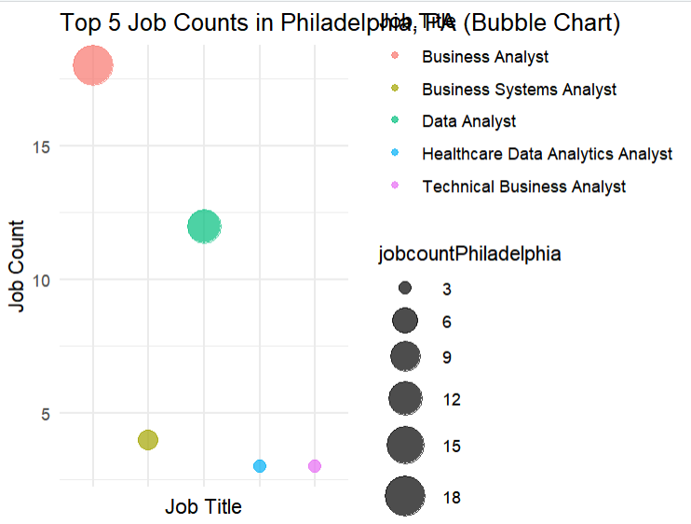

**Q9. Top 5 Job Titles in San Diego, CA**

**Code:**

SanDiego<- data %>%

filter(Location =="San Diego, CA") %>%

group_by(Job.Title) %>%

summarise(jobcountSanDiego=n())

m6 <- SanDiego %>%

arrange(desc(jobcountSanDiego)) %>%

distinct(Job.Title, jobcountSanDiego) %>%

head(5)

ggplot(m6, aes(x = Job.Title, y = jobcountSanDiego, size = jobcountSanDiego, color = Job.Title)) + geom_point(alpha = 0.7) + scale_size(range = c(3, 10)) +

labs(x = "Job Title", y = "Job Count", title = "Top 5 Job Counts in San Diego, CA (Bubble Chart)") + theme_minimal()+ theme(axis.text.x = element_blank())

**Output:**

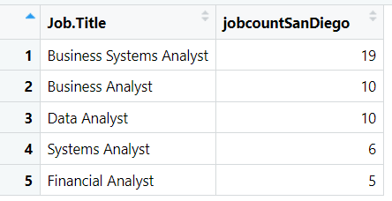

**Chart:**

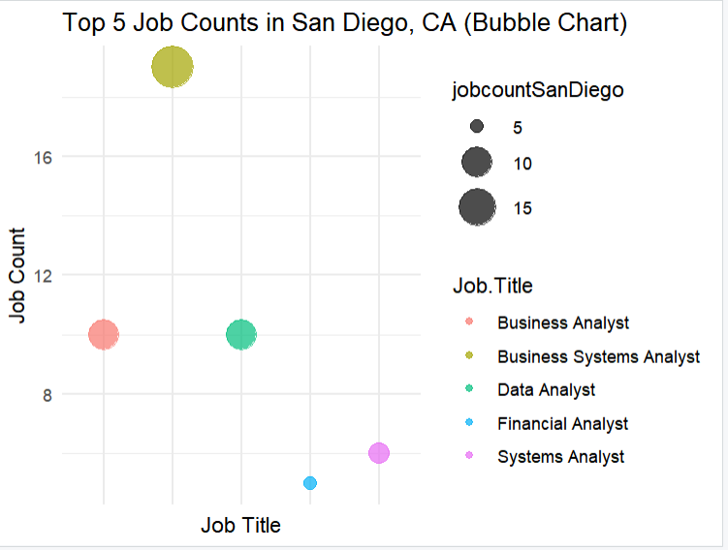

**Q10. Top 5 Job Titles in Irving, TX**

**Code:**

Irving<- data %>%

filter(Location =="Irving, TX") %>%

group_by(Job.Title) %>%

summarise(jobcountIrving=n())

m7 <- Irving %>%

arrange(desc(jobcountIrving)) %>%

distinct(Job.Title, jobcountIrving) %>%

head(5)

ggplot(m7, aes(x = Job.Title, y = jobcountIrving, size = jobcountIrving, color = Job.Title)) +

geom_point(alpha = 0.7) + scale_size(range = c(5, 10)) + labs(x = "Job Title", y = "Job Count", title = "Top 5 Job Counts in Irving, TX") + theme_minimal()+ theme(axis.text.x = element_blank())

**Output:**

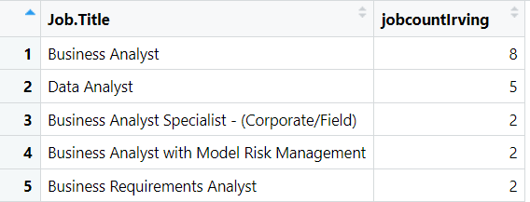

**Chart:**

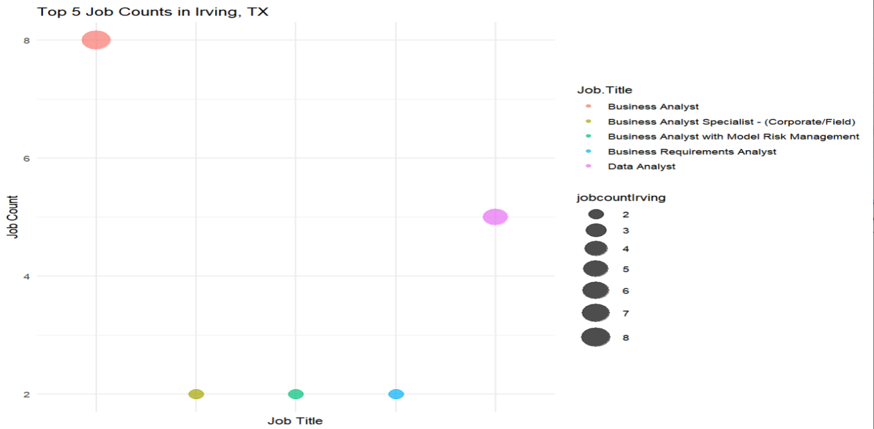

**Q11. Top 5 Job Titles in San Jose, CA**

**Code:**

SanJose<- data %>%

filter(Location =="San Jose, CA") %>%

group_by(Job.Title) %>%

summarise(jobcountSanJose=n())

m8 <- SanJose %>%

arrange(desc(jobcountSanJose)) %>%

distinct(Job.Title, jobcountSanJose) %>%

head(5)

ggplot(m8, aes(x = Job.Title, y = jobcountSanJose, size = jobcountSanJose, color = Job.Title)) + geom_point(alpha = 0.7) + scale_size(range = c(5, 10)) + labs(x = "Job Title", y = "Job Count", title = "Top 5 Job Counts in San Jose, CA") + theme_minimal()+ theme(axis.text.x = element_blank())

**Output:**

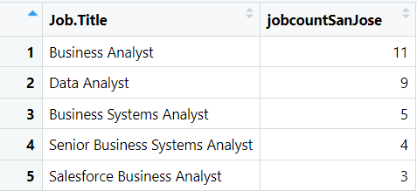

**Chart:**

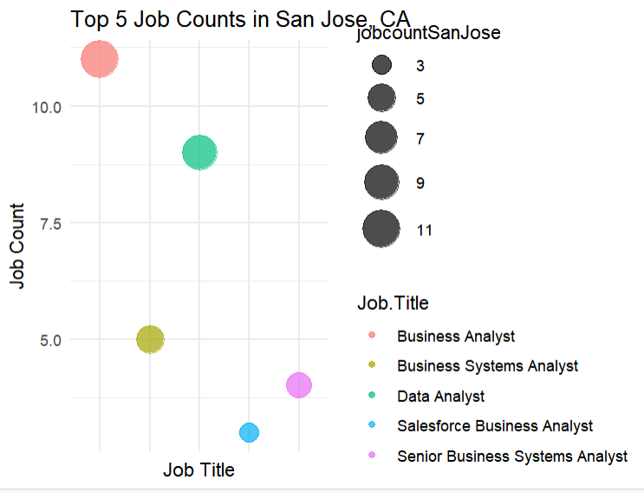

**Q12. Top 5 Job Titles in Jacksonville, FL**

**Code:**

Jacksonville<- data %>%

filter(Location =="Jacksonville, FL") %>%

group_by(Job.Title) %>%

summarise(jobcountJacksonville=n())

m9 <- Jacksonville %>%

arrange(desc(jobcountJacksonville)) %>%

distinct(Job.Title, jobcountJacksonville) %>%

head(5)

ggplot(m9, aes(x = Job.Title, y = jobcountJacksonville, fill = Job.Title)) +

geom_boxplot(color = "black", width = 0.7) + geom_text(aes(label = jobcountJacksonville), vjust = -0.5, size = 3.5) + labs(x = "Job Title", y = "Job Count", title = "Distribution of Job Counts for Top 5 Job Titles in Jacksonville, FL (Box Plot)") + theme_minimal()+ theme(axis.text.x = element_blank())

**Output:**

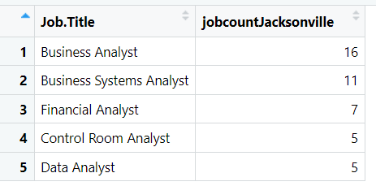

**Charts:**

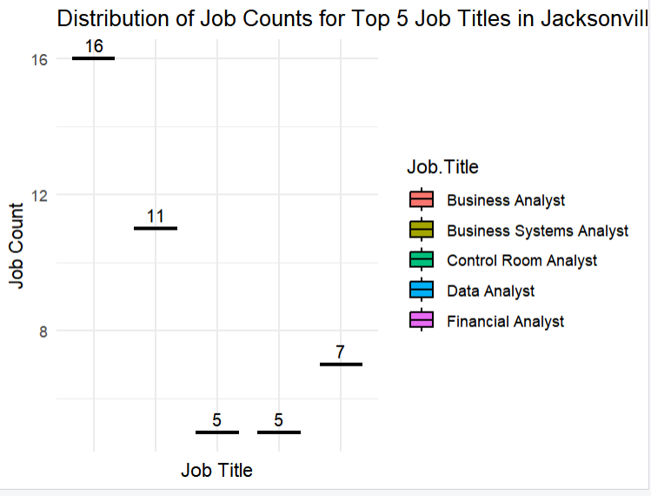

**Q13. Count of Top 10 Job Titles**

**Code:**

maxjob <- data %>%

group_by(Job.Title) %>%

summarise(maxjobcount=n)

m10<- maxjob %>%

arrange(desc(maxjobcount)) %>%

distinct(Job.Title, maxjobcount) %>%

head(10)

ggplot(m10, aes(x = Job.Title, y = maxjobcount, size = maxjobcount, color = Job.Title)) +

geom_point(alpha = 0.7) + scale_size(range = c(5, 10)) + labs(x = "Job Title", y = "Job Count", title = "Top 10 Job Counts") + theme_minimal()+ theme(axis.text.x = element_blank())

**Outputs:**



**Charts:**

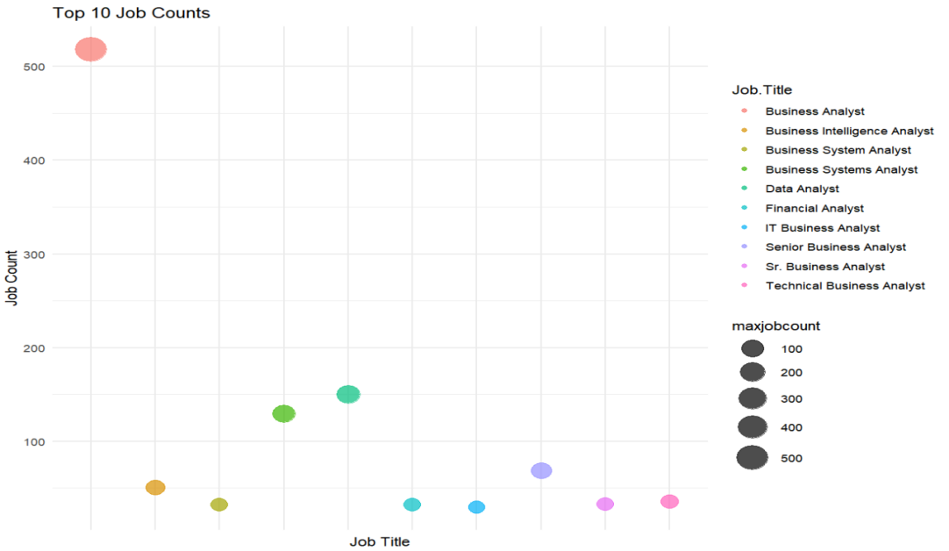

**Q14. Count of Top 10 Job Titles per Location**

**Code:**

maxcountry <- data %>%

group_by(Location) %>%

summarise(maxcountrycount=n())

m11<- maxcountry %>%

arrange(desc(maxcountrycount)) %>%

distinct(Location, maxcountrycount) %>%

head(10)

ggplot(m11, aes(x = Location, y = maxcountrycount, size = maxcountrycount, color = Location)) + geom_point(alpha = 0.7) + scale_size(range = c(5, 10)) + labs(x = "Job Title", y = "Job Count", title = "Top 10 Job Counts per Location") + theme_minimal()+ theme(axis.text.x = element_blank())

**Output:**

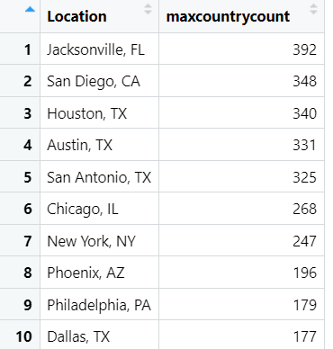

**Chart:**

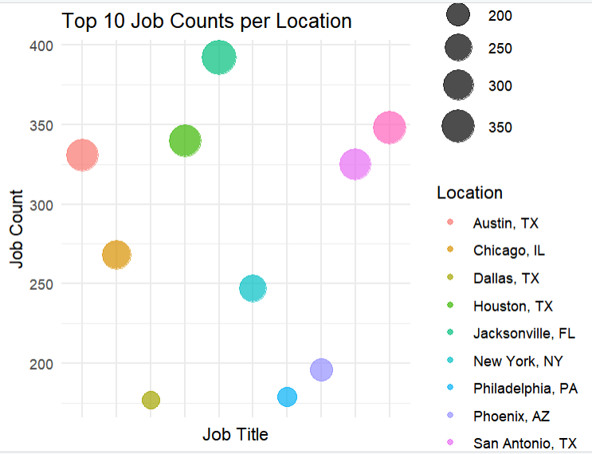

**Q15. Count of Top 10 Country Offers Business Analyst Job**

**Code:**

maxcountry <- data %>%

group_by(Location) %>%

filter(Job.Title == "Business Analyst") %>%

summarise(maxcountrycount=n())

m12<- maxcountry %>%

arrange(desc(maxcountrycount)) %>%

distinct(Location, maxcountrycount) %>%

head(10)

ggplot(m12, aes(x = Location, y = maxcountrycount, size = maxcountrycount, color = Location)) + geom_point(alpha = 0.7) + scale_size(range = c(5, 10)) + geom_text(aes(label = maxcountrycount), size = 5, vjust = -0.5) + labs(x = "Job Title", y = "Job Count", title = "Top 10 Country offers Business Analyst Job") + theme_minimal() + theme(axis.text.x = element_blank())

**Output:**

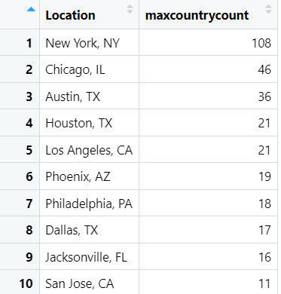

**Chart:**

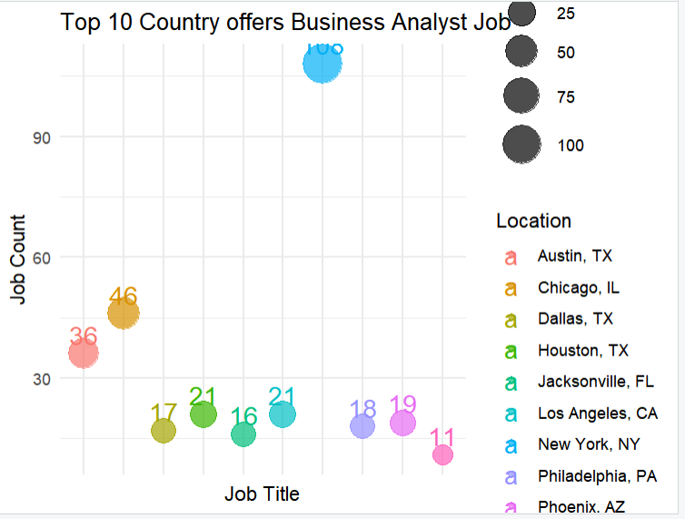

**Q16. Count of Top 10 Country Offers Data Analyst Job**

**Code:**

maxcountry1 <- data %>%

group_by(Location) %>%

filter(Job.Title == "Data Analyst") %>%

summarise(maxcountrycount1=n())

View(maxcountry1)

m13<- maxcountry1 %>%

arrange(desc(maxcountrycount1)) %>%

distinct(Location, maxcountrycount1) %>%

head(10)

View(m13)

ggplot(m13, aes(x = Location, y = maxcountrycount1, size = maxcountrycount1, color = Location)) +

geom_point(alpha = 0.7) +

scale_size(range = c(5, 10)) +

geom_text(aes(label = maxcountrycount1), size = 5, vjust = -0.5) +

labs(x = "Job Title", y = "Job Count", title = "Top 10 Country offers Data Analyst Job") +

theme_minimal() +

theme(axis.text.x = element_blank())

**Output:**

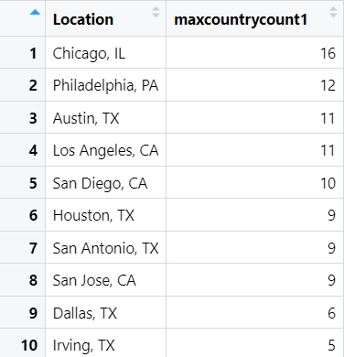

**Chart:**

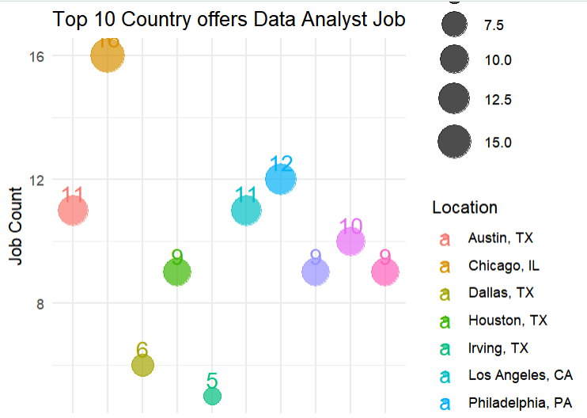

**Q16. Count of Top 10 Country Offers Business System Analyst Job**

**Code:**

maxcountry2 <- data %>%

group_by(Location) %>%

filter(Job.Title == "Business System Analyst") %>%

summarise(maxcountrycount2=n())

m14<- maxcountry2 %>%

arrange(desc(maxcountrycount2)) %>%

distinct(Location, maxcountrycount2) %>%

head(10)

View(m14)

ggplot(m14, aes(x = Location, y = maxcountrycount2, size = maxcountrycount2, color = Location)) +

geom_point(alpha = 0.7) +

scale_size(range = c(5, 10)) +

geom_text(aes(label = maxcountrycount2), size = 5, vjust = -0.5) +

labs(x = "Job Title", y = "Job Count", title = "Top 10 Country offers Business System Analyst Job") +

theme_minimal() +

theme(axis.text.x = element_blank())

**Output:**

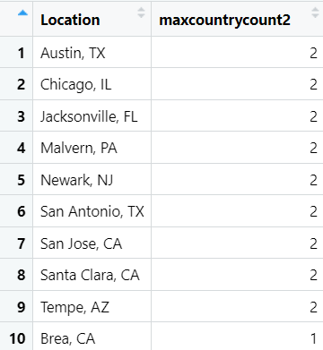

**Chart:**

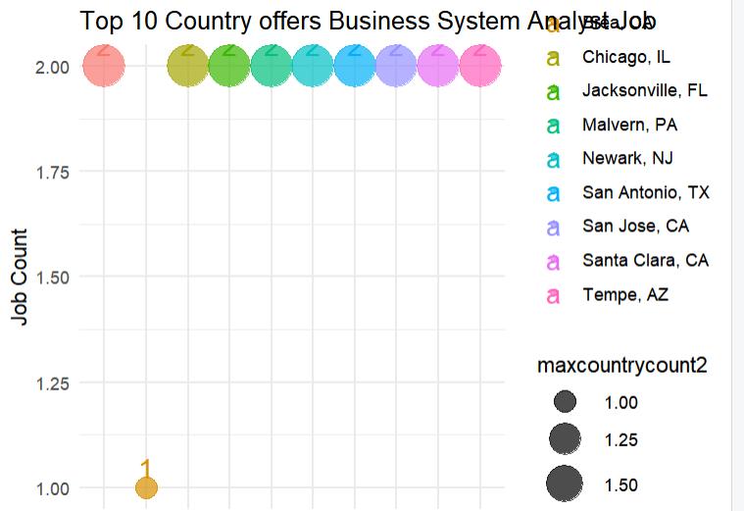

**Q17. Count of Top 10 Country Offers Senior Business Analyst Job**

**Code:**

maxcountry3 <- data %>%

group_by(Location) %>%

filter(Job.Title == "Senior Business Analyst") %>%

summarise(maxcountrycount3=n())

m15<- maxcountry3 %>%

arrange(desc(maxcountrycount3)) %>%

distinct(Location, maxcountrycount3) %>%

head(10)

ggplot(m15, aes(x = Location, y = maxcountrycount3, size = maxcountrycount3, color = Location)) + geom_point(alpha = 0.7) + scale_size(range = c(5, 10)) +

geom_text(aes(label = maxcountrycount3), size = 5, vjust = -0.5) + labs(x = "Job Title", y = "Job Count", title = "Top 10 Country offers Senior Business Analyst Job") + theme_minimal() + theme(axis.text.x = element_blank())

**Output:**

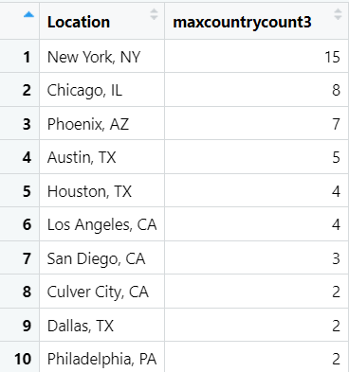

**Chart:**

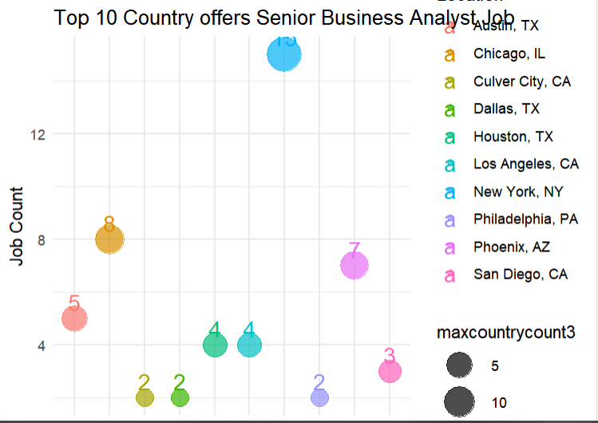

**Q18. Count of Top 10 Country Offers Senior Business Analyst Job**

**Code:**

maxcountry4 <- data %>%

group_by(Location) %>%

filter(Job.Title == "Business Intelligence Analyst") %>%

summarise(maxcountrycount4=n())

m16<- maxcountry4 %>%

arrange(desc(maxcountrycount4)) %>%

distinct(Location, maxcountrycount4) %>%

head(10)

View(m16)

ggplot(m16, aes(x = Location, y = maxcountrycount4, size = maxcountrycount4, color = Location)) + geom_point(alpha = 0.7) + scale_size(range = c(5, 10)) +

geom_text(aes(label = maxcountrycount4), size = 5, vjust = -0.5) +

labs(x = "Job Title", y = "Job Count", title = "Top 10 Country offers Business Intelligence Analyst Job") + theme_minimal() + theme(axis.text.x = element_blank())

**Output:**

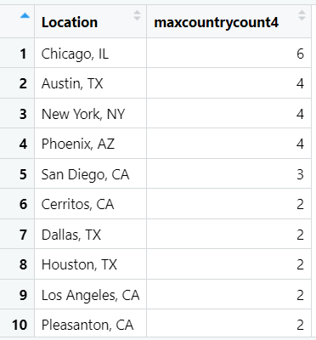

**Chart:**

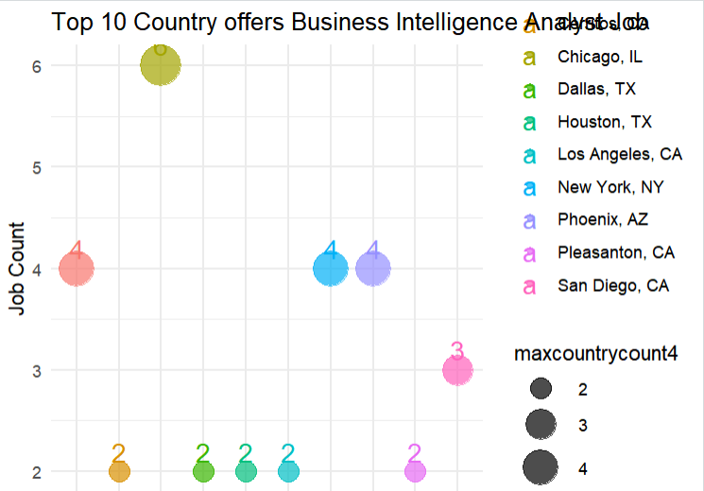

**Q19. Count of Top 10 Business Service Sectors per Location**

**Code:**

maxsector1 <- data %>%

group_by(Location) %>%

filter(Sector == "Business Services") %>%

summarise(BusnessServices_sectorcount1=n())

m17<- maxsector1 %>%

arrange(desc(BusnessServices_sectorcount1)) %>%

distinct(Location, BusnessServices_sectorcount1) %>%

head(10)

ggplot(m17, aes(x = Location, y = BusnessServices_sectorcount1, size = BusnessServices_sectorcount1, color = Location)) + geom_point(alpha = 0.7) +

scale_size(range = c(5, 10)) + labs(x = "Job Title", y = "Job Count", title = "Count of Top 10 Business Service sector per Location") + theme_minimal() + theme(axis.text.x = element_blank())

**Output:**

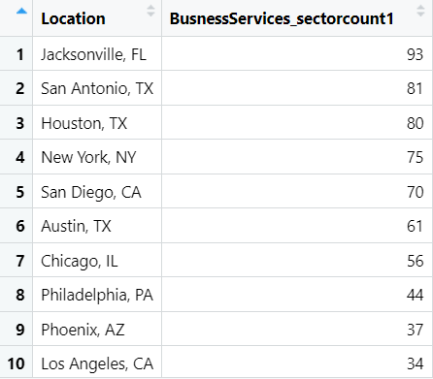

**Chart:**

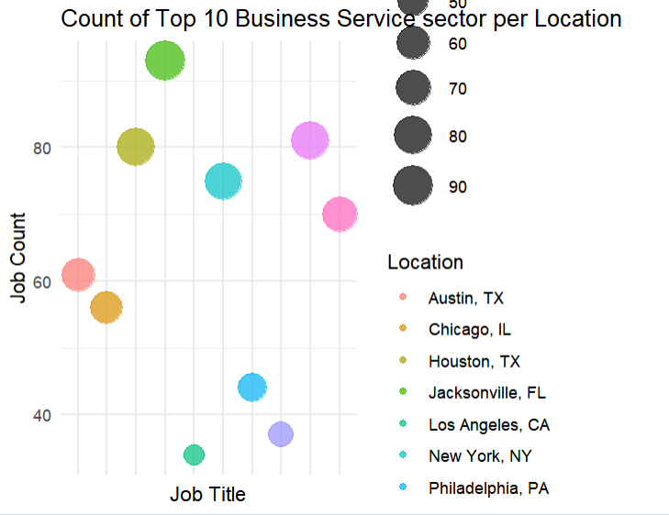

**Q20. Count of Top 10 Jobs Offers in Business Services**

**Code:**

maxsector2 <- data %>%

group_by(Job.Title) %>%

filter(Sector == "Business Services") %>%

summarise(BusnessServices_sectorcount2=n())

m18<- maxsector2 %>%

arrange(desc(BusnessServices_sectorcount2)) %>%

distinct(Job.Title, BusnessServices_sectorcount2) %>%

head(10)

ggplot(m18, aes(x = "", y = BusnessServices_sectorcount2, fill = Job.Title)) +

geom_bar(stat = "identity", width = 1) + coord_polar("y", start = 0) +

labs(title = "Job Distribution in Business Services Sector", fill = "Job Titles") +

theme_void() + geom_text(aes(label = BusnessServices_sectorcount2), position = position_stack(vjust = 0.5), color = "white", size = 3)

**Output:**

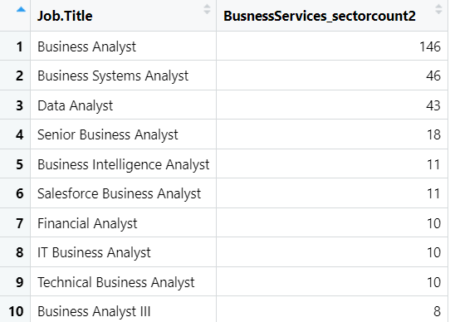

**Chart:**

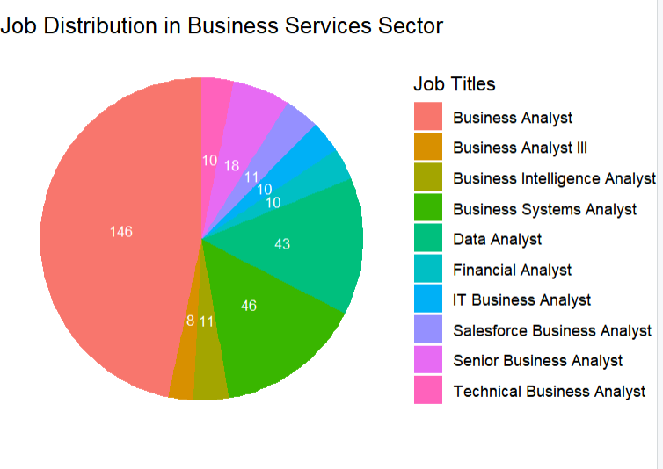

**Q21. Top 10 Jobs pay Max salary in Finance**

**Code:**

maxpayFinance <- data %>%

filter(Sector == "Finance" & Sector!=-1)

View(maxpayFinance)

maxpayFinance <- maxpayFinance %>%

group_by(Job.Title) %>%

summarise(Max_payFinance = max(MaxSalaryRange))

sorted_payFinance <- maxpayFinance %>%

arrange(desc(maxpayFinance))

top10_payFinance <- head(sorted_payFinance,10)

View(top10_payFinance)

**Output:**

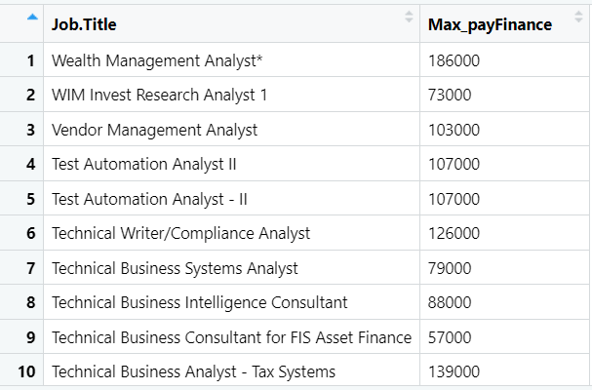

**Q22. Top 10 Jobs pay Max salary in Information Technology**

**Code:**

maxpayFinance <- data %>%

filter(Sector == "Information Technology" & Sector!=-1)

View(maxpayFinance)

maxpayFinance <- maxpayFinance %>%

group_by(Job.Title) %>%

summarise(Max_payFinance = max(MaxSalaryRange))

sorted_payFinance <- maxpayFinance %>%

arrange(desc(maxpayFinance))

top10_payFinance <- head(sorted_payFinance,10)

View(top10_payFinance)

**Output:**

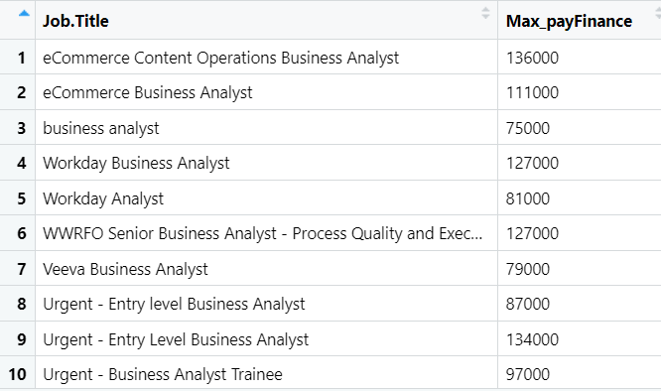

**Q23. Top 10 Jobs pay Max salary in Insurance**

**Code:**

maxpayFinance <- data %>%

filter(Sector == "Insurance" & Sector!=-1)

View(maxpayFinance)

maxpayFinance <- maxpayFinance %>%

group_by(Job.Title) %>%

summarise(Max_payFinance = max(MaxSalaryRange))

View(maxpayFinance)

sorted_payFinance <- maxpayFinance %>%

arrange(desc(maxpayFinance))

top10_payFinance <- head(sorted_payFinance,10)

View(top10_payFinance)

**Output:**

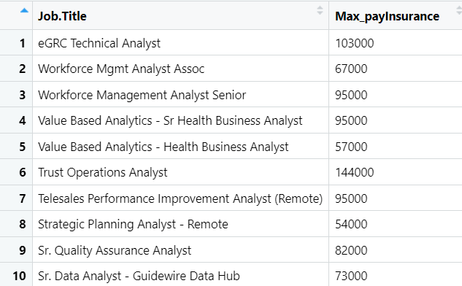

**Q24. Top 10 Jobs pay Max salary in Government**

**Code:**

maxpayGovt <- data %>%

filter(Sector == "Government" & Sector!=-1)

View(maxpayGovt)

maxpayGovt <- maxpayGovt %>%

group_by(Job.Title) %>%

summarise(Max_payGovt = max(MaxSalaryRange))

View(maxpayGovt)

sorted_payGovt <- maxpayGovt %>%

arrange(desc(maxpayGovt))

top10_payGovt <- head(sorted_payGovt,10)

View(top10_payGovt)

**Output:**

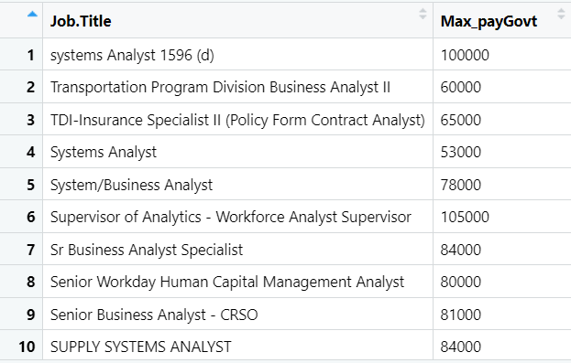

**Q25. Top 10 Jobs pay with least salary in Business Services**

**Code:**

minpay <- data %>%

filter(Sector == "Business Services" & Sector!=-1)

View(minpay)

minpay <- minpay %>%

group_by(Job.Title) %>%

summarise(Min_pay = min(MinSalaryRange))

View(minpay)

sorted_pay <- minpay %>%

arrange((minpay))

bottom10_pay <- head(sorted_pay,10)

View(bottom10_pay)

**Output:**

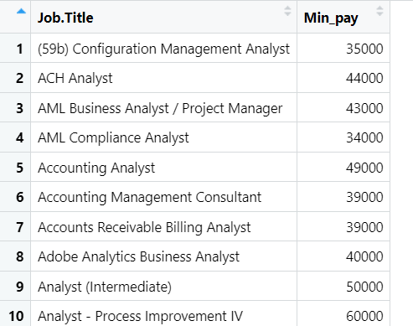

**Q26. Top 10 Jobs pay with least salary in Finance**

**Code:**

minpay1 <- data %>%

filter(Sector == "Finance" & Sector!=-1)

View(minpay1)

minpay1 <- minpay1 %>%

group_by(Job.Title) %>%

summarise(Min_pay1 = min(MinSalaryRange))

View(minpay1)

sorted_pay1 <- minpay1 %>%

arrange(Min_pay1) %>%

filter(Min_pay1<=30000)

View(sorted_pay1)

bottom10_pay1 <- head(sorted_pay1,10)

View(bottom10_pay1)

**Output:**



**Q27. Top 10 Jobs pay with least salary in Information Technology**

**Code:**

minpay2 <- data %>%

filter(Sector == "Information Technology" & Sector!=-1)

View(minpay2)

minpay2 <- minpay2 %>%

group_by(Job.Title) %>%

summarise(Min_pay2 = min(MinSalaryRange))

View(minpay2)

sorted_pay2 <- minpay2 %>%

arrange(Min_pay2) %>%

filter(Min_pay2<=30000)

View(sorted_pay2)

bottom10_pay2 <- head(sorted_pay1,10)

View(bottom10_pay2)

**Output:**



**Q27. Top 10 Jobs pay with least salary in Insurance**

**Code:**

minpay3 <- data %>%

filter(Sector == "Insurance" & Sector!=-1)

View(minpay3)

minpay3 <- minpay3 %>%

group_by(Job.Title) %>%

summarise(Min_pay3 = min(MinSalaryRange))

View(minpay3)

sorted_pay3 <- minpay3 %>%

arrange(Min_pay3) %>%

filter(Min_pay3<=30000)

View(sorted_pay3)

bottom10_pay3 <- head(sorted_pay3,10)

View(bottom10_pay3)

**Output:**

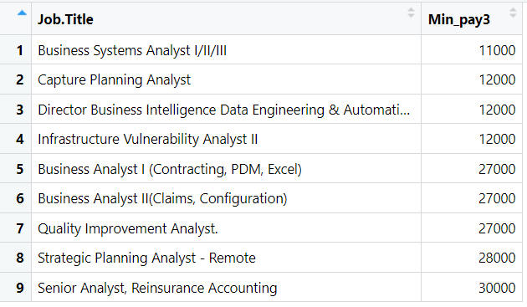

**Q28. Top 10 Jobs pay with least salary in Government**

**Code:**

minpay4 <- data %>%

filter(Sector == "Government" & Sector!=-1)

View(minpay4)

minpay4 <- minpay4 %>%

group_by(Job.Title) %>%

summarise(Min_pay4 = min(MinSalaryRange))

View(minpay4)

sorted_pay4 <- minpay4 %>%

arrange(Min_pay4) %>%

filter(Min_pay4<=40000)

View(sorted_pay4)

bottom10_pay4 <- head(sorted_pay4,10)

View(bottom10_pay4)

**Chart:**



**Q29. Count of Easy Apply companies**

**Code:**

easycompanies <- data %>%

select(Company.Name, Easy.Apply) %>%

filter(Easy.Apply=="TRUE") %>%

summarise(easyapply=n())

View(easycompanies)

**Output:**

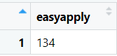

**Q30. Count of Easy apply companies in Business Services**

**Code:**

easysector <- data %>%

select(Company.Name, Sector, Easy.Apply) %>%

filter(Easy.Apply=="TRUE" & Sector=="Business Services") %>%

sumarise(easyapply1=n())

View(easysector)

**Output:**

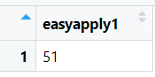

**Q31. Count of Easy apply companies in Information Technology**

**Code:**

easysectorIT <- data %>%

select(Company.Name, Sector, Easy.Apply) %>%

filter(Easy.Apply=="TRUE" & Sector=="Information Technology") %>%

summarise(easyapply2=n())

View(easysectorIT)

**Output:**

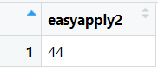

**Q32. Count of Easy apply companies in Finance**

**Code:**

easysectorFinance <- data %>%

select(Company.Name, Sector, Easy.Apply) %>%

filter(Easy.Apply=="TRUE" & Sector=="Finance") %>%

summarise(easyapply3=n())

View(easysectorFinance)

**Output:**

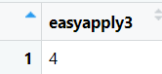

**Q33. Count of Companies where Location equals Headquarters**

**Code:**

# Filter the data using subset

filtered_data <- subset(data, Location == Headquarters)

# View the filtered data

View(filtered_data)

company_count = nrow(filtered_data)

View(company_count)

# Count companies by Location or Headquarters

count <- table(c(filtered_data$Location, filtered_data$Headquarters))

# Print the count

top10_loc_head_company = tail(sorted_loc,10)

View(top10_loc_head_company)

**Output:**

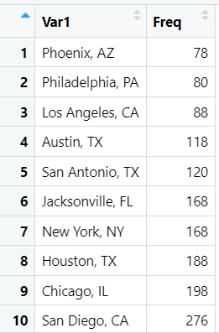

**Q34. Count of Small scale Private Companies**

**Code:**

# Filter the data using filter

filtered_data <- data %>%

filter(Size == "1 to 50 employees" & Type.of.ownership=="Company - Private") %>%

summarise(ownercount=n())

View(filtered_data)

**Output:**

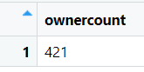

**Q35. Count of Small-scale Public Companies**

**Code:**

# Filter the data using filter

filtered_data1 <- data %>%

filter(Size == "1 to 50 employees" & Type.of.ownership=="Company - Public") %>%

summarise(ownercount1=n())

View(filtered_data1)

**Output:**



**Q36. Count of Large-scale Private Companies**

**Code:**

# Filter the data using filter

filtered_data2 <- data %>%

filter(Size == "10000+ employees" & Type.of.ownership=="Company - Private") %>%

summarise(ownercount2=n())

View(filtered_data2)

**Output:**

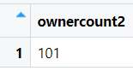

**Q36. Count of Large-scale Public Companies**

**Code:**

filtered_data4 <- data %>%

filter(Size == "10000+ employees" & Type.of.ownership=="Company - Public" ) %>%

summarise(ownercount4=n())

View(filtered_data4)

**Output:**

