Name of the Data Set : UDMYC-Data

Overview of the Data Set:
Total Rows : 9445
Total Columns : 20
The Data-set contains the following variables:

- id: Unique identifier for each entry in the Data-set.
- title: Title of the course.
- url: URL or link associated with the course.
- is_paid: A binary indicator (0 or 1) representing whether the course is paid or free.
- num_subscribers: The number of subscribers enrolled in the course.
- avg_rating: The average rating given by the course participants.
- avg_rating_recent: The average rating given by recent course participants.
- rating: The overall rating of the course.
- num_reviews: The number of reviews received for the course.
- is_wishlisted: A binary indicator (0 or 1) representing whether the course is wishlisted by users.
- num_published_lectures: The number of lectures or lessons published in the course.
- num_published_practice_tests: The number of practice tests published in the course.
- created: The date and time when the course was created.
- published_time: The time when the course was published.
- discount_price_amount: The discounted price amount for the course.
- discount_price_currency: The currency of the discounted price.
- discount_price_price_string: The formatted string representation of the discounted price.
- price_detail_amount: The original price amount of the course.
- price_detail_currency: The currency of the original price.
- price_detail_price_string: The formatted string representation of the original price.

This Data-set likely represents a collection of online courses, with various attributes related to the course's title, pricing, ratings, and other relevant information.

Overview of Tool Used : R Studio

R Studio is an integrated development environment (IDE) specifically designed for the R programming language. It provides a user-friendly interface and a comprehensive set of tools for data analysis, visualization, and statistical modeling.
- Data Analysis: R Studio is widely used for data analysis tasks. It offers a wide range of libraries and packages that enable users to manipulate, clean, and transform data efficiently. R Studio provides various functions and tools for data exploration, descriptive statistics, and data wrangling.
- Data Visualization: R Studio has excellent capabilities for data visualization. It offers packages such as ggplot2 and plotly that allows users to create a wide variety of high-quality charts, plots, and graphs. R Studio provides customization options to tailor the visualizations according to specific requirements.
- Statistical Modeling: R Studio is highly regarded for its statistical modeling capabilities. It provides a vast collection of libraries for statistical analysis, hypothesis testing, regression analysis, time series analysis, and machine learning. R Studio allows users to build complex statistical models and perform advanced statistical computations.
- Reproducible Research: R Studio promotes reproducible research practices. It allows users to create and document data analysis workflows using R Markdown, which combines code, narrative text, and visualizations into a single document. R Studio facilitates the creation of reproducible reports and presentations.
- Collaboration and Sharing: R Studio supports collaboration and sharing of code and projects. It provides version control integration with Git and enables team members to work on the same project simultaneously. R Studio also allows users to publish their analyses and visualizations as interactive web applications or dashboards.
- Extensibility: R Studio is highly extensible. It has a vibrant community that develops and maintains numerous packages to extend its functionality. Users can leverage these packages to access additional statistical methods, data sources, and visualization options.
- Integrated Development Environment: R Studio provides an intuitive and user-friendly IDE for R programming. It offers features like syntax highlighting, code completion, debugging tools, and project management. The IDE enhances productivity and makes it easier for users to write, test, and debug R code.

Overall, R Studio is a powerful tool for data analysis and statistical modeling. Its extensive capabilities, user-friendly interface, and community support make it a popular choice among data scientists, statisticians, and researchers.

Overview of Tool Used: Power BI
Power BI is a business intelligence and data visualization tool developed by Microsoft. It allows users to analyze data and share insights in a user-friendly and interactive manner. Power BI enables individuals and organizations to connect to multiple data sources, transform and shape the data, and create visually appealing reports and dashboards.

Here are some key features and components of Power BI:

- Data Connectivity
- Data Transformation and Modeling
- Data Visualization
- Reports and Dashboards
- Collaboration and Sharing
- Natural Language Querying
- Data Security and Governance
- Integration and Extensibility

Power BI is available in different editions, including Power BI Desktop (for creating reports and visualizations), Power BI Pro (for collaboration and sharing), and Power BI Premium (for enterprise-scale deployments with advanced features and capacity).

Overall, Power BI empowers users to transform data into actionable insights, enabling data-driven decision-making and improving business performance.

Summary :

1. Count of Titles by year created

Code:
v1 <- data1 %>%
mutate(datetime = as.POSIXct(created, format = "%Y-%m-%dT%H:%M:%SZ")) %>%
mutate(year = format(datetime, "%Y")) %>%
group_by(year) %>%
summarise(count1L = n())
View(v1)
# Plot the grapph
ggplot(v1, aes(x=reorder(year, -count1L), y=count1L ))+
geom_bar(stat="identity", fill="steelblue")+
labs(x="Year", y="Count of the Course", title = " Count of Title per Year")+
theme(axis.text.x = element_text(angle=90,hjust = 0.5,vjust = 0.5),
axis.title.x = element_blank()) +
geom_text(aes(label = count1L), vjust = -0.5, color = "white", size = 3, position = position_stack(vjust = 0.5))

Output:
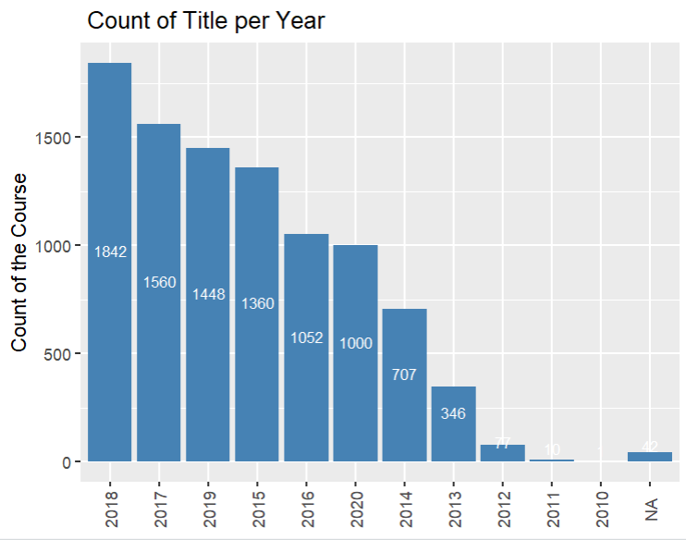

- Total Price_detail_amount per Year
Code:
datetime <- as.POSIXct(data$created, format = "%Y-%m-%dT%H:%M:%SZ")
year<- format(datetime, "%Y")
Total_year_Sale <- aggregate(price_detail_amount ~ year, data, sum)
print(Total_year_Sale)
ggplot(Total_year_Sale, aes(x= reorder(year, -price_detail_amount), y = price_detail_amount)) +
geom_bar(stat = "identity",fill="steelblue") +
labs(x= " Yar", y= "Price_Detail_Amount", title = "Total Price_detail_amount per Year ")+
theme(axis.text.x=element_text(angle = 90, hjust=0.5,vjust=0.5),
axis.title.x = element_blank()) +
geom_text(aes(label = price_detail_amount), vjust = -0.5, color = "white", size = 3, position = position_stack(vjust = 0.5))

Output:

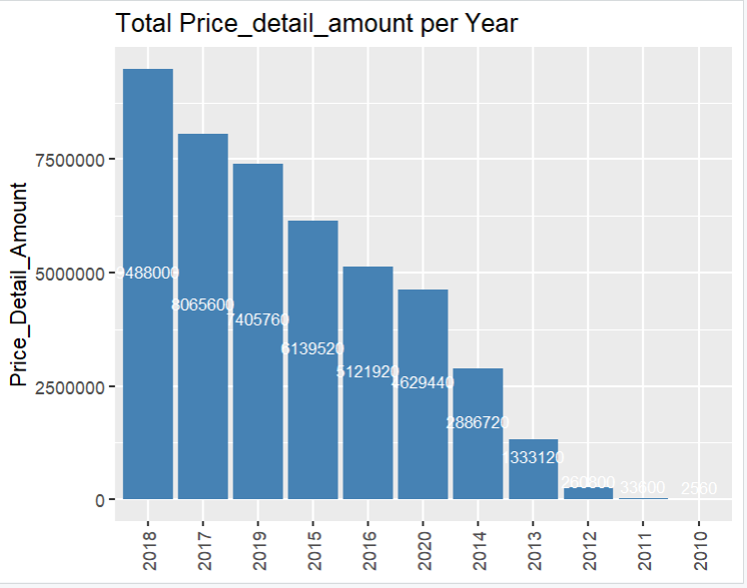
- total sale per month of all years
Code:
Total_Month_Sale = aggregate(price_detail_amount ~ monthname, data, sum)
Total_Month_Sale = Total_Month_Sale[order(Total_Month_Sale$monthname), ]
#Total_Month_Sale <- Total_Month_Sale[order(match(Total_Month_Sale$monthname, month.name)), ]
print(Total_Month_Sale)

ggplot(Total_Month_Sale, aes(x=reorder(monthname, -price_detail_amount), y=price_detail_amount))+
geom_bar(stat = "identity", fill="steelblue")+
labs(x="Name of the Month", y=" Price_Detail_Amount", title="Total Price_Detail_Amount per Month of all Years")+
theme(axis.text.x = element_text(angle=90, hjust=0.5,vjust=0.5),
axis.title.x=element_blank())
geom_text(aes(label = price_detail_amount), vjust = -0.5, color = "white", size = 3, position = position_stack(vjust = 0.5))

Output:
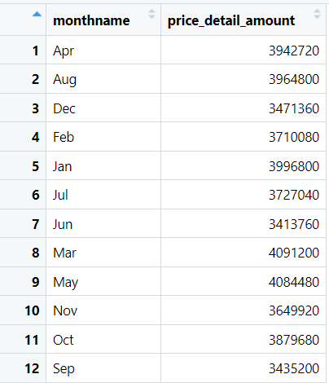

- Top 10 most subscriber courses
Code:
a1 <-data %>%
summarise(title, num_subscribers) %>%
arrange(desc(num_subscribers)) %>%
head(10)
view(a1)
# plot graph
ggplot(a1, aes(x=reorder(title, -num_subscribers), y=num_subscribers ))+
geom_bar(stat="identity", fill="steelblue")+
labs(x="Name of the Course", y="No. of Subscriber", title = "Top 10 most subscriber per course")+
theme(axis.text.x = element_text(angle=90,hjust = 0.5,vjust = 0.5),
axis.title.x = element_blank())
geom_text(aes(label = num_subscribers), vjust = -0.5, color = "white", size = 3, position = position_stack(vjust = 0.5))

Output:
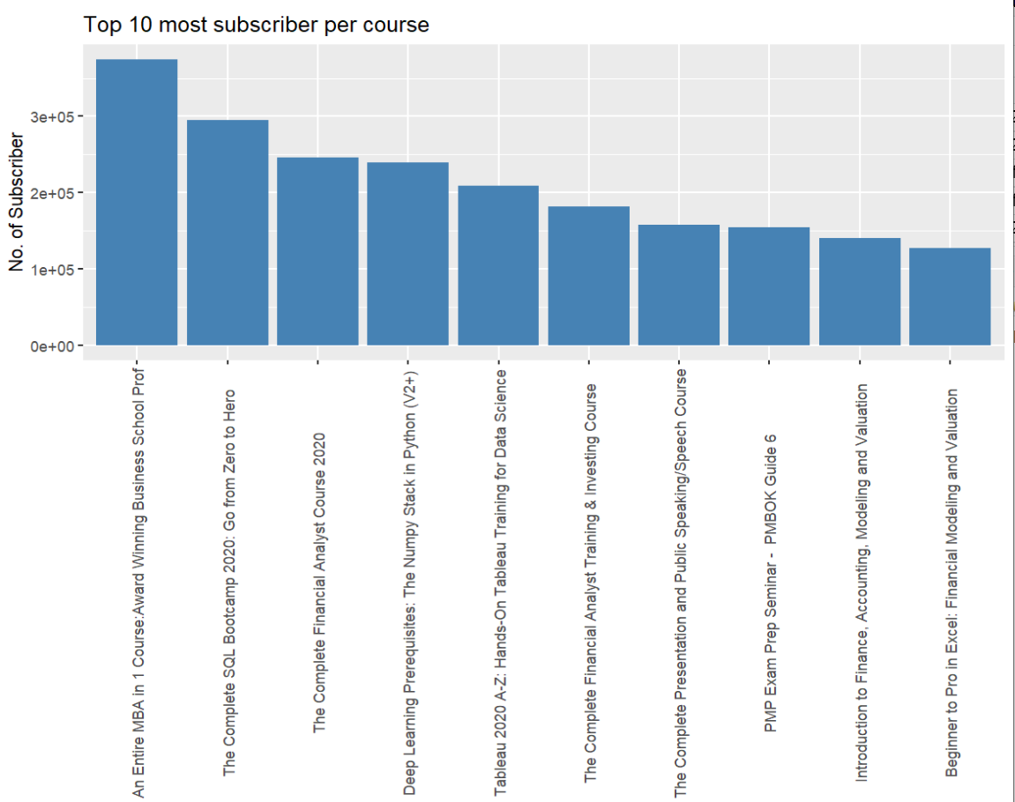

- Number of subscribers > 100000 per year
Code:
data1 <- data1 %>%
mutate(datetime = as.POSIXct(created, format = "%Y-%m-%dT%H:%M:%SZ")) %>%
mutate(year = format(datetime, "%Y")) %>%
filter(num_subscribers >= 100000) %>%
group_by(year) %>%
summarise(count1L = n())
View(data1)

# plot graph
ggplot(data1, aes(x=reorder(year, -count1L), y=count1L ))+
geom_bar(stat="identity", fill="steelblue")+
labs(x="Year", y="Count of Subscriber", title = "Count of subscriber > 100000 per Year")+
theme(axis.text.x = element_text(angle=90,hjust = 0.5,vjust = 0.5),
axis.title.x = element_blank()) +
geom_text(aes(label = count1L), vjust = -0.5, color = "white", size = 3, position = position_stack(vjust = 0.5))

Output:
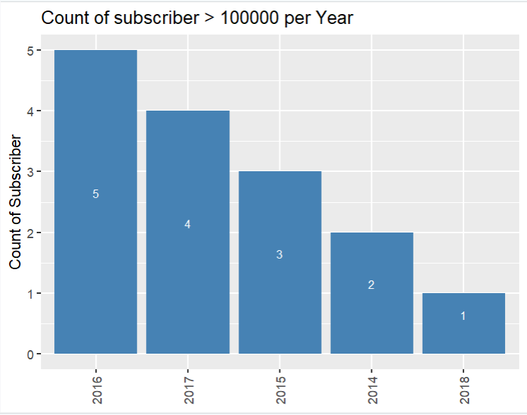

- Number of subscribers > 50000 per year
Code:
data2<- data
data2 <- data2 %>%
mutate(datetime = as.POSIXct(created, format = "%Y-%m-%dT%H:%M:%SZ")) %>%
mutate(year = format(datetime, "%Y")) %>%
filter(!is.na(num_subscribers) & num_subscribers > 50000) %>%
group_by(year) %>%
summarise(count1L = n())
View(data2)

# plot graph
ggplot(data2, aes(x=reorder(year, -count1L), y=count1L ))+
geom_bar(stat="identity", fill="steelblue")+
labs(x="Year", y="Count of Subscriber", title = "Count of subscriber > 50000 per Year")+
theme(axis.text.x = element_text(angle=90,hjust = 0.5,vjust = 0.5),
axis.title.x = element_blank()) +
geom_text(aes(label = count1L), vjust = -0.5, color = "white", size = 3, position = position_stack(vjust = 0.5))

Output:
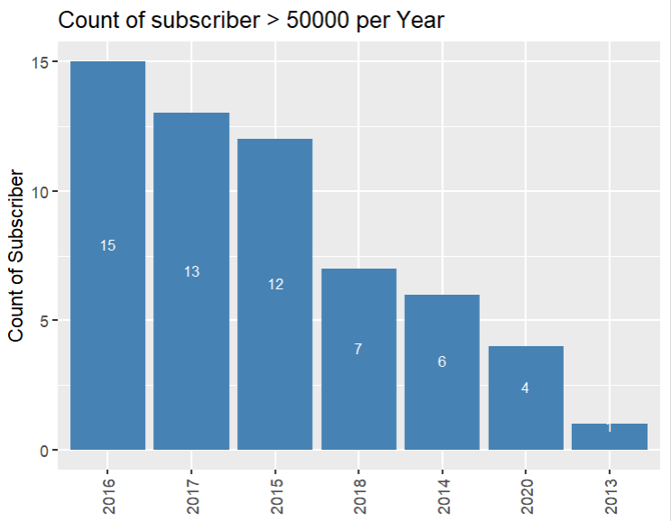

- Number of subscribers > 25000 per year
Code:
data3<- data
data3 <- data3 %>%
mutate(datetime = as.POSIXct(created, format = "%Y-%m-%dT%H:%M:%SZ")) %>%
mutate(year = format(datetime, "%Y")) %>%
filter(!is.na(num_subscribers) & num_subscribers > 25000) %>%
group_by(year) %>%
summarise(count1L = n())
View(data3)

# plot graph
ggplot(data3, aes(x=reorder(year, -count1L), y=count1L ))+
geom_bar(stat="identity", fill="steelblue")+
labs(x="Year", y="Count of Subscriber", title = "Count of subscriber > 25000 per Year")+
theme(axis.text.x = element_text(angle=90,hjust = 0.5,vjust = 0.5),
axis.title.x = element_blank()) +
geom_text(aes(label = count1L), vjust = -0.5, color = "white", size = 3, position = position_stack(vjust = 0.5))

Output:
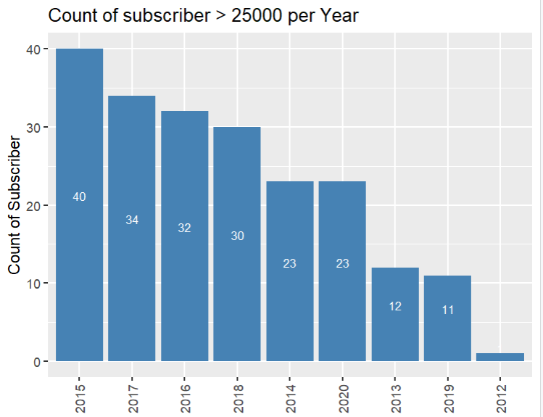

- Number of subscribers > 10000 per year
Code:
data4<- data
data4 <- data4 %>%
mutate(datetime = as.POSIXct(created, format = "%Y-%m-%dT%H:%M:%SZ")) %>%
mutate(year = format(datetime, "%Y")) %>%
filter(!is.na(num_subscribers) & num_subscribers > 10000) %>%
group_by(year) %>%
summarise(count1L = n())
View(data4)

# plot graph
ggplot(data4, aes(x=reorder(year, -count1L), y=count1L ))+
geom_bar(stat="identity", fill="steelblue")+
labs(x="Year", y="Count of Subscriber", title = "Count of subscriber > 10000 per Year")+
theme(axis.text.x = element_text(angle=90,hjust = 0.5,vjust = 0.5),
axis.title.x = element_blank()) +
geom_text(aes(label = count1L), vjust = -0.5, color = "white", size = 3, position = position_stack(vjust = 0.5))

Output:
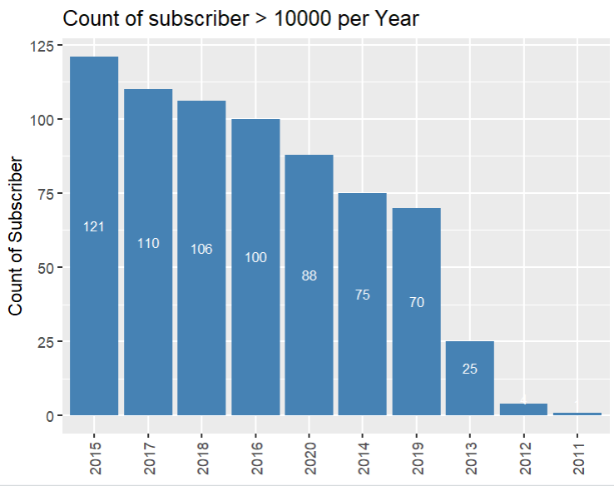

- Number of subscribers < 100 per year

Code:
data5<- data
data5 <- data5 %>%
mutate(datetime = as.POSIXct(created, format = "%Y-%m-%dT%H:%M:%SZ")) %>%
mutate(year = format(datetime, "%Y")) %>%
filter(!is.na(num_subscribers) & num_subscribers < 100) %>%
group_by(year) %>%
summarise(count1L = n())
View(data5)

# plot graph
ggplot(data5, aes(x=reorder(year, -count1L), y=count1L ))+
geom_bar(stat="identity", fill="steelblue")+
labs(x="Year", y="Count of Subscriber", title = "Count of subscriber < 100 per Year")+
theme(axis.text.x = element_text(angle=90,hjust = 0.5,vjust = 0.5),
axis.title.x = element_blank()) +
geom_text(aes(label = count1L), vjust = -0.5, color = "white", size = 3, position = position_stack(vjust = 0.5))

Output:
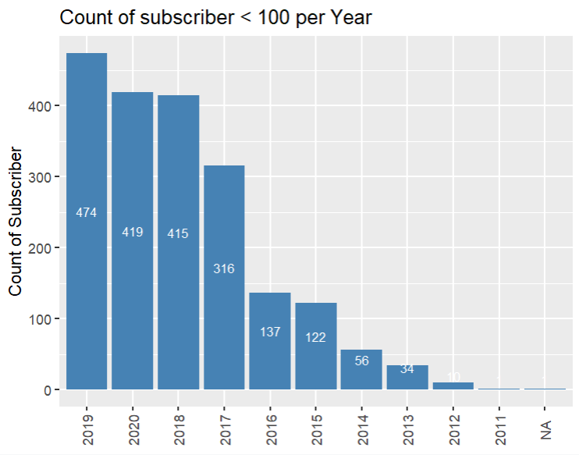

- Number of subscribers < 500 per year
Code:
data6<- data
data6 <- data6 %>%
mutate(datetime = as.POSIXct(created, format = "%Y-%m-%dT%H:%M:%SZ")) %>%
mutate(year = format(datetime, "%Y")) %>%
filter(!is.na(num_subscribers) & num_subscribers < 500) %>%
group_by(year) %>%
summarise(count1L = n())
View(data6)

# plot graph
ggplot(data6, aes(x=reorder(year, -count1L), y=count1L ))+
geom_bar(stat="identity", fill="steelblue")+
labs(x="Year", y="Count of Subscriber", title = "Count of subscriber < 500 per Year")+
theme(axis.text.x = element_text(angle=90,hjust = 0.5,vjust = 0.5),
axis.title.x = element_blank()) +
geom_text(aes(label = count1L), vjust = -0.5, color = "white", size = 3, position = position_stack(vjust = 0.5))

Output:
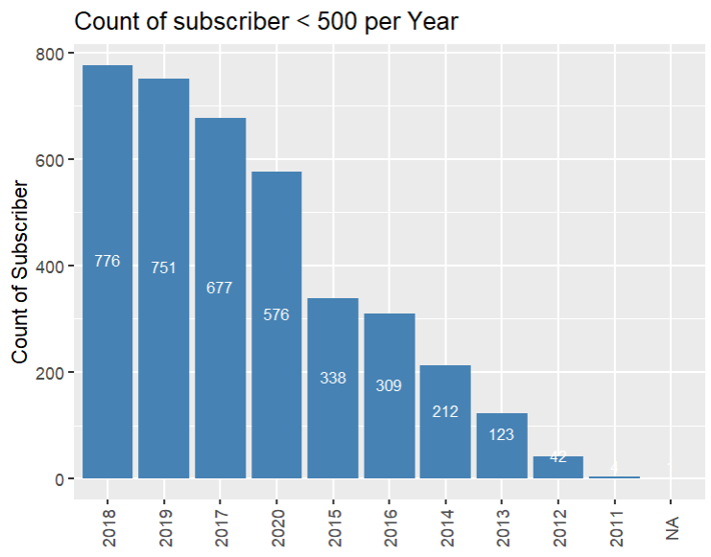

- Number of subscribers < 1000 per year
Code:
data7<- data
data7 <- data7 %>%
mutate(datetime = as.POSIXct(created, format = "%Y-%m-%dT%H:%M:%SZ")) %>%
mutate(year = format(datetime, "%Y")) %>%
filter(!is.na(num_subscribers) & num_subscribers < 1000) %>%
group_by(year) %>%
summarise(count1L = n())
View(data7)

# plot graph
ggplot(data7, aes(x=reorder(year, -count1L), y=count1L ))+
geom_bar(stat="identity", fill="steelblue")+
labs(x="Year", y="Count of Subscriber", title = "Count of subscriber < 1000 per Year")+
theme(axis.text.x = element_text(angle=90,hjust = 0.5,vjust = 0.5),
axis.title.x = element_blank()) +
geom_text(aes(label = count1L), vjust = -0.5, color = "white", size = 3, position = position_stack(vjust = 0.5))

Output:
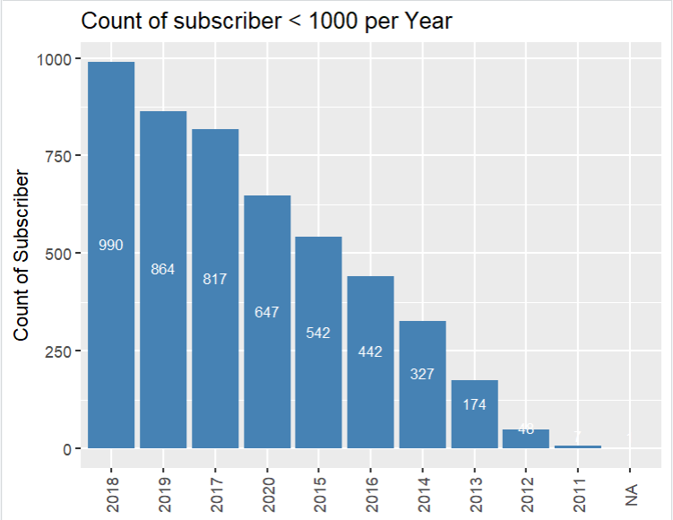

- Number of subscribers < 10000 per year
Code:
data8<- data
data8 <- data8 %>%
mutate(datetime = as.POSIXct(created, format = "%Y-%m-%dT%H:%M:%SZ")) %>%
mutate(year = format(datetime, "%Y")) %>%
filter(!is.na(num_subscribers) & num_subscribers < 10000) %>%
group_by(year) %>%
summarise(count1L = n())
View(data8)

# plot graph
ggplot(data8, aes(x=reorder(year, -count1L), y=count1L ))+
geom_bar(stat="identity", fill="steelblue")+
labs(x="Year", y="Count of Subscriber", title = "Count of subscriber < 10000 per Year")+
theme(axis.text.x = element_text(angle=90,hjust = 0.5,vjust = 0.5),
axis.title.x = element_blank()) +
geom_text(aes(label = count1L), vjust = -0.5, color = "white", size = 3, position = position_stack(vjust = 0.5))

Output:
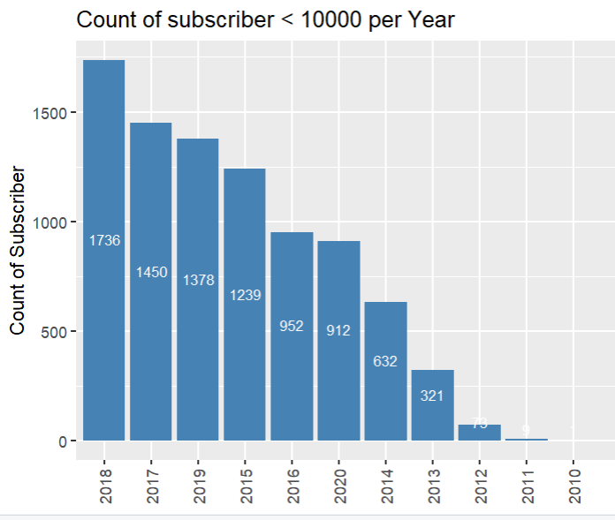

- Number of reviewers < 50000 per year
Code:
data10<- data
data10 <- data10 %>%
mutate(datetime = as.POSIXct(created, format = "%Y-%m-%dT%H:%M:%SZ")) %>%
mutate(year = format(datetime, "%Y")) %>%
filter(!is.na(num_reviews) & num_reviews < 50000) %>%
group_by(year) %>%
summarise(count1L = n())
View(data10)

# plot graph
ggplot(data10, aes(x=reorder(year, -count1L), y=count1L ))+
geom_bar(stat="identity", fill="steelblue")+
labs(x="Year", y="Count of Reviews", title = "Count of Reviews < 50000 per Year")+
theme(axis.text.x = element_text(angle=90,hjust = 0.5,vjust = 0.5),
axis.title.x = element_blank()) +
geom_text(aes(label = count1L), vjust = -0.5, color = "white", size = 3, position = position_stack(vjust = 0.5))

Output:
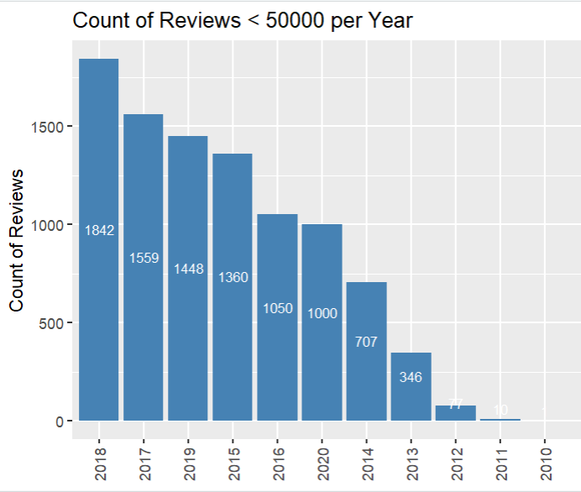

- Number of reviewers < 10000 per year
Code:
data11<- data
data11 <- data11 %>%
mutate(datetime = as.POSIXct(created, format = "%Y-%m-%dT%H:%M:%SZ")) %>%
mutate(year = format(datetime, "%Y")) %>%
filter(!is.na(num_reviews) & num_reviews < 10000) %>%
group_by(year) %>%
summarise(count1L = n())
View(data11)

# plot graph
ggplot(data11, aes(x=reorder(year, -count1L), y=count1L ))+
geom_bar(stat="identity", fill="steelblue")+
labs(x="Year", y="Count of Reviews", title = "Count of Reviews < 10000 per Year")+
theme(axis.text.x = element_text(angle=90,hjust = 0.5,vjust = 0.5),
axis.title.x = element_blank()) +
geom_text(aes(label = count1L), vjust = -0.5, color = "white", size = 3, position = position_stack(vjust = 0.5))

Output:
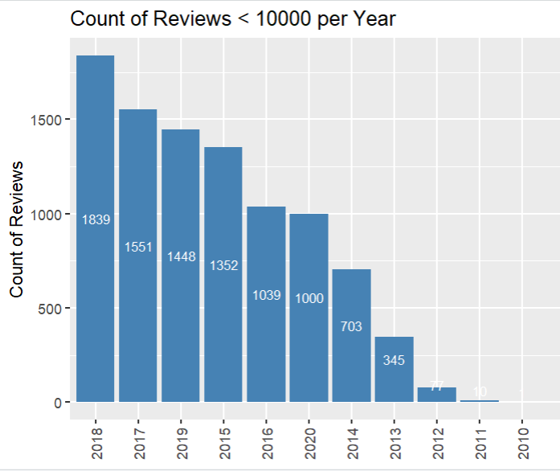

- Number of reviewers < 5000 per year
Code:
data12<- data
data12 <- data12 %>%
mutate(datetime = as.POSIXct(created, format = "%Y-%m-%dT%H:%M:%SZ")) %>%
mutate(year = format(datetime, "%Y")) %>%
filter(!is.na(num_reviews) & num_reviews < 5000) %>%
group_by(year) %>%
summarise(count1L = n())
View(data12)

# plot graph
ggplot(data12, aes(x=reorder(year, -count1L), y=count1L ))+
geom_bar(stat="identity", fill="steelblue")+
labs(x="Year", y="Count of Reviews", title = "Count of Reviews < 5000 per Year")+
theme(axis.text.x = element_text(angle=90,hjust = 0.5,vjust = 0.5),
axis.title.x = element_blank()) +
geom_text(aes(label = count1L), vjust = -0.5, color = "white", size = 3, position = position_stack(vjust = 0.5))

Output:
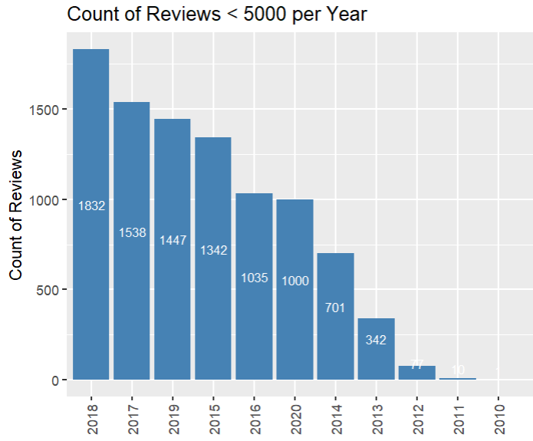

16 .Number of reviewers < 1000 per year
Code:
data13<- data
data13 <- data13 %>%
mutate(datetime = as.POSIXct(created, format = "%Y-%m-%dT%H:%M:%SZ")) %>%
mutate(year = format(datetime, "%Y")) %>%
filter(!is.na(num_reviews) & num_reviews < 1000) %>%
group_by(year) %>%
summarise(count1L = n())
View(data13)

# plot graph
ggplot(data13, aes(x=reorder(year, -count1L), y=count1L ))+
geom_bar(stat="identity", fill="steelblue")+
labs(x="Year", y="Count of Reviews", title = "Count of Reviews < 1000 per Year")+
theme(axis.text.x = element_text(angle=90,hjust = 0.5,vjust = 0.5),
axis.title.x = element_blank()) +
geom_text(aes(label = count1L), vjust = -0.5, color = "white", size = 3, position = position_stack(vjust = 0.5))

Output:
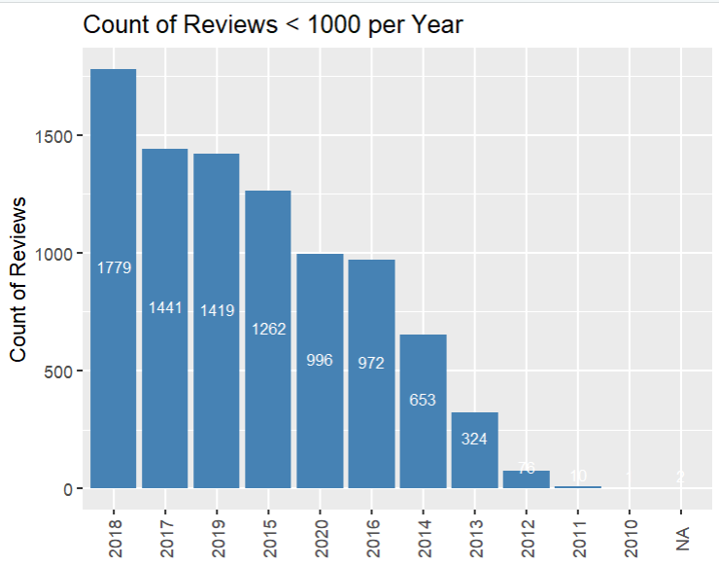

17 .Number of reviewers < 500 per year
Code:
data14<- data
data14 <- data14 %>%
mutate(datetime = as.POSIXct(created, format = "%Y-%m-%dT%H:%M:%SZ")) %>%
mutate(year = format(datetime, "%Y")) %>%
filter(!is.na(num_reviews) & num_reviews < 500) %>%
group_by(year) %>%
summarise(count1L = n())
View(data14)

# plot graph
ggplot(data14, aes(x=reorder(year, -count1L), y=count1L ))+
geom_bar(stat="identity", fill="steelblue")+
labs(x="Year", y="Count of Reviews", title = "Count of Reviews < 500 per Year")+
theme(axis.text.x = element_text(angle=90,hjust = 0.5,vjust = 0.5),
axis.title.x = element_blank()) +
geom_text(aes(label = count1L), vjust = -0.5, color = "white", size = 3, position = position_stack(vjust = 0.5))

Output:
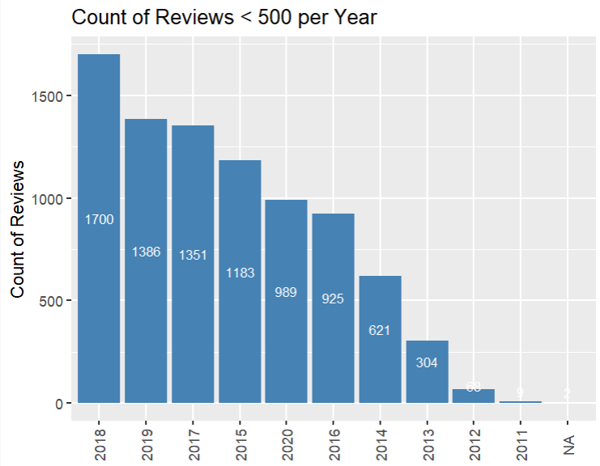

18 .Number of reviewers < 100 per year
Code:
data15<- data
data15 <- data15 %>%
mutate(datetime = as.POSIXct(created, format = "%Y-%m-%dT%H:%M:%SZ")) %>%
mutate(year = format(datetime, "%Y")) %>%
filter(!is.na(num_reviews) & num_reviews < 100) %>%
group_by(year) %>%
summarise(count1L = n())
View(data15)

# plot graph
ggplot(data15, aes(x=reorder(year, -count1L), y=count1L ))+
geom_bar(stat="identity", fill="steelblue")+
labs(x="Year", y="Count of Reviews", title = "Count of Reviews < 100 per Year")+
theme(axis.text.x = element_text(angle=90,hjust = 0.5,vjust = 0.5),
axis.title.x = element_blank()) +
geom_text(aes(label = count1L), vjust = -0.5, color = "white", size = 3, position = position_stack(vjust = 0.5))

Output:
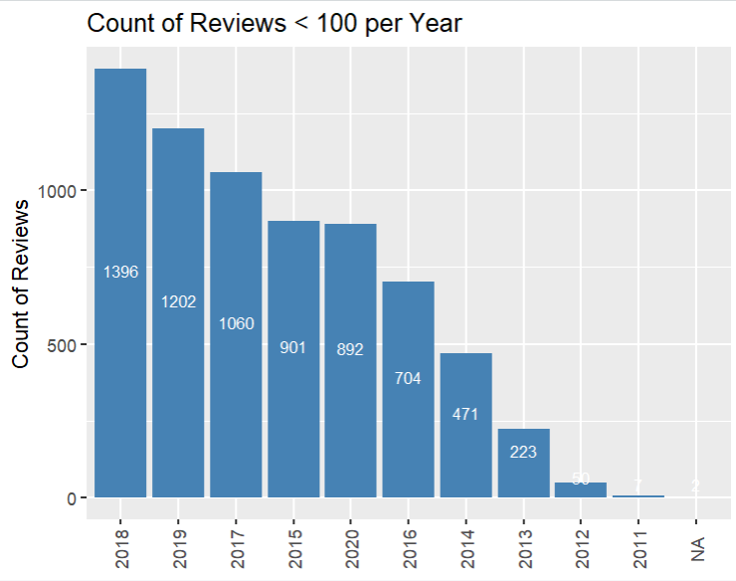

- Number of reviewers < 50 per year
Code:
data16<- data
data16 <- data16 %>%
mutate(datetime = as.POSIXct(created, format = "%Y-%m-%dT%H:%M:%SZ")) %>%
mutate(year = format(datetime, "%Y")) %>%
filter(!is.na(num_reviews) & num_reviews < 50) %>%
group_by(year) %>%
summarise(count1L = n())
View(data16)

# plot graph
ggplot(data16, aes(x=reorder(year, -count1L), y=count1L ))+
geom_bar(stat="identity", fill="steelblue")+
labs(x="Year", y="Count of Reviews", title = "Count of Reviews < 50 per Year")+
theme(axis.text.x = element_text(angle=90,hjust = 0.5,vjust = 0.5),
axis.title.x = element_blank()) +
geom_text(aes(label = count1L), vjust = -0.5, color = "white", size = 3, position = position_stack(vjust = 0.5))
Output:
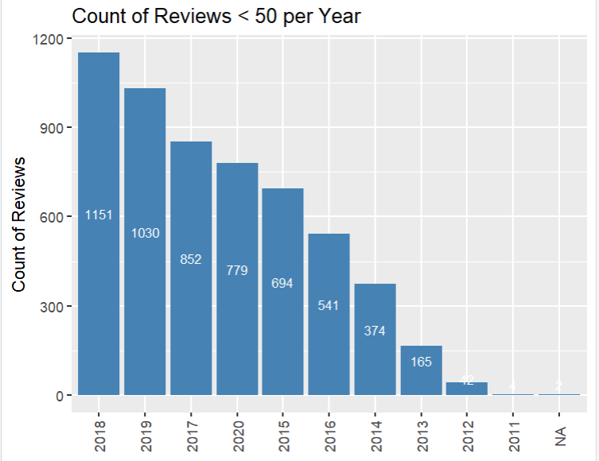

- Number of reviewers < 10 per year
Code:
data17<- data
data17 <- data17 %>%
mutate(datetime = as.POSIXct(created, format = "%Y-%m-%dT%H:%M:%SZ")) %>%
mutate(year = format(datetime, "%Y")) %>%
filter(!is.na(num_reviews) & num_reviews < 10) %>%
group_by(year) %>%
summarise(count1L = n())
View(data17)

# plot graph
ggplot(data17, aes(x=reorder(year, -count1L), y=count1L ))+
geom_bar(stat="identity", fill="steelblue")+
labs(x="Year", y="Count of Reviews", title = "Count of Reviews < 10 per Year")+
theme(axis.text.x = element_text(angle=90,hjust = 0.5,vjust = 0.5),
axis.title.x = element_blank()) +
geom_text(aes(label = count1L), vjust = -0.5, color = "white", size = 3, position = position_stack(vjust = 0.5))

Output:
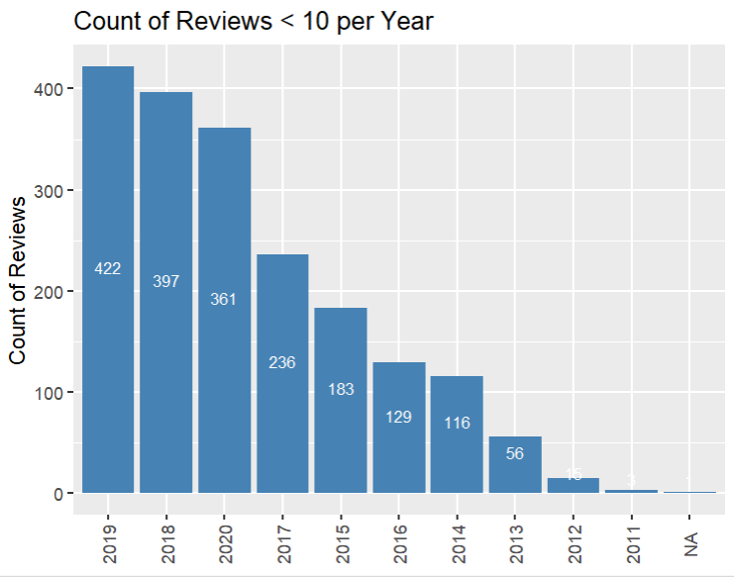

- Best selling course with number of subscribers > 300000
Code:
data18 <- data
data18 <- data18 %>%
filter(num_subscribers >=300000) %>%
summarise(countbest = n())
view(data18)
---------------------------------
data18 <- data
data18 <- data18 %>%
filter(num_subscribers >= 300000) %>%
best_sale<-summarise(countbest = n(), title = unique(title))
view(data18)
--------------------
data18 <- data
data18_titles <- data18 %>%
filter(num_subscribers >= 300000) %>%
distinct(title) %>%
pull(title)
view(data18_titles)

Output:

- Best selling course with rating >= 4.5 & num_reviews >= 50000
Code:
data19 <- data
data19_titles <- data19 %>%
filter(rating >= 4.5 & num_reviews >= 50000) %>%
distinct(title) %>%
pull(title)
view(data19_titles)

Output:


- Best selling course with rating >= 4.0 & num_reviews >= 50000
Code:
data20 <- data
data20_titles <- data20 %>%
filter(rating >= 4.0 & num_reviews >= 50000) %>%
distinct(title) %>%
pull(title)
view(data20_titles)
Output:


- Best selling course with rating >= 3.0 & num_reviews >= 50000
Code:
data21 <- data
data21_titles <- data21 %>%
filter(rating >= 3.0 & num_reviews >= 50000) %>%
distinct(title) %>%
pull(title)
view(data21_titles)
Output:

- Best selling course with rating >= 2.0 & num_reviews >= 50000
Code:
data22 <- data
data22_titles <- data22 %>%
filter(rating >= 2.0 & num_reviews >= 50000) %>%
distinct(title) %>%
pull(title)
view(data22_titles)

Output:

- Best selling course with rating >= 1.0 & num_reviews >= 50000
Code:
data23 <- data
data23_titles <- data23 %>%
filter(rating >= 1.0 & num_reviews >= 50000) %>%
distinct(title) %>%
pull(title)
view(data23_titles)

Output:
- selling course with rating >= 1.0 & num_reviews <= 100
Code:
data24<- data
data24 <- data24 %>%
mutate(datetime = as.POSIXct(created, format = "%Y-%m-%dT%H:%M:%SZ")) %>%
mutate(year = format(datetime, "%Y")) %>%
filter(rating >=1.0 & num_reviews < 100) %>%
group_by(year) %>%
summarise(count1L = n())
View(data24)
# Plot the graph
ggplot(data24, aes(x=reorder(year, -count1L), y=count1L ))+
geom_bar(stat="identity", fill="steelblue")+
labs(x="Year", y="Count of the Course", title = " Count of Title with rating >= 1.0 & num_reviews <= 100 per Year")+
theme(axis.text.x = element_text(angle=90,hjust = 0.5,vjust = 0.5),
axis.title.x = element_blank()) +
geom_text(aes(label = count1L), vjust = -0.5, color = "white", size = 3, position = position_stack(vjust = 0.5))

Output:
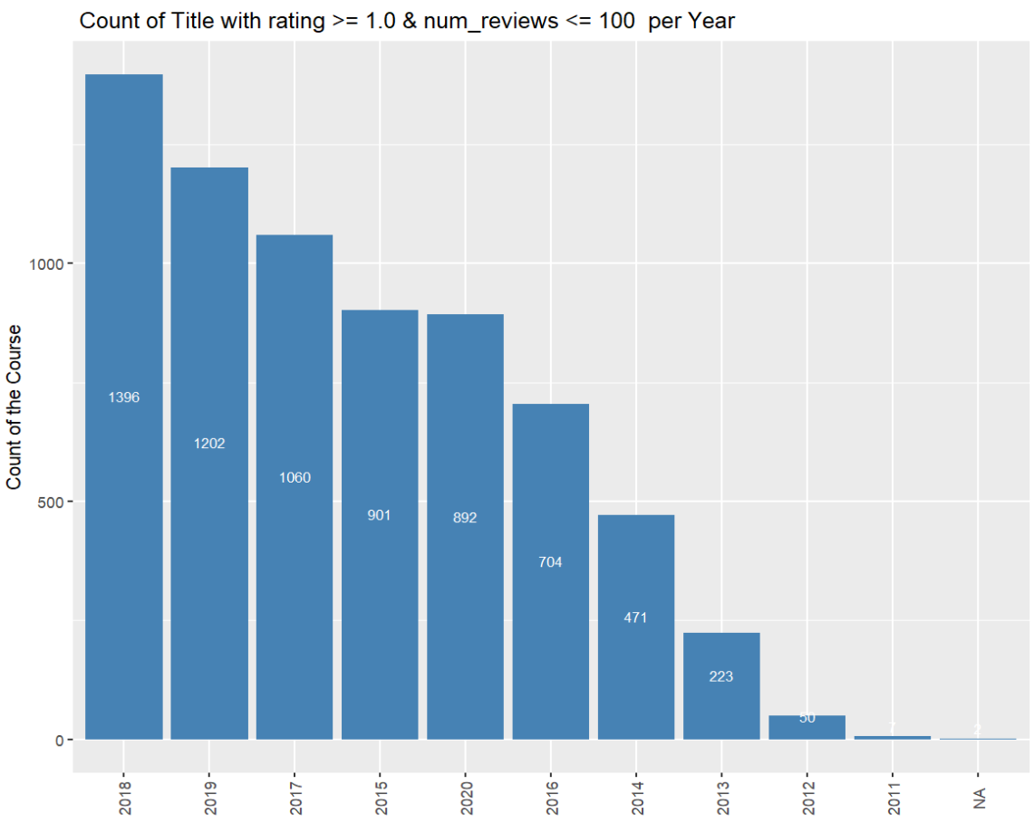

- selling course with rating >= 2.5 & num_reviews <= 500
Code:
data25<- data
data25 <- data25 %>%
mutate(datetime = as.POSIXct(created, format = "%Y-%m-%dT%H:%M:%SZ")) %>%
mutate(year = format(datetime, "%Y")) %>%
filter(rating >= 2.5 & num_reviews <= 500) %>%
group_by(year) %>%
summarise(count1L = n())
View(data25)
# Plot the graph
ggplot(data25, aes(x=reorder(year, -count1L), y=count1L ))+
geom_bar(stat="identity", fill="steelblue")+
labs(x="Year", y="Count of the Course", title = " Count of Title with rating >= 2.5 & num_reviews <= 500 per Year")+
theme(axis.text.x = element_text(angle=90,hjust = 0.5,vjust = 0.5),
axis.title.x = element_blank()) +
geom_text(aes(label = count1L), vjust = -0.5, color = "white", size = 3, position = position_stack(vjust = 0.5))

Output:
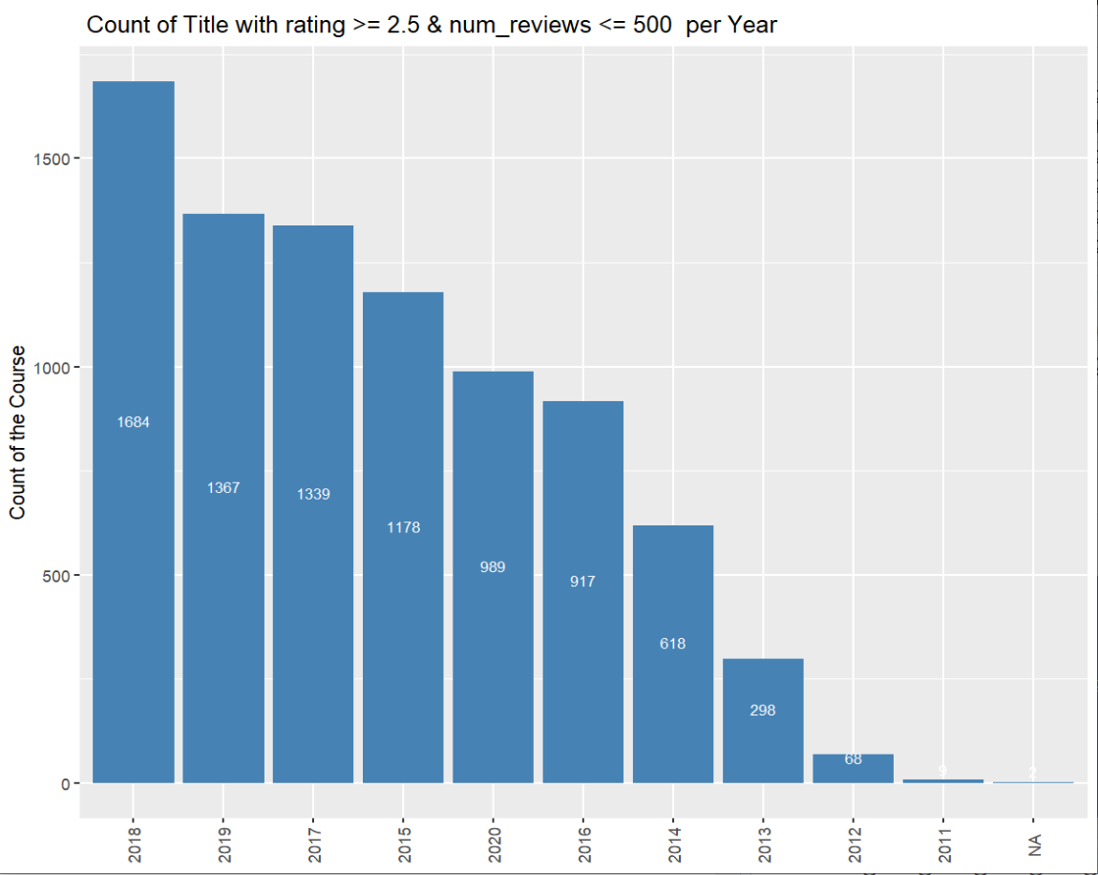

- selling course with rating >= 3.5 & num_reviews <= 2500
Code:
data26<- data
data26 <- data26 %>%
mutate(datetime = as.POSIXct(created, format = "%Y-%m-%dT%H:%M:%SZ")) %>%
mutate(year = format(datetime, "%Y")) %>%
filter(rating >= 3.5 & num_reviews <= 2500) %>%
group_by(year) %>%
summarise(count1L = n())
View(data26)
ggplot(data26, aes(x=reorder(year, -count1L), y=count1L ))+
geom_bar(stat="identity", fill="steelblue")+
labs(x="Year", y="Count of the Course", title = " Count of Title with rating >= 3.5 & num_reviews <= 2500 per Year")+
theme(axis.text.x = element_text(angle=90,hjust = 0.5,vjust = 0.5),
axis.title.x = element_blank()) +
geom_text(aes(label = count1L), vjust = -0.5, color = "white", size = 3, position = position_stack(vjust = 0.5))

Output:
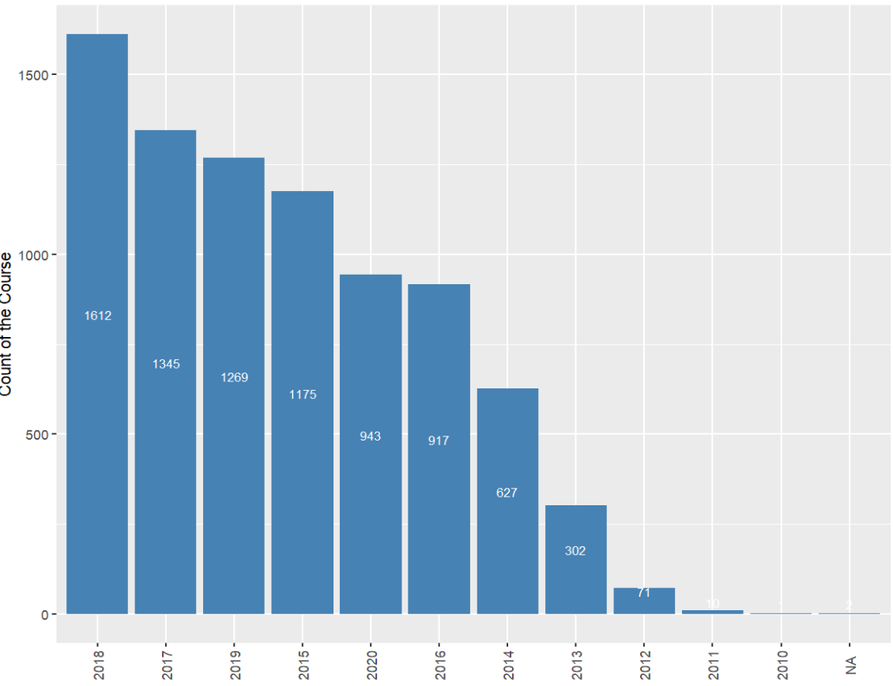

- selling course with rating >= 4.5 & num_reviews <= 2500
Code:
data27<- data
data27 <- data27 %>%
mutate(datetime = as.POSIXct(created, format = "%Y-%m-%dT%H:%M:%SZ")) %>%
mutate(year = format(datetime, "%Y")) %>%
filter(rating >= 3.5 & num_reviews <= 2500) %>%
group_by(year) %>%
summarise(count1L = n())
View(data27)
#Plot the Chart
ggplot(data27, aes(x=reorder(year, -count1L), y=count1L ))+
geom_bar(stat="identity", fill="steelblue")+
labs(x="Year", y="Count of the Course", title = " Count of Title with rating >= 4.5 & num_reviews <= 2500 per Year")+
theme(axis.text.x = element_text(angle=90,hjust = 0.5,vjust = 0.5),
axis.title.x = element_blank()) +
geom_text(aes(label = count1L), vjust = -0.5, color = "white", size = 3, position = position_stack(vjust = 0.5))

Output:
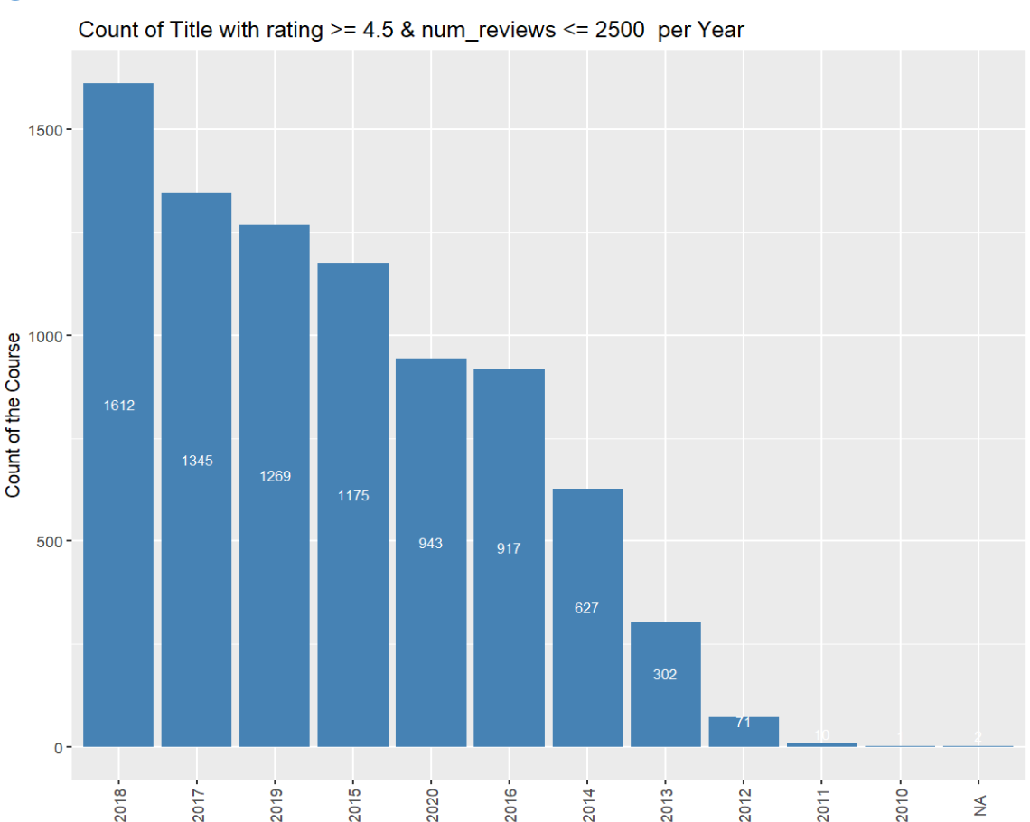

- selling course with rating >= 4.5 & num_reviews <= 10000
Code:
data28<- data
data28 <- data28 %>%
mutate(datetime = as.POSIXct(created, format = "%Y-%m-%dT%H:%M:%SZ")) %>%
mutate(year = format(datetime, "%Y")) %>%
filter(rating >= 4.5 & num_reviews <= 10000) %>%
group_by(year) %>%
summarise(count1L = n())
View(data28)
ggplot(data28, aes(x=reorder(year, -count1L), y=count1L ))+
geom_bar(stat="identity", fill="steelblue")+
labs(x="Year", y="Count of the Course", title = " Count of Title with rating >= 4.5 & num_reviews <= 10000 per Year")+
theme(axis.text.x = element_text(angle=90,hjust = 0.5,vjust = 0.5),
axis.title.x = element_blank()) +
geom_text(aes(label = count1L), vjust = -0.5, color = "white", size = 3, position = position_stack(vjust = 0.5))
Output:
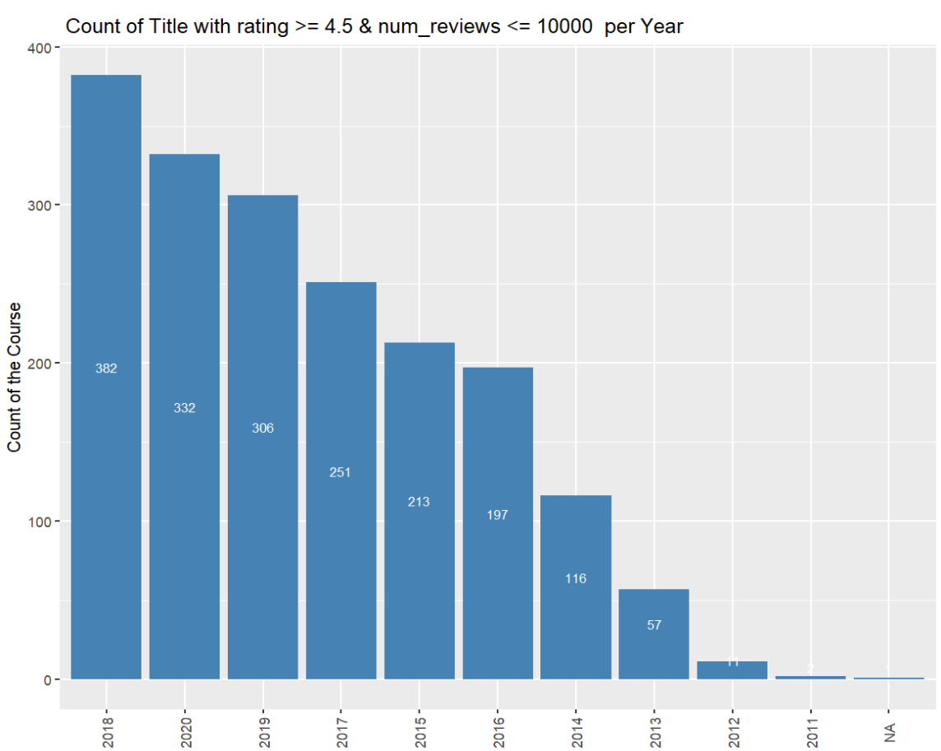

- selling course with rating >= 4.5 & num_reviews <= 25000
Code:
data29<- data
data29 <- data29 %>%
mutate(datetime = as.POSIXct(created, format = "%Y-%m-%dT%H:%M:%SZ")) %>%
mutate(year = format(datetime, "%Y")) %>%
filter(rating >= 4.5 & num_reviews <= 25000) %>%
group_by(year) %>%
summarise(count1L = n())
View(data29)
ggplot(data29, aes(x=reorder(year, -count1L), y=count1L ))+
geom_bar(stat="identity", fill="steelblue")+
labs(x="Year", y="Count of the Course", title = " Count of Title with rating >= 4.5 & num_reviews <= 25000 per Year")+
theme(axis.text.x = element_text(angle=90,hjust = 0.5,vjust = 0.5),
axis.title.x = element_blank()) +
geom_text(aes(label = count1L), vjust = -0.5, color = "white", size = 3, position = position_stack(vjust = 0.5))

Output:
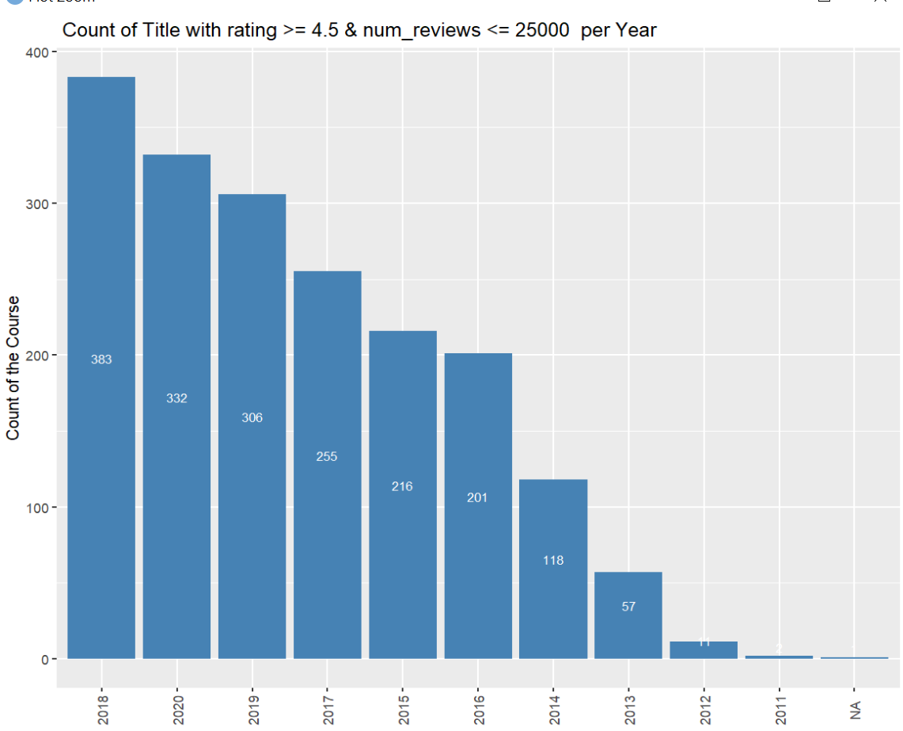

- selling course with rating >= 4.5 & num_reviews <= 50000
Code:
data30<- data
data30 <- data30 %>%
mutate(datetime = as.POSIXct(created, format = "%Y-%m-%dT%H:%M:%SZ")) %>%
mutate(year = format(datetime, "%Y")) %>%
filter(rating >= 4.5 & num_reviews <= 50000) %>%
group_by(year) %>%
summarise(count1L = n())
View(data30)
ggplot(data30, aes(x=reorder(year, -count1L), y=count1L ))+
geom_bar(stat="identity", fill="steelblue")+
labs(x="Year", y="Count of the Course", title = " Count of Title with rating >= 4.5 & num_reviews <= 50000 per Year")+
theme(axis.text.x = element_text(angle=90,hjust = 0.5,vjust = 0.5),
axis.title.x = element_blank()) +
geom_text(aes(label = count1L), vjust = -0.5, color = "white", size = 3, position = position_stack(vjust = 0.5))

Output:
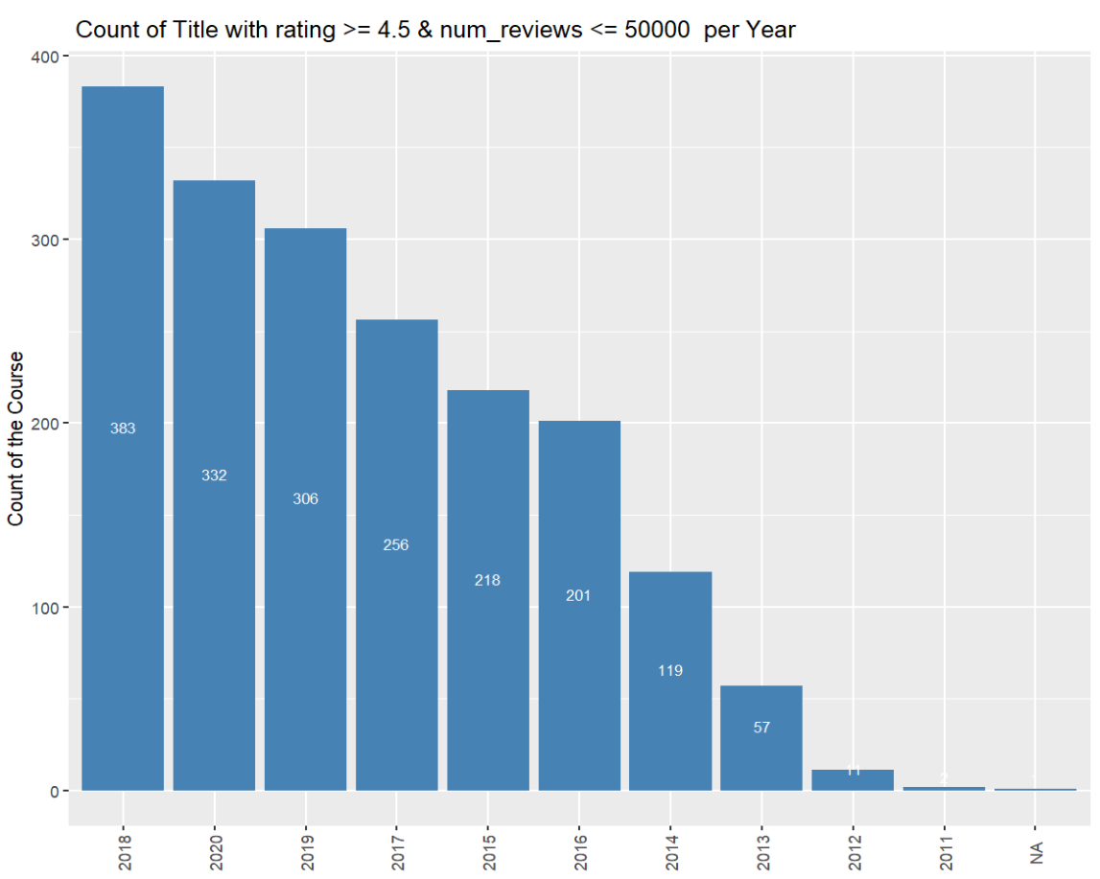

- selling course with rating >= 4.5 & num_reviews <= 75000
Code:
data31<- data
data31 <- data31 %>%
mutate(datetime = as.POSIXct(created, format = "%Y-%m-%dT%H:%M:%SZ")) %>%
mutate(year = format(datetime, "%Y")) %>%
filter(rating >= 4.5 & num_reviews <= 75000) %>%
group_by(year) %>%
summarise(count1L = n())
View(data31)
ggplot(data31, aes(x=reorder(year, -count1L), y=count1L ))+
geom_bar(stat="identity", fill="steelblue")+
labs(x="Year", y="Count of the Course", title = " Count of Title with rating >= 4.5 & num_reviews <= 75000 per Year")+
theme(axis.text.x = element_text(angle=90,hjust = 0.5,vjust = 0.5),
axis.title.x = element_blank()) +
geom_text(aes(label = count1L), vjust = -0.5, color = "white", size = 3, position = position_stack(vjust = 0.5))

Output:
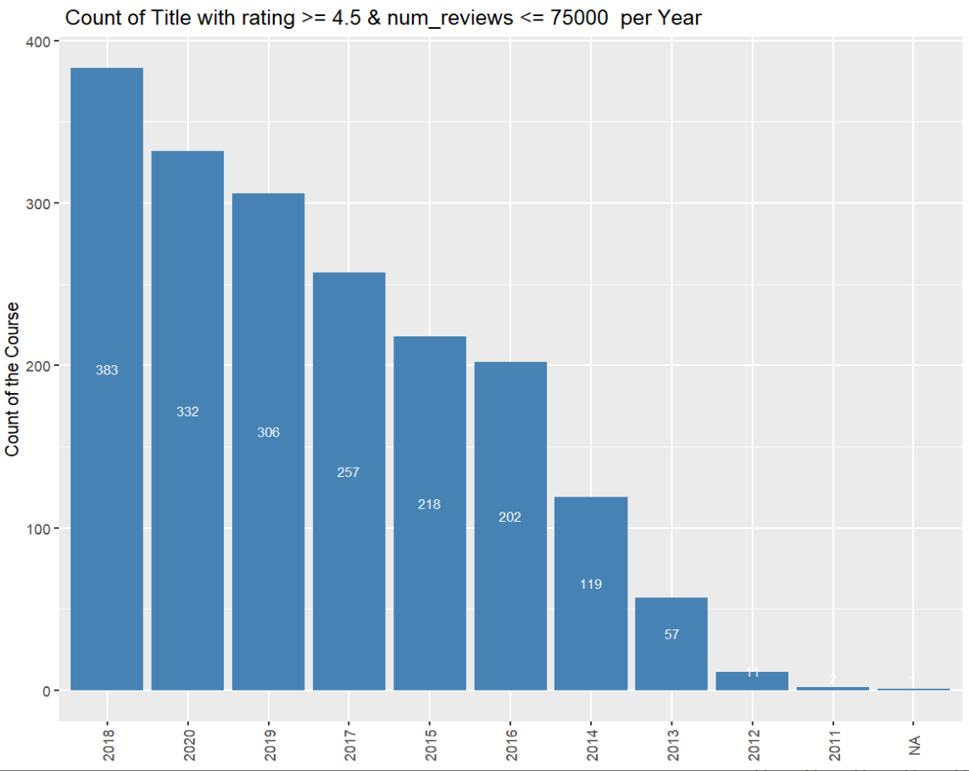

- Best selling course with num_subscriber >=50000 & rating >= 4.5 & num_reviews <= 75000
Code:
data32<- data
data32 <- data32 %>%
mutate(datetime = as.POSIXct(created, format = "%Y-%m-%dT%H:%M:%SZ")) %>%
mutate(year = format(datetime, "%Y")) %>%
filter(num_subscribers >= 50000 & rating >= 4.5 & num_reviews <= 75000) %>%
group_by(year) %>%
summarise(count1L = n())
View(data32)
ggplot(data32, aes(x=reorder(year, -count1L), y=count1L ))+
geom_bar(stat="identity", fill="steelblue")+
labs(x="Year", y="Count of the Course", title = " Count of Title with Subsciber>=5000&rating >= 4.5 & num_reviews <= 75000 per Year")+
theme(axis.text.x = element_text(angle=90,hjust = 0.5,vjust = 0.5),
axis.title.x = element_blank()) +
geom_text(aes(label = count1L), vjust = -0.5, color = "white", size = 3, position = position_stack(vjust = 0.5))

Output:
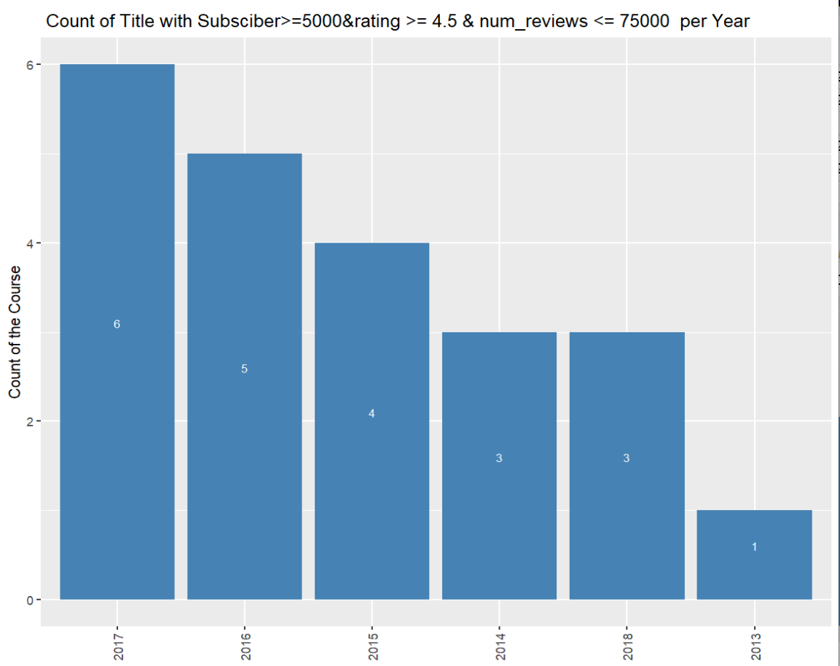
- Best selling course with num_subscriber >=75000 & rating >= 4.5 & num_reviews >= 75000
Code:
data33<- data
data33 <- data33 %>%
mutate(datetime = as.POSIXct(created, format = "%Y-%m-%dT%H:%M:%SZ")) %>%
mutate(year = format(datetime, "%Y")) %>%
filter(num_subscribers >= 75000 & rating >= 4.5 & num_reviews >= 75000) %>%
group_by(year) %>%
summarise(count1L = n())
View(data33)
ggplot(data33, aes(x=reorder(year, -count1L), y=count1L ))+
geom_bar(stat="identity", fill="steelblue")+
labs(x="Year", y="Count of the Course", title = " Count of Title with Subsciber>=75000&rating >= 4.5 & num_reviews <= 75000 per Year")+
theme(axis.text.x = element_text(angle=90,hjust = 0.5,vjust = 0.5),
axis.title.x = element_blank()) +
geom_text(aes(label = count1L), vjust = -0.5, color = "white", size = 3, position = position_stack(vjust = 0.5))

Output:
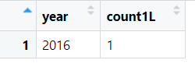

- Best selling course with num_subscriber >=75000 & rating >= 4.5 & num_reviews <= 25000
Code:
data34<- data
data34 <- data34 %>%
mutate(datetime = as.POSIXct(created, format = "%Y-%m-%dT%H:%M:%SZ")) %>%
mutate(year = format(datetime, "%Y")) %>%
filter(num_subscribers >= 75000 & rating >= 4.5 & num_reviews <= 25000) %>%
group_by(year) %>%
summarise(count1L = n())
View(data34)
ggplot(data34, aes(x=reorder(year, -count1L), y=count1L ))+
geom_bar(stat="identity", fill="steelblue")+
labs(x="Year", y="Count of the Course", title = " Count of Title with Subsciber>=75000&rating >= 4.5 & num_reviews <= 25000 per Year")+
theme(axis.text.x = element_text(angle=90,hjust = 0.5,vjust = 0.5),
axis.title.x = element_blank()) +
geom_text(aes(label = count1L), vjust = -0.5, color = "white", size = 3, position = position_stack(vjust = 0.5))
Output:
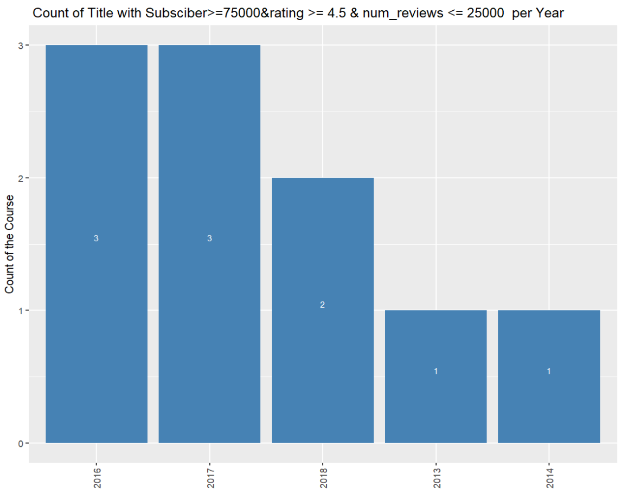

- Best selling course with num_subscriber >=50000 & rating >= 4.0 & num_reviews <= 25000
Code:
data35<- data
data35 <- data35 %>%
mutate(datetime = as.POSIXct(created, format = "%Y-%m-%dT%H:%M:%SZ")) %>%
mutate(year = format(datetime, "%Y")) %>%
filter(num_subscribers >= 50000 & rating >= 4.0 & num_reviews <= 25000) %>%
group_by(year) %>%
summarise(count1L = n())
View(data35)
ggplot(data35, aes(x=reorder(year, -count1L), y=count1L ))+
geom_bar(stat="identity", fill="steelblue")+
labs(x="Year", y="Count of the Course", title = " Count of Title with Subsciber>=50000&rating >= 4.0 & num_reviews <= 25000 per Year")+
theme(axis.text.x = element_text(angle=90,hjust = 0.5,vjust = 0.5),
axis.title.x = element_blank()) +
geom_text(aes(label = count1L), vjust = -0.5, color = "white", size = 3, position = position_stack(vjust = 0.5))
Output:
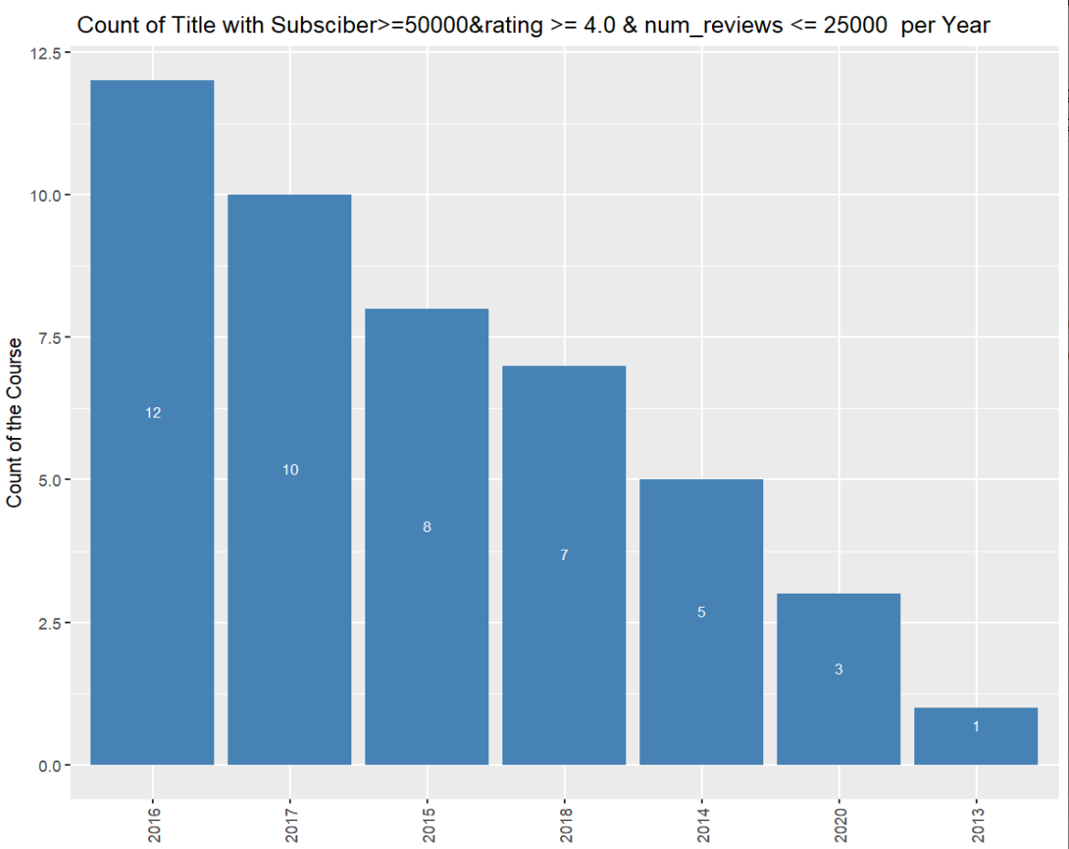

- Best selling course with num_subscriber >=25000 & rating >= 4.0 & num_reviews <= 25000
Code:
data36<- data
data36 <- data36 %>%
mutate(datetime = as.POSIXct(created, format = "%Y-%m-%dT%H:%M:%SZ")) %>%
mutate(year = format(datetime, "%Y")) %>%
filter(num_subscribers >= 25000 & rating >= 4.0 & num_reviews <= 25000) %>%
group_by(year) %>%
summarise(count1L = n())
View(data36)
ggplot(data36, aes(x=reorder(year, -count1L), y=count1L ))+
geom_bar(stat="identity", fill="steelblue")+
labs(x="Year", y="Count of the Course", title = " Count of Title with Subsciber>=25000&rating >= 4.0 & num_reviews <= 25000 per Year")+
theme(axis.text.x = element_text(angle=90,hjust = 0.5,vjust = 0.5),
axis.title.x = element_blank()) +
geom_text(aes(label = count1L), vjust = -0.5, color = "white", size = 3, position = position_stack(vjust = 0.5))
Output:
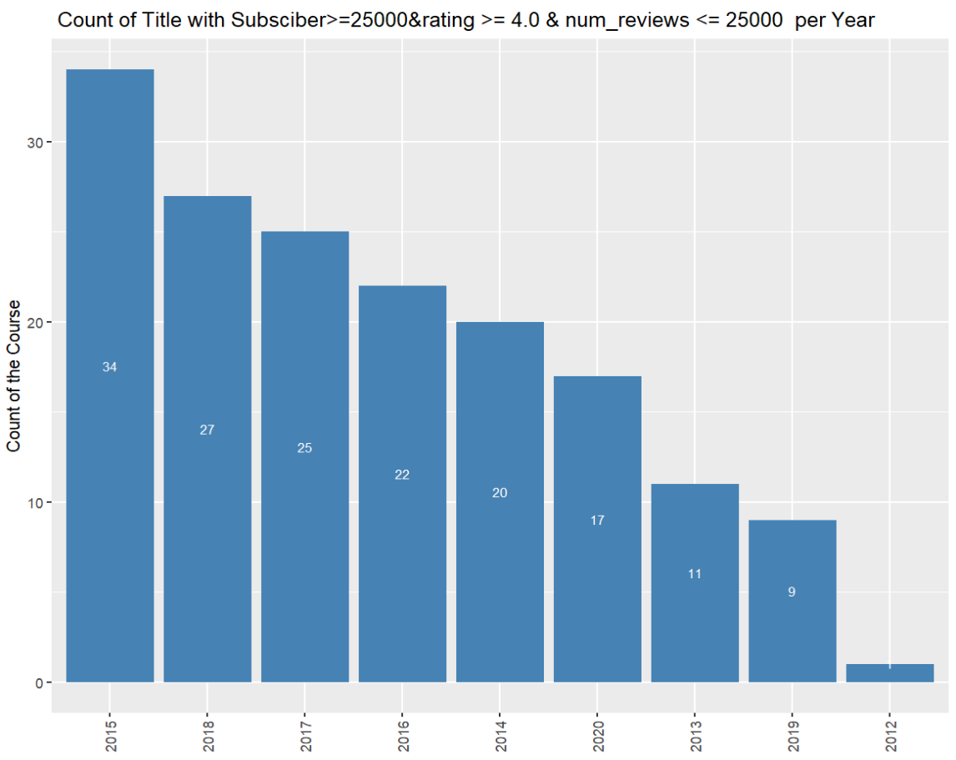

- Best selling course with num_subscriber >= 10000 & rating >= 3.0 & num_reviews <= 25000
Code:
data37<- data
data37 <- data37 %>%
mutate(datetime = as.POSIXct(created, format = "%Y-%m-%dT%H:%M:%SZ")) %>%
mutate(year = format(datetime, "%Y")) %>%
filter(num_subscribers >= 10000 & rating >= 3.0 & num_reviews <= 25000) %>%
group_by(year) %>%
summarise(count1L = n())
View(data37)
ggplot(data37, aes(x=reorder(year, -count1L), y=count1L ))+
geom_bar(stat="identity", fill="steelblue")+
labs(x="Year", y="Count of the Course", title = " Count of Title with Subsciber>=10000&rating >= 3.0 & num_reviews <= 25000 per Year")+
theme(axis.text.x = element_text(angle=90,hjust = 0.5,vjust = 0.5),
axis.title.x = element_blank()) +
geom_text(aes(label = count1L), vjust = -0.5, color = "white", size = 3, position = position_stack(vjust = 0.5))

Output:
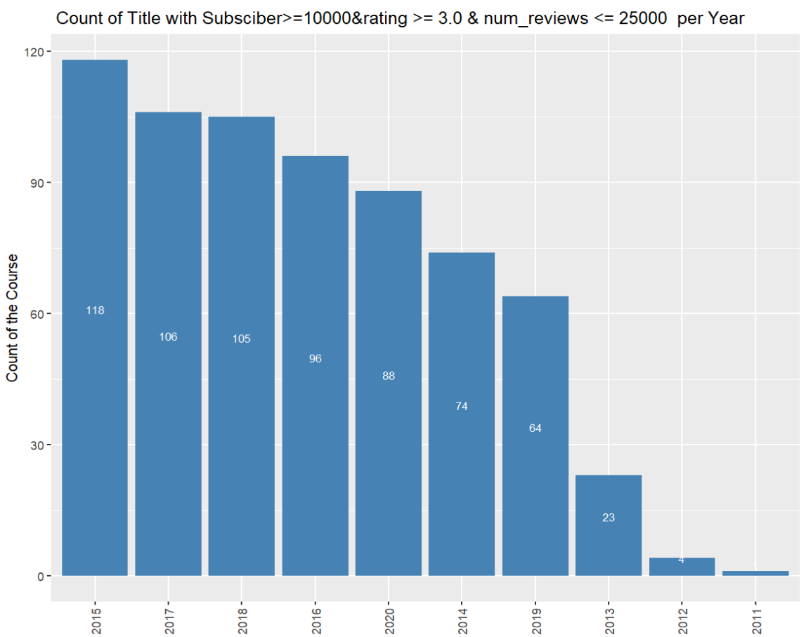

- Best selling course with num_subscriber >= 10000 & rating >= 3.0 & num_reviews <= 10000
Code:
data38<- data
data38 <- data38 %>%
mutate(datetime = as.POSIXct(created, format = "%Y-%m-%dT%H:%M:%SZ")) %>%
mutate(year = format(datetime, "%Y")) %>%
filter(num_subscribers >= 10000 & rating >= 3.0 & num_reviews <= 10000) %>%
group_by(year) %>%
summarise(count1L = n())
View(data38)
ggplot(data38, aes(x=reorder(year, -count1L), y=count1L ))+
geom_bar(stat="identity", fill="steelblue")+
labs(x="Year", y="Count of the Course", title = " Count of Title with Subsciber>=10000&rating >= 3.0 & num_reviews <= 10000 per Year")+
theme(axis.text.x = element_text(angle=90,hjust = 0.5,vjust = 0.5),
axis.title.x = element_blank()) +
geom_text(aes(label = count1L), vjust = -0.5, color = "white", size = 3, position = position_stack(vjust = 0.5))

Output:
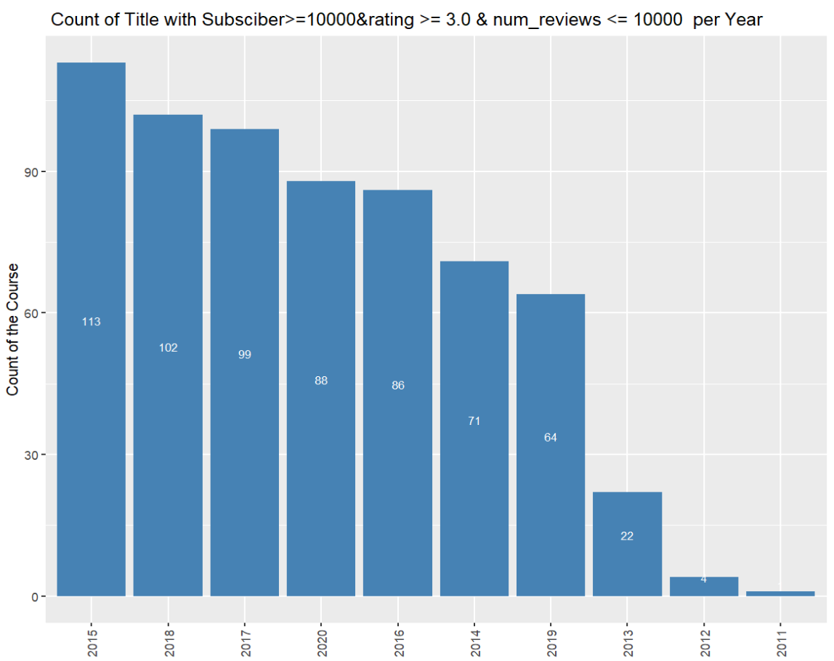

- Best selling course with num_subscriber >= 50000 & rating >= 4.5 & num_reviews <= 40000 & price_detail_amount>=5000
Code:
data39<- data
data39 <- data39 %>%
mutate(datetime = as.POSIXct(created, format = "%Y-%m-%dT%H:%M:%SZ")) %>%
mutate(year = format(datetime, "%Y")) %>%
filter(num_subscribers >= 50000 & rating >= 4.5 & num_reviews <= 40000 & price_detail_amount >=5000) %>%
group_by(year) %>%
summarise(count1L = n())
View(data39)
ggplot(data39, aes(x=reorder(year, -count1L), y=count1L ))+
geom_bar(stat="identity", fill="steelblue")+
labs(x="Year", y="Count of the Course", title = " Count of Title with Subsciber>=50000&rating >= 4.5 & num_reviews <= 40000& Price_Amount>=5000 per Year")+
theme(axis.text.x = element_text(angle=90,hjust = 0.5,vjust = 0.5),
axis.title.x = element_blank()) +
geom_text(aes(label = count1L), vjust = -0.5, color = "white", size = 3, position = position_stack(vjust = 0.5))

Output:
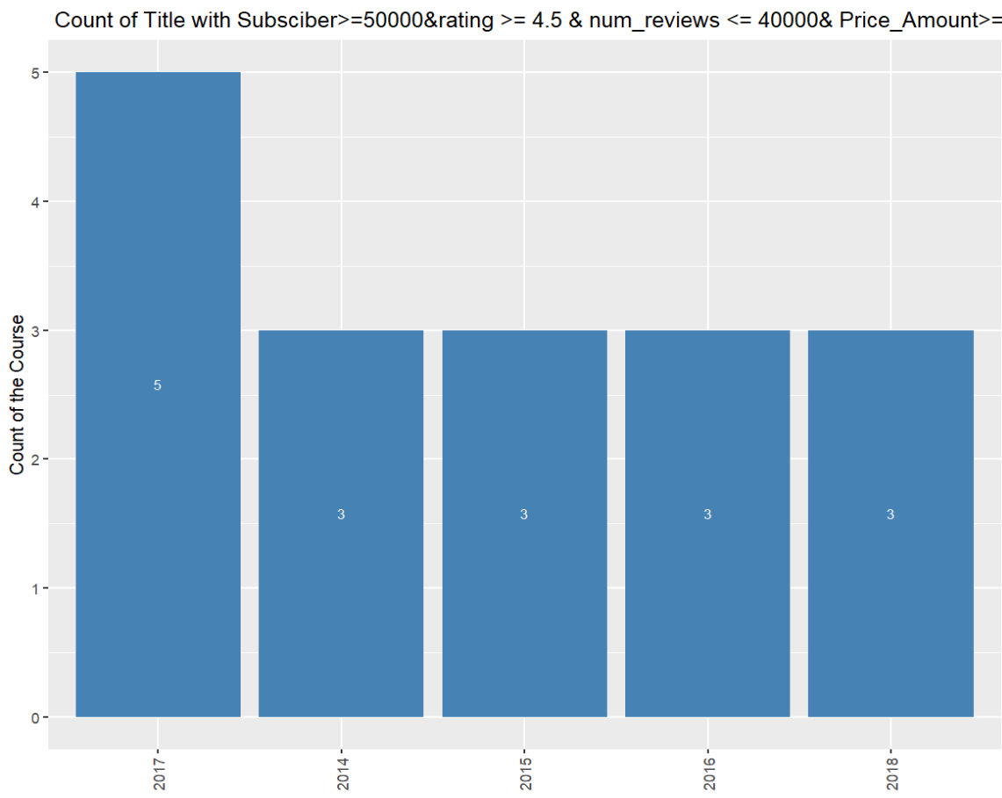
- Best selling course with num_subscriber >= 50000 & rating >= 4.5 & num_reviews >= 40000 & price_detail_amount >=2500
Code:
data40<- data
data40 <- data40 %>%
mutate(datetime = as.POSIXct(created, format = "%Y-%m-%dT%H:%M:%SZ")) %>%
mutate(year = format(datetime, "%Y")) %>%
filter(num_subscribers >= 50000 & rating >= 4.5 & num_reviews >= 40000 & price_detail_amount >=2500) %>%
group_by(year) %>%
distinct(title) %>%
summarise(count1L = n())
View(data40)
ggplot(data40, aes(x=reorder(year, -count1L), y=count1L ))+
geom_bar(stat="identity", fill="steelblue")+
labs(x="Year", y="Count of the Course", title = " Count of Title with Subsciber>=50000&rating >= 4.5 & num_reviews <= 40000& Price_Amount>=2500 per Year")+
theme(axis.text.x = element_text(angle=90,hjust = 0.5,vjust = 0.5),
axis.title.x = element_blank()) +
geom_text(aes(label = count1L), vjust = -0.5, color = "white", size = 3, position = position_stack(vjust = 0.5))

# only names per year
data41<- data
data41 <- data41 %>%
mutate(datetime = as.POSIXct(created, format = "%Y-%m-%dT%H:%M:%SZ")) %>%
mutate(year = format(datetime, "%Y")) %>%
filter(num_subscribers >= 50000 & rating >= 4.5 & num_reviews >= 40000 & price_detail_amount >=2500) %>%
group_by(year) %>%
distinct(title)
View(data41)
Output:


- Best selling course with num_subscriber >= 50000 & rating >= 4.5 & num_reviews >= 40000 & price_detail_amount >=1000
Code:
#count per year
data42<- data
data42 <- data42 %>%
mutate(datetime = as.POSIXct(created, format = "%Y-%m-%dT%H:%M:%SZ")) %>%
mutate(year = format(datetime, "%Y")) %>%
filter(num_subscribers >= 50000 & rating >= 4.5 & num_reviews >= 40000 & price_detail_amount >=1000) %>%
group_by(year) %>%
distinct(title) %>%
summarise(count1L = n())
View(data42)
ggplot(data42, aes(x=reorder(year, -count1L), y=count1L ))+
geom_bar(stat="identity", fill="steelblue")+
labs(x="Year", y="Count of the Course", title = " Count of Title with Subsciber>=50000&rating >= 4.5 & num_reviews >= 40000& Price_Amount>=1000 per Year")+
theme(axis.text.x = element_text(angle=90,hjust = 0.5,vjust = 0.5),
axis.title.x = element_blank()) +
geom_text(aes(label = count1L), vjust = -0.5, color = "white", size = 3, position = position_stack(vjust = 0.5))

# only names per year
data43<- data
data43 <- data43 %>%
mutate(datetime = as.POSIXct(created, format = "%Y-%m-%dT%H:%M:%SZ")) %>%
mutate(year = format(datetime, "%Y")) %>%
filter(num_subscribers >= 50000 & rating >= 4.5 & num_reviews >= 40000 & price_detail_amount >=1000) %>%
group_by(year) %>%
distinct(title)
View(data43)
Output:

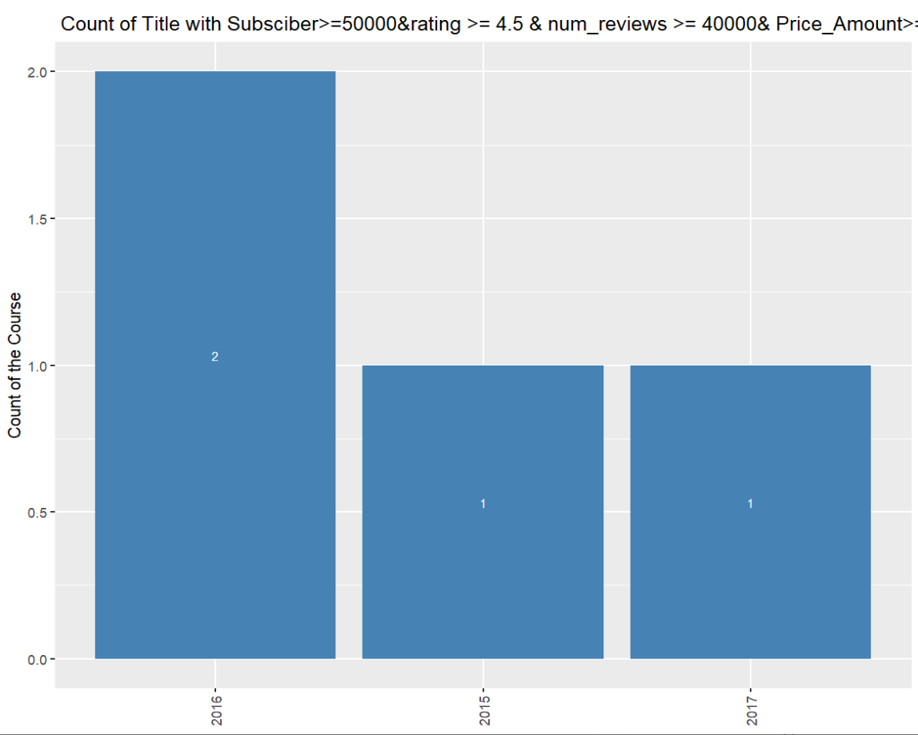

- Best selling course with num_subscriber >= 25000 & rating >= 4.0 & num_reviews >= 25000 & price_detail_amount >=5000
Code:
#count per year
data44<- data
data44 <- data44 %>%
mutate(datetime = as.POSIXct(created, format = "%Y-%m-%dT%H:%M:%SZ")) %>%
mutate(year = format(datetime, "%Y")) %>%
filter(num_subscribers >= 25000 & rating >= 4.0 & num_reviews >= 25000 & price_detail_amount >=5000) %>%
group_by(year) %>%
distinct(title) %>%
summarise(count1L = n())
View(data44)
ggplot(data44, aes(x=reorder(year, -count1L), y=count1L ))+
geom_bar(stat="identity", fill="steelblue")+
labs(x="Year", y="Count of the Course", title = " Count of Title with Subsciber>=25000&rating >= 4.0 & num_reviews <= 25000& Price_Amount>=5000 per Year")+
theme(axis.text.x = element_text(angle=90,hjust = 0.5,vjust = 0.5),
axis.title.x = element_blank()) +
geom_text(aes(label = count1L), vjust = -0.5, color = "white", size = 3, position = position_stack(vjust = 0.5))

# only names per year
data45<- data
data45 <- data45 %>%
mutate(datetime = as.POSIXct(created, format = "%Y-%m-%dT%H:%M:%SZ")) %>%
mutate(year = format(datetime, "%Y")) %>%
filter(num_subscribers >= 25000 & rating >= 4.0 & num_reviews >= 25000 & price_detail_amount >=5000) %>%
group_by(year) %>%
distinct(title)
View(data45)
Output:

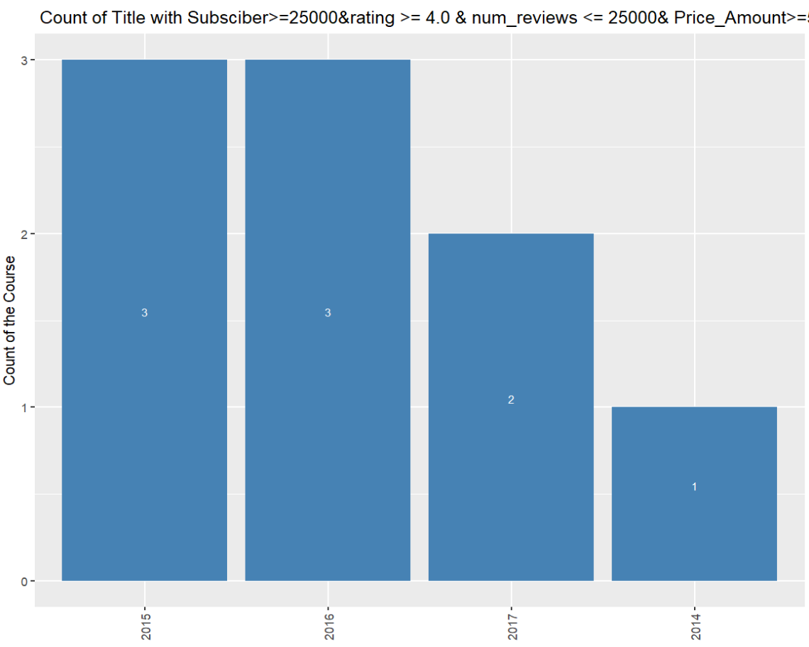
- Best selling course with num_subscriber <= 25000 & rating <= 3.0 & num_reviews <= 25000 & price_detail_amount <=2500
Code:
#count per year
data46<- data
data46 <- data46 %>%
mutate(datetime = as.POSIXct(created, format = "%Y-%m-%dT%H:%M:%SZ")) %>%
mutate(year = format(datetime, "%Y")) %>%
filter(num_subscribers <= 25000 & rating <= 3.0 & num_reviews <= 25000 & price_detail_amount <=2500) %>%
group_by(year) %>%
distinct(title) %>%
summarise(count1L = n())
View(data46)
ggplot(data46, aes(x=reorder(year, -count1L), y=count1L ))+
geom_bar(stat="identity", fill="steelblue")+
labs(x="Year", y="Count of the Course", title = " Count of Title with Subsciber<=25000&rating <= 3.0 & num_reviews <= 25000& Price_Amount>=2500 per Year")+
theme(axis.text.x = element_text(angle=90,hjust = 0.5,vjust = 0.5),
axis.title.x = element_blank()) +
geom_text(aes(label = count1L), vjust = -0.5, color = "white", size = 3, position = position_stack(vjust = 0.5))

Output:
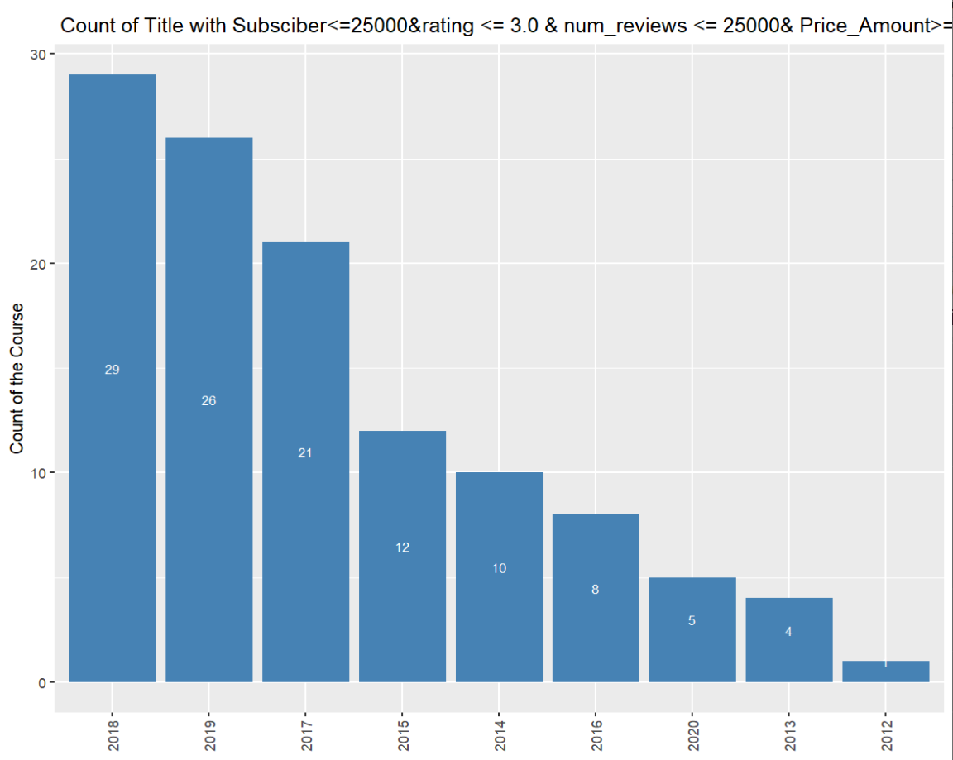

- Best selling course with num_subscriber <= 25000 & rating <= 3.0 & num_reviews <= 25000 & price_detail_amount <=2500 & discount_price_amount <500
Code:
data47<- data
data47 <- data47 %>%
mutate(datetime = as.POSIXct(created, format = "%Y-%m-%dT%H:%M:%SZ")) %>%
mutate(year = format(datetime, "%Y")) %>%
filter(num_subscribers <= 25000 & rating <= 3.0 & num_reviews <= 25000 & price_detail_amount <=2500 & discount_price_amount <=500) %>%
group_by(year) %>%
distinct(title) %>%
summarise(count1L = n())
View(data47)
ggplot(data47, aes(x=reorder(year, -count1L), y=count1L ))+
geom_bar(stat="identity", fill="steelblue")+
labs(x="Year", y="Count of the Course", title = " Count of Title with Subsciber<=25000&rating <= 3.0 & num_reviews <= 25000& Price_Amount<=2500& DiscountAmount<=500 per Year")+
theme(axis.text.x = element_text(angle=90,hjust = 0.5,vjust = 0.5),
axis.title.x = element_blank()) +
geom_text(aes(label = count1L), vjust = -0.5, color = "white", size = 3, position = position_stack(vjust = 0.5))

Output:
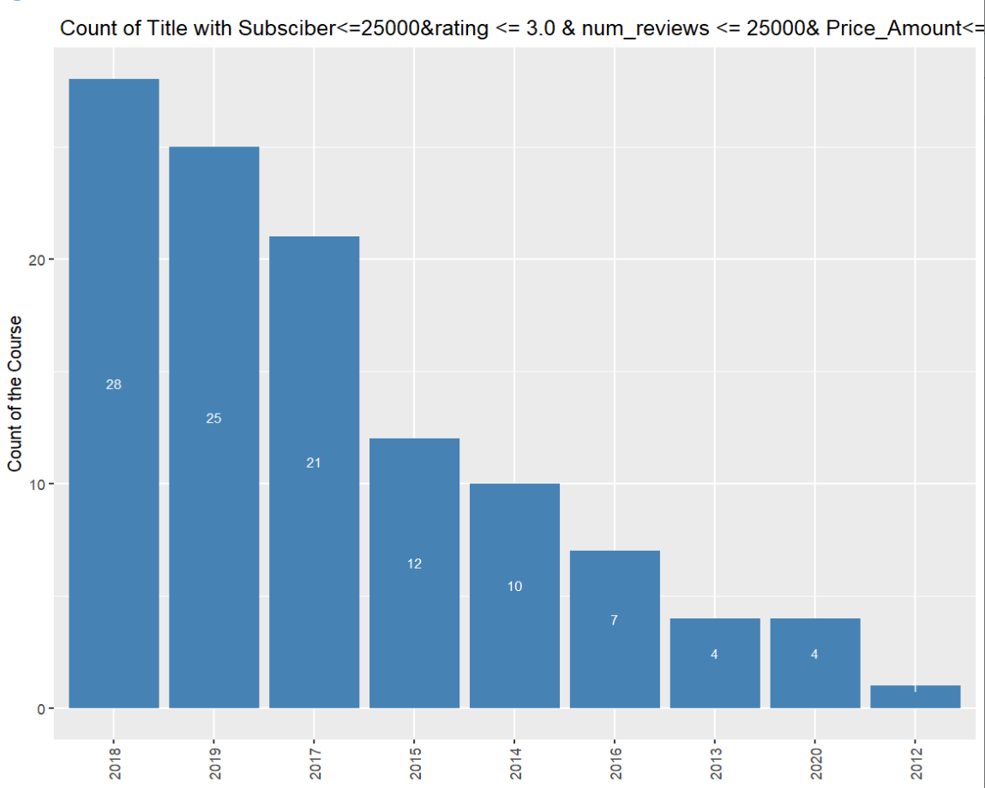

- Best selling course with num_subscriber <= 25000 & rating <= 3.0 & num_reviews <= 25000 & price_detail_amount <=2500 & discount_price_amount <=500
Code:
data48<- data
data48 <- data48 %>%
mutate(datetime = as.POSIXct(created, format = "%Y-%m-%dT%H:%M:%SZ")) %>%
mutate(year = format(datetime, "%Y")) %>%
filter(num_subscribers <= 25000 & rating <= 3.0 & num_reviews <= 25000 & price_detail_amount <=2500 & discount_price_amount <=500) %>%
group_by(year) %>%
distinct(title) %>%
summarise(count1L = n())
View(data48)
ggplot(data48, aes(x=reorder(year, -count1L), y=count1L ))+
geom_bar(stat="identity", fill="steelblue")+
labs(x="Year", y="Count of the Course", title = " Count of Title with Subsciber<=25000&rating <= 3.0 & num_reviews <= 25000& Price_Amount<=2500& DiscountAmount<=500 per Year")+
theme(axis.text.x = element_text(angle=90,hjust = 0.5,vjust = 0.5),
axis.title.x = element_blank()) +
geom_text(aes(label = count1L), vjust = -0.5, color = "white", size = 3, position = position_stack(vjust = 0.5))
Output:
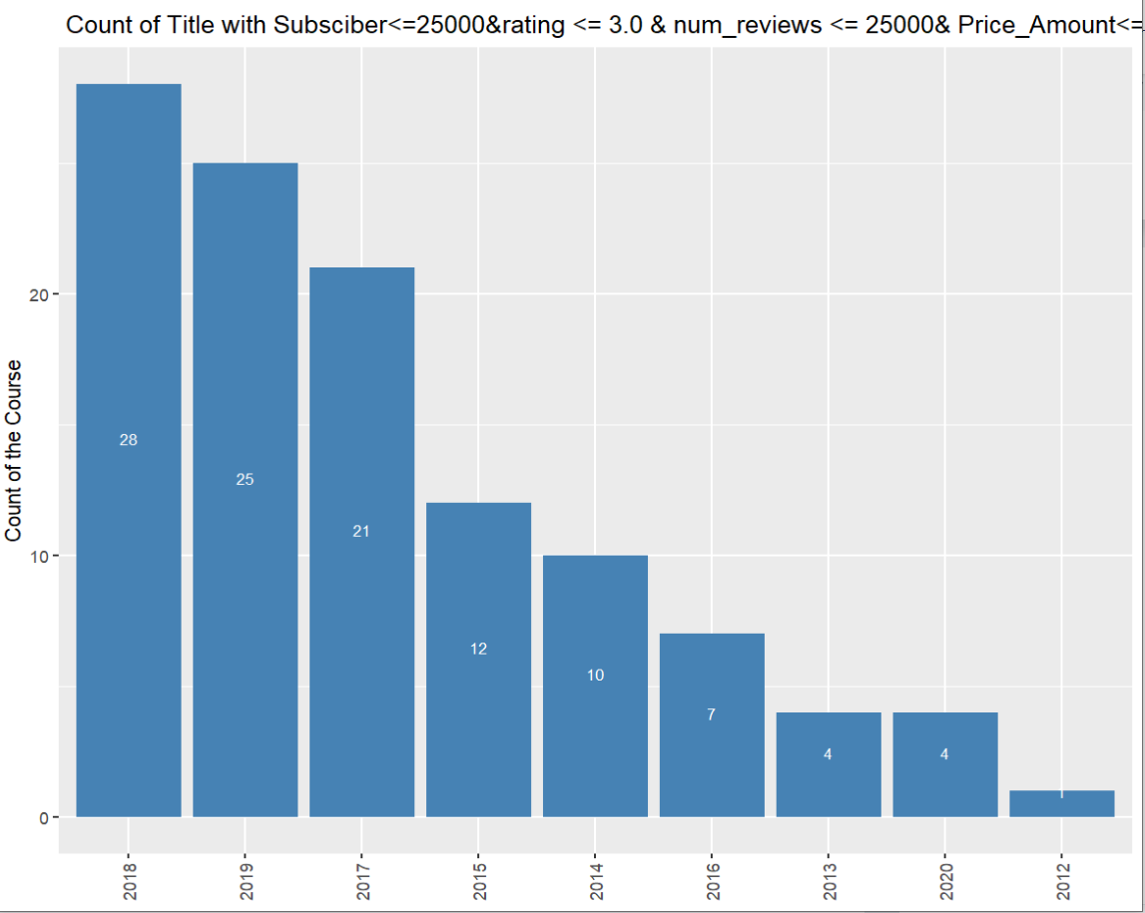

- Best selling course with num_subscriber <= 25000 & rating <= 3.0 & num_reviews <= 25000 & price_detail_amount <=2500 & discount_price_amount >500
Code:
data49<- data
data49 <- data49 %>%
mutate(datetime = as.POSIXct(created, format = "%Y-%m-%dT%H:%M:%SZ")) %>%
mutate(year = format(datetime, "%Y")) %>%
filter(num_subscribers <= 25000 & rating <= 3.0 & num_reviews <= 25000 & price_detail_amount <=2500 & discount_price_amount > 500) %>%
group_by(year) %>%
distinct(title) %>%
summarise(count1L = n())
View(data49)

ggplot(data49, aes(x=reorder(year, -count1L), y=count1L ))+
geom_bar(stat="identity", fill="steelblue")+
labs(x="Year", y="Count of the Course", title = " Count of Title with Subsciber<=25000&rating <= 3.0 & num_reviews <= 25000& Price_Amount<=2500& DiscountAmount>500 per Year")+
theme(axis.text.x = element_text(angle=90,hjust = 0.5,vjust = 0.5),
axis.title.x = element_blank()) +
geom_text(aes(label = count1L), vjust = -0.5, color = "white", size = 3, position = position_stack(vjust = 0.5))

Output:
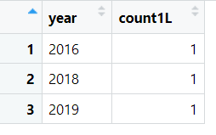

- Best selling course with num_subscriber >= 25000 & rating >= 4.5 & num_reviews >= 25000 & price_detail_amount >=2500 & discount_price_amount <=500
Code:
data50<- data
data50 <- data50 %>%
mutate(datetime = as.POSIXct(created, format = "%Y-%m-%dT%H:%M:%SZ")) %>%
mutate(year = format(datetime, "%Y")) %>%
filter(num_subscribers >= 25000 & rating >= 4.5 & num_reviews >= 25000 & price_detail_amount >=2500 & discount_price_amount <= 500) %>%
group_by(year) %>%
distinct(title) %>%
summarise(count1L = n())
View(data50)
ggplot(data50, aes(x=reorder(year, -count1L), y=count1L ))+
geom_bar(stat="identity", fill="steelblue")+
labs(x="Year", y="Count of the Course", title = " Count of Title with Subsciber>=25000&rating >=4.5 3.0 & num_reviews >= 25000& Price_Amount>=2500& DiscountAmount<=500 per Year")+
theme(axis.text.x = element_text(angle=90,hjust = 0.5,vjust = 0.5),
axis.title.x = element_blank()) +
geom_text(aes(label = count1L), vjust = -0.5, color = "white", size = 3, position = position_stack(vjust = 0.5))
Output:
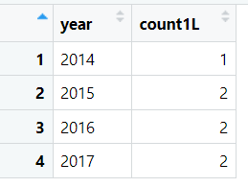

- Best selling course with num_subscriber >= 25000 & rating >= 4.0 & num_reviews >= 25000 & price_detail_amount >=2500 & discount_price_amount <=500
Code:
data51<- data
data51 <- data51 %>%
mutate(datetime = as.POSIXct(created, format = "%Y-%m-%dT%H:%M:%SZ")) %>%
mutate(year = format(datetime, "%Y")) %>%
filter(num_subscribers >= 25000 & rating >= 4.0 & num_reviews >= 25000 & price_detail_amount >=2500 & discount_price_amount <= 500) %>%
group_by(year) %>%
distinct(title) %>%
summarise(count1L = n())
View(data51)
ggplot(data51, aes(x=reorder(year, -count1L), y=count1L ))+
geom_bar(stat="identity", fill="steelblue")+
labs(x="Year", y="Count of the Course", title = " Count of Title with Subsciber>=25000&rating <= 4.0 & num_reviews <= 25000& Price_Amount>=2500& DiscountAmount<=500 per Year")+
theme(axis.text.x = element_text(angle=90,hjust = 0.5,vjust = 0.5),
axis.title.x = element_blank()) +
geom_text(aes(label = count1L), vjust = -0.5, color = "white", size = 3, position = position_stack(vjust = 0.5))

Output:
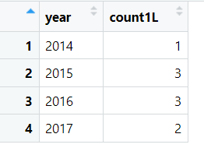

Insights:

- The Best Selling course having more than 300000 subscribers is “An Entire MBA in 1 Course:Award Winning Business School …”
- 3 Best selling-courses based on the given criteria with a rating of 1 or higher and having at least 50,000 reviews
- In the year 2015, there was 1 course, 2016:2 courses and 2017:1 course that met the criteria of having more that 50000 num_subscribers, a rating of 4.5 or higher, at least 40000 reviews or higher, a price of at least 2500 or higher.
- In the year 2014, there was 1 course, 2015:2 courses, 2016:2 course and 2017:2 courses that met the criteria of having at least 25,000 subscribers, a rating of 4.5 or higher, at least 25,000 reviews, a price of at least 2500, and a discount price of 500 or lower.
- In the year 2014, there was 1 course, 2015:3 courses, 2016:3 course and 2017:2 courses that met the criteria of having at least 25,000 subscribers, a rating of 4.0 or higher, at least 25,000 reviews, a price of at least 2500, and a discount price of 500 or lower.
- In the year 2016, there was 1 course, 2018:1 courses, 2019:1 course and 2017:2 courses that met the criteria of having at least 25,000 subscribers, a rating of 3.0 or higher, at least 25,000 reviews, a price of at least 2500, and a discount price of 500 or higher.

