REGIONAL LABOUR MARKET STATISTICS - UK
Origin of the Data set: https://www.ons.gov.uk/employmentandlabourmarket/peopleinwork/employmentandemployeetypes/datasets/headlinelabourforcesurveyindicatorsforallregionshi00
Overview of the Dataset:
The dataset for UK employment statistics consists of various fields that provide valuable insights into the labor market. Here's an overview of the dataset based on the provided fields:
Date of Publication: This field represents the date when the employment statistics data was published, indicating the timing of the dataset.
Quarter_From and Quarter_To: These fields indicate the start and end dates of the quarter to which the employment statistics correspond. They help in analyzing temporal patterns and trends over specific quarters.
Year: The Year field represents the calendar year to which the employment statistics belong. It allows for analyzing trends and changes in employment over different years.
Region: This field categorizes the data based on specific geographic regions within the UK, such as London, South East, North West, etc. It helps in understanding regional variations in employment and labor market dynamics.
Sex: The Sex field categorizes employment data based on gender, distinguishing between male and female. It provides insights into gender disparities and employment patterns.
Age: This field categorizes the data based on age groups which includes all ages 16 and above, the other category is all ages from 16 to 64. This represents the core working group. It allows for analyzing employment patterns across different age cohorts.
Total: The Total field represents the total number of individuals considered within each specific category. It may refer to the total population, total employed, total unemployed, or other relevant metrics depending on the context.
Total economically active: This field represents the total number of individuals considered economically active, which includes both the employed and unemployed individuals actively seeking work.
Total in employment: This field represents the total number of individuals employed during the specified period.
Unemployed: The Unemployed field represents the total number of individuals who are currently unemployed, actively seeking work, and available for employment.
Economically inactive: This field represents the total number of individuals who are not economically active, meaning they are neither employed nor actively seeking work.
Economic activity rate (%): This field calculates the proportion of the working-age population that is economically active, expressed as a percentage.
Employment rate (%): The Employment rate field calculates the proportion of the working-age population that is employed, expressed as a percentage.
Unemployment rate (%): This field calculates the unemployment rate, which represents the proportion of the labor force that is unemployed, expressed as a percentage.
Economic inactivity rate (%): This field calculates the proportion of the working-age population that is economically inactive, expressed as a percentage.
Analyzing this dataset allows for examining trends in employment rates, unemployment rates, economic activity rates, and other labor market indicators across different regions, genders, age groups, and time periods. It provides insights into the dynamics and characteristics of the UK labor market and can be used to identify patterns, assess the impact of policies, and inform decision-making related to employment and workforce development.

Overview of the Tool used: Python
Python is a versatile and widely used programming language that is extensively utilized for data analysis, including the analysis of the "Telecom Users" dataset.:
- Versatile and Easy to Use
- Abundance of Libraries
- Data Manipulation and Exploration
- Data Visualization
- Machine Learning and Statistical Analysis
- Integration and Collaboration
- Scalability and Performance

Overview of Libraries Used:
- Numpy:
- Numpy is a powerful numerical computing library in Python.
- It provides support for large, multi-dimensional arrays and matrices, along with a collection of mathematical functions to operate on these arrays efficiently.
- It is widely used for tasks involving numerical computations, data manipulation, and scientific computing.
- It offers various functionalities such as array creation, indexing, slicing, mathematical operations, linear algebra operations, random number generation, and more.
- Numpy is known for its performance and optimized algorithms, making it a fundamental library for data analysis and scientific computing in Python.
- Pandas:
- Pandas is a versatile data manipulation and analysis library in Python.
- It provides powerful data structures, such as Data Frames and Series, which allow for efficient handling and analysis of structured data.
- Pandas excels in data cleaning, transformation, merging, reshaping, and aggregation tasks.
- It offers a wide range of functions and methods for data exploration, data pre-processing, and data wrangling.
- Pandas is extensively used in data analysis, data pre-processing, and data preparation workflows, as well as in data visualization and statistical analysis.
Matplotlib:
Matplotlib is a popular plotting library in Python.
- It provides a comprehensive set of tools for creating static, animated, and interactive visualizations in Python.
- Matplotlib enables the creation of various types of plots, including line plots, scatter plots, bar plots, histograms, pie charts, and more.
- It offers a high level of customization and control over plot elements such as axes, labels, colors, markers, and legends.
- Matplotlib is widely used for data visualization, exploration, and presentation purposes in scientific, statistical, and data analysis projects.
Seaborn:
- Seaborn is a statistical data visualization library built on top of Matplotlib.
- It provides a higher-level interface for creating attractive and informative statistical graphics.
- Seaborn simplifies the process of creating complex plots, such as heatmaps, violin plots, box plots, and cluster maps, with just a few lines of code.
- It offers a wide range of built-in themes and color palettes that enhance the visual appeal of the plots.
- Seaborn also provides functions for advanced statistical visualizations, such as regression plots, distribution plots, and categorical plots.
- It is commonly used in exploratory data analysis, statistical modeling, and data-driven storytelling.

Summary:
Number of Rows: 1248
Number of Columns: 16

Pre-processing:

import pandas as pd
import numpy as np
employment_data = pd.read_csv("employment_statistics_UK.csv")

#Finding Mean Values
- Mean of Total employment in UK
Code:
Total_mean = empdata['Total'].mean()
Total_mean_formmated = round(Total_mean,1)
print('The mean of Total Employment in UK', Total_mean_formmated)

Output:
The mean of Total Employment in UK 3441145.4

- Mean of Total in employment
Code:
Tot_in_empl_mean = empdata['Total in employment'].mean()
Tot_in_empl_mean_formmated = round(Tot_in_empl_mean,2)
print('The mean of Total Employment in UK', Tot_in_empl_mean_formmated)

Output:
The mean of Total Employment in UK 2319154.38

- Mean of Total in Unemployment
Code:
Tot_in_unempl_mean = empdata['Unemployed'].mean()
Tot_in_unempl_mean_formmated = round(Tot_in_unempl_mean,2)
print('The mean of Total Employment in UK', Tot_in_unempl_mean_formmated)

Output:
The mean of Total Employment in UK 2319154.38

- Describe the data set :

empdata.describe()

Year | Total | Total economically active | Total in employment | Unemployed | Economically inactive | Economic activity rate (%) | Employment rate (%) | Unemployment\nrate (%) | Economic inactivity rate (%)
count | 1248.000000 | 1.248000e+03 | 1.248000e+03 | 1.248000e+03 | 1248.000000 | 1.248000e+03 | 1248.000000 | 1248.000000 | 1248.000000
mean | 2021.769231 | 3.441145e+06 | 2.418300e+06 | 2.319154e+06 | 99145.437500 | 1.022846e+06 | 70.323558 | 67.503125 | 3.989904
std | 0.696847 | 5.132600e+06 | 3.584961e+06 | 3.435461e+06 | 151506.002601 | 1.672787e+06 | 9.182938 | 8.754750 | 1.088989
min | 2021.000000 | 5.759060e+05 | 3.991940e+05 | 3.858200e+05 | 5833.000000 | 1.256100e+05 | 51.700000 | 50.100000 | 1.300000
25% | 2021.000000 | 1.425276e+06 | 1.010288e+06 | 9.702790e+05 | 33277.750000 | 3.298685e+05 | 62.475000 | 59.175000 | 3.200000
50% | 2022.000000 | 1.911438e+06 | 1.375900e+06 | 1.323254e+06 | 52739.500000 | 4.964225e+05 | 69.600000 | 67.600000 | 3.900000
75% | 2022.000000 | 2.630273e+06 | 1.823851e+06 | 1.762658e+06 | 75464.500000 | 9.337658e+05 | 77.900000 | 75.000000 | 4.600000
max | 2023.000000 | 2.311219e+07 | 1.539531e+07 | 1.478665e+07 | 782076.000000 | 9.422786e+06 | 86.000000 | 83.100000 | 8.400000

5. Total Employment in UK includes employment and unemployment per year and Region

Code:
Total_region_yr=empdata1.groupby(['Year','Region']).sum()
print(Total_region_yr)

Output:
Year Region Total
2021 East Midlands 68315218
East of England 88158473
England 800576241
London 133488547
North East 37706683
Northern Ireland 26426474
Scotland 79150455
South East 129604231
South West 79197505
Wales 44618744
West Midland 83332752
Yorkshire and The Humber 77612312
2022 East Midlands 82226347
East of England 106126147
England 963637906
London 160724512
North East 45369838
Northern Ireland 31804483
Scotland 95250862
South East 156008690
South West 95328411
Wales 53695498
West Midland 100306330
Yorkshire and The Humber 93401933
2023 East Midlands 27456999
East of England 35438104
England 321791388
London 53671900
North East 15155506
Northern Ireland 10619908
Scotland 31806911
South East 52095323
South West 31831716
Wales 17929765
West Midland 33494782
Yorkshire and The Humber 31188571

6.Total Employment in UK includes employment and unemployment per Region

Code:
import matplotlib.pyplot as plt

empdata2 = empdata1[['Region', 'Total']]
Total_region = empdata2.groupby(['Region']).sum()

plt.figure(figsize=(10, 6))
plt.bar(range(len(Total_region)), Total_region["Total"])
plt.xlabel("Region")
plt.ylabel("Sum of Total Employment")
plt.title("Total Employment (including Employment and Unemployment) by Region")
plt.xticks(range(len(Total_region)), Total_region.index, rotation=45)

# Adding data labels
for i, Total in enumerate(Total_region["Total"]):
plt.text(i, Total, str(Total), ha='center', va='bottom')

plt.show()
Output:
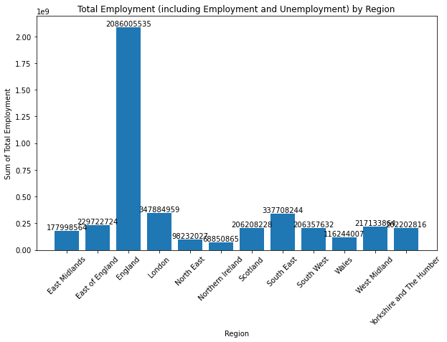

7.Total Employment in UK includes employment and unemployment per year

Code:
empdata3= empdata1[['Year','Region', 'Total']]
Total_Year = empdata3.groupby(['Year']).sum()
print(Total_Year)

plt.figure(figsize=(10, 6))
plt.bar(range(len(Total_Year)), Total_Year["Total"])
plt.xlabel("Year")
plt.ylabel("Sum of Total Employment")
plt.title("Total Employment (including Employment and Unemployment) by Year")
plt.xticks(range(len(Total_Year)), Total_Year.index, rotation=45)

# Adding data labels
for i, Total in enumerate(Total_Year["Total"]):
plt.text(i, Total, str(Total), ha='center', va='bottom')

plt.show()

Chart:
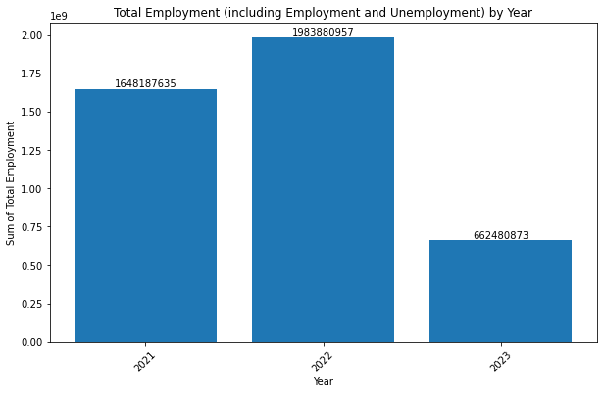

8.Total Employment in UK per Region

Code:

Total_employment = empdata[['Region','Total in employment']]
Total_employment_Region = Total_employment.groupby(['Region']).sum()
print(Total_employment_Region)

plt.figure(figsize=(10, 6))
plt.bar(range(len(Total_employment_Region)), Total_employment_Region["Total in employment"])
plt.xlabel("Region")
plt.ylabel("Sum of Employment(only)")
plt.title("Total Employment (including Employment only) by Region")
plt.xticks(range(len(Total_employment_Region)), Total_employment_Region.index, rotation=45)

# Adding data labels
for i, Total in enumerate(Total_employment_Region["Total in employment"]):
plt.text(i, Total, str(Total), ha='center', va='bottom')

plt.show()

Output:
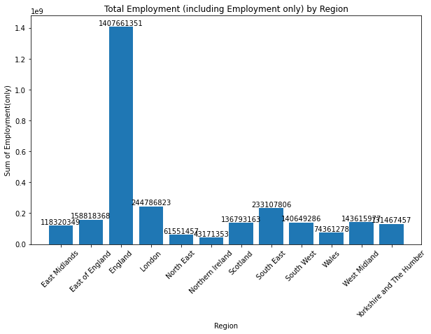

8.Total Employment in UK per year

Code:
Total_employment1 = empdata[['Year','Region','Total in employment']]
Total_employment_Region_Yr = Total_employment1.groupby(['Year']).sum()
print(Total_employment_Region_Yr)

plt.figure(figsize=(10, 6))
plt.bar(range(len(Total_employment_Region_Yr)), Total_employment_Region_Yr["Total in employment"])
plt.xlabel("Year")
plt.ylabel("Sum of Employment only")
plt.title("Total Employment (including Employment only) by Year")
plt.xticks(range(len(Total_employment_Region_Yr)), Total_employment_Region_Yr.index, rotation=45)

# Adding data labels
for i, Total in enumerate(Total_employment_Region_Yr["Total in employment"]):
plt.text(i, Total, str(Total), ha='center', va='bottom')
Chart:
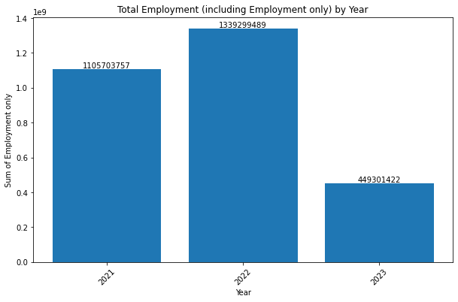

9.Total Unemployment in UK per Region

Code:

Total_unemployment = empdata[['Region','Unemployed']]
Total_unemply_Region = Total_unemployment.groupby(['Region']).sum()
print(Total_unemply_Region)

plt.figure(figsize=(10, 6))
plt.bar(range(len(Total_unemply_Region)), Total_unemply_Region["Unemployed"])
plt.xlabel("Region")
plt.ylabel("Sum of Unemployment(only)")
plt.title("Total Unemployment by Region")
plt.xticks(range(len(Total_unemply_Region)), Total_unemply_Region.index, rotation=45)

# Adding data labels
for i, Total in enumerate(Total_unemply_Region["Unemployed"]):
plt.text(i, Total, str(Total), ha='center', va='bottom')

plt.show()

Chart:
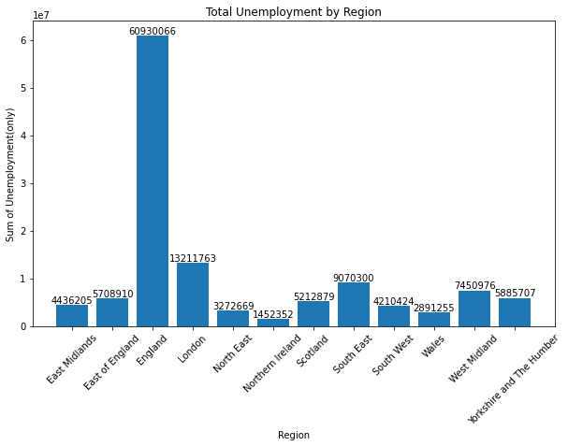

10. Total Unemployment in UK per year

Code:
Total_unemployment1 = empdata[['Year','Region','Unemployed']]
Total_unemply_Year = Total_unemployment1.groupby(['Year']).sum()
print(Total_unemply_Year)

plt.figure(figsize=(10, 6))
plt.bar(range(len(Total_unemply_Year)), Total_unemply_Year["Unemployed"])
plt.xlabel("Year")
plt.ylabel("Sum of Unemployment only")
plt.title("Total Unemployment by Year")
plt.xticks(range(len(Total_unemply_Year)), Total_unemply_Year.index, rotation=45)

# Adding data labels
for i, Total in enumerate(Total_unemply_Year["Unemployed"]):
plt.text(i, Total, str(Total), ha='center', va='bottom')

Chart:
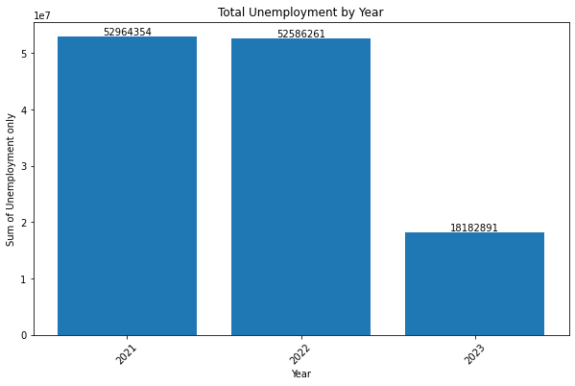

11. Total Active(Economically) employment per Region
Code:
econo_active = empdata[['Region','Total economically active']]
econo_active_region = econo_active.groupby(['Region']).sum()
print(econo_active_region)

plt.figure(figsize=(10, 6))
plt.bar(range(len(econo_active_region)), econo_active_region["Total economically active"])
plt.xlabel("Region")
plt.ylabel("Sum of Active employment)")
plt.title("Total Active Employment by Region")
plt.xticks(range(len(econo_active_region)), econo_active_region.index, rotation=45)

# Adding data labels
for i, Total in enumerate(econo_active_region["Total economically active"]):
plt.text(i, Total, str(Total), ha='center', va='bottom')

plt.show()
Output:
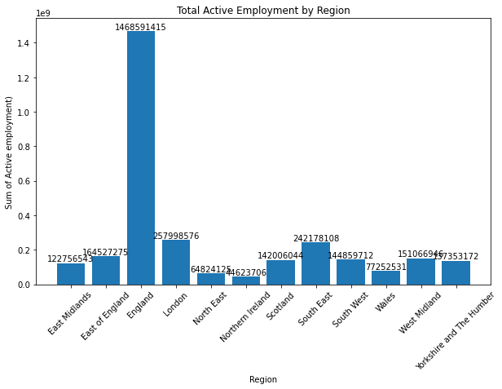

12. Total Active(Economically) employment per year
Code:
econo_active1 = empdata[['Year','Region','Total economically active']]
econo_active_year = econo_active1.groupby(['Year']).sum()
print(econo_active_year)

plt.figure(figsize=(10, 6))
plt.bar(range(len(econo_active_year)), econo_active_year["Total economically active"])
plt.xlabel("Year")
plt.ylabel("Sum of Active employment")
plt.title("Total Active employment by Year")
plt.xticks(range(len(econo_active_year)), econo_active_year.index, rotation=45)

# Adding data labels
for i, Total in enumerate(econo_active_year["Total economically active"]):
plt.text(i, Total, str(Total), ha='center', va='bottom')
plt.show()

Output:
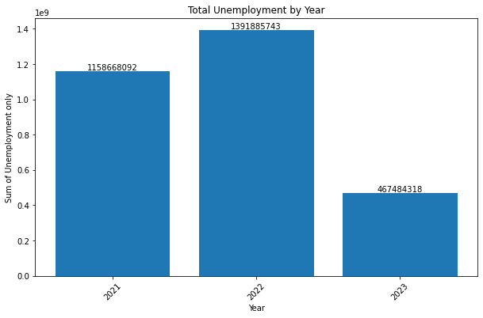

13. Total Inactive(Economically) employment per Region

Code:
econo_inactive = empdata[['Region','Economically inactive']]
econo_inactive_region = econo_inactive.groupby(['Region']).sum()
print(econo_inactive_region)

plt.figure(figsize=(10, 6))
plt.bar(range(len(econo_inactive_region)), econo_inactive_region["Economically inactive"])
plt.xlabel("Region")
plt.ylabel("Sum of Inactive employment)")
plt.title("Total Inactive Employment by Region")
plt.xticks(range(len(econo_inactive_region)), econo_inactive_region.index, rotation=45)

# Adding data labels
for i, Total in enumerate(econo_inactive_region["Economically inactive"]):
plt.text(i, Total, str(Total), ha='center', va='bottom')
plt.show()

Chart:
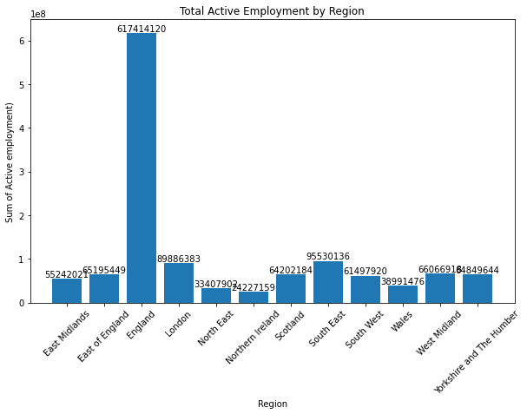

14. Total Inactive(Economically) employment per year
Code:
econo_inactive1 = empdata[['Year','Region','Economically inactive']]
econo_inactive_year = econo_inactive1.groupby(['Year']).sum()
print(econo_inactive_year)

plt.figure(figsize=(10, 6))
plt.bar(range(len(econo_inactive_year)), econo_inactive_year["Economically inactive"])
plt.xlabel("Year")
plt.ylabel("Sum of Inactive employment")
plt.title("Total Inactive employment by Year")
plt.xticks(range(len(econo_inactive_year)), econo_inactive_year.index, rotation=45)

# Adding data labels
for i, Total in enumerate(econo_inactive_year["Economically inactive"]):
plt.text(i, Total, str(Total), ha='center', va='bottom')
plt.show()

Chart:
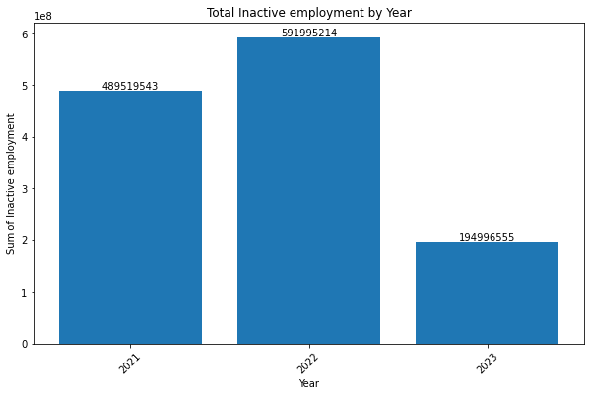

15. Total employment which includes unemployment and employment with the following constrains 1. Age = All aged 16 & over per year

Code:
totalempage = empdata.loc[(empdata['Age'] == 'All aged 16 & over'),['Year','Total']]
totalempage_year = totalempage.groupby(['Year']).sum()
print(totalempage_year)

plt.figure(figsize=(10, 6))
plt.bar(range(len(totalempage_year)), totalempage_year["Total"])
plt.xlabel("Year")
plt.ylabel("Sum of employment")
plt.title("Total employment with all aged 16 and over per Year")
plt.xticks(range(len(totalempage_year)), totalempage_year.index, rotation=45)

# Adding data labels
for i, Total in enumerate(totalempage_year["Total"]):
plt.text(i, Total, str(Total), ha='center', va='bottom')
plt.show()

Output:
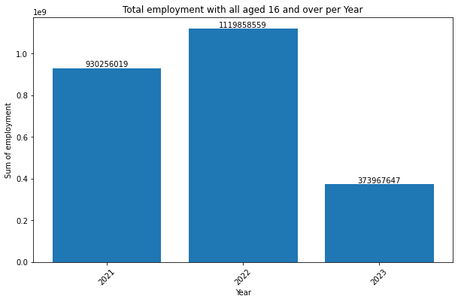

16. Total employment which includes unemployment and employment with the following constrains 1. Age = All aged 16 & over per region

Code:
totalempage = empdata.loc[(empdata['Age'] == 'All aged 16 & over'),['Region','Total']]
totalempage_region = totalempage.groupby(['Region']).sum()
print(totalempage_region)
plt.figure(figsize=(10, 6))
plt.bar(range(len(totalempage_region)), totalempage_region["Total"])
plt.xlabel("Region")
plt.ylabel("Sum of employment)")
plt.title("Total employment with all aged 16 and over per region")
plt.xticks(range(len(totalempage_region)), totalempage_region.index, rotation=45)

# Adding data labels
for i, Total in enumerate(totalempage_region["Total"]):
plt.text(i, Total, str(Total), ha='center', va='bottom')
plt.show()

Output:
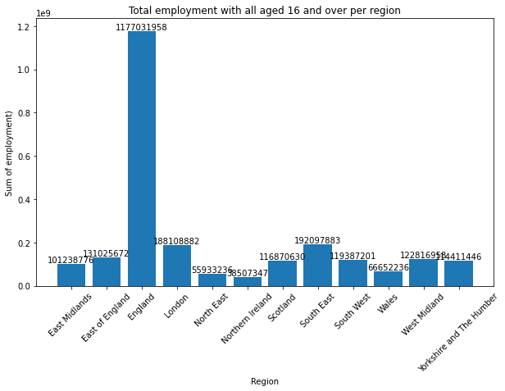

17. Total Unemployment with all aged 16 & over per region
Code:
totalunempage = empdata.loc[(empdata['Age'] == 'All aged 16 & over'),['Region','Unemployed']]
totalunempage_region = totalunempage.groupby(['Region']).sum()
print(totalunempage_region)

plt.figure(figsize=(10, 6))
plt.bar(range(len(totalunempage_region)), totalunempage_region["Unemployed"])
plt.xlabel("Region")
plt.ylabel("Sum of Unemployment)")
plt.title("Total Unemployment with all aged 16 and over per region")
plt.xticks(range(len(totalunempage_region)), totalunempage_region.index, rotation=45)

# Adding data labels
for i, Total in enumerate(totalunempage_region["Unemployed"]):
plt.text(i, Total, str(Total), ha='center', va='bottom')
plt.show()

Chart:
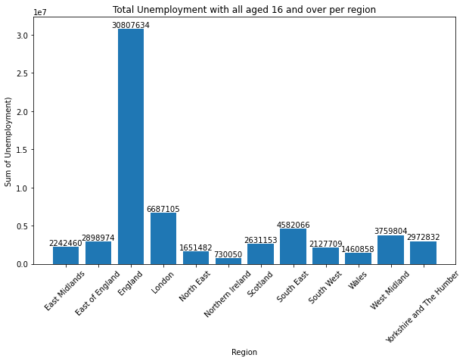

Total Unemployment with all aged 16 & over per Year

Code:
totalunempage = empdata.loc[(empdata['Age'] == 'All aged 16 & over'),['Year','Unemployed']]
totalunempage_year = totalunempage.groupby(['Year']).sum()
print(totalunempage_year)

plt.figure(figsize=(10, 6))
plt.bar(range(len(totalunempage_year)), totalunempage_year["Unemployed"])
plt.xlabel("Year")
plt.ylabel("Sum of Unemployment")
plt.title("Total Unemployment with all aged 16 and over per Year")
plt.xticks(range(len(totalunempage_year)), totalunempage_year.index, rotation=45)

# Adding data labels
for i, Total in enumerate(totalunempage_year["Unemployed"]):
plt.text(i, Total, str(Total), ha='center', va='bottom')
plt.show()
Chart:
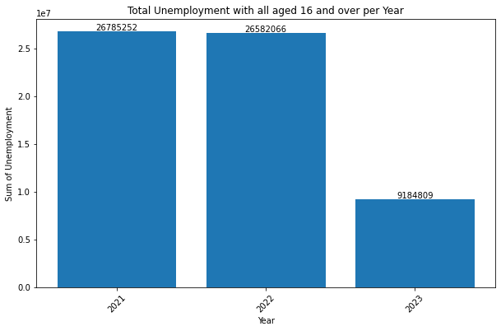

Total Active employment with all aged 16 & over per Year

Code:
totalempageActive = empdata.loc[(empdata['Age'] == 'All aged 16 & over'),['Year','Total economically active']]
totalempageActive_year = totalempageActive.groupby(['Year']).sum()
print(totalempageActive_year)

plt.figure(figsize=(10, 6))
plt.bar(range(len(totalempageActive_year)), totalempageActive_year["Total economically active"])
plt.xlabel("Year")
plt.ylabel("Sum of Active employment")
plt.title("Total Active employment with all aged 16 and over per Year")
plt.xticks(range(len(totalempageActive_year)), totalempageActive_year.index, rotation=45)

# Adding data labels
for i, Total in enumerate(totalempageActive_year["Total economically active"]):
plt.text(i, Total, str(Total), ha='center', va='bottom')
plt.show()
Chart:
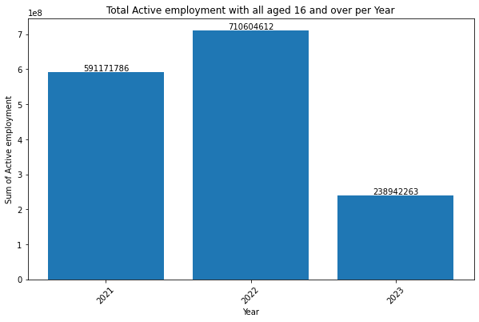

20.Total Active employment with all aged 16 & over per region
Code:
totalempageActive = empdata.loc[(empdata['Age'] == 'All aged 16 & over'),['Region','Total economically active']]
totalempageActive_region = totalempageActive.groupby(['Region']).sum()
print(totalempageActive_region)

plt.figure(figsize=(10, 6))
plt.bar(range(len(totalempageActive_region)), totalempageActive_region["Total economically active"])
plt.xlabel("Region")
plt.ylabel("Sum of Active employment")
plt.title("Total Active employment with all aged 16 and over per region")
plt.xticks(range(len(totalempageActive_region)), totalempageActive_region.index, rotation=45)

# Adding data labels
for i, Total in enumerate(totalempageActive_region["Total economically active"]):
plt.text(i, Total, str(Total), ha='center', va='bottom')

plt.show()
Chart:
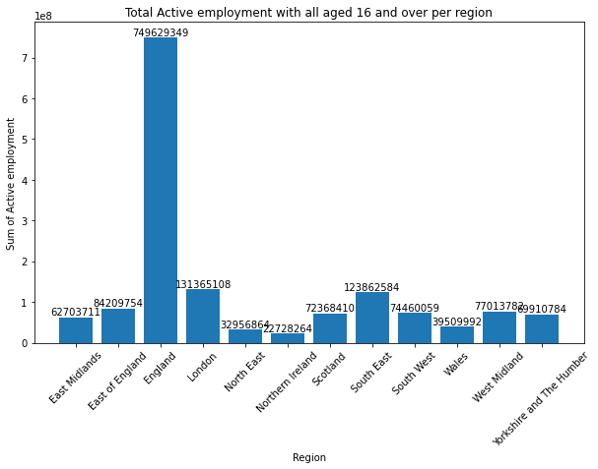

21. Total Inactive employment with all aged 16 & over per year

Code:
totalempageInactive = empdata.loc[(empdata['Age'] == 'All aged 16 & over'),['Year','Economically inactive']]
totalempageInactive_year = totalempageInactive.groupby(['Year']).sum()
print(totalempageInactive_year)

plt.figure(figsize=(10, 6))
plt.bar(range(len(totalempageInactive_year)), totalempageInactive_year["Economically inactive"])
plt.xlabel("Year")
plt.ylabel("Sum of Active employment")
plt.title("Total Active employment with all aged 16 and over per Year")
plt.xticks(range(len(totalempageInactive_year)), totalempageInactive_year.index, rotation=45)

# Adding data labels
for i, Total in enumerate(totalempageInactive_year["Economically inactive"]):
plt.text(i, Total, str(Total), ha='center', va='bottom')

plt.show()

Chart:
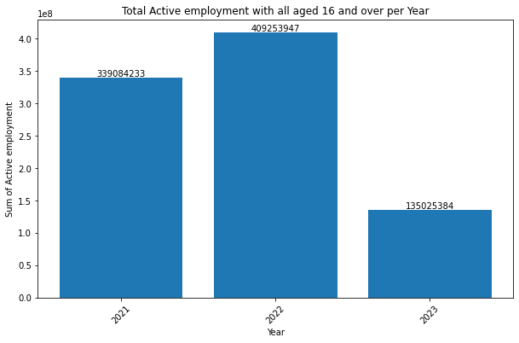

22. Total Inactive employment with all aged 16 & over per region
Code:
totalempageInactive = empdata.loc[(empdata['Age'] == 'All aged 16 & over'),['Region','Economically inactive']]
totalempageInactive_region = totalempageInactive.groupby(['Region']).sum()
print(totalempageInactive_region)

plt.figure(figsize=(10, 6))
plt.bar(range(len(totalempageInactive_region)), totalempageInactive_region["Economically inactive"])
plt.xlabel("Region")
plt.ylabel("Sum of Inactive employment")
plt.title("Total Inactive employment with all aged 16 and over per region")
plt.xticks(range(len(totalempageInactive_region)), totalempageInactive_region.index, rotation=45)

# Adding data labels
for i, Total in enumerate(totalempageInactive_region["Economically inactive"]):
plt.text(i, Total, str(Total), ha='center', va='bottom')

plt.show()
Output:
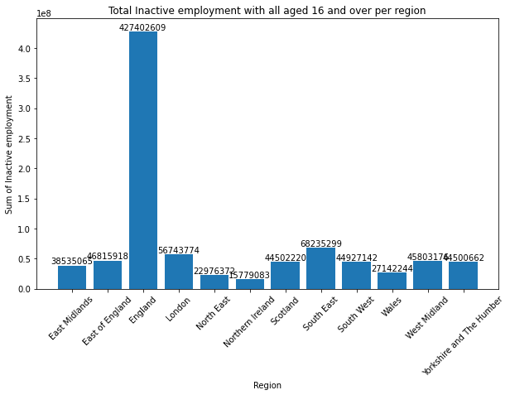

- Maximum employment in total per region
Code:
import matplotlib.pyplot as plt
maxemployment = empdata.groupby(['Region'])['Total'].max().reset_index(name='max')
print(maxemployment)
#plot chart
plt.figure(figsize=(10, 6))
plt.bar(range(len(maxemployment)), maxemployment["max"])
plt.xlabel("Region")
plt.ylabel("Sum of Inactive employment")
plt.title("Maximum employment per region")
plt.xticks(range(len(maxemployment)), maxemployment.index, rotation=45)

# Adding data labels
for i, Total in enumerate(maxemployment["max"]):
plt.text(i, Total, str(Total), ha='center', va='bottom')

plt.show()
Output:
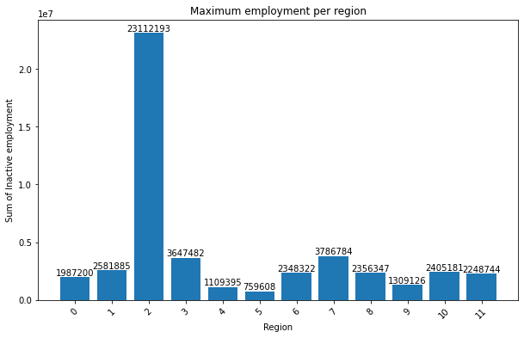

24. # Maximum employment which includes employment and unemployment in UK
Code:
maxemp = empdata.sort_values(by='Total', ascending=False)[['Region', 'Total']]
maxemp_region = maxemp.head(1)
print(maxemp_region)

Output:
Region Total
209 England 23112193

25. Maximum employment region in UK

Code:
maxemp = empdata.sort_values(by='Total in employment', ascending=False)[['Region', 'Total in employment']]
maxemp_region = maxemp.head(1)
print(maxemp_region)
Output:
Region Total in employment
208 England 14786648

26. Maximum Unemployed region in UK

Code:
Total_unemployment = empdata[['Region','Unemployed']]
Total_unemply_Region = Total_unemployment.groupby(['Region']).sum().reset_index()
maxunemp = Total_unemply_Region.sort_values(by='Unemployed', ascending=False)[['Region', 'Unemployed']]
maxunemp_region = maxunemp.head(1)
print(maxunemp_region)
Output:
Region Unemployed
2 England 60930066

27. Maximum Active employment region in UK

Code:
totalempageActive = empdata.loc[(empdata['Age'] == 'All aged 16 & over'),['Region','Total economically active']]
totalempageActive_region = totalempageActive.groupby(['Region']).sum().reset_index()
maxempActive = totalempageActive_region.sort_values(by='Total economically active', ascending=False)[['Region','Total economically active']]
maxempActive_region = maxempActive.head(1)
print(maxempActive_region)

Output:
Region Total economically active
2 England 749629349

28. Maximum Inactive employment region in UK

Code:
totalempageInactive = empdata.loc[(empdata['Age'] == 'All aged 16 & over'),['Region','Economically inactive']]
totalempageInactive_region = totalempageInactive.groupby(['Region']).sum().reset_index()
maxempInactive = totalempageInactive_region.sort_values(by='Economically inactive', ascending=False)[['Region','Economically inactive']]
maxempInactive_region = maxempInactive.head(1)
print(maxempInactive_region)
Output:
Region Economically inactive
2 England 427402609

29. Maximum Active employment region with all age 16 to 64 in UK

Code:
totalempageActive_age = empdata.loc[(empdata['Age'] == 'All aged 16 to 64'),['Region','Total economically active']]
totalempageActive_age_region = totalempageActive_age.groupby(['Region']).sum().reset_index()
maxempActive_age = totalempageActive_age_region.sort_values(by='Total economically active', ascending=False)[['Region','Total economically active']]
maxempActive_age_region = maxempActive_age.head(1)
print(maxempActive_age_region)
Output:
Region Total economically active
2 England 718962066

30. Maximum Inactive employment region with all age 16 to 64 in UK

Code:
totalempageInactive_age = empdata.loc[(empdata['Age'] == 'All aged 16 to 64'),['Region','Economically inactive']]
totalempageInactive_age_region = totalempageInactive_age.groupby(['Region']).sum().reset_index()
maxempInactive_age = totalempageInactive_age_region.sort_values(by='Economically inactive', ascending=False)[['Region','Economically inactive']]
maxempInactive_age_region = maxempInactive_age.head(1)
print(maxempInactive_age_region)

Output:
Region Economically inactive
2 England 190011511

Insights:

Based on the analysis of the dataset, it is observed that the region of England consistently stands out in various aspects of employment. Here are some insights regarding England:
Maximum Total: England has the highest total employment count among all regions in the UK. This indicates a larger workforce and economic activity in England compared to other regions.
Maximum Total economically active: England also has the highest count of economically active individuals, including both the employed and unemployed. This suggests a higher labor force participation rate in England.
Maximum Total in employment: England has the highest count of individuals in employment. This implies a higher rate of job opportunities and a robust employment market in England.
Maximum Unemployed: While having a higher employment count, England also has a higher count of unemployed individuals. This highlights the existence of job seekers and challenges in achieving full employment in the region.
These insights suggest that England, being the largest and most populous region in the UK, exhibits notable characteristics in terms of employment and labor market dynamics. While it demonstrates higher employment and economic activity, it also faces challenges associated with unemployment and economic inactivity. Understanding these trends can inform policymakers and stakeholders in formulating strategies to address employment issues and promote inclusive growth in England.

