Data Set: Employment World
Overview of the Dataset:

Certainly! Based on the variables you provided, here's an overview of the dataset:

- Region/Country/Area: This variable represents the region, country, or area to which the employment data pertains. It provides information about the geographic location or region of the employment statistics.

- Countries: This variable specifies the countries included in the dataset. It helps identify the specific countries for which employment data is recorded.

- Year: The Year variable indicates the calendar year to which the employment data corresponds. It allows for analyzing trends and changes in employment over different years.

- Series: This variable represents the specific series or category of employment data being measured. It could include various aspects of employment, such as total employment, unemployment rates, labor force participation, specific industries, or occupational groups.

- Department: The Department variable indicates the relevant department or agency responsible for collecting and reporting the employment data. It provides information about the source of the data.

- Gender: This variable categorizes the employment data based on gender, distinguishing between male and female. It allows for analyzing gender-specific employment trends and patterns.

- Value: The Value variable represents the numeric value or measurement of the specific employment data point. It could represent the number of employed individuals, unemployment rates, or other relevant metrics depending on the Series variable.

- Footnotes: This variable includes any additional footnotes or comments associated with the employment data. It may provide explanations, qualifications, or references related to specific data points.

- Source: The origin of the data is from International Labour Organization (ILO), Geneva, Key Indicators of the Labour Market (KILM 9th edition) and the ILOSTAT database, last accessed January 2020.

This dataset allows for analyzing employment trends, patterns, and characteristics across different regions, countries, years, series categories, and gender groups. By examining the Value variable within each series category, it is possible to gain insights into the specific employment metrics and understand the dynamics of the labor market in different regions and countries.

Total Rows: 13471
Total Columns: 09

Overview of the Tool Used: Python
Python is a versatile and widely used programming language that is extensively utilized for data analysis, including the analysis of the "Telecom Users" dataset.:
- Versatile and Easy to Use
- Abundance of Libraries
- Data Manipulation and Exploration
- Data Visualization
- Machine Learning and Statistical Analysis
- Integration and Collaboration
- Scalability and Performance
Overview of Libraries Used:
- Numpy:
- Numpy is a powerful numerical computing library in Python.
- It provides support for large, multi-dimensional arrays and matrices, along with a collection of mathematical functions to operate on these arrays efficiently.
- It is widely used for tasks involving numerical computations, data manipulation, and scientific computing.
- It offers various functionalities such as array creation, indexing, slicing, mathematical operations, linear algebra operations, random number generation, and more.
- Numpy is known for its performance and optimized algorithms, making it a fundamental library for data analysis and scientific computing in Python.
- Pandas:
- Pandas is a versatile data manipulation and analysis library in Python.
- It provides powerful data structures, such as Data Frames and Series, which allow for efficient handling and analysis of structured data.
- Pandas excels in data cleaning, transformation, merging, reshaping, and aggregation tasks.
- It offers a wide range of functions and methods for data exploration, data pre-processing, and data wrangling.
- Pandas is extensively used in data analysis, data pre-processing, and data preparation workflows, as well as in data visualization and statistical analysis.
Matplotlib:
Matplotlib is a popular plotting library in Python.
- It provides a comprehensive set of tools for creating static, animated, and interactive visualizations in Python.
- Matplotlib enables the creation of various types of plots, including line plots, scatter plots, bar plots, histograms, pie charts, and more.
- It offers a high level of customization and control over plot elements such as axes, labels, colors, markers, and legends.
- Matplotlib is widely used for data visualization, exploration, and presentation purposes in scientific, statistical, and data analysis projects.
Seaborn:
- Seaborn is a statistical data visualization library built on top of Matplotlib.
- It provides a higher-level interface for creating attractive and informative statistical graphics.
- Seaborn simplifies the process of creating complex plots, such as heatmaps, violin plots, box plots, and cluster maps, with just a few lines of code.
- It offers a wide range of built-in themes and color palettes that enhance the visual appeal of the plots.
- Seaborn also provides functions for advanced statistical visualizations, such as regression plots, distribution plots, and categorical plots.
- It is commonly used in exploratory data analysis, statistical modeling, and data-driven storytelling.

Summary
 | Region/Country/Area | Year | Value
count | 13471.000000 | 13471.000000 | 13471.000000
mean | 395.848341 | 2012.223369 | 34.072012
std | 266.122183 | 5.653000 | 26.718278
min | 1.000000 | 2000.000000 | 0.008000
25% | 152.000000 | 2005.000000 | 9.178000
50% | 392.000000 | 2010.000000 | 27.147000
75% | 626.000000 | 2015.000000 | 57.844000
max | 894.000000 | 2020.000000 | 98.515000

Question 1.

1.Top 5 employment count per Country
Code:
# Create a bar plot
import matplotlib.pyplot as plt
empcountry1 = empdf['Countries'].value_counts()
empcountry1=empcountry1.head(5)
#Bar Plot
plt.figure(figsize=(10, 6))
empcountry1.plot(kind='bar')
plt.xlabel('Composite Land Use Type')
plt.ylabel('Count')
plt.title('Distribution of Composite Land Use Types')
plt.xticks(rotation=45)
plt.show()

Output:
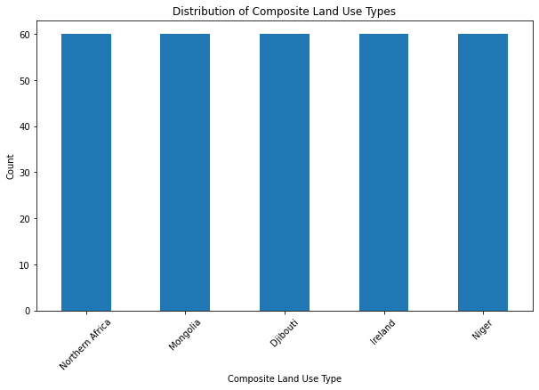

2.Top 5 Countries count per year
Code:
empcountry2 = empdf[['Countries','Year']]
empcountry2_year = empcountry2.groupby(['Year']).count()
emp_country_count_order=empcountry2_year.sort_values(by='Countries', ascending = False)
emp_country_count_top5 = emp_country_count_order.head(5)
print(emp_country_count_top5)

Output:

Year
2010 3318
2005 3314
2015 3189
2020 3189
2001 91

Employment count per department
Code:
emp_dept_count = empdf['Department'].value_counts()
print(emp_dept_count)

Output:
Year
2010 3318
2005 3314
2015 3189
2020 3189
2001 91

4.Employment count per department
Code:
emp_dept_count = empdf['Department'].value_counts()
print(emp_dept_count)

Output:
Dept not Specified 5506
Industry 2656
Services 2656
Agriculture 2653

5.Employment Count in all the departments at Northern Africa per Year
Code:
empdf3=empdf.loc[(empdf['Countries']=='Northern Africa'),['Year', 'Department']]
emp_country_year = empdf3.groupby(['Year']).count()
print(emp_country_year)

Output:
Year
2005 15
2010 15
2015 15
2020 15

6.Employment Count in Service deparment at Northern Africa per Year
Code:
empdf3=empdf.loc[(empdf['Countries']=='Northern Africa') & (empdf['Department']=='Services'),['Year', 'Department']]
emp_country_year = empdf3.groupby(['Year']).count()
print(emp_country_year)

Output:
Year
2005 15
2010 15
2015 15
2020 15

7.Employment Count in Agriculture deparment at Northern Africa per Year
Code:
empdf3=empdf.loc[(empdf['Countries']=='Northern Africa') & (empdf['Department']=='Agriculture'),['Year', 'Department']]
emp_country_year = empdf3.groupby(['Year']).count()
print(emp_country_year)

Output:
Year
2005 3
2010 3
2015 3
2020 3

8.Employment Count is not in any department at Northern Africa Code:

per Year
Code:
empdf3=empdf.loc[(empdf['Countries']=='Northern Africa') & (empdf['Department']=='Dept not Specified'),['Year', 'Department']]
emp_country_year = empdf3.groupby(['Year']).count()
print(emp_country_year)

Output:
Year
2005 3
2010 3
2015 3
2020 3

9. Employment Count in all the deparments at Mongolia per Year
Code:
empdf_mongolia=empdf.loc[(empdf['Countries']=='Mongolia'),['Year', 'Department']]
emp_mangolia_year = empdf_mongolia.groupby(['Year']).count()
print(emp_mangolia_year)

Output:
Year
2005 15
2010 15
2015 15
2020 15

10.Employment Count in the deparment of Industry at Mongolia per Year

Code:
empdf_mongolia=empdf.loc[(empdf['Countries']=='Mongolia') & (empdf['Department']=='Industry'),['Year', 'Department']]
emp_mangolia_year = empdf_mongolia.groupby(['Year']).count()
print(emp_mangolia_year)

Output:
Year
2005 3
2010 3
2015 3
2020 3

11.Employment Count in all the deparments at Ireland per Year
Code:
empdf_ireland=empdf.loc[(empdf['Countries']=='Ireland'),['Year', 'Department']]
empdf_ireland_year = empdf_ireland.groupby(['Year']).size().reset_index(name='count')
#Bar Plot
plt.figure(figsize=(10, 6))
plt.bar(range(len(empdf_ireland_year)), empdf_ireland_year['count'])
plt.xlabel('Year')
plt.ylabel('Count')
plt.title('Employment Count in all the deparments at Ireland per Year')
plt.xticks(range(len(empdf_ireland_year)), empdf_ireland_year['Year'], rotation=45)
plt.show()
Output:
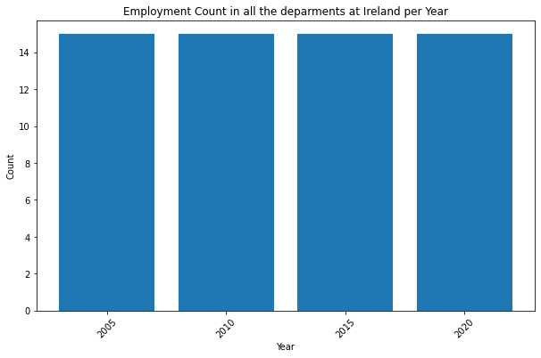

- Employment Count in the deparment of Industry at Ireland per Year
Code:
empdf_ireland_indus=empdf.loc[(empdf['Countries']=='Ireland') & (empdf['Department']=='Industry'),['Year', 'Department']]
empdf_ireland_indus_year = empdf_ireland_indus.groupby(['Year']).size().reset_index(name='count')
print(empdf_ireland_indus_year)
#Bar Plot
plt.figure(figsize=(10, 6))
plt.bar(range(len(empdf_ireland_indus_year)), empdf_ireland_indus_year['count'])
plt.xlabel('Year')
plt.ylabel('Count')
plt.title('Employment Count in the deparment of Industry at Ireland per Year')
plt.xticks(range(len(empdf_ireland_indus_year)), empdf_ireland_indus_year['Year'], rotation=45)
plt.show()

Output:
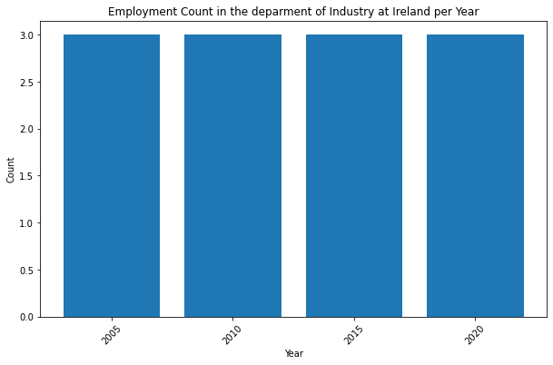
- Employment Count in all the deparments at Western Europe per Year

Code:
empdf_westernerope=empdf.loc[(empdf['Countries']=='Western Europe'),['Year', 'Department']]
empdf_westernerope_year = empdf_westernerope.groupby(['Year']).size().reset_index(name='count')
print(empdf_westernerope_year)
#Bar Plot
plt.figure(figsize=(10, 6))
plt.bar(range(len(empdf_westernerope_year)), empdf_westernerope_year['count'])
plt.xlabel('Year')
plt.ylabel('Count')
plt.title('Employment Count in all the deparments at Western Europe per Year')
plt.xticks(range(len(empdf_westernerope_year)), empdf_westernerope_year['Year'], rotation=45)
plt.show()

Output:
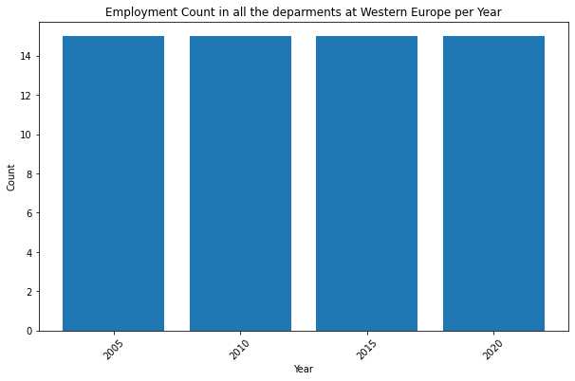

14.Employment Count in the department of Industry at Western Europe per Year
Code:
empdf_westernerope_indus=empdf.loc[(empdf['Countries']=='Western Europe') & (empdf['Department']=='Industry'),['Year', 'Department']]
empdf_westernerope_indus_year = empdf_westernerope_indus.groupby(['Year']).size().reset_index(name='count')
print(empdf_westernerope_indus_year)
#Bar Plot
plt.figure(figsize=(10, 6))
plt.bar(range(len(empdf_westernerope_indus_year)), empdf_westernerope_indus_year['count'])
plt.xlabel('Year')
plt.ylabel('Count')
plt.title('Employment Count in the deparment of Industry at Western Europe per Year')
plt.xticks(range(len(empdf_westernerope_indus_year)), empdf_westernerope_indus_year['Year'], rotation=45)
plt.show()

Output:
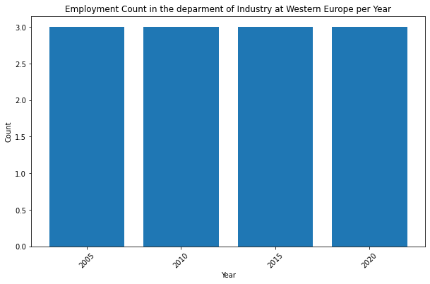

15.Top 5 employment in Labour Force participation per year
Code:
empdf_count=empdf.loc[(empdf['Series'] =="Labour force participation"),['Countries','Year']]
empdf_count_year=empdf_count.groupby('Year').size().reset_index(name='count')
empdf_count_year_order = empdf_count_year.sort_values(by='count', ascending=False)
empdf_count_year_order_top5=empdf_count_year_order.head(5)
print(empdf_count_year_order_top5)
#Bar Plot
plt.figure(figsize=(10, 6))
plt.bar(range(len(empdf_count_year_order_top5)), empdf_count_year_order_top5['count'])
plt.xlabel('Year')
plt.ylabel('Count')
plt.title('Top 5 employment in Labour Force participation per year')
plt.xticks(range(len(empdf_count_year_order_top5)), empdf_count_year_order_top5['Year'], rotation=45)
plt.show()

Output:
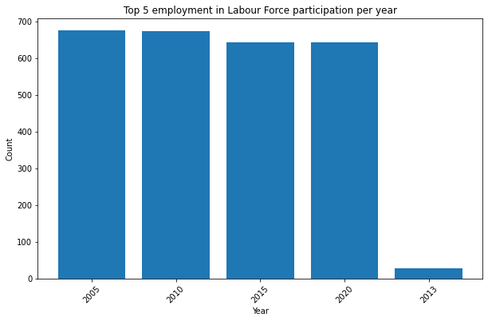

16.Top 5 employment in Employment by industry per year
Code:
empdf_indus=empdf.loc[(empdf['Series'] =="Employment by industry"),['Countries','Year']]
empdf_indus_year=empdf_indus.groupby('Year').size().reset_index(name='count')
empdf_indus_year_order = empdf_indus_year.sort_values(by='Year', ascending=False)
empdf_indus_year_order_top5=empdf_indus_year_order.head(5)
print(empdf_indus_year_order_top5)
#Bar Plot
plt.figure(figsize=(10, 6))
plt.bar(range(len(empdf_indus_year_order_top5)), empdf_indus_year_order_top5['count'])
plt.xlabel('Year')
plt.ylabel('Count')
plt.title('Top 5 employment in Employment by industry per year')
plt.xticks(range(len(empdf_indus_year_order_top5)), empdf_indus_year_order_top5['Year'], rotation=45)
plt.show()
Output:
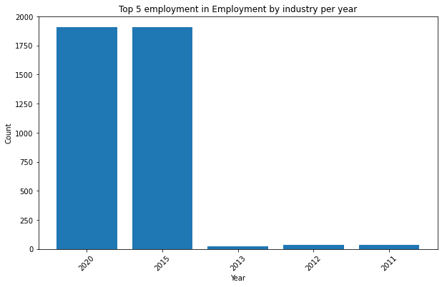

17.Top 5 Male and Female employment per Country
Code:
empdf_count=empdf.loc[(empdf['Gender'] =="Male and Female"),['Countries','Year']]
empdf_count_malefemale=empdf_count.groupby('Countries').size().reset_index(name='count')
empdf_count_malefemale_order = empdf_count_malefemale.sort_values(by='Countries', ascending=True)
empdf_count_malefemale_order_top5=empdf_count_malefemale_order.head(5)
print(empdf_count_malefemale_order_top5)
#Bar Plot
plt.figure(figsize=(10, 6))
plt.bar(range(len(empdf_count_malefemale_order_top5)), empdf_count_malefemale_order_top5['count'])
plt.xlabel('Countries')
plt.ylabel('Count')
plt.title('Top 5 Male and Female employment per Country')
plt.xticks(range(len(empdf_count_malefemale_order_top5)), empdf_count_malefemale_order_top5['Countries'], rotation=45)
plt.show()

Output:
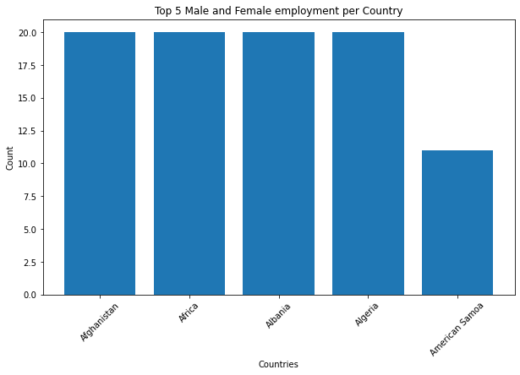

18.Top 5 Female employment per Country
Code:
empdf_count_female=empdf.loc[(empdf['Gender'] =="Female"),['Countries','Year']]
empdf_count_female_country=empdf_count_female.groupby('Countries').size().reset_index(name='count')
empdf_count_female_country_order = empdf_count_female_country.sort_values(by='Countries', ascending=True)
empdf_count_female_country_order_top5=empdf_count_female_country_order.head(5)
print(empdf_count_female_country_order_top5)
#Bar Plot
plt.figure(figsize=(10, 6))
plt.bar(range(len(empdf_count_female_country_order_top5)), empdf_count_female_country_order_top5['count'])
plt.xlabel('Countries')
plt.ylabel('Count')
plt.title('Top 5 Female employment per Country')
plt.xticks(range(len(empdf_count_female_country_order_top5)), empdf_count_female_country_order_top5['Countries'], rotation=45)
plt.show()

Output:
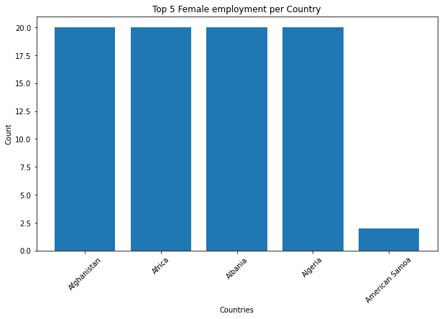

19.Top 5 Male employment per Country
Code:
empdf_count_male=empdf.loc[(empdf['Gender'] =="Male"),['Countries','Year']]
empdf_count_male=empdf_count_male.groupby('Countries').size().reset_index(name='count')
empdf_count_male_order = empdf_count_male.sort_values(by='Countries', ascending=True)
empdf_count_male_order_top5=empdf_count_male_order.head(5)
print(empdf_count_male_order_top5)
#Bar Plot
plt.figure(figsize=(10, 6))
plt.bar(range(len(empdf_count_male_order_top5)), empdf_count_male_order_top5['count'])
plt.xlabel('Countries')
plt.ylabel('Count')
plt.title('Top 5 Male employment per Country')
plt.xticks(range(len(empdf_count_male_order_top5)), empdf_count_male_order_top5['Countries'], rotation=45)
plt.show()

Output:
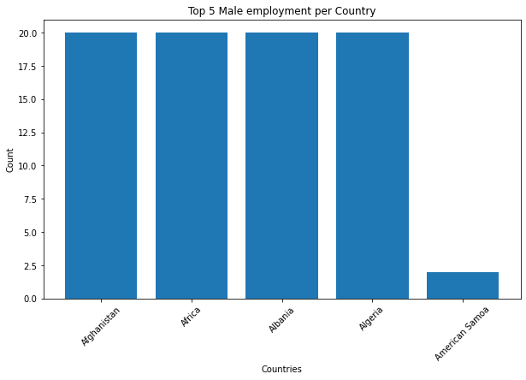
Insight

- The employment count in all the Department in Western Europe and Ireland remained constant at a value of 15 for each of the years 2005, 2010, 2015, and 2020.
- The employment count in the Department of Industry in Western Europe and Ireland remained constant at a value of 3 for each of the years 2005, 2010, 2015, and 2020.
- Afghanistan: The data indicates that there were 20 male, 20 female and 20 male & female individuals employed in Afghanistan.
- Africa: Similarly, the data states that there were 20 male, 20 female and 20 male & female individuals employed in Africa.
- Albania: The dataset suggests that there were 20 male,20 female and 20 male & female individuals employed in Albania.
- Algeria: The data indicates that there were 20 male, 20 female and 20 male & female individuals employed in Algeria.
- American Samoa: According to the provided data, American Samoa had 11 male, 2 female and 2 male & female individuals employed.

In conclusion, while the data provides a glimpse into gender employment figures in these countries.

