Data Set: Trade Commodity from IMF (International Monetary Fund
Overview of the Dataset:
There are 8 variables in the data set:
- Country Name: The name of the country associated with the data. Mentioned ‘World’ in the data set.
- Country Code: A unique code assigned to each country. Mentioed ‘1’ in the data set
- Commodity Name: The name of the commodity for which the data is recorded.
- Commodity Code: A unique code assigned to each commodity.
- Unit Name: The unit of measurement used for the values.
- Unit Code: A unique code assigned to each unit of measurement.
- Time Period: The time period for which the data is recorded.
- Value: The value or measurement associated with the specific commodity and country for the given time period.

This dataset appears to provide information on various commodities over specific time periods. It includes details such as the names and codes of country and commodities, along with the associated values and units of measurement.

Overview of the Tool Used: Python
Python is a versatile and widely used programming language that is extensively utilized for data analysis, including the analysis of the "Telecom Users" dataset.:
- Versatile and Easy to Use
- Abundance of Libraries
- Data Manipulation and Exploration
- Data Visualization
- Machine Learning and Statistical Analysis
- Integration and Collaboration
- Scalability and Performance
Overview of Libraries Used:
- Numpy:
- Numpy is a powerful numerical computing library in Python.
- It provides support for large, multi-dimensional arrays and matrices, along with a collection of mathematical functions to operate on these arrays efficiently.
- It is widely used for tasks involving numerical computations, data manipulation, and scientific computing.
- It offers various functionalities such as array creation, indexing, slicing, mathematical operations, linear algebra operations, random number generation, and more.
- Numpy is known for its performance and optimized algorithms, making it a fundamental library for data analysis and scientific computing in Python.
- Pandas:
- Pandas is a versatile data manipulation and analysis library in Python.
- It provides powerful data structures, such as Data Frames and Series, which allow for efficient handling and analysis of structured data.
- Pandas excels in data cleaning, transformation, merging, reshaping, and aggregation tasks.
- It offers a wide range of functions and methods for data exploration, data pre-processing, and data wrangling.
- Pandas is extensively used in data analysis, data pre-processing, and data preparation workflows, as well as in data visualization and statistical analysis.
Matplotlib:
Matplotlib is a popular plotting library in Python.
- It provides a comprehensive set of tools for creating static, animated, and interactive visualizations in Python.
- Matplotlib enables the creation of various types of plots, including line plots, scatter plots, bar plots, histograms, pie charts, and more.
- It offers a high level of customization and control over plot elements such as axes, labels, colors, markers, and legends.
- Matplotlib is widely used for data visualization, exploration, and presentation purposes in scientific, statistical, and data analysis projects.
Seaborn:
- Seaborn is a statistical data visualization library built on top of Matplotlib.
- It provides a higher-level interface for creating attractive and informative statistical graphics.
- Seaborn simplifies the process of creating complex plots, such as heatmaps, violin plots, box plots, and cluster maps, with just a few lines of code.
- It offers a wide range of built-in themes and color palettes that enhance the visual appeal of the plots.
- Seaborn also provides functions for advanced statistical visualizations, such as regression plots, distribution plots, and categorical plots.
- It is commonly used in exploratory data analysis, statistical modeling, and data-driven storytelling.

Summary

 | Country Code | Value
count | 216220.0 | 216220.000000
mean | 1.0 | 441.331333
std | 0.0 | 5569.869719
min | 1.0 | -77.776723
25% | 1.0 | 0.000000
50% | 1.0 | 19.359054
75% | 1.0 | 96.540964
max | 1.0 | 490008.179000

Q1:Commodity with highest price index per year
Code:
# Extracting the necessary data for plotting
years = commodity_highest_price.index
values = commodity_highest_price['Value']
# Plotting the graph
plt.figure(figsize=(20, 6))
plt.bar(years, values)
plt.xlabel('Year')
plt.ylabel('Highest Price')
plt.title('Commodity with Highest Price Index per Year')
plt.xticks(rotation=45)
plt.tight_layout()
plt.show()

Output:
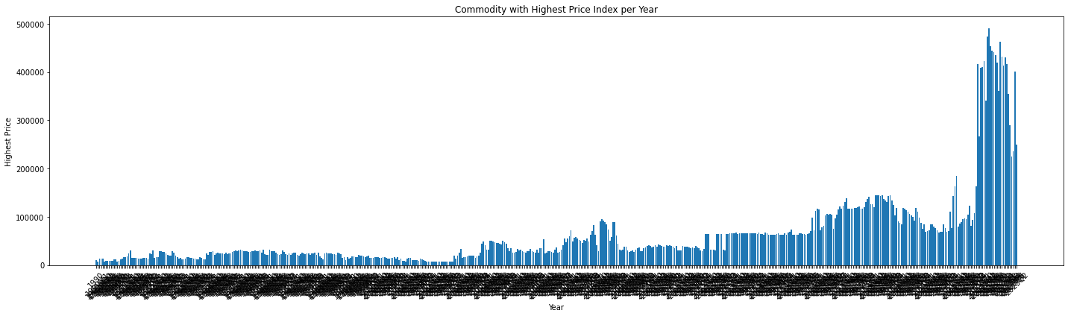
Q2:Commodity with lowest price index per year
Code:
# Assuming you have already executed the code you provided and obtained `commodity_lowest_price` dataframe

# Extracting the necessary data for plotting
years = commodity_lowest_price.index
values = commodity_lowest_price['Value']
commodities = commodity_lowest_price['Commodity Name']

# Plotting the graph
plt.figure(figsize=(10, 6))
plt.bar(years, values)
plt.xlabel('Year')
plt.ylabel('Lowest Price')
plt.title('Commodity with Lowest Price Index per Year')
plt.xticks(rotation=45)

# Adding labels to the bars
#for i, value in enumerate(values):
# plt.text(i, value, commodities[i], ha='center', va='bottom')

plt.tight_layout()
plt.show()
Output:
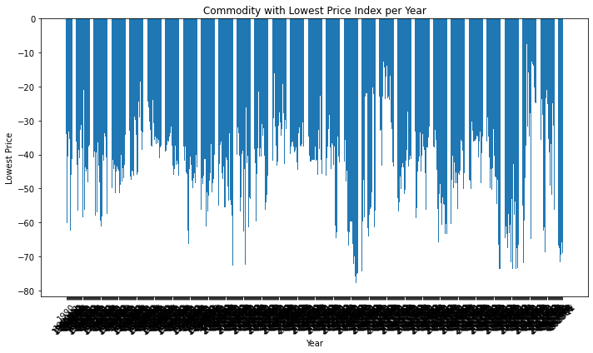
Q3:Average Price Index for Commodity: Coal
Code:
# Specify the desired time periods using regular expressions
selected_patterns_coal = ['Coal']

# Filter the dataframe for the specified patterns
data_coal = pcpdf[pcpdf['Commodity Name'].str.contains('|'.join(selected_patterns_coal))]
avg_coal_data = data_coal['Value'].mean()

# Print the average price index for 'Coal'
print("Average Price Index for Commodity: Coal")
print(avg_coal_data)

Output:
Average Price Index for Commodity: Coal
45.672502107215344

Q4:Average Price Index for Commodity: Copper
Code:
# Specify the desired time periods using regular expressions
selected_patterns_copper = ['Copper']

# Filter the dataframe for the specified patterns
data_copper = pcpdf[pcpdf['Commodity Name'].str.contains('|'.join(selected_patterns_copper))]
avg_copper_data = data_copper['Value'].mean()

# Print the average price index for 'Copper'
print("Average Price Index for Commodity: Copper")
print(avg_copper_data)

Output:
Average Price Index for Commodity: Copper
1202.7810288390865

Q5:Average Price Index for Commodity: Rubber
Code:
# Specify the desired time periods using regular expressions
selected_patterns_Rubber = ['Rubber']

# Filter the dataframe for the specified patterns
data_rubber = pcpdf[pcpdf['Commodity Name'].str.contains('|'.join(selected_patterns_Rubber))]
avg_rubberr_data = data_rubber['Value'].mean()

# Print the average price index for 'Coal'
print("Average Price Index for Commodity: Rubber")
print(avg_rubberr_data)

Output:
Average Price Index for Commodity: Rubber
46.30355432640859

Q6:Identify the type of Coffee with highest price index for the most recent year
Code:
# Filter the dataset for the most recent year
most_recent_year = pcpdf['Time Period'].max()
recent_year_data = pcpdf[pcpdf['Time Period'] == most_recent_year]

# Find the type of coffee with the highest price index
coffee_highest_price = recent_year_data[recent_year_data['Commodity Name'].str.contains('Coffee')]
coffee_highest_price = coffee_highest_price.loc[coffee_highest_price['Value'].idxmax()]

# Extract the type of coffee and the highest price index
coffee_type = coffee_highest_price['Commodity Name']
highest_price_index = coffee_highest_price['Value']

# Print the type of coffee with the highest price index for the most recent year
print("Type of Coffee with Highest Price Index for the Most Recent Year:")
print("Coffee Type:", coffee_type)
print("Highest Price Index:", highest_price_index)

Output:
Type of Coffee with Highest Price Index for the Most Recent Year:
Coffee Type: Coffee, Other Mild Arabica
Highest Price Index: 219.15393480000003

Q7:Identify the type of Crude Oil with highest price index for the most recent year
Code:
# Filter the dataset for the most recent year
most_recent_year = pcpdf['Time Period'].max()
recent_year_data = pcpdf[pcpdf['Time Period'] == most_recent_year]

# Find the type of crude oil with the highest price index
crude_oil_highest_price = recent_year_data[recent_year_data['Commodity Name'].str.contains('Crude')]
crude_oil_highest_price = crude_oil_highest_price.loc[crude_oil_highest_price['Value'].idxmax()]

# Extract the type of crude oil and the highest price index
crude_oil_type = crude_oil_highest_price['Commodity Name']
highest_price_index = crude_oil_highest_price['Value']

# Print the type of crude oil with the highest price index for the most recent year
print("Type of Crude Oil with Highest Price Index for the Most Recent Year:")
print("Crude Oil Type:", crude_oil_type)
print("Highest Price Index:", highest_price_index)
Output:
Type of Crude Oil with Highest Price Index for the Most Recent Year:
Crude Oil Type: Dubai Crude
Highest Price Index: 187.22556840000001

Additional Summary
- Commodity with Top 5 Highest Price Index
Code:
# Sort the dataframe by lowest price in ascending order
highest_price_sorted = commodity_highest_price.sort_values('Value')

# Select the top 5 years with the lowest price indices
top_5_years = highest_price_sorted.head(5)

# Extract the necessary data for plotting
years = top_5_years.index
values = top_5_years['Value']
commodities = top_5_years['Commodity Name']

# Print the top 5 years with corresponding values and commodity names
for year, value, commodity in zip(years, values, commodities):
print(f"Year: {year}, Value: {value}, Commodity Name: {commodity}")

# Plotting the graph
plt.figure(figsize=(10, 6))
plt.plot(years, values, marker='o', linestyle='-', color='b')

# Adding labels to the data points
for year, value, commodity in zip(years, values, commodities):
plt.text(year, value, f'{commodity}\n{value}', ha='center', va='bottom')

plt.xlabel('Year')
plt.ylabel('Highest Price')
plt.title('Commodity with Top 5 Highest Price Index')
plt.xticks(rotation=45)

plt.tight_layout()
plt.show()

Output:
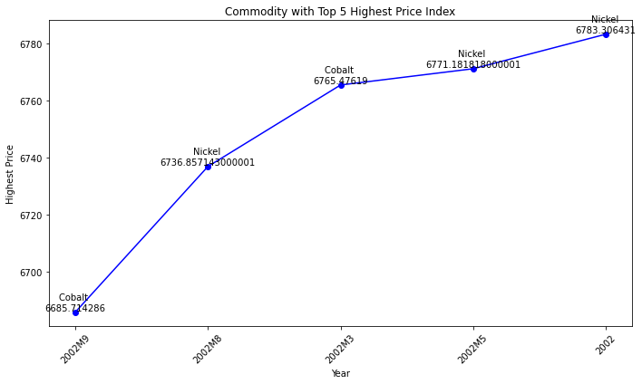

- Commodity with Highest Price index in 2023
Code:
import re
# Convert the index to string if it is not already
commodity_highest_price.index = commodity_highest_price.index.astype(str)

# Specify the desired time periods using regular expressions
#selected_patterns = ['2023', '23M1', '23M2'] # Specify the desired patterns
selected_patterns_23 = ['2023']

# Filter the dataframe for the specified patterns
filtered_data_23 = commodity_highest_price[commodity_highest_price.index.str.contains('|'.join(selected_patterns_23))]

# Print the filtered data
print(filtered_data_23)

# Extract the necessary data for plotting
time_periods = filtered_data_23.index
values = filtered_data_23['Value']
commodities = filtered_data_23['Commodity Name']

# Plotting the graph
plt.figure(figsize=(10, 6))
plt.plot(time_periods, values, marker='o', linestyle='-', color='b')

# Adding labels to the data points
for time_period, value, commodity in zip(time_periods, values, commodities):
plt.text(time_period, value, f'{commodity}\n{value}', ha='center', va='bottom')

plt.xlabel('Time Period')
plt.ylabel('Highest Price')
plt.title('Commodity with Highest Price Index in 2023')
plt.xticks(rotation=45)

plt.tight_layout()
plt.show()

Output:
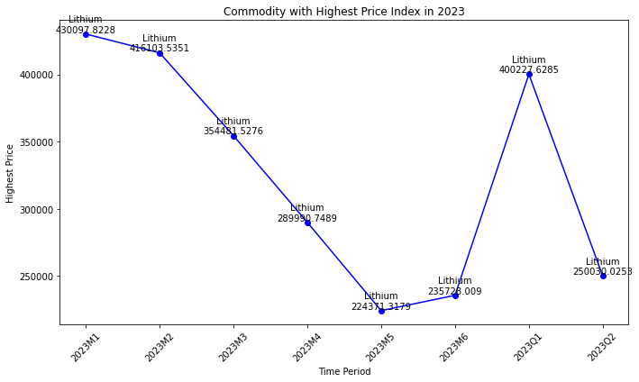

3.Commodity with Highest Price Index in 2022
Code:
# Specify the desired time periods using regular expressions
selected_patterns_22 = ['2022']

# Filter the dataframe for the specified patterns
filtered_data_22 = commodity_highest_price[commodity_highest_price.index.str.contains('|'.join(selected_patterns_22))]

# Print the filtered data
print(filtered_data_22)

# Extract the necessary data for plotting
time_periods = filtered_data_22.index
values = filtered_data_22['Value']
commodities = filtered_data_22['Commodity Name']

# Plotting the graph
plt.figure(figsize=(10, 6))
plt.plot(time_periods, values, marker='o', linestyle='-', color='b')

# Adding labels to the data points
for time_period, value, commodity in zip(time_periods, values, commodities):
plt.text(time_period, value, f'{commodity}\n{value}', ha='center', va='bottom')

plt.xlabel('Time Period')
plt.ylabel('Highest Price')
plt.title('Commodity with Highest Price Index in 2022')
plt.xticks(rotation=45)

plt.tight_layout()
plt.show()

Output:
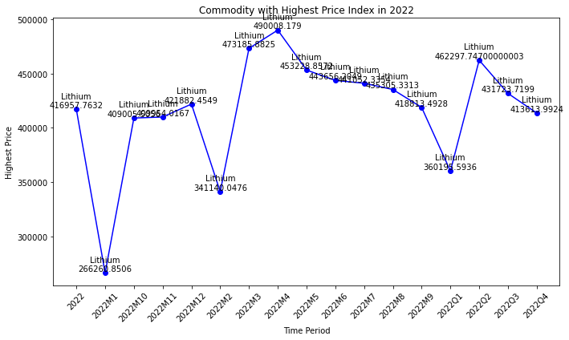
4.Commodity with Highest Price Index in 2021
Code:
# Specify the desired time periods using regular expressions
selected_patterns_21 = ['2021']

# Filter the dataframe for the specified patterns
filtered_data_21 = commodity_highest_price[commodity_highest_price.index.str.contains('|'.join(selected_patterns_21))]

# Print the filtered data
print(filtered_data_21)

# Extract the necessary data for plotting
time_periods = filtered_data_21.index
values = filtered_data_21['Value']
commodities = filtered_data_21['Commodity Name']

# Plotting the graph
plt.figure(figsize=(10, 6))
plt.plot(time_periods, values, marker='o', linestyle='-', color='b')

# Adding labels to the data points
for time_period, value, commodity in zip(time_periods, values, commodities):
plt.text(time_period, value, f'{commodity}\n{value}', ha='center', va='bottom')

plt.xlabel('Time Period')
plt.ylabel('Highest Price')
plt.title('Commodity with Highest Price Index in 2021')
plt.xticks(rotation=45)

plt.tight_layout()
plt.show()

Output:
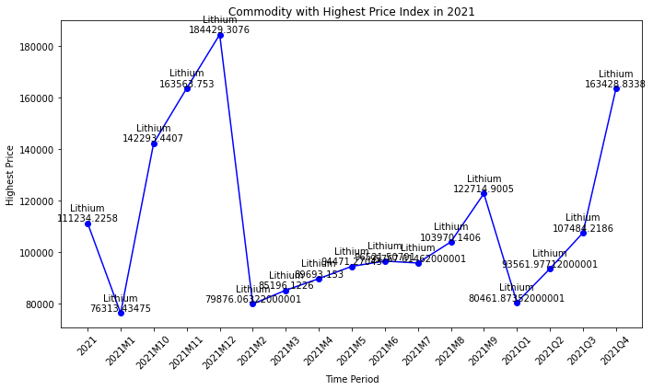

5.Commodity with Highest Price Index in 2020
Code:
# Specify the desired time periods using regular expressions
selected_patterns_20 = ['2020']

# Filter the dataframe for the specified patterns
filtered_data_20 = commodity_highest_price[commodity_highest_price.index.str.contains('|'.join(selected_patterns_20))]

# Print the filtered data
print(filtered_data_20)

# Extract the necessary data for plotting
time_periods = filtered_data_20.index
values = filtered_data_20['Value']
commodities = filtered_data_20['Commodity Name']

# Plotting the graph
plt.figure(figsize=(10, 6))
plt.plot(time_periods, values, marker='o', linestyle='-', color='b')

# Adding labels to the data points
for time_period, value, commodity in zip(time_periods, values, commodities):
plt.text(time_period, value, f'{commodity}\n{value}', ha='center', va='bottom')

plt.xlabel('Time Period')
plt.ylabel('Highest Price')
plt.title('Commodity with Highest Price Index in 2020')
plt.xticks(rotation=45)

plt.tight_layout()
plt.show()

Output:
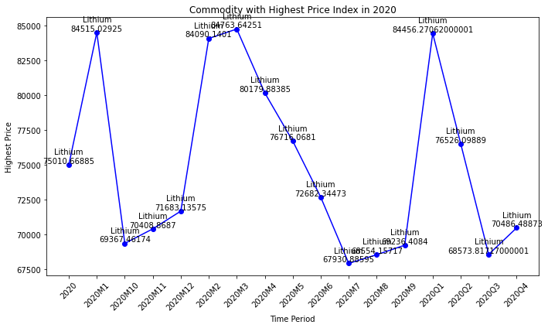

6.Commodity with Highest Price Index in 2010
Code:

# Specify the desired time periods using regular expressions
selected_patterns_10 = ['2010']

# Filter the dataframe for the specified patterns
filtered_data_10 = commodity_highest_price[commodity_highest_price.index.str.contains('|'.join(selected_patterns_10))]

# Print the filtered data
print(filtered_data_10)

# Extract the necessary data for plotting
time_periods = filtered_data_10.index
values = filtered_data_10['Value']
commodities = filtered_data_10['Commodity Name']

# Plotting the graph
plt.figure(figsize=(10, 6))
plt.plot(time_periods, values, marker='o', linestyle='-', color='b')

# Adding labels to the data points
for time_period, value, commodity in zip(time_periods, values, commodities):
plt.text(time_period, value, f'{commodity}\n{value}', ha='center', va='bottom')

plt.xlabel('Time Period')
plt.ylabel('Highest Price')
plt.title('Commodity with Highest Price Index in 2010')
plt.xticks(rotation=45)

plt.tight_layout()
plt.show()

Output:
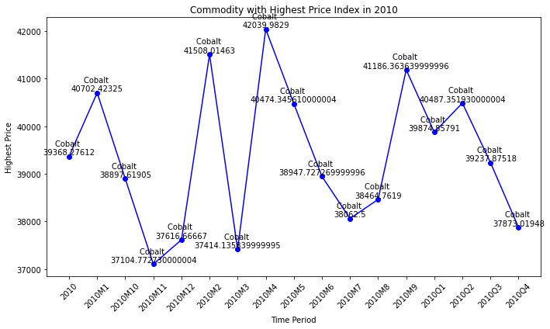
7.Commodity with Highest Price Index in 2020
Code:
# Sort the dataframe by lowest price in ascending order
lowest_price_sorted = commodity_lowest_price.sort_values('Value')

# Select the top 5 years with the lowest price indices
top_5_years = lowest_price_sorted.head(5)

# Extract the necessary data for plotting
years = top_5_years.index
values = top_5_years['Value']
commodities = top_5_years['Commodity Name']

# Print the top 5 years with corresponding values and commodity names
for year, value, commodity in zip(years, values, commodities):
print(f"Year: {year}, Value: {value}, Commodity Name: {commodity}")

# Plotting the graph
plt.figure(figsize=(10, 6))
plt.plot(years, values, marker='o', linestyle='-', color='b')

# Adding labels to the data points
for year, value, commodity in zip(years, values, commodities):
plt.text(year, value, f'{commodity}\n{value}', ha='center', va='bottom')

plt.xlabel('Year')
plt.ylabel('Lowest Price')
plt.title('Commodity with Top 5 Lowest Price Index Year')
plt.xticks(rotation=45)

plt.tight_layout()
plt.show()

Output:
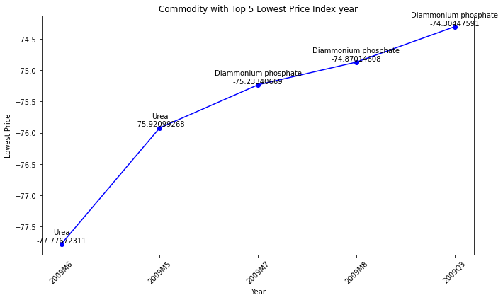

9.Commodity with Lowest Price Index in 2023
Code:
# Convert the index to string if it is not already
commodity_lowest_price.index = commodity_lowest_price.index.astype(str)

# Specify the desired time periods using regular expressions
#selected_patterns = ['2023', '23M1', '23M2'] # Specify the desired patterns
selected_patterns_low23 = ['2023']

# Filter the dataframe for the specified patterns
filtered_data_low23 = commodity_lowest_price[commodity_lowest_price.index.str.contains('|'.join(selected_patterns_low23))]

# Print the filtered data
print(filtered_data_low23)

import matplotlib.pyplot as plt

# Assuming you have already executed the code to filter the dataframe and obtained `filtered_data` dataframe

# Extract the necessary data for plotting
time_periods = filtered_data_low23.index
values = filtered_data_low23['Value']
commodities = filtered_data_low23['Commodity Name']

# Plotting the graph
plt.figure(figsize=(10, 6))
plt.plot(time_periods, values, marker='o', linestyle='-', color='b')

# Adding labels to the data points
for time_period, value, commodity in zip(time_periods, values, commodities):
plt.text(time_period, value, f'{commodity}\n{value}', ha='center', va='bottom')

plt.xlabel('Time Period')
plt.ylabel('Lowest Price')
plt.title('Commodity with Lowest Price Index in 2023')
plt.xticks(rotation=45)

plt.tight_layout()
plt.show()

Output:
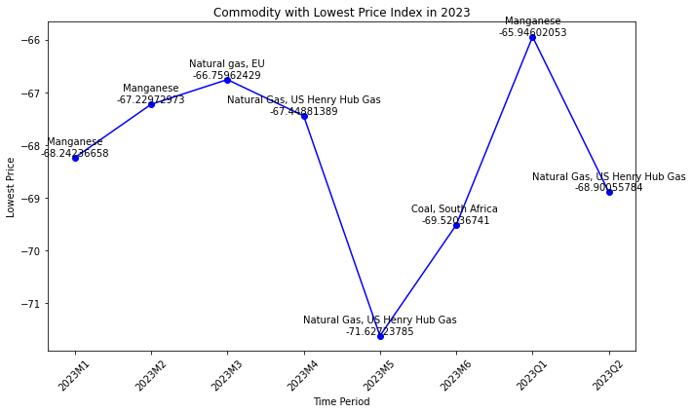

10.Commodity with Lowest Price Index in 2022
Code:
# Convert the index to string if it is not already
commodity_lowest_price.index = commodity_lowest_price.index.astype(str)

# Specify the desired time periods using regular expressions
selected_patterns_low22 = ['2022']

# Filter the dataframe for the specified patterns
filtered_data_low22 = commodity_lowest_price[commodity_lowest_price.index.str.contains('|'.join(selected_patterns_low22))]

# Print the filtered data
print(filtered_data_low22)

import matplotlib.pyplot as plt

# Assuming you have already executed the code to filter the dataframe and obtained `filtered_data` dataframe

# Extract the necessary data for plotting
time_periods = filtered_data_low22.index
values = filtered_data_low22['Value']
commodities = filtered_data_low22['Commodity Name']

# Plotting the graph
plt.figure(figsize=(10, 6))
plt.plot(time_periods, values, marker='o', linestyle='-', color='b')

# Adding labels to the data points
for time_period, value, commodity in zip(time_periods, values, commodities):
plt.text(time_period, value, f'{commodity}\n{value}', ha='center', va='bottom')

plt.xlabel('Time Period')
plt.ylabel('Lowest Price')
plt.title('Commodity with Lowest Price Index in 2022')
plt.xticks(rotation=45)

plt.tight_layout()
plt.show()

Output:
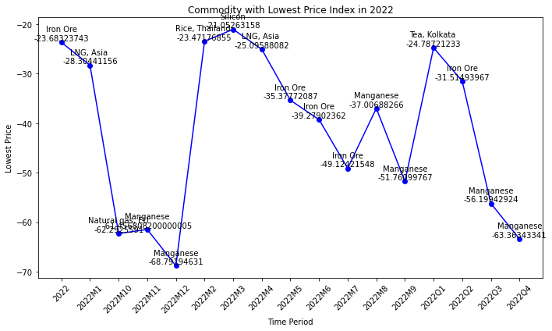

11.Commodity with Lowest Price Index in 2021
Code:
# Convert the index to string if it is not already
commodity_lowest_price.index = commodity_lowest_price.index.astype(str)

# Specify the desired time periods using regular expressions
selected_patterns_low21 = ['2021']

# Filter the dataframe for the specified patterns
filtered_data_low21 = commodity_lowest_price[commodity_lowest_price.index.str.contains('|'.join(selected_patterns_low21))]

# Print the filtered data
print(filtered_data_low21)

# Extract the necessary data for plotting
time_periods = filtered_data_low21.index
values = filtered_data_low21['Value']
commodities = filtered_data_low21['Commodity Name']

# Plotting the graph
plt.figure(figsize=(10, 6))
plt.plot(time_periods, values, marker='o', linestyle='-', color='b')

# Adding labels to the data points
for time_period, value, commodity in zip(time_periods, values, commodities):
plt.text(time_period, value, f'{commodity}\n{value}', ha='center', va='bottom')

plt.xlabel('Time Period')
plt.ylabel('Lowest Price')
plt.title('Commodity with Lowest Price Index in 2021')
plt.xticks(rotation=45)

plt.tight_layout()
plt.show()

Output:
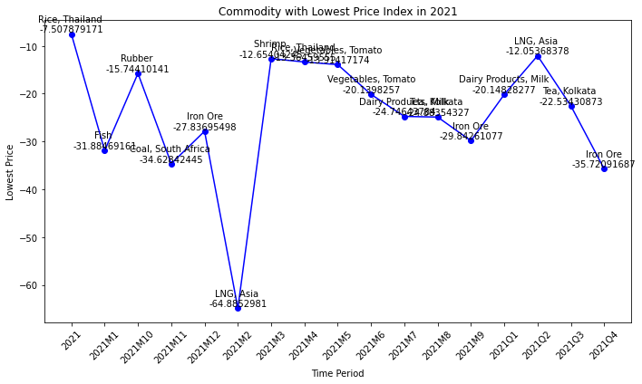

- Commodity with Lowest Price Index in 2020
Code:
# Convert the index to string if it is not already
commodity_lowest_price.index = commodity_lowest_price.index.astype(str)

# Specify the desired time periods using regular expressions
selected_patterns_low20 = ['2020']

# Filter the dataframe for the specified patterns
filtered_data_low20 = commodity_lowest_price[commodity_lowest_price.index.str.contains('|'.join(selected_patterns_low20))]

# Print the filtered data
print(filtered_data_low20)

# Extract the necessary data for plotting
time_periods = filtered_data_low20.index
values = filtered_data_low20['Value']
commodities = filtered_data_low20['Commodity Name']

# Plotting the graph
plt.figure(figsize=(10, 6))
plt.plot(time_periods, values, marker='o', linestyle='-', color='b')

# Adding labels to the data points
for time_period, value, commodity in zip(time_periods, values, commodities):
plt.text(time_period, value, f'{commodity}\n{value}', ha='center', va='bottom')

plt.xlabel('Time Period')
plt.ylabel('Lowest Price')
plt.title('Commodity with Lowest Price Index in 2020')
plt.xticks(rotation=45)

plt.tight_layout()
plt.show()

Output:
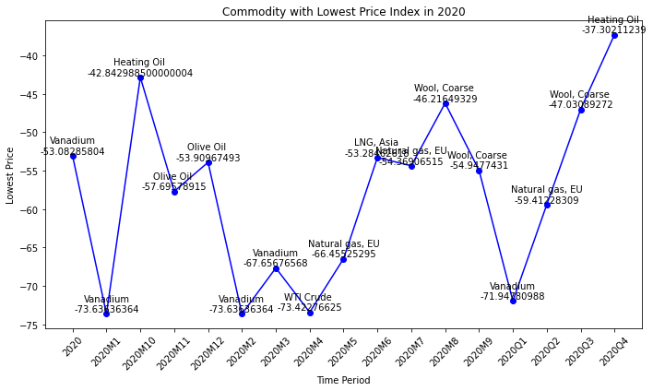

13.Commodity with Lowest Price Index in 2010
Code:
# Convert the index to string if it is not already
commodity_lowest_price.index = commodity_lowest_price.index.astype(str)

# Specify the desired time periods using regular expressions
selected_patterns_low10 = ['2010']

# Filter the dataframe for the specified patterns
filtered_data_low10 = commodity_lowest_price[commodity_lowest_price.index.str.contains('|'.join(selected_patterns_low10))]

# Print the filtered data
print(filtered_data_low10)

# Extract the necessary data for plotting
time_periods = filtered_data_low10.index
values = filtered_data_low10['Value']
commodities = filtered_data_low10['Commodity Name']

# Plotting the graph
plt.figure(figsize=(10, 6))
plt.plot(time_periods, values, marker='o', linestyle='-', color='b')

# Adding labels to the data points
for time_period, value, commodity in zip(time_periods, values, commodities):
plt.text(time_period, value, f'{commodity}\n{value}', ha='center', va='bottom')

plt.xlabel('Time Period')
plt.ylabel('Lowest Price')
plt.title('Commodity with Lowest Price Index in 2010')
plt.xticks(rotation=45)

plt.tight_layout()
plt.show()

Output:
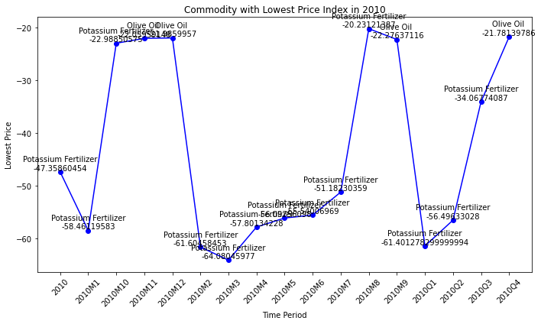

14.Highest Price Index for Commodity: Gold
Code:
# Specify the desired time periods using regular expressions
selected_patterns_gold = ['Gold']

# Filter the dataframe for the specified patterns
data_gold = pcpdf[pcpdf['Commodity Name'].str.contains('|'.join(selected_patterns_gold))]
max_gold_data = data_gold['Value'].max()

# Print the Highest price index for 'Gold'
print("Highest Price Index for Commodity: Gold")
print(max_gold_data)

Output:
Highest Price Index for Commodity: Gold
1999.6685

15.Minimum Price Index for Commodity: Gold
Code:
# Specify the desired time periods using regular expressions
selected_patterns_gold1 = ['Gold']

# Filter the dataframe for the specified patterns
data_gold1 = pcpdf[pcpdf['Commodity Name'].str.contains('|'.join(selected_patterns_gold1))]
min_gold_data = data_gold1['Value'].min()

# Print the Minimum price index for 'Gold'
print("Minimum Price Index for Commodity: Gold")
print(min_gold_data)

Output:
Minimum Price Index for Commodity: Gold
-43.85982936

16.Highest Price Index for Commodity: Silver
Code:
# Specify the desired time periods using regular expressions
selected_patterns_silver = ['Silver']

# Filter the dataframe for the specified patterns
data_silver = pcpdf[pcpdf['Commodity Name'].str.contains('|'.join(selected_patterns_silver))]
max_silver_data = data_silver['Value'].max()

# Print the Highest price index for 'Silver'
print("Highest Price Index for Commodity: Silver")
print(max_silver_data)

Output:
Highest Price Index for Commodity: Silver
-38.65124321

16.Lowest Price Index for Commodity: Metal Index
Code:
# Specify the desired time periods using regular expressions
selected_patterns_metal = ['Metal Index']

# Filter the dataframe for the specified patterns
data_metal = pcpdf[pcpdf['Commodity Name'].str.contains('|'.join(selected_patterns_metal))]
min_metal_data = data_metal['Value'].min()

# Print the Minimum price index for 'Metal Index'
print("Lowest Price Index for Commodity: Metal Index")
print(min_metal_data)

Output:
Lowest Price Index for Commodity: Metal Index
-27.7428739

17.Highest Price Index for Commodity: Metal Index
Code:
# Specify the desired time periods using regular expressions
selected_patterns_metal1 = ['Metal Index']

# Filter the dataframe for the specified patterns
data_metal1 = pcpdf[pcpdf['Commodity Name'].str. Contains ('|'.join (selected_patterns_metal1))]
max_metal_data = data_metal1['Value'].max()

# Print the Highest price index for 'Metal Index'
print("Highest Price Index for Commodity: Metal Index")
print(max_metal_data)

Output:
Highest Price Index for Commodity: Metal Index
227.9209969

Insight

- Gold had the highest price index of 199. On the other hand, gold had the lowest price index of -43.
- Silver had the highest price index is 187 and the lowest price index of -45.
- Metal had the highest price index 45 and the lowest price index for metal is mentioned as -27.
- Cobalt had the highest price index of 6685.714286 in September 2002.
- Nickel had the second-highest price index of 6736.857143 in August 2002.
- Cobalt had the third-highest price index of 6765.47619 in March 2002.
- Nickel had the fourth-highest price index of 6771.181818 in May 2002. Again Nickel had the fifth-highest price index of 6783.306431 in the year 2002.
- Urea had the lowest price index of -77.77672311 in June 2009.
- Urea had the second-lowest price index of -75.92099268 in May 2009.
- Diammonium phosphate had the 3rd, 4th and 5th price index of -75.23340669, -74.87014608 and -74.30447591 in July 2009, August 2009 and in the third quarter of 2009 .

