**Database Operations and Management Techniques**

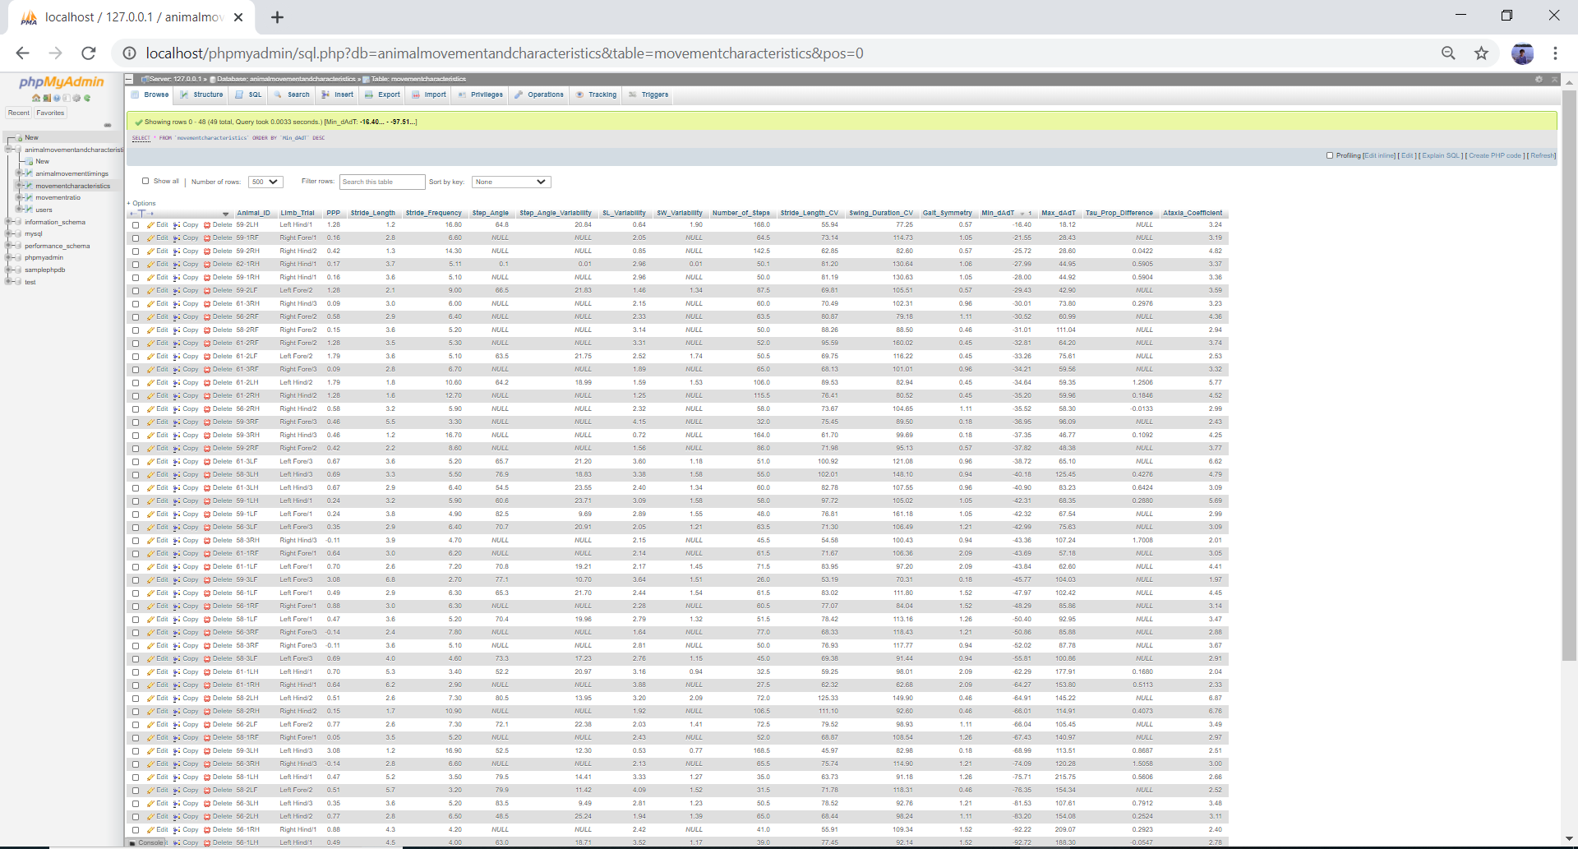

The first and foremost step is to make sure that you are able to view all the rows in the database, so please select 500 for the number of rows you would like to see. Please do not click on the show all button because your browser could potentially crash.

Please avoid using operations apart from the ones listed on this document. We want to make sure that the database remains safe.

PhpMyAdmin is a database management system that stores small scale to large scale data and is user friendly.

The following user interactive operations are provided by PhpMyAdmin software. These operations are the most important because they will be frequently used and could be applied to any database.

**Changing the Order of Columns:** Please hover the mouse over the column’s header that you would like to move to the left or right. Next, right click on that particular header and move to the desirable place.

**Arranging the Columns in Descending or Ascending Order:** When a database is accessed at first, all the columns are arranged in an ascending fashion based on Animal_ID. If you would like to arrange a column by descending values, right click on that column’s header twice. IF you would like to arrange a column by ascending values, right click on that column’s header only once.

If you would like to learn more advanced query methods, the following commands will be of interest. For any query, please click on the edit or edit inline link at the top right corner of the page to type and enter a command. Please do not change or fiddle with the from statement because it automatically has the name of the table. Just leave it how it is.

**Selecting Columns of Interest:** Use this command if you would like particular columns displayed. For example, the following query selects SL_Variability, Stride_Length, and Ataxia_Coefficient.

SELECT SL_Variability AND Stride_Length AND Ataxia_Coefficient

FROM movementcharacteristics

**Selecting Rows Based on Condition:** Use this command if you would like to select rows of data that meets a particular condition for one or more variables. For example, the following query selects Animal_ID rows that have Swing_Duration_CV equal to or greater than 100.

SELECT Animal_ID * FROM movementcharacteristics

WHERE Swing_Duration_CV >= 100

Comparison operator comes before equal to sign. If there is more than one condition, use an AND/OR in between the conditions in the WHERE section.

**Selecting Rows Based on a Boundary Values (Lower and Upper Limits):** This command is useful when you would like to select rows with one or more variables having values within a range. This example selects values for number of steps that have a stride frequency between 4.0 and 7.0, as well as Max_dAdT between 80 and 100.

SELECT Number_of_Steps * FROM movementcharacteristics

WHERE Stride_Frequency BETWEEN 4.00 AND 7.00

AND Max_dAdT BETWEEN 80.00 AND 100.00

**Counting Number of Rows that Meet a Condition:** Use this command when you want to find out how many rows meet a condition. In this example, the query counts how many PPP values are greater than 0.10.

SELECT COUNT(PPP)

FROM movementcharacteristics

WHERE PPP > 0.10

**Selecting the Largest Value from a Column:** This command tells you the largest value for a given column or variable. The following example find the largest PPP.

SELECT MAX(PPP) AS LargestPPP

FROM movementcharacteristics