**Instructions for Using Website**

The first page you will see is the login page.

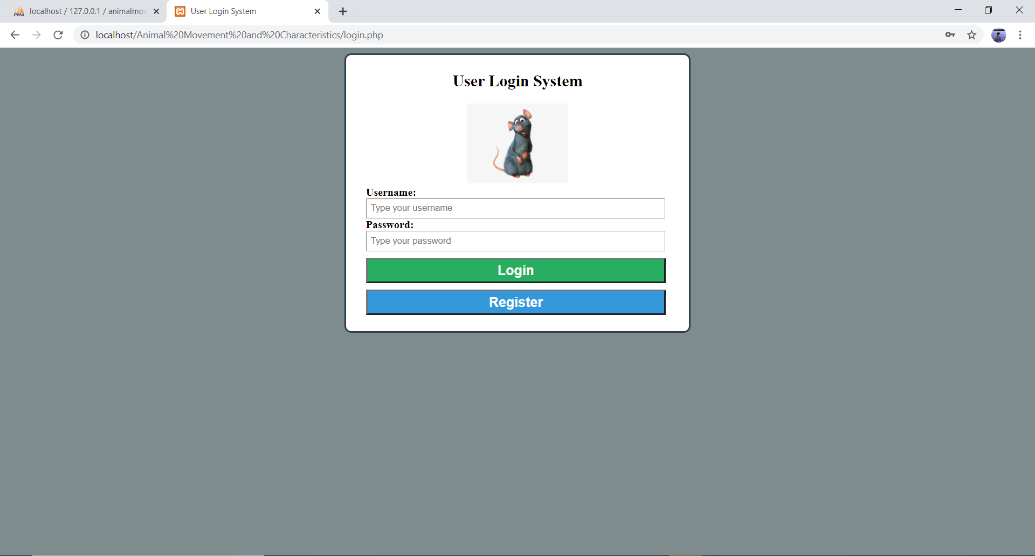

If you are a new user, please click the register button and it will take you to the user registration page. Please enter in a unique username you can remember and a strong password. After confirming the password, please click the create account button and you should see a popup message saying that the account has been created successfully.

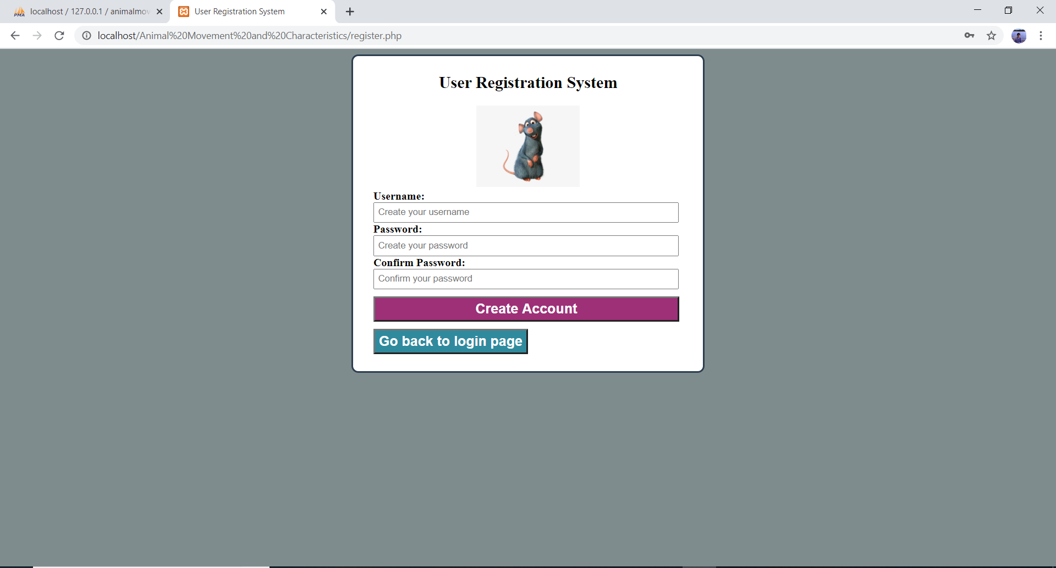

Then click on go back to login page and enter the correct credentials. Click Login.



Once you login, you will see the homepage with three different columns. The columns are grouped by variables with a common relation. All the data pertaining to each variable is stored in that particular database.

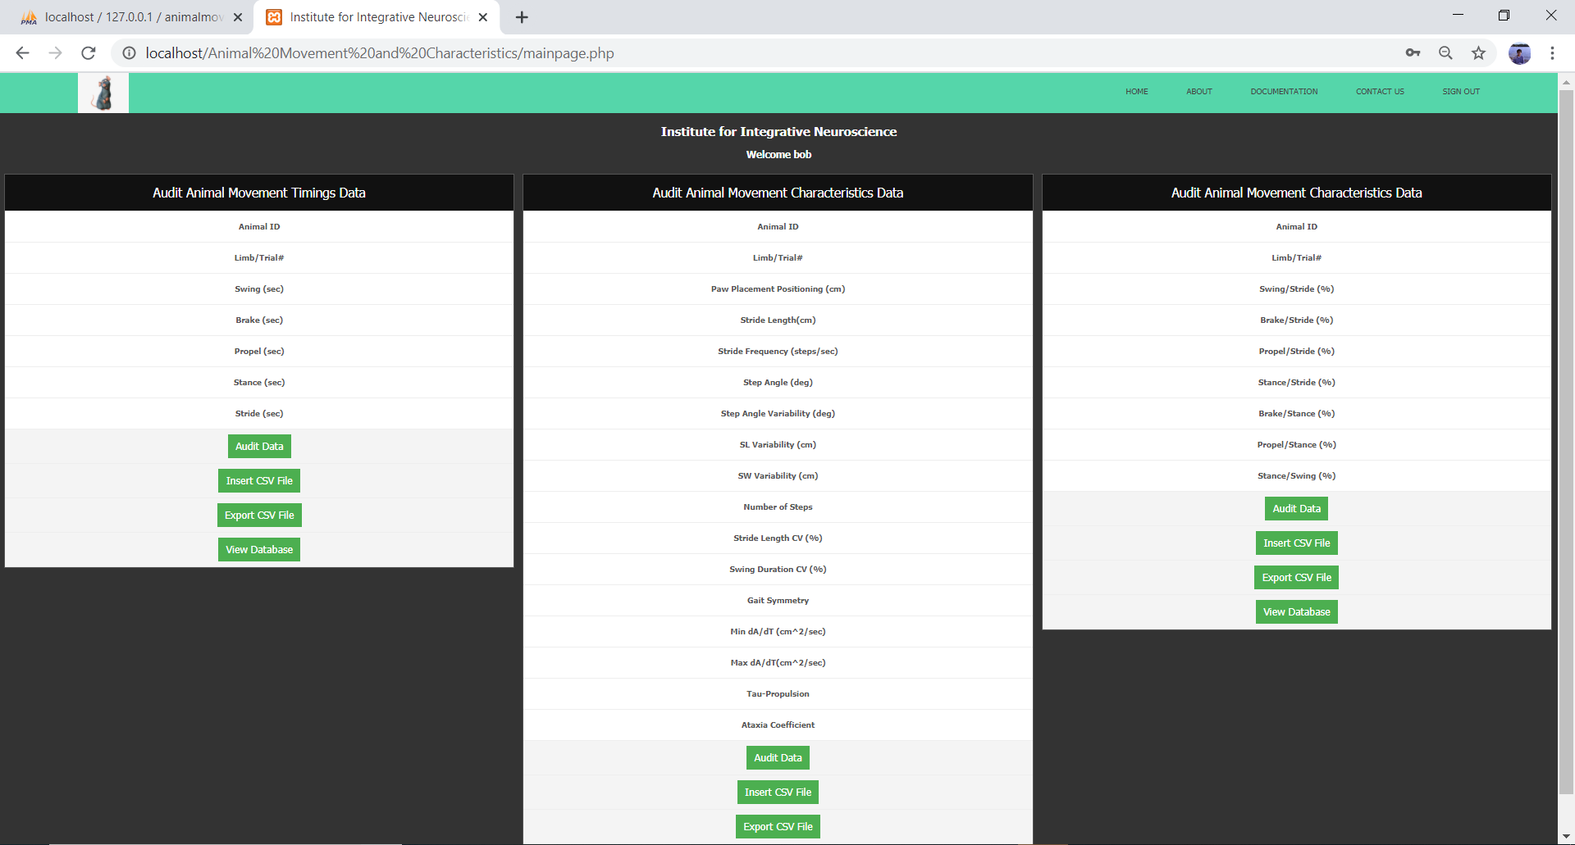

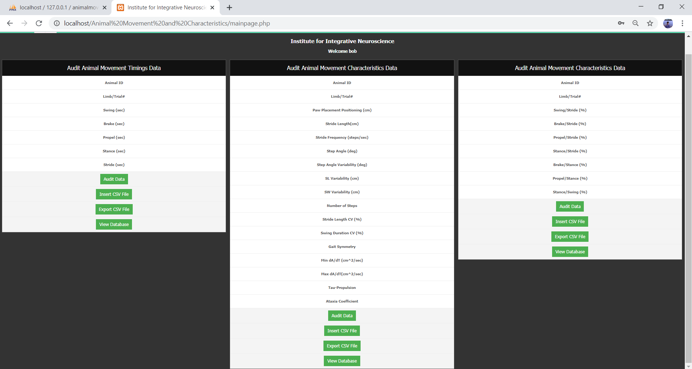

Click Audit Data when you manually want to insert, delete, or modify a particular trial’s data.

Click Insert CSV File when you have an excel spreadsheet saved in a csv format. This option will upload new values into the database.

Click Export CSV when you want to download the database in a csv format.

Click View Database to see all the values stored.

**Audit Data:** An image of the page is shown below. Use the insert button only after entering a new trial’s data completely. The significant figure expectation has been programmed and the cursor next to each entry can be used as a guidance.

If you would like to delete a value that is already stored in the database, type in the Animal_ID and press the blue Go button. The remaining values will then be automatically retrieved. You may then click the delete button and will receive a pop-up saying that the entry has been deleted from the database.

If you would like to modify/update a value that is already stored in the database, type in the Animal_ID and press the blue Go button. The remaining values will then be automatically retrieved. You may then clear any variable’s existing data and enter the new value or values. After that is completed, you should click on the update button. A popup will show up after entry has been modified/updated successfully.

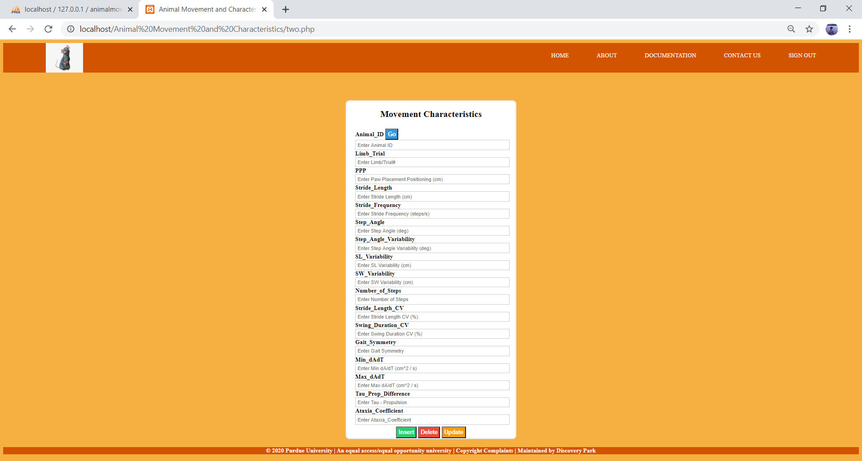

**Insert CSV File:** Before clicking on this button for the first time, it is a good idea to click on the View Database button first to get an idea of how the data is stored by variable names. That way, the CSV file you want to upload can be modified in the correct order to match the order of columns in the database. For now, the CSV columns have to be in the correct order.

An image of the Import CSV page is show below. Please click the Choose File button near the top of the page and upload the csv file you want to store in the database.

Please make sure that you don’t have the column header names on the csv file, but if you cannot remove it, you will have to manually delete that row after the file has been uploaded.

Once you selected the right file to upload, please click the Go button at the bottom right corner, and it will take you to a confirmation page where it says that the query has been accepted. If an error shows up, it is probably due to one or more of the following reasons:

1. The number of columns or rows do not match the database requirements. If this is the case, please check to see if there are no missing columns or an empty values. Inspect your csv file again and then try uploading it. The error should be fixed.
2. The column header names are not removed. If this error shows up, please click the Browse button on the top toolbar of the page and change the number of rows to 500. You should then be able to see that the database accepted the values in numerical order, but the column header names are shown in it’s own row at the buttom. Please check the square box for that corresponding row and then click the Delete button shown at the bottom of the database and confirm the action. This step will get rid of the error.

If no error has shown up, then just click the browse button located on the top menu and change the number of rows to 500. You should now be able to see the new set of values inserted.

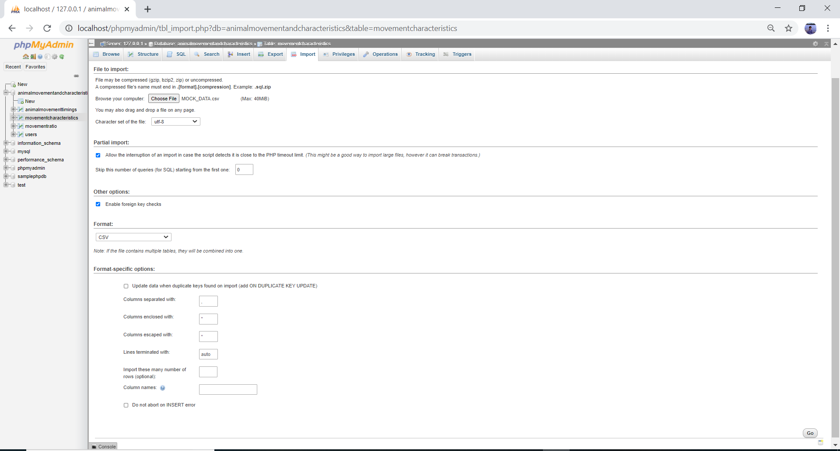

**Export CSV File:** An image of the page is shown below. The options available on this page are really dependent on how the data is going to be used after exporting the database or how you would like to view the data.

In most cases, the data is going to be inserted into a statistical package like Minitab. The best most popular option is to first click on the custom – display all possible options. Next change the format to CSV if already not and select dump all rows, then select the box which says put column names in the first row, and finally click go.

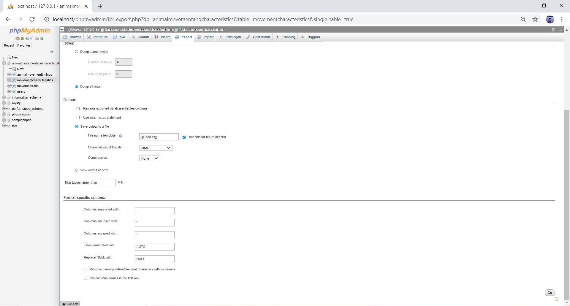

**View Database:** An image of the page is shown below. After the big database page shows, up, please select the number of rows to 500 and you should be able to see the entire database.

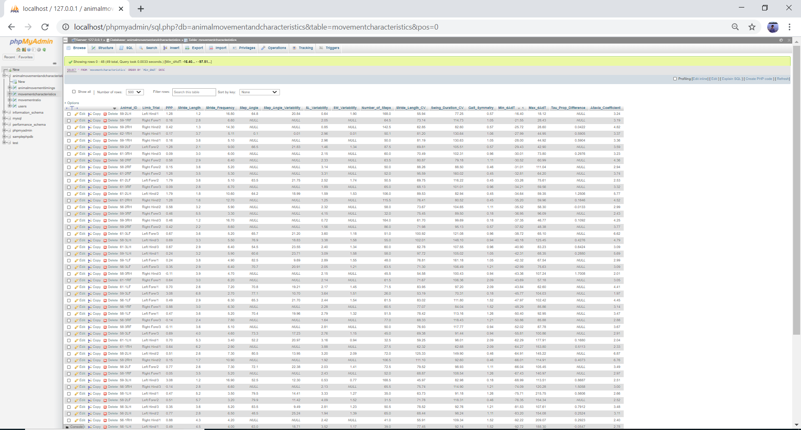

The menu at the top of the home page is self-explanatory. Please make sure to signout after accessing any section of the website.