1.Find all the topics and tasks which are taught or submitted in the month of October:

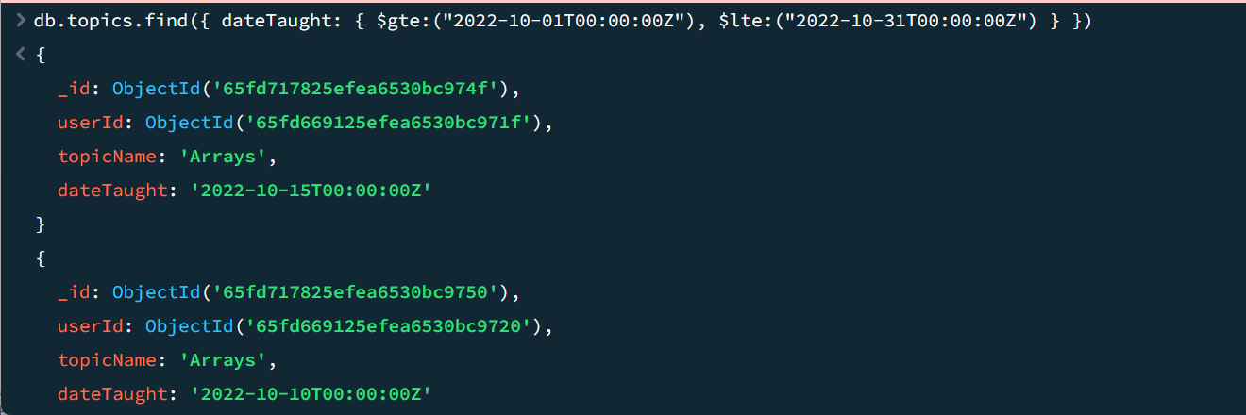

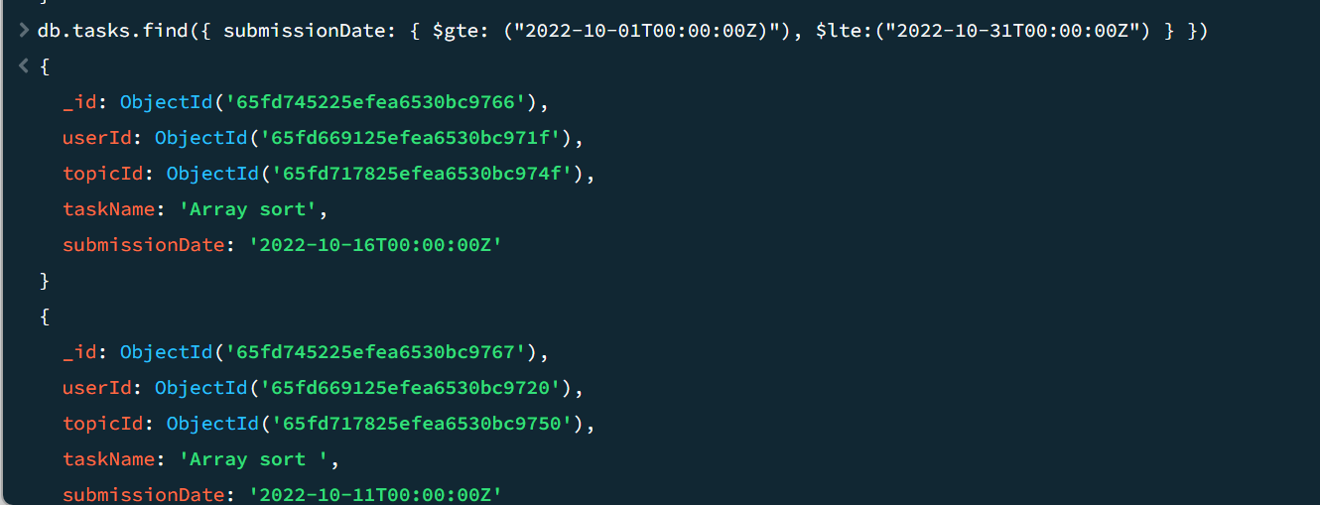

2.Find all the company drives which appeared between 15 oct-2020 and 31-oct-2020:

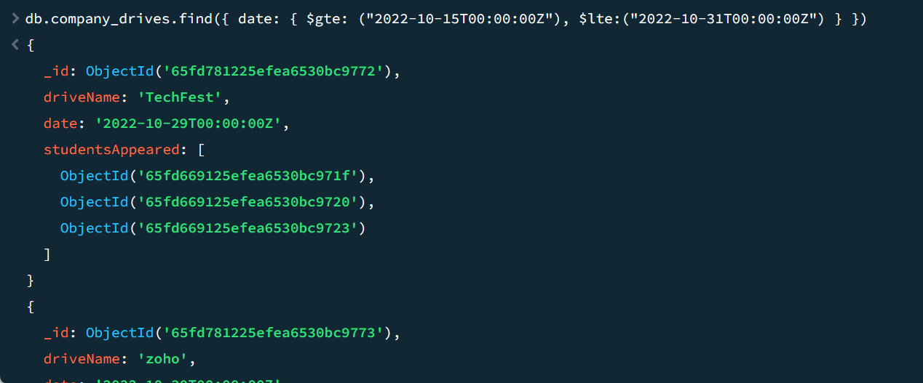

3.Find all the company drives and students who are appeared for the placement:

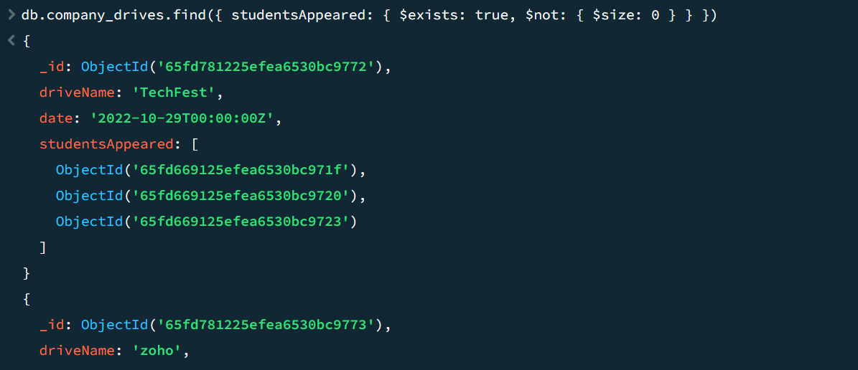

4.Find the number of problems solved by the user in codekata:

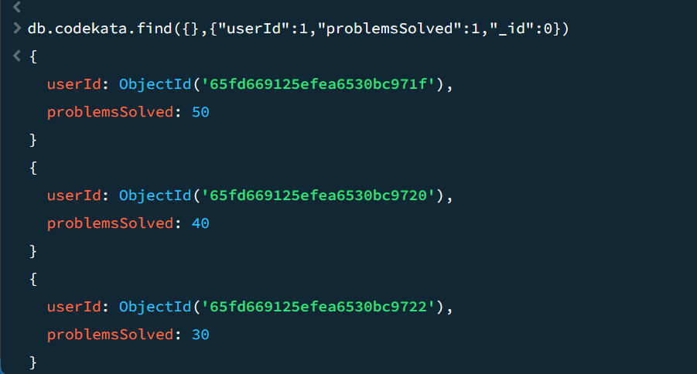

5.Find all the mentors with who has the mentee's count more than 15:

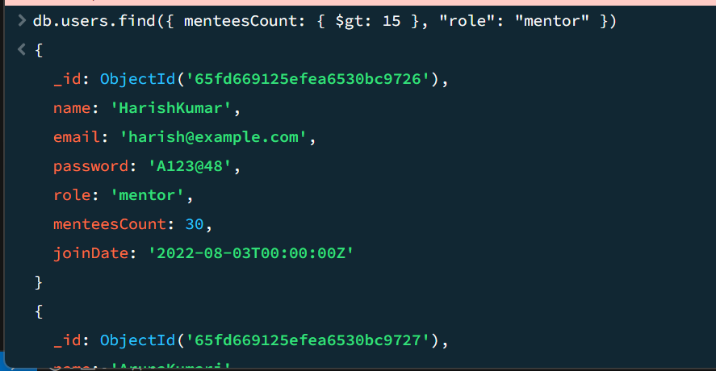

6.Find the number of users who are absent and task is not submitted between 15 oct-2020 and 31-oct-2020:

