1.Find all the information about each products:

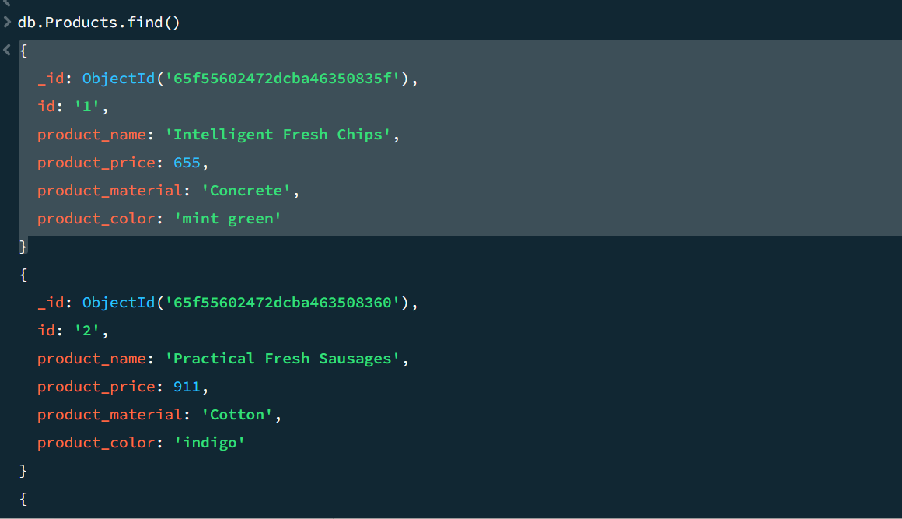

2.Find the product price which are between 400 to 800:

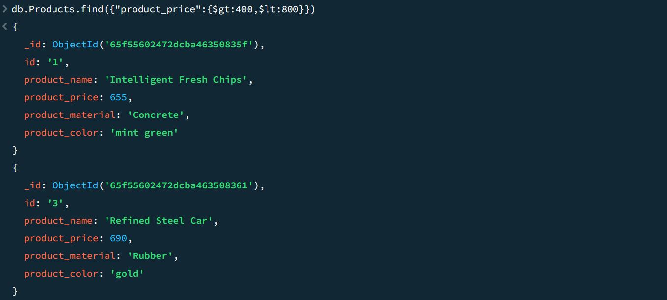

3.Find the product price which are not between 400 to 600: 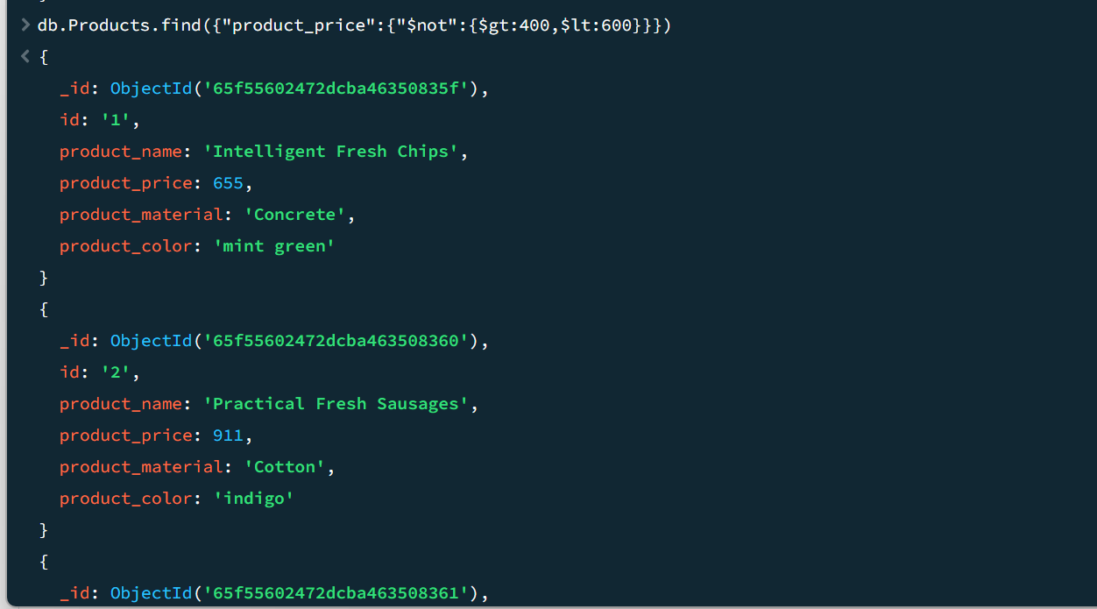

4.List the four product which are greater than 500 in price:

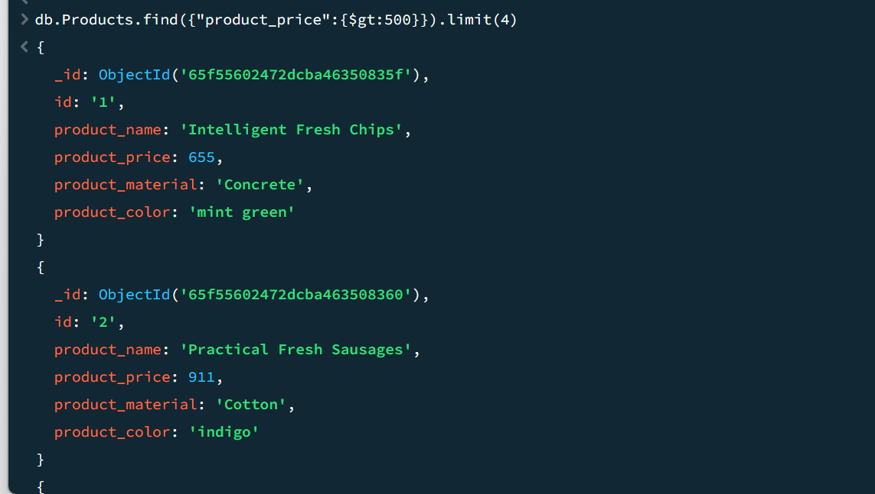

5.Find the product name and product material of each products:

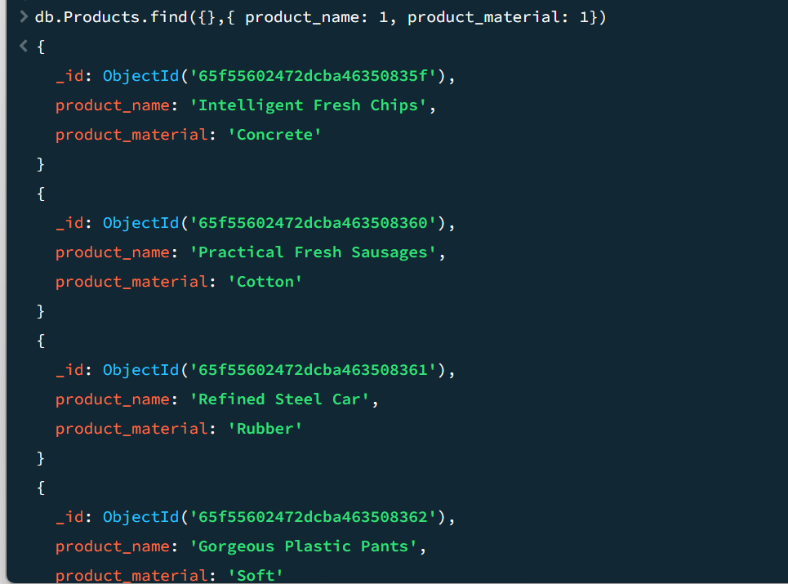

6.Find the product with a row id of 10:

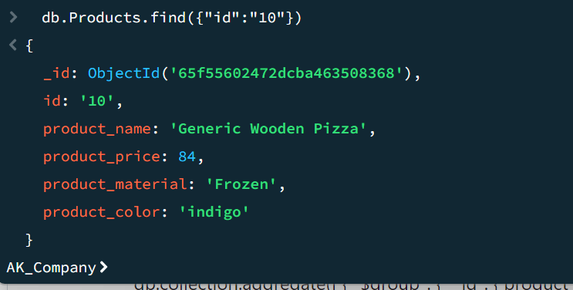

7.Find only the product name and product material:

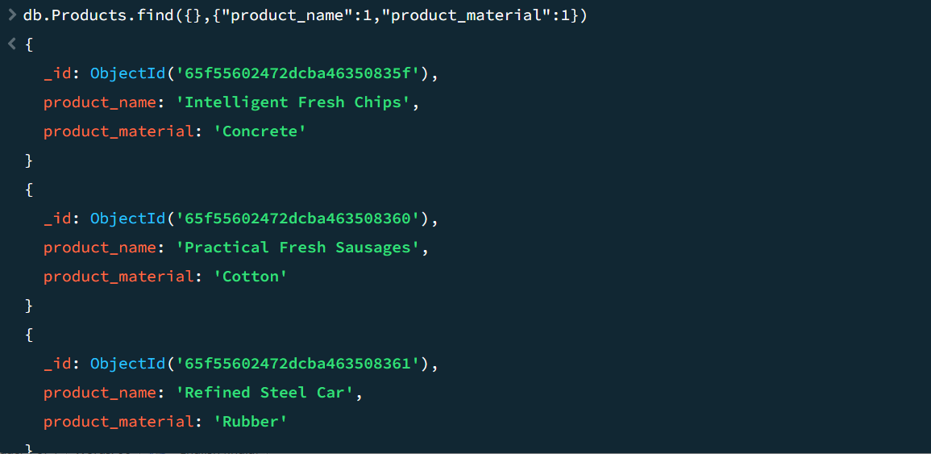

8.Find all products which contain the value of soft in product material:

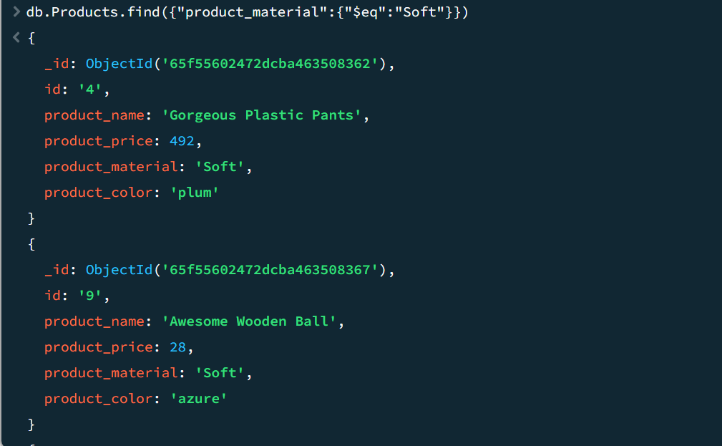

9.Find products which contain product color indigo and product price 492.00:

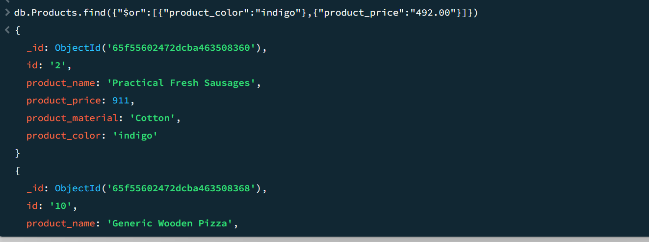

10.Delete the products which product price value are same:

db.Products.aggregate([ { "$group": { "_id": { product_price: "$product_price" }, total: { $sum: 1 } } }, { $match: { total: { $gt: 1 } } } ]).map(val=> db. Products.deleteMany({"product_price": val._id.product_price}))

