I 

LOW LEVEL DESIGN (LLD

INSURANCE PREMIUM PREDICTION

|  |  |
| --- | --- |
| Written By | ARUNKUMAR V |
| Document Version | 0.1 |
| Last Revised Date | 18– Oct-2023 |

INSURANCE PREMIUM PREDICTION LLD i

ii LOW LEVEL DESIGN (LLD) 

**Document Control**

**Change Record:**

|  |  |  |  |
| --- | --- | --- | --- |
| **Version** | **Date** | **Author** | **Comments** |
| 0.1 | 18– Oct -  2023 | ARUNKUMAR | Model prediction is completed |

iii LOW LEVEL DESIGN (LLD) 

Contents

**1. Introduction**....................................................................................................................................1 **1.1. What is Low-Level design document?** ...................................................................................1 **1.2. Scope**.......................................................................................................................................1

**2. Architecture**....................................................................................................................................2 **3. Architecture Description**................................................................................................................3 **3.1. Data Description**.....................................................................................................................

**3.1.. Load Data In DB**..............................................................................................................3

**3.2 Data Exploratory Data Analysis**.................................................................................................3 **3.3 Pre-processing** ...............................................................................................................3

**3.4. Data Classification** .......................................................................................................................3 **3.5 Model Building** .........................................................................................................................3 **3.6. Data Validation**..........................................................................................................................3 **3.7. Deployment**..................................................................................................3

**3.8.Deployment**...............................................................................................................................4

**4. Unit Test Cases** ...............................................................................................................................5

1 LOW LEVEL DESIGN (LLD) 

1. Introduction

1.1. What is Low-Level design document?

The goal of LLD or a low-level design document (LLDD) is to give the internal logical design of the actual program code for Food Recommendation System. LLD describes the class diagrams with the methods and relations between classes and program specs. It describes the modules so that the programmer can directly code the program from the document.

1.2. Scope

Low-level design (LLD) is a component-level design process that follows a step-by step refinement process. This process can be used for designing data structures, required software architecture, source code and ultimately, performance algorithms. Overall, the data organization may be defined during requirement analysis and then refined during data design work

2 LOW LEVEL DESIGN (LLD)

2. Architecture

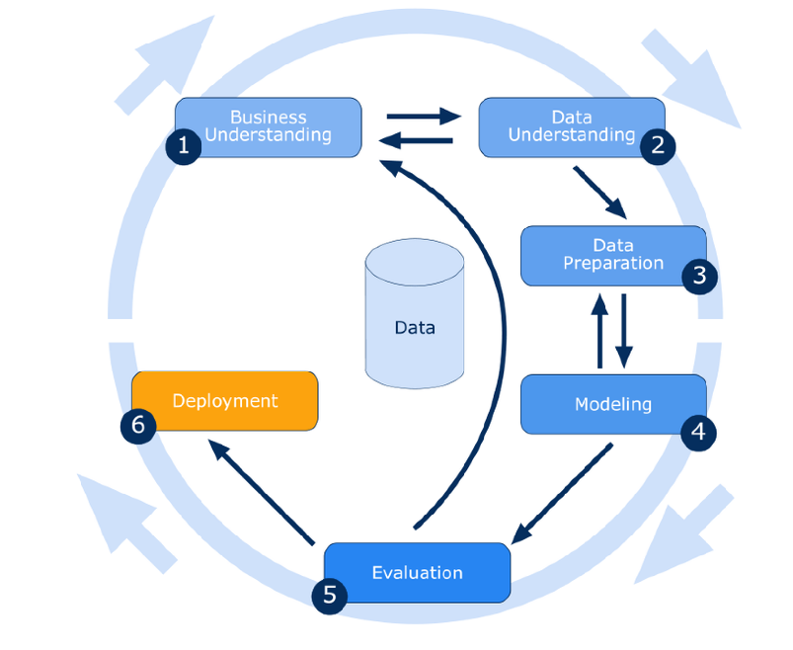

Insurance Premium Prediction

Page | 2

3 LOW LEVEL DESIGN (LLD) 

3. Architecture Description

3.1. Data Description

Insurance premium dataset having >8K records with 8 attributes.   
Insurance premium data is a dataset containing demographic and economic information about adults in a population. It includes attributes such as age, sex,bmi,children,smoker or not, along with their corresponding annual income levels

3.3. Data Transformation

Pre-processed the data by handling missing values and encoding categorical variables into numerical representations. Scale numerical features to ensure they are on a similar scale, avoiding dominance of certain features during analysis. Split the data into training and testing sets to evaluate model performance effectively

3.4. Data Insertion into Database

a. Table creation in the database.

b. Insertion of files in the table

3.5. Export Data from Database

Data Export from Database - The data in a stored database is exported as a CSV file to be used for Data Pre-processing and Model Training.

3.6. Data Pre-processing

Data Pre-processing steps we could use are Null value handling, stop words removal, punctuation removal, Imbalanced data set handling, Handling columns with standard deviation zero or below a threshold, etc.

4 LOW LEVEL DESIGN (LLD) 

3.10. Model Building

we will find the best model for Dataset. Algorithms will be passed with the best parameters derived from Grid-Search. We will calculate the AUC scores for models and select the model with the best score. Similarly, the models will be selected. Models will be saved for use .

3.17. Deployment

We will be deploying the model to AWS.

4. Unit Test Cases

|  |  |  |
| --- | --- | --- |
| **Test Case Description** | **Pre-Requisite** | **Expected Result** |
| Verify whether the Application URL is accessible to the user | 1. Application URL should be defined | Application URL should be  accessible to the user |
| Verify whether the Application loads completely for the user when the URL is accessed | 1. Application URL is accessible  2. Application is  deployed | The Application should load  completely for the user when the URL is accessed |
| Verify whether user is able to edit all input fields | 1. Application is  accessible  2. User is signed up to the application 3. User is logged in to the application | User should be able to edit all input fields |
| Verify whether user gets Submit button to submit the inputs | 1. Application is  accessible  2. User is signed up to the application 3. User is logged in to the application | User should get Submit button to submit the inputs  Link: https://insurancepremiumpredictio-ayw9rrpslpuxh4psnqsuck.streamlit.app/ |