# Wireframe

Wireframe

Insurance Premium Prediction

Revision Number – 1.0

Last Date of Revision – 18-10-2023

**ARUNKUMAR V**

**Contents**

Wireframe

[**Abstract** 4](https://docs.google.com/document/d/1ZLlZEVdMuxYl3o0PziQjZcUbNmAcz-PR/edit#heading=h.gjdgxs)

**Web Interface 5**

**User Input 5**

**Result Page 6**

**Abstract**

Wireframe

Predicting Insurance Premium is a complex task that involves analyzing various factors related to an individual's demographics, education, occupation, and other relevant variables. While I can provide you with some general information, please note that predicting income accurately for specific individuals can be challenging due to the wide range of factors involved and the inherent uncertainty of future outcomes.

**1. Web Interface**

Wireframe

Our web page is one single interface where both input from the user and the prediction is displayed.

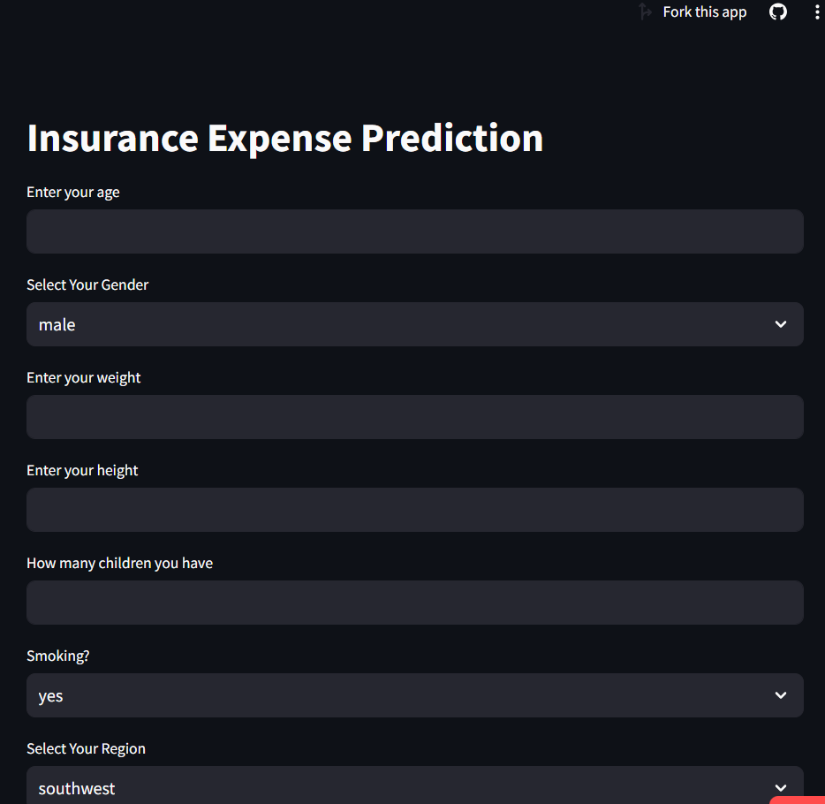

**2. User Input**

Whenever the user hits our url , they first see the user input page here they have to provide the information like:

* Every user input has its own dropdown where the user can select their input.
* After providing the required input and pressing the submit button, the page refreshes and displays the output

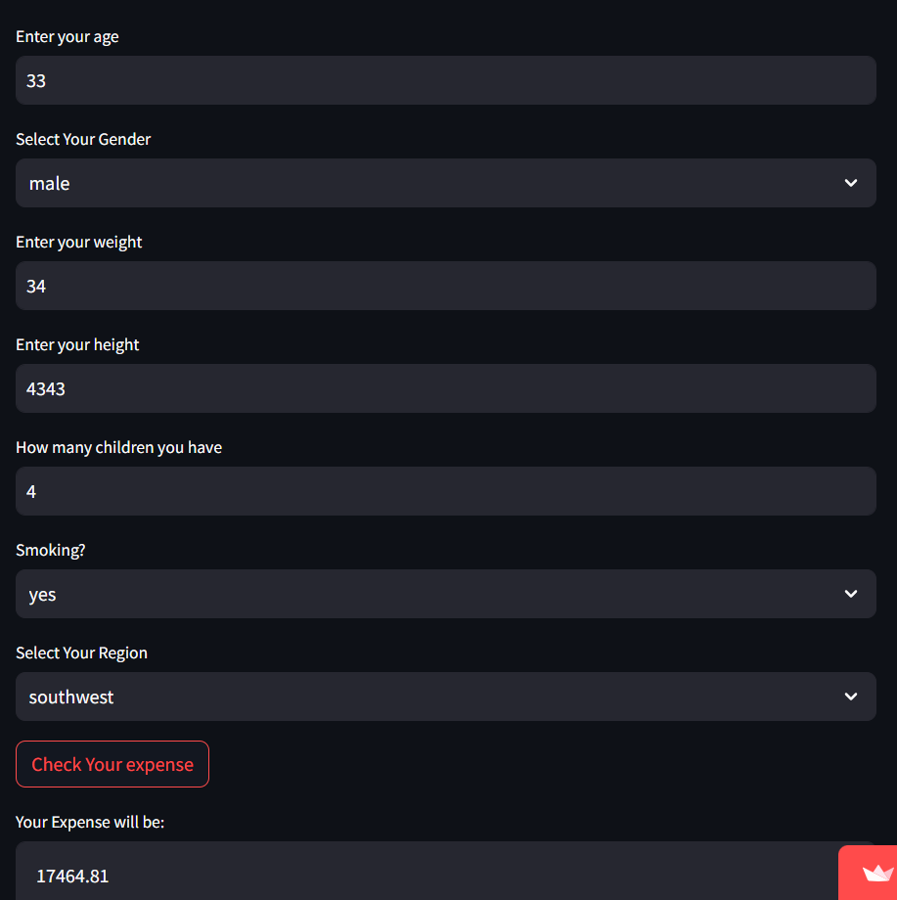

**3. Result Page**

Wireframe

After the user hits the submit button the page gets refreshed and the results are being displayed in the highlighted area in the above frame.

The user can refill all the inputs in same page and get the results in the same way.

**Link:** **https://insurancepremiumpredictio-ayw9rrpslpuxh4psnqsuck.streamlit.app/**