Project2.cpp: The main executing program.

InputFileReader: Reads infile.dat from the current directory.

BankersAlgorithm. Encapsulates the Bankers Algorithm.

This was done using Visual C++ but should run OK on UNIX if the #includes to the precompiled header stdafx.h is dealt with (i.e. delete the #includes or make a blank stdafx.h file).

If the program is run with no argument only the result (safe or unsafe) is printed. If run with any argument, the internal structures are output to show the execution for each pass of the algorithm.

Bill Phillips
Input file:

10 8 6
3
7 5 2 2 1 1
4 3 3 1 2 2
6 2 1 4 2 1
Run with verbose off:
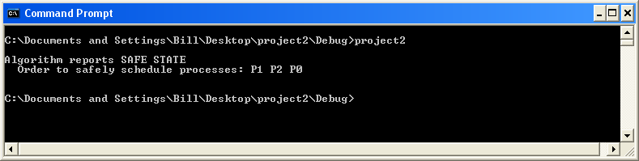

Run with verbose on:
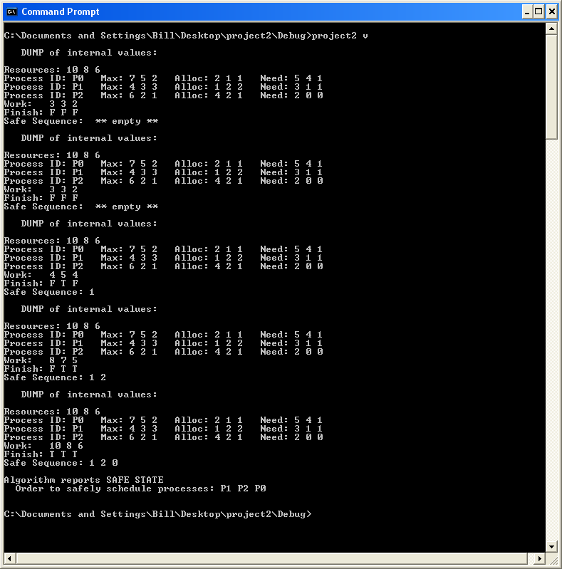

Project2.cpp====================================================
// project2.cpp : Defines the entry point for the console application.
//

#include "stdafx.h"
#include "InputFileReader.h"
#include "BankersAlgorithm.h"

int main(int argc, char* argv[])
{

InputFileReader* ifr = new InputFileReader;

//
// Read the values
// from the input
// file.
//
try
{
ifr->readFile();
}
catch (...)
{printf("***** Error reading input file *****\n\n");}

//
// If the file
// was read OK,
// invoke the
// algorithm.
//
if(ifr->getFileReadOK())
{
const int nP = ifr->getNumberOfProcesses();
BankersAlgorithm BA(ifr,
nP,
ifr->getNumberOfResources(),
ifr->getResources(),
argc>1);

//
// If the algorithm reports "safe state" (returns
// "true") print out the safe order to schedule
// the processes. Otherwise just report
// "unsafe state."
//
if (BA.execute())
{
printf("\nAlgorithm reports SAFE STATE\n");
printf(" Order to safely schedule processes: ");
for (int i=0; i<nP; ++i)
printf("P%d ",BA.getSafeProcess(i));
printf("\n\n");
}
else
printf("\nAlgorithm reports UNSAFE STATE\n\n");
}

delete ifr;

return 0;

}

InputFileReader.h====================================================
#if !defined(InputFileReader___INCLUDED)
#define InputFileReader___INCLUDED

class InputFileReader
{

enum {VALUESPERPROCESS = 6};
enum {NUMBERRESOURCES = 3};

int index;
int numberOfValues;

enum {MAXLENGTH = 2048};
char buffer[MAXLENGTH];

enum {MAXVALS = 1024};
int vals[MAXVALS];

bool fileReadOK;

int numberOfProcesses;

int resources[NUMBERRESOURCES];

public:

InputFileReader();
void readFile();
const int getNumberOfValues();
const int getNextValue();

inline const bool getFileReadOK() {return fileReadOK;}
inline const int getNumberOfResources() {return NUMBERRESOURCES;}
inline const int* const getResources() {return resources;}
inline const int getNumberOfProcesses() {return numberOfProcesses;}

};

#endif

InputFileReader.cpp===================================================
#include "stdafx.h"
#include "InputFileReader.h"
#include <stdio.h>
#include <stdlib.h>
#include <cstring>

InputFileReader::InputFileReader()
{
numberOfProcesses = 0;
numberOfValues = 0;
index = 0;
fileReadOK = false;
}

const int InputFileReader::getNumberOfValues()
{
return (fileReadOK)? numberOfValues : 0;
}

const int InputFileReader::getNextValue()
{
return (index < numberOfValues) ? vals[index++] : 0;
}

void InputFileReader::readFile()
{

fileReadOK = false;

//
// Read the data from "infile.dat" in the current
// directory. It is assumed that the data
// is OK so no error checking is done.
//
FILE* const fp = fopen("infile.dat", "r");

int lastChar = 0;
for (int i = 0; i < MAXLENGTH; ++i)
{
const char ch = getc(fp);
if (ch == EOF)
{
fileReadOK = true;
buffer[lastChar++] = '\0';
fclose(fp);
break;
}

if((ch!='\n') && (ch!='\r')) buffer[lastChar++] = ch;
else buffer[lastChar++] = ' ';

}

char delim[] = " ";

resources[0] = atoi(strtok(buffer,delim));
for (int j = 1; j<NUMBERRESOURCES; ++j)
resources[j] = atoi(strtok(NULL,delim));

numberOfProcesses = atoi(strtok(NULL,delim));
numberOfValues = VALUESPERPROCESS*numberOfProcesses;
for ( j = 0; j<numberOfValues; ++j)
vals[j] = atoi(strtok(NULL,delim));

fileReadOK = true;

}

BankersAlgorithm.h===================================================
#if !defined(bankersAlgorithm___INCLUDED)
#define bankersAlgorithm___INCLUDED

#include "InputFileReader.h"
#include <vector>

using namespace std;
class BankersAlgorithm
{

const bool verbose;

InputFileReader* const ifr;

const int numProcesses;
const int numResources;
const int* resources;

typedef vector<int> vIType;
typedef vector<bool> vBType;
typedef vIType::iterator vIIter;
typedef vBType::iterator vBIter;

vIType tempResources;
vBType ftst;
vBType fini;
vIType aSeq;

class vWType
{
public:
vIType v;
vWType& vWType::operator+=(vWType& x)
{
if (this->v.size())
{
vIIter l = v.begin();
for (vIIter r = x.v.begin(); r != x.v.end(); ++r)
*l = *l++ + *r;
}
else this->v = x.v;
return *this;
}
vWType& vWType::operator-=(vWType& x)
{
vIIter l = v.begin();
for (vIIter r = x.v.begin(); r != x.v.end(); ++r)
if (this->v.size())
*l = *l++ - *r;
else
*l++ = -*r;
return *this;
}
};

vWType work;

class rROW
{
public:
vWType mx;
vWType al;
vWType nd;
};

typedef vector<rROW*> vTType;
typedef vTType::iterator vVIter;

vTType rTable;

void oV(const char* const c, vIType& a, const int r);
void oB(const char* const c, vBType& a, const int r);
void dump();

public:

BankersAlgorithm
( InputFileReader* const infr,
const int np,
const int nr,
const int* const r,
const bool v
);

const bool execute();

const int getSafeProcess(const unsigned int i);

void load();

~BankersAlgorithm() {rTable.clear();}

};

#endif
BankersAlgorithm.cpp==================================================
#include "stdafx.h"
#include "BankersAlgorithm.h"

BankersAlgorithm::BankersAlgorithm
(
InputFileReader* const infr,
const int np,
const int nr,
const int* const r,
const bool v
) :
verbose(v),
numProcesses(np),
numResources(nr),
resources(r),
ifr (infr)
{

//
// Load the data read from the input file
// into the internal data structures.
//
this->load();
}

void BankersAlgorithm::load()
{

//
// Load the internal data structures needed by the
// Banker's Algorithm.
//
vWType tempWork;

for (int i=0; i<numProcesses; ++i)
{

//
// Create a new row and populate it from values
// extracted from the input file.
//
rROW* r = new rROW();
for (int j=0; j<numResources; ++j)
r->mx.v.push_back(ifr->getNextValue());

for ( j=0; j<numResources; ++j)
{
r->al.v.push_back(ifr->getNextValue());
r->nd.v.push_back(r->mx.v[j] - r->al.v[j]);
}
tempWork += r->al;

//
// Add the row to the computation
// table.
//
rTable.push_back(r);

}

//
// Compute the initial values for the
// "work," "finish" and "all true" vectors.
//
for (int j=0; j<numResources; ++j)
{
tempResources.push_back(resources[j]);
fini.push_back(false);
ftst.push_back(true);
}

work.v = tempResources;
work -= tempWork;

}

//
// The following three functions are used
// to dump the contents of the internal
// structures when verbose is set to true.
//
void BankersAlgorithm::oV(const char* const c, vIType& a, const int r=0)
{
if (verbose)
{
printf(c);
if (a.size())
for(vIIter i = a.begin(); i!=a.end(); ++i) printf("%d ",*i);
else printf(" ** empty **");
if(r) for (int k=0; k<r; ++k) printf("\n");
}
}

void BankersAlgorithm::oB(const char* const c, vBType& a, const int r=0)
{
if (verbose)
{
printf(c);
for(vBIter i = a.begin(); i!=a.end(); ++i)
if (*i) printf("T ");
else printf("F ");
if(r) for (int k=0; k<r; ++k) printf("\n");
}
}

void BankersAlgorithm::dump()
{
if (verbose)
{
int pID = 0;
printf("\n DUMP of internal values:\n");
oV("\nResources: ",tempResources, 1);
for(vVIter i = rTable.begin(); i!=rTable.end(); ++i)
{
printf("Process ID: P%d ", pID++);
oV("Max: ", (*i)->mx.v );
oV(" Alloc: ",(*i)->al.v );
oV(" Need: ", (*i)->nd.v,1);
}
oV("Work: ", work.v,1);
oB("Finish: ", fini, 1);
oV("Safe Sequence: ",aSeq, 1);
}
}

const int BankersAlgorithm::getSafeProcess(const unsigned int i)
{
if (i<numProcesses) return aSeq[i];
else return -1;
}

const bool BankersAlgorithm::execute()
{

vIType workLast;

//
// Loop until the work vector doesn't change (Unsafe) or
// until fini vector is all true (safe);
//
while(workLast != work.v)
{

workLast = work.v;

for(int pID=0; pID<numProcesses; ++pID)
{
dump();

//
// If the work vector >= need then it's OK to
// allocate the requested resources and
// schedule the process next.
//
if(work.v >= rTable[pID]->nd.v)
{

//
// If the process has not been
// scheduled it is OK to do so.
//
if(!fini[pID])
{

//
// Add the needed resources to the work vector,
// schedule the process and test if all processes
// have been scheduled.
//
work += rTable[pID]->al;
fini[pID] = true;
aSeq.push_back(pID);
if (fini == ftst)
{
dump();
return true;
}

}
}
}
}
return false;
}

