**Requirements Analysis Document (RAD)**

**Data Storage Subsystem (DSS)**

**for the**

**Predictive Waste Water Management System**

**Phase 1.0**

Prepared by

Fairleigh Dickinson Software Development - Analysis Team

**Security Notice**: The information contained within this document is Restricted. Unauthorized disclosure is prohibited. Failure to observe policy regarding proprietary information can result in disciplinary action, including dismissal, as well as result in a violation of proprietary rights and subject you and/or third parties to legal liability.

Purpose

The Predictive Wastewater Management System is an architectural framework that has been developed by Eastech which provides measurement, monitoring and analytics that can be predicted for the flow of data. It provides a toolkit for optimization and predictive algorithms. The important part of every system is security; it provides security for applications, data and resources. For private access it has authenticity, authorized actors and role based capacities. This system has Audit and alert to handle all the events that occurs in the system and allows gathering the data from the flow cell and storing that data into the storage system. It also provides capability of configuring the flow cell.Document Control

Document History

|  |  |  |
| --- | --- | --- |
| Date | Version | Comments |
| 02/18/2015 | 1.0 I | Initial draft |
| 03/25/2015 | 1.0 II | Included analysis model and dynamic models |
| 04/08/2015 | 1.0 | Document placed under formal internal control |
| 04/08/2015 | 1.1 | Fixed change request -1 |

Authors

|  |  |  |  |
| --- | --- | --- | --- |
| Name | Title | Organization | Phone |
| Sowmya Brahmarouthu | DSS Lead | FDU | 201-397-0100 |
| William Phillips | FDU faculty | CS Department | 201-247-2573 |

Reviewers

|  |  |  |  |
| --- | --- | --- | --- |
| Name | Title | Organization | Phone |
| Mark LaPlante | Product Manager | Eastech | 918-664-1212 |
| William Phillips | FDU faculty | CS Department | 201-247-2573 |
| Amitha Peddi | SQA Engineer | FDU SQA | 336-848-8346 |

Sign Off List

|  |  |  |
| --- | --- | --- |
| Name | Title | Phone |
| Mark LaPlante | Product Manager | 918-664-1212 |
| Alfredo Tan | CS Department Chair | 2324 |
| Amitha Peddi | SQA Engineer | 336-848-8346 |

Document Sign Off

_________________________________ ________________________________

Table of Contents

1 Introduction 5

1.1 Purpose of the System 5

1.2 Scope of the System 6

1.2.1 Actors 6

1.2.2 Subsystems 6

1.2.3 Context Diagram 7

1.3 Objectives and Success Criteria of the Project 8

1.4 Definitions, Acronyms and Abbreviations 8

1.5 References 8

1.6 Overview 8

2 Current System 9

3 Proposed System 10

3.1 Overview 10

3.2 Functional Requirements 10

3.3 Nonfunctional Requirements 10

3.3.1 Security 10

3.4 Use Cases 11

3.4.1 System Administrator configures Data Storage 11

3.4.2 Data Gathering requests data to be gathered from Flowcell 12

3.4.3 Data Analysis requests data from the Data Storage 13

3.4.4 Use Case Diagram 14

3.5 Object Model 15

3.5.1 DGSDSSInterface (Boundary) 15

3.5.2 DGSFlowcellInterface(Boundary) 15

3.5.3 SADGSInterface (Boundary) 15

3.5.4 AASDSSInterface (Boundary) 15

3.5.5 DASDSSInterface (Boundary) 15

3.5.6 DGSDSSControl (Control) 15

3.5.7 DGSFlowcellcontrol (Control) 15

3.5.8 SADGSControl (Control) 15

3.5.9 DASDSSControl (Control) 15

3.5.10 DSSConfigurationData (Entity) 16

3.5.11 DSSData (Entity) 16

3.5.12 Conceptual Class Diagram 17

4 Dynamic model 18

4.1 System Administrator configures Data Storage 18

4.1.1 Sequence Diagram 19

4.1.2 Collaboration Diagram 20

4.2 Data Gathering requests data to be gathered from Flowcell 21

4.2.1 Sequence diagram 21

4.2.2 Collaboration Diagram 22

4.3 Data Analysis requests data from the Data Storage 23

4.3.1 Sequence Diagram 23

4.3.2 Collaboration Diagram 24

# Introduction

This document describes the requirements and the analysis functional model for the Data Storage subsystem.

## Purpose of the System

The data storage subsystem plays an important role in the predictive waste water management system. This subsystem is responsible in storing of the gathered data and analyzed data.

Data Storage Subsystem:

* The data that has been requested by the data gathering subsystem (DGS) will be stored by the DSS.
* Supports security for applications, software components, data, and resources
* System administrator provides configuring data for the DS.
* Shall leverage Commercial Off-the-shelf (COTS) solutions as appropriate.
* The data stored is provided to the Data Analysis subsystem (DAS) for algorithm development/execution.

## Scope of the System

The context diagram for the Data storage subsystem is shown in  Figure 1. The Data storage shall support the actors shown in section 1.2.1

### Actors

|  |  |
| --- | --- |
| **Actor Catalog** | |
| **Actor Name** | **Description** |
| System Administrator | The System Administrator is an actor who adds and deletes users to and from the PWMS, assigns roles, and performs other system administration duties |
| FlowCell | The Eastech FlowCell participatory sensing device. It provides the data required for algorithm development and execution. |

### Subsystems

|  |  |
| --- | --- |
| **Subsystems** | |
| **Subsystem Name** | **Description** |
| DataGathering(DGS) | The PWMS subsystem that collects the data from the FlowCell participatory sensors. |
| DataAnalysis(DAS) | The PWMS subsystem that performs data reduction, analysis and provides reports for the Data Analyst |
| AuditAndAlert(AAS) | The PWMS subsystem that periodically surveys the PWMS data and alerts the Watchman of a potential emergency situation. Maintains a store of audit records for the PWMS for an audit report. |
| DataStorage(DSS) | The PWMS subsystem that stores and organizes the PWMS data for use by the DataGathering, DataAnalysis, and AuditAndAlert subsystems. |

### Context Diagram

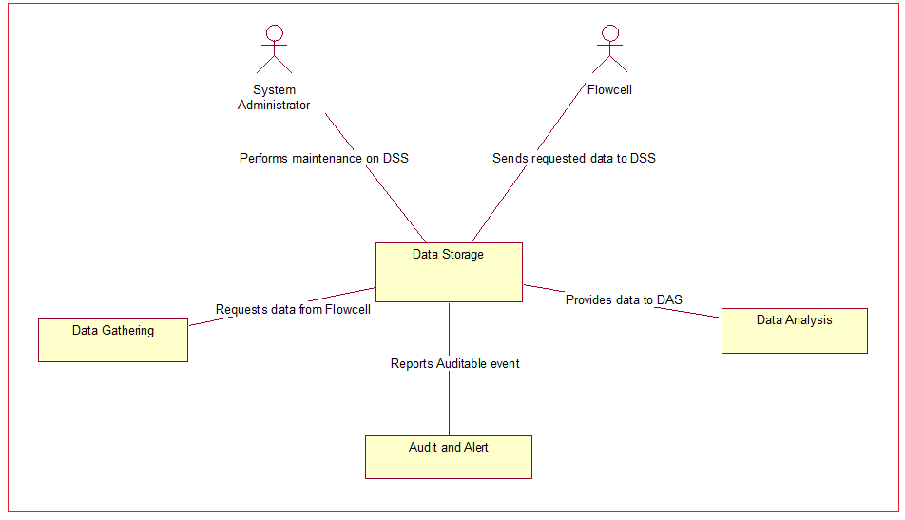

## Objectives and Success Criteria of the Project

System acceptance tests shall be created for each of the six RAD documents (this one and one RAD for each of the five subsystems). Success of this project or shall be contingent upon the test criteria being met to the satisfaction of Eastech and Fairleigh Dickinson.

## Definitions, Acronyms and Abbreviations

PWMS- Predictive Wastewater Management System

AAS – Audit and Alert Subsystem

SA – System Administrator

DGS – Data Gathering Subsystem

DAS – Data Analysis Subsystem

DSS- Data Storage Subsystem

## References

System Level Requirements Analysis Document for the Predictive Wastewater Management System (PWMS)

Bernd Bruegge and Allen H. Dutoit, *Object-Oriented Software Engineering: Using UML, Patterns and Java*, 3rd

Edition, Prentice Hall, 2010 (ISBN 0-13-606125-7)

Jacobson, Ivar *Object-Oriented Software Engineering-A Use Case Driven Approach.* Addison Wesley 1992.

Martin Fowler, *UML Distilled: A Brief Guide to the Standard Object Modeling Language,* 3rd ed., Addison

Wesley, 2003.

Roger S. Pressman, *Software Engineering: A Practitioner’s Approach*, 7th Edition, McGraw Hill, 2009 (ISBN

9780071267823)

Black and Veatch, Smart Integrated Infrastructure White Paper, September 23, 2014.

## Overview

This document describes the data stored in the DSS of the Predictive Wastewater Management System (PWMS). It takes data from the gathering subsystem and stores that in this subsystem. The data that has been stored in here is retrieved by the DAS to create algorithms.

# Current System

There is no current system in place for the PWMS. However, there are a number of applications involving participatory sensing systems and how those systems operate and can be made secure. The literature shall be thoroughly researched to leverage the state-of-the-art in implementing and securing the PWMS from unauthorized users.

# Proposed System

Our vision closely resembles the system described in the Black and Veatch Whitepaper. By employing the scenario/ use case driven approach we intend to define how end users will employ the system toward the measurement, monitoring, analysis, storage and role-enforcement functions of the PWMS.

## Overview

The overall requirements for PWMS, considering the subsystems as analysis objects are described in this RAD. PWMS gathers from DSS and stores data into DSS from the participatory network formed by a collection of Flowcell sensors. The stored data is monitored periodically for alert situations in the PWMS being monitored by AAS. A framework shall be provided for use by the Data Analyst in order to create, package and run predictive, optimization algorithms DAS. The ACS provides security and handles authentication and authorization for PWMS.

## Functional Requirements

1. The DSS shall store data for the PWMS.
2. The DSS shall provide data to the DAS for algorithm development and execution.
3. System administrator configures the data storage subsystem.
4. The DSS shall report Auditable Events to the Audit and Alert Subsystem (AAS).
5. The DSS shall report Alertable Events to the Audit and Alert Subsystem (AAS).
6. Auditable events shall be,
   1. When a message is received from DGS.
   2. When the data is retrieved from the Flowcells.
   3. Configuration file updated.
7. Alertable events shall be,
   1. When an internal error occurs.
   2. When an intrusion attempt is made.

## Nonfunctional Requirements

Nonfunctional requirements are those requirements that are not found by doing use cases or modeling but are nevertheless required for successful operation of the PWMS.

### Security

The data channels to and from the DSS shall be secure.

## Use Cases

Use cases are provided as the functional model of PWMS. The use cases are realized by tracing the event flows through the analysis model as part of the dynamic modelling process.

### System Administrator configures Data Storage

|  |  |  |  |  |
| --- | --- | --- | --- | --- |
| **PWMS Use Case** | | | | |
| ***Project*** | PWMS | | | |
| ***ID Number*** | DSS001 | ***Status*** | For Customer Review | |
| ***Creation Date*** | 3/5/2015 | ***Last Revision Date*** | | 3/5/2015 |
| ***Author(s)*** | Sowmya Brahmarouthu | | | |
| ***Requirements Map*** | 3,4,5 | | | |

**Description/Intent**

System administrator configures Data Storage

**Actors**

System administrator and data storage

**Extends**

None

**Uses**

None

**Pre-Conditions**

The Data Storage Subsystem is operating normally.

**Post-Conditions**

The Data Storage Subsystem is operating normally. The Data Storage Subsystem configuration is updated.

**Ideal Course of Action**

1. System Administrator logs into the Data Storage subsystem.
2. System Administrator selects the “Configure Data Storage Subsystem” on the System Admin dashboard.
3. A menu of configurable data is displayed.
4. Changes are made to the configurable data.
5. System Administrator selects “configure”
6. An auditable event is sent to the Audit and Alert subsystem
7. The use case ends.

**Exceptional Course of Actions**

None

**Comments**

None

### Data Gathering requests data to be gathered from Flowcell

|  |  |  |  |  |
| --- | --- | --- | --- | --- |
| **PWMS Use Case** | | | | |
| ***Project*** | PWMS | | | |
| ***ID Number*** | DSS002 | ***Status*** | For Customer Review | |
| ***Creation Date*** | 3/5/2015 | ***Last Revision Date*** | | 3/5/2015 |
| ***Author(s)*** | Sowmya Brahmarouthu | | | |
| ***Requirements Map*** | 1,4 | | | |

**Description/Intent**

Data gathering requests data to be gathered from Flowcell

**Actors**

Data gathering, Audit and Alert, Flowcell

**Extends**

None

**Uses**

None

**Pre-Conditions**

System is operating normally

**Post-Conditions**

Data is being stored into the DSS

**Ideal Course of Action**

1. DGS sends message to DSS identifying the flowcells and data to be stored.
2. Audit and Alert notified.
3. DSS retrives the required data from the Flowcells.

**Exceptional Course of Actions**

1. Data unavailable from flowcells.
2. Audit and Alert notified (Auditable event).

**Comments**

None

### Data Analysis requests data from the Data Storage

|  |  |  |  |  |
| --- | --- | --- | --- | --- |
| **PWMS Use Case** | | | | |
| ***Project*** | PWMS | | | |
| ***ID Number*** | DSS003 | ***Status*** | For Customer Review | |
| ***Creation Date*** | 3/5/2015 | ***Last Revision Date*** | | 3/5/2015 |
| ***Author(s)*** | Sowmya Brahmarouthu | | | |
| ***Requirements Map*** | 2,4 | | | |

**Description/Intent**

Data Analysis request data from the Data Storage

**Actors**

Data Analysis, Audit and Alert system

**Extends**

None

**Uses**

None

**Pre-Conditions**

The Data Analysis subsystem is ready to operate.

**Post-Conditions**

The Data Analysis subsystem is ready to operate. The stored data is retrieved by the Data Analysis.

**Ideal Course of Action**

1. DAS requests data for a dataset from DSS.
2. Requested dataset is sent to DAS.
3. Audit and alert notified.
4. Use case ends.

**Exceptional Course of Actions**

1. Requested dataset is not available.
2. Audit and alert notified.
3. Use case ends.

**Comments**

None

### Use Case Diagram

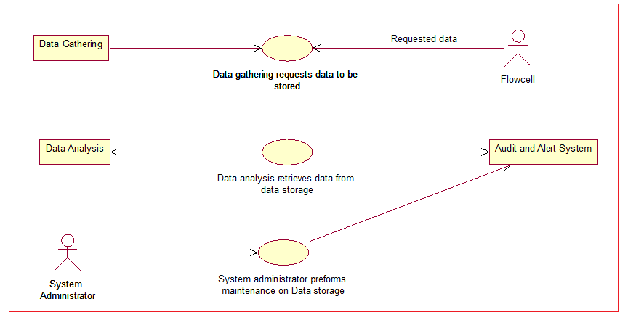

## Object Model

The Object Model is represented by the Conceptual Class Diagram shown on Figure 3.6.1

The DSS is comprised of the following objects.

### DGSDSSInterface (Boundary)

This is the interface used by the DSS which stores the gathered data from DGS.

### DGSFlowcellInterface(Boundary)

This is the interface used by the flowcells to input data into the DGS.

### SADGSInterface (Boundary)

This is the interface that the system administrator uses to input configuration data.

### AASDSSInterface (Boundary)

This is the interface that the Audit and alert system sends events to the DSS configured data.

### DASDSSInterface (Boundary)

This is the interface that receives the data to be analyzed in the system.

### DGSDSSControl (Control)

The DSS controls what type of data is to be stored from the gathered data.

### DGSFlowcellcontrol (Control)

The DGS controls what type of data should be gathered from the flowcell.

### SADGSControl (Control)

System administrator controls gathered data within the DGS.

### DASDSSControl (Control)

DGS controls the gathered data and allows DAS to accomplish their functions to be performed.

### DSSConfigurationData (Entity)

Configuration data is the collection of configured data used by the DSS.

### DSSData (Entity)

DSS data holds the data that has been gathered from the DGS.

### Conceptual Class Diagram

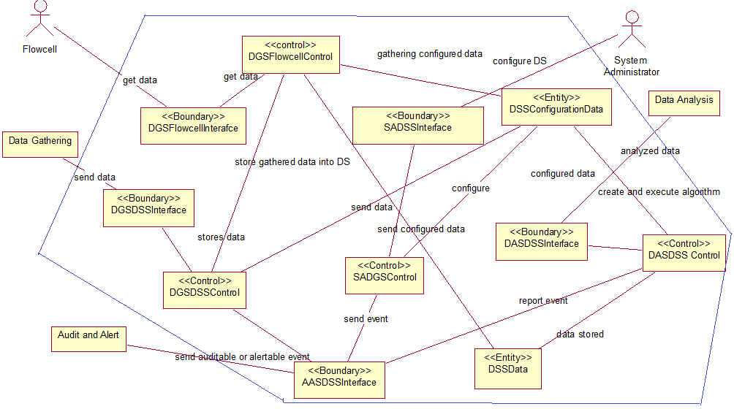

# Dynamic model

The dynamic model depicting interaction among the ACS subsystem objects are described in this section. Dynamic modeling at this level shows interactions amongst the ACS subsystem objects with other subsystems decomposed into entity, boundary and control objects for each subsystem in the individual RADs for each of the subsystems. Sequence, communication, state and activity diagrams are the Unified Modeling Language (UML) components that are used to show the dynamic model.

The sequence and communication diagrams correspond one-to-one with the use cases of this document.

## System Administrator configures Data Storage

System Administrator configures and updates the configured data to DSS.

### Sequence Diagram

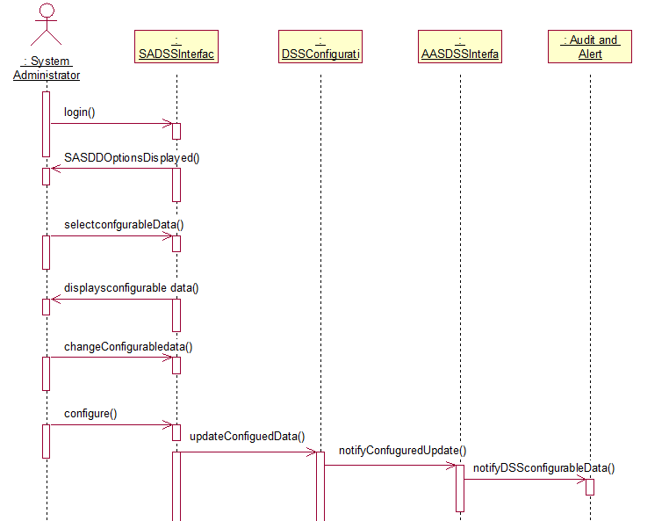

### Collaboration Diagram

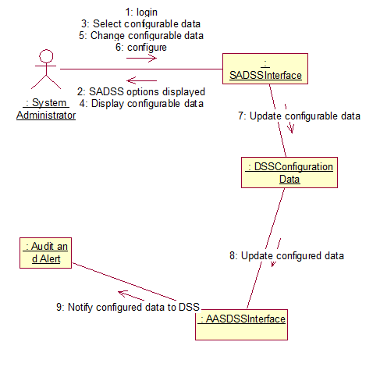

## Data Gathering requests data to be gathered from Flowcell

Data gathering system requests for the data to be gathered from the Flowcell system.

### Sequence diagram

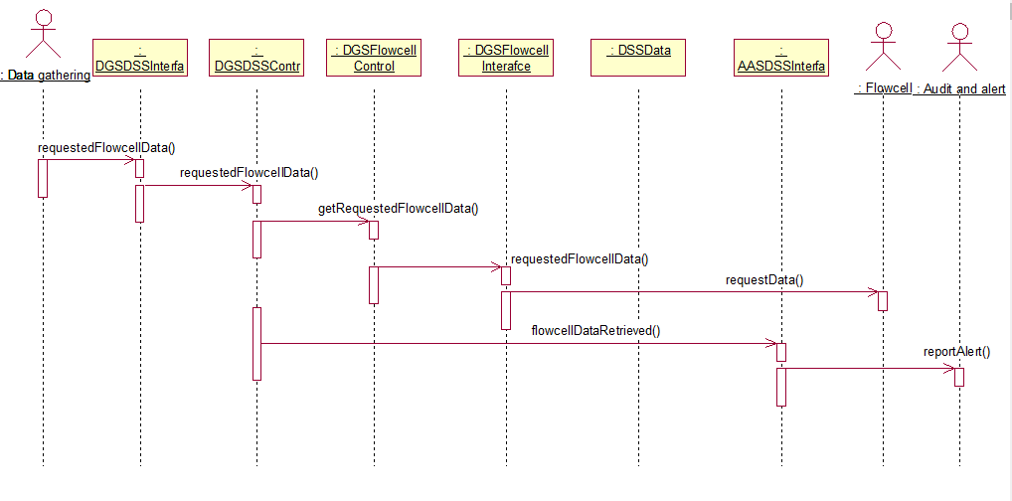

### Collaboration Diagram

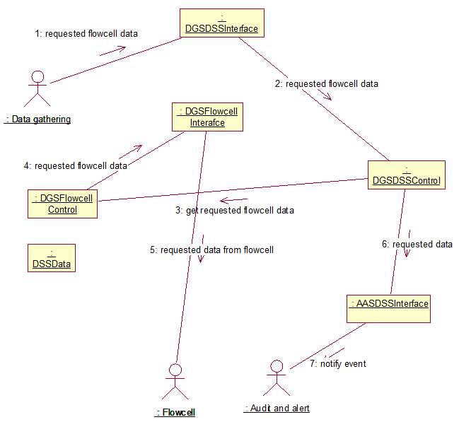

## Data Analysis requests data from the Data Storage

The Data analysis requests data from the Data storage subsystem.

### Sequence Diagram

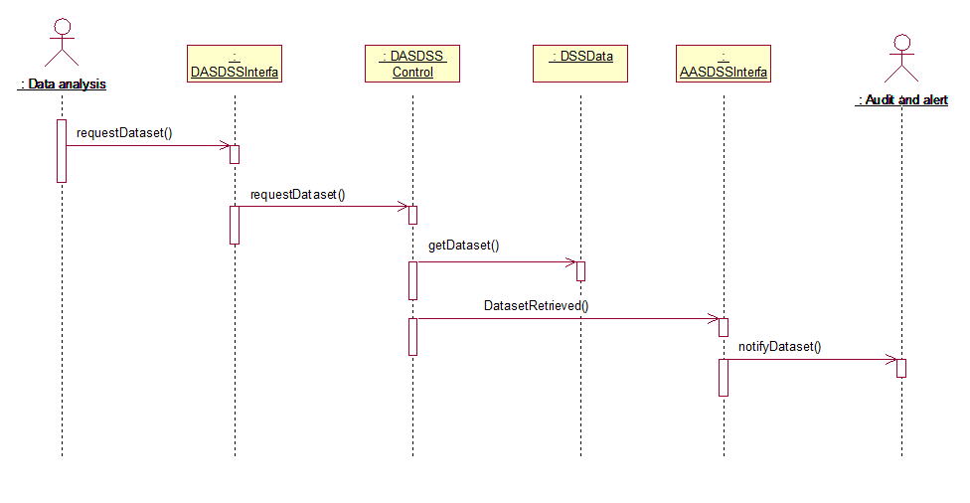

### Collaboration Diagram

