

Arwa Khaled Sengab

22101522
Course: CBIO313: Data Mining and Machine Learning-2026SPRG
Tittle:
Chronic Kidney Disease Prediction Using Machine Learning
Under supervision of Dr. Muhammad Elsayeh
Date :1/6/2026

Abstract
Chronic Kidney Disease (CKD) is a serious health condition that affects kidney function and may lead to kidney failure if not detected early. The aim of this project was to develop a machine learning model capable of predicting CKD using clinical and laboratory measurements. The dataset contained 400 patient records and included several numerical and categorical variables. Data preprocessing involved handling missing values, encoding categorical variables, feature engineering, feature selection, and feature scaling. Three machine learning algorithms, Logistic Regression, Random Forest, and Support Vector Machine (SVM), were trained and evaluated. The SVM model achieved the highest accuracy of 98.75%. The final model was deployed using Streamlit to provide real-time predictions through a user-friendly web application. The results demonstrate the effectiveness of machine learning in supporting the early detection of Chronic Kidney Disease.

Introduction
Chronic Kidney Disease is a progressive medical condition in which the kidneys gradually lose their ability to filter waste products and excess fluids from the blood. According to global health reports, CKD affects millions of individuals worldwide and represents a major public health challenge. Early diagnosis is important because timely intervention can slow disease progression and reduce complications.
Machine learning has become an important tool in healthcare because it can identify patterns in clinical data and support medical decision-making. By analyzing patient information, machine learning models can assist healthcare professionals in predicting diseases and improving patient outcomes.
The objective of this project was to develop and evaluate machine learning models for CKD prediction and identify the model that provides the best classification performance.

Dataset Description
The dataset was obtained from the UCI Machine Learning Repository and contains 400 patient records with 25 clinical features and one target variable. The target variable indicates whether a patient has Chronic Kidney Disease or not.
Examples of features included:
- Age
- Blood Pressure
- Albumin
- Sugar
- Blood Glucose Random
- Blood Urea
- Serum Creatinine
- Hemoglobin
- Packed Cell Volume
- Hypertension
The dataset contained missing values and mixed data types, making it suitable for demonstrating data cleaning and preprocessing techniques.
Dataset Source: UCI Chronic Kidney Disease Dataset
Dataset Property | Value
Samples | 400
Features | 25
Missing Values Before Cleaning | 1009
Missing Values After Cleaning | 0
CKD Cases | 250
Non-CKD Cases | 150

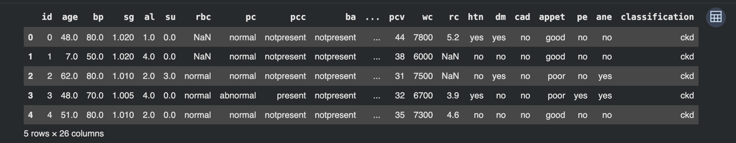
Figure1.dataset overview

Data Preprocessing
Several preprocessing steps were performed before model development.

Data Cleaning
Missing values were handled using median imputation for numerical variables and mode imputation for categorical variables. Categorical features were converted into numerical representations to enable machine learning analysis.
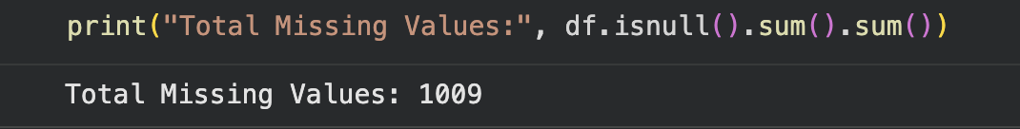
Figure 2. Total Missing Values Before Data Cleaning
The original CKD dataset contained 1,009 missing values distributed across multiple clinical features. Missing values were handled during preprocessing to improve data quality and ensure reliable model training.
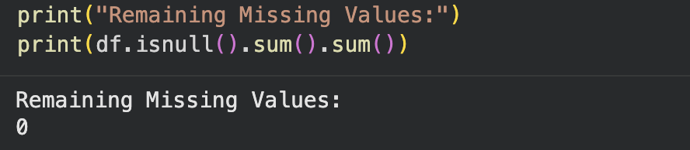
Figure 3. Remaining Missing Values After Data Cleaning
After applying median and mode imputation techniques, the number of missing values was reduced to zero, indicating that the dataset was fully cleaned and ready for analysis.

Feature Engineering
A new feature called Anemia_Status was created using hemoglobin levels. Patients with low hemoglobin values were categorized as anemic, while others were categorized as normal. This feature provided additional clinically meaningful information.
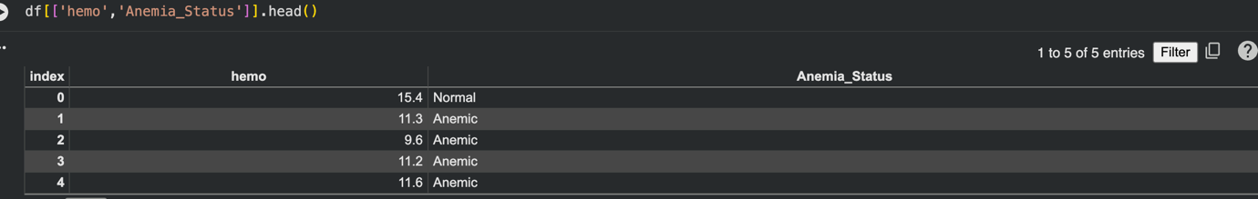
Figure 4. Creation of the Anemia_Status Feature Based on Hemoglobin Levels
A new feature, Anemia_Status, was generated from hemoglobin values during the feature engineering stage. Patients with low hemoglobin levels were classified as Anemic, while patients with normal hemoglobin levels were classified as Normal. This feature was created to provide additional clinically relevant information and improve CKD prediction performance.
Feature Selection
SelectKBest was used to identify the most informative features for CKD prediction. The selected features included:
- Age
- Albumin
- Sugar
- Blood Glucose Random
- Blood Urea
- Serum Creatinine
- Hemoglobin
- Packed Cell Volume
- Red Blood Cell Count
- Hypertension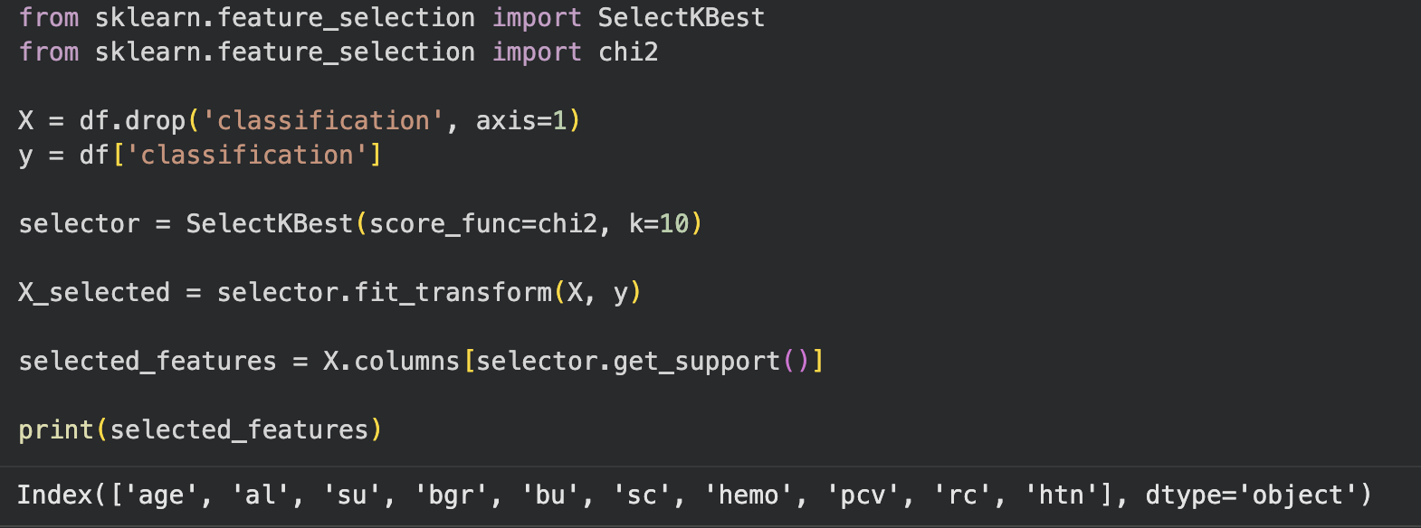
Figure 5. Top 10 Selected Features Using SelectKBest (Chi-Square Test)
The SelectKBest feature selection method with the Chi-Square (χ²) test was applied to identify the most informative features for Chronic Kidney Disease prediction. The top selected features were age, albumin (al), sugar (su), blood glucose random (bgr), blood urea (bu), serum creatinine (sc), hemoglobin (hemo), packed cell volume (pcv), red blood cell count (rc), and hypertension (htn).

Data Splitting and Scaling
The dataset was divided into training and testing sets using an 80:20 ratio. Feature scaling was applied using StandardScaler to ensure that all variables were on a comparable scale
before model training.
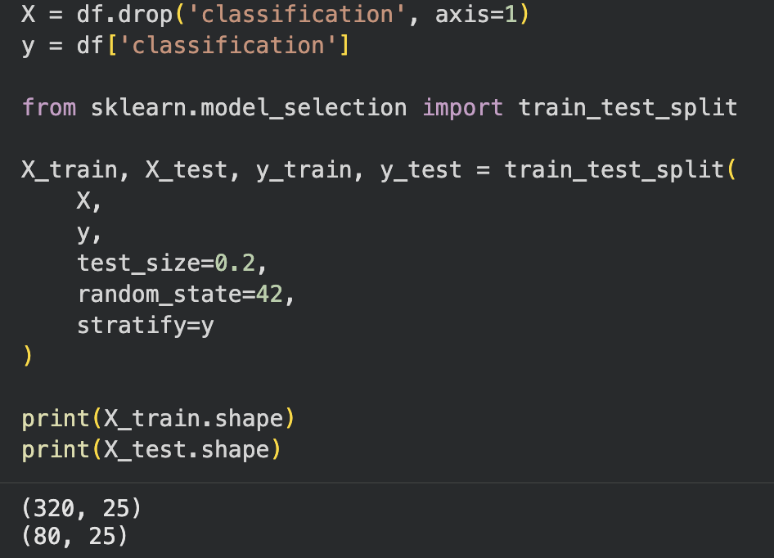
Figure 5. Train-Test Split of the CKD Dataset
The dataset was divided into training and testing subsets using an 80:20 ratio. The training set contained 320 samples, while the testing set contained 80 samples. Stratified sampling was applied to preserve the original class distribution of CKD and non-CKD patients in both subsets.

Exploratory Data Analysis
Exploratory Data Analysis was performed to better understand the dataset and identify important patterns.
The age distribution showed that most patients were middle-aged and older adults, suggesting that CKD is more common in these age groups.
The serum creatinine boxplot demonstrated that CKD patients generally had significantly higher serum creatinine levels compared to non-CKD patients. This result is consistent with the role of creatinine as an indicator of kidney function.
The hemoglobin analysis revealed lower hemoglobin levels among CKD patients, indicating a potential association between CKD and anemia.
A correlation heatmap showed strong relationships between CKD and several clinical variables, particularly serum creatinine, blood urea, hemoglobin, packed cell volume, and red blood cell count.

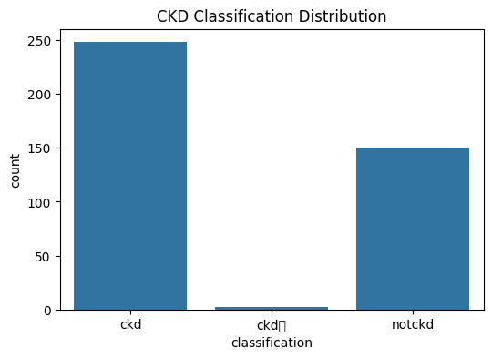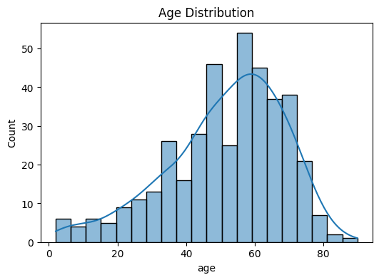
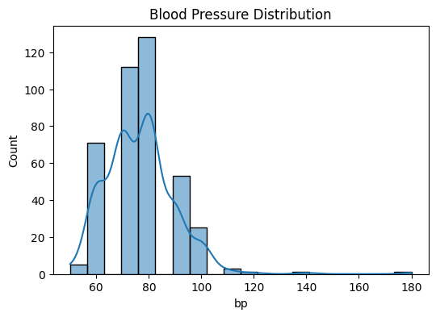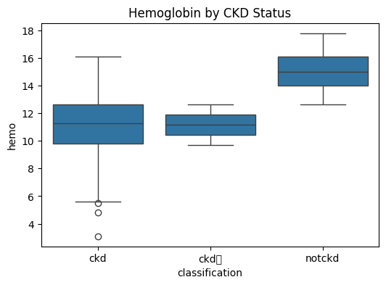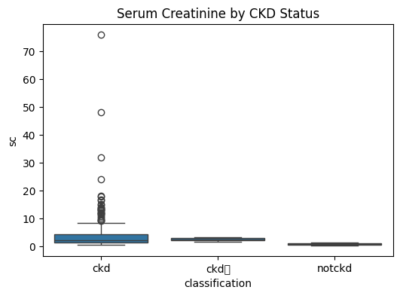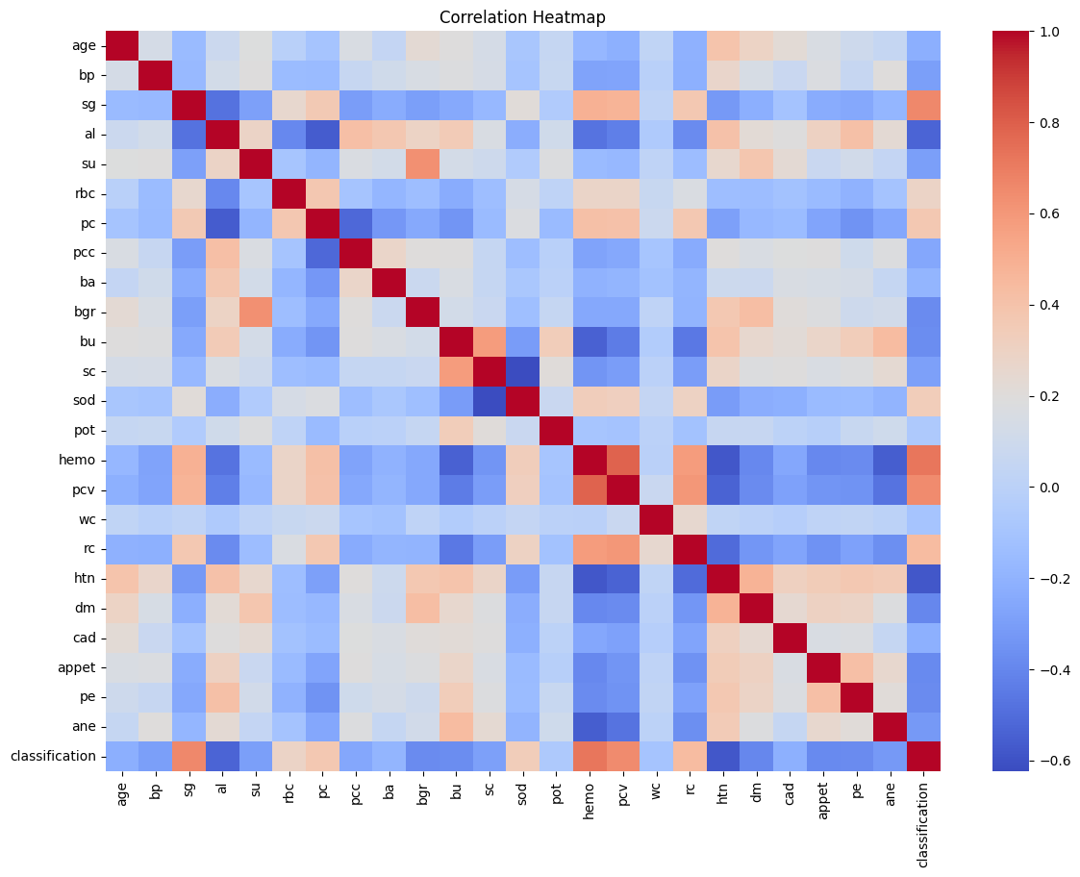

Figure 6. CKD Classification Distribution
Distribution of CKD and non-CKD patients in the dataset.

Figure 7. Age Distribution
Distribution of patient ages included in the CKD dataset.

Figure 8. Blood Pressure Distribution
Distribution of blood pressure measurements among patients.

Figure 9. Hemoglobin by CKD Status
Comparison of hemoglobin levels between CKD and non-CKD patients.

Figure 10. Serum Creatinine by CKD Status
Comparison of serum creatinine levels between CKD and non-CKD patients.

Figure 11. Correlation Heatmap
Correlation matrix showing relationships among clinical features and CKD status.

Machine Learning Models
Three machine learning algorithms were evaluated:

Logistic Regression
Logistic Regression achieved an accuracy of 97.5%, demonstrating strong baseline classification performance.

Random Forest
Random Forest achieved an accuracy of 97.5%. The ensemble-based approach effectively captured complex relationships between features.

Support Vector Machine
Support Vector Machine achieved the highest accuracy of 98.75%, making it the best-performing model in this study.
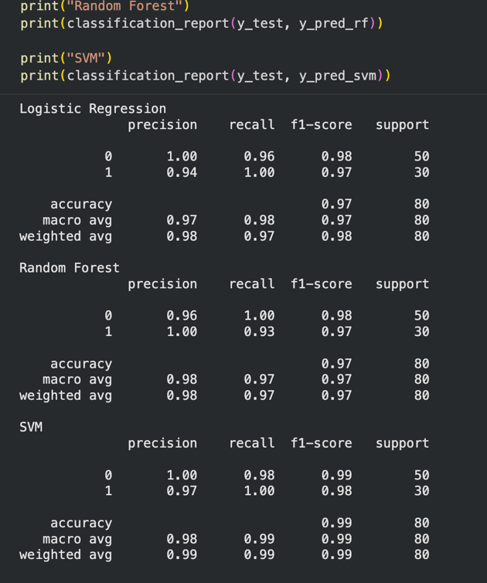

Figure 12. Classification Report of Machine Learning Models

Performance evaluation of Logistic Regression, Random Forest, and Support Vector Machine models using precision, recall, F1-score, and accuracy metrics.

Hyperparameter Tuning and Validation
GridSearchCV was applied to optimize Random Forest parameters. The best parameter combination included:
- n_estimators = 50
- max_depth = None
- min_samples_split = 2
The optimized model achieved a cross-validation score of 99.06%.
Cross-validation was used to evaluate model stability and ensure that the model generalized well to unseen data. The high validation score indicated strong model reliability and minimal overfitting.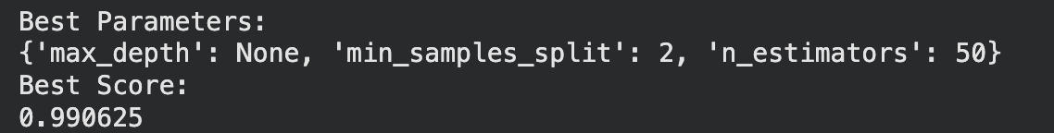

Figure 13. Hyperparameter Tuning Results Using GridSearchCV
Optimal Random Forest parameters identified using GridSearchCV with the corresponding cross-validation score.

Model Evaluation
Several evaluation metrics were used, including accuracy, precision, recall, and F1-score.
All models achieved excellent performance; however, the SVM model consistently outperformed the other algorithms.
The confusion matrix showed that the SVM model correctly classified 79 out of 80 test samples, with only one misclassified instance.
The ROC curve achieved an Area Under the Curve (AUC) value of 1.00, indicating near-perfect discrimination between CKD and non-CKD patients.
The learning curve demonstrated minimal overfitting and strong generalization performance, as training and validation accuracies remained consistently high.
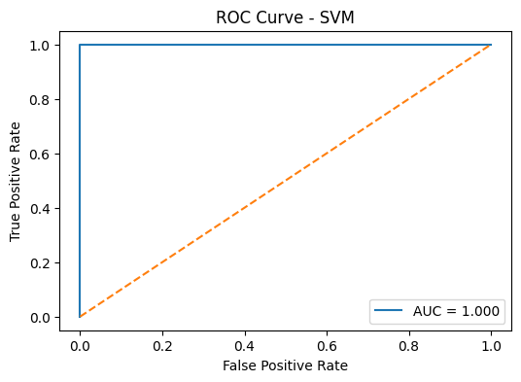
AUC: 1.0

Figure 14. ROC Curve of the SVM Model
Receiver Operating Characteristic (ROC) curve of the Support Vector Machine model with Area Under the Curve (AUC).

Deployment
The final SVM model was deployed using Streamlit. The web application allows users to enter patient clinical information and receive real-time CKD predictions. This deployment demonstrates the practical application of machine learning in healthcare and provides a user-friendly interface for prediction.
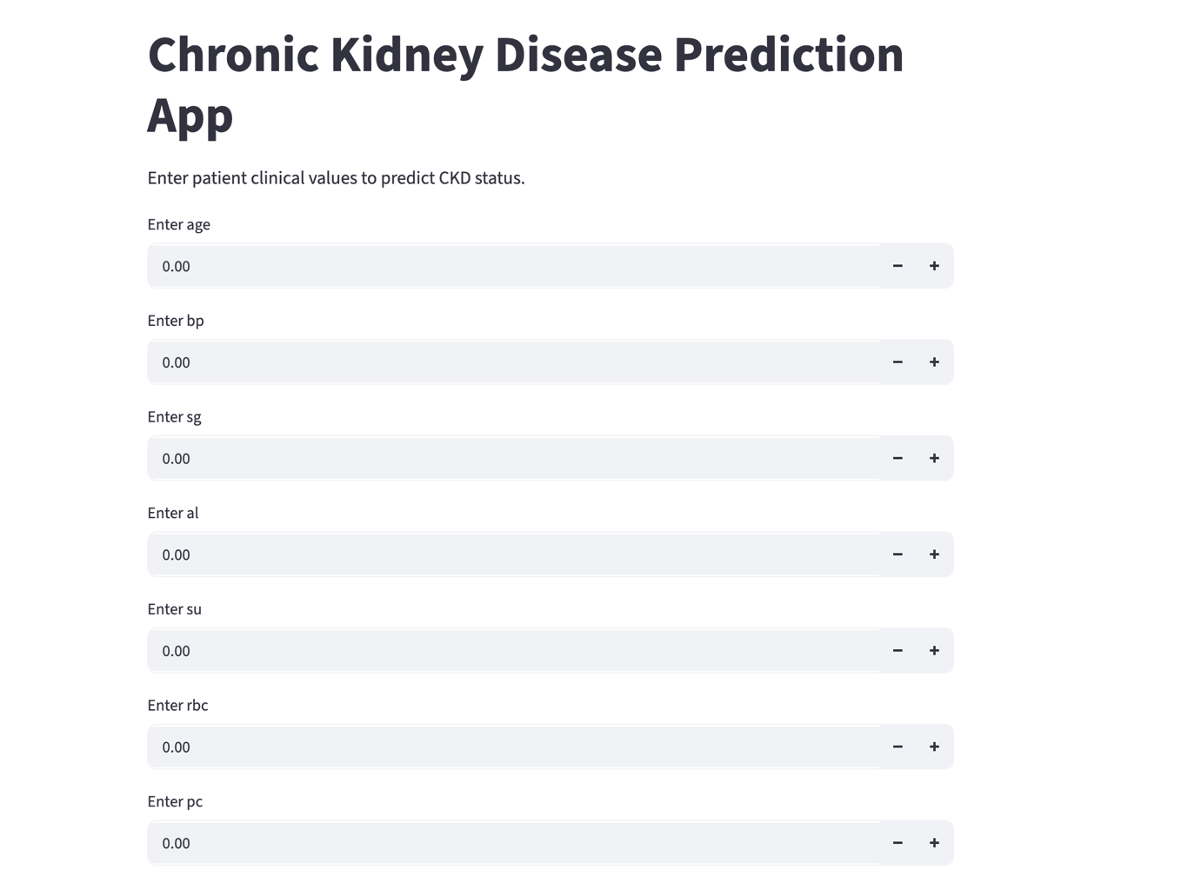
Figure 14. Streamlit Web Application Interface
Streamlit application developed for real-time Chronic Kidney Disease prediction.

Conclusion
This project successfully developed a machine learning model for Chronic Kidney Disease prediction using clinical and laboratory measurements. After preprocessing, feature engineering, feature selection, and model evaluation, the Support Vector Machine model achieved the highest performance with an accuracy of 98.75%. The model also demonstrated excellent precision, recall, F1-score, and AUC values. The successful deployment of the model using Streamlit highlights the potential of machine learning as a practical tool for supporting early CKD detection and clinical decision-making.

Future Work
Future work could focus on using larger and more diverse datasets to improve model robustness and generalization. Additional machine learning and deep learning approaches may also be investigated. Furthermore, the Streamlit application can be enhanced with improved visualization features and integrated into healthcare information systems to support real-world clinical use.

References:
- Dua, D., & Graff, C. (2019). UCI Machine Learning Repository. University of California, Irvine, School of Information and Computer Sciences. Available at: https://archive.ics.uci.edu
- Pedregosa, F., Varoquaux, G., Gramfort, A., Michel, V., Thirion, B., Grisel, O., et al. (2011). Scikit-learn: Machine Learning in Python. Journal of Machine Learning Research, 12, 2825–2830. Available at: https://scikit-learn.org
- Streamlit Inc. (2025). Streamlit Documentation. Available at: https://docs.streamlit.io
- Han, J., Kamber, M., & Pei, J. (2022). Data Mining: Concepts and Techniques (4th ed.). Morgan Kaufmann. Available at: https://www.sciencedirect.com/book/9780128117606/data-mining

