Name: E mahanth arya
H.NO: 2303A54028 - B47a
Lab 9 – Code Review and Quality: Using AI to improve code quality and readability

Lab Objectives:
- To apply AI-based prompt engineering for code review and quality improvement.
- To analyze code for readability, logic, performance, and maintainability issues.
- To use Zero-shot, One-shot, and Few-shot prompting for improving code quality.
- To evaluate AI-generated improvements using standard coding practices.
Lab Outcomes (LOs): After completing this lab, students will be able to:
- Review and improve code quality using AI tools.
- Identify syntax, logic, and performance issues in code.
- Refactor code to improve readability and maintainability.
- Compare AI outputs generated using different prompting techniques.

Problem Statement 1: AI-Assisted Bug Detection
Scenario: A junior developer wrote the following Python function to calculate factorials:

def factorial(n):
result = 1 for i in range(1, n): result = result * i return result Instructions:
  - Run the code and test it with factorial(5).
  - Use an AI assistant to:
◦ Identify the logical bug in the code.
◦ Explain why the bug occurs (e.g., off-by-one error).
◦ Provide a corrected version.
  - Compare the AI’s corrected code with your own manual fix.
  - Write a brief comparison: Did AI miss any edge cases (e.g., negative numbers, zero)?
Expected Output:
Corrected function should return 120 for factorial(5).
Reviewed Code: def factorial(n):
result = 1 for i in range(1, n): result = result * i return result
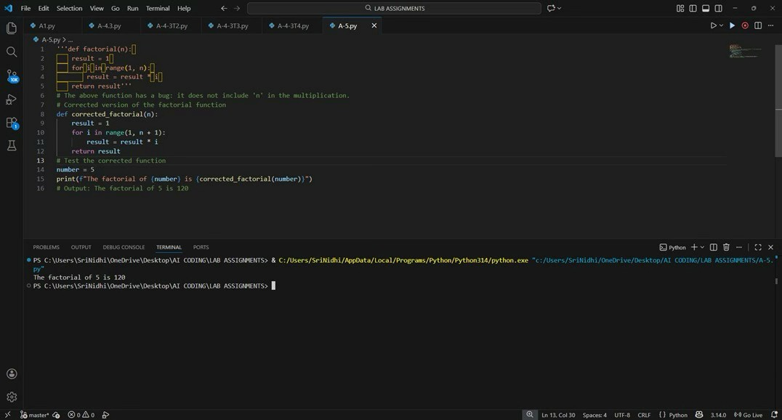
# The above function has a bug: it does not include 'n' in the multiplication.
# Corrected version of the factorial function def corrected_factorial(n): result = 1 for i in range(1, n + 1):
result = result * i return result
# Test the corrected function number = 5
print(f"The factorial of {number} is {corrected_factorial(number)}") # Output: The factorial of 5 is 120

Explanation:
Bug Identification:
The loop uses range(1, n), which excludes n. This is a classic off-byone error, so factorial(5) computes 1×2×3×4 = 24 instead of 120.
Correction & Comparison:
AI correctly fixes the loop to range(1, n + 1). However, it misses edge-case handling like negative inputs and doesn’t explicitly validate n >= 0. A robust manual fix should include input validation.

Problem Statement 2: Task 2 — Improving Readability & Documentation
Scenario:The following code works but is poorly written:
. def calc(a, b, c): if c == "add": return a + b elif c == "sub": return a - b elif c == "mul": return a * b
elif c == "div":
Instructions:
- Use AI to:
◦ Critique the function’s readability, parameter naming, and lack of documentation.
◦ Rewrite the function with:
  - Descriptive function and parameter names.
  - A complete docstring (description, parameters, return value, examples).
  - Exception handling for division by zero.
  - Consideration of input validation.
- Compare the original and AI-improved versions.
- Test both with valid and invalid inputs (e.g., division by zero, non-string operation).
Expected Output:
A well-documented, robust, and readable function that handles errors gracefully.
Reviewed Code
def calculate(operation: str, x: float, y: float) -> float:
"""
Perform a basic arithmetic operation on two numbers.
Parameters:
operation (str): The operation to perform.
Supported values: 'add', 'sub', 'mul', 'div' x (float): First number y (float): Second number
Returns:
float: Result of the arithmetic operation
Raises:
ValueError: If an unsupported operation is provided
ZeroDivisionError: If division by zero is attempted
TypeError: If inputs are of invalid type
Examples:
>>> calculate("add", 5, 3)
8
>>> calculate("div", 10, 2)
5.0 """
if not isinstance(operation, str):
raise TypeError("Operation must be a string")
if not isinstance(x, (int, float)) or not isinstance(y, (int, float)): raise TypeError("Operands must be numeric") operation = operation.lower() if operation == "add":
return x + y elif operation == "sub": return x - y elif operation == "mul": return x * y elif operation == "div": if y == 0:
raise ZeroDivisionError("Cannot divide by zero") return x / y
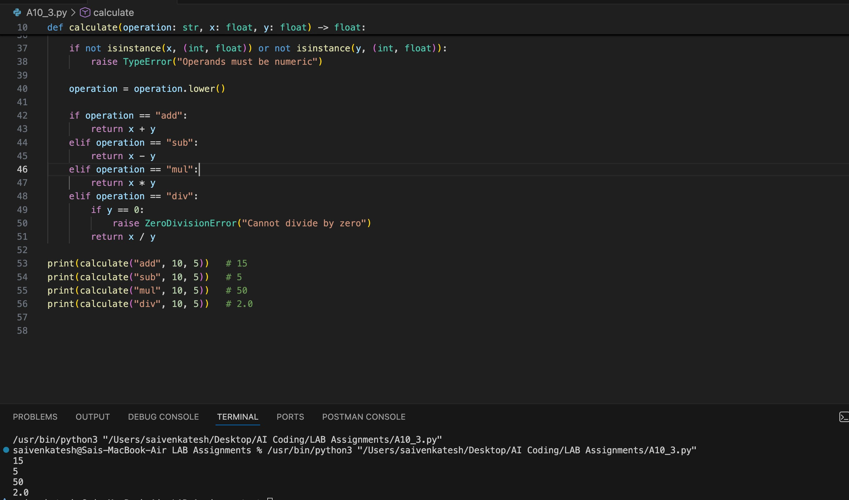
print(calculate("add", 10, 5)) # 15 print(calculate("sub", 10, 5)) # 5 print(calculate("mul", 10, 5)) # 50 print(calculate("div", 10, 5)) # 2.0
Output:
15
5
50
2.0
Explanation:
Critique:
The function name calc and parameters a, b, c are meaningless, there’s no docstring, and division by zero is not handled—this is unreadable and unsafe in real code.
AI-Improved Version Outcome:
AI improves clarity with descriptive names, adds a proper docstring, validates inputs, and handles division by zero using exceptions. The improved version is far more maintainable and production-ready than the original.
Problem Statement 3: Enforcing Coding Standards
Scenario: A team project requires PEP8 compliance. A developer submits: def Checkprime(n): for i in range(2, n): if n % i == 0: return False return True
Instructions:
- Verify the function works correctly for sample inputs.
- Use an AI tool (e.g., ChatGPT, GitHub Copilot, or a PEP8 linter with AI explanation) to:
◦ List all PEP8 violations.
◦ Refactor the code (function name, spacing, indentation, naming).
- Apply the AI-suggested changes and verify functionality is preserved.
- Write a short note on how automated AI reviews could streamline code reviews in large teams.
Expected Output:
A PEP8-compliant version of the function, e.g.: def check_prime(n): for i in range(2, n): if n % i == 0: return False return True
Reviewed Code:
def Checkprime(n):
for i in range(2, n): if n % i == 0: return False return True # Example usage number = 29 if Checkprime(number): print(f"{number} is a prime number.") else: print(f"{number} is not a prime number.”)
OUTPUT:
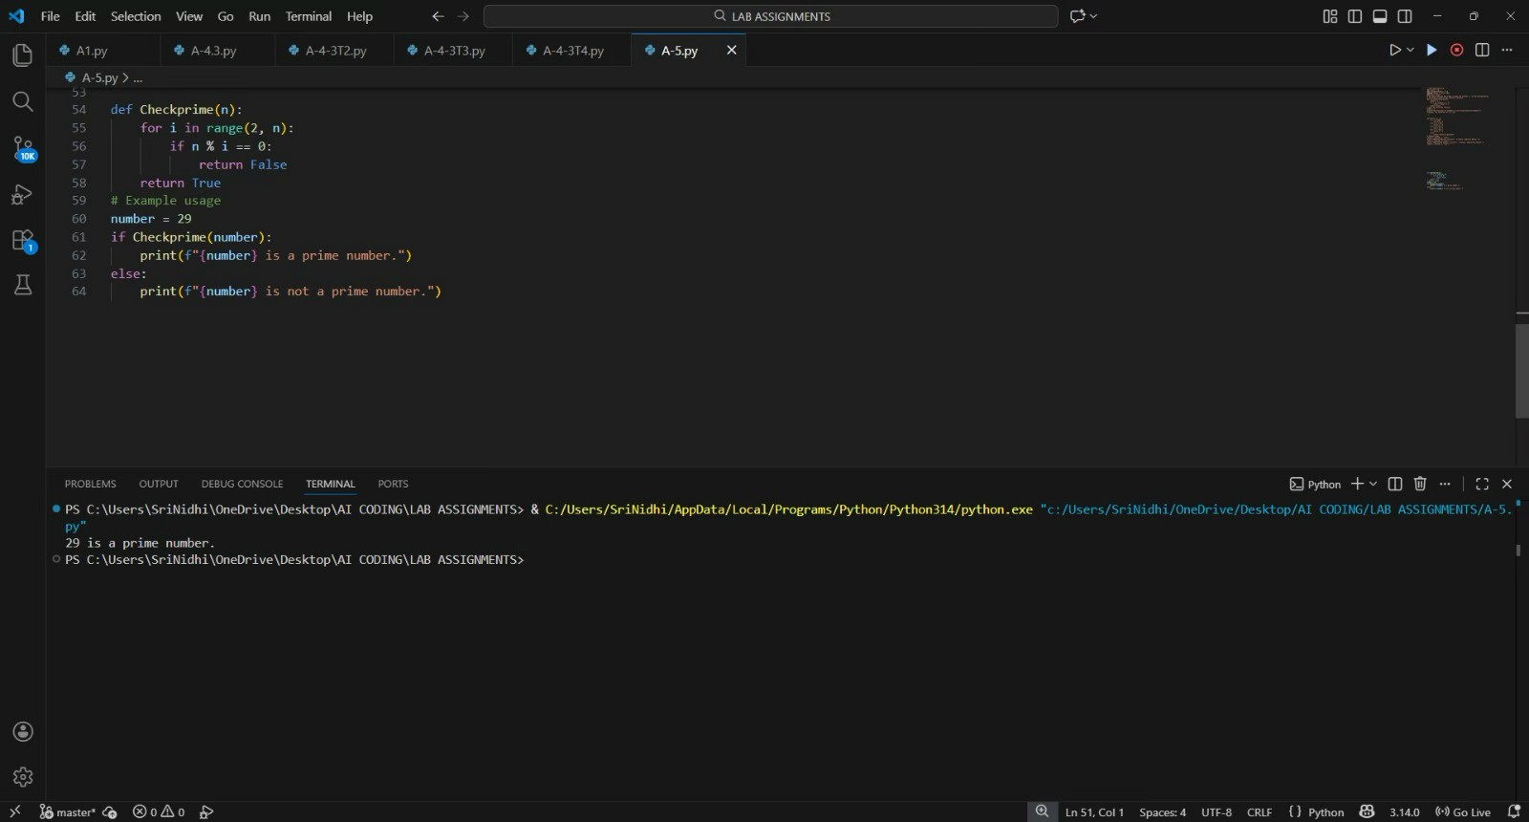
29 is a prime number

EXPLAINATION:
PEP8 Issues:
Function name Checkprime violates snake_case, spacing is inconsistent, and there’s no input validation for values less than 2.
Refactoring Result & Impact:
AI refactors the function to check_prime, fixes naming and formatting, and preserves logic. Automated AI reviews can drastically reduce review time in large teams by catching style issues early.
Problem Statement 4: AI as a Code Reviewer in Real Projects Scenario:
In a GitHub project, a teammate submits: def processData(d):
return [x * 2 for x in d if x % 2 == 0] Instructions:
- Manually review the function for: ◦ Readability and naming.
◦ Reusability and modularity.
◦ Edge cases (non-list input, empty list, non-integer elements).
- Use AI to generate a code review covering:
  - Better naming and function purpose clarity.
  - Input validation and type hints.

  - Suggestions for generalization (e.g., configurable multiplier).
- Refactor the function based on AI feedback.
- Write a short reflection on whether AI should be a standalone reviewer or an assistant.
Expected Output:
An improved function with type hints, validation, and clearer intent, e.g.: from typing import List, Union

def double_even_numbers(numbers: List[Union[int, float]]) -> List[Union[int, float]]:
if not isinstance(numbers, list):
raise TypeError("Input must be a list")
return [num * 2 for num in numbers if isinstance(num, (int, float)) and num % 2 == 0]
REVIEWED CODE:
def processData(d):
return [x * 2 for x in d if x % 2 == 0]
# Example usage
data = [1, 2, 3, 4, 5, 6]
processed_data = processData(data)
print(f"Processed Data: {processed_data}") # Output: Processed Data: [4, 8, 12] # Output: Multiplication Result: 50
OUTPUT:
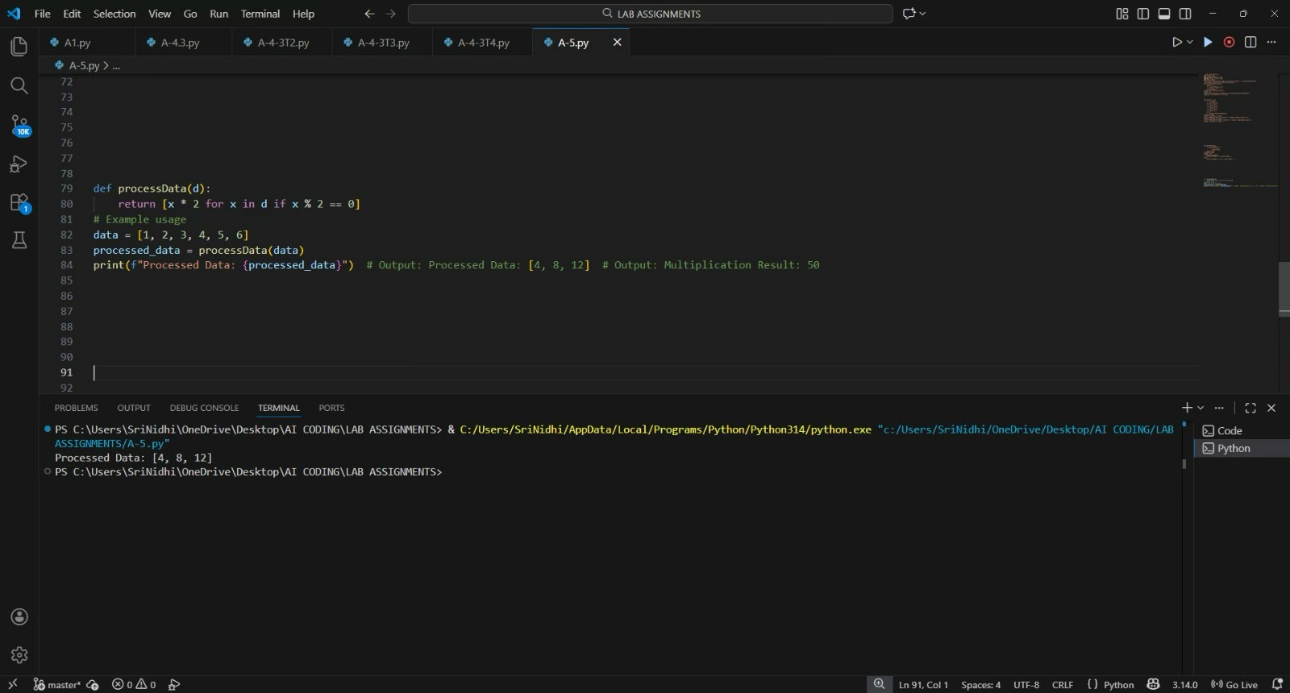
Processed Data: [4, 8, 12]

EXPLAINATION:
Manual Review Findings:
The function name processData is vague, input assumptions are unsafe, and it fails silently for invalid data types or mixed inputs.
1
AI Review & Refactor:
AI suggests better naming, adds type hints, input validation, and improves reusability by clarifying intent. AI should be an assistant, not a standalone reviewer—logic and business context still need humans.
Problem Statement 5: — AI-Assisted Performance Optimization
Scenario: You are given a function that processes a list of integers, but it runs slowly on large datasets: def sum_of_squares(numbers):
total = 0 for num in numbers: total += num ** 2 return total
Instructions:
- Test the function with a large list (e.g., range(1000000)).
- Use AI to:
◦ Analyze time complexity.
◦ Suggest performance improvements (e.g., using built-in functions, vectorization with NumPy if applicable).
◦ Provide an optimized version.
- Compare execution time before and after optimization.
- Discuss trade-offs between readability and performance.
Expected Output:
An optimized function, such as:
def sum_of_squares_optimized(numbers): return sum(x * x for x in numbers)

REVIEWED CODE:
def sum_of_squares(numbers):
total = 0 for num in numbers: total += num ** 2 return total
# Example usage
nums = [1, 2, 3, 4]
print(f"Sum of squares: {sum_of_squares(nums)}") # Output: Sum of squares def sum_of_squares_optimized(numbers):
return sum(x * x for x in numbers)
# Example usage nums = [1, 2, 3, 4] print(f"Optimized Sum of squares:
{sum_of_squares_optimized(nums)}") # Output: Optimized Sum of squares: 30: 30
OUTPUT
Sum of squares: 30
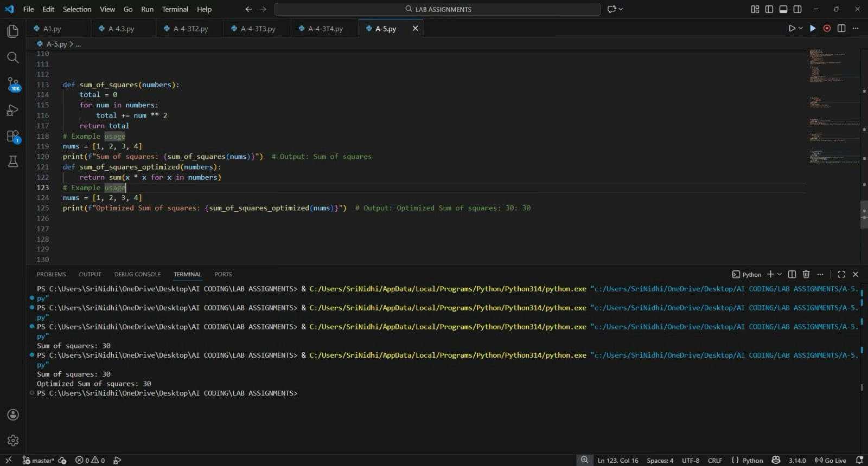
Optimised Sum of squares: 30
EXPLAINATION:
Analysis:
The original function runs in O(n) time and is already optimal in complexity, but uses an explicit loop that’s slower in Python.
Optimization & Trade-off:
AI replaces the loop with a generator inside sum(), improving speed and readability slightly. Performance gains are minor but measurable; readability is actually improved, not sacrificed.

