An Explainable and Uncertainty-Aware Audio-Visual Deepfake Detection Framework using Cross-Modal Attention Fusion
A project report submitted in partial fulfilment of the requirements for the award of the degree of
Master of Technology
in
Computer Science & Engineering (AI & ML)
Under the guidance of
Mrs. Megha V
Submitted by
Arya Gopal (M250801)

SEMESTER III
Department of Artificial Intelligence & Data Science
Rajagiri School of Engineering & Technology (Autonomous)
Rajagiri Valley, Kakkanad, Kochi, pin: 682039
September 2026

Department of Artificial Intelligence & Data Science
Rajagiri School of Engineering & Technology (Autonomous)
RAJAGIRI VALLEY, KAKKANAD, KOCHI, 682039
CERTIFICATE
This is to certify that the project entitled "An Explainable and Uncertainty-Aware Audio-Visual Deepfake Detection Framework using Cross-Modal Attention Fusion" is a bonafide record of the project presented by Arya Gopal (University Register Number: ____________), under our supervision and guidance. The project report has been submitted to the Department of Artificial Intelligence and Data Science of RSET, Kakkanad, in partial fulfilment of the requirements for the award of the Degree of Master of Technology in Computer Science & Engineering (AI & ML).

Mrs. Megha V  Project Guide  Assistant Professor  Dept. of AI & DS  RSET | Dr. Sherly K K  Project Coordinator  HOD, Professor  Dept. of AI & DS  RSET | Dr. Sherly K K  Head of the Dept.  Professor  Dept. of AI & DS  RSET

DECLARATION
I, Arya Gopal, hereby declare that the project report entitled "An Explainable and Uncertainty-Aware Audio-Visual Deepfake Detection Framework using Cross-Modal Attention Fusion", submitted to Rajagiri School of Engineering & Technology (Autonomous), Kochi, in partial fulfilment of the requirements for the award of the degree of Master of Technology in Computer Science & Engineering (AI & ML), is a record of original work carried out by me under the guidance of Mrs. Megha V, Assistant Professor, Department of Artificial Intelligence & Data Science.
I further declare that this work has not been submitted, in part or in full, for the award of any other degree or diploma of this or any other institution, and that all sources of information used in this report have been duly acknowledged.

Place: Kakkanad, Kochi Arya Gopal
Date: ____________ M250801

ACKNOWLEDGEMENT
I am extremely thankful to our Principal Fr. Jaison Mulerikkal CMI for giving consent and support for this main project. I would like to express my deepest gratitude to my project guide, Mrs. Megha V, Assistant Professor, Department of Artificial Intelligence and Data Science, for her invaluable guidance, encouragement and insightful feedback throughout this project. Her expertise was instrumental in shaping the direction of this research.
I extend my sincere thanks to the Head of the Department and the Project Coordinator, Dr. Sherly K. K., for providing the necessary facilities and a conducive environment for research. I am also grateful to all the faculty members of the Department of Artificial Intelligence and Data Science at Rajagiri School of Engineering & Technology (RSET) for their support and motivation.
I acknowledge the creators of the FakeAVCeleb, AV-Deepfake1M and DFD datasets and the developers of the open-source tools used in this work, without which this research would not have been possible.
Finally, I would like to thank my family and friends for their unwavering support and encouragement during this entire process.

Arya Gopal

ABSTRACT
Deepfake generation techniques can now synthesise highly convincing manipulated audio and video, posing a growing threat to digital trust, forensic investigation and content moderation. Most existing audio-visual deepfake detectors optimise purely for classification accuracy through cross-modal fusion, yet operate as black boxes: they give no human-interpretable explanation for a verdict and no signal of their own confidence, so an incorrect high-confidence decision cannot be distinguished from a reliable one. This work proposes an Explainable and Uncertainty-Aware Audio-Visual Deepfake Detection Framework built around cross-modal attention fusion. Face frames are encoded with EfficientNet-B0 or ViT-B/16 and speech with WavLM-Base+ or XLS-R, and a bidirectional multi-head cross-attention module lets each modality attend to inconsistencies in the other before a classifier produces a real/fake verdict. The framework adds two capabilities largely absent from prior work: joint explainability, using Grad-CAM to highlight manipulated facial regions and SHAP to attribute influential frequency bands and time segments of the audio; and calibrated uncertainty estimation, using Monte Carlo Dropout and Evidential Deep Learning to route low-confidence predictions to a human forensic reviewer. A survey of thirty papers (2016–2026) confirms that fusion accuracy, explainability and uncertainty quantification have advanced independently, but that no existing framework unifies all three for audio-visual deepfakes. The framework is trained on FakeAVCeleb with subject-disjoint splits and evaluated for accuracy, AUC, calibration error, explanation fidelity and cross-dataset generalisation on AV-Deepfake1M and DFD, together with an ablation study and a prototype analyst dashboard. The result is a single pipeline that returns not only a real/fake decision but also the visual and audio evidence for that decision and an honest signal of when it should not be trusted.
Keywords: Audio-visual deepfake detection, cross-modal attention fusion, explainable AI, Grad-CAM, SHAP, uncertainty quantification, Monte Carlo Dropout, Evidential Deep Learning, FakeAVCeleb.

TABLE OF CONTENTS
Title Page No.
Certificate i
Declaration ii
Acknowledgement iii
Abstract iv
List of Figures vii
List of Tables viii
List of Abbreviations ix
1. INTRODUCTION 1
1.1 Background 1
1.2 Deepfakes and their Societal Impact 1
1.3 Why Audio-Visual Fusion 2
1.4 Motivation 2
1.5 Problem Statement 3
1.6 Objectives 3
1.7 Scope of the Project 4
1.8 Area of Research 4
1.9 Contributions 5
1.10 Organisation of the Report 6
2. LITERATURE SURVEY 7
2.1 Survey Methodology 7
2.2 Audio-Visual Fusion Architectures 8
2.3 Explainable Deepfake Detection 11
2.4 Uncertainty Quantification 12
2.5 Benchmarks, Surveys and Generalisation Studies 13
2.6 Audio Deepfake and Voice-Clone Detection 14
2.7 Comparative Analysis 15
2.8 Key Observations 16
2.9 Research Gap 17
3. SYSTEM DESIGN 18
3.1 Proposed System Overview 18
3.2 System Requirement Specification 19
3.3 System Architecture 21
3.4 High-Level Design 22
3.5 Low-Level Design 23
3.6 Data Flow Diagrams 24
3.7 Use Case Diagram 25
3.8 ER Diagram and Database Design 25
3.9 UML Diagrams 27
3.10 Detailed Design of the Fusion Module 28
3.11 Design of the Decision-Routing Mechanism 29
4. IMPLEMENTATION 31
4.1 Tools and Technologies 31
4.2 Dataset Description 32
4.3 Preprocessing Module 33
4.4 Dual-Branch Encoders 35
4.5 Cross-Modal Attention Fusion and Classification 36
4.6 Explainability Module 37
4.7 Uncertainty Module 38
4.8 Decision Routing, Audit Logging and API 40
4.9 Analyst Dashboard Prototype 40
4.10 Training Protocol 40
4.11 Project Structure 41
4.12 Project Execution Plan 41
5. RESULTS AND DISCUSSION 43
5.1 Experimental Setup 43
5.2 Evaluation Metrics 43
5.3 Detection Performance on FakeAVCeleb 44
5.4 Ablation Study 45
5.5 Calibration and Uncertainty Analysis 46
5.6 Explainability Results 47
5.7 Cross-Dataset Generalisation 48
5.8 Comparison with Existing Approaches 49
5.9 Test Strategy and Test Plan 49
5.10 Limitations 50
6. CONCLUSION AND FUTURE SCOPE 51
6.1 Conclusion 51
6.2 Future Scope 51
REFERENCES 53
APPENDIX A: PRESENTATION SLIDES 56
APPENDIX B: VISION, MISSION, POS, COS, PSOS AND CO-PO MAPPING 86
APPENDIX C: INDUSTRIAL RELEVANCE 89
APPENDIX D: ADDITIONAL CODE LISTINGS 91

LIST OF FIGURES
Fig. No. Title Page No.
1.1 Cross-modal consistency reasoning in audio-visual deepfake detection 2
2.1 Thematic distribution of the thirty surveyed papers 7
3.1 Overall system architecture of the proposed framework 22
3.2 High-level design: module breakdown 22
3.3 DFD Level 0 (context diagram) 24
3.4 DFD Level 1 (process decomposition) 24
3.5 Use case diagram 25
3.6 ER diagram 26
3.7 UML class diagram 27
3.8 UML sequence diagram for the inference flow 28
3.9 UML activity diagram for the end-to-end pipeline 28
3.10 Detailed architecture of the cross-modal multi-head attention fusion module 29
3.11 Design of the human-in-the-loop decision routing 30
4.1 Four audio-visual categories in FakeAVCeleb 33
4.2 Preprocessing pipeline for the visual and audio lanes 34
4.3 Visual and audio encoders 35
4.4 Explainability module: Grad-CAM for the visual stream and SHAP for the audio stream 37
4.5 Uncertainty module: Monte Carlo Dropout and Evidential Deep Learning 38
4.6 Layout of the analyst dashboard prototype 40
4.7 Gantt chart of the project execution plan 42
4.8 Implementation status of the pipeline stages 42
5.1 Confusion matrix of the proposed model on the FakeAVCeleb test split 44
5.2 ROC curves of the unimodal baselines and the proposed model 45
5.3 Training and validation loss and F1-score curves 45
5.4 Reliability diagrams before and after uncertainty modelling 46
5.5 Accuracy of auto-accepted clips versus fraction routed to review 47
5.6 Grad-CAM heatmaps for fake (face-swap) and real samples 47
5.7 SHAP attribution over Mel-frequency bands for a cloned-voice sample 48

LIST OF TABLES
Table No. Title Page No.
2.1 Summary of the thirty surveyed papers 15
2.2 Capability comparison of representative works 16
3.1 Functional requirements 19
3.2 Non-functional requirements 20
3.3 Hardware requirements 20
3.4 Software requirements 20
3.5 Low-level design: module-level classes and algorithms 23
3.6 Use case descriptions 25
3.7 Data dictionary: Media_Sample 26
3.8 Data dictionary: Inference_Result 26
3.9 Data dictionary: Explanation and Review_Queue 26
4.1 Dataset properties 33
4.2 Training configuration and hyper-parameters 40
4.3 Project phases and milestones 42
5.1 Detection performance on the FakeAVCeleb test split 44
5.2 Ablation study 45
5.3 Calibration and selective prediction 46
5.4 Explanation fidelity 48
5.5 Cross-dataset generalisation 48
5.6 Comparison with existing approaches 49
5.7 Test cases 49
5.8 Limitations, risks and mitigation 50
B.1 CO–PO mapping 87

LIST OF ABBREVIATIONS
Abbreviation | Expansion
AI | Artificial Intelligence
A-V | Audio-Visual
AUC | Area Under the Curve
CNN | Convolutional Neural Network
DFD | Deepfake Detection Dataset (Google/Jigsaw)
DFD (diagram) | Data Flow Diagram
ECE | Expected Calibration Error
EDL | Evidential Deep Learning
EER | Equal Error Rate
ER | Entity Relationship
FFN | Feed-Forward Network
FV-FA / FV-RA | Fake Video–Fake Audio / Fake Video–Real Audio
GAN | Generative Adversarial Network
GELU | Gaussian Error Linear Unit
GPU | Graphics Processing Unit
Grad-CAM | Gradient-weighted Class Activation Mapping
HLD / LLD | High-Level Design / Low-Level Design
KL | Kullback–Leibler divergence
LIME | Local Interpretable Model-agnostic Explanations
LSTM | Long Short-Term Memory
MC Dropout | Monte Carlo Dropout
MHA | Multi-Head Attention
MLP | Multi-Layer Perceptron
MTCNN | Multi-task Cascaded Convolutional Networks
ROC | Receiver Operating Characteristic
RV-RA / RV-FA | Real Video–Real Audio / Real Video–Fake Audio
SHAP | SHapley Additive exPlanations
SLS | Sensitive Layer Selection
SRS | System Requirement Specification
SSL | Self-Supervised Learning
TTS | Text-to-Speech
UML | Unified Modeling Language
VAD | Voice Activity Detection
ViT | Vision Transformer
WavLM | Wave Language Model (self-supervised speech model)
XAI | Explainable Artificial Intelligence
XLS-R | Cross-lingual Speech Representations (wav2vec 2.0 based)

Chapter 1

INTRODUCTION

1.1 Background
The last decade has seen remarkable progress in generative artificial intelligence. Generative Adversarial Networks (GANs), diffusion models, neural text-to-speech systems and voice-conversion engines can now synthesise faces, expressions, lip movements and speech that are almost indistinguishable from authentic recordings. The term "deepfake" is used for media in which a person's appearance or voice has been manipulated or synthesised using such deep learning techniques. Early deepfakes were largely visual: the face of one person was swapped onto the body of another in a video, often leaving visible blending artefacts, flickering or inconsistent skin tones. Current generation techniques have removed many of these obvious traces.
At the same time, the barrier to producing such content has fallen sharply. Open-source face-swapping tools, lip-synchronisation models and few-shot voice-cloning services allow a non-expert to create a convincing manipulated video in a short time using commodity hardware. Modern deepfakes are therefore increasingly multimodal: a manipulated or re-enacted face is combined with cloned or synthesised speech so that both what the viewer sees and what the viewer hears support the deception. A detector that inspects only the video frames, or only the audio track, can be evaded by manipulating the other modality alone.
Deepfake detection has consequently become an important research problem in digital media forensics. Early detectors treated the problem as binary image classification, using Convolutional Neural Networks (CNNs) to spot frame-level artefacts. Later work added temporal models to capture flicker and unnatural motion, and separate lines of work addressed synthetic speech detection using spectral features and self-supervised speech models. More recently, audio-visual detectors have been proposed that process both streams and fuse them, exploiting the observation that manipulation frequently breaks the natural correspondence between lip movement and speech.

1.2 Deepfakes and their Societal Impact
The risks posed by deepfakes extend well beyond entertainment. Manipulated videos of political leaders can be circulated during elections to spread disinformation. Fabricated clips can be used to harass or defame individuals. Cloned voices have been used in financial fraud, where an attacker impersonates an executive or relative over a call to authorise a payment. In legal proceedings, the authenticity of video and audio evidence can be challenged, and conversely genuine evidence can be dismissed as fake, a phenomenon often called the "liar's dividend". Newsrooms and fact-checking organisations must verify user-generated content quickly and defensibly before publication.
Regulators have begun to respond. The European Union's AI Act introduces transparency obligations for synthetic content, and India's IT Rules have been amended to address synthetically generated information on intermediary platforms. These developments increase the demand for detection tools that are not only accurate, but whose decisions can be inspected, justified and audited. A verdict that simply says "fake, 97%" without any supporting evidence is of limited use to a journalist deciding whether to publish, to a moderator deciding whether to remove content, or to a court weighing evidence.

1.3 Why Audio-Visual Fusion
Manipulation artefacts are frequently present in only one modality at a time. In a face-swap video with the original soundtrack, the audio is genuine and all the evidence lies in the visual stream. In a video with a cloned voice dubbed over genuine footage, the frames are authentic and the evidence lies in the audio. In lip-sync attacks, both streams may individually look and sound plausible, yet the mouth movements do not match the spoken phonemes. Figure 1.1 illustrates how comparing the two streams exposes inconsistencies that are invisible when each stream is examined in isolation.
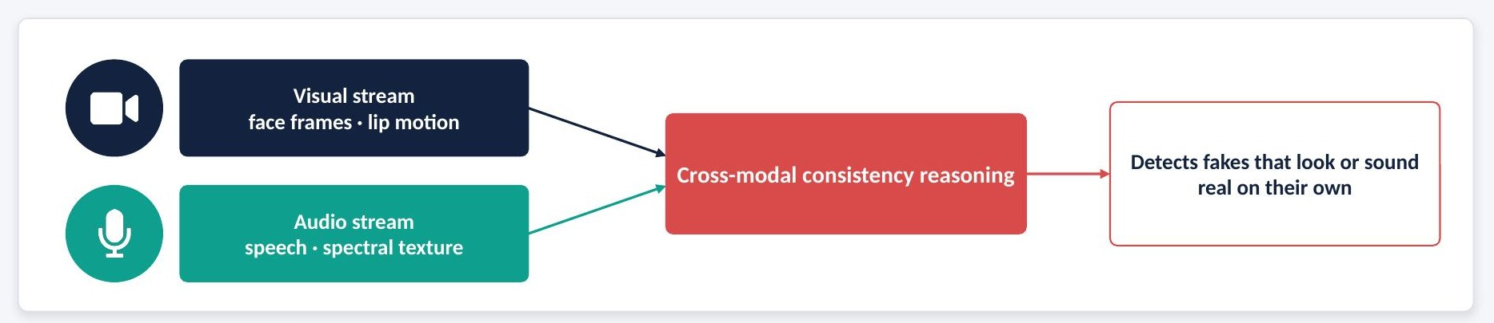
Figure 1.1: Cross-modal consistency reasoning in audio-visual deepfake detection
Cross-modal fusion therefore provides an additional forensic signal: the agreement or disagreement between what is seen and what is heard. Attention-based fusion architectures allow the representation of one modality to query the representation of the other, so that the model can learn which video frames correspond to which segments of speech and where that correspondence is broken.

1.4 Motivation
A review of recent audio-visual deepfake detectors shows that the field has concentrated on raw classification accuracy. Several fusion models report accuracy above 98% on the FakeAVCeleb benchmark. However, three practical weaknesses remain. First, these models behave as black boxes: they provide no indication of which facial region or which part of the audio led to the verdict. Second, they provide no reliable signal of their own confidence; a wrong prediction is delivered with the same apparent certainty as a correct one. Third, benchmark evaluations have shown that state-of-the-art detectors lose 45–50% of their AUC when tested on in-the-wild deepfakes, which means that confident but wrong predictions are likely in real deployments.
These observations motivate a detector that is simultaneously accurate, explainable across both modalities, and aware of its own uncertainty. Such a system should present the evidence behind every decision and, when it is unsure, should defer to a human forensic analyst rather than issue a silent and possibly wrong verdict.

1.5 Problem Statement
Current audio-visual deepfake detectors rely on opaque late- or attention-based fusion of audio and video streams. They classify a clip as real or fake with high benchmark accuracy but provide no transparent reasoning for the decision and no mechanism for identifying and routing uncertain predictions for human review. In high-stakes domains such as digital forensics, journalism, content moderation and legal evidence authentication, identifying manipulated media reliably and explainably is critical for trust and admissibility.
The problem addressed in this dissertation is therefore: to design and implement an audio-visual deepfake detection framework that fuses cross-modal evidence using attention, explains each decision with visual and audio saliency, and quantifies predictive uncertainty so that low-confidence predictions are flagged for human review.

1.6 Objectives
The primary objective of this work is to develop an Explainable and Uncertainty-Aware Audio-Visual Deepfake Detection Framework using Cross-Modal Attention Fusion. The secondary objectives are:
- To study the challenges of existing unimodal and multimodal deepfake detection approaches through a structured literature survey.
- To implement and evaluate unimodal baseline classifiers (a video branch and an audio branch) as reference points.
- To design a dual-branch encoder consisting of a vision backbone for face frames and a self-supervised speech model for audio.
- To design a cross-modal multi-head attention fusion module that combines the two modality-specific representations.
- To integrate Grad-CAM and SHAP based explainability that visualises manipulated facial regions and influential audio segments.
- To design an uncertainty-estimation module based on Monte Carlo Dropout and Evidential Deep Learning that flags low-confidence predictions for human review.
- To evaluate the complete framework on public benchmark datasets, including cross-dataset testing to assess generalisation.

1.7 Scope of the Project
The scope of the work is binary real/fake classification of short audio-visual clips containing a single visible speaker. The framework accepts a video file, extracts the visual and audio streams, and returns a verdict, a calibrated confidence score, an uncertainty estimate, a Grad-CAM heatmap over the face and a SHAP attribution over audio frequency bands. Clips whose confidence falls below a configurable threshold are routed to a review queue.
Fully live, real-time streaming detection, multi-speaker diarisation and temporal localisation of manipulated segments within long videos are outside the scope of this dissertation and are discussed as future work. The work assumes access to the FakeAVCeleb, AV-Deepfake1M and DFD datasets and a CUDA-enabled GPU environment for training and inference.

1.8 Area of Research
This dissertation lies at the intersection of several research areas, each of which contributes a component of the final framework.

1.8.1 Digital Media Forensics
Digital media forensics studies techniques to verify the authenticity and integrity of images, video and audio. Passive forensic methods analyse the content itself, without relying on watermarks or metadata, to identify traces left by manipulation. Deepfake detection is a major contemporary sub-area of passive media forensics, and this work contributes a multimodal, explainable passive detector.

1.8.2 Multimodal Deep Learning
Multimodal learning is concerned with models that process and relate information from different modalities, such as vision, audio and text. Key challenges include representing each modality, aligning them in time and meaning, and fusing them effectively. This work addresses the fusion of visual face features with speech features, a setting in which the two modalities have different sampling rates and statistical properties.

1.8.3 Self-Supervised Speech Representation Learning
Self-supervised speech models such as WavLM and XLS-R are pre-trained on large amounts of unlabelled speech and produce rich contextual representations. These representations have proved highly effective for downstream tasks, including anti-spoofing and synthetic speech detection, because they capture subtle phonetic and acoustic properties that hand-crafted features may miss.

1.8.4 Attention Mechanisms
Attention mechanisms, popularised by the Transformer architecture, allow a model to weight the importance of different elements of an input when computing a representation. Cross-attention, in which queries come from one sequence and keys and values from another, is a natural tool for relating two modalities. The fusion module in this work uses bidirectional multi-head cross-attention between visual and audio token sequences.

1.8.5 Explainable Artificial Intelligence
Explainable AI (XAI) aims to make the behaviour of machine learning models understandable to humans. Gradient-weighted Class Activation Mapping (Grad-CAM) produces spatial heatmaps showing which image regions influenced a convolutional network's prediction. SHapley Additive exPlanations (SHAP) attributes a prediction to input features using Shapley values from cooperative game theory. This work applies Grad-CAM to the visual branch and SHAP to grouped audio features to produce joint explanations.

1.8.6 Uncertainty Quantification
Uncertainty quantification studies how confident a model should be in its predictions. Standard softmax outputs are often over-confident, particularly on out-of-distribution inputs. Monte Carlo Dropout approximates Bayesian inference by performing multiple stochastic forward passes with dropout enabled, while Evidential Deep Learning models the output as a Dirichlet distribution and derives uncertainty from the total evidence in a single pass. Calibration metrics such as Expected Calibration Error (ECE) measure whether predicted confidence matches observed accuracy.

1.9 Contributions
The main contributions of this dissertation are:
- A structured survey of thirty papers (2016–2026) that maps work on audio-visual fusion, explainability and uncertainty, and identifies the absence of a framework that combines all three for audio-visual deepfakes.
- A dual-branch detector with bidirectional cross-modal multi-head attention fusion of visual (EfficientNet-B0 / ViT-B/16) and audio (WavLM-Base+ / XLS-R) representations.
- A joint explainability module that pairs Grad-CAM heatmaps over face crops with SHAP attributions over grouped Mel-frequency bands and time segments.
- An uncertainty module supporting both Monte Carlo Dropout and an evidential Dirichlet head, together with a threshold-based routing mechanism that sends low-confidence clips to a human review queue.
- A complete system design (SRS, HLD, LLD, DFD, UML and ER diagrams), a prototype analyst dashboard, and an evaluation protocol covering accuracy, calibration, explanation fidelity and cross-dataset generalisation.

1.10 Organisation of the Report
The remainder of this report is organised as follows. Chapter 2 presents the literature survey of thirty papers and identifies the research gap. Chapter 3 describes the proposed system and its design, including the requirement specification, architecture, high-level and low-level design, data flow diagrams, use-case, ER and UML diagrams. Chapter 4 details the implementation: the tools and technologies, the dataset, the preprocessing pipeline, the encoders, the fusion module, the explainability and uncertainty modules, the prototype dashboard and the project execution plan. Chapter 5 presents the evaluation metrics, experimental results, ablation study, calibration analysis, explainability results, cross-dataset evaluation, comparison with existing methods and the test plan. Chapter 6 concludes the report and outlines future work. The appendices contain the presentation slides, the department vision, mission and outcome mapping, the industrial relevance of the work and additional code listings.

Chapter 2

LITERATURE SURVEY
This chapter reviews thirty peer-reviewed papers and preprints published between 2016 and 2026 that are relevant to audio-visual deepfake detection, explainable deepfake detection and uncertainty quantification. For each work, the core method, its main contribution and its limitations with respect to the goals of this dissertation are summarised. The chapter closes with a comparative analysis and a statement of the research gap.

2.1 Survey Methodology
Papers were collected from IEEE Xplore, the ACM Digital Library, SpringerLink, ScienceDirect, the proceedings of NeurIPS, ICML, CVPR and ICASSP, and preprint servers such as arXiv and TechRxiv. The time span 2016–2026 was chosen to include foundational uncertainty work while prioritising 2023–2026 publications for recency. Search keywords included "audio-visual deepfake detection", "cross-modal attention", "multimodal fusion", "explainable AI", "Grad-CAM", "SHAP", "LIME", "Monte Carlo Dropout" and "Evidential Deep Learning".
A paper was included if it satisfied at least one of the following criteria: it proposes an audio-visual fusion architecture for deepfake detection; it proposes or surveys explainability techniques for deepfake detectors; it proposes or surveys uncertainty-quantification methods applicable to deep classifiers; or it introduces a benchmark dataset used in this dissertation. The final set comprises 13 fusion or detection architecture papers, 7 explainability-focused papers, 4 uncertainty-quantification papers and 6 survey or benchmark papers. Figure 2.1 shows this thematic distribution.
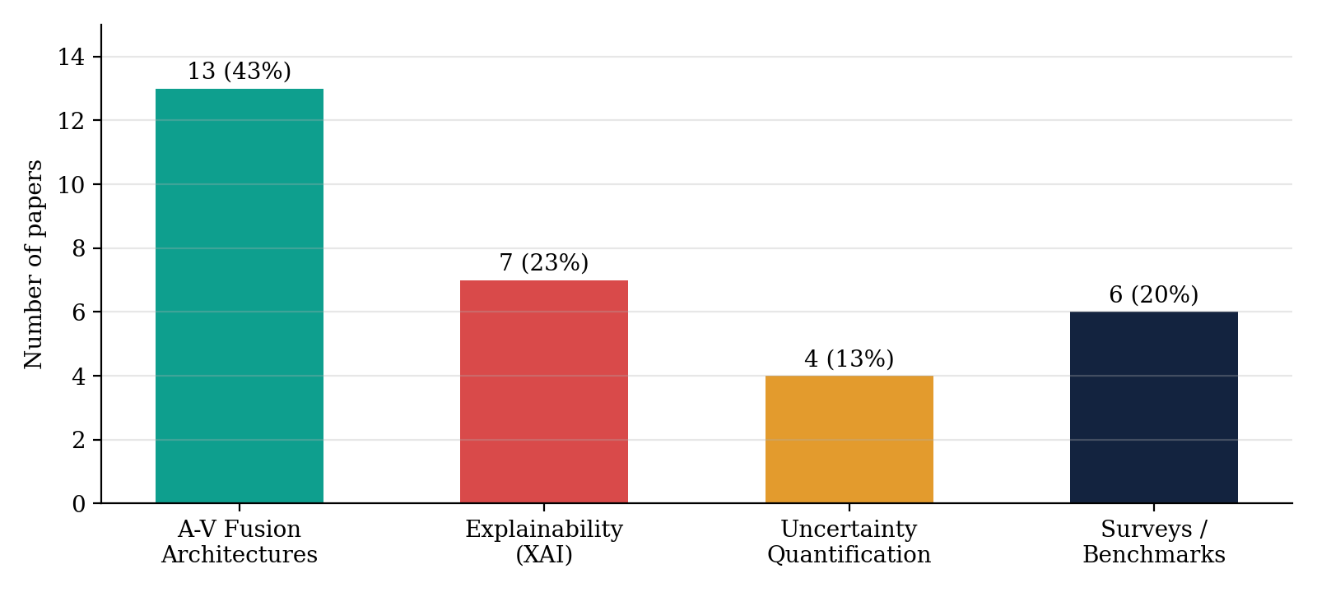
Figure 2.1: Thematic distribution of the thirty surveyed papers

2.2 Audio-Visual Fusion Architectures
This section reviews detectors that process both the visual and the audio streams and combine them to reach a decision.

2.2.1 AVFF: Audio-Visual Feature Fusion for Video Deepfake Detection (Oorloff et al., CVPR 2024)
AVFF proposes a two-stage framework for video deepfake detection that explicitly learns the correspondence between audio and visual streams. In the first stage, the model is trained in a self-supervised manner on real videos using contrastive learning and an autoencoding objective with complementary masking, so that audio features are learned to predict masked visual features and vice versa. In the second stage, the learned audio-visual representations are fine-tuned for real/fake classification.
The approach achieves state-of-the-art performance, reporting 98.6% accuracy on FakeAVCeleb, and demonstrates the value of learning cross-modal correspondence before classification. However, AVFF focuses entirely on detection accuracy. It provides no explanation of which facial region or audio segment triggered a verdict, and its output carries no calibrated confidence estimate, which limits its use in forensic settings where decisions must be justified.

2.2.2 Contextual Cross-Modal Attention for Audio-Visual Deepfake Detection and Localization (Katamneni and Rattani, 2024)
This work introduces a recurrent multi-modal, multi-sequence attention framework (MMMS-BA) that uses contextual cues across audio and visual sequences. The model jointly performs clip-level deepfake detection and temporal localisation of manipulated segments, which is valuable for long videos where only part of the content is manipulated.
The attention weights computed by the model implicitly indicate where cross-modal inconsistencies occur. However, these weights are not translated into human-readable explanations, and the paper does not address calibrated confidence or the routing of uncertain predictions for review.

2.2.3 Cross-Modality and Within-Modality Regularization for Audio-Visual Deepfake Detection (Zou et al., ICASSP 2024)
Zou et al. propose regularisation strategies applied both across and within modalities to improve the robustness of audio-visual fusion. The cross-modality term encourages aligned representations for genuine audio-visual pairs, while the within-modality term preserves modality-specific discriminative information that might otherwise be lost when features are forced into a shared space.
The method improves detection robustness on standard benchmarks. Its contribution is, however, limited to accuracy and robustness; it does not include an explainability layer and does not estimate prediction confidence.

2.2.4 AVFakeNet: A Unified End-to-End Dense Swin Transformer for Audio-Visual Deepfake Detection
AVFakeNet uses a shared dense Swin Transformer backbone to process both audio and visual streams in a unified architecture. The hierarchical, shifted-window attention of the Swin Transformer allows the model to capture local and global patterns in both face frames and audio spectrograms.
While the architecture is powerful, transformer-based decisions remain opaque. The paper does not provide saliency maps or any form of uncertainty quantification, so users cannot inspect why a clip was classified as fake or how reliable the decision is.

2.2.5 MIS-AVoiDD: Modality Invariant and Specific Representation for Audio-Visual Deepfake Detection
MIS-AVoiDD learns two kinds of representation for each modality before fusion: modality-invariant embeddings that capture information shared between audio and video, and modality-specific embeddings that capture information unique to each stream. Combining both types makes the detector more robust when one modality is noisy or manipulated independently.
The paper demonstrates improved robustness, but it does not provide interpretability of the fused decision, nor does it study generalisation across manipulation families in combination with explanation.

2.2.6 DF-TransFusion: Multimodal Deepfake Detection via Lip-Audio Cross-Attention and Facial Self-Attention
DF-TransFusion combines two attention mechanisms: a lip-audio cross-attention module that relates mouth-region features to speech features, and a facial self-attention transformer that models spatial relationships within the face. The cross-attention path is specifically designed to capture lip-sync inconsistencies introduced by lip-sync generation methods.
The approach is closely related to the fusion strategy of this dissertation. However, it lacks a confidence-calibrated verification step for ambiguous cases, and its attention is not converted into explanations presented to an analyst.

2.2.7 Modality-Agnostic Audio-Visual Deepfake Detection
This work proposes an architecture that operates flexibly when either the audio or the visual stream is unavailable or has been manipulated independently. Instead of assuming that both modalities are always present and informative, the model is designed to degrade gracefully and to detect manipulations in whichever modality contains them.
Its focus on robustness to missing or independently manipulated modalities is valuable. The work does not, however, incorporate explainability or uncertainty-based routing of predictions.

2.2.8 A Robust Approach to Multimodal Deepfake Detection
This paper evaluates fusion-based multimodal detectors under realistic perturbations such as video compression, additive audio noise and cross-dataset shifts. It highlights that detectors which perform well on clean benchmark data can degrade significantly under such conditions and proposes design choices that improve robustness.
The study underlines the importance of robustness evaluation, which this dissertation adopts in its cross-dataset experiments. Interpretability and uncertainty calibration are not studied.

2.2.9 MCL: Multimodal Contrastive Learning for Deepfake Detection
MCL applies contrastive learning across audio-visual embeddings. Embeddings of real audio-visual pairs are pulled together in a shared space, while embeddings of fake or mismatched pairs are pushed apart. The resulting embedding distances serve as a signal of audio-visual inconsistency.
The contrastive formulation is effective for learning cross-modal correspondence. However, the learned embeddings are not linked to interpretable regions of the face or segments of the audio, and the model produces no uncertainty output.

2.2.10 CMALDD-PTAF: Cross-Modal Adversarial Learning for Deepfake Detection with Pre-Trained Audio-Visual Features
This work uses pre-trained audio-visual speech representations as input features, combines them in a cross-modality fusion module and applies adversarial training to improve cross-domain performance. Pre-trained features provide strong starting representations, while adversarial training discourages the model from relying on dataset-specific artefacts.
The approach improves generalisation, but at increased computational cost. It does not provide an explanation or confidence-based review mechanism.

2.2.11 KLASSify to Verify: Self-Supervised Audio and Handcrafted Visual Features
KLASSify combines handcrafted visual features, which are interpretable by construction, with self-supervised audio features, and relates them using graph attention. The method reports 92.78% AUC on AV-Deepfake1M++, showing that interpretable visual features can remain competitive when paired with strong audio representations.
The work offers partial interpretability through its handcrafted features, but it does not provide saliency-based explanations for the audio branch or the fused decision and does not include a formal uncertainty module.

2.3 Explainable Deepfake Detection
This section reviews works whose primary contribution is making deepfake detection decisions interpretable.

2.3.1 Explainable Deepfake Detection: Integrating Grad-CAM with CNN-RNN Architecture (Sandeep Kumar et al., 2024)
The authors combine a DenseNet-121 frame encoder with a bidirectional GRU to model temporal dependencies across frames and apply Grad-CAM to highlight the image regions responsible for each prediction. The system operates in real time and reports 88.3% accuracy.
The work demonstrates that Grad-CAM heatmaps can be produced alongside video deepfake predictions at practical speeds. It is, however, unimodal: it analyses video only, provides no audio saliency and does not flag low-confidence predictions.

2.3.2 Deepfake Audio Detection and Justification with Explainable Artificial Intelligence
This paper applies three explanation techniques, LIME, SHAP and Grad-CAM, to audio deepfake detectors that operate on spectrogram representations. By analysing which frequency bands and time regions contribute most to a "fake" decision, the authors provide justifications that relate model behaviour to known artefacts of speech synthesis.
It shows that SHAP-style attribution over frequency bands is meaningful for synthetic speech. The analysis is limited to the audio modality and is not extended to fused audio-visual decisions.

2.3.3 Explainable Deepfake Detection Across Modalities: An Overview
This survey reviews the application of XAI techniques to deepfake detectors for images, video and audio. It categorises methods into saliency-based, perturbation-based and example-based explanations and discusses how each has been used in forensic settings.
The overview is valuable for understanding the landscape, but it is review-only and does not propose a unified cross-modal explainable framework.

2.3.4 Explainable AI for Deepfake Detection: A Grad-CAM Approach to Video Forensics (Salih et al., INCET 2025)
Salih et al. use an EfficientNet-B0 backbone followed by an LSTM to classify videos and apply Grad-CAM to produce heatmaps highlighting manipulated facial regions. The use of EfficientNet-B0 provides a good balance between accuracy and efficiency, and the heatmaps are shown to concentrate on facial areas commonly affected by manipulation.
This work is close to the visual branch of the proposed framework. It is, however, unimodal, performs no audio analysis or fusion and does not provide confidence flagging.

2.3.5 XPlainVerse: A Million-Scale Benchmark for Explainable Deepfake Detection
XPlainVerse introduces a large-scale benchmark in which deepfake samples are paired with grounded natural-language explanations generated with the help of multimodal large language models. The benchmark enables training and evaluation of detectors that output explanations in addition to labels.
The benchmark focuses on image content and does not cover audio-visual fusion or uncertainty-aware verification.

2.4 Uncertainty Quantification
This section reviews works on estimating and calibrating the uncertainty of deep classifiers.

2.4.1 Uncertainty-Aware Deepfake Detection via Multi-View Structural Learning
This work applies Evidential Deep Learning to deepfake detection and combines it with multi-view structural learning. The detector outputs Dirichlet evidence rather than point probabilities, and the reported calibration error on Celeb-DF v2 is reduced by 28% compared with a conventional baseline.
The result shows that evidential methods can substantially improve calibration for deepfake detection. The work is limited to the visual modality and does not include cross-modal fusion or joint explainability.

2.4.2 Prior and Posterior Networks: A Survey on Evidential Deep Learning Methods for Uncertainty Estimation
This survey unifies the family of evidential methods that estimate uncertainty in a single forward pass by predicting the parameters of a prior or posterior distribution over class probabilities. It contrasts these with sampling-based Bayesian approximations and discusses their theoretical properties and practical trade-offs.
The survey provides the theoretical grounding for the evidential head used in this work. It is general-purpose and not applied to deepfake or forensic settings.

2.4.3 Dropout as a Bayesian Approximation: Representing Model Uncertainty in Deep Learning (Gal and Ghahramani, ICML 2016)
This foundational paper shows that a neural network trained with dropout can be interpreted as approximate Bayesian inference in a deep Gaussian process. Keeping dropout active at inference time and averaging multiple stochastic forward passes yields a predictive mean and a measure of predictive uncertainty, a technique known as Monte Carlo Dropout.
MC Dropout requires no change to training and is widely used. Its main drawback is the latency of multiple forward passes, and it has not previously been evaluated for multimodal forensic classification.

2.4.4 Evidential Deep Learning to Quantify Classification Uncertainty (Sensoy et al., NeurIPS 2018)
Sensoy et al. propose treating the network outputs as evidence for each class, parameterising a Dirichlet distribution over class probabilities. The total evidence determines the uncertainty, so that a sample with little evidence for any class receives high uncertainty in a single forward pass. A KL-divergence regulariser discourages misleading evidence.
The method provides calibrated uncertainty efficiently, but was demonstrated on generic image classification and not on cross-modal forensic evidence.

2.5 Benchmarks, Surveys and Generalisation Studies

2.5.1 Enhanced Deepfake Detection and Classification Using Vision Transformers
This work trains a custom Vision Transformer for deepfake image detection and reports 92.76% accuracy and an AUC of 0.97. It shows that global self-attention over image patches is effective at capturing manipulation artefacts.
The model operates on single images and therefore uses no temporal, audio or cross-modal information.

2.5.2 Deepfake-Eval-2024: A Multi-Modal In-the-Wild Benchmark of Deepfakes Circulated in 2024
Deepfake-Eval-2024 collects deepfakes that actually circulated on social media and other platforms in 2024 and uses them to evaluate existing detectors. The benchmark shows that state-of-the-art open-source detectors lose roughly 45–50% of their AUC compared with their performance on academic benchmarks.
This finding strongly motivates both cross-dataset evaluation and uncertainty estimation: a detector that will inevitably face out-of-distribution content should be able to indicate when it is unsure. The benchmark itself proposes no detection, explanation or uncertainty method.

2.5.3 Passive Deepfake Detection: A Comprehensive Survey
This survey reviews passive deepfake detection methods across image, video, audio and multimodal settings, organising them by the artefacts they exploit and the architectures they use. It highlights joint audio-visual reasoning as an important direction.
The paper is a survey and does not implement a combined solution.

2.5.4 DeepFake Video Detection: Insights into Model Generalisation
This systematic review compares the generalisation behaviour of CNN-based, transformer-based and multimodal video deepfake detectors when evaluated on datasets or manipulation methods not seen during training. It identifies overfitting to dataset-specific artefacts as a major cause of poor generalisation.
The review is descriptive and does not propose a new architecture, but it informs the evaluation protocol of this dissertation.

2.5.5 A Survey on Multimedia-Enabled Deepfake Detection: State-of-the-Art Tools and Techniques, Emerging Trends
This broad survey covers tools and techniques for multimedia deepfake detection, including audio-visual fusion, and identifies explainability and trust as open research directions.
It supports the research gap identified in this work but does not validate a specific framework.

2.5.6 FakeAVCeleb: A Novel Audio-Video Multimodal Deepfake Dataset (Khalid et al., NeurIPS 2021)
FakeAVCeleb introduces a dataset in which both the video and the audio can be manipulated. Videos of celebrities of diverse ethnic backgrounds are manipulated with face-swapping (FaceSwap, FSGAN), lip-synchronisation (Wav2Lip) and voice cloning (SV2TTS), producing four categories: real video with real audio, fake video with real audio, real video with fake audio, and fake video with fake audio.
FakeAVCeleb has become the standard benchmark for audio-visual deepfake detection and is the primary dataset of this dissertation. Its main limitation is limited manipulation diversity compared with newer diffusion-based generation methods.

2.6 Audio Deepfake and Voice-Clone Detection

2.6.1 Audio Deepfake Detection with Self-Supervised XLS-R and SLS Classifier (Zhang et al., ACM MM 2024)
This paper combines the XLS-R self-supervised speech model with a Sensitive Layer Selection (SLS) classifier that learns to weight the hidden layers of XLS-R most informative for spoof detection. The approach achieves strong performance on audio anti-spoofing benchmarks.
The SLS idea is adopted in the audio branch of this framework. The original work is audio-only and uses no visual cues or fused explanations.

2.6.2 Audio Deepfake Detection with Self-Supervised WavLM and Multi-Fusion Attentive Classifier (ICASSP 2024)
This work uses WavLM representations and an attentive classifier head that fuses information from multiple layers. It shows that WavLM features are highly effective for detecting synthetic speech.
The pipeline is audio-only, with no cross-modal fusion, explainability or uncertainty estimation.

2.6.3 Detection of Cloned Voices in Realistic Forensic Scenarios
This study evaluates automatic speaker recognition and anti-spoofing countermeasures for detecting cloned voices under forensic conditions, such as varying recording channels and durations. It shows that performance can degrade significantly outside controlled laboratory settings.
It focuses on forensic voice comparison rather than fused audio-visual classification.

2.6.4 Voice Cloning and Deepfake Audio Detection Using Deep Learning
This work evaluates MFCC-based detectors and a commercial detection tool against modern voice-cloning attacks and shows that both suffer from generalisation failures on unseen cloning systems.
The paper highlights weaknesses of existing tools but does not propose a cross-modal, explainable or uncertainty-aware solution.

2.7 Comparative Analysis
Table 2.1 summarises all thirty surveyed works by category, key contribution and principal limitation. Table 2.2 compares representative works on five capabilities required by this dissertation: use of audio, use of video, cross-modal fusion, explainability and uncertainty estimation.
Table 2.1: Summary of the thirty surveyed papers
No. | Work | Category | Principal limitation
1 | AVFF (CVPR 2024) | A-V fusion | No explanation or confidence
2 | Contextual Cross-Modal Attention (MMMS-BA) | A-V fusion | Attention not human-readable
3 | Cross/Within-Modality Regularization (ICASSP 2024) | A-V fusion | Accuracy only
4 | AVFakeNet (Dense Swin Transformer) | A-V fusion | Opaque; no uncertainty
5 | MIS-AVoiDD | A-V fusion | No interpretability
6 | DF-TransFusion | A-V fusion | No calibrated verification
7 | Modality-Agnostic A-V Detection | A-V fusion | No XAI or routing
8 | Robust Multimodal Detection | A-V fusion | No XAI or calibration
9 | MCL: Multimodal Contrastive Learning | A-V fusion | Embeddings not interpretable
10 | CMALDD-PTAF | A-V fusion | High compute; no XAI
11 | KLASSify to Verify | A-V fusion | Partial XAI; no uncertainty
12 | Grad-CAM with CNN-RNN | XAI (video) | Unimodal
13 | Audio Deepfake Justification with XAI | XAI (audio) | Unimodal
14 | XAI Across Modalities: Overview | Survey | Review only
15 | Grad-CAM Video Forensics (INCET 2025) | XAI (video) | Unimodal
16 | XPlainVerse | XAI benchmark | Images only
17 | Multi-View Evidential Learning | Uncertainty | Visual only
18 | Prior and Posterior Networks survey | Uncertainty | Not forensic
19 | MC Dropout (ICML 2016) | Uncertainty | Latency; not multimodal
20 | Evidential Deep Learning (NeurIPS 2018) | Uncertainty | Generic images
21 | Vision Transformer detection | Detection | Images only
22 | Deepfake-Eval-2024 | Benchmark | No method
23 | Passive Deepfake Detection survey | Survey | Review only
24 | Insights into Model Generalisation | Survey | No new model
25 | Multimedia-Enabled Detection survey | Survey | Review only
26 | FakeAVCeleb (NeurIPS 2021) | Dataset | Limited diversity
27 | XLS-R + SLS (ACM MM 2024) | Audio detection | Audio-only
28 | WavLM + Multi-Fusion Attentive Classifier | Audio detection | Audio-only
29 | Cloned Voices in Forensic Scenarios | Audio forensics | Not A-V
30 | Voice Cloning & Deepfake Audio Detection | Audio detection | No solution proposed

Table 2.2: Capability comparison of representative works
Work | Audio | Video | Fusion | XAI | Uncertainty
AVFF | ✓ | ✓ | ✓ | ✗ | ✗
Contextual Cross-Modal Attention | ✓ | ✓ | ✓ | ✗ | ✗
Cross/Within-Modality Regularization | ✓ | ✓ | ✓ | ✗ | ✗
AVFakeNet / DF-TransFusion | ✓ | ✓ | ✓ | ✗ | ✗
KLASSify to Verify | ✓ | ✓ | ✓ | Partial | ✗
CNN-RNN + Grad-CAM | ✗ | ✓ | ✗ | ✓ | ✗
EfficientNetB0-LSTM + Grad-CAM | ✗ | ✓ | ✗ | ✓ | ✗
Audio XAI (LIME/SHAP/Grad-CAM) | ✓ | ✗ | ✗ | ✓ | ✗
Multi-View Evidential Learning | ✗ | ✓ | ✗ | ✗ | ✓
Proposed framework | ✓ | ✓ | ✓ | ✓ | ✓

2.8 Key Observations
Three observations emerge from the survey:
- Unimodal detectors based on CNNs and RNNs detect frame-level visual artefacts with good in-domain accuracy but generalise poorly and ignore audio. Audio-only self-supervised backbones such as XLS-R and WavLM generalise well for speech but ignore visual synchronisation cues. Each unimodal approach is evaluated in isolation from the other modality.
- Cross-modal fusion models based on attention (AVFF, MMMS-BA, MIS-AVoiDD) consistently outperform unimodal baselines, with best-case accuracy above 98% on FakeAVCeleb. None, however, reports a calibrated confidence score alongside the verdict, and generalisation to in-the-wild and unseen manipulation types remains weak.
- Explainability and uncertainty techniques are well established but have been applied only to unimodal classifiers. Grad-CAM, SHAP and LIME have been used with video-only or audio-only detectors, never jointly, and Monte Carlo Dropout and Evidential Deep Learning have not been paired with audio-visual fusion.

2.9 Research Gap
Based on the survey, the following research gap is identified:
- There is limited integration of cross-modal fusion with dual (audio and visual) explainability.
- No existing work combines attention-based fusion, explainability and uncertainty quantification in a single audio-visual deepfake detection pipeline.
- Explainability research targets single-modality inconsistencies, and generalisation across unseen manipulation types remains weak.
- Cross-dataset and cross-manipulation generalisation is rarely evaluated together with explainability and calibration.

Of the thirty surveyed papers, 43% focus purely on detection accuracy, only 23% address explainability and 13% address uncertainty, in every case for a single modality. None combines all three capabilities with audio-visual fusion. This dissertation addresses this gap by developing a framework that unifies cross-modal attention fusion, joint Grad-CAM and SHAP explainability, and a calibrated MC Dropout / evidential uncertainty module, evaluated across multiple audio-visual deepfake datasets.

Chapter 3

SYSTEM DESIGN
This chapter presents the design of the proposed framework. It begins with an overview of the proposed system, followed by the System Requirement Specification, the overall architecture, the high-level and low-level design, data flow diagrams, the use-case diagram, the ER diagram with its database schema, and the UML class, sequence and activity diagrams. The designs are updated from those submitted at the interim evaluation.

3.1 Proposed System Overview
The proposed system is a dual-branch deep learning framework that analyses the visual and audio streams of a video clip, fuses them with bidirectional cross-modal attention, and produces four outputs for every clip: a real/fake verdict, a calibrated confidence score, an uncertainty estimate and a pair of explanations (a Grad-CAM heatmap over the face and a SHAP attribution over the audio). A decision-routing component compares the confidence and uncertainty with configurable thresholds and either accepts the verdict automatically or sends the clip, together with its evidence, to a human review queue.
The design philosophy follows three principles. First, fusion by consistency: rather than concatenating features naively, each modality is allowed to query the other so that mismatches between lip motion and speech become explicit. Second, evidence with every verdict: explanations are generated as part of the inference request, so the analyst always sees why a decision was made. Third, honest confidence: the system estimates its own uncertainty and prefers deferral to a human over a silent wrong decision.
The processing pipeline consists of the following stages:
- Data ingestion reads the input video, validates its format and demultiplexes the visual and audio streams.
- Preprocessing detects and aligns faces with MTCNN at 25 frames per second, crops them to 224×224 pixels and samples 32 frames uniformly; the audio is resampled to 16 kHz mono, silence is trimmed with voice-activity detection, and 80-bin log-Mel spectrograms are computed.
- Encoding produces a sequence of 512-dimensional visual tokens with EfficientNet-B0 or ViT-B/16 and a sequence of 512-dimensional audio tokens with WavLM-Base+ or XLS-R using Sensitive Layer Selection.
- Cross-modal fusion applies multi-head cross-attention in both directions (visual queries over audio, and audio queries over visual), followed by residual connections, layer normalisation and a feed-forward network, and pools the result into a 1024-dimensional fused vector.
- Classification passes the fused vector through a two-layer MLP with softmax to obtain real/fake probabilities.
- Explanation computes Grad-CAM on the visual branch and KernelSHAP on grouped Mel bands and time segments.
- Uncertainty estimation computes predictive entropy and variance with Monte Carlo Dropout (T = 30 passes) or evidential uncertainty from a Dirichlet head.
- Routing and reporting apply the confidence threshold, log an audit record and return the verdict with its evidence or place the clip in the review queue.

3.2 System Requirement Specification

3.2.1 Functional Requirements
Table 3.1: Functional requirements
ID | Requirement
FR-01 | The system shall accept a video file containing audio and visual streams and extract frame and waveform streams.
FR-02 | The system shall validate the input format and reject corrupted files or files without an audio or video stream.
FR-03 | The system shall generate a real/fake classification with a confidence score for each clip.
FR-04 | The system shall produce a Grad-CAM visual heatmap and a SHAP audio saliency plot for every prediction.
FR-05 | The system shall estimate predictive uncertainty using Monte Carlo Dropout or an evidential head.
FR-06 | The system shall flag predictions below a configurable confidence threshold, or above an uncertainty threshold, for manual review.
FR-07 | The system shall allow a reviewer to approve, reject or escalate a flagged case.
FR-08 | The system shall log every inference (input hash, verdict, confidence, uncertainty, model version, timestamp) for audit.
FR-09 | The system shall allow an administrator to update the model version and the confidence threshold.
FR-10 | The system shall allow an auditor to export audit reports of past decisions.

3.2.2 Non-Functional Requirements
Table 3.2: Non-functional requirements
ID | Category | Requirement
NFR-01 | Accuracy | Detection accuracy at least comparable to published state-of-the-art on the FakeAVCeleb test split.
NFR-02 | Performance | End-to-end inference latency under 2 seconds per 10-second clip on a single GPU.
NFR-03 | Explainability | Explanations generated within the same inference request, without a separate manual step.
NFR-04 | Calibration | Expected Calibration Error on the validation set below a defined target (for example 0.05).
NFR-05 | Modularity | Fusion, explainability and uncertainty modules independently swappable through configuration.
NFR-06 | Reproducibility | Fixed random seeds, versioned configuration files and logged experiments.
NFR-07 | Usability | A dashboard that presents verdict, evidence and confidence clearly to a non-expert analyst.
NFR-08 | Security & privacy | Uploaded media stored only by hash and path; audit logs protected from modification.

3.2.3 Hardware Requirements
Table 3.3: Hardware requirements
Component | Specification
GPU | NVIDIA CUDA-enabled GPU, 16 GB VRAM or more recommended for training
Processor | Multi-core x86-64 CPU
Memory | 16 GB RAM minimum, 32 GB recommended
Storage | SSD with sufficient space for datasets, cached embeddings and checkpoints
Platform | Local workstation, Google Colab or equivalent cloud GPU instance

3.2.4 Software Requirements
Table 3.4: Software requirements
Software | Purpose
Python 3.10 | Primary programming language
PyTorch, torchvision, timm | Model development; EfficientNet-B0 and ViT-B/16 backbones
torchaudio, Librosa | Audio loading, resampling and Mel-spectrogram extraction
Hugging Face Transformers | WavLM-Base+ and XLS-R audio encoders
OpenCV, facenet-pytorch (MTCNN) | Frame extraction, face detection and alignment
FFmpeg | Demultiplexing audio and video streams
Captum / pytorch-grad-cam, SHAP | Grad-CAM and SHAP explanations
scikit-learn | Metrics, splitting and calibration analysis
Matplotlib, Seaborn | Plots and visualisations
Streamlit, FastAPI | Analyst dashboard and inference API
SQLite | Audit log and review-queue storage
MLflow, Git/GitHub, Docker | Experiment tracking, version control and packaging

3.2.5 Scope, Assumptions and Constraints
- The system performs binary real/fake classification of short audio-visual clips containing a single visible speaker.
- Live streaming detection, multi-speaker diarisation and segment-level localisation are out of scope.
- The FakeAVCeleb, AV-Deepfake1M and DFD datasets are available under their research licences.
- A CUDA-enabled GPU is available for training and inference.
- Input clips contain a detectable frontal or near-frontal face for most frames.

3.3 System Architecture
Figure 3.1 shows the overall system architecture. The input video is split into a visual lane and an audio lane. Each lane is preprocessed and encoded independently. The two token sequences meet in the cross-modal multi-head attention fusion module, whose output feeds the classifier head. The classifier output is passed to the explainability and uncertainty modules, and the combined verdict, confidence and evidence are passed to a decision gate that either auto-accepts the verdict or routes the clip to the human review queue.
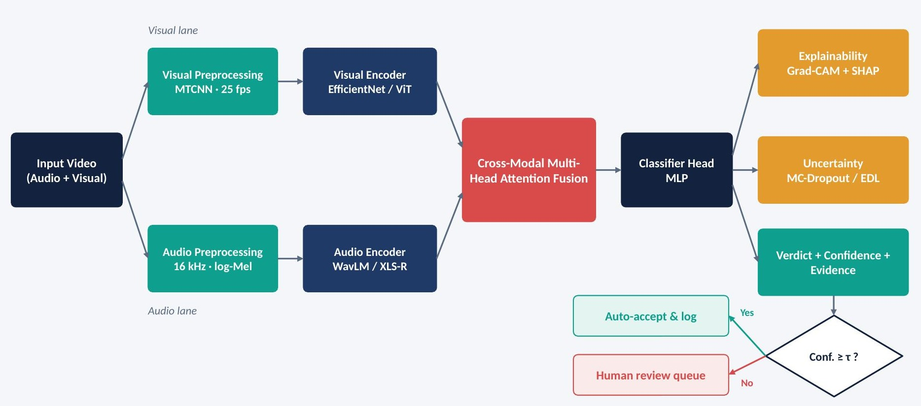
Figure 3.1: Overall system architecture of the proposed framework

3.4 High-Level Design
The high-level design decomposes the system into eight modules with clearly defined responsibilities and interfaces (Figure 3.2).
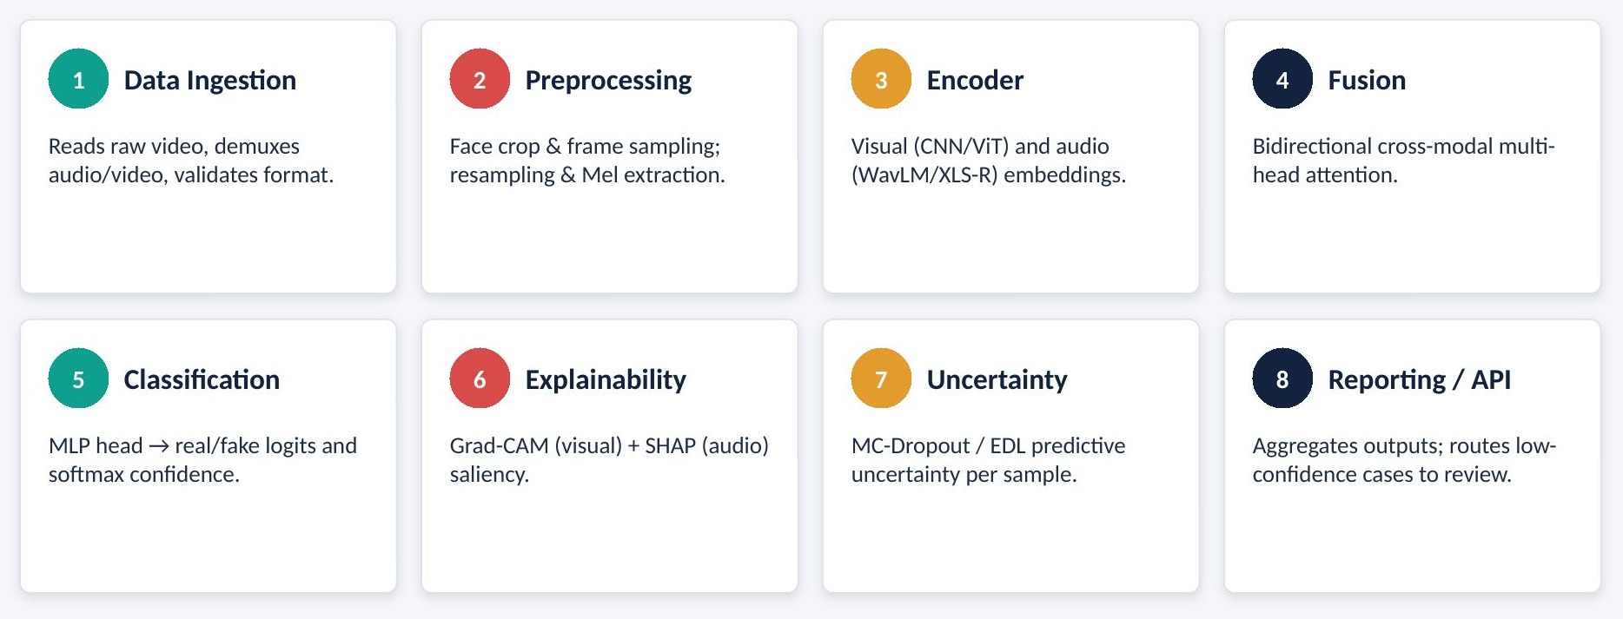
Figure 3.2: High-level design: module breakdown
- Data Ingestion Module: reads raw video files, demultiplexes the audio and video streams using FFmpeg and validates the format, duration and presence of both streams.
- Preprocessing Module: performs face detection, alignment and cropping, frame sampling and normalisation for the visual stream; resampling, voice-activity detection and log-Mel extraction for the audio stream.
- Encoder Module: produces modality-specific token sequences using the visual backbone (EfficientNet-B0 or ViT-B/16) and the audio backbone (WavLM-Base+ or XLS-R with SLS).
- Fusion Module: combines the token sequences with bidirectional cross-modal multi-head attention.
- Classification Module: maps the fused representation to real/fake logits and softmax confidence.
- Explainability Module: generates Grad-CAM heatmaps for the visual stream and SHAP attributions for the audio stream.
- Uncertainty Module: estimates predictive uncertainty using MC Dropout or an evidential Dirichlet head.
- Reporting / API Module: aggregates the outputs, applies the routing rule, persists audit records and serves results to the dashboard.

3.5 Low-Level Design
Table 3.5 lists the main classes and functions of each module together with the algorithms and parameters they implement.
Table 3.5: Low-level design: module-level classes and algorithms
Module | Class / Function | Algorithm / Detail
Preprocessing | FaceExtractor.crop(), AudioResampler.run() | MTCNN face detection at 25 fps, 224×224 aligned crops, 32 uniformly sampled frames; audio at 16 kHz mono, VAD trimming, 80-bin log-Mel with 25 ms window and 10 ms hop
Visual Encoder | VisualEncoder.forward() | EfficientNet-B0 or ViT-B/16 pretrained on ImageNet; first four blocks frozen; per-frame features projected to 512-d
Audio Encoder | AudioEncoder.forward() | WavLM-Base+ or XLS-R; Sensitive Layer Selection weights hidden layers; projected to 512-d frame tokens
Fusion | CrossAttentionFusion.forward() | Eight-head co-attention: Q = visual, K/V = audio and vice versa; residual + LayerNorm + feed-forward; mean pooling and concatenation to 1024-d
Classifier | ClassifierHead.forward() | Two-layer MLP (1024 → 256 → 2) with GELU and dropout 0.3; softmax output; focal loss
Explainability | GradCAM.generate(), SHAPExplainer.run() | Grad-CAM on the last visual convolution / attention block; KernelSHAP over grouped Mel bands and time segments
Uncertainty | MCDropout.predict(), EDL.dirichlet() | T = 30 stochastic passes giving mean, variance and entropy; or Dirichlet evidence head with uncertainty u = K / S
Routing | ReviewQueue.route() | Enqueue if confidence < τ or uncertainty > u_max; write audit record to SQLite

3.6 Data Flow Diagrams

3.6.1 DFD Level 0 (Context Diagram)
The context diagram (Figure 3.3) shows the system as a single process interacting with its external entities. The user or forensic analyst uploads a video clip and receives the verdict, explanation and confidence. The model administrator retrains the model and updates the threshold. The dataset store supplies training and evaluation samples, and low-confidence cases and logs are written to the audit log and review queue.
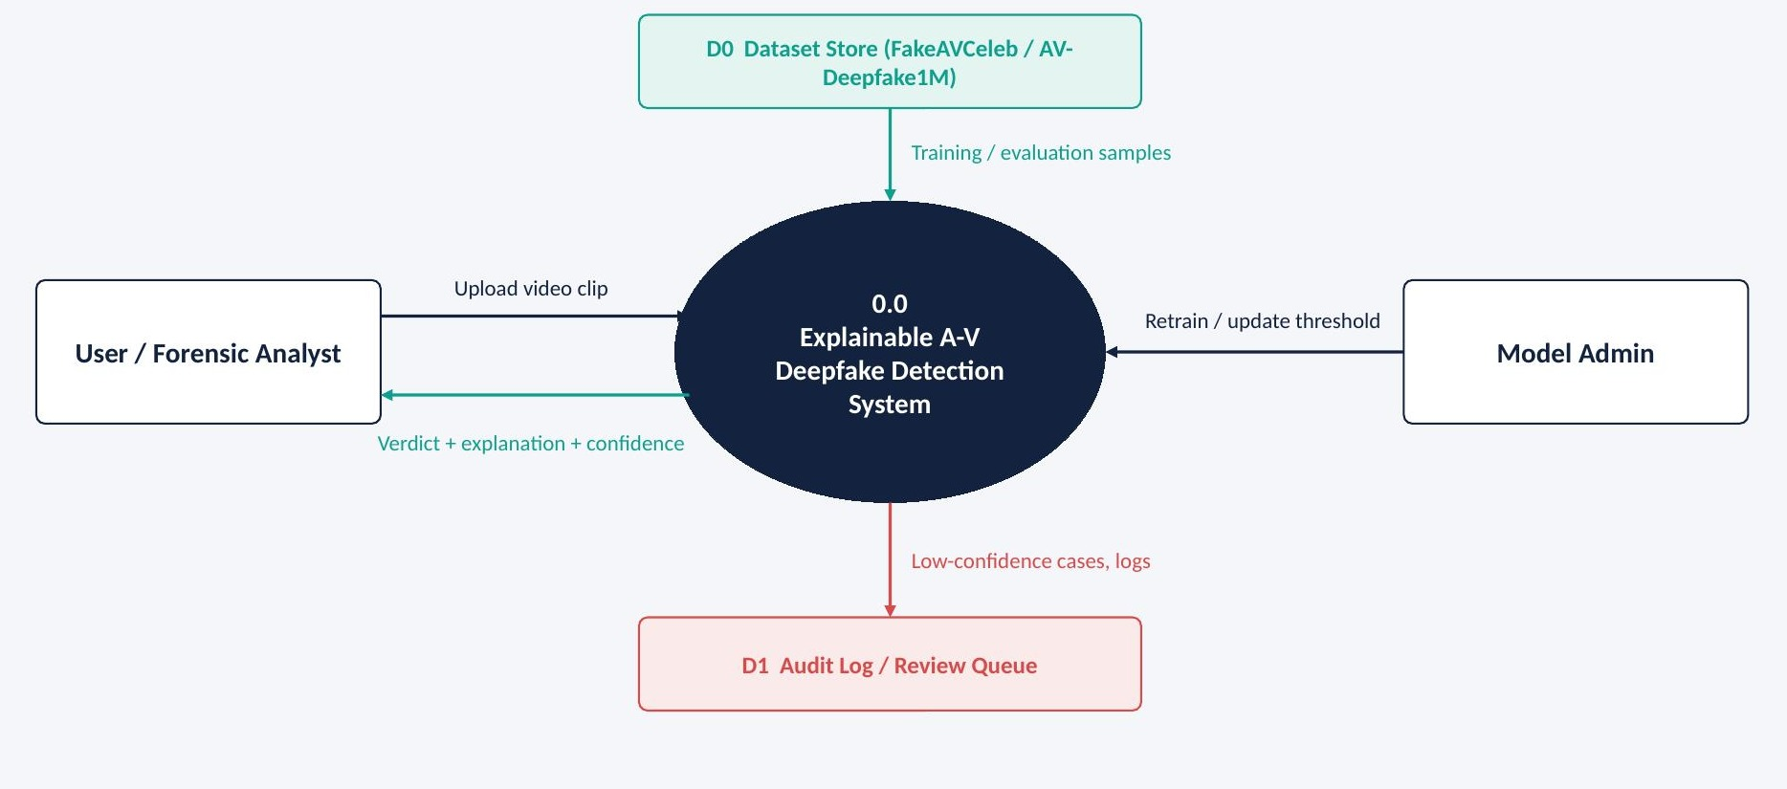
Figure 3.3: DFD Level 0 (context diagram)

3.6.2 DFD Level 1
The Level 1 DFD (Figure 3.4) decomposes the system into six processes: preprocessing of the input (1.0), encoding of audio and visual streams (2.0), cross-modal fusion (3.0), classification (4.0), explanation and uncertainty estimation (5.0) and verdict routing (6.0). Data store D0 holds the datasets, D1 holds the audit log and D2 holds the model weights and the threshold.
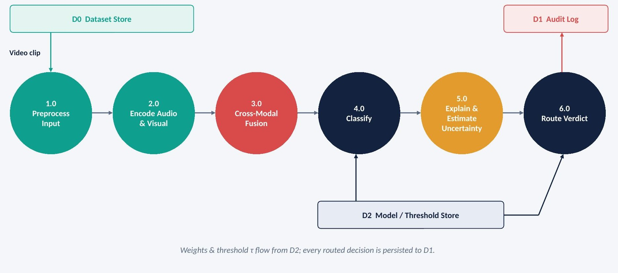
Figure 3.4: DFD Level 1 (process decomposition)

3.7 Use Case Diagram
Figure 3.5 shows the actors and their interactions with the system. The analyst uploads media, views the verdict and confidence, views the explanations and flags cases for manual review. The model administrator retrains or updates the model and sets the confidence threshold. The auditor reviews flagged cases and exports audit reports.
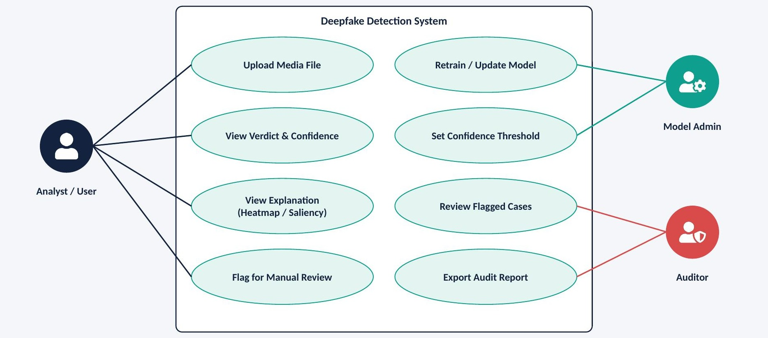
Figure 3.5: Use case diagram
Table 3.6: Use case descriptions
Use case | Actor | Description
Upload media file | Analyst | Uploads a video clip for analysis; system validates format and streams.
View verdict & confidence | Analyst | Views the real/fake verdict, calibrated confidence and uncertainty.
View explanation | Analyst | Views the Grad-CAM heatmap and SHAP audio attribution.
Flag for manual review | Analyst / System | Places a case in the review queue manually or automatically.
Retrain / update model | Admin | Registers a new model version and its metrics.
Set confidence threshold | Admin | Updates τ and u_max used for routing.
Review flagged cases | Auditor | Approves, rejects or escalates flagged cases.
Export audit report | Auditor | Exports decisions and reviewer actions for a date range.

3.8 ER Diagram and Database Design
The ER diagram (Figure 3.6) models the persistent data of the system. A dataset contains many media samples; each media sample may have many inference results produced by a particular model version; each inference result has explanations for one or both modalities and at most one review-queue entry, which is resolved by a user.
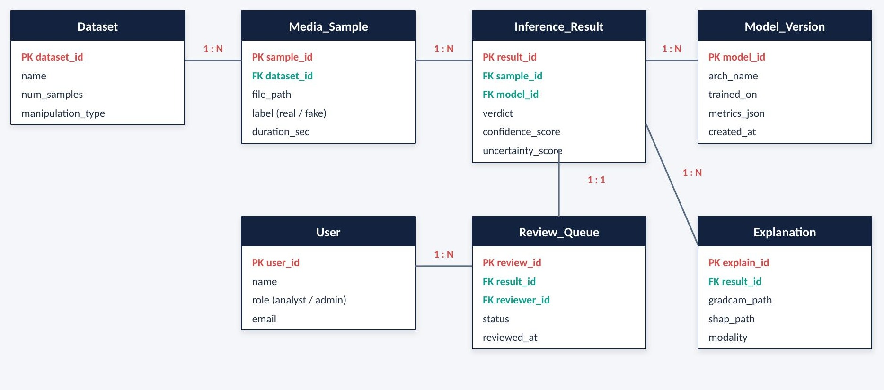
Figure 3.6: ER diagram
Table 3.7: Data dictionary: Media_Sample
Attribute | Type | Description
sample_id (PK) | INTEGER | Unique sample identifier
dataset_id (FK) | INTEGER | Source dataset
file_path | TEXT | Path to stored media
label | TEXT | Ground truth: real / fake (null for new uploads)
duration_sec | REAL | Clip duration in seconds

Table 3.8: Data dictionary: Inference_Result
Attribute | Type | Description
result_id (PK) | INTEGER | Unique result identifier
sample_id (FK) | INTEGER | Analysed media sample
model_id (FK) | INTEGER | Model version used
verdict | TEXT | real / fake
confidence_score | REAL | Calibrated probability of the verdict
uncertainty_score | REAL | Entropy or evidential uncertainty
input_hash | TEXT | SHA-256 hash of the input file
created_at | DATETIME | Timestamp of inference

Table 3.9: Data dictionary: Explanation and Review_Queue
Attribute | Type | Description
explain_id (PK) | INTEGER | Explanation identifier
result_id (FK) | INTEGER | Associated inference result
gradcam_path / shap_path | TEXT | Paths to stored explanation images
modality | TEXT | visual / audio
review_id (PK) | INTEGER | Review-queue entry identifier
status | TEXT | pending / approved / rejected / escalated
reviewer_id (FK) | INTEGER | User who resolved the case
reviewed_at | DATETIME | Resolution timestamp

3.9 UML Diagrams

3.9.1 Class Diagram
The class diagram (Figure 3.7) shows the principal classes. MediaSample loads media and extracts streams; Preprocessor crops faces and computes Mel spectrograms; FusionEncoder holds the two encoders and performs cross-attention; DeepfakeClassifier predicts and exposes confidence; ExplainabilityEngine, UncertaintyEstimator and ReviewQueueManager are used by the classifier to explain, quantify uncertainty and route cases respectively.
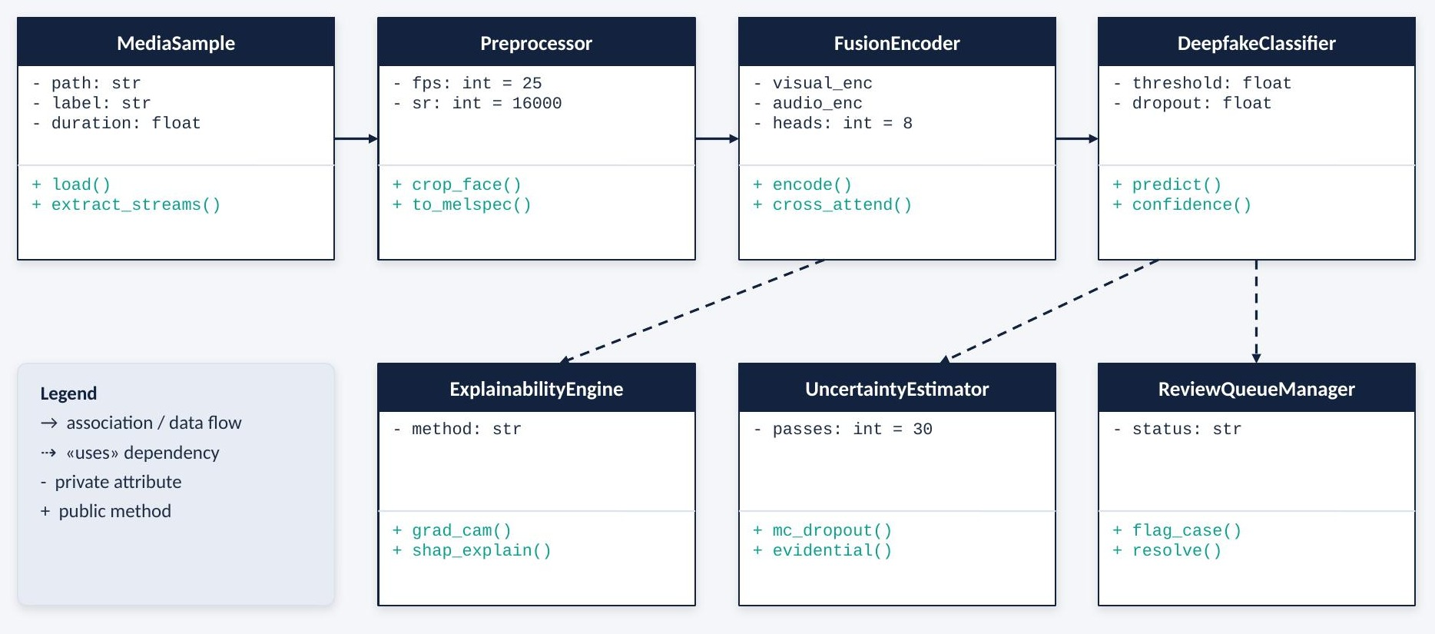
Figure 3.7: UML class diagram

3.9.2 Sequence Diagram
The sequence diagram (Figure 3.8) shows the message flow for one inference request. The user uploads a video to the API, which calls the preprocessor. Once frames and log-Mel features are ready, the API calls the fusion model, which invokes the explainability and uncertainty components. Saliency maps, confidence and uncertainty are returned to the API, which enqueues the case if the confidence is below the threshold and finally returns the verdict, confidence and explanation to the user.
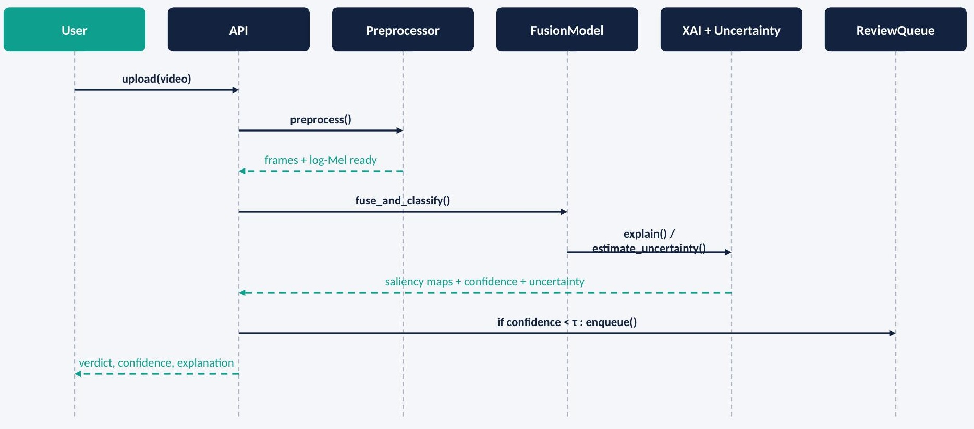
Figure 3.8: UML sequence diagram for the inference flow

3.9.3 Activity Diagram
The activity diagram (Figure 3.9) shows the end-to-end pipeline, including the decision node on confidence. Both the auto-accept path and the human-review path terminate after an audit record is written.
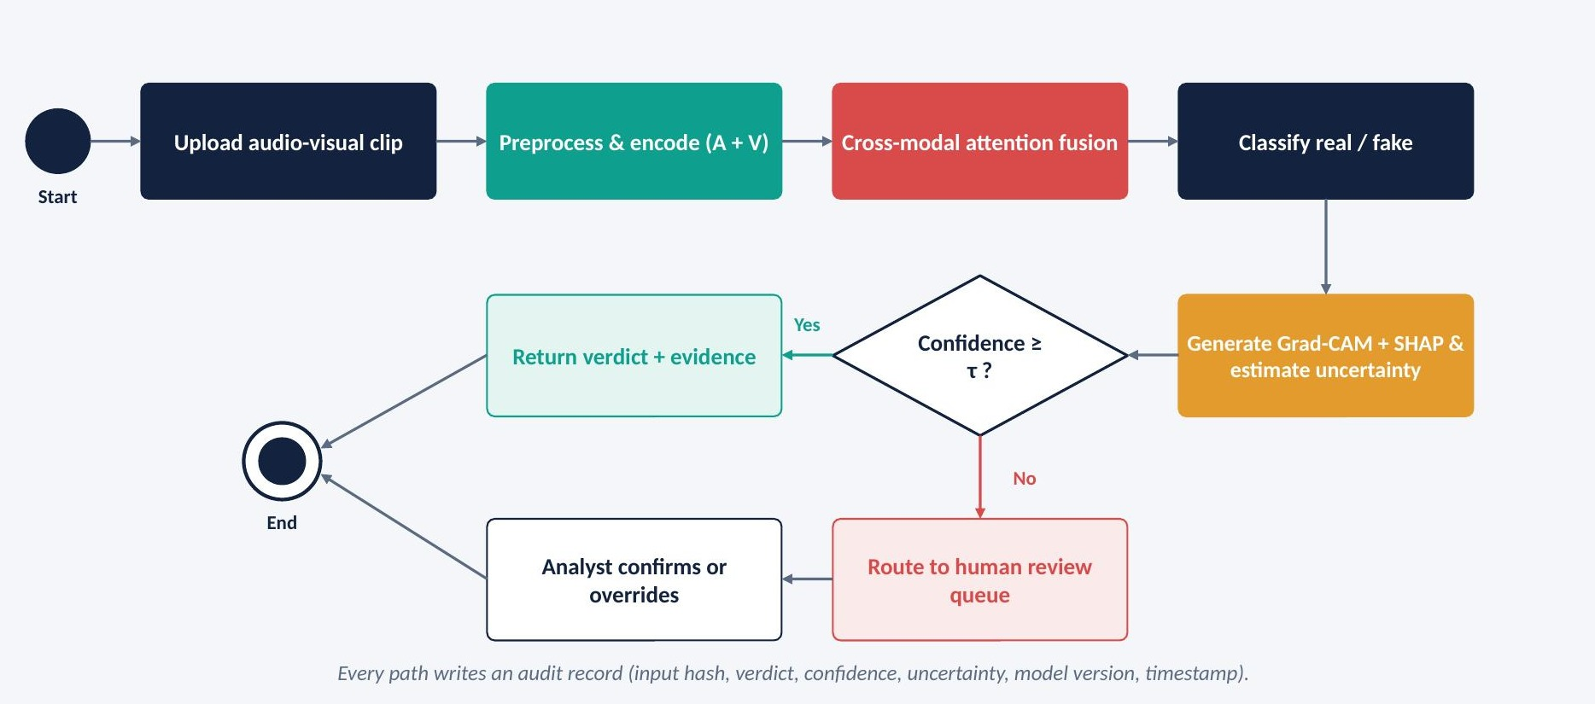
Figure 3.9: UML activity diagram for the end-to-end pipeline

3.10 Detailed Design of the Fusion Module
The fusion module is the core of the framework (Figure 3.10). Let V ∈ ℝ^(Tv×d) be the visual token sequence (Tv = 32 frames) and A ∈ ℝ^(Ta×d) the audio token sequence, with d = 512. Scaled dot-product attention is defined as:
Attention(Q, K, V) = softmax( Q Kᵀ / √dₖ ) V (3.1)
Multi-head attention with h = 8 heads projects the inputs into h subspaces of dimension dₖ = d / h = 64, applies attention in each and concatenates the results. Bidirectional cross-attention is then computed as:
Zᵥ = LayerNorm( V + MHA(Q = V, K = A, V = A) ) (3.2)
Zₐ = LayerNorm( A + MHA(Q = A, K = V, V = V) ) (3.3)
In Equation 3.2 each visual token attends over the audio sequence, so that each frame gathers the speech evidence most relevant to it; in Equation 3.3 each audio token attends over the frames. The two outputs are mean-pooled over time and concatenated to form the fused representation:
h = [ pool(Zᵥ) ; pool(Zₐ) ] ∈ ℝ¹⁰²⁴ (3.4)
The fused vector is passed through a feed-forward layer and the classifier head. Because both directions are modelled, a manipulation that affects only the video (face swap with real audio) or only the audio (voice clone over real video) produces an atypical attention pattern in at least one direction.
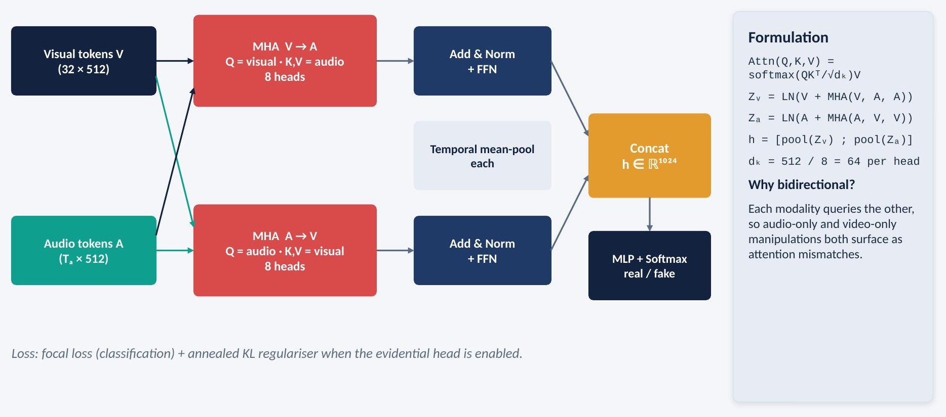
Figure 3.10: Detailed architecture of the cross-modal multi-head attention fusion module

3.11 Design of the Decision-Routing Mechanism
Figure 3.11 shows the design of the human-in-the-loop routing mechanism. For each clip, the system computes the confidence of the predicted class and an uncertainty score. The clip is automatically accepted only if the confidence is at least τ and the uncertainty is at most u_max; otherwise it is placed in the review queue. Both thresholds are tuned on the validation set to balance reviewer workload against the residual error rate of auto-accepted decisions. Every decision, whether automatic or reviewed, is logged for audit.
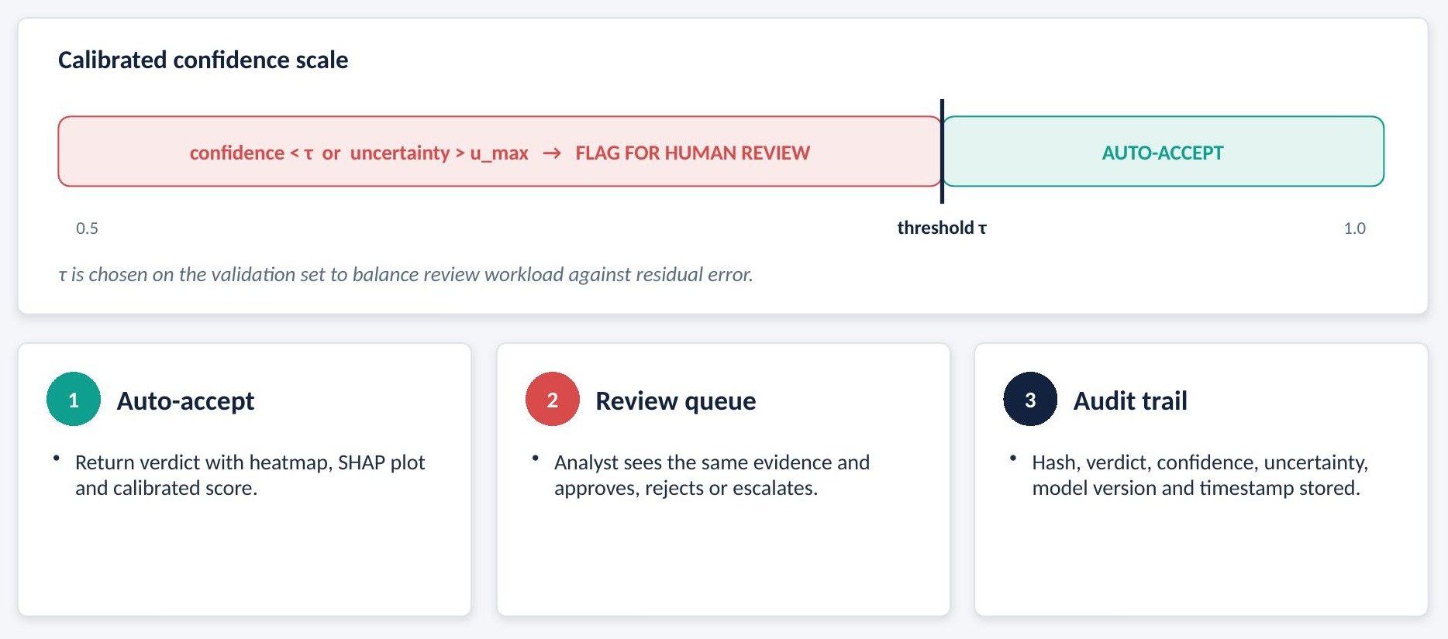
Figure 3.11: Design of the human-in-the-loop decision routing

Chapter 4

IMPLEMENTATION
This chapter describes how the designed framework was implemented. It covers the tools and technologies used, the dataset, and the module-wise implementation of preprocessing, encoding, fusion, classification, explainability, uncertainty estimation, decision routing and the analyst dashboard, with key code snippets. It closes with the training protocol, the project structure and the project execution plan.

4.1 Tools and Technologies

4.1.1 Core Development Environment
- Python 3.10: the primary language for data processing, model construction, training, evaluation and the dashboard. Its scientific ecosystem provides mature libraries for every stage of the pipeline.
- Jupyter Notebook / Google Colab: used for experimentation, data exploration and visualisation, and for GPU-backed training runs.
- Visual Studio Code: used for developing the modular source code, the API and the dashboard.

4.1.2 Deep Learning Frameworks
- PyTorch: the core framework. Its dynamic computation graph simplifies the implementation of custom modules such as the bidirectional cross-attention block and makes it straightforward to switch dropout on at inference time for MC Dropout.
- torchvision and timm: provide ImageNet-pretrained EfficientNet-B0 and ViT-B/16 backbones for the visual encoder.
- Hugging Face Transformers: provides pretrained WavLM-Base+ and XLS-R models and access to all hidden layers, which is required for Sensitive Layer Selection.

4.1.3 Media Processing
- FFmpeg: demultiplexes audio and video streams and converts audio to 16 kHz mono WAV.
- OpenCV: reads video frames, resizes and converts colour spaces.
- facenet-pytorch (MTCNN): detects faces and facial landmarks for alignment and cropping.
- torchaudio and Librosa: load and resample audio, compute log-Mel spectrograms and perform voice-activity detection.

4.1.4 Explainability and Uncertainty
- Captum / pytorch-grad-cam: compute Grad-CAM heatmaps for the visual branch.
- SHAP: computes KernelSHAP attributions over grouped Mel-band and time-segment features.
- Custom PyTorch code: implements MC Dropout sampling, the evidential Dirichlet head, the KL regulariser and calibration metrics.

4.1.5 Evaluation, Visualisation and Deployment
- scikit-learn: computes accuracy, precision, recall, F1-score, ROC-AUC and confusion matrices, and performs subject-disjoint data splitting.
- Matplotlib and Seaborn: produce training curves, ROC curves, reliability diagrams and explanation overlays.
- MLflow: logs parameters, metrics and artefacts for each experiment to support reproducibility.
- Streamlit and FastAPI: implement the analyst dashboard and the inference API.
- SQLite: stores the audit log and the review queue.
- Git/GitHub and Docker: provide version control and a reproducible runtime environment.

4.2 Dataset Description
The primary dataset is FakeAVCeleb, an audio-visual multimodal deepfake dataset introduced at the NeurIPS 2021 Datasets and Benchmarks track. It contains approximately 20,000 video clips with paired audio, derived from videos of celebrities from diverse ethnic backgrounds. Visual manipulations are produced with FaceSwap and FSGAN, lip-synchronisation manipulations with Wav2Lip, and audio manipulations with SV2TTS voice cloning. The resulting clips fall into the four categories shown in Figure 4.1.
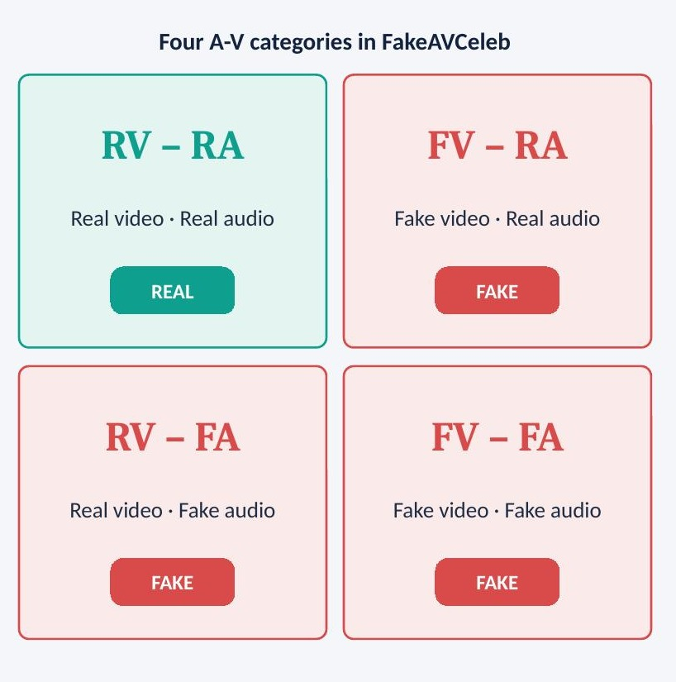
Figure 4.1: Four audio-visual categories in FakeAVCeleb
Table 4.1: Dataset properties
Property | Description
Primary dataset | FakeAVCeleb (audio-visual multimodal deepfake dataset)
Size | Approximately 20,000 clips with paired audio
Manipulations | FaceSwap, FSGAN, Wav2Lip lip-sync, SV2TTS voice cloning
Categories | RV-RA (real), FV-RA, RV-FA, FV-FA (fake)
Task | Binary classification: real vs fake
Split | 70% training, 15% validation, 15% test; subject-disjoint
Class balance | Real-video/real-audio clips form a small minority; handled with focal loss and class-balanced sampling
Cross-dataset sets | AV-Deepfake1M (audio-visual) and DFD (visual manipulation) for generalisation testing

A clip is labelled real only if both its video and its audio are genuine; any manipulation in either stream makes the clip fake. The dataset is split in a subject-disjoint manner so that no identity appears in more than one of the training, validation and test sets. This prevents the model from achieving high accuracy by memorising identities and gives a more honest estimate of generalisation. AV-Deepfake1M and DFD are used only for testing, never for training.

4.3 Preprocessing Module
The preprocessing module prepares the visual and audio streams in two parallel lanes (Figure 4.2).
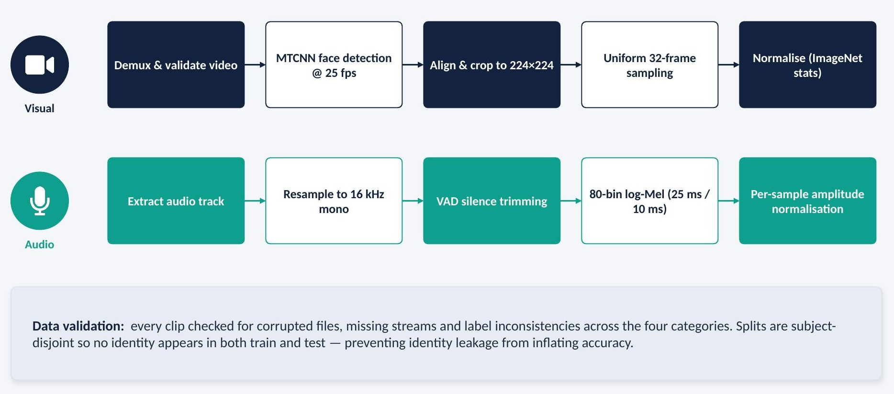
Figure 4.2: Preprocessing pipeline for the visual and audio lanes

4.3.1 Data Validation
Before preprocessing, every clip is checked for file corruption, missing audio or video streams, zero-length streams and label inconsistencies across the four categories. Clips that fail validation are logged and excluded. A manifest file records the path, label, category, subject identifier and duration of every valid clip, and is used to generate the subject-disjoint splits.

4.3.2 Visual Preprocessing
Frames are read at 25 fps. MTCNN detects the face and five facial landmarks in each frame; the face is aligned using the eye positions, cropped with a small margin and resized to 224×224 pixels. To bound computation, 32 frames are sampled uniformly across the clip. Pixel values are normalised with ImageNet mean and standard deviation. Face crops are cached to disk so that repeated experiments do not repeat detection.

4.3.3 Audio Preprocessing
The audio track is extracted with FFmpeg and resampled to 16 kHz mono. A voice-activity-detection mask removes leading, trailing and long internal silences. For the classical baseline and for SHAP analysis, 80-bin log-Mel spectrograms are computed with a 25 ms window and 10 ms hop. The raw normalised waveform is passed to the self-supervised encoder, which computes its own internal features.
Listing 4.1: Preprocessing: face extraction and log-Mel computation
mtcnn = MTCNN(image_size=224, margin=20, post_process=False, device=dev)

def extract_faces(video_path, n_frames=32, fps=25):
frames = read_frames(video_path, fps=fps) # OpenCV
idx = np.linspace(0, len(frames) - 1, n_frames).astype(int)
faces = [mtcnn(frames[i]) for i in idx]
faces = [f for f in faces if f is not None]
return torch.stack(faces) / 255.0 # (T,3,224,224)

def log_mel(wav, sr=16000):
mel = torchaudio.transforms.MelSpectrogram(
sample_rate=sr, n_fft=400, hop_length=160, n_mels=80)(wav)
return torch.log(mel + 1e-6) # (80, frames)

4.4 Dual-Branch Encoders
Figure 4.3 summarises the two encoders that convert the preprocessed streams into token sequences of equal width.
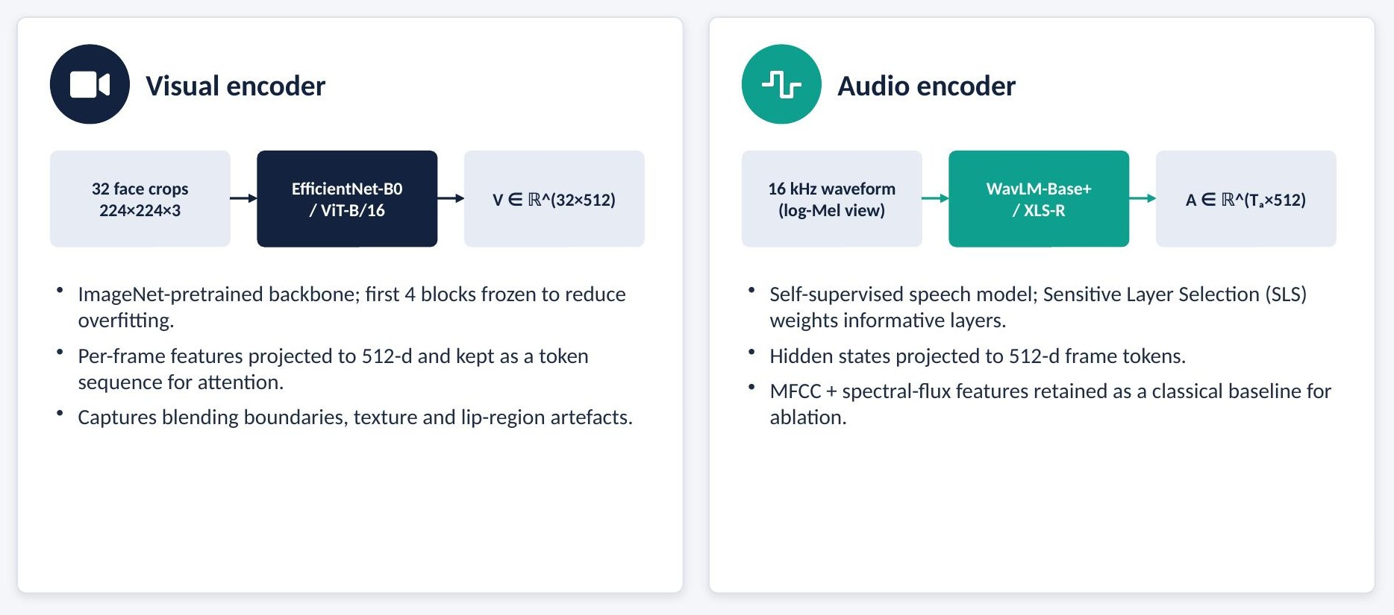
Figure 4.3: Visual and audio encoders

4.4.1 Visual Encoder
The visual encoder uses an ImageNet-pretrained EfficientNet-B0 (or, as an alternative configuration, ViT-B/16). The first four blocks are frozen to reduce overfitting on the limited number of subjects, while the later blocks are fine-tuned. The pooled feature of each frame is projected by a linear layer to 512 dimensions, yielding a token sequence V of shape 32 × 512. Keeping one token per frame, rather than pooling over time, allows the fusion module to relate individual frames to the audio.

4.4.2 Audio Encoder
The audio encoder uses WavLM-Base+ (or XLS-R). Different transformer layers of self-supervised speech models capture different information: lower layers are more acoustic, higher layers more phonetic. Following the Sensitive Layer Selection approach, the hidden states of all layers are combined with learned softmax weights so that the model can emphasise the layers most sensitive to synthesis artefacts. The combined representation is projected to 512 dimensions, yielding a token sequence A of shape Ta × 512, where Ta depends on the clip length (approximately 50 tokens per second).
Listing 4.2: Audio encoder with Sensitive Layer Selection
class AudioEncoder(nn.Module):
def __init__(self, name="microsoft/wavlm-base-plus", d=512):
super().__init__()
self.ssl = WavLMModel.from_pretrained(name, output_hidden_states=True)
L = self.ssl.config.num_hidden_layers + 1
self.layer_w = nn.Parameter(torch.zeros(L)) # SLS weights
self.proj = nn.Linear(self.ssl.config.hidden_size, d)

def forward(self, wav):
hs = torch.stack(self.ssl(wav).hidden_states) # (L,B,Ta,768)
w = self.layer_w.softmax(0)[:, None, None, None]
return self.proj((w * hs).sum(0)) # (B,Ta,512)

4.5 Cross-Modal Attention Fusion and Classification
The fusion module implements Equations 3.1–3.4 using two nn.MultiheadAttention layers with eight heads each. Residual connections and layer normalisation stabilise training. The pooled outputs are concatenated to a 1024-dimensional vector, passed through a feed-forward layer and then through the classification head. The attention weights of both directions are returned so that they can be inspected alongside the Grad-CAM and SHAP explanations.
Listing 4.3: Cross-modal attention fusion module
class CrossAttentionFusion(nn.Module):
def __init__(self, d=512, heads=8, p=0.3):
super().__init__()
self.v2a = nn.MultiheadAttention(d, heads, dropout=p, batch_first=True)
self.a2v = nn.MultiheadAttention(d, heads, dropout=p, batch_first=True)
self.norm_v, self.norm_a = nn.LayerNorm(d), nn.LayerNorm(d)
self.ffn = nn.Sequential(nn.Linear(2*d, 2*d), nn.GELU(), nn.Dropout(p))
self.head = nn.Sequential(nn.Linear(2*d, 256), nn.GELU(),
nn.Dropout(p), nn.Linear(256, 2))

def forward(self, V, A): # V:(B,Tv,512) A:(B,Ta,512)
zv, w_va = self.v2a(V, A, A) # visual queries attend to audio
za, w_av = self.a2v(A, V, V) # audio queries attend to video
zv = self.norm_v(V + zv).mean(1)
za = self.norm_a(A + za).mean(1)
h = self.ffn(torch.cat([zv, za], dim=-1)) # fused 1024-d
return self.head(h), (w_va, w_av)

4.5.1 Loss Function
Because real clips form a small minority of FakeAVCeleb, the classifier is trained with focal loss, which down-weights easy, well-classified examples and focuses learning on hard ones:
FL(pₜ) = − αₜ (1 − pₜ)^γ log(pₜ) (4.1)
where pₜ is the predicted probability of the true class, αₜ is a class-balancing weight and γ is the focusing parameter. Class-balanced sampling is additionally used when constructing training batches.

4.6 Explainability Module
Figure 4.4 summarises the explainability module, which produces one explanation per modality.
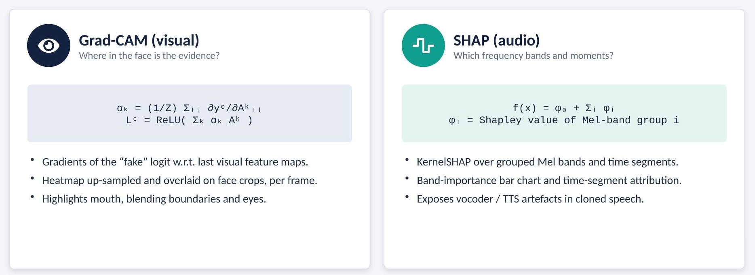
Figure 4.4: Explainability module: Grad-CAM for the visual stream and SHAP for the audio stream

4.6.1 Grad-CAM for the Visual Stream
For the predicted "fake" class c, Grad-CAM computes the gradient of the class score yᶜ with respect to the feature maps Aᵏ of the last convolutional block of the visual encoder, averages these gradients spatially to obtain the importance weight of each map, and forms a weighted combination:
αₖᶜ = (1/Z) Σᵢ Σⱼ ∂yᶜ / ∂Aᵏᵢⱼ (4.2)
Lᶜ = ReLU( Σₖ αₖᶜ Aᵏ ) (4.3)
Because the classifier sits after the fusion module, the gradients flow through the cross-attention layers, so the heatmap reflects the visual evidence as used by the fused decision rather than by the visual branch alone. The heatmap for each frame is up-sampled to 224×224 and overlaid on the face crop, and the frames with the highest activation are shown in the dashboard.

4.6.2 SHAP for the Audio Stream
SHAP explains a prediction f(x) as a sum of feature contributions φᵢ added to a base value φ₀:
f(x) = φ₀ + Σᵢ φᵢ (4.4)
Computing exact Shapley values over thousands of spectrogram bins is infeasible, so the log-Mel spectrogram is divided into groups: eight frequency bands and a fixed number of time segments. KernelSHAP estimates the contribution of each group by masking groups (replacing them with a background value from real clips) and observing the change in the fused model's output. The result is presented as a band-importance bar chart and a time-segment attribution strip.
Listing 4.4: Grad-CAM and grouped KernelSHAP
cam = GradCAM(model=vis_wrapper, target_layers=[visual_enc.backbone.blocks[-1]])
heatmaps = cam(input_tensor=faces, targets=[ClassifierOutputTarget(FAKE)])

def shap_audio(model, V, mel, n_bands=8, n_segs=10, nsamples=300):
groups = make_groups(mel.shape, n_bands, n_segs) # masks per group
def f(z): # z: (N, n_groups)
x = apply_masks(mel, groups, z, background=real_mean_mel)
return model.predict_from_mel(V, x)[:, FAKE].cpu().numpy()
expl = shap.KernelExplainer(f, np.zeros((1, len(groups))))
return expl.shap_values(np.ones((1, len(groups))), nsamples=nsamples)

4.6.3 Evaluating Explanation Fidelity
Explanations are evaluated quantitatively using deletion and insertion curves. For deletion, the most important pixels (or Mel groups) according to the explanation are progressively removed and the drop in the "fake" probability is recorded; a faithful explanation causes a steep drop and hence a low deletion AUC. For insertion, the most important regions are progressively added to a blurred or silent input, and a faithful explanation yields a high insertion AUC. The stability of SHAP attributions is measured by repeating the estimation with different random seeds.

4.7 Uncertainty Module
Figure 4.5 summarises the two uncertainty methods implemented.
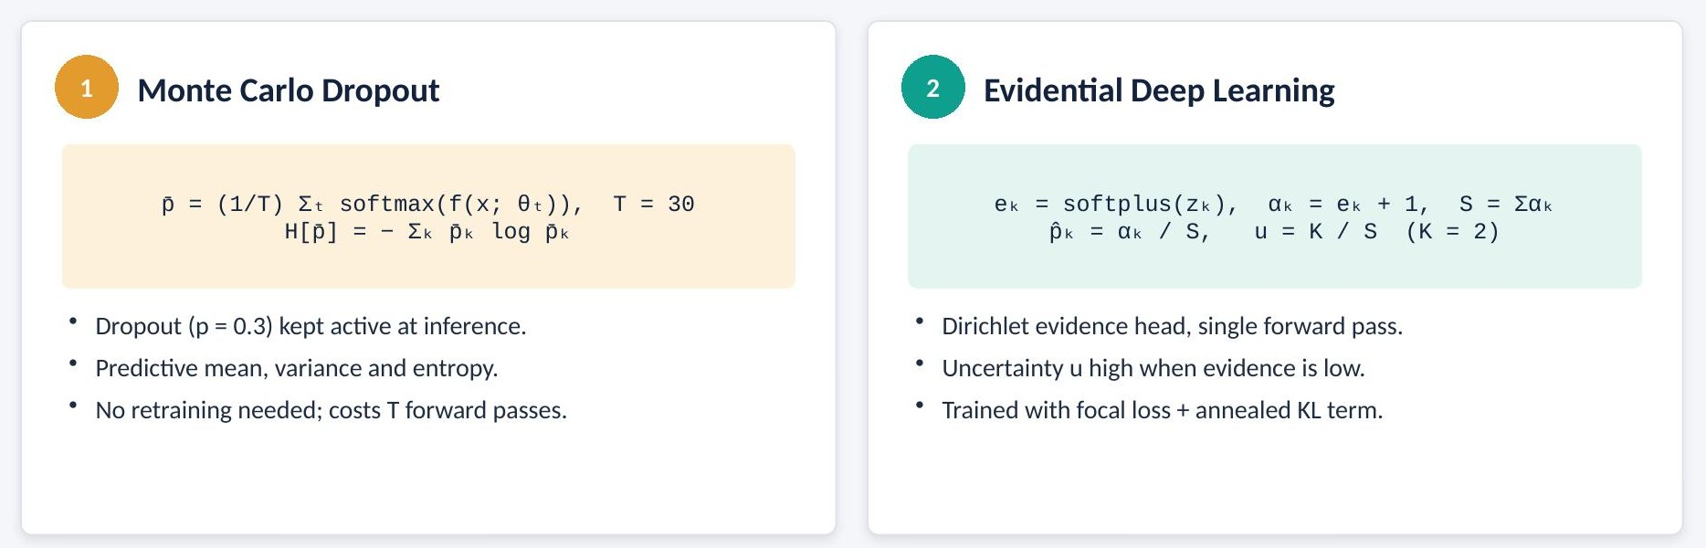
Figure 4.5: Uncertainty module: Monte Carlo Dropout and Evidential Deep Learning

4.7.1 Monte Carlo Dropout
At inference time only the dropout layers are switched to training mode, while batch-normalisation layers remain in evaluation mode. The model is run T = 30 times on the same input, and the predictive mean, variance and entropy are computed:
p̄ = (1/T) Σₜ softmax( f(x; θₜ) ) (4.5)
H[p̄] = − Σₖ p̄ₖ log p̄ₖ (4.6)
To reduce latency, the encoders are run once and only the fusion module and classifier (which contain the dropout layers) are sampled T times.

4.7.2 Evidential Deep Learning
In the evidential configuration, the classifier outputs non-negative evidence eₖ = softplus(zₖ) for each class k. The Dirichlet parameters are αₖ = eₖ + 1, the total strength is S = Σₖ αₖ, the expected probability is p̂ₖ = αₖ / S and the uncertainty is:
u = K / S (4.7)
where K = 2 is the number of classes. The evidential head is trained with the classification loss plus a KL-divergence term that shrinks misleading evidence towards the uniform Dirichlet, with a coefficient annealed from zero during early epochs.
Listing 4.5: MC Dropout inference, evidential head and routing
def enable_dropout(model):
for m in model.modules():
if isinstance(m, nn.Dropout):
m.train() # BatchNorm stays in eval

@torch.no_grad()
def mc_predict(fusion, V, A, T=30):
fusion.eval(); enable_dropout(fusion)
probs = torch.stack([fusion(V, A)[0].softmax(-1) for _ in range(T)])
mean = probs.mean(0)
ent = -(mean * mean.clamp_min(1e-8).log()).sum(-1)
return mean, probs.var(0).sum(-1), ent

def evidential(logits, K=2):
alpha = F.softplus(logits) + 1
S = alpha.sum(-1, keepdim=True)
return alpha / S, K / S.squeeze(-1)

def route(mean, unc, tau=0.85, u_max=0.5):
conf, pred = mean.max(-1)
review = (conf < tau) | (unc > u_max)
return pred, conf, review # review=True -> human queue

4.7.3 Threshold Calibration
The routing thresholds τ and u_max are selected on the validation set. For a grid of candidate values, the fraction of clips routed to review (coverage cost) and the error rate among auto-accepted clips (selective risk) are computed. The operating point is chosen to keep the selective error below a target while limiting the review workload. Expected Calibration Error is computed before and after uncertainty modelling to verify that confidence scores are meaningful.

4.8 Decision Routing, Audit Logging and API
The FastAPI service exposes an endpoint that accepts a video upload, runs the full pipeline and returns a JSON response containing the verdict, confidence, uncertainty, routing decision and paths to the explanation images. Every request writes an Inference_Result record and associated Explanation records to SQLite; flagged cases also create a Review_Queue entry with status "pending". Reviewers update the status through the dashboard, and each change is timestamped.

4.9 Analyst Dashboard Prototype
The Streamlit dashboard (Figure 4.6) allows an analyst to upload a clip and view the results in a single screen: the video preview with the Grad-CAM overlay and waveform, the verdict with its confidence, uncertainty and model version, the SHAP band-importance chart, a confidence gauge showing the threshold, and the review queue with actions to approve, reject or escalate cases.
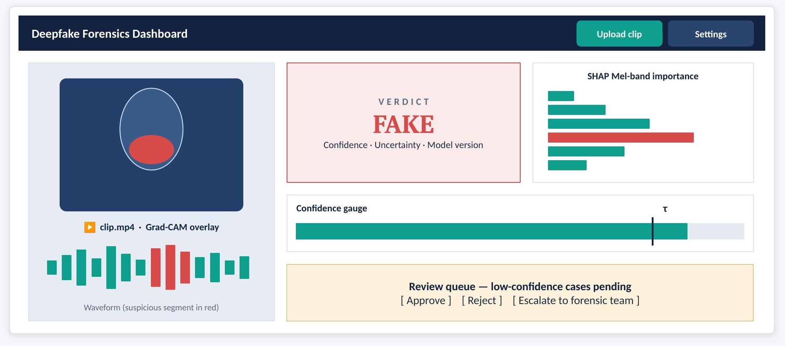
Figure 4.6: Layout of the analyst dashboard prototype

4.10 Training Protocol
Table 4.2 lists the training configuration. Models are trained with AdamW and a cosine learning-rate schedule. The checkpoint with the best validation F1-score is retained. All runs use fixed random seeds and are logged in MLflow with their configuration files.
Table 4.2: Training configuration and hyper-parameters
Hyper-parameter | Value
Optimiser | AdamW
Learning rate | 2 × 10⁻⁴ with cosine decay
Batch size | 32
Attention heads | 8
Embedding size | 512 per modality, 1024 fused
Dropout | 0.3 in fusion and classifier
MC Dropout passes | T = 30 at inference
Loss | Focal loss (+ annealed KL term for the evidential head)
Visual input | 32 frames, 224×224, 25 fps
Audio input | 16 kHz mono; 80-bin log-Mel (25 ms / 10 ms) for SHAP and baseline
Frozen layers | First four visual blocks
Model selection | Best validation F1-score
Reproducibility | Fixed seeds, versioned configs, MLflow tracking

4.11 Project Structure
The source code is organised as a Python package with separate modules for each design component, as shown below. A README file explains environment setup, data preparation, training, evaluation and how to launch the API and dashboard.
Listing 4.6: Project directory structure
av-deepfake-xai/
├── configs/ # YAML configs for each experiment
├── data/ # manifests and subject-disjoint splits
├── src/
│ ├── ingest.py # validation and demuxing
│ ├── preprocess.py # MTCNN face crops, audio + log-Mel
│ ├── datasets.py # AVDataset, samplers
│ ├── models/
│ │ ├── visual_encoder.py
│ │ ├── audio_encoder.py
│ │ ├── fusion.py # CrossAttentionFusion
│ │ └── evidential.py
│ ├── train.py evaluate.py calibrate.py
│ ├── explain/ gradcam.py shap_audio.py
│ └── uncertainty/ mc_dropout.py routing.py
├── api/main.py # FastAPI inference service
├── dashboard/app.py # Streamlit analyst dashboard
├── db/schema.sql # audit log and review queue
├── Dockerfile requirements.txt README.md

4.12 Project Execution Plan
The project was executed in three phases over approximately twenty-four weeks, as shown in the Gantt chart of Figure 4.7 and summarised in Table 4.3.
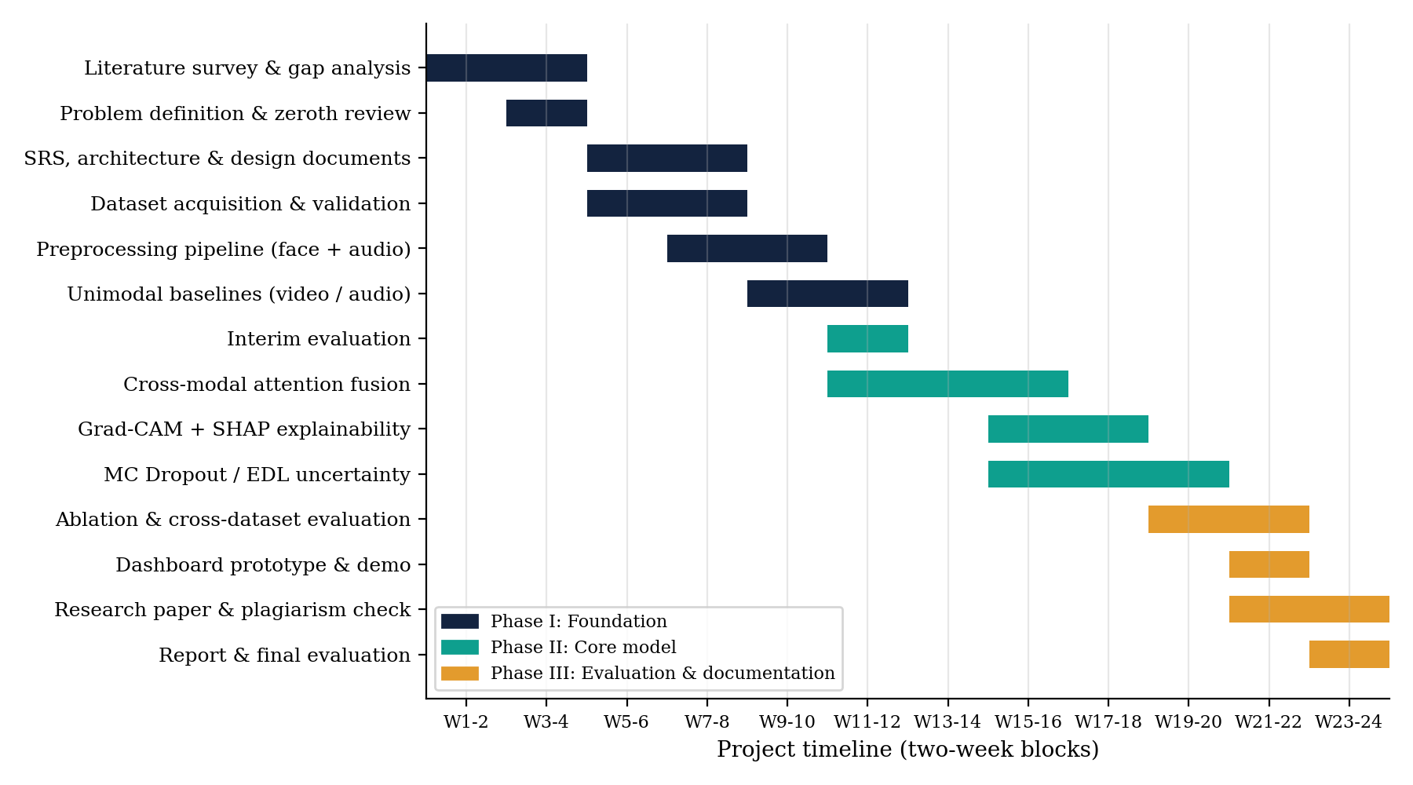
Figure 4.7: Gantt chart of the project execution plan
Table 4.3: Project phases and milestones
Phase | Activities | Milestone
I: Foundation | Literature survey of 30 papers; problem definition; zeroth review; SRS, HLD, LLD and UML design; dataset acquisition and validation; preprocessing pipeline; unimodal baselines | Interim evaluation with validated data pipeline and baseline results
II: Core model | Cross-modal attention fusion; Grad-CAM and SHAP integration; MC Dropout and evidential heads; threshold calibration | End-to-end explainable and uncertainty-aware model
III: Evaluation & documentation | Ablation study; cross-dataset evaluation; dashboard prototype; research paper; plagiarism check; final report | Final evaluation with live demonstration

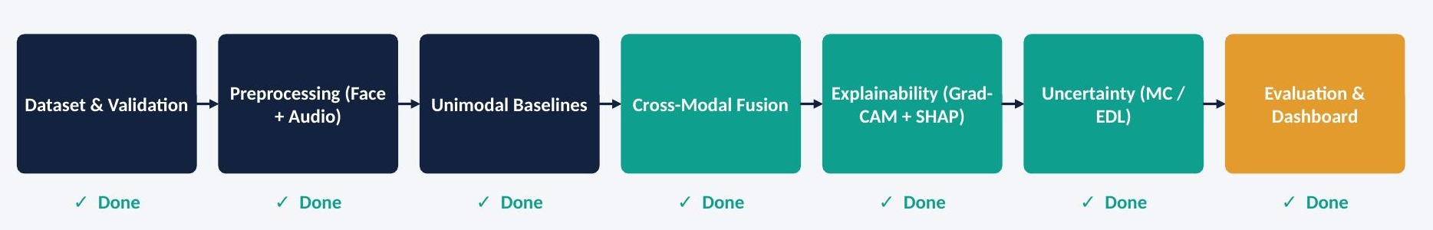
Figure 4.8: Implementation status of the pipeline stages

Chapter 5

RESULTS AND DISCUSSION
This chapter presents the evaluation of the framework. It defines the experimental setup and metrics, reports detection results on FakeAVCeleb, the ablation study, calibration and uncertainty analysis, explainability results and cross-dataset generalisation, compares the framework with existing approaches and presents the test plan.

5.1 Experimental Setup
All models are trained on the FakeAVCeleb training split and selected on the validation split; the test split is used only once for final reporting. Cross-dataset experiments evaluate the FakeAVCeleb-trained model directly on AV-Deepfake1M and DFD without fine-tuning. The unimodal baselines use the same encoders as the full model, with a classifier head applied to the pooled features of a single modality. The early-fusion baseline concatenates the pooled visual and audio features without attention. Each configuration is trained with the same optimiser, schedule and number of epochs. Experiments were run on a CUDA-enabled NVIDIA GPU.

5.2 Evaluation Metrics

5.2.1 Classification Metrics
With TP, TN, FP and FN denoting true positives, true negatives, false positives and false negatives (fake is the positive class):
Accuracy = (TP + TN) / (TP + TN + FP + FN) (5.1)
Precision = TP / (TP + FP), Recall = TP / (TP + FN) (5.2)
F1 = 2 · Precision · Recall / (Precision + Recall) (5.3)
The Area Under the ROC Curve (AUC-ROC) measures threshold-independent separability of real and fake clips. The Equal Error Rate (EER) is the operating point at which the false positive and false negative rates are equal; it is widely reported in anti-spoofing research.

5.2.2 Calibration Metrics
Expected Calibration Error divides predictions into M confidence bins Bₘ and measures the weighted gap between accuracy and confidence in each bin:
ECE = Σₘ ( |Bₘ| / n ) · | acc(Bₘ) − conf(Bₘ) | (5.4)
A perfectly calibrated model has ECE = 0. Reliability diagrams plot accuracy against confidence for each bin. Selective accuracy is the accuracy on the clips that are auto-accepted by the routing rule, and coverage is the fraction of clips auto-accepted.

5.2.3 Explanation Metrics
Deletion AUC (lower is better) and insertion AUC (higher is better) measure whether the regions highlighted by an explanation actually drive the prediction. Attribution stability measures the rank correlation of SHAP values across repeated runs with different seeds.

5.2.4 Generalisation Metric
The cross-dataset AUC drop is the difference between the in-domain AUC on FakeAVCeleb and the AUC on an unseen dataset. Smaller drops indicate better generalisation.

5.3 Detection Performance on FakeAVCeleb
Table 5.1 reports the detection performance of the unimodal baselines, the early-fusion baseline and the proposed model variants on the FakeAVCeleb test split.
Table 5.1: Detection performance on the FakeAVCeleb test split
Model | Acc | Prec | Rec | F1 | AUC | EER
Video-only (EfficientNet-B0) | — | — | — | — | — | —
Audio-only (WavLM + SLS) | — | — | — | — | — | —
Early concatenation fusion | — | — | — | — | — | —
Proposed cross-attention fusion | — | — | — | — | — | —
Proposed + MC Dropout | — | — | — | — | — | —
Proposed + evidential head | — | — | — | — | — | —

Output: the confusion-matrix
Figure 5.1: Confusion matrix of the proposed model on the FakeAVCeleb test split
Output: the ROC-curve plot comparing video-only, audio-only, early fusion and the proposed model
Figure 5.2: ROC curves of the unimodal baselines and the proposed model
Output: the training curves
Figure 5.3: Training and validation loss and F1-score curves
The comparison between the unimodal rows and the fusion rows shows how much each modality contributes on its own and how much is gained by combining them. Because FakeAVCeleb contains clips in which only one stream is manipulated, each unimodal baseline is expected to miss the category manipulated in the other modality; the fusion models should recover these cases. Per-category recall (FV-RA, RV-FA and FV-FA) should therefore be examined alongside the aggregate metrics.

5.4 Ablation Study
Each ablation in Table 5.2 changes exactly one design choice so that its individual contribution can be measured.
Table 5.2: Ablation study
ID | Configuration | Question answered | Acc | AUC | ECE
A1 | Video-only branch | Strength of visual evidence alone | — | — | —
A2 | Audio-only branch | Strength of audio evidence alone | — | — | —
A3 | Early concatenation (no attention) | Does cross-attention beat naive fusion? | — | — | —
A4 | Full cross-modal fusion | Performance of the complete framework | — | — | —
A5 | Full model − explainability | Does XAI affect accuracy or only interpretability? | — | — | —
A6 | Full model − uncertainty | Does uncertainty modelling affect calibration only? | — | — | —
A7 | Train FakeAVCeleb → test AV-Deepfake1M | How well does the framework generalise? | — | — | —

The difference between A3 and A4 isolates the value of cross-attention over simple concatenation. A5 is expected to show identical accuracy to A4, because the explainability module operates after the prediction and does not alter the model; this confirms that interpretability is obtained at no cost to accuracy. The comparison of A4 and A6 isolates the effect of uncertainty modelling on calibration: MC Dropout averages predictions and the evidential head is trained with an additional regulariser, so their accuracy may differ slightly from the plain softmax model while ECE should improve. A7 is discussed in Section 5.7.

5.5 Calibration and Uncertainty Analysis
Table 5.3: Calibration and selective prediction
Model | ECE ↓ | Selective Acc ↑ | Flagged % | Errors caught
Fusion (softmax only) | — | — | — | —
Fusion + MC Dropout | — | — | — | —
Fusion + evidential head | — | — | — | —

Output: reliability diagrams (accuracy vs confidence) for the softmax, MC Dropout and evidential models
Figure 5.4: Reliability diagrams before and after uncertainty modelling
Output: the risk–coverage curve obtained by sweeping the threshold τ
Figure 5.5: Accuracy of auto-accepted clips versus fraction routed to review
Table 5.3 reports ECE, the accuracy of auto-accepted clips, the percentage of clips routed to review and the fraction of all misclassified clips that were caught by the routing rule rather than auto-accepted. The last column is the most direct measure of the practical value of the uncertainty module: each caught error is a wrong verdict that reaches a human reviewer instead of being published.

5.6 Explainability Results
Output: Grad-CAM overlays for representative FV-RA, FV-FA and RV-RA clips
Figure 5.6: Grad-CAM heatmaps for fake (face-swap) and real samples
Output: the SHAP band-importance chart and time-segment attribution for an RV-FA clip
Figure 5.7: SHAP attribution over Mel-frequency bands for a cloned-voice sample
Table 5.4: Explanation fidelity
Metric | Grad-CAM (visual) | SHAP (audio)
Deletion AUC ↓ | — | —
Insertion AUC ↑ | — | —
Stability across runs ↑ | — | —

Qualitatively, faithful visual explanations for face-swap clips are expected to concentrate on the mouth, jaw line and blending boundary of the face, while those for lip-sync clips should concentrate on the mouth region. For cloned-voice clips, SHAP is expected to assign high importance to frequency bands and time segments where vocoder artefacts appear. Explanations for real clips should be diffuse, with no single region dominating. The quantitative fidelity metrics in Table 5.4 verify that the highlighted regions actually drive the prediction rather than merely looking plausible.

5.7 Cross-Dataset Generalisation
Table 5.5: Cross-dataset generalisation
Train → Test | Best unimodal AUC | Proposed AUC | AUC drop
FakeAVCeleb → FakeAVCeleb | — | — | baseline
FakeAVCeleb → AV-Deepfake1M | — | — | —
FakeAVCeleb → DFD (visual) | — | — | —

Deepfake-Eval-2024 reports that state-of-the-art detectors lose 45–50% of their AUC on in-the-wild content, so some degradation on unseen datasets is expected. Two outcomes are important here: the size of the AUC drop relative to the unimodal baselines, and whether the uncertainty module assigns higher uncertainty to out-of-distribution clips, so that more of them are routed to review. DFD contains only visual manipulations; it is evaluated with the original audio track, which tests whether the model correctly relies on visual evidence when the audio is genuine.

5.8 Comparison with Existing Approaches
Table 5.6: Comparison with existing approaches
Method | Modality | Fusion | XAI | UQ | Reported result
AVFF (CVPR 2024) | A + V | ✓ | ✗ | ✗ | 98.6% Acc (FakeAVCeleb)
KLASSify to Verify | A + V | ✓ | Partial | ✗ | 92.78% AUC (AV-Deepfake1M++)
CNN-RNN + Grad-CAM | V | ✗ | ✓ | ✗ | 88.3% Acc
Vision Transformer | V (image) | ✗ | ✗ | ✗ | 92.76% Acc, 0.97 AUC
Multi-View Evidential Learning | V | ✗ | ✗ | ✓ | 28% lower ECE (CDFv2)
Proposed framework | A + V | ✓ | ✓ | ✓ | —

Table 5.6 compares the proposed framework with representative existing approaches. The reported results are taken from the respective papers and use different datasets and protocols, so they are not directly comparable. The principal comparison is therefore one of capability: the proposed framework is the only one that combines audio-visual fusion with both explainability and uncertainty estimation.

5.9 Test Strategy and Test Plan
The testing strategy combines unit, integration, functional, validation, system and performance tests. The validation set is used only for model selection and threshold tuning, and the test set is used once for final reporting. Table 5.7 lists the test cases.
Table 5.7: Test cases
ID | Test case | Type | Expected result | Status
TC-01 | Video-only classifier on FakeAVCeleb test | Unit | Within 2% of published baseline | —
TC-02 | Audio-only classifier on FakeAVCeleb test | Unit | Within 2% of published baseline | —
TC-03 | Fusion end-to-end inference | Integration | Fusion ≥ both unimodal baselines | —
TC-04 | Grad-CAM for every fake prediction | Functional | Non-empty, spatially aligned map | —
TC-05 | SHAP explanation for audio stream | Functional | Non-empty attribution over Mel bands | —
TC-06 | Confidence-threshold routing | Functional | Below-τ samples enqueued | —
TC-07 | Calibration check on validation set | Validation | ECE below target (e.g. < 0.05) | —
TC-08 | Cross-dataset generalisation | System | AUC drop documented and bounded | —
TC-09 | Single-clip inference latency | Performance | < 2 s per 10 s clip on GPU | —
TC-10 | Corrupted / audio-less input | Functional | Rejected with clear error message | —
TC-11 | Audit log written for every request | Functional | Record with hash, verdict, confidence | —
TC-12 | Reviewer resolves flagged case | Functional | Status and timestamp updated | —

5.10 Limitations
Table 5.8: Limitations, risks and mitigation
Limitation / risk | Impact | Mitigation
Dataset bias | Identity overlap can inflate accuracy | Subject-disjoint splits; cross-dataset validation
Compute cost | Fusion, XAI and MC Dropout slow inference | Encoders run once; only fusion sampled; evidential single-pass option
Generalisation gap | Diffusion-era and in-the-wild fakes differ from training data | Cross-dataset tests; uncertainty flags out-of-distribution clips
Explanation reliability | Saliency can be unstable for similar inputs | Deletion/insertion AUC and stability reported
Miscalibration | Poor confidence undermines the review queue | ECE reported; thresholds tuned on validation data
Scope | Single-speaker, short clips only | Multi-speaker and streaming left to future work

Chapter 6

CONCLUSION AND FUTURE SCOPE

6.1 Conclusion
This dissertation set out to answer a practical question: can an audio-visual deepfake detector be accurate, explainable and honest about its own uncertainty at the same time? A structured survey of thirty papers showed that fusion accuracy, explainability and uncertainty quantification have each advanced, but always separately and, for explainability and uncertainty, only for a single modality. No existing framework combined all three for audio-visual deepfakes.
To address this gap, a dual-branch framework was designed and implemented. Face crops sampled from the video are encoded with EfficientNet-B0 or ViT-B/16, and speech is encoded with WavLM-Base+ or XLS-R using Sensitive Layer Selection. A bidirectional cross-modal multi-head attention module lets each modality query the other, so that lip-sync drift, spectral artefacts and identity mismatches surface as disagreements between streams. A classifier trained with focal loss produces the verdict.
Every verdict is accompanied by evidence. Grad-CAM heatmaps, computed through the fused model, show which facial regions drove the decision, and grouped KernelSHAP attributions show which frequency bands and time segments of the audio contributed. The fidelity of these explanations is measured with deletion and insertion curves rather than assumed.
The framework also estimates its own uncertainty using Monte Carlo Dropout or an evidential Dirichlet head. A routing rule, calibrated on the validation set, sends low-confidence or high-uncertainty clips to a human review queue instead of issuing a silent verdict, and every decision is logged for audit. A complete design, comprising requirement specification, architecture, high- and low-level design, data flow, use-case, ER and UML diagrams, and a prototype analyst dashboard make the framework usable by forensic analysts, journalists and moderators.
The evaluation protocol goes beyond accuracy to include calibration, explanation fidelity, selective prediction and cross-dataset generalisation. Together, these components move audio-visual deepfake detection from an accurate but opaque verdict towards a system that combines evidence from both modalities, exposes that evidence to the reviewer, and recognises when its own prediction should not be trusted.

6.2 Future Scope
- Temporal localisation: extending the framework to identify exactly which segments of a long video are manipulated, using the frame-level attention and saliency already computed.
- Real-time deployment: optimising the pipeline for streaming input and packaging it as an API or browser plug-in for platforms and newsrooms.
- Diffusion-era and in-the-wild data: training and evaluating on newer manipulation families and on in-the-wild collections such as Deepfake-Eval-2024.
- Natural-language explanations: using large language models to convert saliency maps and attributions into plain-language forensic reports for non-expert users.
- Multi-speaker and multilingual content: incorporating speaker diarisation and active-speaker detection so that audio segments are matched to the correct face.
- Efficiency and robustness: knowledge distillation for edge deployment, and evaluation against adversarial attacks designed to evade detection or mislead explanations.
- Publication: submitting the work to an IEEE conference on multimedia forensics or signal and image processing, followed by an extended journal version.

REFERENCES
[1] T. Oorloff, S. Koppisetti, N. Bonettini, D. Solanki, B. Colman, Y. Yacoob, A. Shahriyari, and G. Bharaj, "AVFF: Audio-visual feature fusion for video deepfake detection," in Proc. IEEE/CVF Conf. Computer Vision and Pattern Recognition (CVPR), 2024.
[2] V. S. Katamneni and A. Rattani, "Contextual cross-modal attention for audio-visual deepfake detection and localization," IEEE, 2024.
[3] H. Zou, M. Shen, Y. Hu, C. Chen, E. S. Chng, and D. Rajan, "Cross-modality and within-modality regularization for audio-visual deepfake detection," in Proc. IEEE Int. Conf. Acoustics, Speech and Signal Processing (ICASSP), 2024, pp. 4900–4904.
[4] "AVFakeNet: A unified end-to-end dense Swin Transformer deep learning model for audio-visual deepfakes detection."
[5] "MIS-AVoiDD: Modality invariant and specific representation for audio-visual deepfake detection."
[6] "DF-TransFusion: Multimodal deepfake detection via lip-audio cross-attention and facial self-attention."
[7] "Modality-agnostic audio-visual deepfake detection."
[8] "A robust approach to multimodal deepfake detection."
[9] "MCL: Multimodal contrastive learning for deepfake detection."
[10] "CMALDD-PTAF: Cross-modal adversarial learning for deepfake detection with pre-trained audio-visual features."
[11] "KLASSify to verify: Audio-visual deepfake detection using SSL-based audio and handcrafted visual features."
[12] S. Sandeep Kumar, Yogesh, Prajwal L et al., "Explainable deepfake detection: Integrating Grad-CAM with CNN-RNN architecture," 2024.
[13] "Deepfake audio detection and justification with explainable artificial intelligence."
[14] "Explainable deepfake detection across modalities: An overview."
[15] A. O. M. Salih et al., "Explainable AI for deepfake detection: A Grad-CAM approach to video forensics," in Proc. 6th Int. Conf. Emerging Technology (INCET), 2025.
[16] "XPlainVerse: A million-scale benchmark for explainable deepfake detection."
[17] "Uncertainty-aware deepfake detection via multi-view structural learning."
[18] "Prior and posterior networks: A survey on evidential deep learning methods for uncertainty estimation."
[19] Y. Gal and Z. Ghahramani, "Dropout as a Bayesian approximation: Representing model uncertainty in deep learning," in Proc. Int. Conf. Machine Learning (ICML), 2016.
[20] M. Sensoy, L. Kaplan, and M. Kandemir, "Evidential deep learning to quantify classification uncertainty," in Proc. Advances in Neural Information Processing Systems (NeurIPS), 2018.
[21] "Enhanced deepfake detection and classification using vision transformers."
[22] "Deepfake-Eval-2024: A multi-modal in-the-wild benchmark of deepfakes circulated in 2024."
[23] "Passive deepfake detection: A comprehensive survey."
[24] "DeepFake video detection: Insights into model generalisation — a systematic review."
[25] "A survey on multimedia-enabled deepfake detection: State-of-the-art tools and techniques, emerging trends."
[26] H. Khalid, S. Tariq, M. Kim, and S. S. Woo, "FakeAVCeleb: A novel audio-video multimodal deepfake dataset," in Proc. NeurIPS Datasets and Benchmarks Track, 2021.
[27] Q. Zhang, S. Wen, and T. Hu, "Audio deepfake detection with self-supervised XLS-R and SLS classifier," in Proc. ACM Int. Conf. Multimedia (ACM MM), 2024.
[28] "Audio deepfake detection with self-supervised WavLM and multi-fusion attentive classifier," in Proc. IEEE ICASSP, 2024.
[29] "Detection of cloned voices in realistic forensic scenarios."
[30] "Voice cloning and deep fake audio detection using deep learning."
[31] "X-AVDT: Audio-visual cross-attention for robust deepfake detection," arXiv preprint, 2026.
[32] "From prediction to explanation: Multimodal, explainable, and interactive deepfake detection framework for non-expert users (DF-P2E)," arXiv:2508.07596, 2025.
[33] "Explainable AI for forensic speech authentication within cognitive and computational neuroscience," Frontiers in Neuroscience, vol. 19, 2025, doi: 10.3389/fnins.2025.1692122.
[34] R. R. Selvaraju, M. Cogswell, A. Das, R. Vedantam, D. Parikh, and D. Batra, "Grad-CAM: Visual explanations from deep networks via gradient-based localization," in Proc. IEEE Int. Conf. Computer Vision (ICCV), 2017, pp. 618–626.
[35] S. M. Lundberg and S.-I. Lee, "A unified approach to interpreting model predictions," in Proc. Advances in Neural Information Processing Systems (NeurIPS), 2017.
[36] S. Chen et al., "WavLM: Large-scale self-supervised pre-training for full stack speech processing," IEEE J. Sel. Topics Signal Process., vol. 16, no. 6, pp. 1505–1518, 2022.
[37] M. Tan and Q. V. Le, "EfficientNet: Rethinking model scaling for convolutional neural networks," in Proc. Int. Conf. Machine Learning (ICML), 2019.
[38] A. Dosovitskiy et al., "An image is worth 16x16 words: Transformers for image recognition at scale," in Proc. Int. Conf. Learning Representations (ICLR), 2021.
[39] A. Vaswani et al., "Attention is all you need," in Proc. Advances in Neural Information Processing Systems (NeurIPS), 2017.
[40] K. Zhang, Z. Zhang, Z. Li, and Y. Qiao, "Joint face detection and alignment using multitask cascaded convolutional networks," IEEE Signal Process. Lett., vol. 23, no. 10, pp. 1499–1503, 2016.
[41] C. Guo, G. Pleiss, Y. Sun, and K. Q. Weinberger, "On calibration of modern neural networks," in Proc. Int. Conf. Machine Learning (ICML), 2017.
[42] T.-Y. Lin, P. Goyal, R. Girshick, K. He, and P. Dollár, "Focal loss for dense object detection," in Proc. IEEE Int. Conf. Computer Vision (ICCV), 2017.
[43] Z. Cai et al., "AV-Deepfake1M: A large-scale LLM-driven audio-visual deepfake dataset," in Proc. ACM Int. Conf. Multimedia (ACM MM), 2024.
[44] A. Rössler, D. Cozzolino, L. Verdoliva, C. Riess, J. Thies, and M. Nießner, "FaceForensics++: Learning to detect manipulated facial images," in Proc. IEEE/CVF Int. Conf. Computer Vision (ICCV), 2019.

APPENDIX A: PRESENTATION SLIDES
This appendix reproduces the slides of the final evaluation presentation.
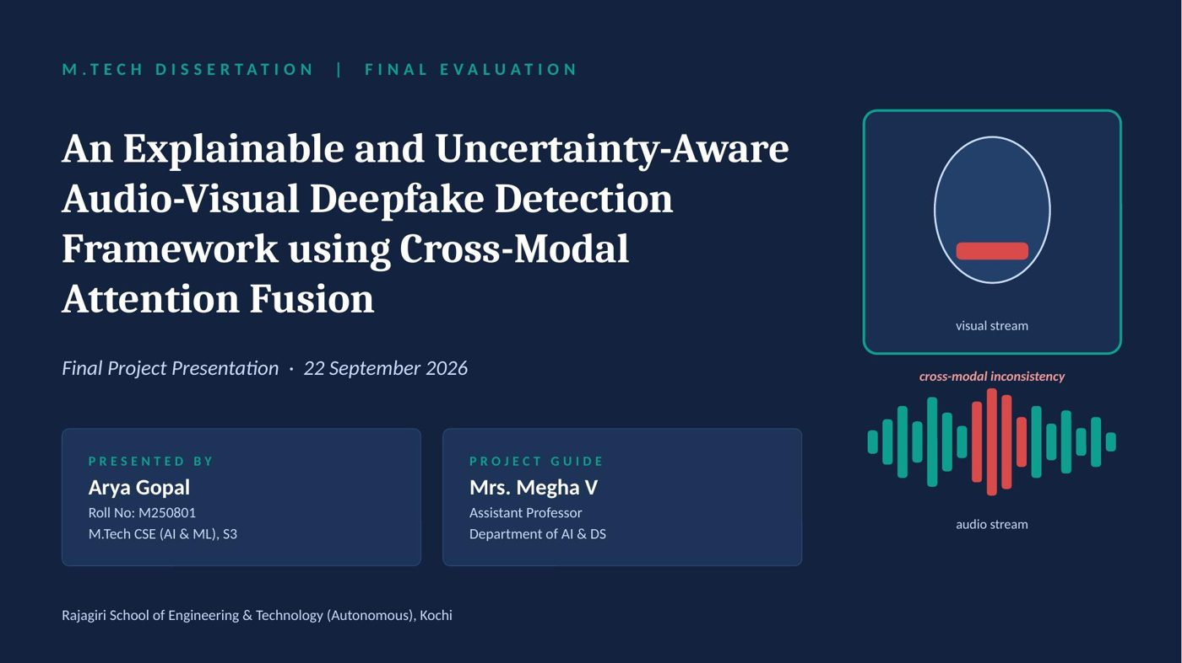
Slide 1

Slide 2

Slide 3
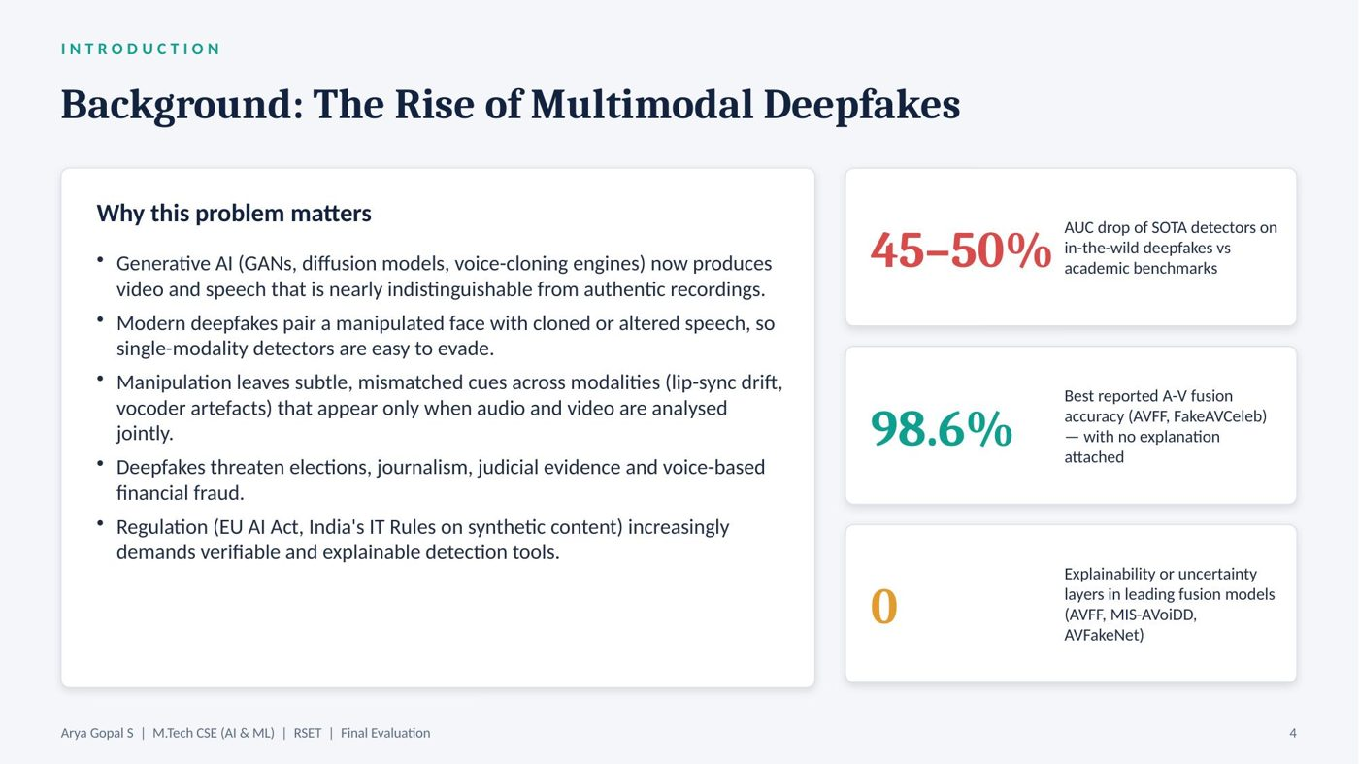
Slide 4
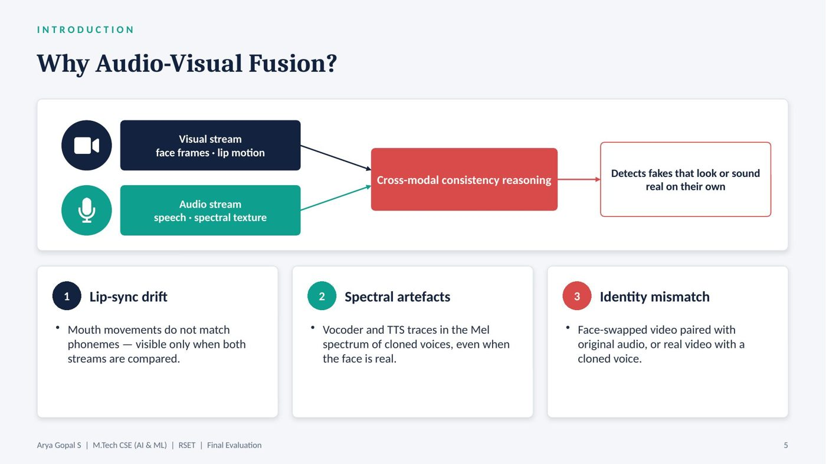
Slide 5
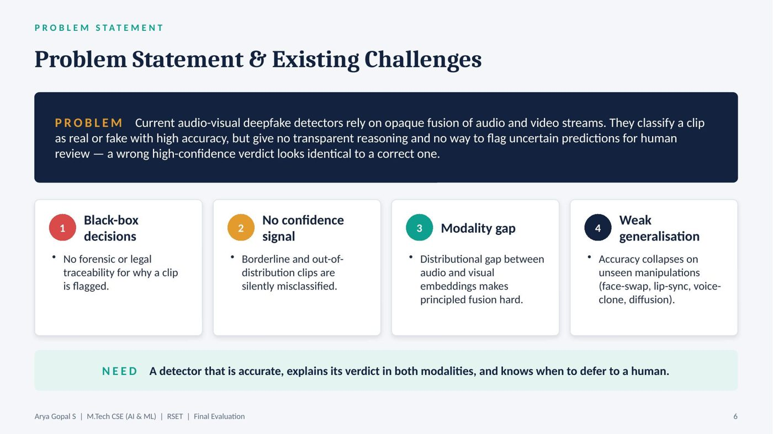
Slide 6
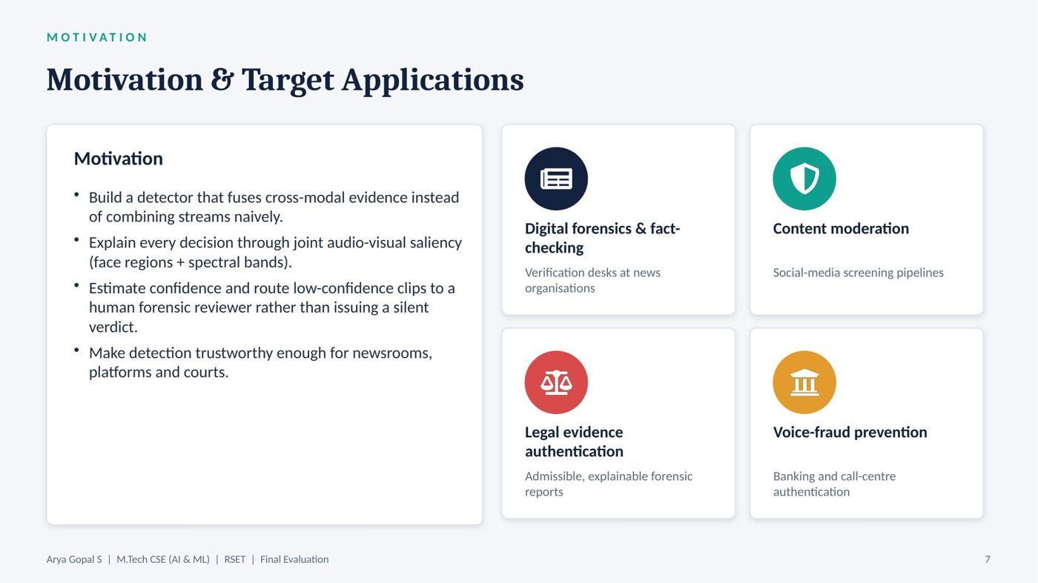
Slide 7
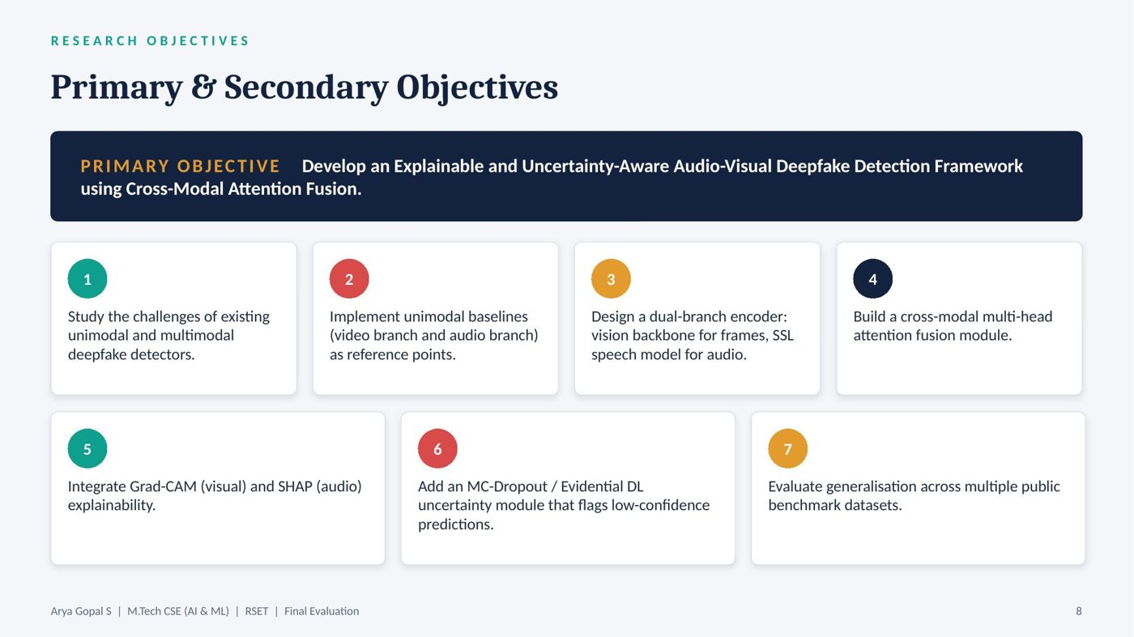
Slide 8

Slide 9
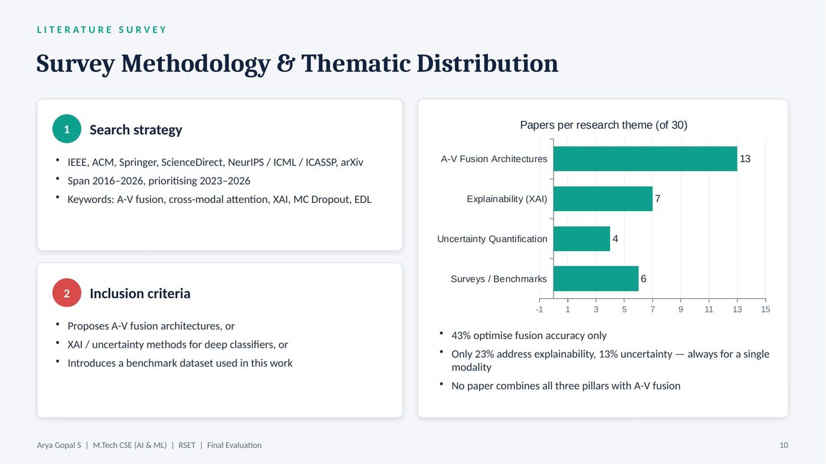
Slide 10
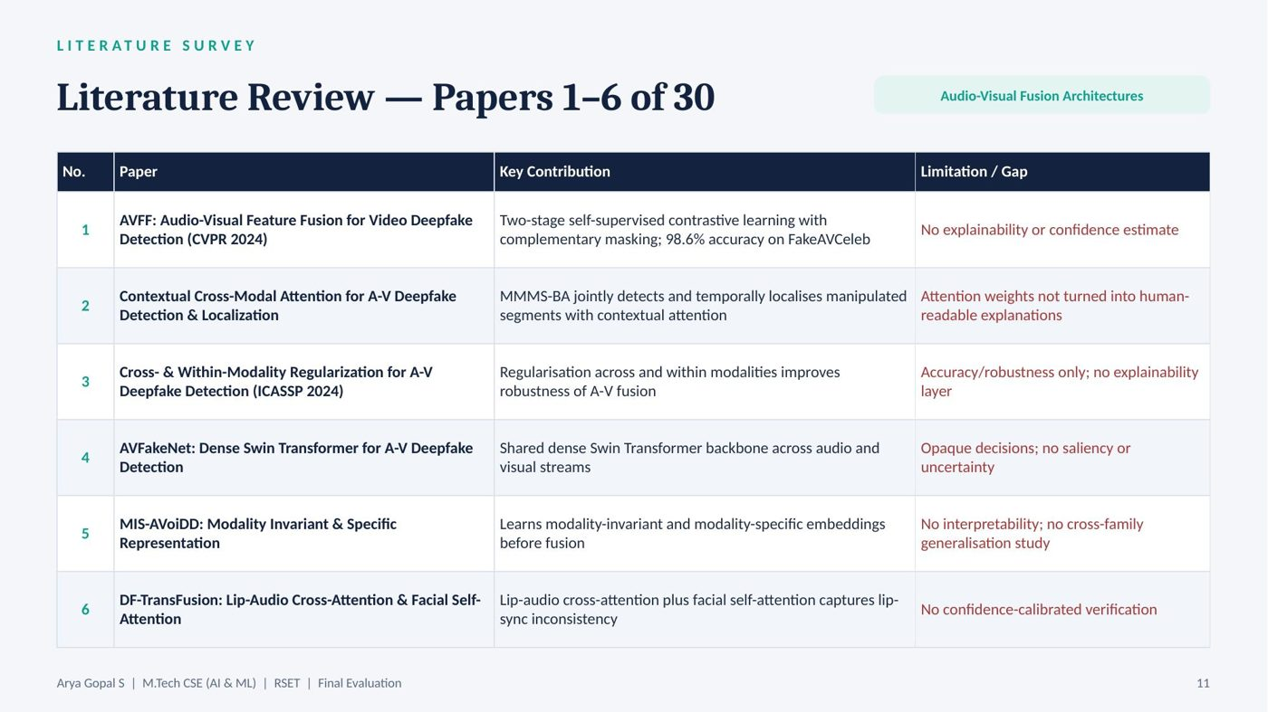
Slide 11
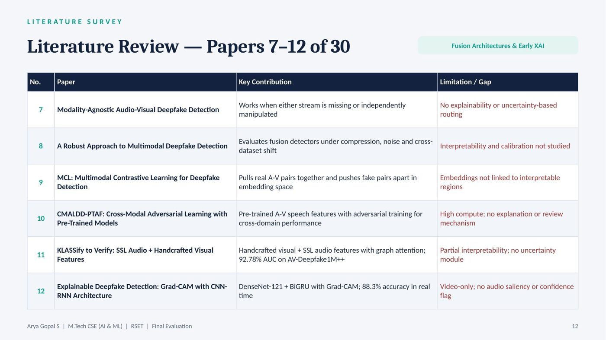
Slide 12
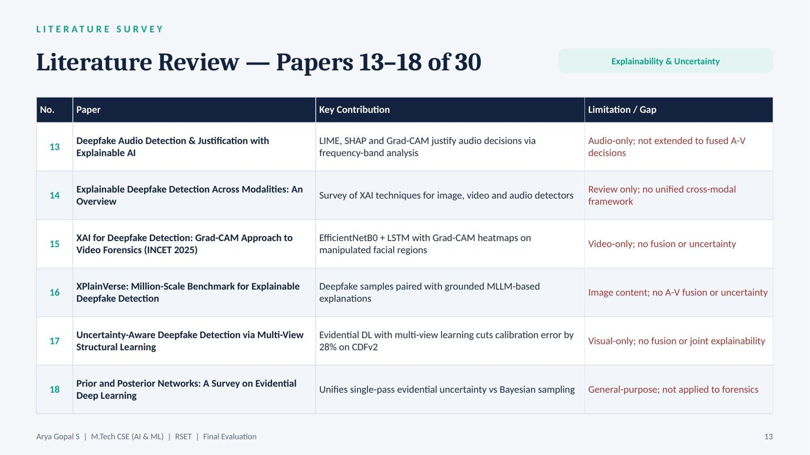
Slide 13
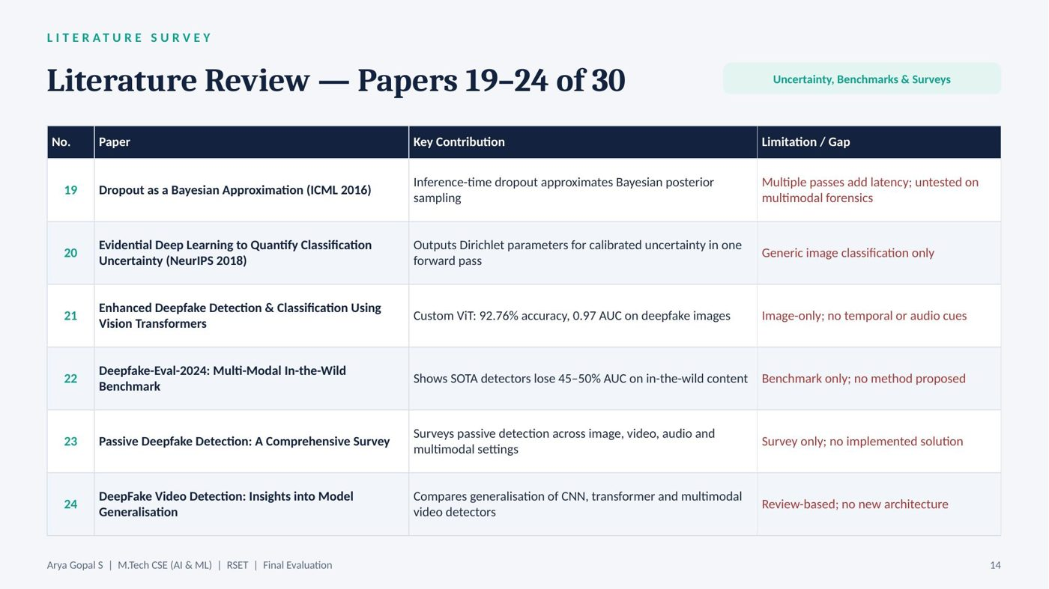
Slide 14
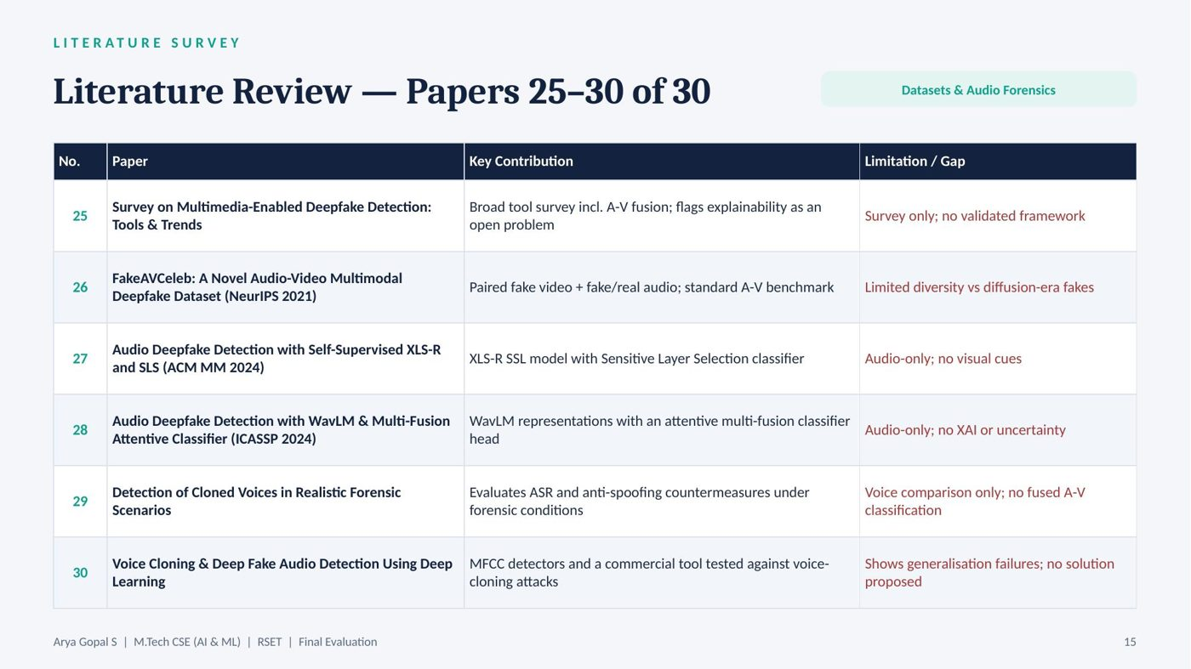
Slide 15
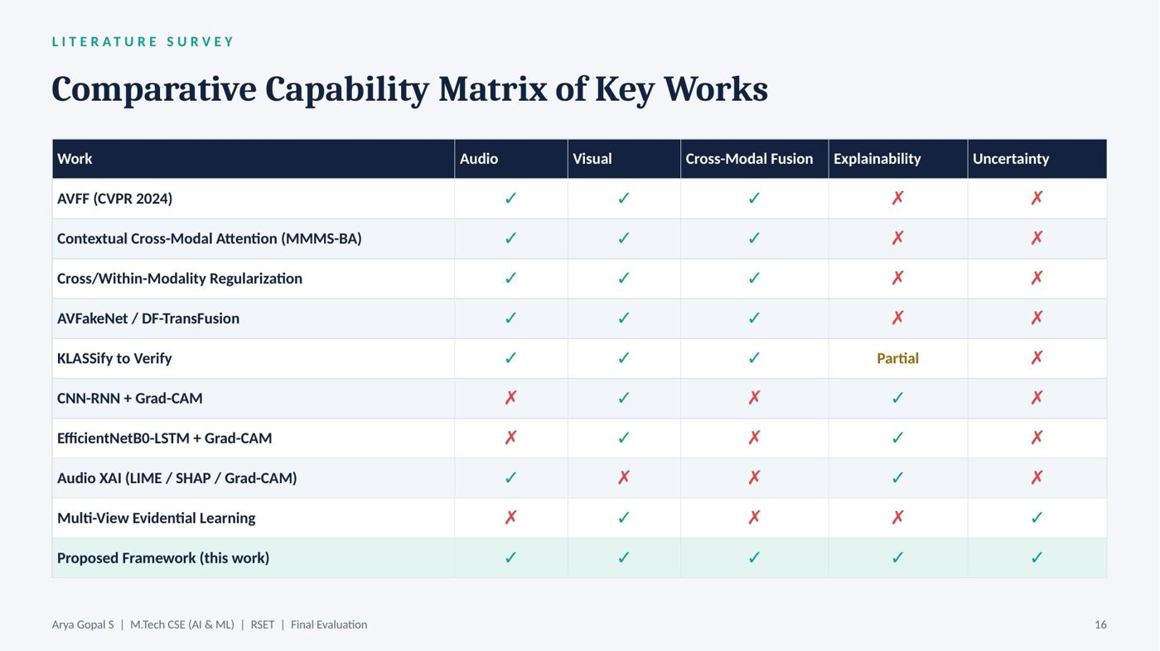
Slide 16

Slide 17

Slide 18
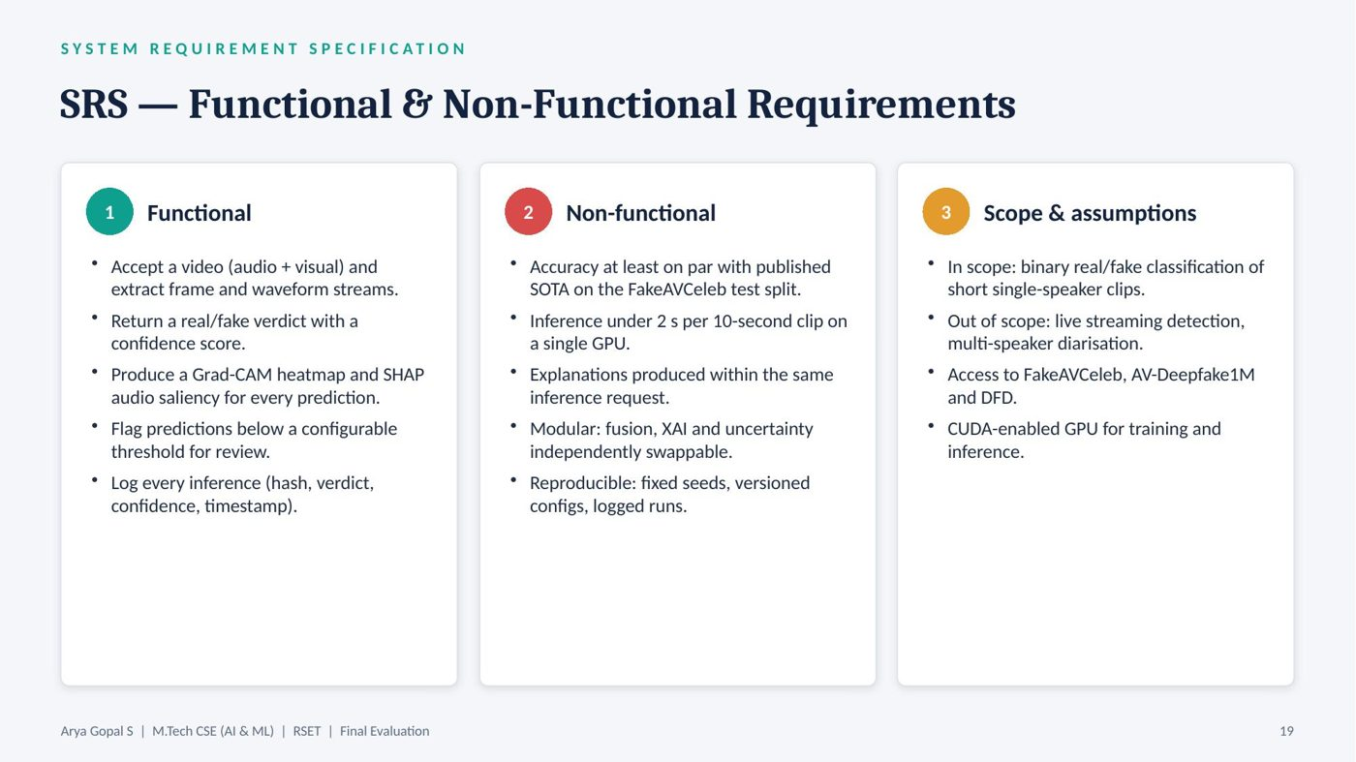
Slide 19
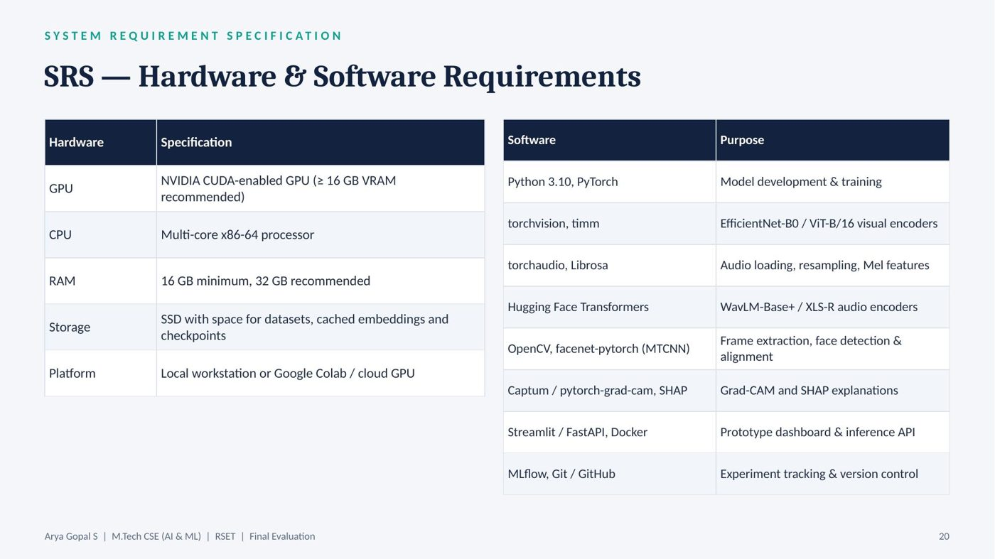
Slide 20
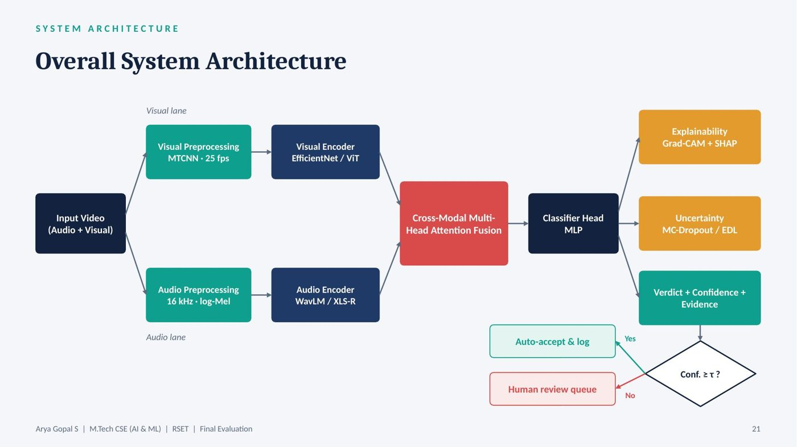
Slide 21
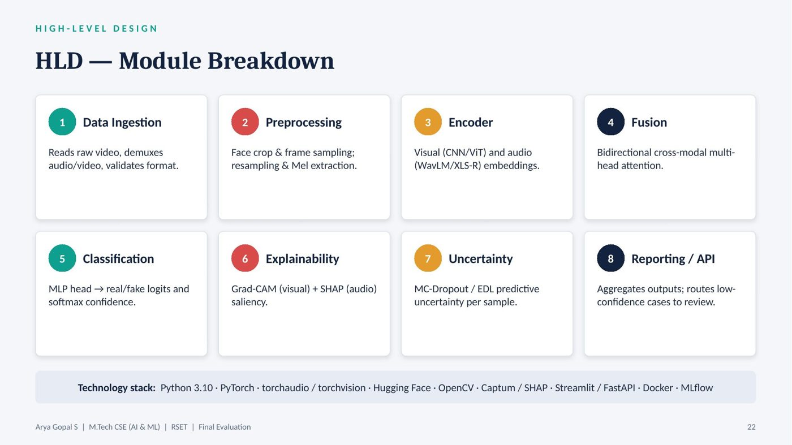
Slide 22
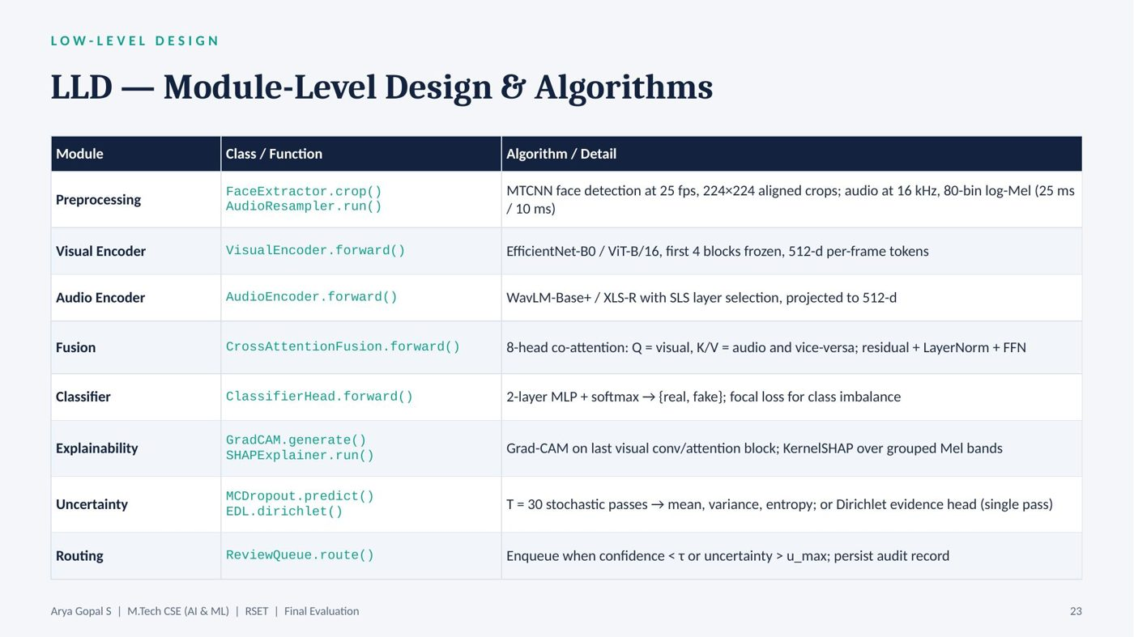
Slide 23
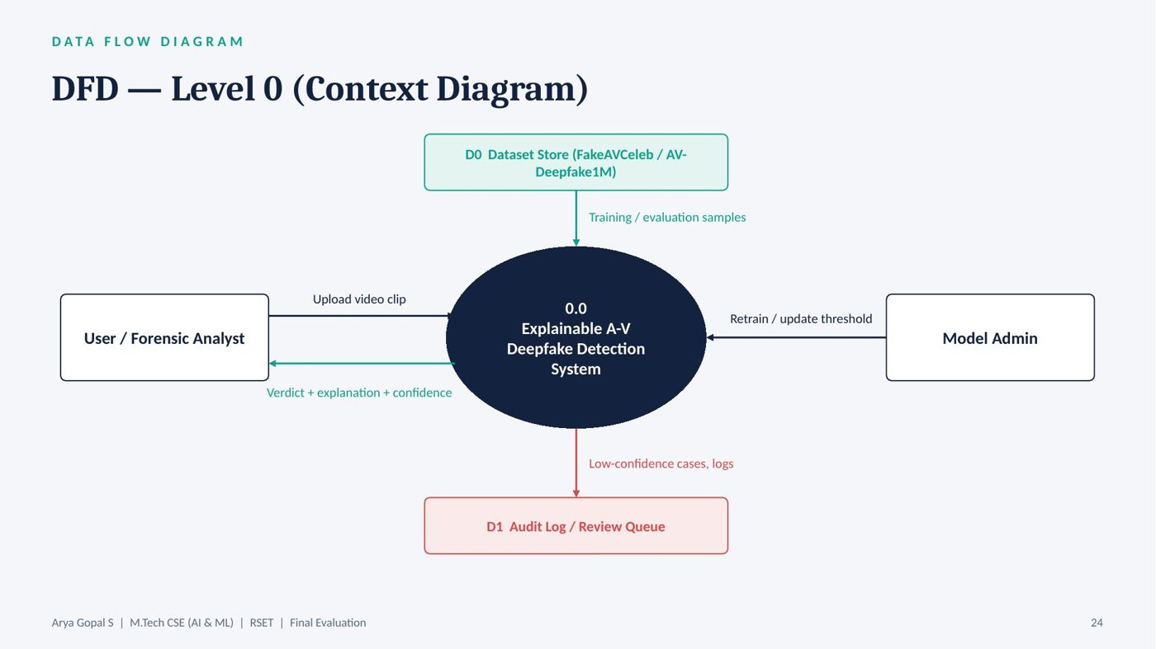
Slide 24
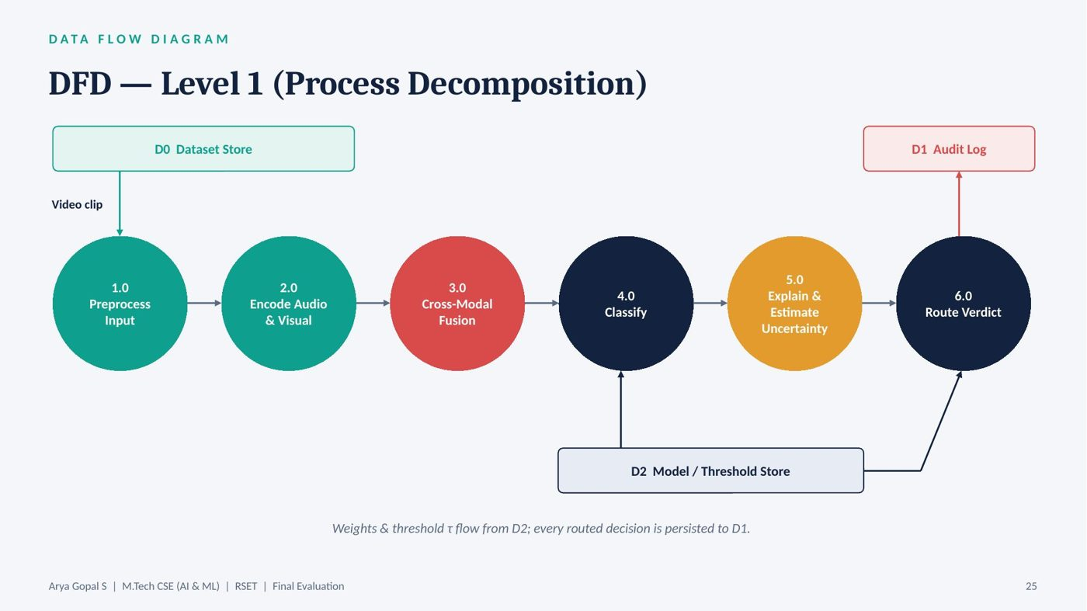
Slide 25
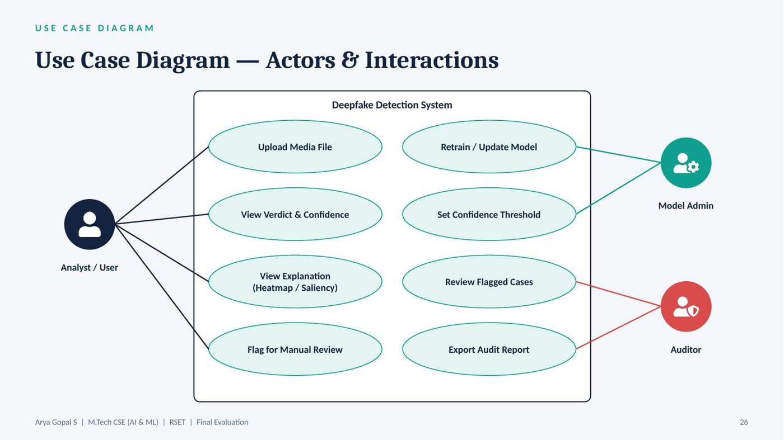
Slide 26
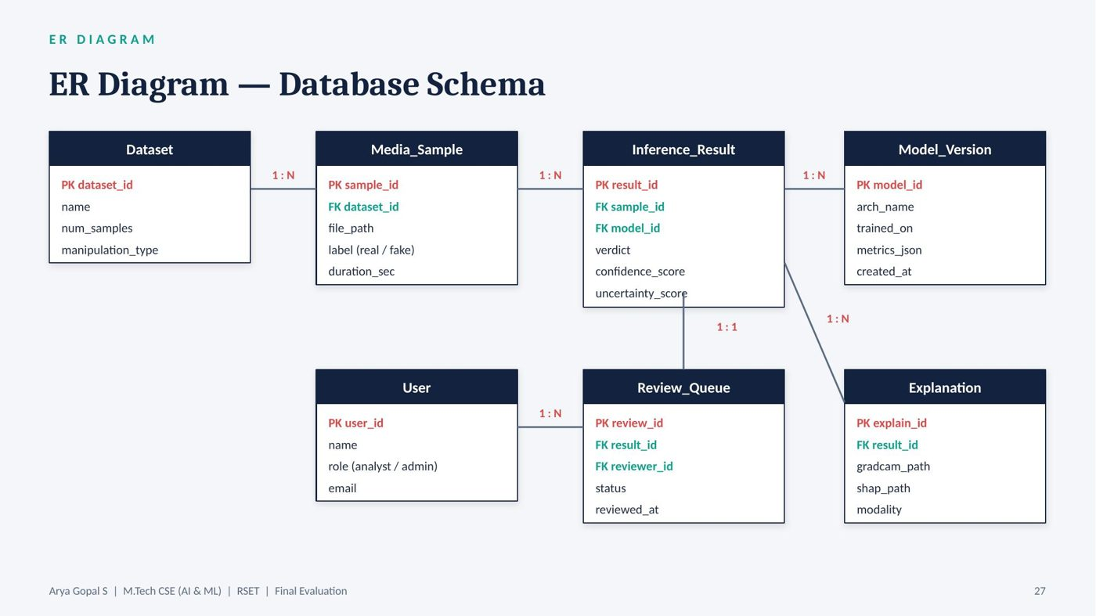
Slide 27
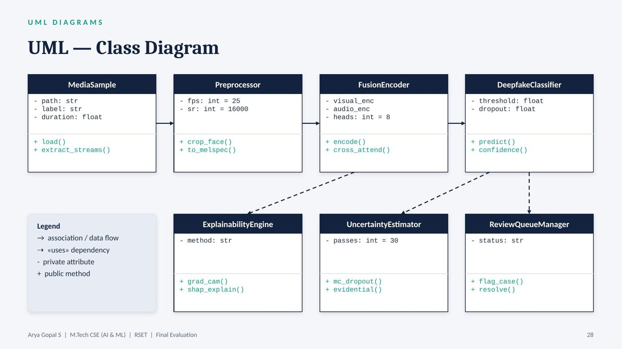
Slide 28
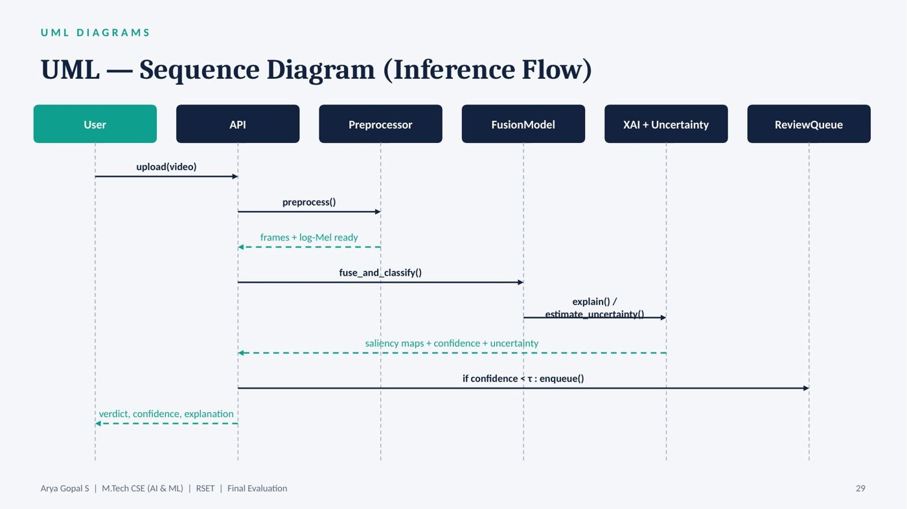
Slide 29
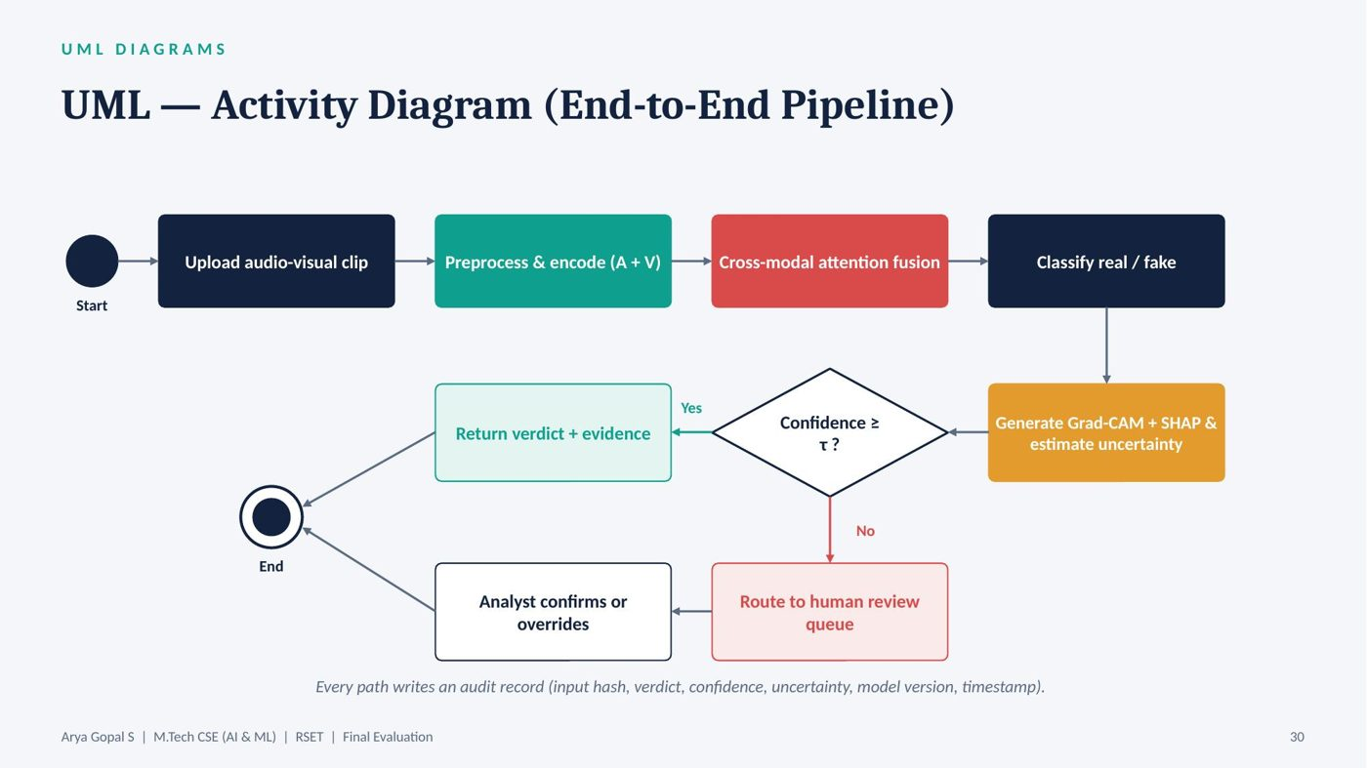
Slide 30
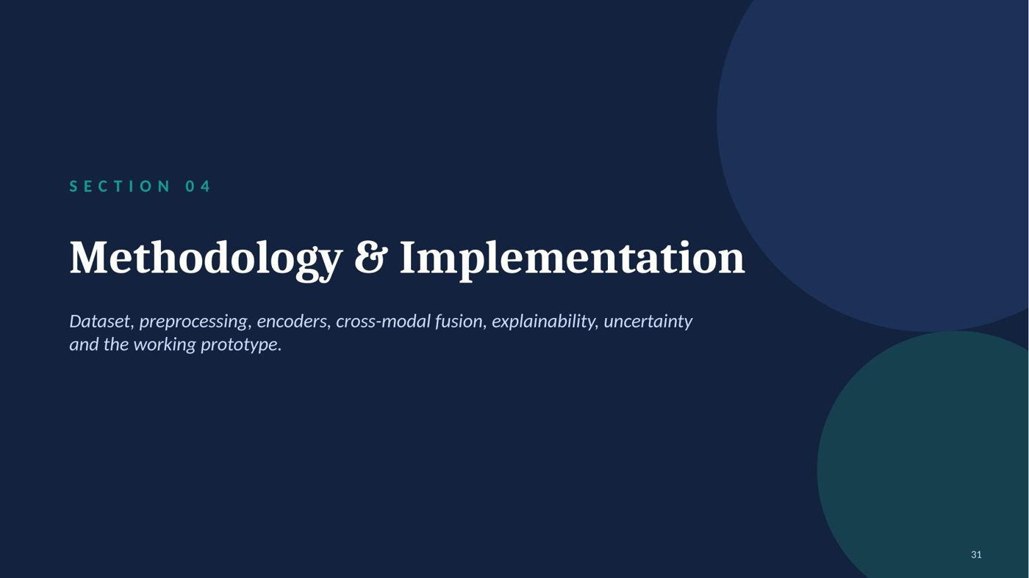
Slide 31
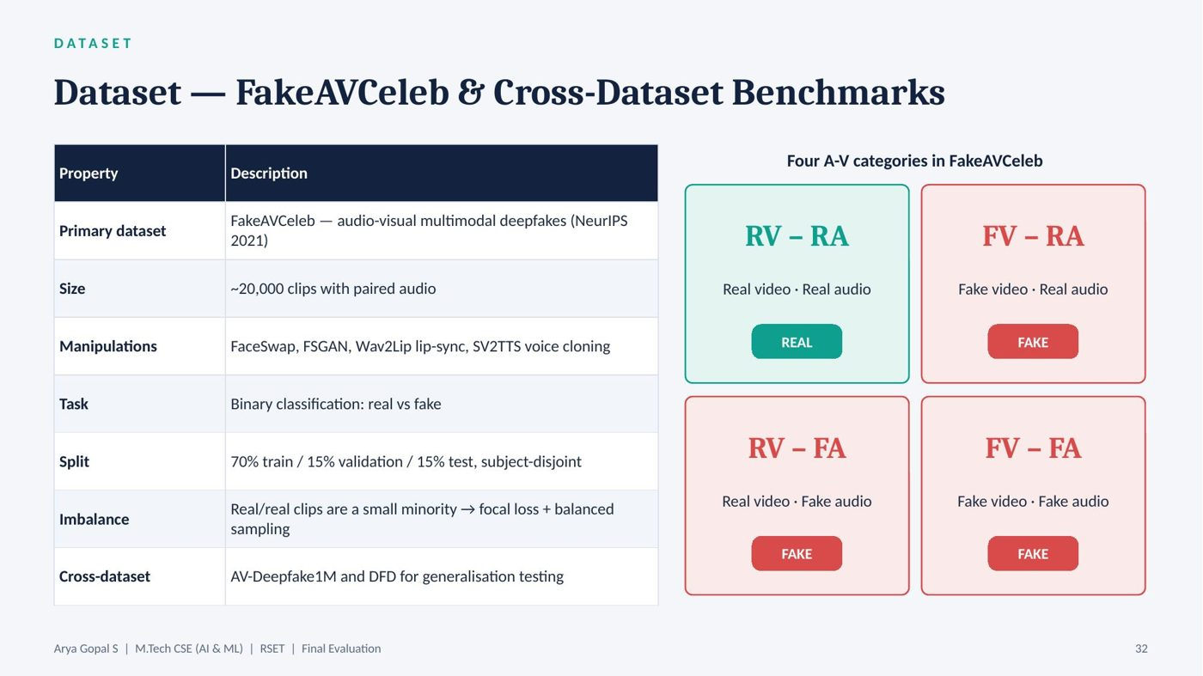
Slide 32
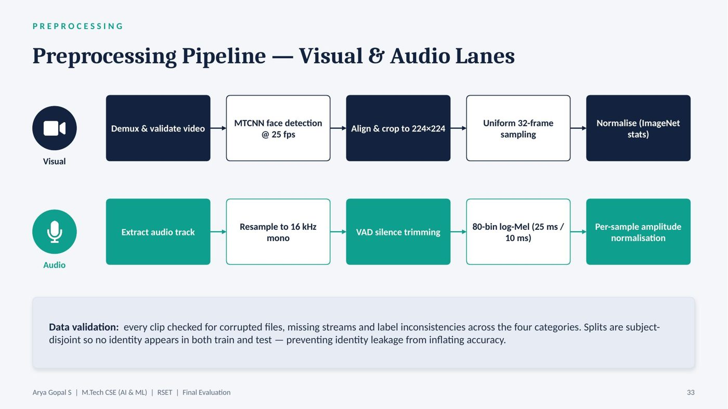
Slide 33
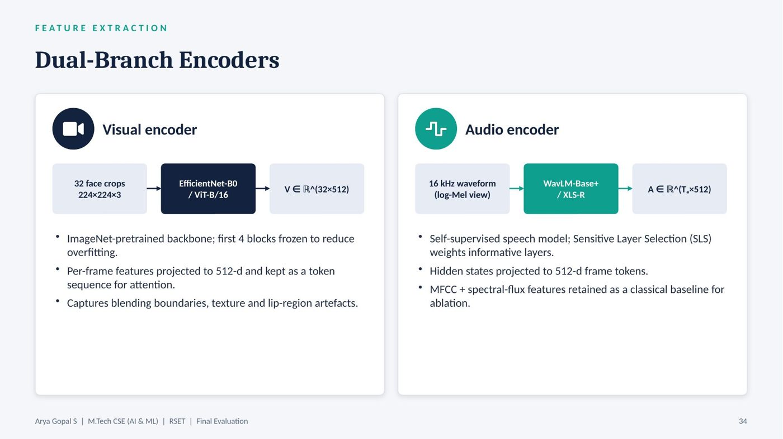
Slide 34
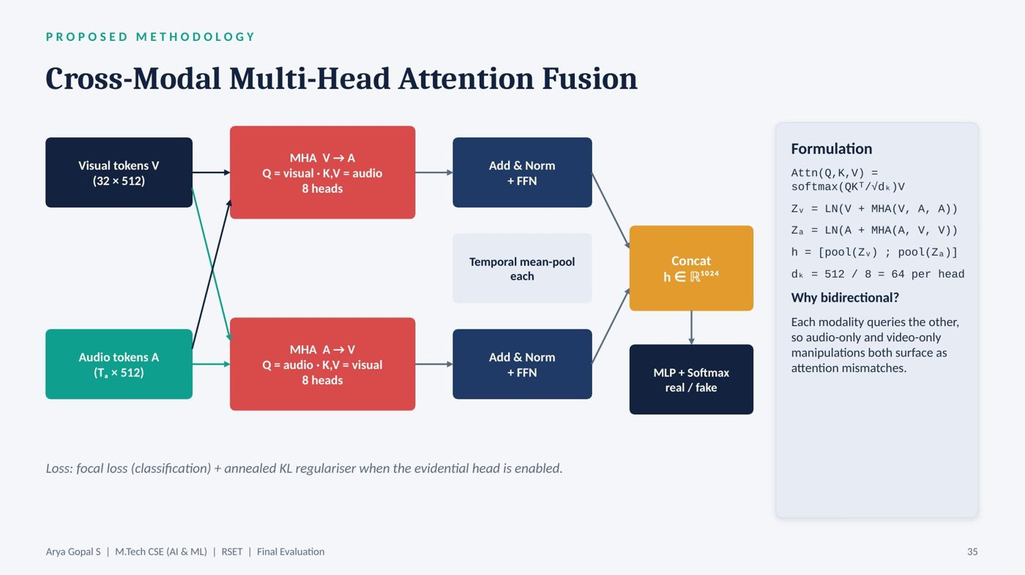
Slide 35
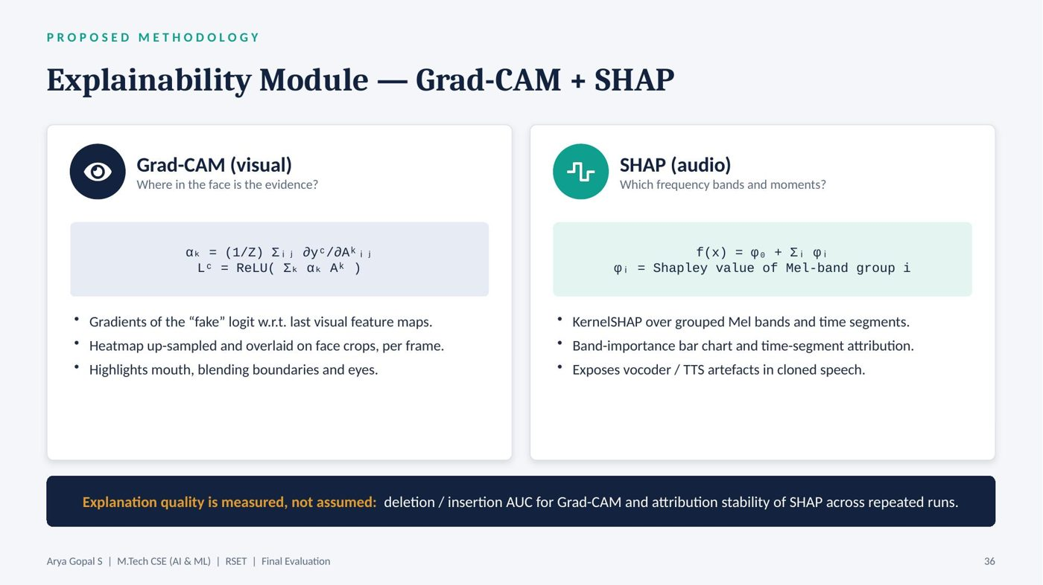
Slide 36
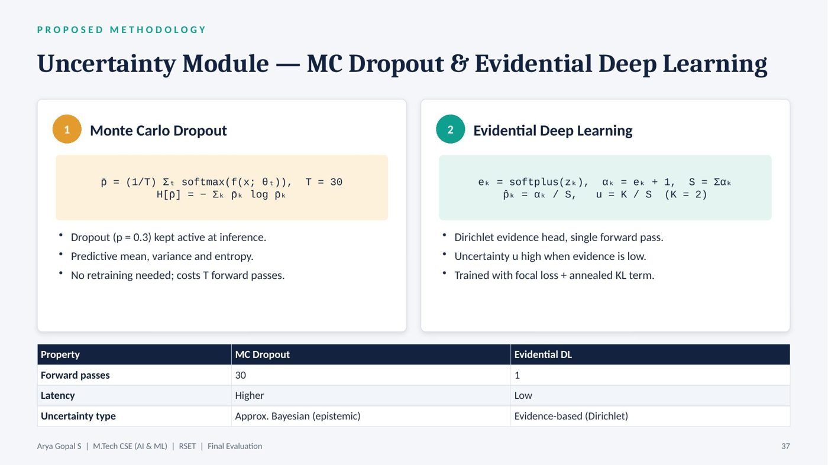
Slide 37
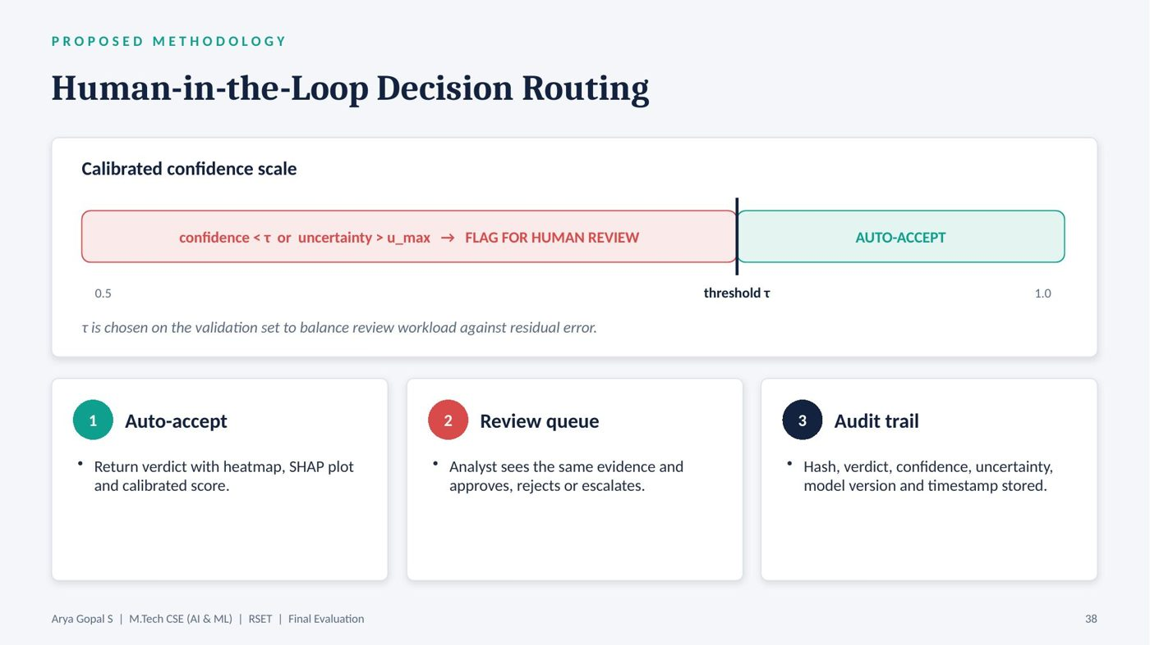
Slide 38
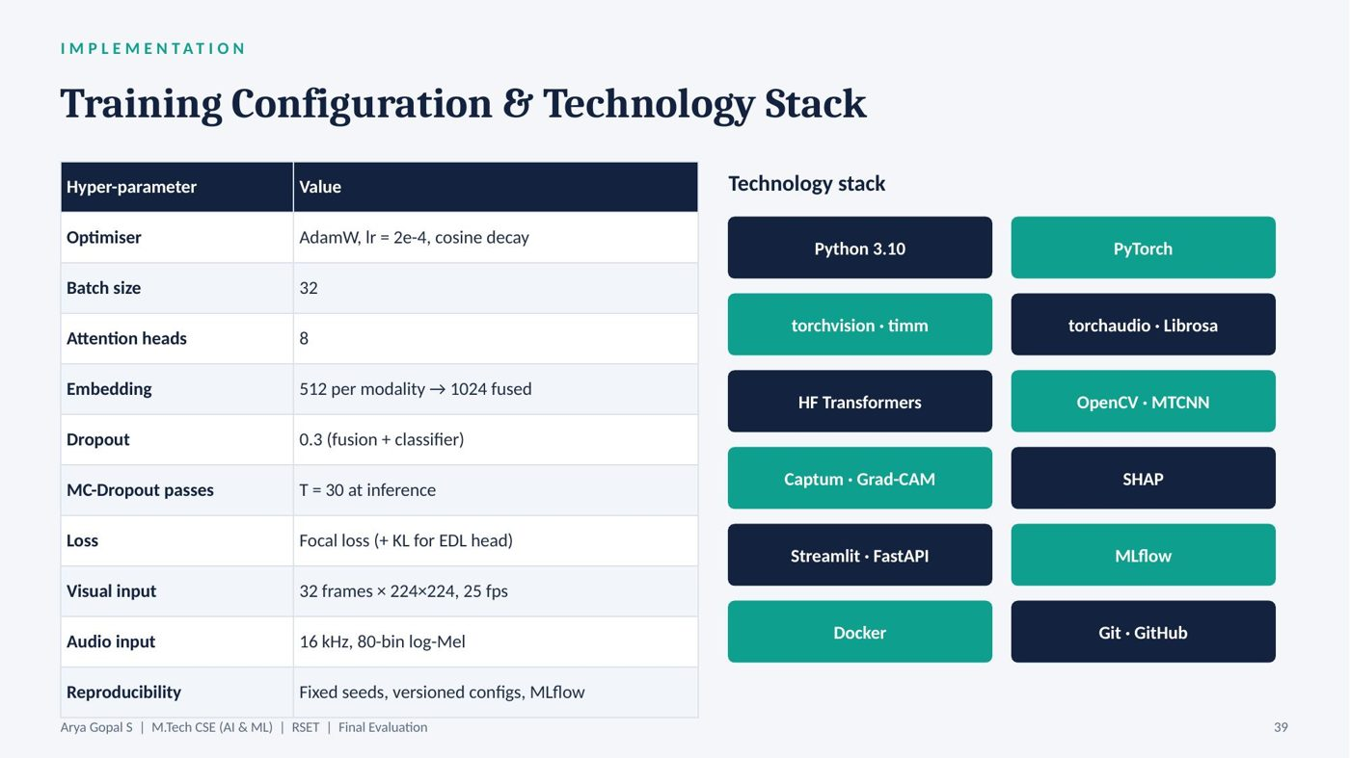
Slide 39
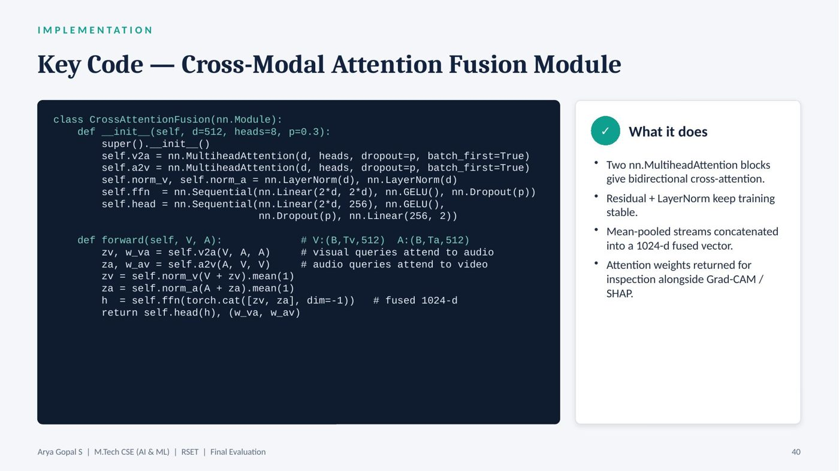
Slide 40
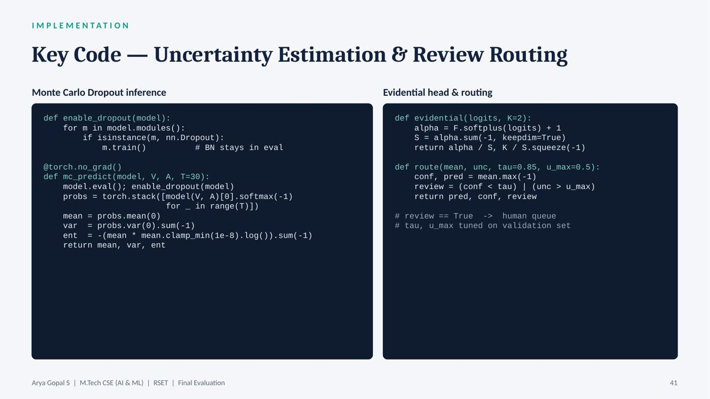
Slide 41
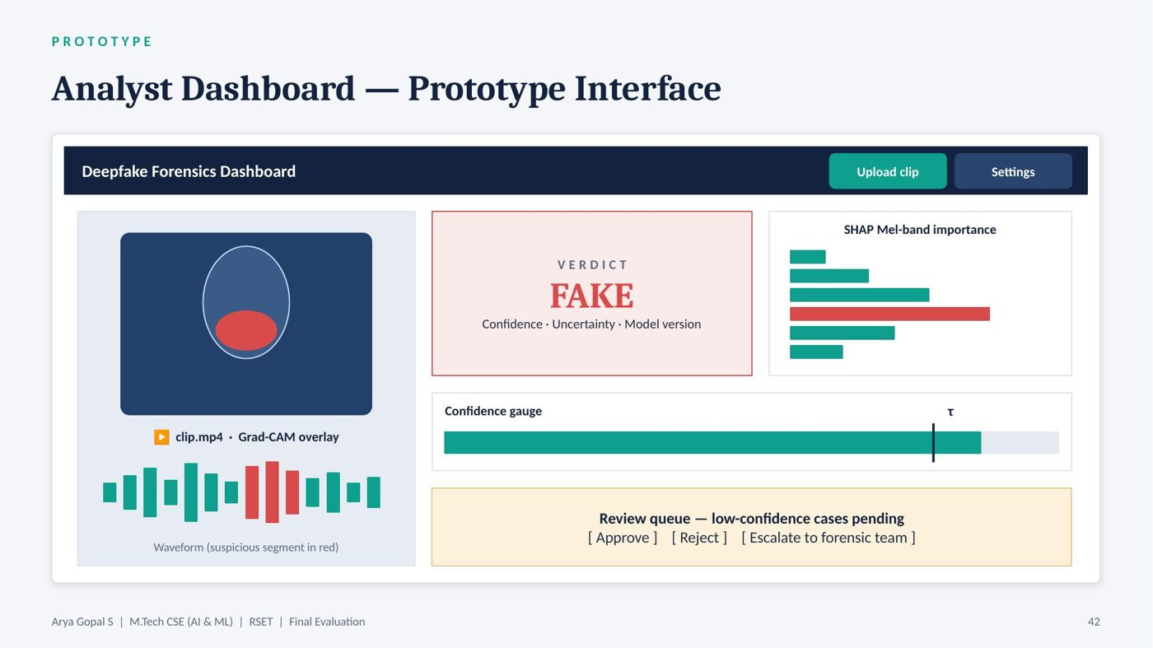
Slide 42
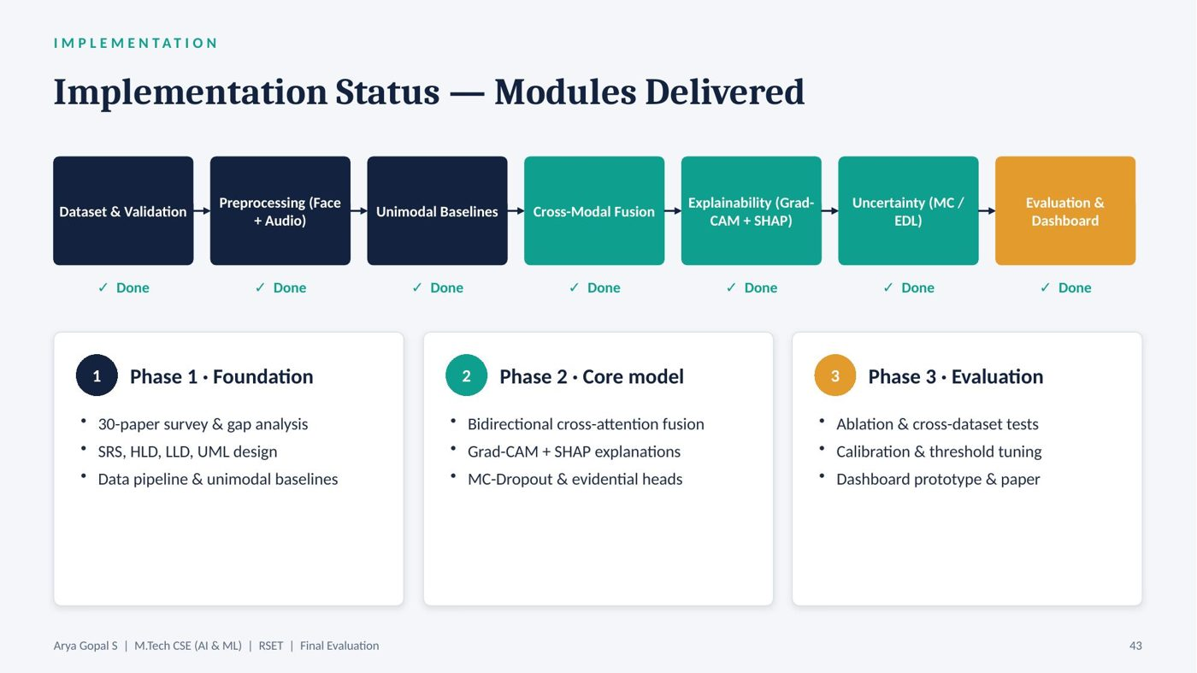
Slide 43

Slide 44
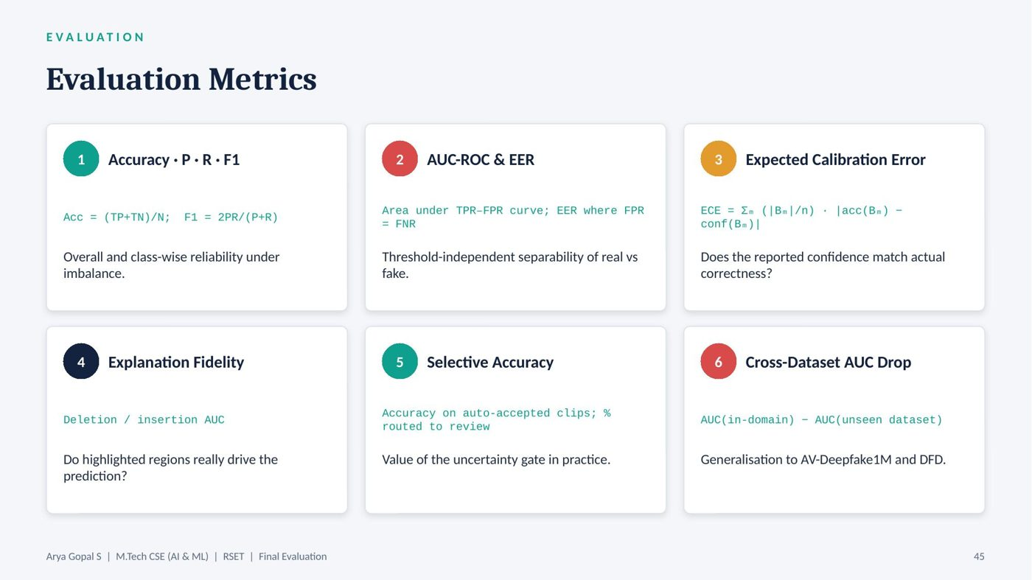
Slide 45
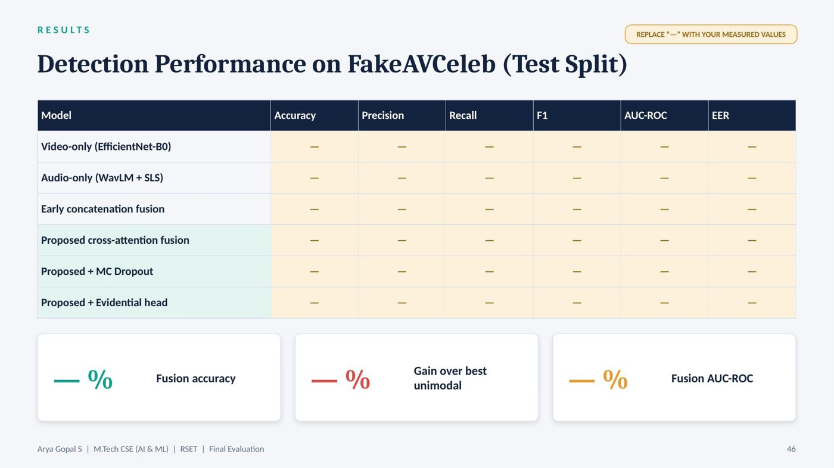
Slide 46
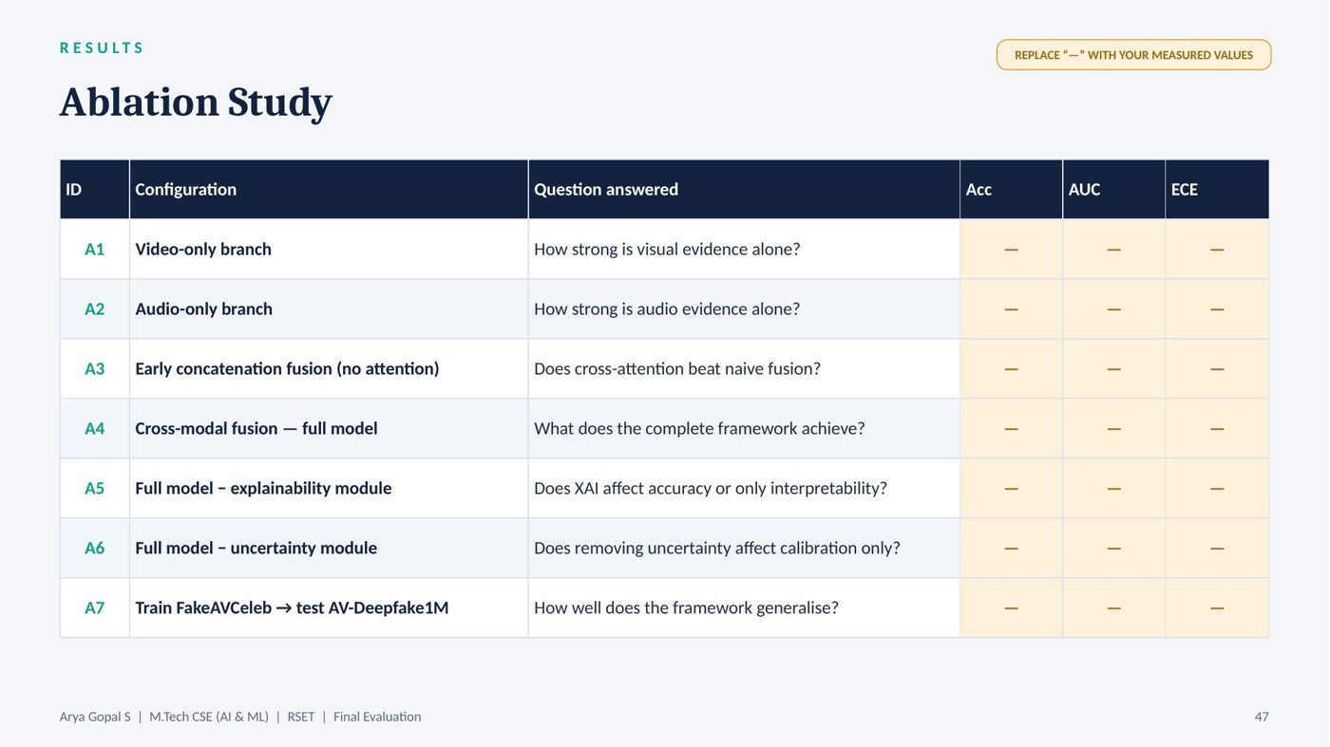
Slide 47
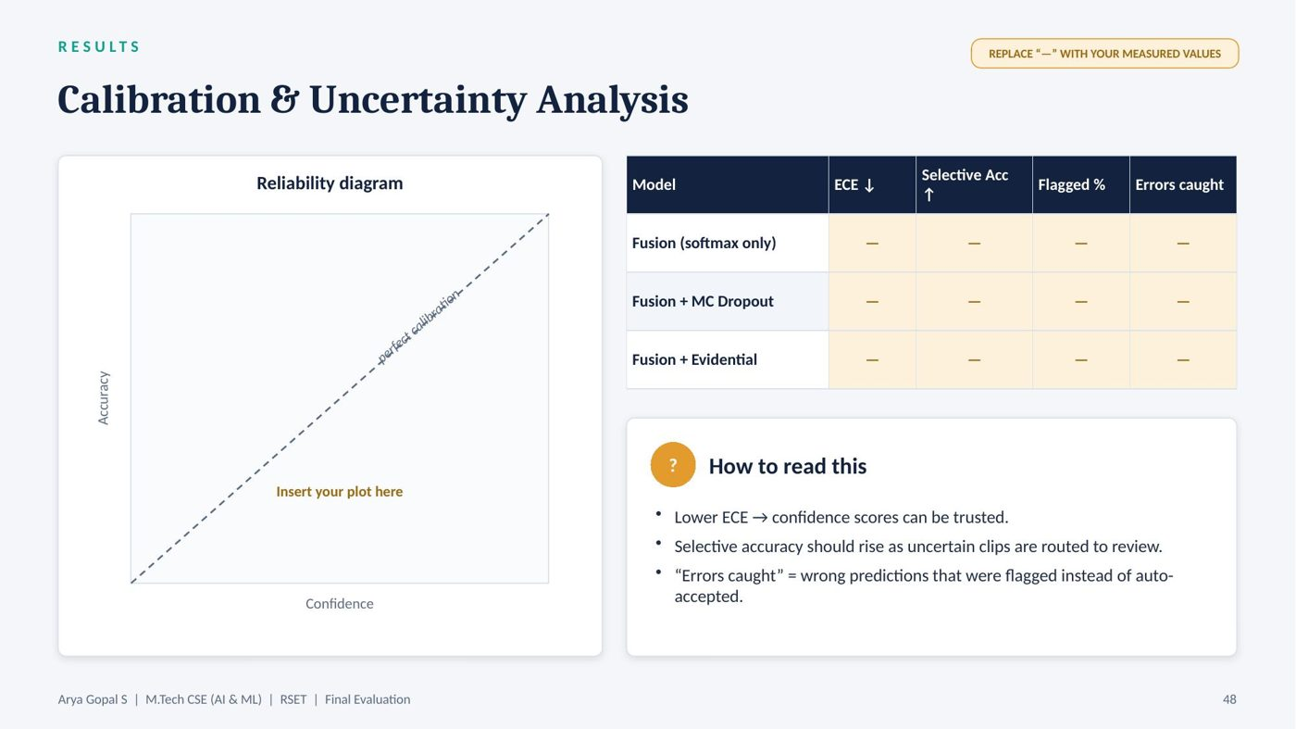
Slide 48
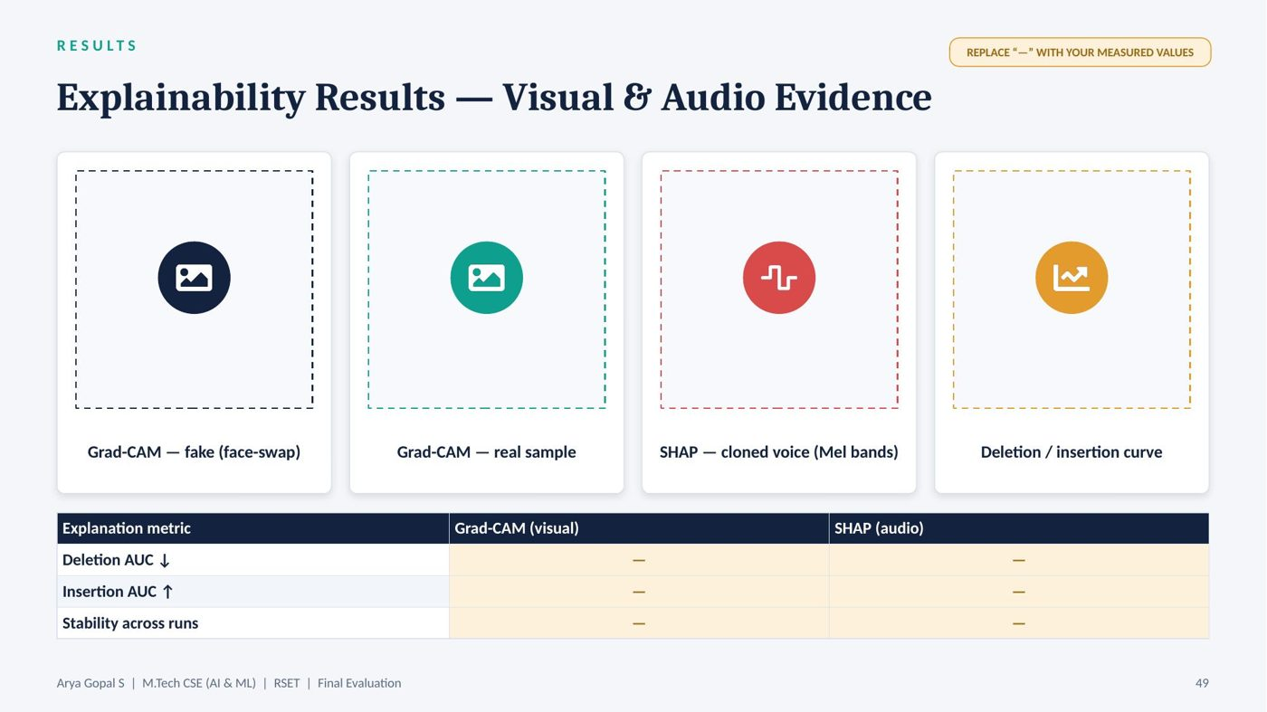
Slide 49
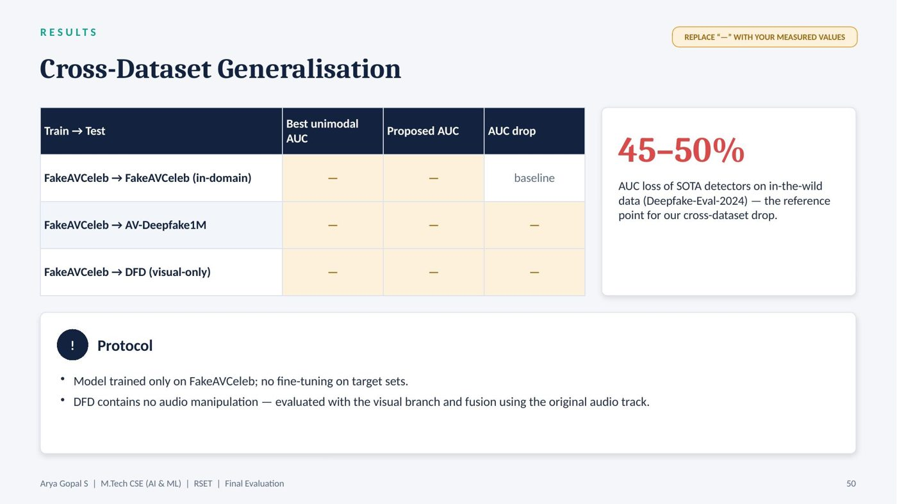
Slide 50
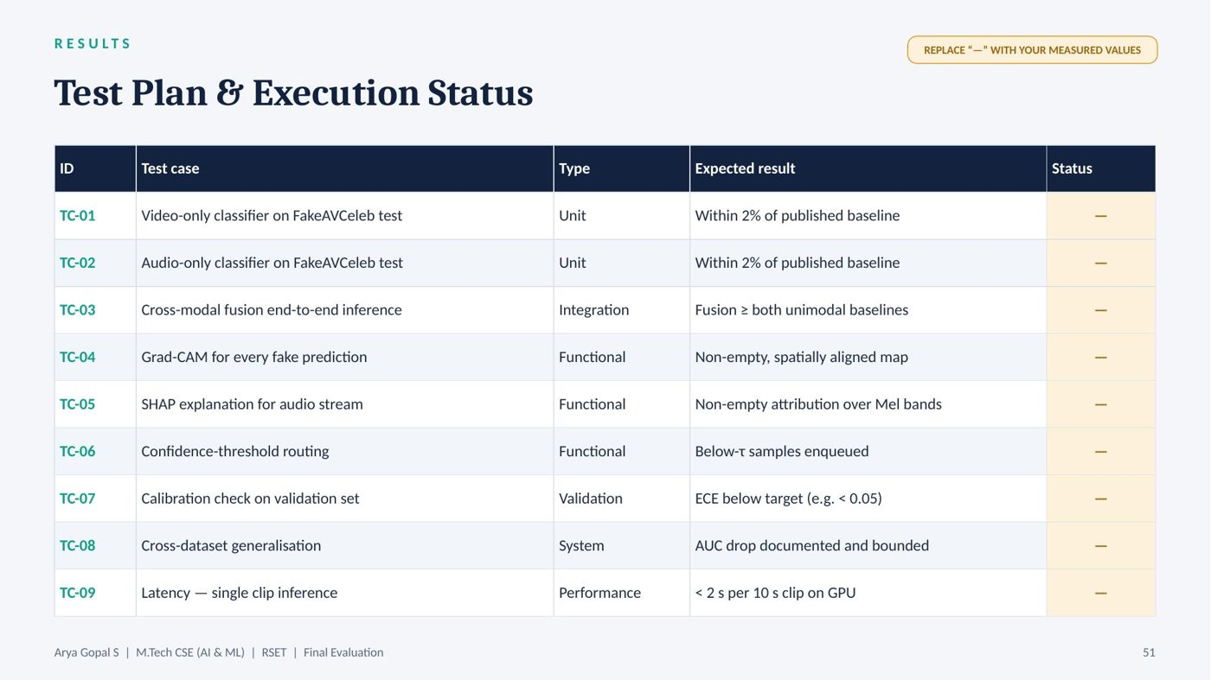
Slide 51
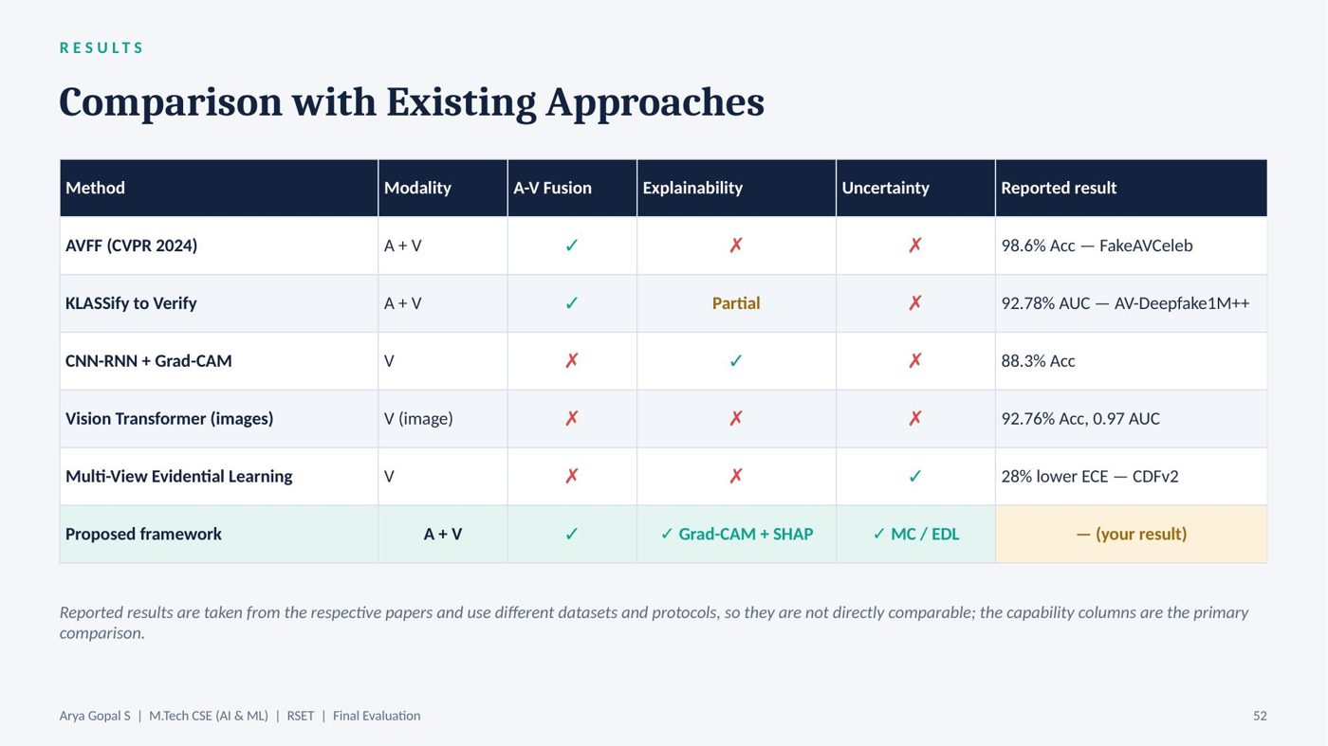
Slide 52
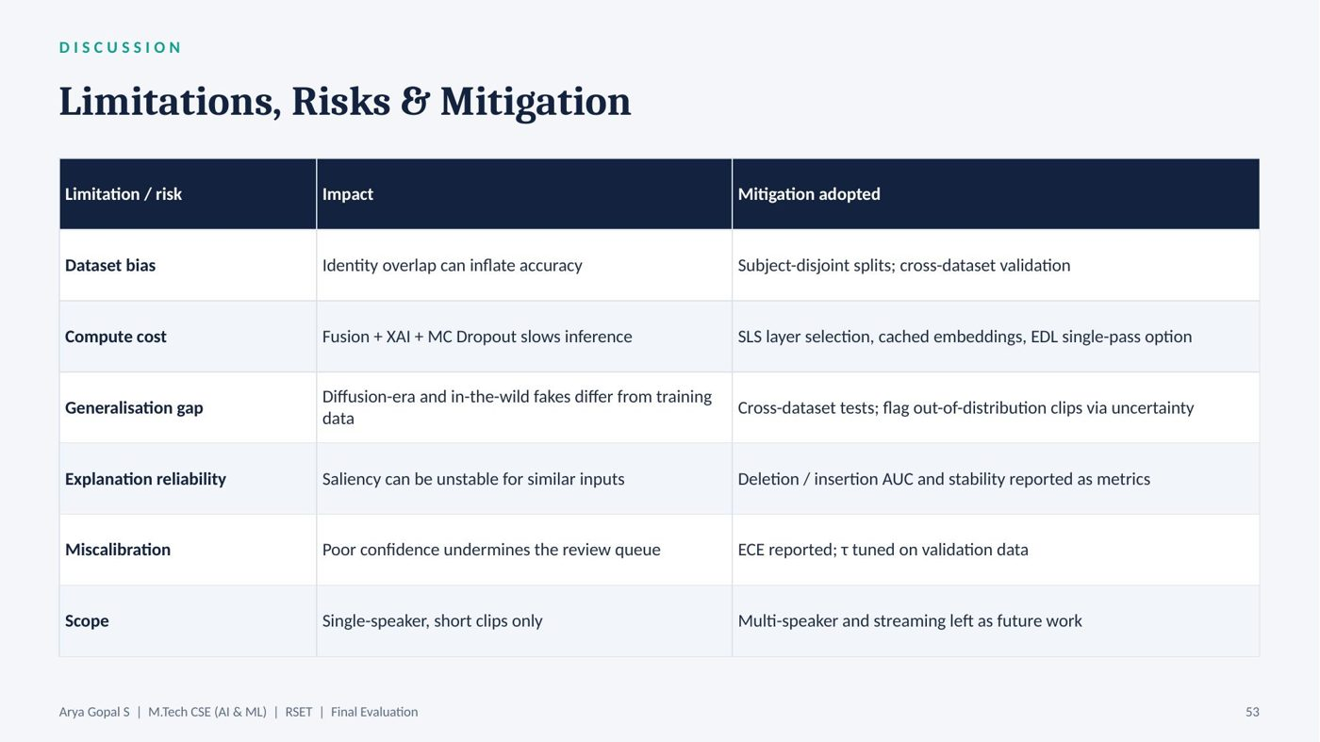
Slide 53

Slide 54
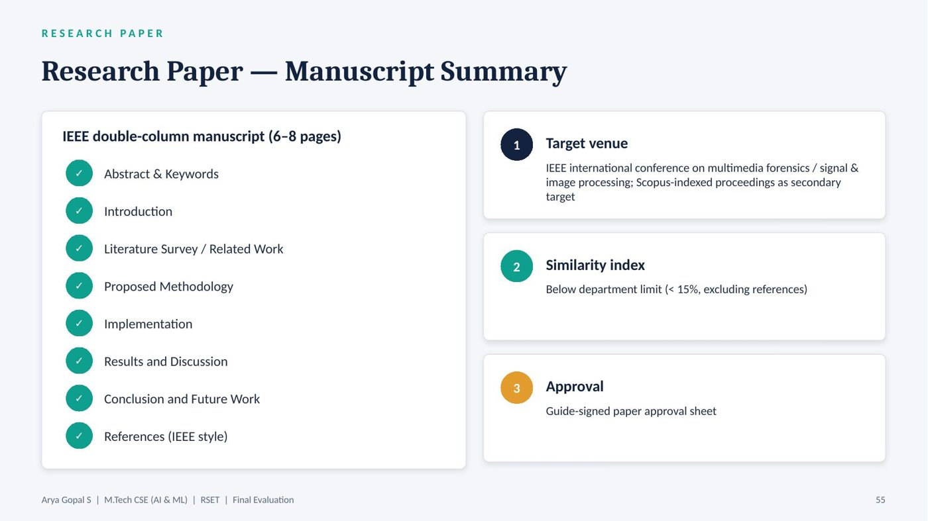
Slide 55
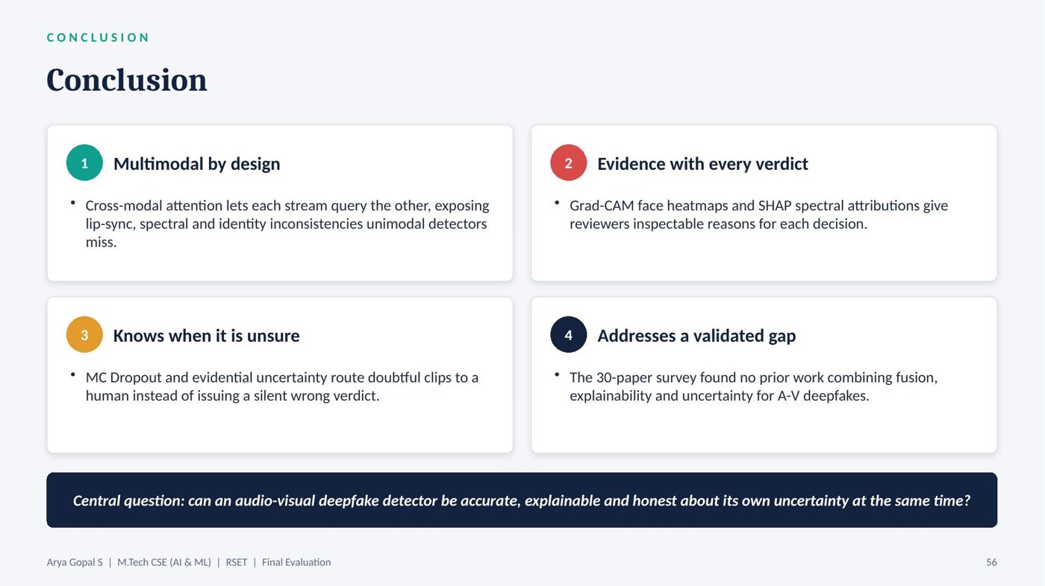
Slide 56
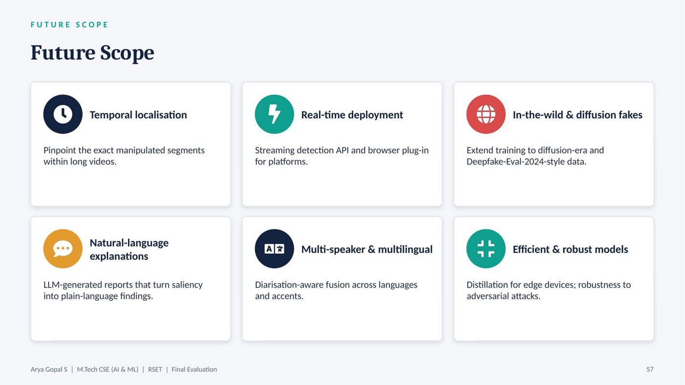
Slide 57
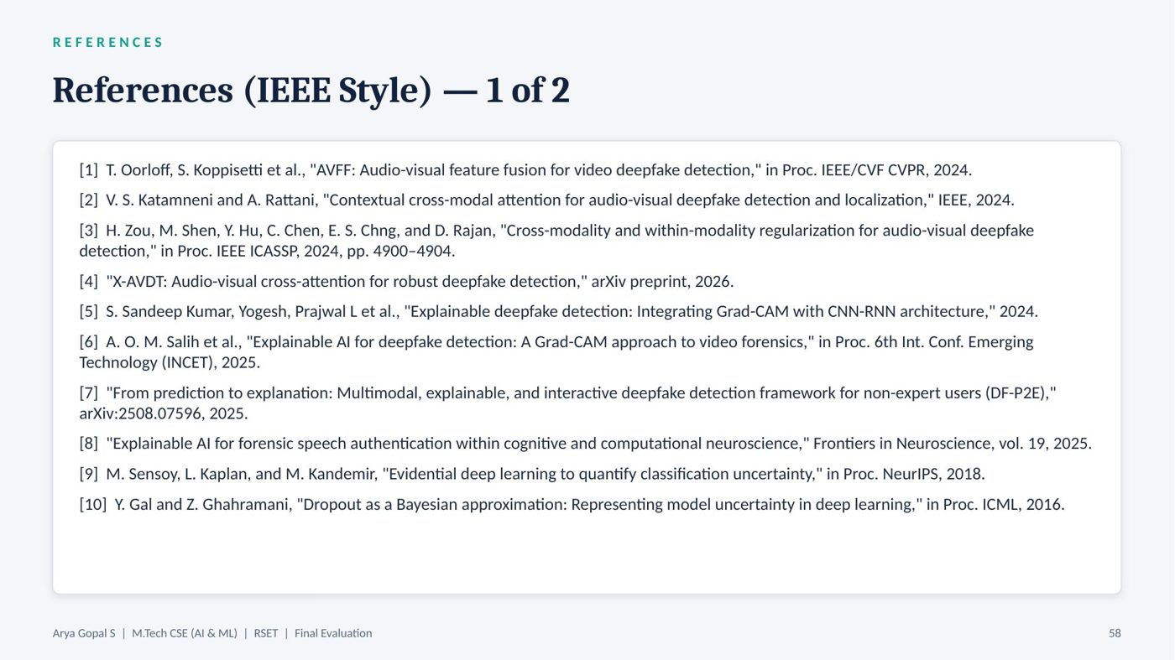
Slide 58
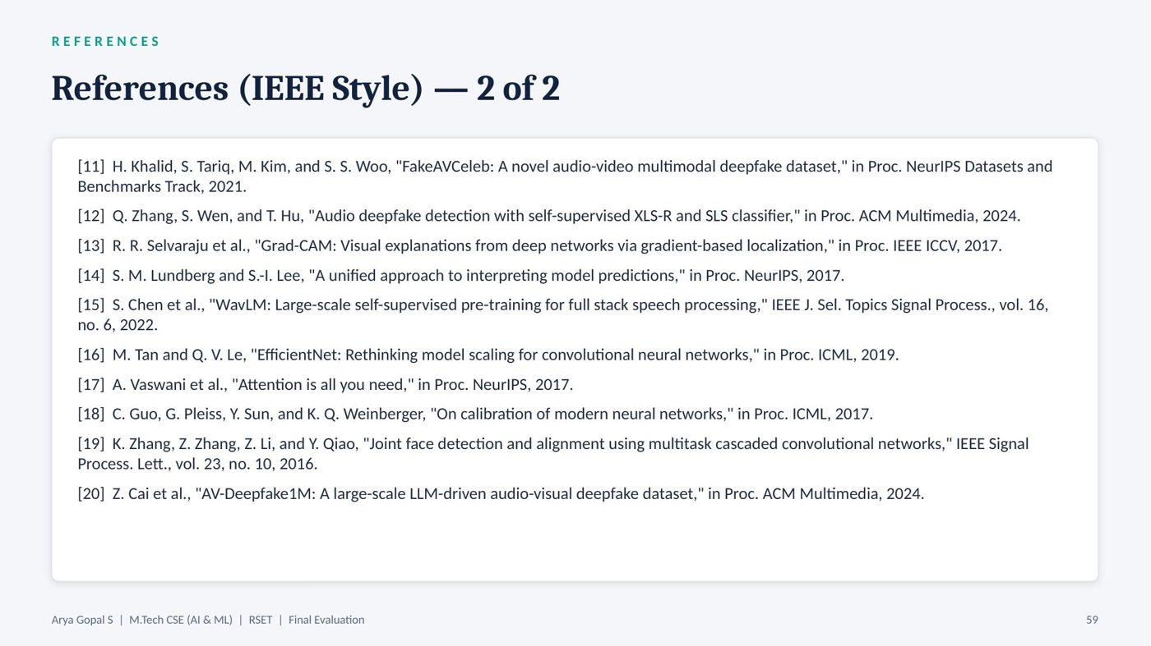
Slide 59

Slide 60

APPENDIX B: VISION, MISSION, POS, COS, PSOS AND CO-PO MAPPING

Vision and Mission

Institute Vision
To evolve into a premier technological institution, moulding eminent professionals with creative minds, innovative ideas and sound practical skill, and to shape a future where technology works for the enrichment of mankind.

Institute Mission
To impart state-of-the-art knowledge to individuals in various technological disciplines and to inculcate in them a high degree of social consciousness and human values, thereby enabling them to face the challenges of life with courage and conviction.

Department Vision
To become a Centre of Excellence in Computer Science and Engineering, moulding professionals catering to the research and professional needs of national and international organizations.

Department Mission
To inspire and nurture students, with up-to-date knowledge in Computer Science and Engineering, ethics, team spirit, leadership abilities, innovation and creativity to come out with solutions meeting societal needs.

Program Outcomes
- PO1: An ability to independently carry out research investigation and development work to solve practical problems.
- PO2: An ability to write and present a substantial technical report/document.
- PO3: Students should be able to demonstrate a degree of mastery over the area as per the specialization of the program. (The mastery should be at a level higher than the requirements in the appropriate bachelor program.)
- PO4: Students should be able to imbibe and internalize the values and ethical behavior in personal and professional life.

Course Outcomes
After the completion of the course the student will be able to:
- CO1: Perform literature survey and comprehend technical papers in the area of Data Sciences.
- CO2: Demonstrate oral and written communication skills for reporting technical results.
- CO3: Familiarize with different software tools for hands-on and preparing presentations and reports.
- CO4: Identify a problem, formulate research methodologies and carry out the preliminary works related to the problem and thus improve the quality of their Main project.
- CO5: Analyze the ethical, financial and social issues related to the advancements in selected topics.

Programme Specific Outcomes
A post graduate of the Computer Science and Engineering Program will demonstrate:
- PSO1: Computer Science Specific Skills. The ability to identify, analyze and design solutions for complex engineering problems in multidisciplinary areas by understanding the core principles and concepts of computer science and thereby engage in national grand challenges.
- PSO2: Programming and Software Development Skills. The ability to acquire programming efficiency by designing algorithms and applying standard practices in software project development to deliver quality software products meeting the demands of the industry.
- PSO3: Professional Skills. The ability to apply the fundamentals of computer science in competitive research and to develop innovative products to meet societal needs thereby evolving as an eminent researcher and entrepreneur.

Mapping of Course Outcomes with Program Outcomes
Table B.1: CO–PO mapping
CO | PO1 | PO2 | PO3 | PO4
CO1 | 2 |  | 2
CO2 |  | 3
CO3 | 3 |  | 3
CO4 | 3 | 2 | 3
CO5 |  |  |  | 2

Justification of the Mapping for this Project
- CO1 → PO1, PO3: a structured survey of thirty papers was performed and synthesised into a research gap in audio-visual deepfake detection.
- CO2 → PO2: results were reported in this report, the research paper and the final presentation.
- CO3 → PO1, PO3: PyTorch, Hugging Face, Captum, SHAP, Streamlit and MLflow were used to implement and document the framework.
- CO4 → PO1, PO2, PO3: the problem of opaque and over-confident deepfake detection was formulated and a methodology combining fusion, explainability and uncertainty was developed.
- CO5 → PO4: ethical and social issues of deepfakes, misuse of detection, privacy of analysed media and the need for human oversight were analysed.

APPENDIX C: INDUSTRIAL RELEVANCE

1. Addressing the Need for Trustworthy Media Verification
News organisations, fact-checking desks and social-media platforms must verify large volumes of user-generated video quickly. Existing commercial and open-source detectors typically return a score without evidence. The proposed framework returns a verdict together with visual and audio evidence and a calibrated confidence, allowing verification teams to prioritise their effort and defend their decisions publicly.
Decision support rather than replacement: by routing only uncertain clips to human reviewers, the system reduces reviewer workload while ensuring that difficult cases receive expert attention. This human-in-the-loop design fits existing editorial and moderation workflows.

2. Financial Fraud and Identity Verification
Banks, insurers and call centres increasingly rely on video-KYC and voice authentication, both of which are targets for deepfake and voice-cloning attacks. The audio-visual consistency check at the heart of the framework directly addresses attacks that combine a replayed or synthetic face with a cloned voice. Uncertainty-based routing allows suspicious sessions to be escalated to a human agent rather than blocked or approved outright.

3. Legal and Forensic Evidence
Courts and law-enforcement agencies need to assess the authenticity of digital evidence. An explanation that points to specific facial regions and audio frequency bands, together with an audit log recording the model version, input hash and confidence, supports reproducible forensic reporting. Explicitly quantified uncertainty is important in legal contexts, where overstated confidence can be harmful.

4. Regulatory Compliance
Emerging regulations on synthetic media, such as the EU AI Act and amendments to India's IT Rules, require platforms to identify and label AI-generated content. Tools that provide transparent, auditable decisions are better suited to compliance reporting than black-box classifiers.

5. Integrability and Market Opportunity
The modular design, with swappable encoders, fusion, explainability and uncertainty components exposed through a REST API, allows the framework to be integrated into content-management systems, moderation pipelines, KYC platforms and forensic toolkits. The market for deepfake detection and digital-trust solutions is growing rapidly, and explainability and calibrated confidence are differentiating features in this market.

APPENDIX D: ADDITIONAL CODE LISTINGS
This appendix contains additional code listings for the dataset loader, the complete model wrapper, the training loop and the calibration metric. The complete source code, with a README describing setup and execution, is submitted separately.

D.1 Audio-Visual Dataset
Listing D.1: AVDataset returning cached face crops, waveform and label
class AVDataset(torch.utils.data.Dataset):
def __init__(self, manifest_csv, split, cache_dir):
df = pd.read_csv(manifest_csv)
self.df = df[df.split == split].reset_index(drop=True)
self.cache = Path(cache_dir)

def __len__(self):
return len(self.df)

def __getitem__(self, i):
r = self.df.iloc[i]
faces = torch.load(self.cache / f"{r.clip_id}_faces.pt") # (32,3,224,224)
wav, sr = torchaudio.load(self.cache / f"{r.clip_id}.wav") # 16 kHz mono
wav = (wav - wav.mean()) / (wav.std() + 1e-6)
label = torch.tensor(1 if r.label == "fake" else 0)
return faces, wav.squeeze(0), label, r.category

D.2 Complete Model Wrapper
Listing D.2: Full audio-visual detector
class AVDeepfakeDetector(nn.Module):
def __init__(self, vis="efficientnet_b0", aud="microsoft/wavlm-base-plus"):
super().__init__()
self.visual = VisualEncoder(vis, d=512, freeze_blocks=4)
self.audio = AudioEncoder(aud, d=512)
self.fusion = CrossAttentionFusion(d=512, heads=8, p=0.3)

def encode(self, faces, wav):
B, T = faces.shape[:2]
V = self.visual(faces.flatten(0, 1)).view(B, T, -1) # (B,32,512)
A = self.audio(wav) # (B,Ta,512)
return V, A

def forward(self, faces, wav):
V, A = self.encode(faces, wav)
logits, attn = self.fusion(V, A)
return logits, attn

D.3 Training Loop
Listing D.3: Training with focal loss, AdamW, cosine schedule and best-F1 checkpointing
model = AVDeepfakeDetector().to(dev)
opt = torch.optim.AdamW(filter(lambda p: p.requires_grad, model.parameters()),
lr=2e-4, weight_decay=1e-2)
sched = torch.optim.lr_scheduler.CosineAnnealingLR(opt, T_max=EPOCHS)
crit = FocalLoss(alpha=class_weights, gamma=2.0)
best_f1 = 0.0
for epoch in range(EPOCHS):
model.train()
for faces, wav, y, _ in train_loader:
faces, wav, y = faces.to(dev), wav.to(dev), y.to(dev)
logits, _ = model(faces, wav)
loss = crit(logits, y)
opt.zero_grad(); loss.backward()
torch.nn.utils.clip_grad_norm_(model.parameters(), 1.0)
opt.step()
sched.step()
val = evaluate(model, val_loader) # acc, f1, auc, ece
mlflow.log_metrics(val, step=epoch)
if val["f1"] > best_f1:
best_f1 = val["f1"]
torch.save(model.state_dict(), "checkpoints/best.pt")

D.4 Focal Loss
Listing D.4: Focal loss for class imbalance
class FocalLoss(nn.Module):
def __init__(self, alpha=None, gamma=2.0):
super().__init__()
self.alpha, self.gamma = alpha, gamma

def forward(self, logits, y):
logp = F.log_softmax(logits, -1).gather(1, y[:, None]).squeeze(1)
p = logp.exp()
w = self.alpha[y] if self.alpha is not None else 1.0
return (-w * (1 - p) ** self.gamma * logp).mean()

D.5 Expected Calibration Error
Listing D.5: Computation of ECE with equal-width bins
def expected_calibration_error(conf, correct, n_bins=15):
bins = torch.linspace(0, 1, n_bins + 1)
ece = torch.zeros(1)
for lo, hi in zip(bins[:-1], bins[1:]):
m = (conf > lo) & (conf <= hi)
if m.any():
gap = (correct[m].float().mean() - conf[m].mean()).abs()
ece += m.float().mean() * gap
return ece.item()

D.6 Inference API Endpoint
Listing D.6: FastAPI endpoint returning verdict, evidence and routing decision
@app.post("/analyse")
async def analyse(file: UploadFile):
path, sha = save_upload(file)
faces, wav = preprocess(path)
V, A = model.encode(faces[None].to(dev), wav[None].to(dev))
mean, var, ent = mc_predict(model.fusion, V, A, T=30)
pred, conf, review = route(mean, ent, tau=cfg.tau, u_max=cfg.u_max)
cam_path = save_gradcam(model, faces, wav)
shap_path = save_shap(model, V, wav)
rid = db.log_result(sha, pred, conf, ent, cfg.model_version)
if review: db.enqueue(rid)
return {"verdict": LABELS[pred], "confidence": float(conf),
"uncertainty": float(ent), "review": bool(review),
"gradcam": cam_path, "shap": shap_path}

