**DOKUZ EYLUL UNIVERSITY**

**ENGINEERING FACULTY**

**DEPARTMENT OF COMPUTER ENGINEERING**

**CME 3201**

**DATABASE MANAGEMENT SYSTEMS**

**YODA AIRLINES**

**PROJECT FINAL REPORT**

**by**

**FİLİZ DEVRİM YILMAZ - 2015510069**

**EZGİ BERFİN ŞAHİN - 2016510089**

**December, 2018**

**İZMİR**

**TABLE OF CONTENTS**

1. Problem Description
2. Solution System & Operation List
3. System Constraints
4. ER Diagram
5. Database Schema
6. Relational Algebra
7. SQL Statements
8. Interface Screenshots of Main Operations
9. Additional Properties
10. Used Technology, Tools & Challenges

**1)PROBLEM DESCRIPTION**

Every year millions of flights are made from one of the World’s 41,820 airports to another one. These days you don’t have to visit travel agent’s offices in order to buy plane tickets. Many airline companies sell their plane tickets online from their own websites. So we wanted to create a website for a airline company named ‘YODA Airlines’. In this project we took examples from websites of Turkish Airlines and Pegasus which are both famous airline companies from Turkey. Airline Reservation System is a system that users can book their flights online for their travels. The system incorporate airline schedules, passenger reservations and ticket records.

**2)SOLUTION SYSTEM & OPERATION LIST**

The proper way of using our website consist of 2 ways. You can book your flight with or without loginning the website. You get a page for buying the ticket. In that page you should firstly choose whether your trip is one-way or a round-trip. You then pick your departure location and arrival location from the dropdown lists. Next thing to select is date. When you pick the locations the website lists the dates in the date dropdown list that has a flight to this route. So obviously you don’t have many date options. Number of passengers is limited to a maximum of 5. Each passenger has their own seperate ticket. The website list the flights that has the chosen conditions. If you chose the one-way trip you should pick one otherwise you should pick 1 for going and 1 for coming back from the flight list. Next screen you get 4 different ways of flight class type. (Süper Eko,Eko,Avantaj,Business). Flight class types specifies your luggage capacity and the extra services you get. The last step is to choose your seat in the

airplane which has also types like Koridor, Pencere Yanı, Ön Sıra Keyfi, Ekstra Diz Mesafesi, Diğer Koltuklar.

**3)SYSTEM CONSTRAINTS**

Each user has their own tickets which contains all offered flights for a particular city-pair with their available seats in the different booking classes. Users can book for future flights maximum 1 year away from the booking

date.Users have a right for cancellation of the flight but the airline has a right to not accept this request unless it is more than 2 hours from the flight time.Users

must check-in online or from the airline counters maximum 30 minutes from the flight time.

**4)ER DIAGRAM**

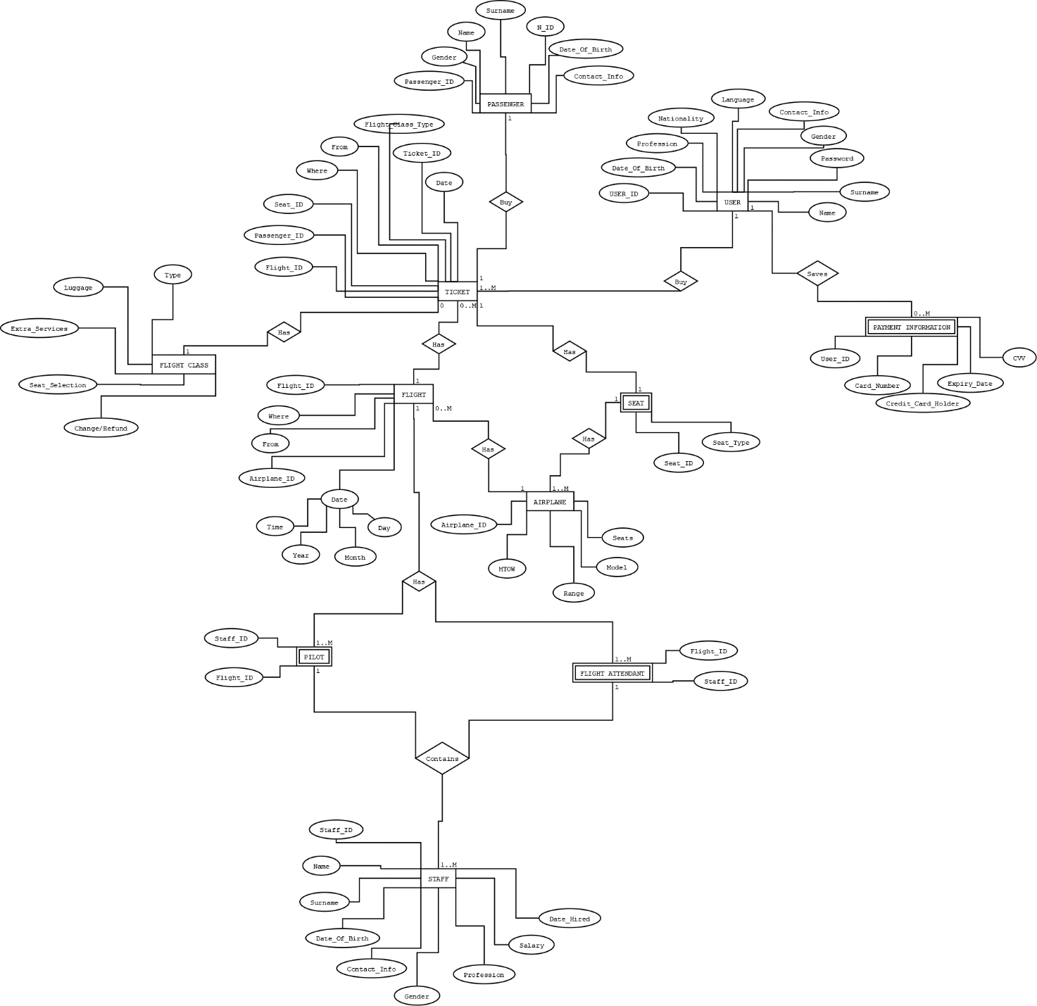

**5)DATABASE SCHEMA**

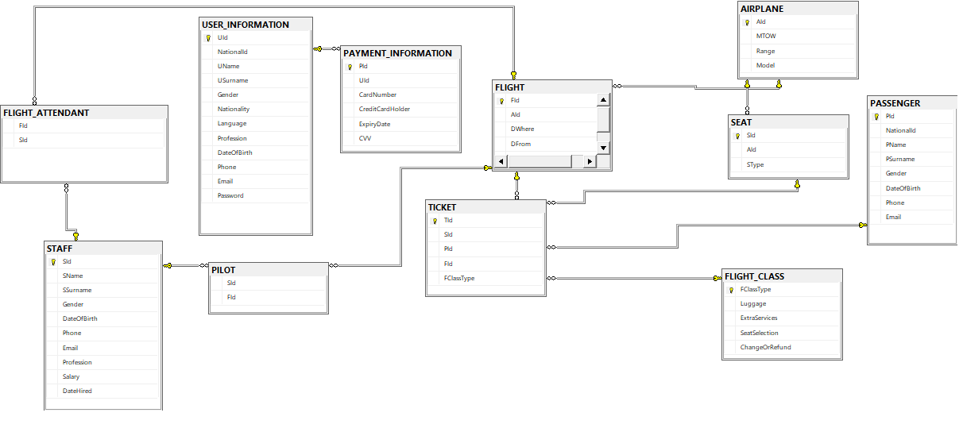

Primary Keys

USER_INFORMATION UId, PAYMENT_INFORMATION PId, FLIGHT FId, AIRPLANE AId, TICKET TId, STAFF SId, FLIGHT_CLASS FId, SEAT SId, PASSENGER PId

Foreign Keys

SEAT AId from AIRPLANE

PILOT FId from FLIGHT

SId from STAFF

FLIGHT AId from AIRPLANE

TICKET SId from SEAT

FId from FLIGHT

PId from PASSENGER

FId from FLIGHT_CLASS

FLIGHT_ATTENDANT FId from FLIGHT

SId from STAFF

PAYMENT_INFORMATION UId from USER_INFORMATION

**6)RELATIONAL ALGEBRA**

Query1

ALTER PROCEDURE [dbo].[SP_GetFlightsBySelection] @selectedCityFrom NVARCHAR(50), @selectedCityTo NVARCHAR(50), @selectedDate VARCHAR(10)

AS

SELECT [dbo].[FLIGHT].DFrom AS DEPARTURE, [dbo].[FLIGHT].DWhere AS ARRIVAL, [dbo].[AIRPLANE].Model AS AIRPLANE,

CONVERT(VARCHAR(10),[dbo].[FLIGHT].Date,3) AS DATE, CONVERT(VARCHAR(10),[dbo].[FLIGHT].Date,8) AS TIME

FROM [dbo].[FLIGHT] JOIN [dbo].[AIRPLANE] ON [dbo].[FLIGHT].AId = [dbo].[AIRPLANE].AId

WHERE @selectedCityFrom = [dbo].[FLIGHT].DFrom AND @selectedCityTo = [dbo].[FLIGHT].DWhere AND @selectedDate = CONVERT(VARCHAR(10),[dbo].[FLIGHT].Date,3)

∏(DFrom,DWhere,Model,DATE,TIME)

(@selectedCityFrom = DFrom AND @selectedCityTo = DWhere AND @selectedDate = DATE)(FLIGHT.AId I><I AIRPLANE.AId)

Query2

USE [YodaAirlines]

GO

/****** Object: StoredProcedure [dbo].[SP_GetRoundTripToByFrom] Script Date: 12/25/2018 8:07:23 AM ******/

SET ANSI_NULLS ON

GO

SET QUOTED_IDENTIFIER ON

GO

ALTER PROCEDURE [dbo].[SP_GetRoundTripToByFrom] @selectedFrom NVARCHAR(50)

AS

SELECT DISTINCT F.DWhere

FROM [dbo].[FLIGHT] AS F, [dbo].FLIGHT AS P

WHERE F.DFrom = P.DWhere AND F.DWhere = P.DFrom AND F.Date < P.Date AND F.DFrom = @selectedFrom

∏(F.DWhere)(F.DFrom = P.DWhere AND F.DWhere = P.DFrom AND

F.Date < P.Date AND F.DFrom = @selectedFrom)(FLIGHT F I><I P FLIGHT)

**7)SQL STATEMENTS**

﻿//inserting into USER INFORMATION table

INSERT INTO [dbo].[USER_INFORMATION]([NationalId],[UName],[USurname],[Gender],[Nationality],[Language],[Profession],[DateOfBirth],[Phone],[Email],[Password])

VALUES (23, 'Yoda', '-', 'Erkek', 'Tekir', 'Türkçe', 'Kedi', '2018-08-15', '0xxxxxxxxxx', 'xxx@xxx', 'kediyimben')

//inserting into AIRPLANE table

INSERT INTO [dbo].[AIRPLANE]([Model],[MTOW],[Range])

VALUES ('Airbus A220', '60,800', '3,200')

//inserting into FLIGHT table

INSERT INTO [dbo].[FLIGHT]([AId], [Date], [DFrom], [DWhere])

VALUES (4, '2019-01-14 22:00:00.000', 'SEUL', 'İZMİR')

//inserting into FLIGHT CLASS table

INSERT INTO [dbo].[FLIGHT_CLASS]([FClassType],[Luggage],[ExtraServices],[SeatSelection],[ChangeOrRefund])

VALUES ('BUSINESS','20 KG + 12 KG KABİN','+','+','+')

//inserting into PAYMENT INFORMATION table

INSERT INTO [dbo].[PAYMENT_INFORMATION]

VALUES (3, '2XXX 3XXX 4XXX 5XXX', 'YODA', '12/20', '355')

//inserting into SEAT table

INSERT INTO [dbo].[SEAT]([AId],[SType])

VALUES (4,'Diğer Koltuklar')

//inserting into STAFF table

INSERT INTO [dbo].[STAFF]

VALUES ('Ceren', 'Öğüt', 'Kadın', '1996-07-12', '0xxxxxxxxxx', 'xxx@xxx', 'FLIGHT ATTENDANT', '3200','2018-12-04')

//inserting into FLIGHT ATTENDANT table

INSERT INTO [dbo].[FLIGHT_ATTENDANT]

VALUES (13, 4)

INSERT INTO [dbo].[FLIGHT_ATTENDANT]

VALUES (8, 7)

INSERT INTO [dbo].[FLIGHT_ATTENDANT]

VALUES (12, 1)

INSERT INTO [dbo].[FLIGHT_ATTENDANT]

VALUES (10, 3)

INSERT INTO [dbo].[FLIGHT_ATTENDANT]

VALUES (11, 5)

INSERT INTO [dbo].[FLIGHT_ATTENDANT]

VALUES (9, 4)

INSERT INTO [dbo].[FLIGHT_ATTENDANT]

VALUES (7, 2)

INSERT INTO [dbo].[FLIGHT_ATTENDANT]

VALUES (14, 6)

INSERT INTO [dbo].[FLIGHT_ATTENDANT]

VALUES (13, 8)

INSERT INTO [dbo].[FLIGHT_ATTENDANT]

VALUES (14, 9)

INSERT INTO [dbo].[FLIGHT_ATTENDANT]

VALUES (13, 10)

INSERT INTO [dbo].[FLIGHT_ATTENDANT]

VALUES (7, 11)

INSERT INTO [dbo].[FLIGHT_ATTENDANT]

VALUES (9, 12)

INSERT INTO [dbo].[FLIGHT_ATTENDANT]

VALUES (12, 13)

INSERT INTO [dbo].[FLIGHT_ATTENDANT]

VALUES (13, 14)

INSERT INTO [dbo].[FLIGHT_ATTENDANT]

VALUES (8, 15)

INSERT INTO [dbo].[FLIGHT_ATTENDANT]

VALUES (10, 16)

INSERT INTO [dbo].[FLIGHT_ATTENDANT]

VALUES (11, 17)

INSERT INTO [dbo].[FLIGHT_ATTENDANT]

VALUES (11, 18)

//inserting into PILOT table

INSERT INTO [dbo].[PILOT]

VALUES (1,8)

INSERT INTO [dbo].[PILOT]

VALUES (1,4)

INSERT INTO [dbo].[PILOT]

VALUES (1,9)

INSERT INTO [dbo].[PILOT]

VALUES (1,10)

INSERT INTO [dbo].[PILOT]

VALUES (1,11)

INSERT INTO [dbo].[PILOT]

VALUES (2,2)

INSERT INTO [dbo].[PILOT]

VALUES (2,3)

INSERT INTO [dbo].[PILOT]

VALUES (2,13)

INSERT INTO [dbo].[PILOT]

VALUES (2,14)

INSERT INTO [dbo].[PILOT]

VALUES (3,5)

INSERT INTO [dbo].[PILOT]

VALUES (3,6)

INSERT INTO [dbo].[PILOT]

VALUES (3,15)

INSERT INTO [dbo].[PILOT]

VALUES (3,16)

INSERT INTO [dbo].[PILOT]

VALUES (3,17)

INSERT INTO [dbo].[PILOT]

VALUES (3,18)

INSERT INTO [dbo].[PILOT]

VALUES (4,1)

INSERT INTO [dbo].[PILOT]

VALUES (4,7)

INSERT INTO [dbo].[PILOT]

VALUES (4,12)

//Sql Queries For Creating The Tables

CREATE TABLE [dbo].[AIRPLANE]

(

[AId] [int] IDENTITY(1,1) PRIMARY KEY NOT NULL,

[MTOW] [nvarchar](50) NULL,

[Range] [nvarchar](50) NULL,

[Model] [nvarchar](50) NULL

)

CREATE TABLE [dbo].[FLIGHT]

(

[FId] [int] IDENTITY(1,1) PRIMARY KEY NOT NULL,

[AId] [int] FOREIGN KEY REFERENCES AIRPLANE(AId),

[DWhere] [nvarchar](50) NULL,

[DFrom] [nvarchar](50) NULL,

[Date] [datetime] NULL

)

CREATE TABLE [dbo].[FLIGHT_CLASS]

(

[FClassType] [nvarchar](50) PRIMARY KEY NOT NULL,

[Luggage] [nvarchar](50) NULL,

[ExtraServices] [nvarchar](50) NULL,

[SeatSelection] [nvarchar](50) NULL,

[ChangeOrRefund] [nvarchar](50) NULL

)

CREATE TABLE [dbo].[PASSENGER]

(

[PId] [int] IDENTITY(1,1) PRIMARY KEY NOT NULL,

[NationalId] [int] NULL,

[PName] [nvarchar](50) NULL,

[PSurname] [nvarchar](50) NULL,

[Gender] [nvarchar](50) NULL,

[Birthday] [date] NULL,

[Phone] [nvarchar](50) NULL,

[Email] [nvarchar](50) NULL

)

CREATE TABLE [dbo].[USER_INFORMATION]

(

[UId] [int] IDENTITY(1,1) PRIMARY KEY NOT NULL,

[NationalId] [int] NULL,

[UName] [nvarchar](50) NULL,

[USurname] [nvarchar](50) NULL,

[Gender] [nvarchar](50) NULL,

[Nationality] [nvarchar](50) NULL,

[DateOfBirth] [date] NULL,

[Phone] [nvarchar](50) NULL,

[Email] [nvarchar](50) NULL,

[Password] [nvarchar](50) NULL

)

CREATE TABLE [dbo].[PAYMENT_INFORMATION]

(

[PId] [int] IDENTITY(1,1) PRIMARY KEY NOT NULL,

[UId] [int] FOREIGN KEY REFERENCES USER_INFORMATION(UId),

[CardNumber] [int] NULL,

[CreditCardHolder] [nvarchar](50) NULL,

[ExpiryDate] [date] NULL,

[CVV] [int] NULL

)

CREATE TABLE [dbo].[STAFF]

(

[SId] [int] IDENTITY(1,1) PRIMARY KEY NOT NULL,

[SName] [nvarchar](50) NULL,

[SSurname] [nvarchar](50) NULL,

[Gender] [nvarchar](50) NULL,

[DateOfBirth] [date] NULL,

[Phone] [nvarchar](50) NULL,

[Email] [nvarchar](50) NULL,

[Profession] [nvarchar](50) NULL,

[Salary] [nvarchar](50) NULL,

[DatHired] [date] NULL

)

CREATE TABLE [dbo].[FLIGHT_ATTENDANT]

(

[SId] [int] FOREIGN KEY REFERENCES STAFF(SId) NULL,

[FId] [int] FOREIGN KEY REFERENCES FLIGHT(FId) NULL

)

CREATE TABLE [dbo].[PILOT]

(

[SId] [int] FOREIGN KEY REFERENCES STAFF(SId) NULL,

[FId] [int] FOREIGN KEY REFERENCES FLIGHT(FId) NULL

)

CREATE TABLE [dbo].[SEAT]

(

[SId] [int] IDENTITY(1,1) PRIMARY KEY NOT NULL,

[AId] [int] FOREIGN KEY REFERENCES AIRPLANE(AId),

[SType] [nvarchar](50) NULL,

)

CREATE TABLE [dbo].[TICKET]

(

[TId] [int] IDENTITY(1,1) PRIMARY KEY NOT NULL,

[SId] [int] FOREIGN KEY REFERENCES SEAT(SId) NULL,

[FId] [int] FOREIGN KEY REFERENCES FLIGHT(FId) NULL,

[FClassType] [nvarchar](50) FOREIGN KEY REFERENCES FLIGHT_CLASS(FClassType),

[PId] [int] FOREIGN KEY REFERENCES PASSENGER(PId) NULL

)

//Stored Procedures

USE [YodaAirlines]

GO

/****** Object: StoredProcedure [dbo].[SP_DeleteById] Script Date: 12/25/2018 8:05:50 AM ******/

SET ANSI_NULLS ON

GO

SET QUOTED_IDENTIFIER ON

GO

ALTER procedure [dbo].[SP_DeleteById] @Id int

as

delete from [dbo].[USER_INFORMATION] where [dbo].[USER_INFORMATION].UId = @Id

USE [YodaAirlines]

GO

/****** Object: StoredProcedure [dbo].[SP_GetFlightDateByFromWhere] Script Date: 12/25/2018 8:06:25 AM ******/

SET ANSI_NULLS ON

GO

SET QUOTED_IDENTIFIER ON

GO

ALTER PROCEDURE [dbo].[SP_GetFlightDateByFromWhere] @selectedFrom NVARCHAR(50), @selectedWhere NVARCHAR(50)

AS

SELECT CONVERT(VARCHAR(10),[dbo].[FLIGHT].Date,3)

FROM [dbo].[FLIGHT]

WHERE [dbo].[FLIGHT].DFrom = @selectedFrom AND [dbo].[FLIGHT].DWhere = @selectedWhere

GROUP BY [dbo].[FLIGHT].Date

ORDER BY [dbo].[FLIGHT].Date ASC

USE [YodaAirlines]

GO

/****** Object: StoredProcedure [dbo].[SP_GetFlightsBySelection] Script Date: 12/25/2018 8:06:37 AM ******/

SET ANSI_NULLS ON

GO

SET QUOTED_IDENTIFIER ON

GO

ALTER PROCEDURE [dbo].[SP_GetFlightsBySelection] @selectedCityFrom NVARCHAR(50), @selectedCityTo NVARCHAR(50), @selectedDate VARCHAR(10)

AS

SELECT [dbo].[FLIGHT].DFrom AS DEPARTURE, [dbo].[FLIGHT].DWhere AS ARRIVAL, [dbo].[AIRPLANE].Model AS AIRPLANE, CONVERT(VARCHAR(10),[dbo].[FLIGHT].Date,3) AS DATE, CONVERT(VARCHAR(10),[dbo].[FLIGHT].Date,8) AS TIME

FROM [dbo].[FLIGHT] JOIN [dbo].[AIRPLANE] ON [dbo].[FLIGHT].AId = [dbo].[AIRPLANE].AId

WHERE @selectedCityFrom = [dbo].[FLIGHT].DFrom AND @selectedCityTo = [dbo].[FLIGHT].DWhere AND @selectedDate = CONVERT(VARCHAR(10),[dbo].[FLIGHT].Date,3)

USE [YodaAirlines]

GO

/****** Object: StoredProcedure [dbo].[SP_GetReturnFligthsBySelection] Script Date: 12/25/2018 8:07:00 AM ******/

SET ANSI_NULLS ON

GO

SET QUOTED_IDENTIFIER ON

GO

ALTER PROCEDURE [dbo].[SP_GetReturnFligthsBySelection] @selectedFrom NVARCHAR(50), @selectedTo NVARCHAR(50), @selectedDate NVARCHAR(50)

AS

SELECT * FROM [dbo].[ReturnFlights] AS WR

WHERE WR.DEPARTURE = @selectedFrom AND WR.ARRIVAL = @selectedTo AND WR.DATE = @selectedDate

USE [YodaAirlines]

GO

/****** Object: StoredProcedure [dbo].[SP_GetRoundTripFrom] Script Date: 12/25/2018 8:07:09 AM ******/

SET ANSI_NULLS ON

GO

SET QUOTED_IDENTIFIER ON

GO

ALTER PROCEDURE [dbo].[SP_GetRoundTripFrom]

AS

SELECT DISTINCT F.DFrom FROM [dbo].[FLIGHT] AS F, [dbo].FLIGHT AS P

WHERE F.DFrom = P.DWhere AND F.DWhere = P.DFrom AND F.Date < P.Date

USE [YodaAirlines]

GO

/****** Object: StoredProcedure [dbo].[SP_GetToByFrom] Script Date: 12/25/2018 8:07:43 AM ******/

SET ANSI_NULLS ON

GO

SET QUOTED_IDENTIFIER ON

GO

ALTER PROCEDURE [dbo].[SP_GetToByFrom] @selectedFrom NVARCHAR(50)

AS

SELECT DISTINCT F.DWhere

FROM [dbo].[FLIGHT] AS F JOIN [dbo].[FLIGHT] AS P ON F.AId = P.AId

WHERE F.DFrom = @selectedFrom

USE [YodaAirlines]

GO

/****** Object: StoredProcedure [dbo].[SP_GetUserByID] Script Date: 12/25/2018 8:07:55 AM ******/

SET ANSI_NULLS ON

GO

SET QUOTED_IDENTIFIER ON

GO

ALTER PROCEDURE [dbo].[SP_GetUserByID] @ID int

AS

SELECT [dbo].[USER_INFORMATION].UId as UId, [dbo].[USER_INFORMATION].NationalId as UNId, [dbo].[USER_INFORMATION].UName as UName, [dbo].[USER_INFORMATION].USurname as USurname, [dbo].[USER_INFORMATION].Gender as UGender, [dbo].[USER_INFORMATION].Nationality as UNationality, [dbo].[USER_INFORMATION].Language as ULanguage, [dbo].[USER_INFORMATION].Profession as UProfession, [dbo].[USER_INFORMATION].DateOfBirth as UDateOfBirth, [dbo].[USER_INFORMATION].Phone as UPhone, [dbo].[USER_INFORMATION].Email as UEmail, [dbo].[USER_INFORMATION].Password as UPassword

from [dbo].[USER_INFORMATION]

WHERE UId = @ID

USE [YodaAirlines]

GO

/****** Object: StoredProcedure [dbo].[SP_UserAdd] Script Date: 12/25/2018 8:08:07 AM ******/

SET ANSI_NULLS ON

GO

SET QUOTED_IDENTIFIER ON

GO

ALTER PROCEDURE [dbo].[SP_UserAdd] (@UName nvarchar(50) = null, @USurname nvarchar(50) = null, @Gender nvarchar(50) = null, @NationalId int = null, @Nationality nvarchar(50) = null, @Language nvarchar(50) = null, @Profession nvarchar(50) = null, @DateOfBirth date = null, @Email nvarchar(50) = null, @Phone nvarchar(50) = null, @Password nvarchar(50) = null)

AS

begin

INSERT INTO [dbo].[USER_INFORMATION]([NationalId],[UName],[USurname],[Gender],[Nationality],[Language],[Profession],[DateOfBirth],[Phone],[Email],[Password])

VALUES (@NationalId, @UName, @USurname, @Gender, @Nationality, @Language, @Profession, @DateOfBirth, @Phone, @Email, @Password)

end

USE [YodaAirlines]

GO

/****** Object: StoredProcedure [dbo].[SP_GetRoundTripToByFrom] Script Date: 12/25/2018 8:07:23 AM ******/

SET ANSI_NULLS ON

GO

SET QUOTED_IDENTIFIER ON

GO

ALTER PROCEDURE [dbo].[SP_GetRoundTripToByFrom] @selectedFrom NVARCHAR(50)

AS

SELECT DISTINCT F.DWhere FROM [dbo].[FLIGHT] AS F, [dbo].FLIGHT AS P

WHERE F.DFrom = P.DWhere AND F.DWhere = P.DFrom AND F.Date < P.Date AND F.DFrom = @selectedFrom

USE [YodaAirlines]

GO

/****** Object: StoredProcedure [dbo].[spSelectUsers] Script Date: 12/25/2018 8:08:16 AM ******/

SET ANSI_NULLS ON

GO

SET QUOTED_IDENTIFIER ON

GO

ALTER PROCEDURE [dbo].[spSelectUsers]

AS

SELECT [dbo].[USER_INFORMATION].UId as UId, [dbo].[USER_INFORMATION].NationalId as UNId, [dbo].[USER_INFORMATION].UName as UName, [dbo].[USER_INFORMATION].USurname as USurname, [dbo].[USER_INFORMATION].Gender as UGender, [dbo].[USER_INFORMATION].Nationality as UNationality, [dbo].[USER_INFORMATION].Language as ULanguage, [dbo].[USER_INFORMATION].Profession as UProfession, [dbo].[USER_INFORMATION].DateOfBirth as UDateOfBirth, [dbo].[USER_INFORMATION].Phone as UPhone, [dbo].[USER_INFORMATION].Email as UEmail, [dbo].[USER_INFORMATION].Password as UPassword

from [dbo].[USER_INFORMATION]

//Views

USE [YodaAirlines]

GO

/****** Object: View [dbo].[PrintedTicket] Script Date: 12/25/2018 8:09:27 AM ******/

SET ANSI_NULLS ON

GO

SET QUOTED_IDENTIFIER ON

GO

CREATE VIEW [dbo].[PrintedTicket]

AS

SELECT P.PName AS NAME, P.PSurname AS SURNAME, P.Gender AS GENDER, P.NationalId AS NATIONALID, F.DFrom AS DEPARTURE, F.DWhere AS ARRIVAL, F.Date AS DATE, S.SType, FC.FClassType

FROM [dbo].[TICKET] AS T, [dbo].[FLIGHT] AS F, [dbo].[PASSENGER] AS P, [dbo].[FLIGHT_CLASS] AS FC, [dbo].[SEAT] AS S

WHERE T.FId = F.FId AND T.SId = S.SId AND T.PId = P.PId AND T.FClassType = FC.FClassType

GO

USE [YodaAirlines]

GO

/****** Object: View [dbo].[ReturnFlights] Script Date: 12/25/2018 8:10:06 AM ******/

SET ANSI_NULLS ON

GO

SET QUOTED_IDENTIFIER ON

GO

ALTER VIEW [dbo].[ReturnFlights]

AS

SELECT DISTINCT P.DFrom AS DEPARTURE, P.DWhere AS ARRIVAL, A.Model AS AIRPLANE, CONVERT(VARCHAR(10),P.Date,3) AS DATE, CONVERT(VARCHAR(10),P.Date,8) AS TIME

FROM [dbo].[FLIGHT] AS F, [dbo].FLIGHT AS P, [dbo].[AIRPLANE] AS A

WHERE F.DFrom = P.DWhere AND F.DWhere = P.DFrom AND F.Date < P.Date AND P.AId = A.AId

GO

**8)INTERFACE SCREENSHOTS OF MAIN OPERATIONS**

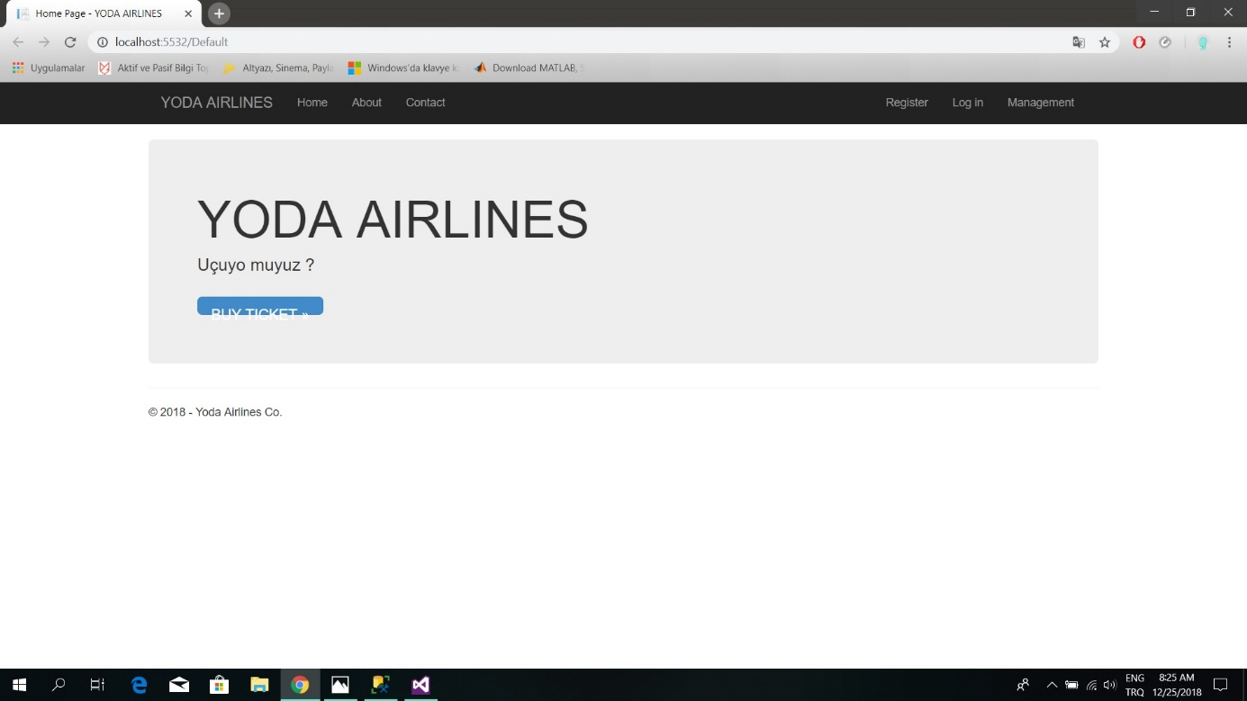

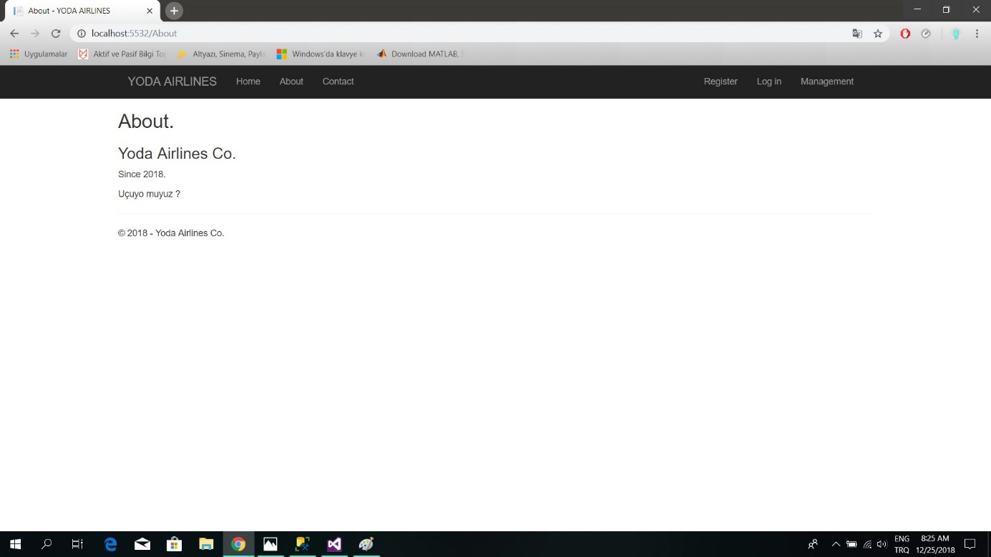

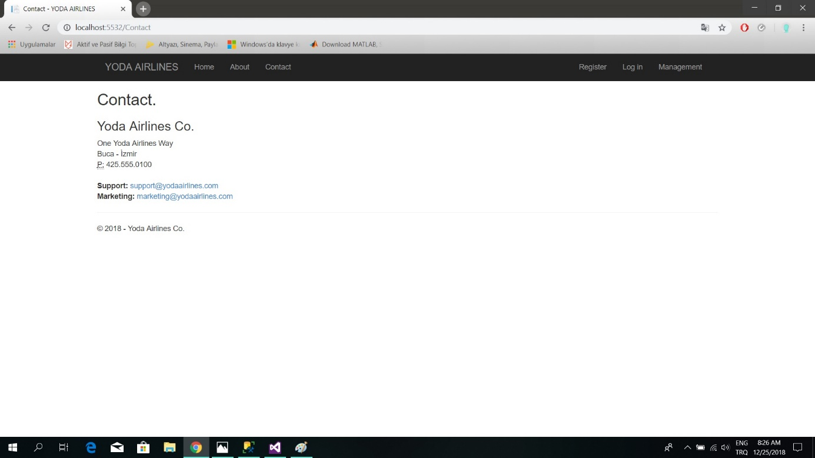

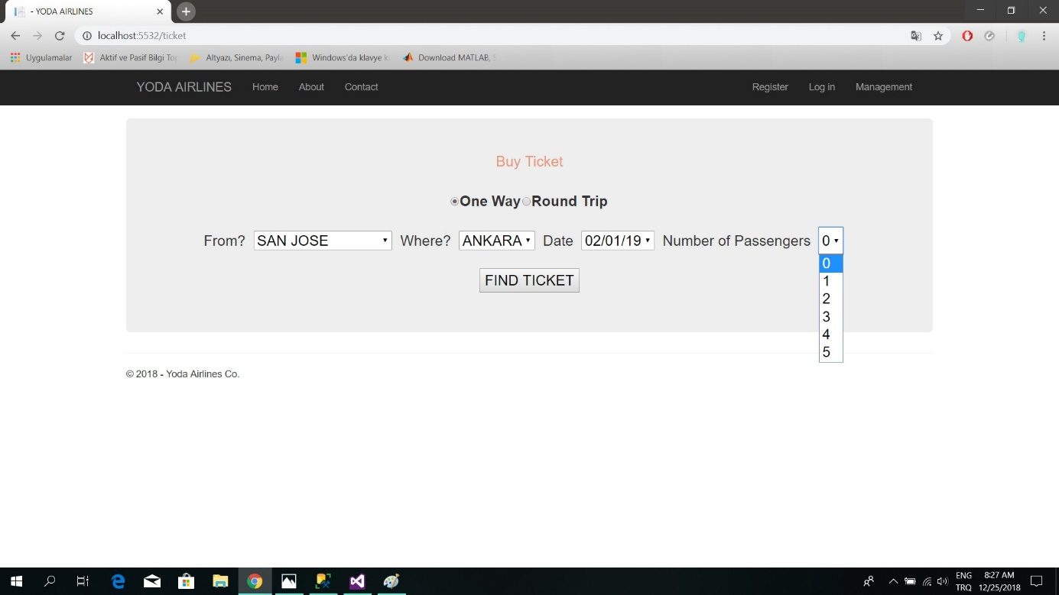

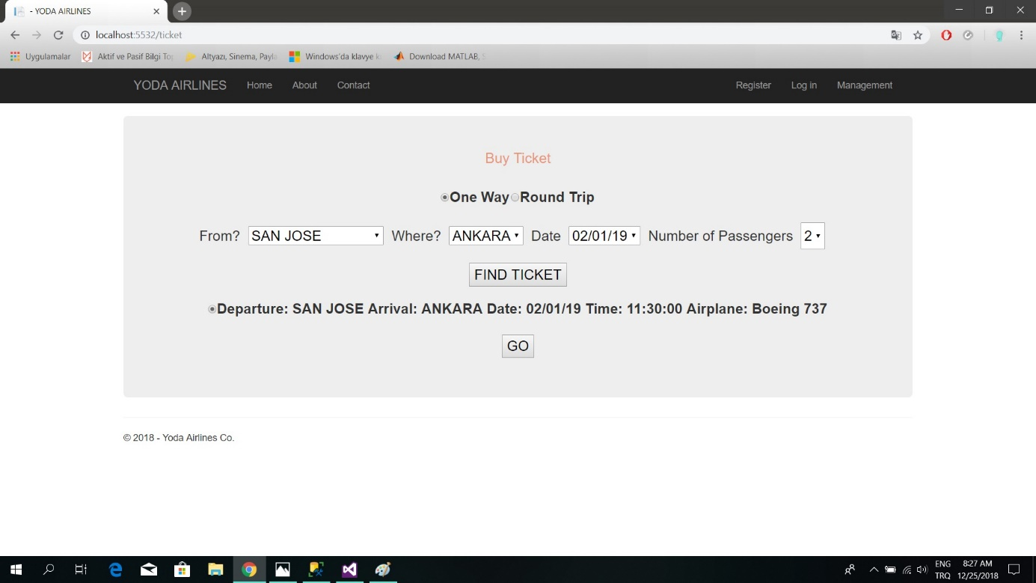

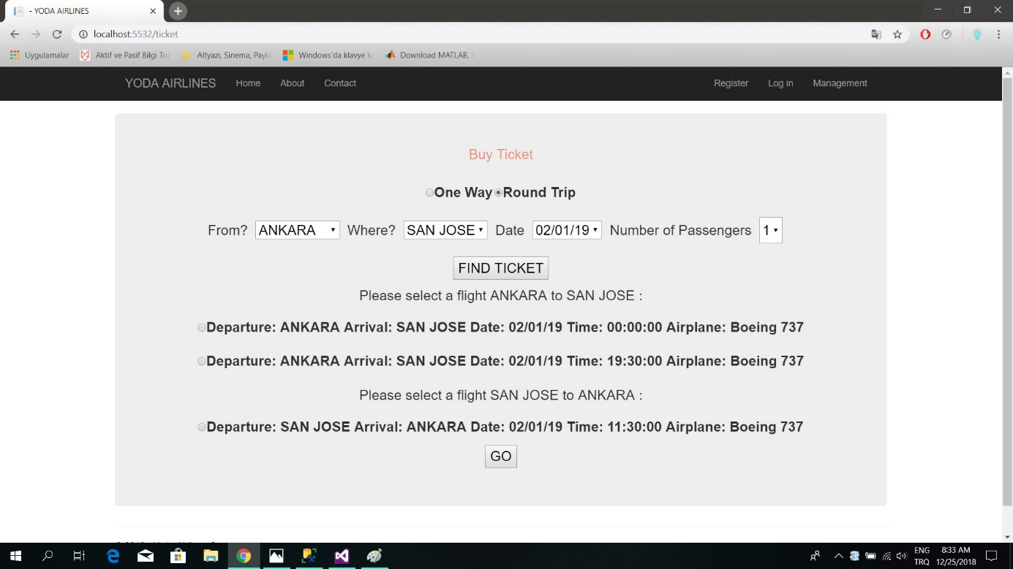

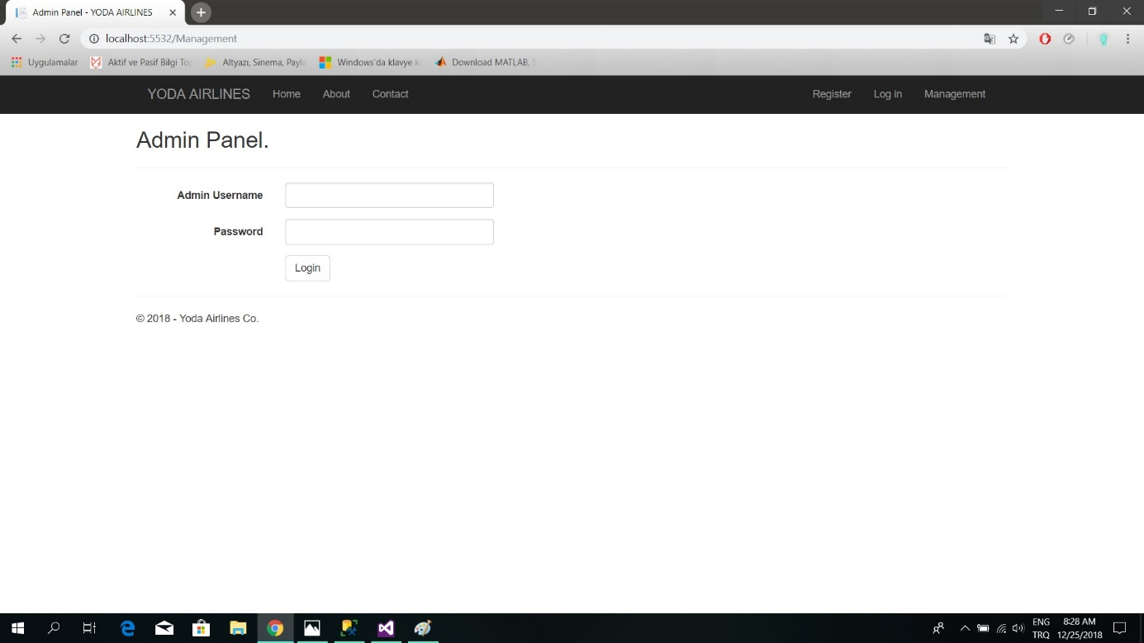

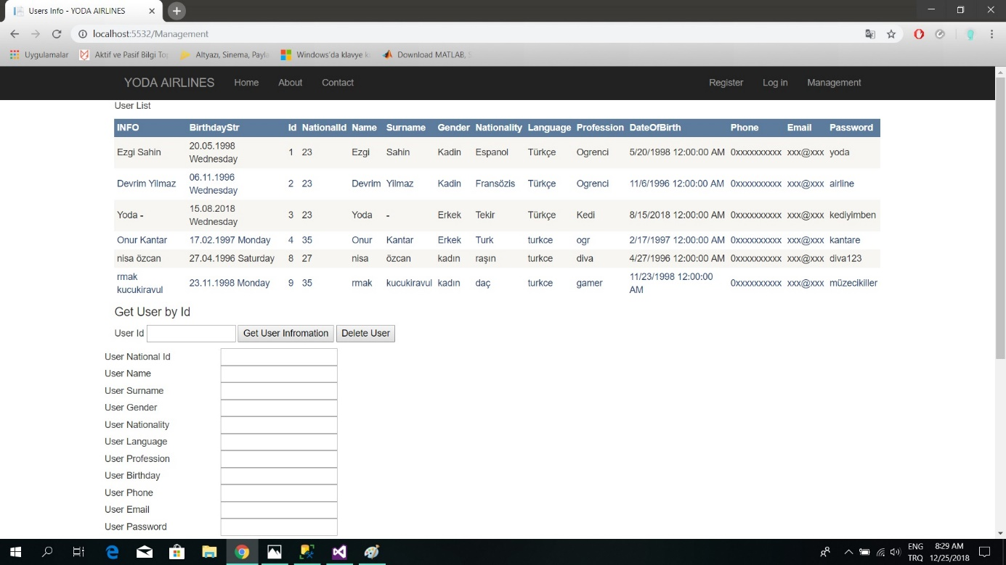

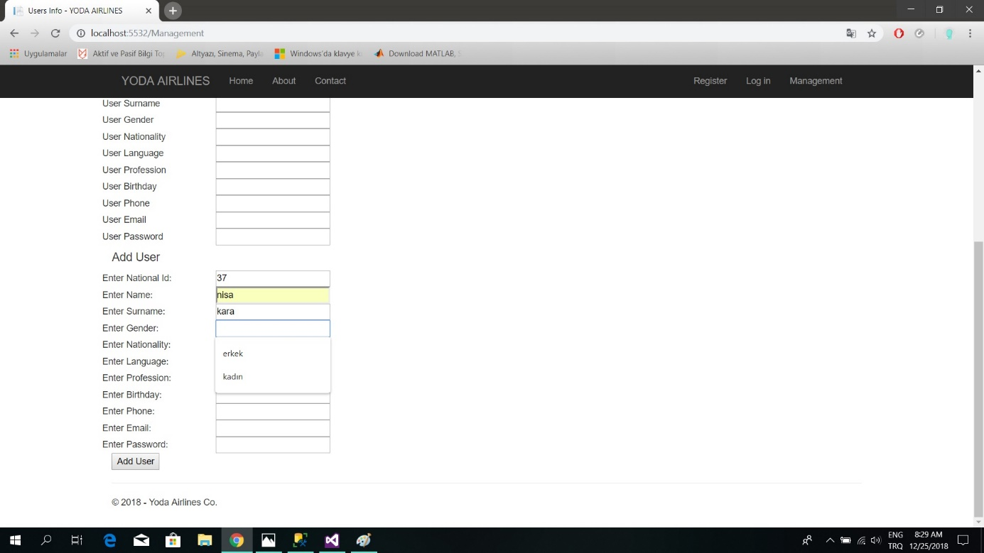

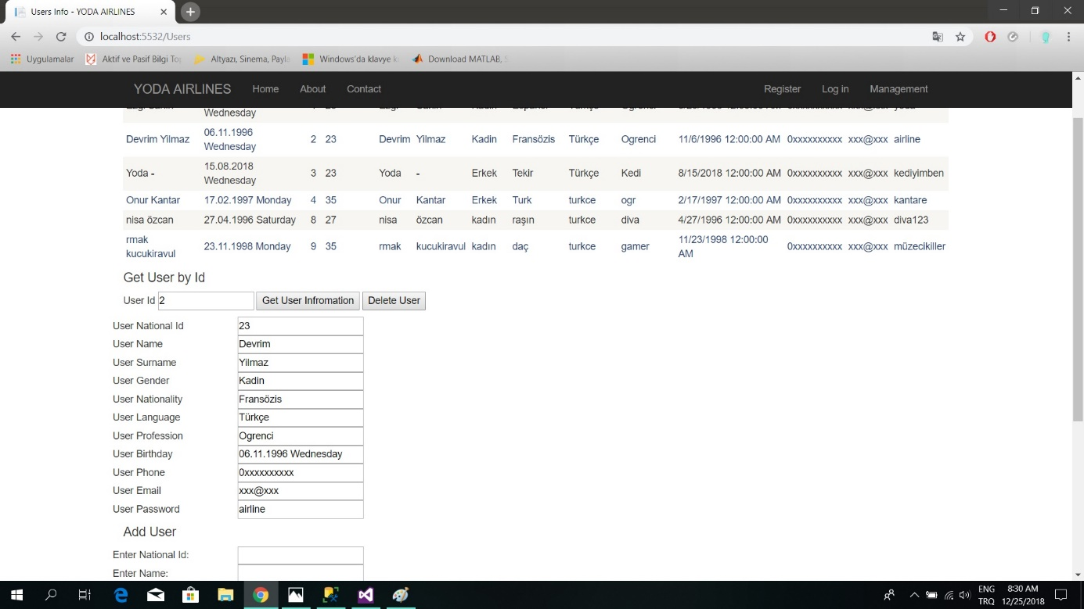

**9)ADDITIONAL PROPERTIES**

There are no additional properties in our project.

**10)USED TECHNOLOGY,TOOLS & CHALLENGES**

Technologies used in this project are .NET and MSSQL. NET is a server-side web development technology. Microsoft SQL Server is a relational database management system that supports wide variety of transaction processing. Tools used in this project are Microsoft Visual Studio and Microsoft SQL Server Management Studio. We used C# as the programming language in our project.