Intelligent Detection of Cashew Plant Diseases using Machine Learning and Deep Learning algorithms

Manoj Kumar Pradhan

B.Tech CSE Student

KIIT University Bhubaneswar, India

[2105557@kiit.ac.in](mailto:2105557@kiit.ac.in)

Omprakash

B.Tech CSE Student

KIIT University Bhubaneswar, India

[2105560@kiit.ac.in](mailto:2105560@kiit.ac.in)

Raj Singh

B.Tech CSE Student

KIIT University Bhubaneswar, India

[2105732@kiit.ac.in](mailto:2105732@kiit.ac.in)

Aryan Maitra

B.Tech CSE Student

KIIT University Bhubaneswar, India

[2105777@kiit.ac.in](mailto:2105777@kiit.ac.in)

Vishal Banerjee

B.Tech CSE Student

KIIT University Bhubaneswar, India

[2105847@kiit.ac.in](mailto:2105847@kiit.ac.in)

***Abstract: India holds the esteemed position of being the world's second-largest exporter of cashew nuts, a crop that significantly contributes to the livelihoods of numerous small and marginal farmers. The cashew industry not only generates income for these farmers but also fuels employment opportunities in processing and export sectors, thereby playing a pivotal role in the nation's economy. However, the potential for cashew production remains largely untapped due to various factors such as inefficient agricultural practices, adverse weather conditions, and the menace of pests and diseases. Among these challenges, diseases pose a significant threat to yield, making early detection imperative for implementing effective control measures and minimizing losses. This research paper endeavors to address the issue of cashew plant disease detection through the application of intelligent algorithms such as machine learning and deep learning. Specifically, the study focuses on the development and evaluation of an Intelligent Detection System for Cashew Plant Diseases using a combination of traditional machine learning techniques and advanced deep learning algorithms. Five distinct algorithms, namely Support Vector Machine (SVM), Random Forest, MobileNet, InceptionV3, and ResNet152V2, are employed and evaluated based on predefined metrics to determine the most effective model. The research methodology involves data preprocessing, model training, and result evaluation, with a particular emphasis on the efficiency of Convolutional Neural Network (CNN) models for early disease detection. The proposed approach holds promise as a reliable and efficient solution for the early detection of cashew plant diseases, thereby facilitating increased production and improved agricultural outcomes.***

***Keywords: Agriculture Industry, Plant diseases, Cashew plants, Anthracnose, leaf miner & red rust, Machine learning algorithms, Convolutional neural network, Automated detection, Food security, Sustainability.***

I. INTRODUCTION

Cashew (*Anacardium occidentale*) is native to Brazil, but was introduced to India in the second half of the 16th century. The commercial cultivation of cashew nuts takes place probably in eight states of India which includes Andhra Pradesh, Goa, Karnataka, Kerala, Maharashtra, Odisha, Tamil Nadu and West Bengal. India is the third largest producer and exporter of cashews after Vietnam and Nigeria. It also consumes a significant amount of cashews and leads to processing. More than 90% of cashew processing workers are women and processing plants are concentrated mainly in Kerala, Andhra Pradesh and Maharashtra. The cultivation and use of cashew nuts offers economic promise to both rural farmers and urban industrial processors.

The early detection of cashew diseases is essential to prevent rapid spread of pathogens and pests, minimize economic loss and resource usage. By treating diseases at an early stage, farmers promote sustainable agricultural practices, improve food security and ensure a stable and reliable supply of cashews, which are essential for nutrition and income in many communities.

Cashew crops are damaged by more than 300 insects, pests and diseases worldwide that limit its productivity. We found nearly 50% of annual crop loss due to pests and diseases. Anthracnose, fruit rot, leaf miner, red rust and gummosis are some of the diseases causing damage among Cashew Production in India. Among these diseases we took Anthracnose, leaf miner & red rust and tried to detect it.

So, let's discuss how they affect the cashew plants:

1)Anthracnose which is caused by the fungus Colletotrichum gloeosporioides where dark brown to black spots is visible on the leaves, often surrounded by a yellow halo.

2)Leaf miners are small insect larvae (usually butterflies or flies) that tunnel through leaf tissue where irregular tortuous tunnels (mines) appear on the leaves.

3)Red rust is caused by the fungus Puccinia anacardii where these rust spores appear on the undersides of leaves and yellowish spots with red edges appear on the upper surface of the leaf.

There are many existing techniques used for detecting diseases like laboratory tests, visual inspection and remote sensing techniques. But in this we face some challenges like lack of trained personnel, high cost, time-consuming processes and not finding skilled experts. We need improved detection methods for cashew plant diseases. The new method should be accurate, efficient and cost-effective. It should minimize false positives and negatives, provide faster results to enable timely action, and be affordable for farmers and industry stakeholders.

We can work to prevent our plant from those diseases or we could save our cashew farm only if we could detect the disease from the symptoms as early as possible. By this we could find the disease and then go for preventive measures like controlled irrigation applications of pesticides etc. Now for detection we can apply Machine Learning and Deep Learning models. With images of healthy and diseased plant parts (leaves) powerful algorithms like ResNet, SVM, or Inception housed in libraries like TensorFlow, Keras, or scikit-learn can be trained to learn the disease patterns.

For plant disease detection we can also use a special technique known as convolutional neural networks (CNNs). The higher accuracy of the CNN model for plant disease classification has proved to be better than all other kinds of ML and DL methods. Studies have shown that CNNs can achieve high accuracy rates in the range of 93-99% in classifying images of plant leaves affected by diseases and pests. By using CNNs model we will identify the infected and healthy leaves, as well as to detect illness in afflicted plants. The CNN model is designed to suit both healthy and sick leaves. We are using CNN model because it will perform more efficiently on image processing tasks.

This trained model, tested for high accuracy, can be integrated into mobile apps, web tools, or sensor systems using platforms like TensorFlow Lite or Keras for real-time field detection. This empowers farmers to identify and manage diseases early on, promoting healthier and more productive cashew trees.

II. LITERATURE REVIEW

The apple leaf disease dataset (ALDD), which is made up of complex images captured in real-world settings as well as laboratory images, was first created using data augmentation and image annotation technologies. PENG JIANG, YUEHAN CHEN, BIN LIU, DONGJIAN HE, AND CHUNQUAN LIANG used a variety of CNN models to identify ALDD. Through the use of several deep-CNN models in the experiments, the INAR-SSD model achieves 78.80% mAP and 23.13 FPS, which is a 2.98% mAP improvement over earlier antiquated techniques.(Aryan maitra)

A research study conducted by Halil Durmus, Ece Olcay Güneş, Mürvet Kirci focuses on utilizing deep learning for disease detection in tomato plants using the PlantVillage dataset. The most popular technique known as convolution neural networks (CNNs) are used in this. Powerful CNNs architectures like, for this particular project AlexNet and SqueezeNet are used for handling high-dimensional data, especially images. On finding accuracy among the two CNN models, SqueezeNet is found to be proficient with an accuracy of 94.3% and also this method can be used for smaller networks, will cost lower data and updating speed will be higher.

Jihen Amara, Bassem Bouaziz, and Alsayed Algergawy's proposed research paper addresses the illnesses that impact the leaves of banana plants. A novel method based on CNNs for the identification of banana plant diseases was developed in response to developments in computer vision, particularly convolution neural networks (CNNs), which have demonstrated impressive performance in the field of picture classification. The LeNet architecture, on which their approach is built, requires very little picture preprocessing (Le891). Straight from photos, the model can pick up visual characteristics. A pair of distinct sick leaf types can be distinguished from healthy ones using the proposed model.. The accuracy on a grayscale scale is 94.44%, and on a color scale, it was found to be 98.67%. This demonstrates that with minimal computational effort, the suggested method can greatly support an accurate diagnosis of leaf diseases.(aryan maitra)

A research study by Dimitrios Moshou, Cédric Bravo, Jonathan West, Stijn Wahlen, Alastair McCartney, Herman Ramon focused on detecting and classifying yellow rust infection in wheat plants using optical data analysis and artificial neural networks. Self-organizing maps (SOM) and multilayer perceptrons (MLP) were used for data visualization and classification. The results showed high accuracy as 95% in identifying diseased and healthy plants, with only a small percentage of misclassifications. This model is used for classifying diseased and healthy spectra with a success rate of 95%. Artificial Neural Networks, specifically multilayer perceptrons, are also employed for classification, providing better results with up to 99% correct classification.

A residual Network recognition model by Xu Wenchao and Yan Zhi describes how to quickly and accurately discover and identify strawberry diseases and take corresponding control measures using advanced CNN model like G-ResNet-50 which is proposed based on transfer learning and deep residual network for strawberry disease identification and classification. The results of model training and testing on 7,525 four-category leaf datasets show that the G-ResNet50 model has faster convergence speed and better classification effect, and its average recognition accuracy rate reached 98.67%, which is significantly higher than other models.

|  |  |  |  |  |
| --- | --- | --- | --- | --- |
| **Ref. No.** | **Research Paper** | **Author Name** | **Problem Addressed** | **Method used** |
| 1. | Real-time detection of apple leaf diseases using deep learning approaches based on improved Convolutional Neural Networks. | Peng Jiang,  Yuehan Chen,  Bin Liu,  Dongjian He,  And Chunquan Liang | Real-time detection of apple leaf diseases (ALDD) faces challenges from varying spot sizes and environmental factors. Innovative solutions are required to maintain real-time processing capabilities amidst these obstacles. | This research paper employs a combination of dataset creation, CNN architectures, data augmentation, and performance evaluation techniques to develop and evaluate an effective apple leaf disease detection model. |
| 2. | Disease Detection on the Leaves of the Tomato Plants by Using Deep Learning | Halil Durmus, Ece Olcay Güneş, Mürvet Kirci | The diseases and pests affect the leaflets and leaves, the roots, the stems, and the fruits of the tomato plants. Phonological changes on the leaves and leaflets on the tomato plants can be abnormal growth, discoloration, spots, damages, wilting desiccation, and necrosis. | The paper utilizes CNNs, particularly SqueezeNet, with the PlantVillage dataset for tomato disease detection. It shows SqueezeNet's superiority over AlexNet in accuracy and efficiency for this application. |
| 3. | A Deep Learning-based Approach for Banana Leaf Diseases Classification | Jihen Amara, Bassem Bouaziz and Alsayed Algergawy | A system to automatically classify and diagnose banana diseases is desperately needed, as there are very few resources and experts available worldwide in the field of banana pathology. Banana sigatoka and banana speckle are two diseases that will kill the plant if left untreated.  (aryan maitra) | Inspired by computer vision advancements, a CNN-based system is developed for banana plant disease recognition. Utilizing the LeNet architecture ILe891, minimal image preprocessing is needed, enabling direct learning of visual features from images. |
| 4. | Automatic detection of ‘yellow rust’ in wheat using reflectance measurements and neural networks. | Dimitrios Moshou, Cédric Bravo, Jonathan West, Stijn Wahlen, Alastair McCartney, Herman Ramon | Yellow rust decreases chlorophyll levels in wheat, hindering photosynthesis. Tailored interventions are crucial to mitigate its impact on crop yield and ensure food security, necessitating an understanding of the pathogen's interaction with chlorophyll degradation pathways. | This paper employs Self-Organizing Maps (SOM) and Multilayer Perceptrons (MLP) for data visualization and classification, achieving high accuracy in distinguishing diseased and healthy plants with minimal misclassification. |
| 5. | Research on Strawberry Disease Diagnosis Based on Improved Residual Network Recognition Model | Xu Wenchao and Yan Zhi | Common strawberry diseases like powdery mildew, anthracnose, and leaf spot lead to yield reduction. Accurate and rapid identification is crucial. Manual methods are inefficient, lacking real-time capability, accuracy, and timeliness. | This paper introduces G-ResNet-50, an advanced CNN model for strawberry disease identification. Built on transfer learning and deep residual networks, it offers faster convergence and improved classification accuracy. |

TABLE I. COMPARISON OF RELATED RESEARCH IN THIS FIELD

III. DISEASE CATEGORIES

Anthracnose, leaf miner, and red rust are three common diseases affecting cashew plants worldwide. Each disease presents unique challenges for growers, including reduced productivity, decreased fruit quality and financial losses. Effective management of these diseases requires an integrated approach that combines cultural, chemical, and biological control methods tailored to the specific conditions of cashew orchards. By implementing appropriate management strategies, cashew growers can minimize the impact of these diseases and maintain healthy, productive orchards for sustainable cashew production.

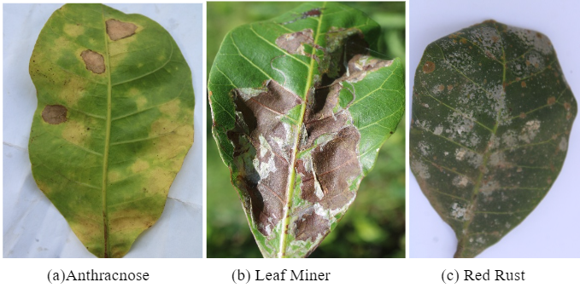

Fig 3.1: The figure depicts the three categories of Cashew leaves plant

3.1 Anthracnose

Anthracnose is one of the most economically significant diseases affecting cashew plants (Anacardium occidentale). It is caused by various fungal pathogens belonging to the Colletotrichum genus, with Colletotrichum gloeosporioides being one of the most common species responsible for anthracnose in cashew. This disease affects cashew plants worldwide, particularly in tropical and subtropical regions where environmental conditions favor fungal growth and spread.

3.2 Leaf Miner

Leaf miner infestations in cashew plants are primarily caused by the larvae of various insect species, including moths, flies, and beetles. These insects lay their eggs on cashew leaves, and the resulting larvae tunnel through the leaf tissue, feeding on the plant's internal tissues. Leaf Miner damage is a common problem in cashew-growing regions worldwide, particularly in areas with high insect populations and conducive environmental conditions.

3.3 Red Rust

Red rust, also known as rust or rust disease, is a fungal disease that affects a wide range of plant species, including cashew plants. It is caused by various species of the fungal genus Puccinia, which produce distinctive rust-colored spores on infected plant tissues. Red rust is prevalent in tropical and subtropical regions with warm, humid climates, where environmental conditions favor fungal growth and spread.

IV. METHODOLOGY

In this section, we have explained the methodology used in our research work. The system architecture will consist of the following components:

4.1 Data Collection

The gathering of data is essential to machine learning models. Accurate prediction-making models are trained by the skillful collection of pertinent data pieces. This entails defining the exact issue that the model will address and the attributes that it must acquire. Although data originates from many sources, quality is crucial. Important considerations include security, privacy, and bias mitigation. A clear plan that makes use of several sources, gives data quality first priority, and monitors modifications is crucial. These procedures enable data collecting, which in turn enables machine learning and deep learning models to yield insightful results.{OMPRAKASH}

4.2 Data Cleaning and Preprocessing

Preprocessing and data cleaning are essential steps in the machine learning and deep learning processes because they convert unprocessed data into a structured format that algorithms can use for training and prediction. These procedures include managing outliers, integrating data from many sources, handling missing values, and normalizing or scaling variables. In addition, methods like feature selection and dimensionality reduction are frequently used to minimize complexity. The precision and dependability of machine learning and deep learning models are greatly increased by the careful preprocessing of data. In general, these procedures are essential for guaranteeing the accuracy and consistency of input data, which has a direct effect on the functionality and efficiency of deep learning and machine learning models.

{OMPRAKASH}

4.3 Model Deployment

Model development in machine learning and deep learning refers to the process of creating, training, evaluating, and fine-tuning predictive models that can make accurate predictions or decisions based on input data. Overall, model development is an iterative process that requires careful consideration of various factors, including problem formulation, data quality, algorithm selection and performance optimization, to build effective and robust machine learning and deep

learning models.

4.4 Model Evaluation

Model evaluation in machine learning is the process of determining how well a model performs its task. Model evaluation is performed both during experimentation and in production. Model evaluation in machine learning and deep learning techniques involves assessing the performance of a trained model to understand how well it generalizes to the unseen data and to identify areas for improvement. Overall, model evaluation is a critical step in the machine learning and deep learning workflow, providing insights into the model's performance and guiding decisions related to model selection, hyperparameter tuning and deployment. It helps to ensure that the trained model is robust, reliable and effective for the intended application.

4.5 Saving of model

Saving a machine learning or deep learning model is crucial for preserving its learned knowledge and facilitating future reuse. This involves saving the model's architecture, parameters, and weights into a file format. By doing so, we can easily load and deploy the model for subsequent predictions or analysis, ensuring that the training efforts are not lost. This efficient preservation enables us to leverage the model's insights and make accurate predictions without the need for retraining from scratch. Furthermore, saving the model promotes efficient sharing, deployment and integration into production systems, thereby unlocking the practical potential of machine learning and deep learning across various applications.

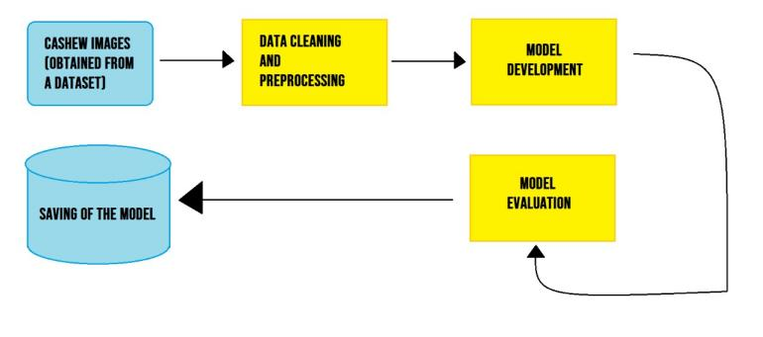

Fig 4.1: Diagram Representing the Process of Workflow

V. IMPLEMENTATION

5.1 Data Collection

The data will be collected from the Dataset for Crop Pest and Disease Detection available on Mendeley Data website which contains images of some plant diseases including Cashew leaf diseases and the below table indicates the number of images in each category as shown in Table II. We will collect only the Cashew leaf images which have been categorized into healthy, red rust, anthracnose and leaf miner.

|  |  |
| --- | --- |
| **Types** | **Number of Images** |
| Healthy | 1368 |
| Red Rust | 1682 |
| Anthracnose | 1729 |
| Leaf Miner | 1378 |

TABLE II. DATASET OF ORIGINAL CASHEW PLANT LEAF

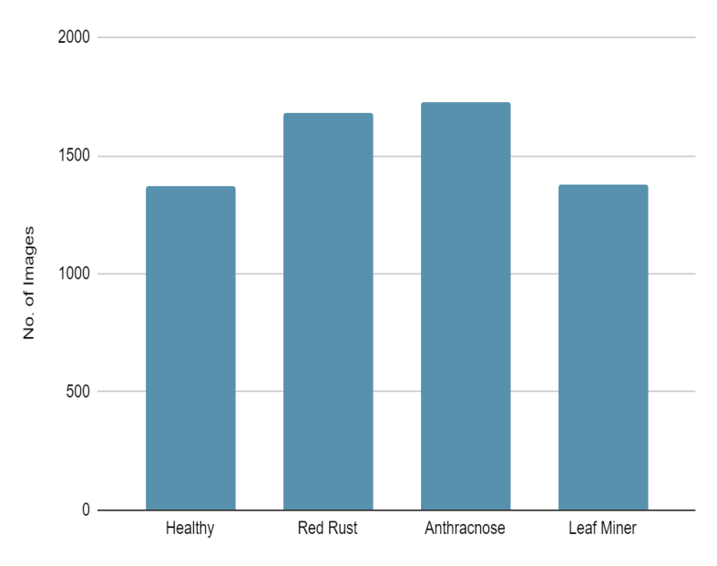

Fig 5.1- Bar Graph of the dataset without class balancing

5.2 Data Cleaning and Preprocessing

5.2.1 Class balancing

We plotted a bar graph of the types of images (healthy, red rust, anthracnose and leaf miner) against the number of images present in the dataset as shown in Fig 5.1. From the figure 5.1 we can see that there is an imbalance class present in our dataset. So, there may be a

bias towards the classification. So, we apply class balancing and data augmentation in the dataset of every categorized from various sources to make the dataset of 2000 images.

|  |  |
| --- | --- |
| **Types** | **Number of Images** |
| Healthy | 2000 |
| Red Rust | 2002 |
| Anthracnose | 2001 |
| Leaf Miner | 2002 |

TABLE III. DATASET AFTER APPLYING CLASS BALANCING 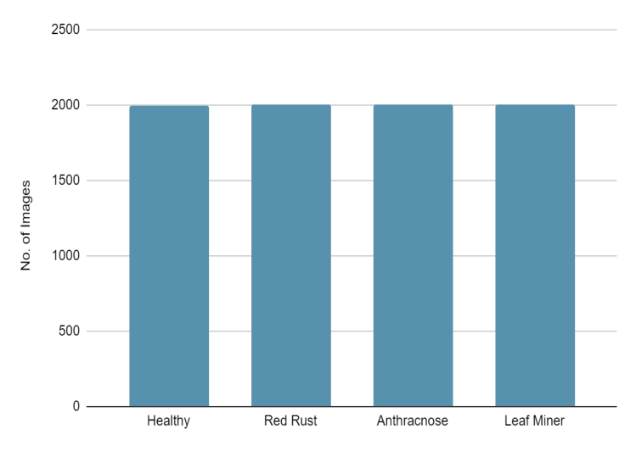

Fig 5.2- Bar Graph of the dataset with class balancing

In figure 5.2 we can see that after data augmentation, the extra images are generated and we can see that class is balanced as compared to the previous graph in figure 5.1.

5.2.2 Data resizing and augmentation

In the next step to extract the essential features resizing and augmentation of images is done. Resizing is done to make all the images uniform of the size 255*255 px. Then data augmentation is done by horizontal and vertical flipping of the images to increase the size of the dataset and make the model more accurate as shown in Fig 5.2.

5.2.3 Data Splitting

In this step we splitted the dataset into training, testing and validation sets to evaluate the performance of the trained model accurately. Typically, the data is splitted into a larger portion for training, a smaller portion for validation, and another portion for testing in the ratio of 80:10:10.

|  |  |  |  |
| --- | --- | --- | --- |
| **Types** | **Training** | **Testing** | **Validation** |
| Healthy | 1600 | 200 | 201 |
| Red Rust | 1601 | 200 | 201 |
| Anthracnose | 1600 | 200 | 200 |
| Leaf Miner | 1601 | 200 | 201 |

TABLE IV. DATASET AFTER SPLITTING TRAINING, TESTING AND VALIDATION SAMPLES

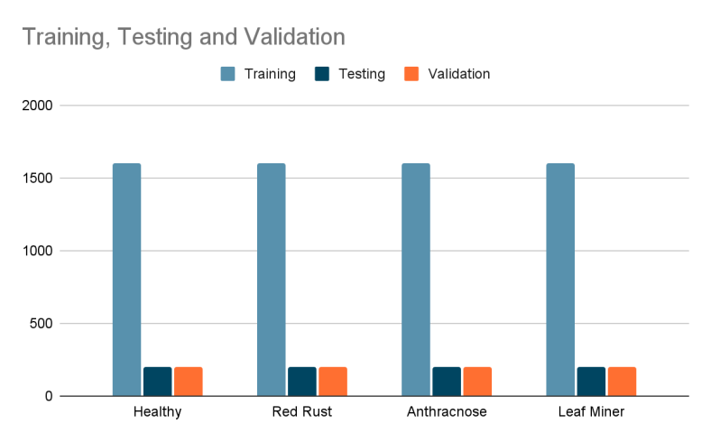

Fig 5.3- Bar Graph of the dataset after splitting

5.3. MODEL DEVELOPMENT

After cleaning and prepping the dataset, three deep learning models—ResNet, MobileNet, and Inception—and two machine learning models—SVM and Random Forest—are deployed on the data. {omprakash}

5.3.1 SVM

Classifying pictures is done using the Support Vector Machine (SVM) approach. Typically used for pattern identification and classification, SVM is a supervised learning technique. Non-linear and linear issues are both solved with it. The data is essentially divided into several classes by creating a hyper plane. The SVM classifier is trained using the pertinent characteristics (such color and shape) extracted from the pictures after preprocessing our cashew disease dataset.{Omprakash}

5.3.2 Random Forest

One method for supervised learning is random forest. Classification and regression can both be done with it. Reducing overfitting and producing high prediction accuracy values for missing data in the data sets are the primary benefits of the Random Forest Classifier. It can handle many kinds of picture data since it performs well with both numerical and category features. Both feature selection and high-dimensional data handling are naturally handled by Random Forest. Analysing the testing dataset to determine how well the training model performed.

.

5.3.3 ResNet152V2

ResNet152V2 is one of the most popular models of CNN which helps in various aspects such as image classification, image recogination and image segmentations. This model is particularly beneficial for a limited dataset. Like other CNNs, ResNet152v2 processes images through a series of stacked layers. Each layer extracts progressively higher-level features from the image, such as edges, shapes and ultimately, entire objects. ResNet152v2 includes a specific technique called residual connections. These connections allow the network to learn from both the current layer's information and the information from earlier layers.

5.3.4 MobileNet

For embedded and mobile vision applications, convolutional neural networks like MobileNet were created. Built on a streamlined design, it can create lightweight deep neural networks with minimal latency for mobile and embedded devices by utilizing depth-wise separable convolutions. The number of parameters and methods needed to maintain a respectable level of accuracy will be decreased with the use of this model, which will also obliquely assist in lowering the number of operators and parameters needed to analyze a picture.

{Omi}

5.3.5 InceptionV3

The InceptionV3 model will support the recognition of images. When it comes to picture categorization, Inception-V3 offers a number of benefits. It has proven to be effective in a number of trials, yielding excellent accuracy rates between 92% and 97%. The convolution layer, pooling layer, and fully linked layer make up the architecture of the Inceptionv3 classification network. In this, data is passed forward after being processed layer by layer.{OMi}

# 5.4 RESULT EVALUATION

After the execution of different model, we are evaluating them against 5 evaluation metrics:

5.4.1 Accuracy

This is measured as the ratio of accurately predicted instances to total instances, and it indicates the overall accuracy of the model.

According to the table CNN Models are performing much better than traditional ML algorithms. MobileNet architecture has achieved the highest accuracy of 94.25% among all.{OMI}

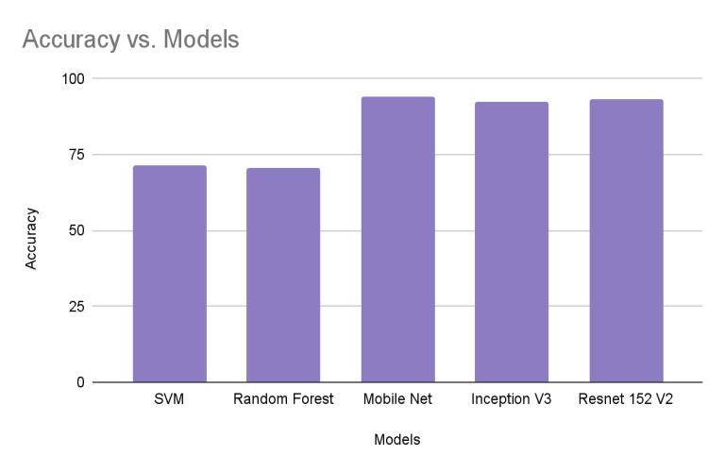

Fig 5.4: Bar graph for comparison of models on basis of their accuracy

5.4.2 Precision

The ratio of accurately anticipated positive observations to all predicted positive observations is known as precision. It centers on how accurate positive predictions are. In this case, CNN Models are superior; MobileNet has the greatest precision score (94.23%).{OMI}

5.4.3 Recall (Sensitivity)

The ratio of all actual positive observations to all accurately predicted positive observations is computed using recall. It assesses the model's capacity to locate every pertinent example within a given dataset. Whereas MobileNet has the maximum recall of 94.25%, CNN Models are on the upper edge in this instance.{OMI}

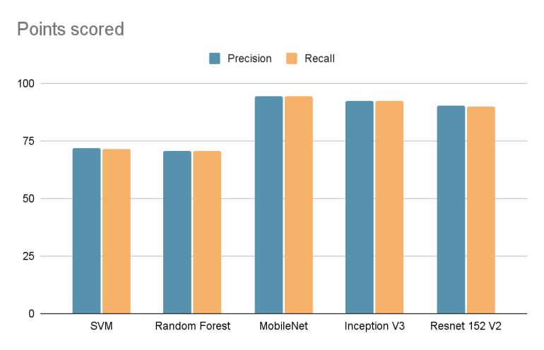

Fig 5.5: Bar graph with the prison and recall values

5.4.4 F1-score

The F1-score represents the harmonic mean of recall and precision. It offers recall and precision in a balanced manner. With a score of 94.20%, MobileNet has the advantage.{OMI}

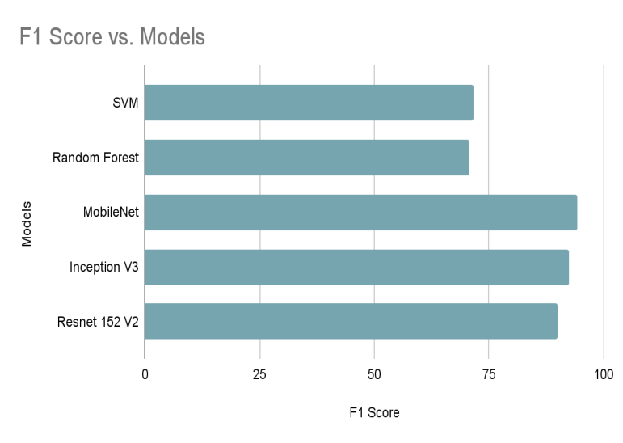

Fig 5.6: Bar graph showing the F1-score of the various models.

5.4.5 ROC AUC score

The true positive rate is plotted against the false positive rate to create the Receiver Operating Characteristic (ROC) curve. The model's capacity to distinguish between positive and negative classes is shown by the Area Under the ROC Curve (ROC AUC), which condenses the ROC curve into a single value. Greater performance of the model is indicated by a higher ROC AUC score. The greatest models from CNN are working here as well.{Omi}

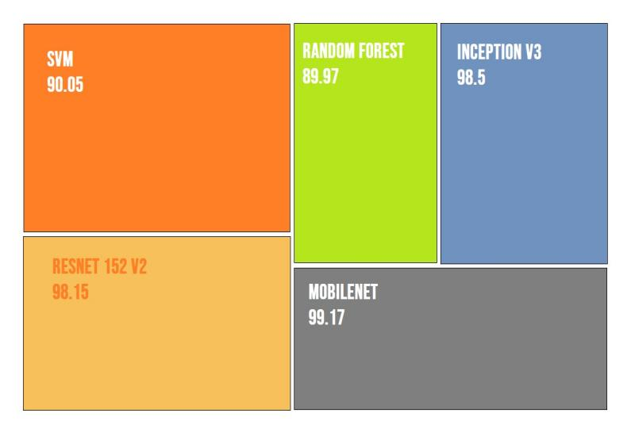

Fig 5.7: Tree Map showing the AUC of the different models.

Then we display the output prediction as shown in Fig 5.8 along with percentage of confidence.

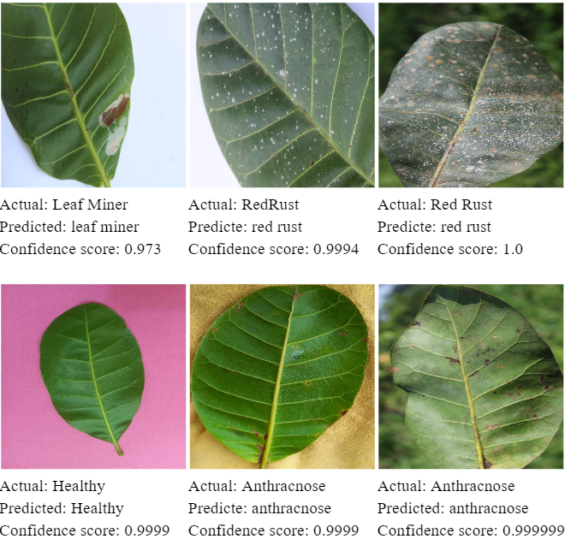

 Fig 5.8: The output displayed from the model with confidence %

4.5 Saving of the model

Then the trained and evaluated model is saved in the system as shown in Fig 5.8.

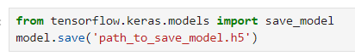

Fig 5.9: Model is being saved

VI. CONCLUSION AND FUTURE SCOPE

6.1 Conclusion

Our research conclusively demonstrates the efficiency of Convolutional Neural Networks (CNNs) for early disease detection in cashew plants. These models exhibit superior performance compared to alternative approaches in accurately classifying healthy leaves, those infected with anthracnose, red rust or suffering from Leaf Miner damage. This finding paves the way for the development of a user-friendly, cost-effective disease detection system leveraging CNN technology. Such a system has the potential to empower cashew farmers with a practical tool for early disease identification in the field. Furthermore, the envisioned tool's compatibility with mobile devices addresses potential resource constraints faced by some cashew farmers.

The implementation of a CNN-based disease detection system could have a significant and positive impact on the cashew farming industry. Early and accurate disease identification enables farmers to implement targeted interventions, potentially minimizing crop losses and optimizing cashew yield. This research, coupled with advancements in image processing technology, particularly for low-resolution mobile device images, lays the groundwork for establishing CNN-based disease detection as a cornerstone of sustainable and productive cashew cultivation.

6.2 Future Scope

Building upon the success of this research, future efforts can focus on preventative measures against cashew diseases, leveraging the strengths of CNNs and potentially incorporating additional data sources. Expanding disease detection capabilities is paramount. The current model excels at identifying three specific diseases, but broadening the scope to incorporate a wider variety of cashew ailments into the CNN architecture would empower farmers with a more comprehensive tool to identify potential threats to their crops. Integrating real-time disease identification through image capture and analysis on mobile devices would be a valuable addition for field use, enabling early detection and immediate intervention to prevent outbreaks from spreading.

Predictive modeling with environmental data represents another avenue for advancement. While image-based detection is powerful, CNNs can be enhanced by incorporating environmental data as supplementary input. Factors like temperature, humidity, and precipitation patterns influence disease outbreaks and thus integrating these variables into the model could provide a more nuanced understanding of disease risk. Developing predictive capabilities would enable farmers to take proactive and protective measures, such as adjusting irrigation practices or applying fungicides prophylactically to prevent disease outbreaks before they occur and thereby enhancing cashew crop production and protection strategies.

ACKNOWLEDGMENT

We would like to express our sincere gratitude to our university professor Dr. Jagannath Singh, Associate Professor at KIIT University, Bhubaneswar from the School of Computer Engineer for his constant support, wise criticism, and encouragement throughout the project's planning and implementation. He is a true inspiration to us with his commitment to promoting academic success. We also thank our team members for their cooperation and efforts, which have added a variety of viewpoints and ideas to the project.

REFERENCES

1. Cashew | Description, Poison & Processing | Britannica [Online]. Available:<https://www.britannica.com/plant/cashew>
2. Pestalotia leaf spots (A) Powdery mildew (B) and Red rust © [Online]. Available:<https://www.researchgate.net/figure/Pestalotia-leaf-spots-A-Powdery-mildew-B-and-Red-rust-C_fig3_317332955>
3. FAQ Pest and Disease Management [Online]. Available:<https://cashew.icar.gov.in/faq-pest-and-disease-management/>
4. First report of wilt disease in cashew (Anacardium occidentale L.) caused by Fusarium decemcellulare in Kerala, India [Online]. Available:<https://cabiagbio.biomedcentral.com/articles/10.1186/s43170-023-00142-w>
5. Minor pests, diseases of cashew and importance of pollinators K. Vanitha and T.N. Raviprasad ICAR- Directorate of Cashew Research, Darbe (P.O), Puttur, Dakshina Kannada, Karnataka, India [Online]. Available: <https://krishi.icar.gov.in/jspui/bitstream/123456789/43500/1/e-Manual%20-minor%20pests%2C%20diseases%2C%20polliantors.pdf>
6. Diseases of cashew nut plants (Anacardium Occidentale L.) in Burkina Faso [Online]. Available: <https://medcraveonline.com/APAR/diseases-of-cashew-nut-plants-anacardium-occidentale-l-in-burkina-faso.html>
7. Early detection and control of anthracnose disease in cashew leaves to improve crop yield using image processing and machine learning techniques [Online]. Available: <https://link.springer.com/article/10.1007/s11760-023-02552-9>
8. An advanced deep learning models-based plant disease detection: A review of recent research [Online]. Available: <https://www.frontiersin.org/journals/plant-science/articles/10.3389/fpls.2023.1158933/full>
9. Cashew Disease Management [Online]. Available: <https://www.ikisan.com/tn-cashew-disease-management.html#:~:text=In%20order%20to%20prevent%20the,the%20spread%20of%20the%20disease>
10. TNAU Agritech Portal Crop Protection 2015 [Online]. Available: <https://agritech.tnau.ac.in/crop_protection/crop_prot_crop%20diseases_plantation_cashew.html>
11. Leaf Disease Detection using Support Vector Machine [Online]. Available: <https://ieeexplore.ieee.org/abstract/document/9182128/figures#figures>
12. Random Forest Wikipedia [Online]. Available: <https://en.wikipedia.org/wiki/Random_forest>
13. An Improved MobileNet for Disease Detection on Tomato Leaves,July 2023, Advances in Technology Innovation 8(3):192-209 [Online]. Available: <https://www.researchgate.net/publication/372126407_An_Improved_MobileNet_for_Disease_Detection_on_Tomato_Leaves>
14. Inceptionv3 Wikipedia [Online]. Available: <https://en.wikipedia.org/wiki/Inceptionv3>
15. Leaf Disease Identification: Enhanced Cotton Leaf Disease Identification Using Deep CNN Models [Online]. Available: <https://ieeexplore.ieee.org/document/9719405>
16. A Comparison of Keras Application Models with Pre-Trained Weights in Predicting the Disease of Lanzones Leaf, 2022 [Online]. Available: <https://ieeexplore.ieee.org/document/10109363>
17. Dataset for Crop Pest and Disease Detection Published on 2023 [Online]. Available: <https://data.mendeley.com/datasets/bwh3zbpkpv/1>
18. Research on Strawberry Disease Diagnosis Based on Improved Residual Network Recognition Model 2021 [Online]. Available: <https://www.hindawi.com/journals/mpe/2022/6431942/>
19. Real-Time Detection of Apple Leaf Diseases Using Deep Learning Approach Based on Improved Convolutional Neural Networks of 2019 [Online]. Available: <https://ieeexplore.ieee.org/document/8706936>
20. A Deep Learning-based Approach for Banana Leaf Diseases Classification [Online]. Available: <http://btw2017.informatik.uni-stuttgart.de/slidesandpapers/E1-10/paper_web.pdf>
21. Disease Detection on the Leaves of the Tomato Plants by Using Deep Learning [Online]. Available[:https://ieeexplore.ieee.org/abstract/document/8047016](:https:/ieeexplore.ieee.org/abstract/document/8047016)
22. Automatic detection of ‘yellow rust’ in wheat using reflectance measurements and neural networks [Online]. Available:

<https://www.sciencedirect.com/science/article/pii/S0168169904000705>