Summary and Next steps followed by flowchart

We have Questions generated by llm with all the methods(zero,few),Dr yang has human generated questions,list and contents of books except those 8 books(have asked shay to give content)

Next Steps
- First, we will freeze all the datasets so that no further changes are made during the evaluation process.
- Next, we will merge all the CSV files that contain the questions generated by the LLM into a single dataset.
- Then we will perform a human evaluation on the LLM-generated questions based on the rubrics that will be used for assigning scores on a likert scale.
- Next, we will assess the quality of the human-generated questions with the same rubric
- We will then compute the ROUGE score for human and llm generated questions
- Following this, we will use an LLM as a judge to automatically evaluate the quality of the human and llm generated questions.
- After that, a machine learning model will be trained on a combination of questions produced by LLM and scores from human assessment.
- Finally, we will test the test machine learning model on human-generated questions and llm generated questions and compare the predictions with the ground-truth labels.

Few rows of dataset
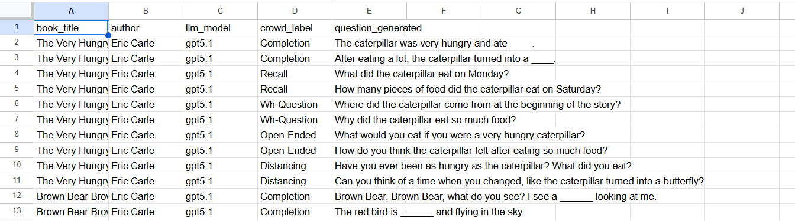

Flowchart
