

APRIL 2023

StudySavvy

## MINI-PROJECT-II REPORT

***Submitted by***

Adarsh Sisodia (201500030)

Aryan Pokhriyal (201500155)

Kumkum Singh (201500360)

Sanjhi Dixit (201500618)

***in partial fulfilment for the award of the degree of***

# BACHELOR OF ENGINEERING

**IN**

Computer Engineering and Application

## GLA University, Mathura

APRIL 2023

**TABLE OF CONTENTS**

1.Abstract ……..3

2.Introduction ……..4

3.Design flow/ Process ……..5

4.Result & Analysis ….6-11

5.Conclusion & future work …….12

6. References …….13

7.GitHub Link …….14

**ABSTRACT**

The E-Learning Website is a web-based platform that aims to provide an interactive and engaging learning experience for users of all ages. The website is designed to be user-friendly, visually appealing, and accessible across different devices, making it convenient for learners to access educational content anytime, anywhere.

The website offers a wide range of educational resources, including multimedia content such as videos, interactive simulations, and quizzes, as well as written materials such as articles and e-books. The content is organized into various subjects and topics, covering a diverse range of academic disciplines and interests. Learners can easily browse through the content, select the topics of their choice, and progress at their own pace.

In addition to the content and interactive features, the E-Learning Website also prioritizes user data privacy and security. The website adheres to industry standards for data protection and encryption, ensuring that users' personal information and learning progress are kept secure and confidential.

Overall, the E-Learning Website aims to revolutionize the way people learn by providing a dynamic and interactive online learning environment. It encourages self-paced learning, promotes collaboration and community engagement, and offers personalized learning experiences to users around the world.

**Introduction**

The world of education has evolved rapidly in recent times, with a shift towards online and remote learning becoming more prevalent than ever. As part of this digital revolution, I have developed an e-learning website, an innovative platform that provides a dynamic and interactive learning experience for students, teachers, and learners of all ages.

The e-learning website is designed to offer a comprehensive and engaging online learning environment that is accessible anytime, anywhere. Through this platform, learners can access a wide range of educational resources, including lessons, courses, tutorials, quizzes, and interactive learning modules, that are specifically tailored to their individual needs and learning styles.

The primary objective of this project is to create a user-friendly and intuitive e-learning website that enhances the learning experience for users. The website incorporates modern web design principles and advanced technologies to ensure seamless navigation, interactivity, and engagement. It also includes features such as progress tracking, assessments, and user feedback to provide a personalized and effective learning experience.

Overall, this project aims to contribute to the field of education by providing an innovative and effective platform for online learning. The e-learning website is intended to empower learners with the knowledge and skills they need to succeed in today's digital world, and I am excited to share the details of this project in this report.

# DESIGN FLOW/PROCESS

The basic idea was to make the website so friendly even teenagers can learn from scratch using front-end technology. The E-Learning Website aims to revolutionize the way people learn by providing a dynamic and interactive online learning environment. The website offers a wide range of educational resources, including multimedia content such as videos, interactive simulations, and quizzes, as well as written materials such as articles and e-books. Learners can easily browse through the content, select the topics of their choice, and progress at their own pace. It is an interactive website . The technologies used are HTML, CSS, PHP and SQL.

# RESULTS AND ANALYSIS

Home Page:-

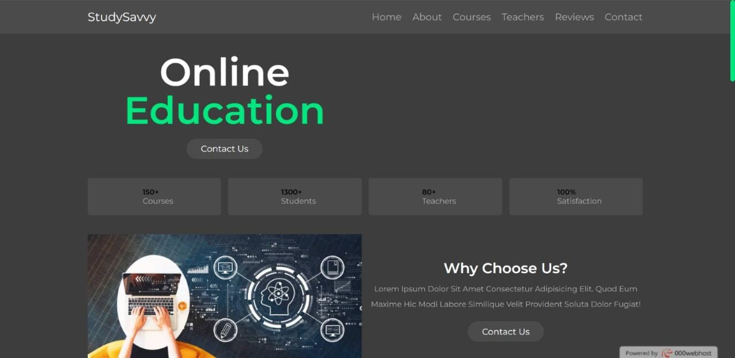

The Home page is the base page of our website it will allow the user to travel through all the pages and allow users to experience all the opportunities.

It consists of a nav bar, and a footer, with background URLs and images linked to several pages of the website. HTML,CSS is the only technology used in it.

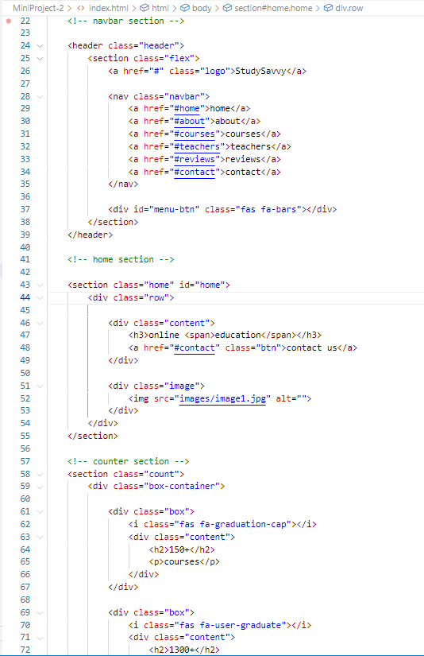

About us Page:-

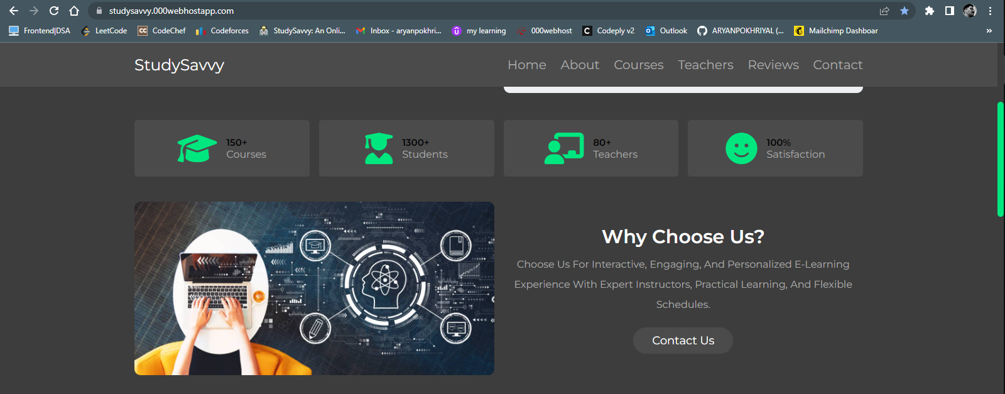

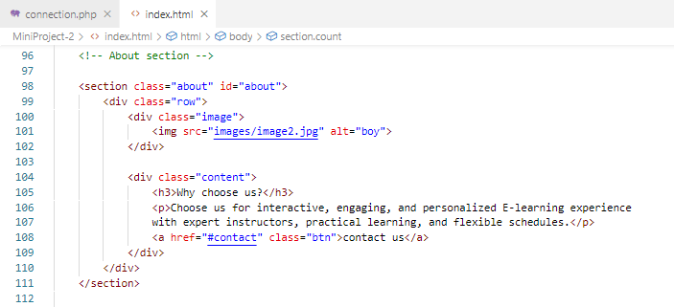

Course Registration Page:-

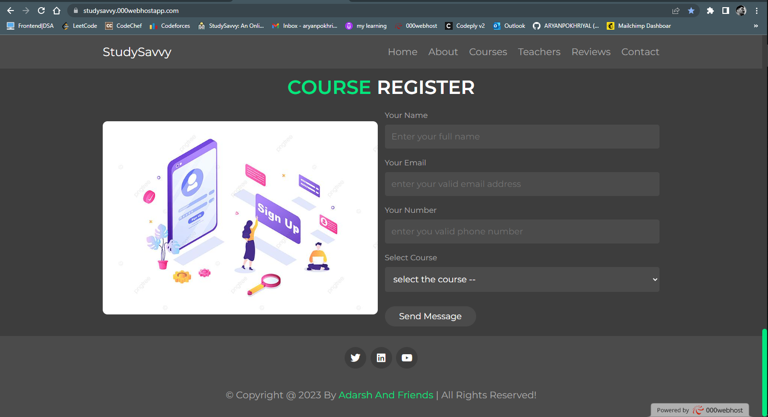

. 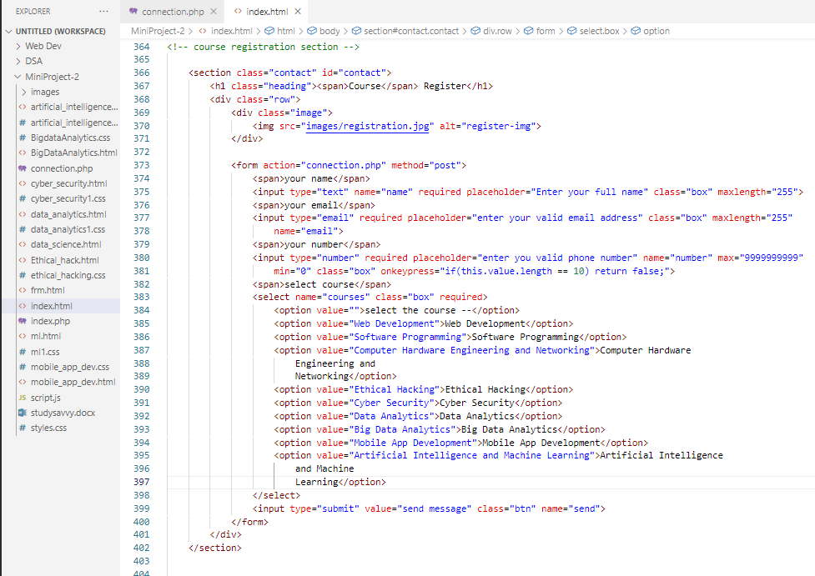

Courses Page:-

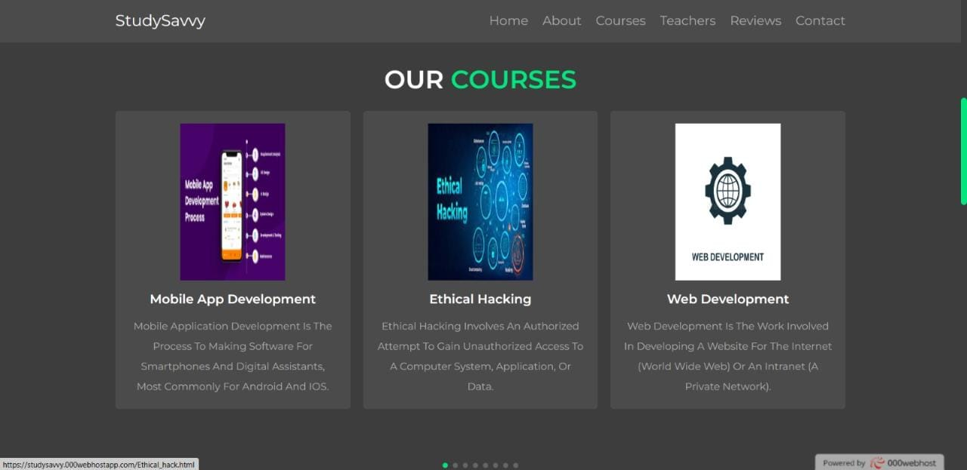

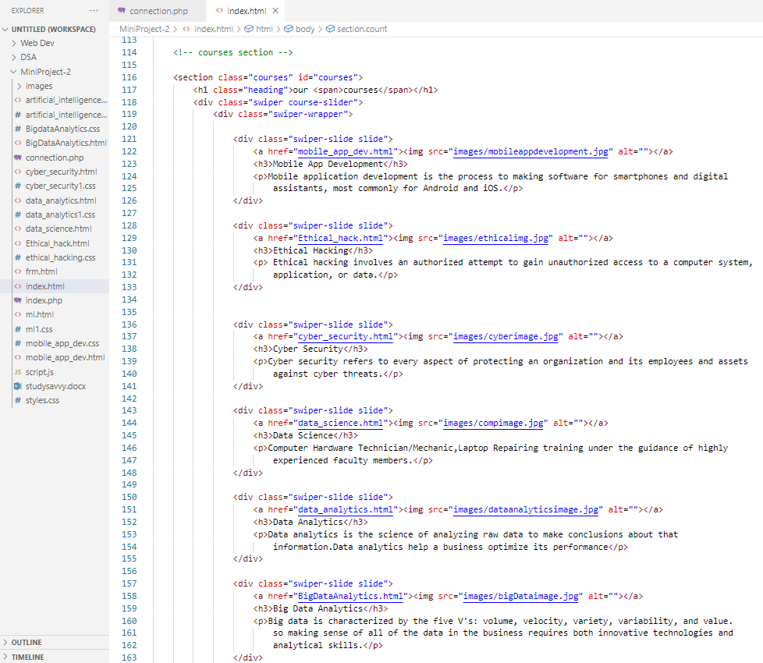Reviews Page:-

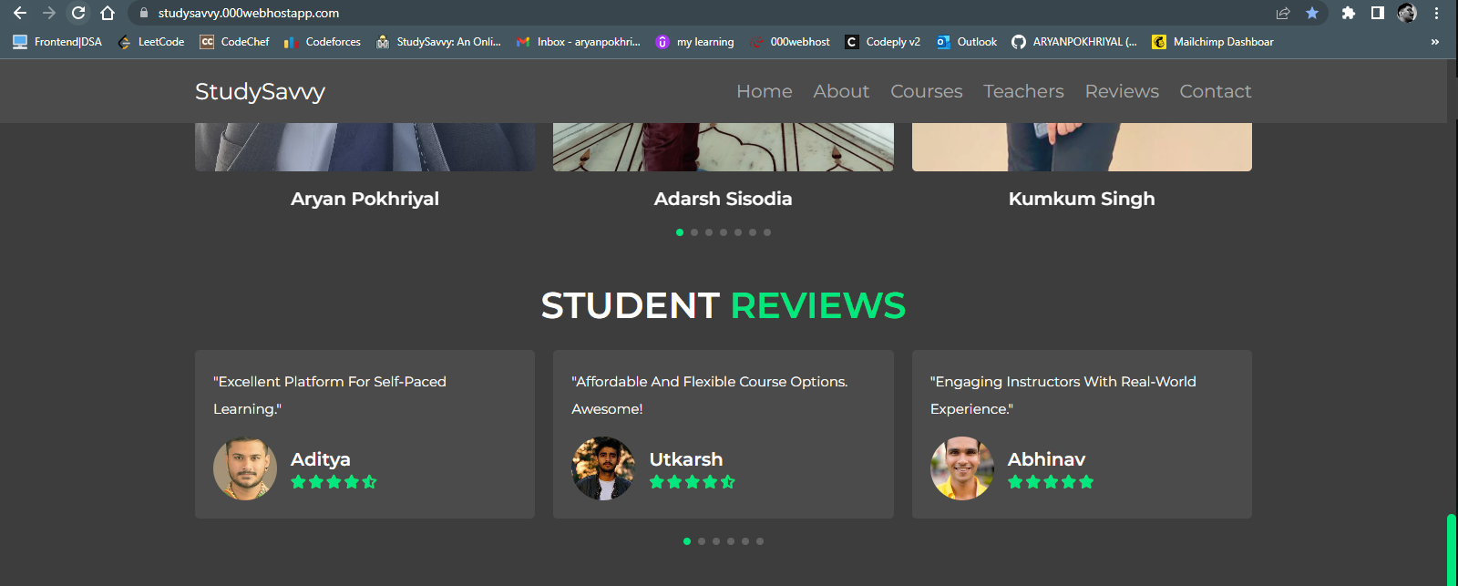

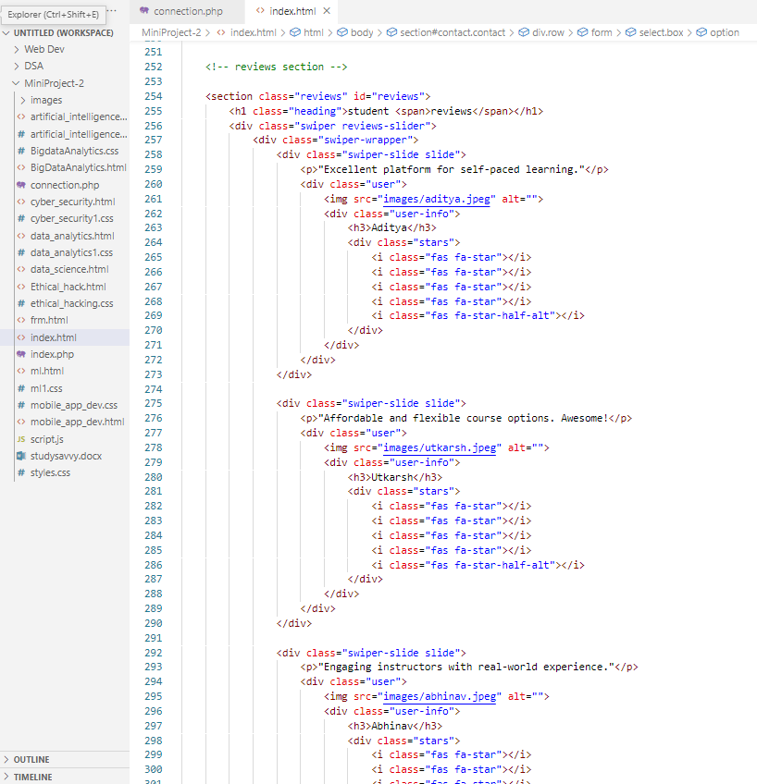

Database page:

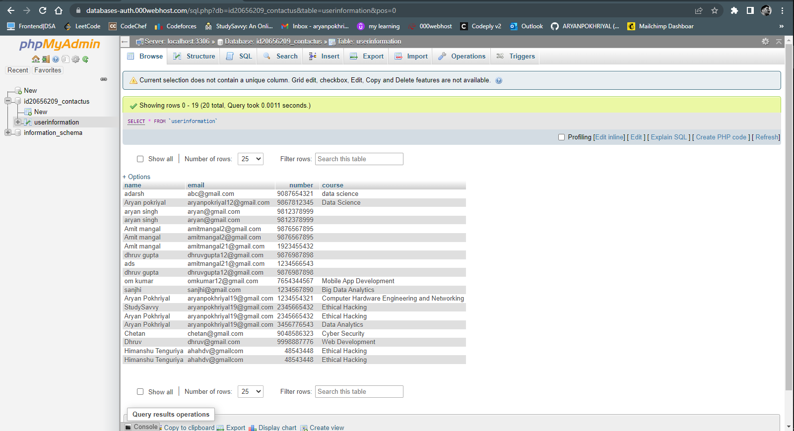

Connection.php :

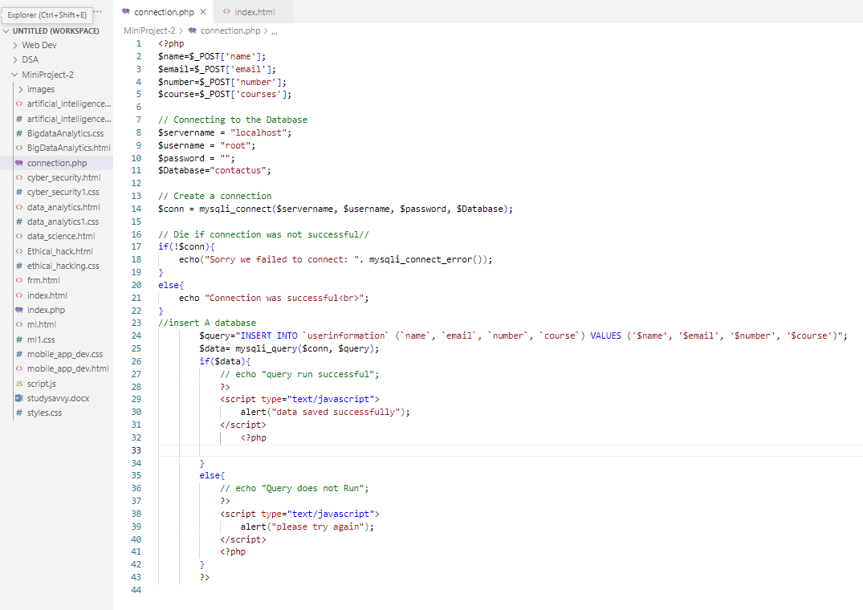

**EXPERT TUTOR PAGE: -**

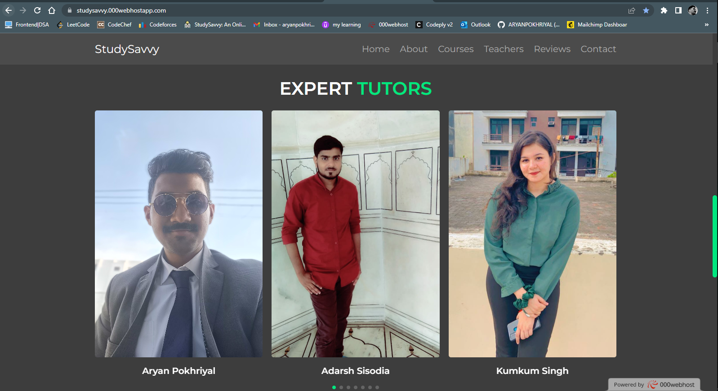

# Code:

# 

# CONCLUSION AND FUTURE WORK

This project is an open-source website for all age groups. Friendly UI helps in finding the required information. Though all the vital information is free but in future, we are going to modify, the paid courses will help users with one-on-one tutors. A big-time database will be monitored and we will provide goodies and memberships to learners.

# REFERENCES

Websites:

* W3Schools
* YouTube
* JavaTpoint
* GFG

**GITHUB LINK**