1. ARRANGEMENT OF CONTENTS:

The sequence in which the project report material should be arranged and bound may be as follows:

TITLE PAGE

BONAFIDE CERTIFICATE ACKNOWLEDGEMENT TABLE OF CONTENTS LIST OF FIGURES

LIST OF TABLES ABSTRACT GRAPHICAL ABSTRACT ABBREVIATIONS SYMBOLS

**Chapter 1: Introduction**

(Including Identification of client & need, Relevant contemporary issues, Problem Identification, Task Identification, Timeline, organization of the report)

**Chapter 2: Literature survey**

Timeline of the reported problem as investigated throughout the world, bibliometric analysis, proposed solutions by different researchers, summary linking literature review with the project, Problem Definition, Goals and Objectives. **Chapter 3: Design flow/Process**

Concept Generation, Evaluation & Selection of Specifications/Features, Design Constraints– Regulations, Economic, Environmental, Health, manufacturability, Safety, Professional, Ethical, Social & Political Issues considered in design, Analysis and Feature finalization subject to constraints, Design Flow (at least 2 alternative designs to make the project), Best Design selection (supported with comparison and reason) and Implementation plan ((Flowchart

/algorithm/ detailed block diagram).

**Chapter 4 Results analysis and validation**

Implementation of design using Modern Engineering tools in analysis, design drawings/schematics/ solid models, report preparation, project management, and communication, Testing/characterization/interpretation/data validation.

**Chapter 5: Conclusion and future work** deviation from expected results and way ahead References

Appendix

User manual (Complete step by step instructions along with pictures necessary to run the project) Achievements

The table and figures shall be introduced in the appropriate places.

1. PAGE DIMENSION AND BINDING SPECIFICATIONS:
   * The dimension of the project report should be in A4 size.
   * The project report should be bound using flexible cover of the thick white art paper.
   * The cover should be **printed in black letters** and the text for printing should be identical.
2. PREPARATION FORMAT:
   1. **Cover Page & Title Page** – A specimen copy of the Cover page & Title page of the project report are given in **Appendix 1.**
   2. Bonafide Certificate
      * The Bonafide Certificate shall be in double line spacing using Font Style Times New Roman and Font Size 14, as per the format in **Appendix 2/2A.**
      * The certificate shall carry the supervisor’s signature and shall be followed by the supervisor’s name, academic designation (not any other responsibilities of administrative nature), department and full address of the institution where the supervisor has guided the student.
      * The term **‘SUPERVISOR’** must be typed in capital letters between the supervisor’s name and academic designation.
      * If the project was carried out in an Industry, certificate from the same industry in their format should be attached in the report.
   3. **Abstract –** Abstract should be one page synopsis of the project report typed double line spacing, Font Style Times New Roman and Font Size 14**.**
   4. Table of Contents
      * The table of contents should list all material following it as well as any material which precedes it.
      * The title page and Bonafide Certificate will not find a place among the items listed in the Table of Contents but the page numbers of which are in lower case Roman letters.
      * One and a half spacing should be adopted for typing the matter under this head.
      * A specimen copy of the Table of Contents of the project report is given in

Appendix 3.

* 1. List of Tables
     + The list should use exactly the same captions as they appear above the tables in the text.
     + One and a half spacing should be adopted for typing the matter under this head.
  2. List of Figures
     + The list should use exactly the same captions as they appear below the figures in the text.
     + One and a half spacing should be adopted for typing the matter under this head.
  3. List of Symbols, Abbreviations and Nomenclature
     + One and a half spacing should be adopted or typing the matter under this head.
     + Standard symbols, abbreviations etc. should be used.
  4. **Chapters** – The chapters may be broadly divided into 3 parts: (i) Introductory chapter, (ii) Chapters developing the main theme of the project work (iii) and Conclusion.

The main text will be divided into several chapters and each chapter may be further divided into several divisions and sub-divisions.

* + - Each chapter should be given an appropriate title.
    - Tables and figures in a chapter should be placed in the immediate vicinity of the reference where they are cited.
  1. **Appendices** – Appendices are provided to give supplementary information, which is included in the main text may serve as a distraction and cloud the central theme.
     + Appendices should be numbered using Arabic numerals, e.g., Appendix-1, Appendix-2, etc.
     + Appendices, Tables and References appearing in appendices should be numbered and referred to as appropriate places just as in the case of chapters.
     + Appendices shall carry the title of the work reported and the same title shall be made in the contents page also.
  2. List of References
     + The listing of references should be typed 4 spaces below the heading “REFERENCES” in alphabetical order in single spacing left – justified.
     + The reference material should be listed in the alphabetical order of the first author.
     + The name of the author/authors should be immediately followed by the year and other details.

A typical illustrative list given below relates to the citation example quoted above.

REFERENCES

1. Ariponnammal, S. and Natarajan, S. (1994) ‘Transport Phonomena of Sm Sel – X Asx’, Pramana – Journal of Physics Vol.42, No.1, pp.421-425.
2. Barnard, R.W. and Kellogg, C. (1980) ‘Applications of Convolution Operators to Problems in Univalent Function Theory’, Michigan Mach, J., Vol.27, pp.81– 94.
3. Shin, K.G. and Mckay, N.D. (1984) ‘Open Loop Minimum Time Control of Mechanical Manipulations and its Applications’, Proc.Amer.Contr.Conf., San Diego, CA, pp. 1231-1236.
   1. Table and figures
      * By the word Table, is meant tabulated numerical data in the body of the project report as well as in the appendices.
      * All other non-verbal materials used in the body of the project work and appendices such as charts, graphs, maps, photographs and diagrams may be designated as figures.

4 TYPING INSTRUCTIONS:

* The impression on the typed copies should be black in colour.
* One and a half spacing should be used for typing the general text. The general text shall be typed in the Font style ‘Times New Roman’ and Font size 12.
* Name of the Chapter shall be typed in the Font style ‘Times New Roman’, BOLD and Font size 16.
* Heading shall be typed in the Font style ‘Times New Roman’, BOLD and Font size 14.
* Sub - Heading shall be typed in the Font style ‘Times New Roman’, BOLD and Font size 12

**E-shopping Web Application**

### A PROJECT REPORT

#### Submitted by

**Bishal Ganguly (20BCG1066)**

**Arnav Sahu (20BCG1011)**

#### in partial fulfillment for the award of the degree of

**Bachelors of Engineering Computer Science**

###### IN

##### **Games and Graphics**



###### Chandigarh University

**2020-2024**



**BONAFIDE CERTIFICATE**

Certified that this project report **“E-shopping Web Application”** is the bonafide work of “**BISHAL GANGULY & ARNAV SAHU**” who carried out the project work under my/our supervision.

###### SIGNATURE

###### Aman Kaushik

###### HEAD OF THE DEPARTMENT

###### SIGNATURE

###### Sant Kumar Maurya

###### SUPERVISOR

Submitted for the project viva-voce examination held on

INTERNAL EXAMINER EXTERNAL EXAMINER

ACKNOWLEDGEMENT

I would like to express my profound gratitude towards many individuals, as without their kind support, it would not be possible for me to complete this project. I would like to extent my sincere thanks to **Mr. Sant Kumar Maurya(**supervisor) (AIT-CSE) and Co-Supervisor **Mr. Manvinder Singh**, who gave me the golden opportunity in enhancing my hidden capabilities.

Unfortunately, I addressed several difficulties in coordinating the activities of the project but I am highly indebted to all my instructors for their guidance and constant supervision, as well as for providing necessary information regarding the project and also their support in completing the project.

I would like to express my gratitude towards my batchmates without whom I wouldn’t have been able to complete this project. I would also like to thank my parents and friends for their kind co-operation and encouragement as they helped me a lot in completion of this project.

At last, I end up thanking all who helped me in finalizing the project within the limited time frame.

**TABLE OF CONTENTS**

List of Figures i

List of Tables ii

Abstract iii

Graphical Abstract iv

Abbrevations v

Symbols vi

Chapter 1 4

### 1.1 ................................................................................................................................ 5

### 1.2 ..................................................................................................................................

### 1.2.1 ..........................................................................................................................

### 1.3 ..................................................................................................................................

### 1.3.1 ..........................................................................................................................

### 1.3.2 ..........................................................................................................................

### Chapter 2. ....................................................................................................................

### 2.1 ..................................................................................................................................

### ..................................................................................................................................

### 2.2 ..................................................................................................................................

### ..................................................................................................................................

### Chapter 3. ....................................................................................................................

### Chapter 4. ………………………….………………………………………...

### Chapter 5. ……………………………………………………………………

### References (If Any) ......................................................................................................

# List of Figures

Figure 3.1 ………………………………………………………………………………….

Figure 3.2 ………………………………………………………………………………….

Figure 4.1 …………………………………………………………………………….……

# List of Tables

3.1 LOGIN TABLE

3.2 USER DETAILS

3.3 PRODUCT DETAILS

3.4 PRODUCT ORDERS

# ABSTRACT

This project is a web based shopping system for an existing shop. The project objective is to deliver the online shopping application into android platform.

This project is an attempt to provide the advantages of online shopping to customers of a real shop. It helps buying the products in the shop anywhere through internet by using an android device. Thus the customer will get the service of online shopping and home delivery from his favorite shop. This system can be implemented to any shop in the locality or to multinational branded shops having retail outlet chains.

If shops are providing an online portal where their customers can enjoy easy shopping from anywhere, the shops won’t be losing any more customers to the trending online shops such as flipcart or ebay. Since the application is available in the Smartphone it is easily accessible and always available.

# 

# GRAPHICAL ABSTRACT

# 

**ABBREVIATIONS**

|  |  |
| --- | --- |
| Abbreviation | Meaning |
| HTML | Hyper Text Markup Language use to crate structure of website |
| CSS | Cascading Style sheet use to give style to web page |
| <tags> | Reference to use html |
| <link> | Reference to links to html |
| SUI | shopping Under Influence |
| <a> | Used to link pages |

CHAPTER-1 INTRODUCTION

This project is a web based shopping system for an existing shop. The project objective is to deliver the online shopping application into android platform.

Online shopping is the process whereby consumers directly buy goods or services from a seller in real-time, without an intermediary service, over the Internet. It is a form of electronic commerce.

This project is an attempt to provide the advantages of online shopping to customers of a real shop. It helps buying the products in the shop anywhere through internet by using an android device.

Thus the customer will get the service of online shopping and home delivery from his favorite shop

* 1. **PROJECT OBJECTIVE:**

The objective of the project is to make an application in web site platform to purchase items in an existing shop. In order to build such an application complete web support need to be provided. A complete and efficient web application which can provide the online shopping experience is the basic objective of the project. The web application can be implemented in the form of an android application with web view

* 1. PROJECT OVER VIEW:

The central concept of the application is to allow the customer to shop virtually using the Internet and allow customers to buy the items and articles of their desire from the store. The information pertaining to the products are stores on an RDBMS at the server side (store).

The Server process the customers and the items are shipped to the address submitted by them. The application was designed into two modules first is for the customers who wish to buy the articles. Second is for the storekeepers who maintains and updates the information pertaining to the articles and those of the customers. The end user of this product is a departmental store where the application is hosted on the web and the administrator maintains the database.

The application which is deployed at the customer database, the details of the items are brought forward from the database for the customer view based on the selection through the menu and the database of all the products are updated at the end of each transaction.

Data entry into the application can be done through various screens designed for various levels of users. Once the authorized personnel feed the relevant data into the system, several reports could be generated as per the security.

* 1. PROJECT SCOPE:

This system can be implemented to any shop in the locality or to multinational branded shops having retail outlet chains. The system recommends a facility to accept the orders 24*7 and a home delivery system which can make customers happy.

If shops are providing an online portal where their customers can enjoy easy shopping from anywhere, the shops won’t be losing any more customers to the trending online shops such as flipcart or ebay. Since the application is available in the Smartphone it is easily accessible and always available.

* 1. STUDY OF THE SYSTEM
     1. MODULES:

The system after careful analysis has been identified to be presented with the following modules and roles. The modules involved are:

* Administrator
* Moderators
* Users
  + - 1. ADMINISTRATOR:

The administrator is the super user of this application. Only admin have access into this admin page. Admin may be the owner of the shop. The administrator has all the information about all the users and about all products.

This module is divided into different sub-modules.

1. Manage Moderators

2. Manage Products

3. Manage Users

4. Manage Orders

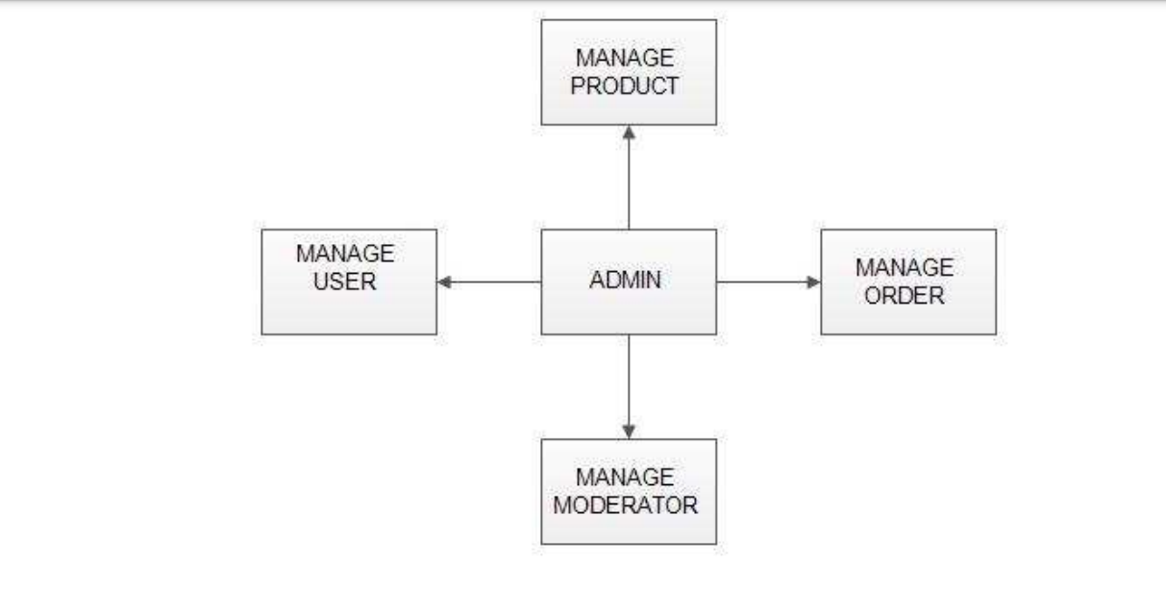

Fig 1.1: Admin module

MANAGE MODERATOR

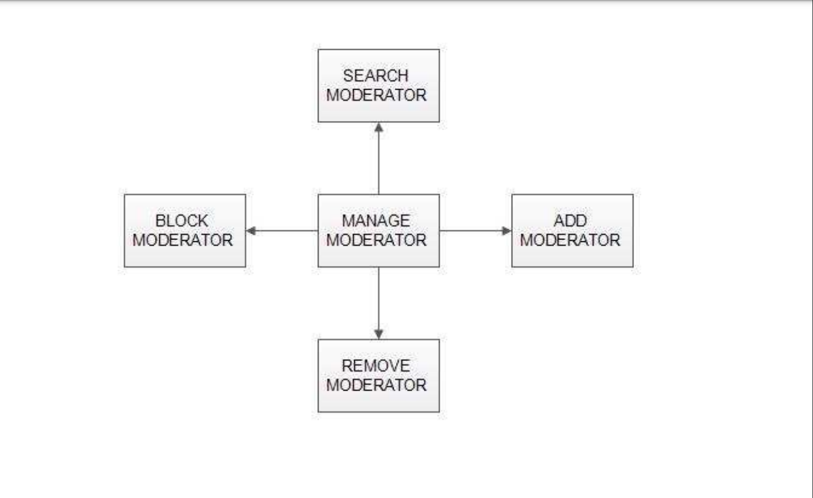

Fig 1.2: Manage Moderator

* **Add Moderator**

Only admin is having the privilege to add a moderator. A moderator can be considered as a staff who manages the orders or owner of a group of products.

* **Block moderator**

Admin can restrict a moderator from managing the orders by blocking them. Admin can unblock a blocked user if needed.

* **Remove Moderator**

Admin has privilege to delete a moderator who was added.

* **Search moderator**

All existing moderators can be viewed by the administrator as a list. If there is number of moderators and admin need to find one of them, the admin can search for a moderator by name.

**MANAGE PRODUCTS**

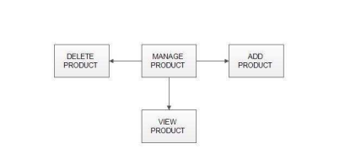

Fig 1.3: Manage Products

¬ **Add Products**

The shopping cart project contains different kind of products. The products can be classified into different categories by name. Admin can add new products into the existing system with all its details including an image.

**¬ Delete Products**

Administrator can delete the products based on the stock of that particular product.

**¬ Search products**

Admin will have a list view of all the existing products. He can also search for a particular product by name.

**MANAGE USER**

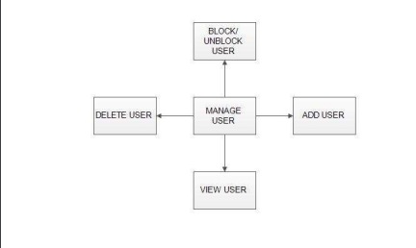

Fig 1.4: Manage User

**¬ View Users**

The admin will have a list view of all the users registered in the system. Admin can view all the details of each user in the list except password.

**¬ Add Users**

Admin has privileges to add a user directly by providing the details.

**¬ Delete &Block Users**

Administrator has a right to delete or block a user. The default status of a new user registered is set as blocked. The admin must accept the new user by unblocking him.

**MANAGE ORDERS**

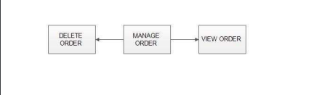

Fig 1.5: Manage Orders

**¬ View Order**

Administrator can view the Orders which is generated by the users. He can verify the details of the purchase.

**¬ Delete order**

Admin can delete order from the orders list when the product is taken for delivery.

* + - 1. MODERATORS

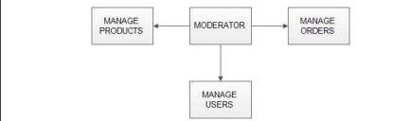

Fig 1.6: Moderator Module

A moderator is considered as a staff who can manage orders for the time being. As a future update moderator may give facility to add and manage his own products . Moderators can reduce the work load of admin. Now moderator has all the privilege an admin having except managing other moderators. He can add products and users. He can also check the orders and edit his profile.

* Manage products
* Manage users
* Manage orders

1.4.1.3 USERS

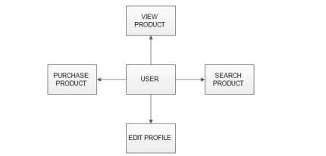

Fig 1.7: User Module

**¬ Registration**

A new user will have to register in the system by providing essential details in order to view the products in the system. The admin must accept a new user by unblocking him.

**¬ Login**

A user must login with his user name and password to the system after registration.

**¬ View Products**

User can view the list of products based on their names after successful login. A detailed description of a particular product with product name, products details, product image, price can be viewed by users.

**¬ Search Product**

Users can search for a particular product in the list by name.

**¬ Add to cart**:

The user can add the desired product into his cart by clicking add to cart option on the product.

He can view his cart by clicking on the cart button. All products added by cart can be viewed in the cart. User can remove an item from the cart by clicking remove.

**¬ Submit Cart:**

After confirming the items in the cart the user can submit the cart by providing a delivery address.On successful submitting the cart will become empty.

**¬ History**

In the history the user will have a view of pending orders.

**¬ Edit Profile**

The user can view and edit the profile

CHAPTER-2 SYSTEM ANALYSIS

System analysis is the process of gathering and interpreting facts, diagnosing problems and using the information to recommend improvements on the system. System analysis is a problem solving activity that requires intensive communication between the system users and system developers. System analysis or study is an important phase of any system development process. The system is viewed as a whole, the inputs are identified and the system is subjected to close study to identify the problem areas. The solutions are given as a proposal. The proposal is reviewed on user request and suitable changes are made. This loop ends as soon as the user is satisfied with the proposal.

2.1 EXISTING SYSTEM

The current system for shopping is to visit the shop manually and from the available product choose the item customer want and buying the item by payment of the price of the item .

1. It is less user-friendly.
2. User must go to shop and select products.
3. It is difficult to identify the required product.
4. Description of the product limited.
5. It is a time consuming process
6. Not in reach of distant users.

2.2 PROPOSED SYSTEM

In the proposed system customer need not go to the shop for buying the products. He can order the product he wish to buy through the application in his Smartphone. The shop owner will be admin of the system. Shop owner can appoint moderators who will help owner in managing the customers and product orders. The system also recommends a home delivery system for the purchased products.

**2.3 SYSTEM REQUIREMENT SPECIFICATION**

2.3.1 GENERAL DESCRIPTION

Product Description:

The system consists of two parts .A web application which can provide the online shopping service and an android application for the customer to access the web service from his Smartphone. Web application should be able to help the customer for selecting his item and to help the owner in managing the orders from the customers.

Problem Statement:

As online shopping became a trend nowadays the regular shops are losing their customers to online brands. Customers have effortless shopping experience and saving time through shopping online. For competing with those online brands , If shops are providing an online portal where their customers can shop through internet and get the products at their doors it will increase the number of customers.

2.3.2 SYSTEM OBJECTIVES

* To provide an android application for online shopping of products in an existing shop.
* To provide a online shopping web site for the same shop.

2.3.3 SYSTEM REQUIREMENTS

2.3.3.1 NON FUNCTIONAL REQUIREMENTS

i. EFFICIENCY REQUIREMENT

When an online shopping cart android application implemented customer can purchase product in an efficient manner.

ii. RELIABILITY REQUIREMENT

The system should provide a reliable environment to both customers and owner. All orders should be reaching at the admin without any errors.

iii. USABILITY REQUIREMENT

The android application is designed for user friendly environment and ease of use.

iv. IMPLEMENTATION REQUIREMENT

Implementation of the system using css and html in front end with jsp as back end and it will be used for database connectivity. And the database part is developed by mysql. Responsive web designing is used for making the website compatible for any type of screen.

v. DELIVERY REQUIREMENT

The whole system is expected to be delivered in four months of time with

a weekly evaluation by the project guide.

2.3.3.2 FUNCTIONAL REQUIREMENTS USER

**¬ USER LOGIN**

**Description of feature**

This feature used by the user to login into system. A user must login with his user name and password to the system after registration. If they are invalid, the user not allowed to enter the system.

**Functional requirement**

- Username and password will be provided after user registration is confirmed.

- Password should be hidden from others while typing it in the field

**¬ REGISTER NEW USER**

**Description of feature**

A new user will have to register in the system by providing essential details in order to view the products in the system. The admin must accept a new user by unblocking him.

**Functional requirement**

- System must be able to verify and validate information.

- The system must encrypt the password of the customer to provide security.

¬ PURCHASING AN ITEM

**Description of feature**

The user can add the desired product into his cart by clicking add to cart option on the product. He can view his cart by clicking on the cart button. All products added by cart can be viewed in the cart. User can remove an item from the cart by clicking remove. After confirming the items in the cart the user can submit the cart by providing a delivery address. On successful submitting the cart will become empty.

**Functional requirement**

- System must ensure that, only a registered customer can purchase items.

**ADMIN**

¬ MANAGE USER

**Description of feature**

The administrator can add user, delete user, view user and block user.

¬ MANAGE MODERATOR

Description of feature The administrator can add moderator, delete moderator, block moderator and search for a moderator.

¬ MANAGE PRODUCTS

**Description of feature**

The administrator can add product, delete product and view product.

¬ MANAGE ORDERS

**Description of feature**

The administrator can view orders and delete orders.

**Functional requirements**

-The system must identify the login of the admin

-Admin account should be secured so that only owner of the shop can access that account

**MODERATOR**

**Description of features**

A moderator is considered as a staff who can manage orders for the time being. As a future update moderator may give facility to add and manage his own products. Moderators can reduce the work load of admin. Now moderator has all the privilege of an admin having except managing other moderators. He can manage users and manage products. He can also check the orders and edit his profile.

**Functional requirement**

-The system must identify the login of a moderator.

**CHAPTER-3 SYSTEM DESIGN**

System design is the solution for the creation of a new system. This phase focuses on the detailed implementation of the feasible system. It emphasis on translating design. Specifications to performance specification. System design has two phases of development

* Logical design
* Physical design

During logical design phase the analyst describes inputs (sources), output s(destinations), databases (data sores) and procedures (data flows) all in a format that meets the user requirements. The analyst also specifies the needs of the user at a level that virtually determines the information flow in and out of the system and the data resources. Here the logical design is done through data flow diagrams and database design. The physical design is followed by physical design or coding. Physical design produces the working system by defining the design specifications, which specify exactly what the candidate system must do. The programmers write the necessary programs that accept input from the user, perform necessary processing on accepted data and produce the required report on a hard copy or display it on the screen.

**3.1 INPUT AND OUTPUT DESIGN**

3.1.1 INPUT DESIGN:

Input design is the link that ties the information system into the world of its users. The input design involves determining the inputs, validating the data, minimizing the data entry and provides a multi-user facility. Inaccurate inputs are the most common cause of errors in data processing. Errors entered by the data entry operators can be controlled by input design. The user-originated inputs are converted to a computer based format in the input design. Input data are collected and organized into groups of similar data. Once identified, the appropriate input media are selected for processing. All the input data are validated and if any data violates any conditions, the user is warned by a message. If the data satisfies all the conditions, it is transferred to the appropriate tables in the database. In this project the student details are to be entered at the time of registration. A page is designed for this purpose which is user friendly and easy to use. The design is done such that users get appropriate messages when exceptions occur.

**3.1.2 OUTPUT DESIGN**:

Computer output is the most important and direct source of information to the user. Output design is a very important phase since the output needs to be in an efficient manner. Efficient and intelligible output design improves the system relationship with the user and helps in decision making. Allowing the user to view the sample screen is important because the user is the ultimate judge of the quality of output. The output module of this system is the selected notifications

**3.2 DATABASE**

DATABASE DESIGN:

Databases are the storehouses of data used in the software systems. The data is stored in tables inside the database. Several tables are created for the manipulation of the data for the system. Two essential settings for a database are

* Primary Key- the field that is unique for all the record occurrences.
* Foreign Key-the field used to set relation between tables.

Normalization is a technique to avoid redundancy in the tables.

**3.3 SYSTEM TOOLS**

The various system tools that have been used in developing both the front end and the back end of the project are being discussed in this chapter

3.3.1.FRONT END:

JSP, HTML, CSS, JAVA SCRIPT,ANDROID are utilized to implement the frontend.

**Java Server Pages (JSP)**

Different pages in the applications are designed using jsp. A Java Server Pages component is a type of Java servlet that is designed to fulfil the role of a user interface for a Java web application. Web developers write JSPs as text files that combine HTML or XHTML code, XML elements, and embedded JSP actions and commands. Using JSP, one can collect input from users through web page.

**HTML (Hyper Text Markup Language)**

HTML is a syntax used to format a text document on the web.

**CSS (Cascading Style Sheets)**

CSS is a style sheet language used for describing the look and formatting of a document written in a markup language.

**Java Script**

JS is a dynamic computer programming language. It is most commonly used as part of web browsers, whose implementations allow client-side scripts to interact with the user, control the browser, communicate asynchronously, and alter the document content that is displayed. Java Script is used to create pop up windows displaying different alerts in the system like “User registered successfully”, ”Product added to cart” etc.

**Android**

The application is delivered to customer through an android application. So android platform is used to develop the user application.

**3.3.2 BACK EN**D

The back end is implemented using MySQL which is used to design the databases.

**MySQL**

MySQL is the world's second most widely used open-source relational database management system (RDBMS). The SQL phrase stands for Structured Query Language.

An application software called Navicat was used to design the tables in MySQL.

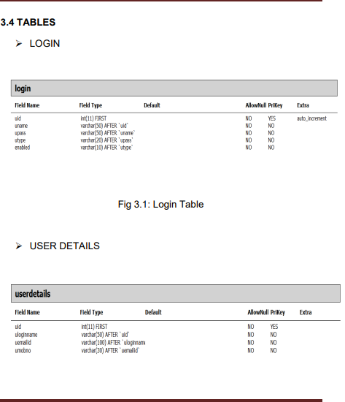

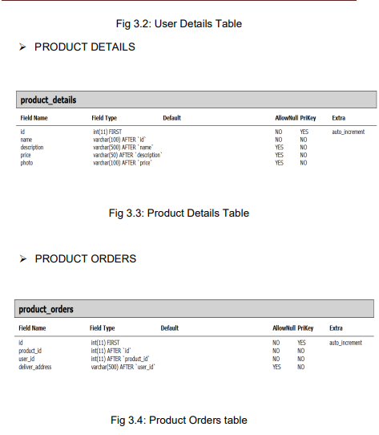

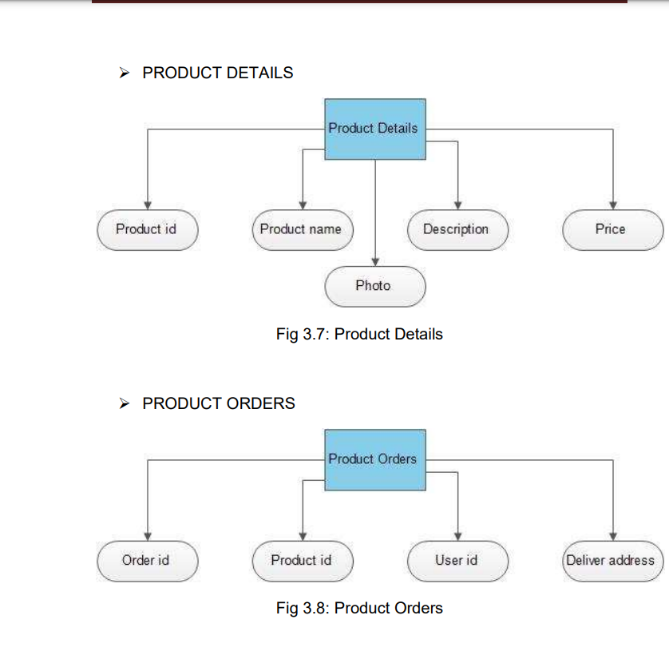

3.6 DATA FLOW DIAGRAM

A Data Flow Diagram (DFD) is a structured analysis and design tool that can be used for flowcharting. A DFD is a network that describes the flow of data and the processes that change or transform the data throughout a system. This network is constructed by using a set of symbols that do not imply any physical implementation. It has the purpose of clarifying system requirements and identifying major transformations. So it is the starting point of the design phase that functionally decomposes the requirements specifications down to the lowest level of detail. DFD can be considered to an abstraction of the logic of an information-oriented or a process-oriented system flow-chart. For these reasons DFD’s are often referred to as logical data flow diagrams.

**EXTERNAL ENTITY**

An external entity is a source or destination of a data flow. Only those entities which originate or receive data are represented on a data flow diagram. The symbol used is a rectangular box.

**PROCESS**

A process shows a transformation or manipulation of data flow within the system. The symbol used is an oval shape.

**DATAFLOW**

The data flow shows the flow of information from a source to its destination. Data flow is represented by a line, with arrowheads showing the direction of flow. Information always flows to or from a process and may be written, verbal or electronic. Each data flow may be referenced by the processes or data stores at its head and tail, or by a description of its contents.

**DATA STORE**

A data store is a holding place for information within the system: It is represented by an open ended narrow rectangle. Data stores may be long-term files such as sales ledgers, or may be short-term accumulations: for example batches of documents that are waiting to be processed. Each data store should be given a reference followed by an arbitrary number.

**¬ LOGIN DFD**

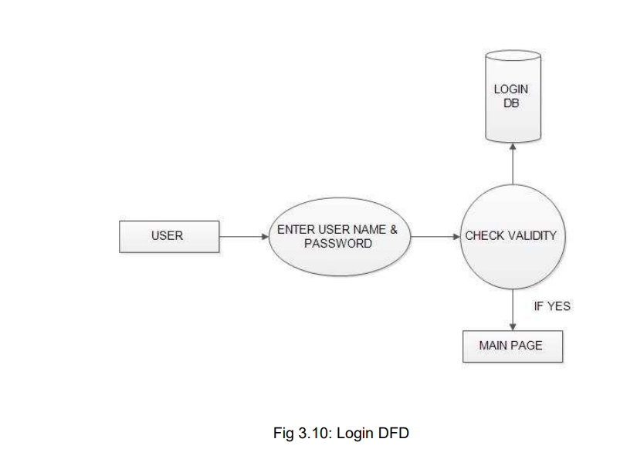

**¬ REGISTRATION DFD**

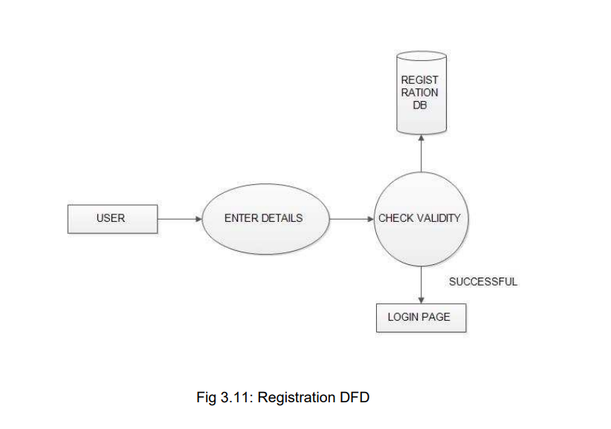

**¬ ADMIN DFD**

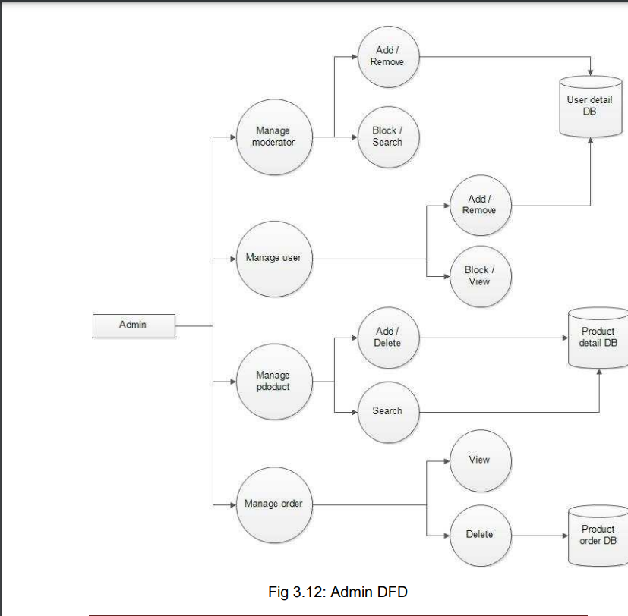

**¬ MODERATOR DFD**

**SCREEN SHORTS**

**Preview**

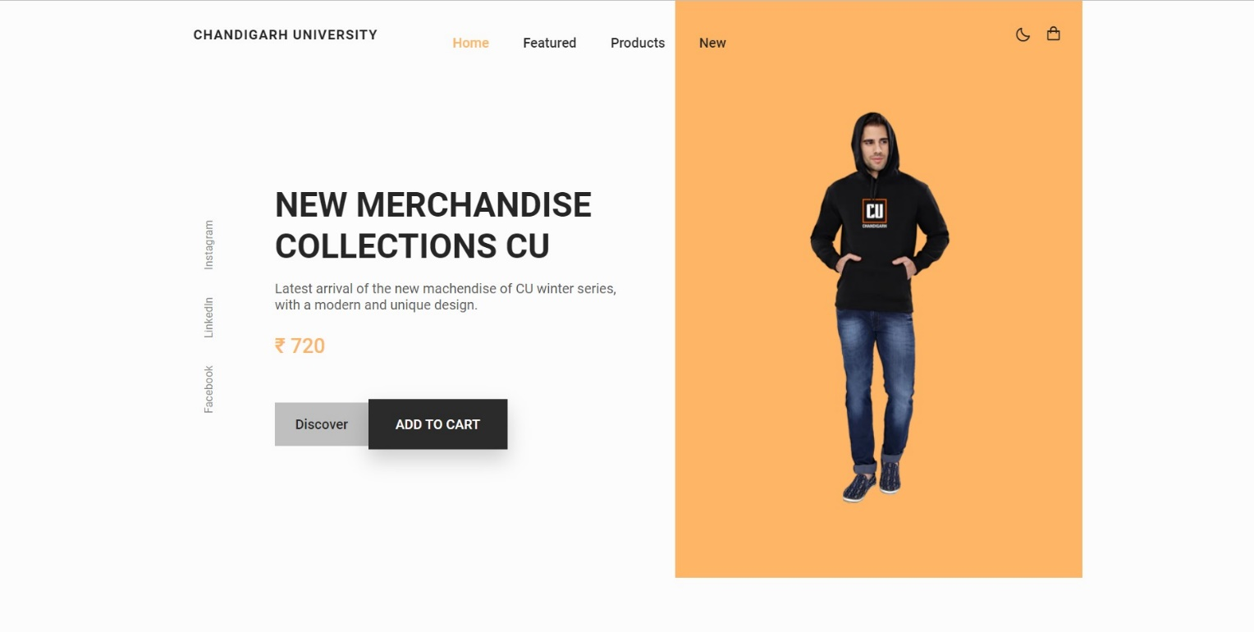

**Featured Product**

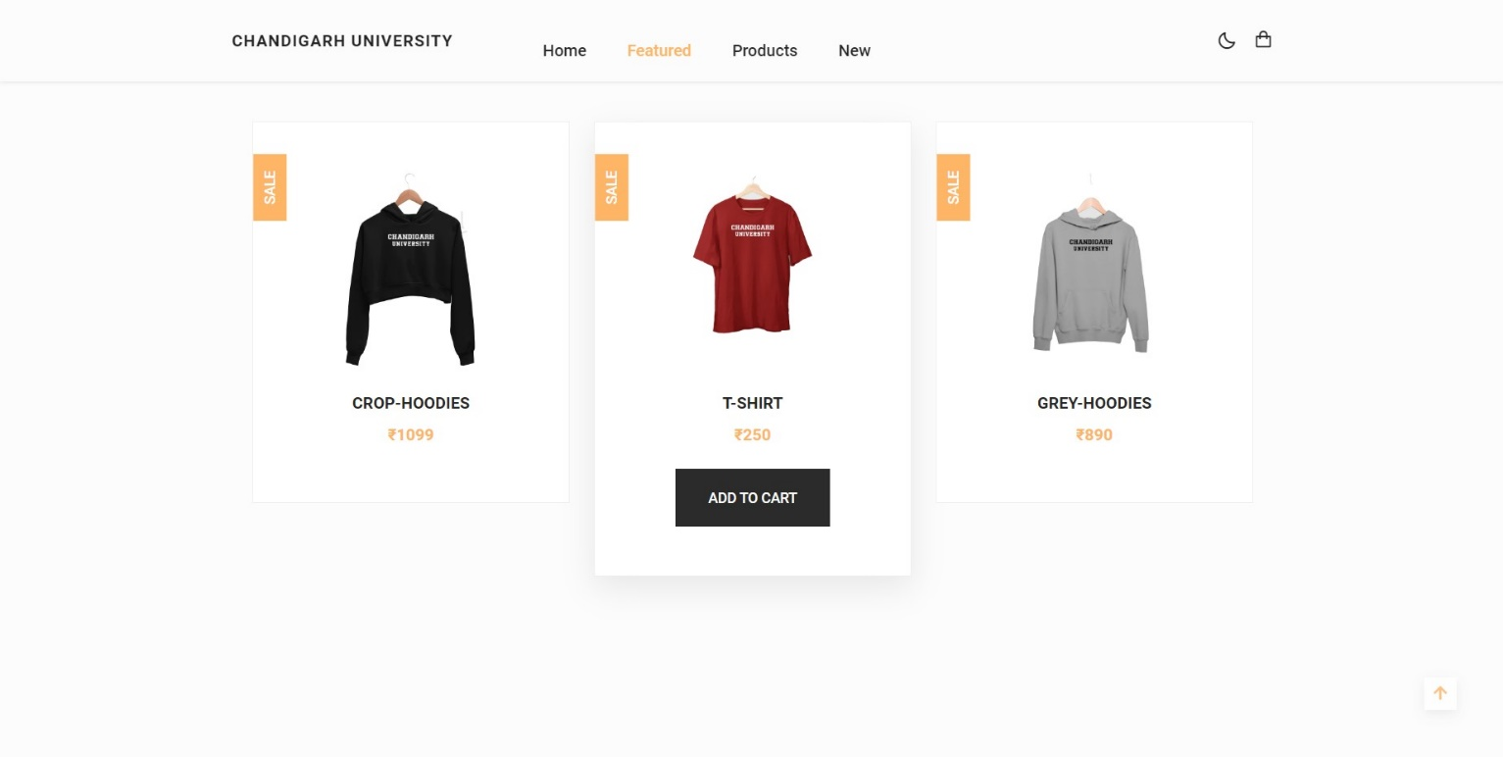

**News Letter and Footer**

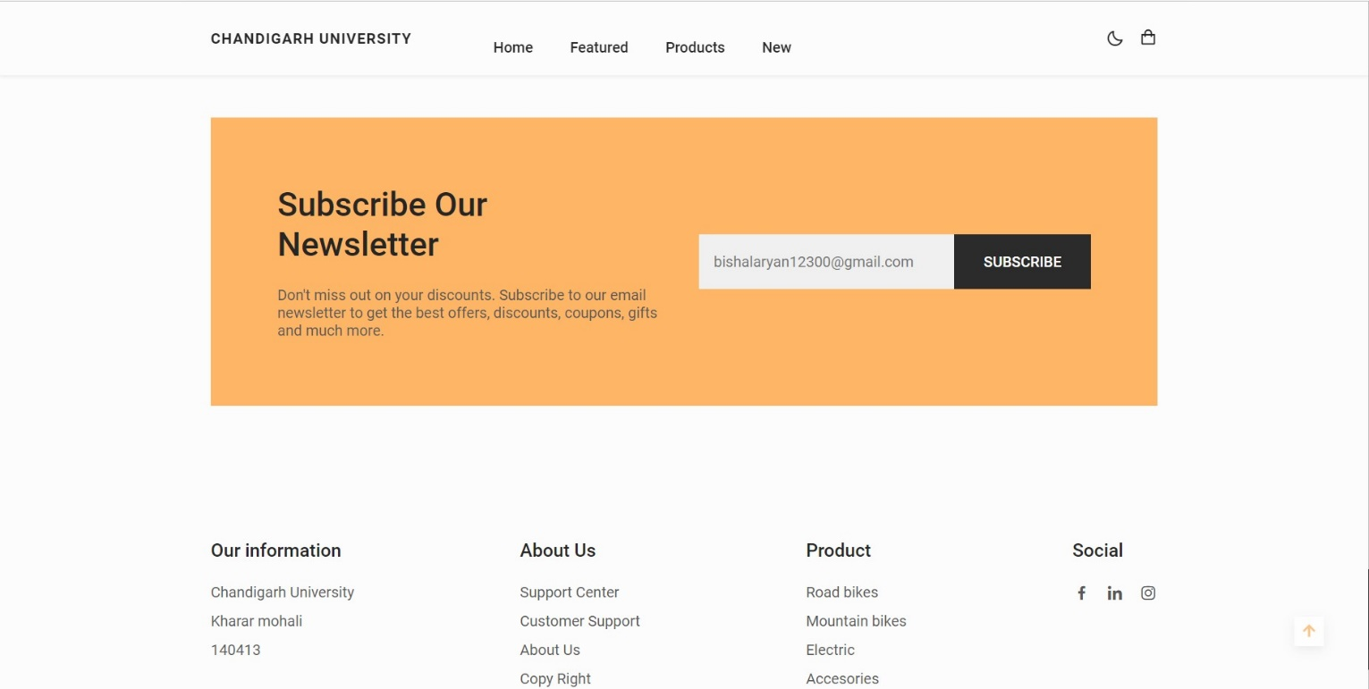

**Add to Cart Page**

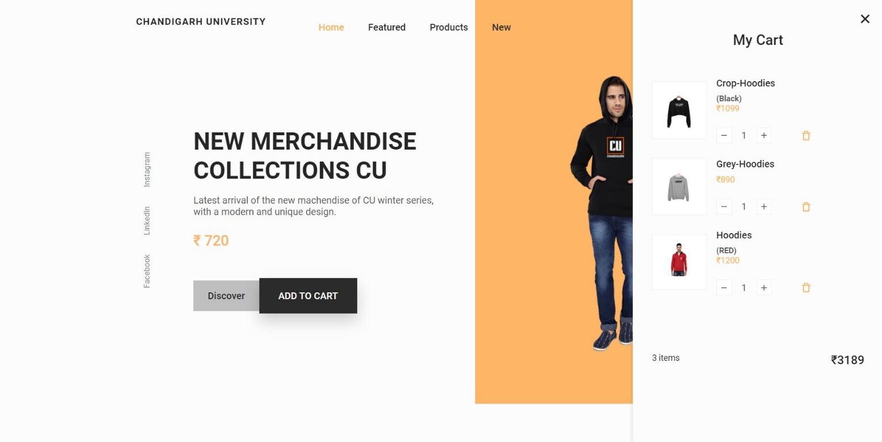

**Dark Mode**

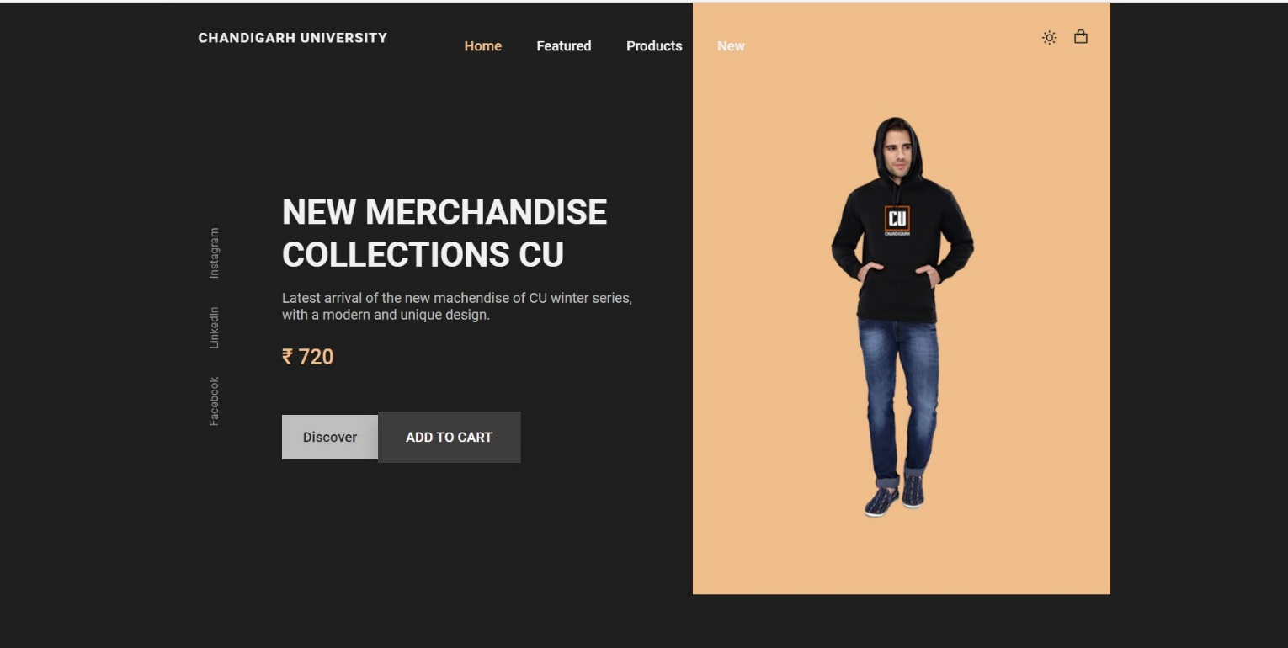

**Responsive Website**

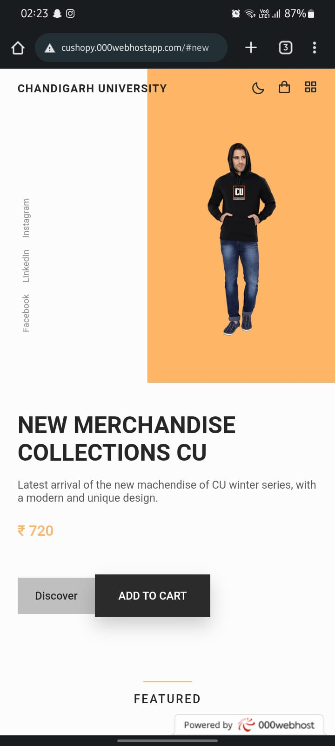

**Codes**

**HTML**

**<!DOCTYPE html>**

**<html lang="en">**

**<head>**

**<meta charset="UTF-8">**

**<meta name="viewport" content="width=device-width, initial-scale=1.0">**

**<!--=============== FAVICON ===============-->**

**<link rel="shortcut icon" href="assets/img/favicon.png" type="image/x-icon">**

**<!--=============== BOXICONS ===============-->**

**<link rel="stylesheet" href="https://cdn.jsdelivr.net/npm/boxicons@latest/css/boxicons.min.css">**

**<!--=============== SWIPER CSS ===============-->**

**<link rel="stylesheet" href="assets/css/swiper-bundle.min.css">**

**<!--=============== CSS ===============-->**

**<link rel="stylesheet" href="assets/css/styles.css">**

**<title>BISHAL WEBSITE</title>**

**</head>**

**<body>**

**<!--==================== HEADER ====================-->**

**<header class="header" id="header">**

**<nav class="nav container">**

**<a href="/assets/img/favicon.png" class="nav__logo">**

**CHANDIGARH UNIVERSITY**

**<div class="nav__menu" id="nav-menu">**

**<ul class="nav__list">**

**<li class="nav__item">**

**<a href="#home" class="nav__link active-link">Home</a>**

**</li>**

**<li class="nav__item">**

**<a href="#featured" class="nav__link">Featured</a>**

**</li>**

**<li class="nav__item">**

**<a href="#products" class="nav__link">Products</a>**

**</li>**

**<li class="nav__item">**

**<a href="#new" class="nav__link">New</a>**

**</li>**

**</ul>**

**<div class="nav__close" id="nav-close">**

**<i class='bx bx-x' ></i>**

**</div>**

**</div>**

**<div class="nav__btns">**

**<!-- Theme change button -->**

**<i class='bx bx-moon change-theme' id="theme-button"></i>**

**<div class="nav__shop" id="cart-shop">**

**<i class='bx bx-shopping-bag' ></i>**

**</div>**

**<div class="nav__toggle" id="nav-toggle">**

**<i class='bx bx-grid-alt' ></i>**

**</div>**

**</div>**

**</nav>**

**</header>**

**<!--==================== CART ====================-->**

**<div class="cart" id="cart">**

**<i class='bx bx-x cart__close' id="cart-close"></i>**

**<h2 class="cart__title-center">My Cart</h2>**

**<div class="cart__container">**

**<article class="cart__card">**

**<div class="cart__box">**

**<img src="assets/img/featured1.png" alt="" class="cart__img">**

**</div>**

**<div class="cart__details">**

**<h3 class="cart__title">Crop-Hoodies<h5>(Black)</h5></h3>**

**<span class="cart__price">₹1099</span>**

**<div class="cart__amount">**

**<div class="cart__amount-content">**

**<span class="cart__amount-box">**

**<i class='bx bx-minus' ></i>**

**</span>**

**<span class="cart__amount-number">1</span>**

**<span class="cart__amount-box">**

**<i class='bx bx-plus' ></i>**

**</span>**

**</div>**

**<i class='bx bx-trash-alt cart__amount-trash' ></i>**

**</div>**

**</div>**

**</article>**

**<article class="cart__card">**

**<div class="cart__box">**

**<img src="assets/img/featured3.png" alt="" class="cart__img">**

**</div>**

**<div class="cart__details">**

**<h3 class="cart__title">Grey-Hoodies</h3>**

**<span class="cart__price">₹890</span>**

**<div class="cart__amount">**

**<div class="cart__amount-content">**

**<span class="cart__amount-box">**

**<i class='bx bx-minus' ></i>**

**</span>**

**<span class="cart__amount-number">1</span>**

**<span class="cart__amount-box">**

**<i class='bx bx-plus' ></i>**

**</span>**

**</div>**

**<i class='bx bx-trash-alt cart__amount-trash' ></i>**

**</div>**

**</div>**

**</article>**

**<article class="cart__card">**

**<div class="cart__box">**

**<img src="assets/img/new1.png" alt="" class="cart__img">**

**</div>**

**<div class="cart__details">**

**<h3 class="cart__title">Hoodies<h5>(RED)</h5></h3>**

**<span class="cart__price">₹1200</span>**

**<div class="cart__amount">**

**<div class="cart__amount-content">**

**<span class="cart__amount-box">**

**<i class='bx bx-minus' ></i>**

**</span>**

**<span class="cart__amount-number">1</span>**

**<span class="cart__amount-box">**

**<i class='bx bx-plus' ></i>**

**</span>**

**</div>**

**<i class='bx bx-trash-alt cart__amount-trash' ></i>**

**</div>**

**</div>**

**</article>**

**</div>**

**<div class="cart__prices">**

**<span class="cart__prices-item">3 items</span>**

**<span class="cart__prices-total">₹3189</span>**

**</div>**

**</div>**

**<!--==================== MAIN ====================-->**

**<main class="main">**

**<!--==================== HOME ====================-->**

**<section class="home" id="home">**

**<div class="home__container container grid">**

**<div class="home__img-bg">**

**<img src="assets/img/home.png" alt="" class="home__img">**

**</div>**

**<div class="home__social">**

**<a href="https://www.facebook.com/profile.php?id=100009320394349" target="_blank" class="home__social-link">**

**Facebook**

**</a>**

**<a href="https://www.linkedin.com/in/bishal-ganguly-3a51b220a/" target="_blank" class="home__social-link">**

**LinkedIn**

**</a>**

**<a href="https://www.instagram.com/_aryan_abir_/" target="_blank" class="home__social-link">**

**Instagram**

**</a>**

**</div>**

**<div class="home__data">**

**<h1 class="home__title">NEW MERCHANDISE <br> COLLECTIONS CU</h1>**

**<p class="home__description">**

**Latest arrival of the new machendise of CU winter series,**

**with a modern and unique design.**

**</p>**

**<span class="home__price">₹ 720</span>**

**<div class="home__btns">**

**<a href="#" class="button button--gray button--small">**

**Discover**

**</a>**

**<button class="button home__button">ADD TO CART</button>**

**</div>**

**</div>**

**</div>**

**</section>**

**<!--==================== FEATURED ====================-->**

**<section class="featured section container" id="featured">**

**<h2 class="section__title">**

**Featured**

**</h2>**

**<div class="featured__container grid">**

**<article class="featured__card">**

**<span class="featured__tag">Sale</span>**

**<img src="assets/img/featured1.png" alt="" class="featured__img">**

**<div class="featured__data">**

**<h3 class="featured__title">Crop-Hoodies</h3>**

**<span class="featured__price">₹1099</span>**

**</div>**

**<button class="button featured__button">ADD TO CART</button>**

**</article>**

**<article class="featured__card">**

**<span class="featured__tag">Sale</span>**

**<img src="assets/img/featured2.png" alt="" class="featured__img">**

**<div class="featured__data">**

**<h3 class="featured__title">T-Shirt</h3>**

**<span class="featured__price">₹250</span>**

**</div>**

**<button class="button featured__button">ADD TO CART</button>**

**</article>**

**<article class="featured__card">**

**<span class="featured__tag">Sale</span>**

**<img src="assets/img/featured3.png" alt="" class="featured__img">**

**<div class="featured__data">**

**<h3 class="featured__title">Grey-Hoodies</h3>**

**<span class="featured__price">₹890</span>**

**</div>**

**<button class="button featured__button">ADD TO CART</button>**

**</article>**

**</div>**

**</section>**

**<!--==================== STORY ====================-->**

**<section class="story section container">**

**<div class="story__container grid">**

**<div class="story__data">**

**<h2 class="section__title story__section-title">**

**Our Story**

**</h2>**

**<h1 class="story__title">**

**Inspirational Merchandise of <br> this year**

**</h1>**

**<p class="story__description">**

**The latest and modern trends of this year, is available in various**

**presentations in this store, discover them now.**

**</p>**

**<a href="#" class="button button--small">Discover</a>**

**</div>**

**<div class="story__images">**

**<img src="assets/img/story.png" alt="" class="story__img">**

**<div class="story__square"></div>**

**</div>**

**</div>**

**</section>**

**<!--==================== PRODUCTS ====================-->**

**<section class="products section container" id="products">**

**<h2 class="section__title">**

**Products**

**</h2>**

**<div class="products__container grid">**

**<article class="products__card">**

**<img src="assets/img/product1.png" alt="" class="products__img">**

**<h3 class="products__title">Black-Hoodies</h3>**

**<span class="products__price">₹1099</span>**

**<button class="products__button">**

**<i class='bx bx-shopping-bag'></i>**

**</button>**

**</article>**

**<article class="products__card">**

**<img src="assets/img/product2.png" alt="" class="products__img">**

**<h3 class="products__title">Classy CropTop</h3>**

**<span class="products__price">₹560</span>**

**<button class="products__button">**

**<i class='bx bx-shopping-bag'></i>**

**</button>**

**</article>**

**<article class="products__card">**

**<img src="assets/img/product3.png" alt="" class="products__img">**

**<h3 class="products__title">Crop-Hoodies</h3>**

**<span class="products__price">₹1099</span>**

**<button class="products__button">**

**<i class='bx bx-shopping-bag'></i>**

**</button>**

**</article>**

**<article class="products__card">**

**<img src="assets/img/product4.png" alt="" class="products__img">**

**<h3 class="products__title">Navy Blue-Hoodies</h3>**

**<span class="products__price">₹1099</span>**

**<button class="products__button">**

**<i class='bx bx-shopping-bag'></i>**

**</button>**

**</article>**

**<article class="products__card">**

**<img src="assets/img/product5.png" alt="" class="products__img">**

**<h3 class="products__title">Classy T-shirt</h3>**

**<span class="products__price">₹560</span>**

**<button class="products__button">**

**<i class='bx bx-shopping-bag'></i>**

**</button>**

**</article>**

**</div>**

**</section>**

**<!--==================== TESTIMONIAL ====================-->**

**<section class="testimonial section container">**

**<div class="testimonial__container grid">**

**<div class="swiper testimonial-swiper">**

**<div class="swiper-wrapper">**

**<div class="testimonial__card swiper-slide">**

**<div class="testimonial__quote">**

**<i class='bx bxs-quote-alt-left' ></i>**

**</div>**

**<p class="testimonial__description">**

**It's very comfortable as all know about Chandigarh University tshirt but i found at the price 560 on sale❤️**

**</p>**

**<h3 class="testimonial__date">May 27. 2022</h3>**

**<div class="testimonial__perfil">**

**<img src="assets/img/testimonial1.jpg" alt="" class="testimonial__perfil-img">**

**<div class="testimonial__perfil-data">**

**<span class="testimonial__perfil-name">Anand Kumar Sharma</span>**

**<span class="testimonial__perfil-detail">Verified Customer<img src="assets/img/verify.png" height="50px" width="20px" alt=""></span>**

**</div>**

**</div>**

**</div>**

**<div class="testimonial__card swiper-slide">**

**<div class="testimonial__quote">**

**<i class='bx bxs-quote-alt-left' ></i>**

**</div>**

**<p class="testimonial__description">**

**This sweater is pretty great. I love the length and the fit and mostly I love how cozy it is. It keeps me warm,**

**looks great and is soft and luxurious. I am thinking about getting another in a different color…because if it’s this good, why not?**

**</p>**

**<h3 class="testimonial__date">August 06. 2022</h3>**

**<div class="testimonial__perfil">**

**<img src="assets/img/testimonial2.jpg" alt="" class="testimonial__perfil-img">**

**<div class="testimonial__perfil-data">**

**<span class="testimonial__perfil-name">Anisha Sharma</span>**

**<span class="testimonial__perfil-detail">Verified Customer<img src="assets/img/verify.png" height="50px" width="20px" alt=""></span>**

**</div>**

**</div>**

**</div>**

**<div class="testimonial__card swiper-slide">**

**<div class="testimonial__quote">**

**<i class='bx bxs-quote-alt-left' ></i>**

**</div>**

**<p class="testimonial__description">**

**Excellent shirt! Very comfortable and it has a soft lining which keeps you warm. Great shirt, i wear it almost daily.**

**It’s not water-proof so keep that in mind when outside. Also, get 1 size bigger so when it shrinks, it’ll still fit.**

**</p>**

**<h3 class="testimonial__date">August 227. 2022</h3>**

**<div class="testimonial__perfil">**

**<img src="assets/img/testimonial3.jpg" alt="" class="testimonial__perfil-img">**

**<div class="testimonial__perfil-data">**

**<span class="testimonial__perfil-name">Rahul Yadav</span>**

**<span class="testimonial__perfil-detail">Verified Customer<img src="assets/img/verify.png" height="50px" width="20px" alt=""></span>**

**</div>**

**</div>**

**</div>**

**</div>**

**<div class="swiper-button-next">**

**<i class='bx bx-right-arrow-alt' ></i>**

**</div>**

**<div class="swiper-button-prev">**

**<i class='bx bx-left-arrow-alt' ></i>**

**</div>**

**</div>**

**<div class="testimonial__images">**

**<div class="testimonial__square"></div>**

**<img src="assets/img/testimonial.png" alt="" class="testimonial__img">**

**</div>**

**</div>**

**</section>**

**<!--==================== NEW ====================-->**

**<section class="new section container" id="new">**

**<h2 class="section__title">**

**New Arrivals**

**</h2>**

**<div class="new__container">**

**<div class="swiper new-swiper">**

**<div class="swiper-wrapper">**

**<article class="new__card swiper-slide">**

**<span class="new__tag">New</span>**

**<img src="assets/img/new1.png" alt="" class="new__img">**

**<div class="new__data">**

**<h3 class="new__title">RED-Hoodies</h3>**

**<span class="new__price">₹1200</span>**

**</div>**

**<button class="button new__button">ADD TO CART</button>**

**</article>**

**<article class="new__card swiper-slide">**

**<span class="new__tag">New</span>**

**<img src="assets/img/new2.png" alt="" class="new__img">**

**<div class="new__data">**

**<h3 class="new__title">Grey-Swet Hoodies</h3>**

**<span class="new__price">₹1150</span>**

**</div>**

**<button class="button new__button">ADD TO CART</button>**

**</article>**

**<article class="new__card swiper-slide">**

**<span class="new__tag">New</span>**

**<img src="assets/img/new3.png" alt="" class="new__img">**

**<div class="new__data">**

**<h3 class="new__title">GREY MEN-Hoodies</h3>**

**<span class="new__price">₹1200</span>**

**</div>**

**<button class="button new__button">ADD TO CART</button>**

**</article>**

**<article class="new__card swiper-slide">**

**<span class="new__tag">New</span>**

**<img src="assets/img/new4.png" alt="" class="new__img">**

**<div class="new__data">**

**<h3 class="new__title">Maroon-Swet Hoodies</h3>**

**<span class="new__price">₹1150</span>**

**</div>**

**<button class="button new__button">ADD TO CART</button>**

**</article>**

**</div>**

**</div>**

**</div>**

**</section>**

**<!--==================== NEWSLETTER ====================-->**

**<section class="newsletter section container">**

**<div class="newsletter__bg grid">**

**<div>**

**<h2 class="newsletter__title">Subscribe Our <br> Newsletter</h2>**

**<p class="newsletter__description">**

**Don't miss out on your discounts. Subscribe to our email**

**newsletter to get the best offers, discounts, coupons,**

**gifts and much more.**

**</p>**

**</div>**

**<form action="" class="newsletter__subscribe">**

**<input type="email" placeholder="bishalaryan12300@gmail.com" class="newsletter__input">**

**<button class="button">**

**SUBSCRIBE**

**</button>**

**</form>**

**</div>**

**</section>**

**</main>**

**<!--==================== FOOTER ====================-->**

**<footer class="footer section">**

**<div class="footer__container container grid">**

**<div class="footer__content">**

**<h3 class="footer__title">Our information</h3>**

**<ul class="footer__list">**

**<li>Chandigarh University</li>**

**<li>Kharar mohali</li>**

**<li>140413</li>**

**</ul>**

**</div>**

**<div class="footer__content">**

**<h3 class="footer__title">About Us</h3>**

**<ul class="footer__links">**

**<li>**

**<a href="mailto:bishalganguly00123@gmial.com" class="footer__link">Support Center</a>**

**</li>**

**<li>**

**<a href="mailto:bishalganguly00123@gmial.com" class="footer__link">Customer Support</a>**

**</li>**

**<li>**

**<a href="https://www.cuchd.in/about/" class="footer__link">About Us</a>**

**</li>**

**<li>**

**<a href="#" class="footer__link">Copy Right</a>**

**</li>**

**</ul>**

**</div>**

**<div class="footer__content">**

**<h3 class="footer__title">Product</h3>**

**<ul class="footer__links">**

**<li>**

**<a href="#" class="footer__link">Road bikes</a>**

**</li>**

**<li>**

**<a href="#" class="footer__link">Mountain bikes</a>**

**</li>**

**<li>**

**<a href="#" class="footer__link">Electric</a>**

**</li>**

**<li>**

**<a href="#" class="footer__link">Accesories</a>**

**</li>**

**</ul>**

**</div>**

**<div class="footer__content">**

**<h3 class="footer__title">Social</h3>**

**<ul class="footer__social">**

**<a href="https://www.facebook.com/profile.php?id=100009320394349" target="_blank" class="footer__social-link">**

**<i class='bx bxl-facebook'></i>**

**</a>**

**<a href="https://www.linkedin.com/in/bishal-ganguly-3a51b220a/" target="_blank" class="footer__social-link">**

**<i class='bx bxl-linkedin' ></i>**

**</a>**

**<a href="https://www.instagram.com/_aryan_abir_/" target="_blank" class="footer__social-link">**

**<i class='bx bxl-instagram' ></i>**

**</a>**

**</ul>**

**</div>**

**</div>**

**<span class="footer__copy">&#169;All rigths reserved . 20BCG1066 . 20BCG1011</span>**

**</footer>**

**<!--=============== SCROLL UP ===============-->**

**<a href="#" class="scrollup" id="scroll-up">**

**<i class='bx bx-up-arrow-alt scrollup__icon' ></i>**

**</a>**

**<!--=============== SWIPER JS ===============-->**

**<script src="assets/js/swiper-bundle.min.js"></script>**

**<!--=============== MAIN JS ===============-->**

**<script src="assets/js/main.js"></script>**

**</body>**

**</html>**

**CSS (Cascading Style Sheet)**

**/*=============== GOOGLE FONTS ===============*/**

**@import url("https://fonts.googleapis.com/css2?family=Roboto:wght@400;500;700&display=swap");**

**/*=============== VARIABLES CSS ===============*/**

**:root {**

**--header-height: 3.5rem;**

**/*========== Colors ==========*/**

**--first-color: hsl(31, 100%, 70%);**

**--button-color: hsl(0, 0%, 17%);**

**--button-color-alt: hsl(0, 0%, 21%);**

**--title-color: hsl(0, 0%, 15%);**

**--text-color: hsl(0, 0%, 35%);**

**--text-color-light: hsl(0, 0%, 55%);**

**--body-color: hsl(0, 0%, 99%);**

**--container-color: #fff;**

**--border-color: hsl(0, 0%, 94%);**

**/*========== Font and typography ==========*/**

**--body-font: 'Roboto', sans-serif;**

**--biggest-font-size: 2rem;**

**--h1-font-size: 1.5rem;**

**--h2-font-size: 1.25rem;**

**--h3-font-size: 1rem;**

**--normal-font-size: .938rem;**

**--small-font-size: .813rem;**

**--smaller-font-size: .75rem;**

**/*========== Font weight ==========*/**

**--font-medium: 500;**

**--font-bold: 700;**

**/*========== Margenes Bottom ==========*/**

**--mb-0-5: .5rem;**

**--mb-0-75: .75rem;**

**--mb-1: 1rem;**

**--mb-1-5: 1.5rem;**

**--mb-2: 2rem;**

**--mb-2-5: 2.5rem;**

**--mb-3: 3rem;**

**/*========== z index ==========*/**

**--z-tooltip: 10;**

**--z-fixed: 100;**

**}**

**@media screen and (min-width: 968px) {**

**:root {**

**--biggest-font-size: 2.5rem;**

**--h1-font-size: 2.25rem;**

**--h2-font-size: 1.5rem;**

**--h3-font-size: 1.25rem;**

**--normal-font-size: 1rem;**

**--small-font-size: .875rem;**

**--smaller-font-size: .813rem;**

**}**

**}**

**/*=============== BASE ===============*/**

**\* {**

**box-sizing: border-box;**

**padding: 0;**

**margin: 0;**

**}**

**html {**

**scroll-behavior: smooth;**

**}**

**body,**

**button,**

**input {**

**font-family: var(--body-font);**

**font-size: var(--normal-font-size);**

**}**

**body {**

**margin: 0;**

**background-color: var(--body-color);**

**color: var(--text-color);**

**/*For animation dark mode*/**

**transition: .4s;**

**}**

**h1, h2, h3, h4 {**

**color: var(--title-color);**

**font-weight: var(--font-medium);**

**}**

**ul {**

**list-style: none;**

**}**

**a {**

**text-decoration: none;**

**}**

**img {**

**max-width: 100%;**

**height: auto;**

**}**

**button {**

**cursor: pointer;**

**border: none;**

**outline: none;**

**}**

**/*=============== THEME ===============*/**

**/*========== Variables Dark theme ==========*/**

**body.dark-theme {**

**--first-color: hsl(31, 76%, 74%);**

**--button-color: hsl(0, 0%, 24%);**

**--button-color-alt: hsl(0, 0%, 28%);**

**--title-color: hsl(0, 0%, 95%);**

**--text-color: hsl(0, 0%, 75%);**

**--body-color: hsl(0, 0%, 12%);**

**--container-color: hsl(0, 0%, 16%);**

**--border-color: hsl(0, 0%, 20%);**

**}**

**/*========== Button Dark/Light ==========*/**

**.change-theme {**

**color: var(--title-color);**

**font-size: 1.25rem;**

**cursor: pointer;**

**}**

**/*==========**

**Color changes in some parts of**

**the website, in dark theme**

**==========*/**

**.dark-theme .change-theme,**

**.dark-theme .nav__toggle,**

**.dark-theme .nav__shop,**

**.dark-theme .button--gray {**

**color: hsl(0, 0%, 15%);**

**}**

**.dark-theme .scroll-header {**

**box-shadow: 0 1px 4px hsla(0, 0%, 4%, .3);**

**}**

**.scroll-header .change-theme,**

**.scroll-header .nav__toggle,**

**.scroll-header .nav__shop {**

**color: var(--title-color);**

**}**

**.dark-theme::-webkit-scrollbar {**

**background: hsl(0, 0%, 30%);**

**}**

**/*=============== REUSABLE CSS CLASSES ===============*/**

**.container {**

**max-width: 1024px;**

**margin-left: var(--mb-1-5);**

**margin-right: var(--mb-1-5);**

**}**

**.grid {**

**display: grid;**

**}**

**.main {**

**overflow: hidden;**

**}**

**.section {**

**padding: 6.5rem 0 1rem;**

**}**

**.section__title {**

**position: relative;**

**font-size: var(--h3-font-size);**

**margin-bottom: var(--mb-3);**

**text-transform: uppercase;**

**letter-spacing: 2px;**

**text-align: center;**

**}**

**.section__title::before {**

**content: '';**

**position: absolute;**

**top: -1rem;**

**left: 0;**

**right: 0;**

**margin: 0 auto;**

**width: 67px;**

**height: 1px;**

**background-color: var(--first-color);**

**}**

**/*=============== HEADER & NAV ===============*/**

**.header {**

**width: 100%;**

**background: transparent;**

**position: fixed;**

**top: 0;**

**left: 0;**

**z-index: var(--z-fixed);**

**/*For animation dark mode*/**

**transition: .4s;**

**}**

**.nav {**

**height: var(--header-height);**

**display: flex;**

**justify-content: space-between;**

**align-items: center;**

**}**

**.nav__logo,**

**.nav__toggle,**

**.nav__shop,**

**.nav__close {**

**color: var(--title-color);**

**}**

**.nav__logo {**

**text-transform: uppercase;**

**font-weight: var(--font-bold);**

**letter-spacing: 1px;**

**display: inline-flex;**

**align-items: center;**

**column-gap: .25rem;**

**}**

**.nav__logo-icon {**

**font-size: 1.25rem;**

**}**

**.nav__btns {**

**display: flex;**

**align-items: center;**

**column-gap: 1rem;**

**}**

**.nav__toggle,**

**.nav__shop {**

**font-size: 1.25rem;**

**cursor: pointer;**

**}**

**@media screen and (max-width: 767px) {**

**.nav__menu {**

**position: fixed;**

**background-color: var(--body-color);**

**top: 0;**

**right: -100%;**

**width: 100%;**

**height: 100%;**

**padding: 6rem 2rem 3.5rem;**

**transition: .3s;**

**}**

**}**

**.nav__list {**

**display: flex;**

**flex-direction: column;**

**align-items: center;**

**row-gap: 2rem;**

**}**

**.nav__link {**

**color: var(--title-color);**

**font-weight: var(--font-medium);**

**text-transform: uppercase;**

**font-size: var(--h2-font-size);**

**transition: .3s;**

**}**

**.nav__link:hover {**

**color: var(--first-color);**

**}**

**.nav__close {**

**font-size: 2rem;**

**position: absolute;**

**top: .9rem;**

**right: 1.25rem;**

**cursor: pointer;**

**}**

**/* Show menu */**

**.show-menu {**

**right: 0;**

**}**

**/* Change background header */**

**.scroll-header {**

**background-color: var(--body-color);**

**box-shadow: 0 1px 4px hsla(0, 4%, 15%, .10);**

**}**

**/* Active link */**

**.active-link {**

**color: var(--first-color);**

**}**

**/*=============== HOME ===============*/**

**.home__container {**

**position: relative;**

**row-gap: 2.5rem;**

**}**

**.home__img {**

**width: 240px;**

**}**

**.home__img-bg {**

**background-color: var(--first-color);**

**width: 258px;**

**height: 430px;**

**padding-bottom: 2rem;**

**display: flex;**

**justify-content: center;**

**align-items: flex-end;**

**justify-self: flex-end;**

**transform: translateX(1.5rem);**

**}**

**.home__social {**

**position: absolute;**

**top: 35%;**

**left: -5rem;**

**transform: rotate(-90deg);**

**display: flex;**

**column-gap: 1rem;**

**}**

**.home__social-link {**

**font-size: var(--smaller-font-size);**

**color: var(--text-color-light);**

**transition: .3s;**

**}**

**.home__social-link:hover {**

**color: var(--title-color);**

**}**

**.home__title {**

**font-size: var(--biggest-font-size);**

**font-weight: var(--font-bold);**

**margin-bottom: var(--mb-1);**

**}**

**.home__description {**

**margin-bottom: var(--mb-1-5);**

**}**

**.home__price {**

**display: inline-block;**

**font-size: var(--h2-font-size);**

**font-weight: var(--font-medium);**

**color: var(--first-color);**

**margin-bottom: var(--mb-3);**

**}**

**.home__btns {**

**display: flex;**

**align-items: center;**

**}**

**.home__button {**

**box-shadow: 0 12px 24px hsla(0, 0%, 10%, .2);**

**}**

**/*=============== BUTTONS ===============*/**

**.button {**

**display: inline-block;**

**background-color: var(--button-color);**

**color: #FFF;**

**padding: 1.25rem 2rem;**

**font-weight: var(--font-medium);**

**transition: .3s;**

**}**

**.button:hover {**

**background-color: var(--button-color-alt);**

**}**

**.button--gray {**

**background-color: hsl(0, 0%, 75%);**

**color: var(--title-color);**

**}**

**.button--gray:hover {**

**background-color: hsl(0, 0%, 63%);**

**}**

**.button--small {**

**padding: 1rem 1.5rem;**

**}**

**/*=============== FEATURED ===============*/**

**.featured__container {**

**row-gap: 2.5rem;**

**}**

**.featured__card {**

**position: relative;**

**text-align: center;**

**background-color: var(--container-color);**

**padding-top: 2rem;**

**border: 1px solid var(--border-color);**

**overflow-y: hidden;**

**transition: .3s;**

**}**

**.featured__tag {**

**background-color: var(--first-color);**

**padding: .5rem 1rem;**

**color: #fff;**

**text-transform: uppercase;**

**font-size: var(--small-font-size);**

**font-weight: var(--font-medium);**

**position: absolute;**

**transform: rotate(-90deg);**

**left: -1rem;**

**top: 3rem;**

**}**

**.featured__img {**

**height: 214px;**

**margin-bottom: var(--mb-1);**

**}**

**.featured__title,**

**.featured__price {**

**font-size: var(--h3-font-size);**

**font-weight: var(--font-bold);**

**}**

**.featured__title {**

**text-transform: uppercase;**

**margin-bottom: var(--mb-0-75);**

**}**

**.featured__price {**

**display: block;**

**color: var(--first-color);**

**transition: .3s;**

**}**

**.featured__button {**

**font-size: var(--small-font-size);**

**transform: translateY(1rem);**

**opacity: 0;**

**}**

**.featured__card:hover {**

**box-shadow: 0 12px 32px hsla(0, 0%, 20%, .1);**

**padding: 2rem 0 3rem 0;**

**}**

**.featured__card:hover .featured__button {**

**transform: translateY(0);**

**opacity: 1;**

**}**

**.featured__card:hover .featured__price {**

**margin-bottom: var(--mb-1-5);**

**}**

**/*=============== STORY ===============*/**

**.story__container {**

**row-gap: 7.5rem;**

**}**

**.story__title {**

**font-size: var(--h1-font-size);**

**margin-bottom: var(--mb-1);**

**}**

**.story__description {**

**margin-bottom: var(--mb-2-5);**

**}**

**.story__images {**

**position: relative;**

**}**

**.story__img,**

**.story__square {**

**width: 250px;**

**}**

**.story__square {**

**height: 250px;**

**background-color: var(--first-color);**

**}**

**.story__img {**

**position: absolute;**

**left: 9rem;**

**top: 5rem;**

**}**

**/*=============== PRODUCTS ===============*/**

**.products__container {**

**grid-template-columns: repeat(2, 1fr);**

**gap: 2rem;**

**}**

**.products__card {**

**position: relative;**

**background-color: var(--container-color);**

**padding: 1.25rem 0;**

**border: 1px solid var(--border-color);**

**text-align: center;**

**transition: .3s;**

**}**

**.products__img {**

**height: 125px;**

**margin-bottom: var(--mb-1);**

**}**

**.products__title,**

**.products__price {**

**font-size: var(--small-font-size);**

**font-weight: var(--font-medium);**

**}**

**.products__title {**

**text-transform: uppercase;**

**margin-bottom: var(--mb-0-5);**

**}**

**.products__price {**

**color: var(--first-color);**

**}**

**.products__button {**

**background-color: var(--button-color);**

**padding: .4rem;**

**color: #fff;**

**font-size: 1rem;**

**position: absolute;**

**right: 0;**

**bottom: 0;**

**transition: .3s;**

**}**

**.products__button:hover {**

**background-color: var(--button-color-alt);**

**}**

**.products__card:hover {**

**box-shadow: 0 8px 32px hsla(0, 0%, 10%, .1);**

**}**

**/*=============== TESTIMONIAL ===============*/**

**.testimonial__container {**

**row-gap: 4rem;**

**}**

**.testimonial__quote {**

**display: inline-flex;**

**background-color: var(--container-color);**

**padding: .5rem .75rem;**

**font-size: 1.5rem;**

**color: var(--first-color);**

**box-shadow: 0 4px 12px hsla(0, 0%, 20%, .1);**

**margin-bottom: var(--mb-2);**

**}**

**.testimonial__description {**

**margin-bottom: var(--mb-1);**

**}**

**.testimonial__date {**

**font-size: var(--normal-font-size);**

**margin-bottom: var(--mb-2);**

**}**

**.testimonial__perfil {**

**display: flex;**

**align-items: center;**

**column-gap: 1rem;**

**margin-bottom: 7rem;**

**}**

**.testimonial__perfil-img {**

**width: 60px;**

**height: 60px;**

**border-radius: 3rem;**

**}**

**.testimonial__perfil-data {**

**display: flex;**

**flex-direction: column;**

**row-gap: .5rem;**

**}**

**.testimonial__perfil-name {**

**font-size: var(--h3-font-size);**

**font-weight: var(--font-medium);**

**color: var(--title-color);**

**}**

**.testimonial__perfil-detail {**

**font-size: var(--small-font-size);**

**}**

**.testimonial__images {**

**position: relative;**

**}**

**.testimonial__img,**

**.testimonial__square {**

**width: 250px;**

**}**

**.testimonial__square {**

**height: 250px;**

**background-color: var(--first-color);**

**margin-left: auto;**

**}**

**.testimonial__img {**

**position: absolute;**

**right: 2rem;**

**top: 3rem;**

**}**

**.testimonial-swiper {**

**margin-left: initial;**

**margin-right: initial;**

**}**

**.swiper-button-prev:after,**

**.swiper-button-next:after {**

**content: '';**

**}**

**/* Swiper class */**

**.swiper-button-next,**

**.swiper-button-prev {**

**top: initial;**

**bottom: 5%;**

**width: initial;**

**height: initial;**

**background-color: var(--container-color);**

**box-shadow: 0 4px 12px hsla(0, 0%, 20%, .1);**

**padding: .25rem;**

**font-size: 1.5rem;**

**color: var(--first-color);**

**}**

**.swiper-button-next {**

**right: initial;**

**left: 4rem;**

**}**

**/*=============== NEW ===============*/**

**.new__card {**

**position: relative;**

**text-align: center;**

**background-color: var(--container-color);**

**padding-top: 2rem;**

**border: 1px solid var(--border-color);**

**overflow-y: hidden;**

**transition: .3s;**

**}**

**.new__tag {**

**background-color: var(--first-color);**

**padding: .5rem 1rem;**

**color: #fff;**

**text-transform: uppercase;**

**font-size: var(--small-font-size);**

**font-weight: var(--font-medium);**

**position: absolute;**

**top: 1rem;**

**right: 1rem;**

**transition: .3s;**

**}**

**.new__img {**

**height: 215px;**

**margin-bottom: var(--mb-1);**

**}**

**.new__title,**

**.new__price {**

**font-size: var(--h3-font-size);**

**font-weight: var(--font-bold);**

**}**

**.new__title {**

**text-transform: uppercase;**

**margin-bottom: var(--mb-0-75);**

**}**

**.new__price {**

**display: block;**

**color: var(--first-color);**

**transition: .3s;**

**}**

**.new__button {**

**font-size: var(--small-font-size);**

**transform: translateY(1rem);**

**opacity: 0;**

**}**

**.new__card:hover {**

**background-color: var(--first-color);**

**box-shadow: 0 12px 32px hsla(0, 0%, 20%, .1);**

**padding: 2rem 0 3rem 0;**

**}**

**.new__card:hover .new__tag {**

**background-color: var(--button-color);**

**}**

**.new__card:hover .new__button {**

**transform: translateY(0);**

**opacity: 1;**

**}**

**.new__card:hover .new__title {**

**color: hsl(0, 0%, 15%);**

**}**

**.new__card:hover .new__price {**

**color: hsl(0, 0%, 15%);**

**margin-bottom: var(--mb-1-5);**

**}**

**/*=============== NEWSLETTER ===============*/**

**.newsletter__bg {**

**background-color: var(--first-color);**

**padding: 3rem 1.5rem;**

**text-align: center;**

**row-gap: 2.5rem;**

**}**

**.newsletter__title {**

**font-size: var(--h1-font-size);**

**color: hsl(0, 0%, 15%);**

**margin-bottom: var(--mb-1-5);**

**}**

**.newsletter__description {**

**color: hsl(0, 0%, 35%);**

**}**

**.newsletter__subscribe {**

**display: flex;**

**flex-direction: column;**

**row-gap: .75rem;**

**}**

**.newsletter__input {**

**border: none;**

**outline: none;**

**background-color: hsl(0, 0%, 94%);**

**padding: 1.25rem 1rem;**

**color: hsl(0, 0%, 15%);**

**}**

**/*=============== FOOTER ===============*/**

**.footer__container {**

**row-gap: 2rem;**

**border-bottom: 1px solid var(--border-color);**

**padding-bottom: 3rem;**

**}**

**.footer__title {**

**font-size: var(--h2-font-size);**

**margin-bottom: var(--mb-1-5);**

**}**

**.footer__list,**

**.footer__links {**

**display: flex;**

**flex-direction: column;**

**row-gap: .75rem;**

**}**

**.footer__link {**

**color: var(--text-color);**

**}**

**.footer__link:hover {**

**color: var(--title-color);**

**}**

**.footer__social {**

**display: flex;**

**column-gap: 1rem;**

**}**

**.footer__social-link {**

**font-size: 1.25rem;**

**color: var(--text-color);**

**}**

**.footer__social-link:hover {**

**color: var(--title-color);**

**}**

**.footer__copy {**

**display: block;**

**margin: 3.5rem 0 1rem 0;**

**text-align: center;**

**font-size: var(--smaller-font-size);**

**color: var(--text-color-light);**

**}**

**/*=============== SCROLL UP ===============*/**

**.scrollup {**

**position: fixed;**

**right: 1rem;**

**bottom: -30%;**

**background-color: var(--container-color);**

**box-shadow: 0 4px 12px hsla(0, 0%, 20%, .1);**

**display: inline-flex;**

**padding: .25rem;**

**z-index: var(--z-tooltip);**

**opacity: .8;**

**transition: .4s;**

**}**

**.scrollup:hover {**

**opacity: 1;**

**}**

**.scrollup__icon {**

**font-size: 1.5rem;**

**color: var(--first-color);**

**}**

**/* Show Scroll Up*/**

**.show-scroll {**

**bottom: 3rem;**

**}**

**/*=============== SCROLL BAR ===============*/**

**::-webkit-scrollbar {**

**width: .6rem;**

**background: hsl(0, 0%, 74%);**

**}**

**::-webkit-scrollbar-thumb {**

**background: hsl(0, 0%, 17%);**

**}**

**/*=============== CART ===============*/**

**.cart {**

**position: fixed;**

**background-color: var(--body-color);**

**z-index: var(--z-fixed);**

**width: 100%;**

**height: 100%;**

**top: 0;**

**right: -100%;**

**padding: 3.5rem 2rem;**

**transition: .4s;**

**}**

**.cart__title-center {**

**font-size: var(--h2-font-size);**

**text-align: center;**

**margin-bottom: var(--mb-3);**

**}**

**.cart__close {**

**font-size: 2rem;**

**color: var(--title-color);**

**position: absolute;**

**top: 1.25rem;**

**right: .9rem;**

**cursor: pointer;**

**}**

**.cart__container {**

**display: grid;**

**row-gap: 1.5rem;**

**}**

**.cart__card {**

**display: flex;**

**align-items: center;**

**column-gap: 1rem;**

**}**

**.cart__box {**

**background-color: var(--container-color);**

**padding: .75rem 1.25rem;**

**border: 1px solid var(--border-color);**

**}**

**.cart__img {**

**width: 50px;**

**}**

**.cart__title {**

**font-size: var(--normal-font-size);**

**margin-bottom: .5rem;**

**}**

**.cart__price {**

**display: block;**

**font-size: var(--small-font-size);**

**color: var(--first-color);**

**margin-bottom: var(--mb-1-5);**

**}**

**.cart__amount,**

**.cart__amount-content{**

**display: flex;**

**align-items: center;**

**}**

**.cart__amount{**

**column-gap: 3rem;**

**}**

**.cart__amount-content{**

**column-gap: 1rem;**

**}**

**.cart__amount-box {**

**display: inline-flex;**

**padding: .25rem;**

**background-color: var(--container-color);**

**border: 1px solid var(--border-color);**

**cursor: pointer;**

**}**

**.cart__amount-trash {**

**font-size: 1.15rem;**

**color: var(--first-color);**

**cursor: pointer;**

**}**

**.cart__prices {**

**margin-top: 6rem;**

**display: flex;**

**justify-content: space-between;**

**}**

**.cart__prices-item,**

**.cart__prices-total {**

**color: var(--title-color);**

**}**

**.cart__prices-item {**

**font-size: var(--small-font-size);**

**}**

**.cart__prices-total {**

**font-size: var(--h3-font-size);**

**font-weight: var(--font-medium);**

**}**

**/* Show cart */**

**.show-cart {**

**right: 0;**

**}**

**/*=============== BREAKPOINTS ===============*/**

**/* For small devices */**

**@media screen and (max-width: 320px) {**

**.container {**

**margin-left: var(--mb-1);**

**margin-right: var(--mb-1);**

**}**

**.home__img-bg {**

**width: 220px;**

**}**

**.home__title {**

**font-size: var(--h1-font-size);**

**}**

**.home__button {**

**font-size: var(--smaller-font-size);**

**}**

**.story__square,**

**.story__img,**

**.testimonial__square,**

**.testimonial__img {**

**width: 180px;**

**}**

**.story__square,**

**.testimonial__square {**

**height: 180px;**

**}**

**.products__container {**

**grid-template-columns: repeat(1, 180px);**

**justify-content: center;**

**}**

**}**

**/* For medium devices */**

**@media screen and (min-width: 576px) {**

**.home__img-bg {**

**width: 340px;**

**}**

**.featured__container {**

**grid-template-columns: repeat(2, 1fr);**

**justify-content: center;**

**align-items: flex-start;**

**gap: 1.5rem;**

**}**

**.footer__container {**

**grid-template-columns: repeat(2, 1fr);**

**}**

**}**

**@media screen and (min-width: 767px) {**

**.section {**

**padding: 8rem 0 1rem;**

**}**

**.cart {**

**width: 420px;**

**box-shadow: -2px 0 4px hsla(0, 0%, 15%, .1);**

**}**

**.nav {**

**height: calc(var(--header-height) + 1.5rem);**

**justify-content: initial;**

**column-gap: 3rem;**

**}**

**.nav__toggle,**

**.nav__close {**

**display: none;**

**}**

**.nav__list {**

**flex-direction: row;**

**column-gap: 2.5rem;**

**}**

**.nav__link {**

**text-transform: initial;**

**font-size: var(--normal-font-size);**

**}**

**.nav__btns {**

**margin-left: auto;**

**}**

**.home__container {**

**padding-top: 6rem;**

**grid-template-columns: 1fr max-content;**

**align-items: center;**

**}**

**.home__img-bg {**

**order: 1;**

**transform: translate(1.5rem, -6rem);**

**}**

**.home__data {**

**padding: 0 0 3rem 6rem;**

**}**

**.home__social {**

**top: 47%;**

**column-gap: 2rem;**

**}**

**.featured__title,**

**.featured__price,**

**.new__title,**

**.new__price {**

**font-size: var(--normal-font-size);**

**}**

**.story__container,**

**.testimonial__container,**

**.newsletter__bg {**

**grid-template-columns: repeat(2, 1fr);**

**align-items: center;**

**}**

**.story__section-title {**

**text-align: initial;**

**}**

**.story__section-title::before {**

**margin: initial;**

**}**

**.story__images {**

**order: -1;**

**}**

**.products__container {**

**grid-template-columns: repeat(3, 200px);**

**justify-content: center;**

**gap: 2.5rem;**

**}**

**.products__card {**

**padding: 2rem 0;**

**}**

**.products__img {**

**height: 155px;**

**}**

**.newsletter__bg {**

**text-align: initial;**

**column-gap: 2rem;**

**padding: 4.5rem;**

**}**

**.newsletter__subscribe {**

**flex-direction: row;**

**}**

**.newsletter__input {**

**width: 100%;**

**}**

**.footer__container {**

**grid-template-columns: repeat(4, max-content);**

**justify-content: space-between;**

**}**

**.footer__title {**

**font-size: var(--h3-font-size);**

**}**

**}**

**@media screen and (min-width: 992px) {**

**.section__title {**

**font-size: var(--h2-font-size);**

**}**

**.home__container {**

**column-gap: 2rem;**

**}**

**.home__img-bg {**

**width: 480px;**

**height: 680px;**

**}**

**.home__img {**

**width: 420px;**

**}**

**.home__social {**

**left: -6rem;**

**}**

**.home__data {**

**padding: 0 0 8rem 6rem;**

**}**

**.featured__container {**

**grid-template-columns: repeat(3, 312px);**

**padding-top: 2rem;**

**}**

**.story__container,**

**.testimonial__container {**

**column-gap: 8rem;**

**}**

**.story__square,**

**.story__img,**

**.testimonial__square,**

**.testimonial__img {**

**width: 450px;**

**}**

**.story__square,**

**.testimonial__square {**

**height: 450px;**

**}**

**.products__container,**

**.new__container {**

**padding-top: 2rem;**

**}**

**.testimonial__container {**

**padding-bottom: 4rem;**

**}**

**}**

**/* For large devices */**

**@media screen and (min-width: 1024px) {**

**.container {**

**margin-left: auto;**

**margin-right: auto;**

**}**

**.story__container,**

**.testimonial__container {**

**column-gap: 13rem;**

**}**

**.story__container {**

**padding-top: 3rem;**

**}**

**.story__img {**

**left: 5rem;**

**top: 6rem;**

**}**

**.testimonial__img {**

**right: 2rem;**

**top: 2rem;**

**}**

**.scrollup {**

**right: 3rem;**

**}**

**}**

**Java Script**

**/*=============== SHOW MENU ===============*/**

**const navMenu = document.getElementById('nav-menu'),**

**navToggle = document.getElementById('nav-toggle'),**

**navClose = document.getElementById('nav-close')**

**/*===== MENU SHOW =====*/**

**/* Validate if constant exists */**

**if(navToggle){**

**navToggle.addEventListener('click', () =>{**

**navMenu.classList.add('show-menu')**

**})**

**}**

**/*===== MENU HIDDEN =====*/**

**/* Validate if constant exists */**

**if(navClose){**

**navClose.addEventListener('click', () =>{**

**navMenu.classList.remove('show-menu')**

**})**

**}**

**/*=============== REMOVE MENU MOBILE ===============*/**

**const navLink = document.querySelectorAll('.nav__link')**

**const linkAction = () =>{**

**const navMenu = document.getElementById('nav-menu')**

**// When we click on each nav__link, we remove the show-menu class**

**navMenu.classList.remove('show-menu')**

**}**

**navLink.forEach(n => n.addEventListener('click', linkAction))**

**/*=============== CHANGE BACKGROUND HEADER ===============*/**

**const scrollHeader = () =>{**

**const header = document.getElementById('header')**

**// When the scroll is greater than 50 viewport height, add the scroll-header class to the header tag**

**this.scrollY >= 50 ? header.classList.add('scroll-header')**

**: header.classList.remove('scroll-header')**

**}**

**window.addEventListener('scroll', scrollHeader)**

**/*=============== TESTIMONIAL SWIPER ===============*/**

**let testimonialSwiper = new Swiper(".testimonial-swiper", {**

**spaceBetween: 30,**

**loop: 'true',**

**navigation: {**

**nextEl: ".swiper-button-next",**

**prevEl: ".swiper-button-prev",**

**},**

**});**

**/*=============== NEW SWIPER ===============*/**

**let newSwiper = new Swiper(".new-swiper", {**

**spaceBetween: 24,**

**loop: 'true',**

**breakpoints: {**

**576: {**

**slidesPerView: 2,**

**},**

**768: {**

**slidesPerView: 3,**

**},**

**1024: {**

**slidesPerView: 4,**

**},**

**},**

**});**

**/*=============== SCROLL SECTIONS ACTIVE LINK ===============*/**

**const sections = document.querySelectorAll('section[id]')**

**const scrollActive = () =>{**

**const scrollY = window.pageYOffset**

**sections.forEach(current =>{**

**const sectionHeight = current.offsetHeight,**

**sectionTop = current.offsetTop - 58,**

**sectionId = current.getAttribute('id'),**

**sectionsClass = document.querySelector('.nav__menu a[href*=' + sectionId + ']')**

**if(scrollY > sectionTop && scrollY <= sectionTop + sectionHeight){**

**sectionsClass.classList.add('active-link')**

**}else{**

**sectionsClass.classList.remove('active-link')**

**}**

**})**

**}**

**window.addEventListener('scroll', scrollActive)**

**/*=============== SHOW SCROLL UP ===============*/**

**const scrollUp = () =>{**

**const scrollUp = document.getElementById('scroll-up')**

**// When the scroll is higher than 350 viewport height, add the show-scroll class to the a tag with the scrollup class**

**this.scrollY >= 350 ? scrollUp.classList.add('show-scroll')**

**: scrollUp.classList.remove('show-scroll')**

**}**

**window.addEventListener('scroll', scrollUp)**

**/*=============== SHOW CART ===============*/**

**const cart = document.getElementById('cart'),**

**cartShop = document.getElementById('cart-shop'),**

**cartClose = document.getElementById('cart-close')**

**/*===== CART SHOW =====*/**

**/* Validate if constant exists */**

**if(cartShop){**

**cartShop.addEventListener('click', () =>{**

**cart.classList.add('show-cart')**

**})**

**}**

**/*===== CART HIDDEN =====*/**

**/* Validate if constant exists */**

**if(cartClose){**

**cartClose.addEventListener('click', () =>{**

**cart.classList.remove('show-cart')**

**})**

**}**

**/*=============== DARK LIGHT THEME ===============*/**

**const themeButton = document.getElementById('theme-button')**

**const darkTheme = 'dark-theme'**

**const iconTheme = 'bx-sun'**

**// Previously selected topic (if user selected)**

**const selectedTheme = localStorage.getItem('selected-theme')**

**const selectedIcon = localStor**

**age.getItem('selected-icon')**

**// We obtain the current theme that the interface has by validating the dark-theme class**

**const getCurrentTheme = () => document.body.classList.contains(darkTheme) ? 'dark' : 'light'**

**const getCurrentIcon = () => themeButton.classList.contains(iconTheme) ? 'bx bx-moon' : 'bx bx-sun'**

**// We validate if the user previously chose a topic**

**if (selectedTheme) {**

**// If the validation is fulfilled, we ask what the issue was to know if we activated or deactivated the dark**

**document.body.classList[selectedTheme === 'dark' ? 'add' : 'remove'](darkTheme)**

**themeButton.classList[selectedIcon === 'bx bx-moon' ? 'add' : 'remove'](iconTheme)**

**}**

**// Activate / deactivate the theme manually with the button**

**themeButton.addEventListener('click', () => {**

**// Add or remove the dark / icon theme**

**document.body.classList.toggle(darkTheme)**

**themeButton.classList.toggle(iconTheme)**

**// We save the theme and the current icon that the user chose**

**localStorage.setItem('selected-theme', getCurrentTheme())**

**localStorage.setItem('selected-icon', getCurrentIcon())**

**})**

**Conclusion**

The project entitled **E-Shopping Web Application** was completed successfully. The system has been developed with much care and free of errors and at the same time it is efficient and less time consuming. The purpose of this project was to develop a web application and an android application for purchasing items from a shop. This project helped us in gaining valuable information and practical knowledge on several topics like designing web pages using html & css, usage of responsive templates, designing of android applications, and management of database using mysql .

The entire system is secured. Also the project helped us understanding about the development phases of a project and software development life cycle. We learned how to test different features of a project. This project has given us great satisfaction in having designed an application which can be implemented to any nearby shops or branded shops selling various kinds of products by simple modifications. There is a scope for further development in our project to a great extend.

A number of features can be added to this system in future like providingmoderator more control over products so that each moderator can maintain their own products. Another feature we wished to implement was providing classes for customers so that different offers can be given to each class. System may keep track of history of purchases of each customer and provide suggestions based on their history. These features could have implemented unless the time did not limited us.

**REFERENCES**

**[1] JavaScript Enlightenment,Cody Lindley-First Edition, based on**

**JavaScript 1.5, ECMA-262, Edition**

**[2] Mc GrawHill’s , Java : The complete reference 7thEdition, Herbert**

**Schildit**

**[3] Complete CSS Guide ,Maxine Sherrin and John Allsopp-O'Reilly**

**Media; September 2012**

* [**http://www.w3schools.com/html/defualt.asp**](http://www.w3schools.com/html/defualt.asp)**,**
* [**http://www.w3schools.com/css/default.asp**](http://www.w3schools.com/css/default.asp)**,**
* [**http://www.w3schools.com/js/default.asp**](http://www.w3schools.com/js/default.asp)

**Table 1: Caption of the Table (Size-10, New times Roman, BOLD)**

|  |  |  |  |  |
| --- | --- | --- | --- | --- |
|  |  |  |  |  |
|  |  |  |  |  |
|  |  |  |  |  |