2. LEAP YEAR

import datetime
date = datetime.date.today()
currentYear = int(date.strftime("%Y"))
print("enter the last year")
endYear = int(input())
print("list of leap year:")
for year in range(currentYear,endYear):
if((year%4==0)and(year%100!= 0)or(year%400==0)):
print(year)

op

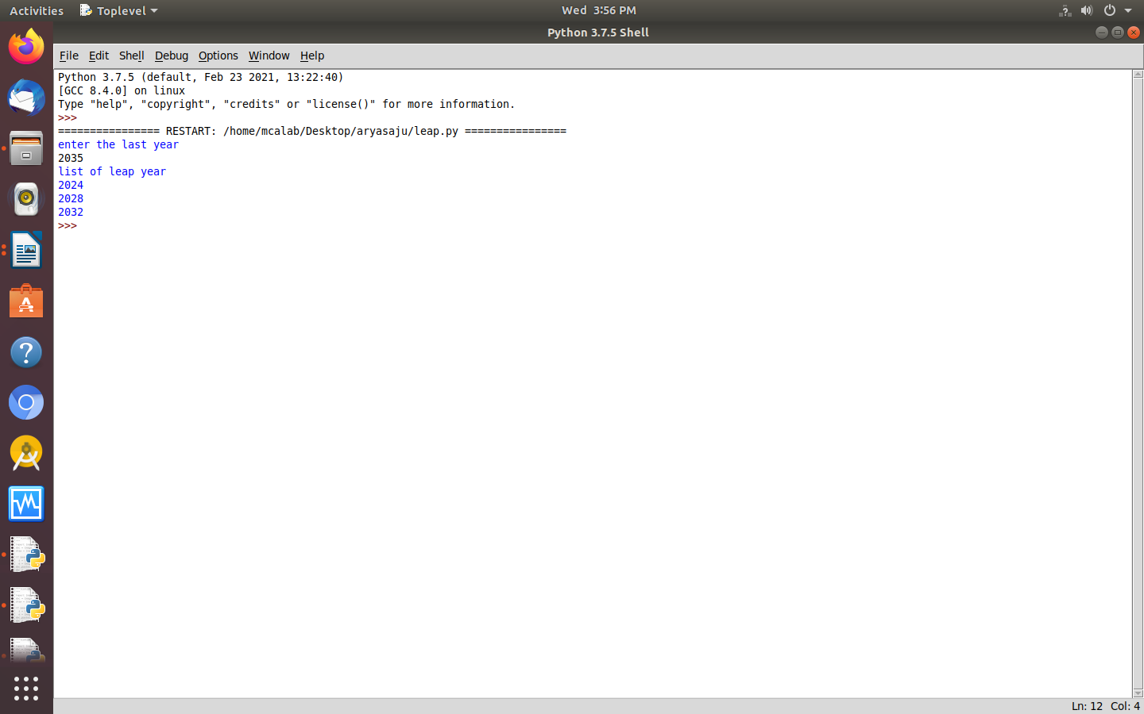

3. (a). POSITIVE NUMBERS FROM LIST

numbers=[34.6,-203.4,44.9,68.3,-12.2,44.6,12.7]
newlist=[n for n in numbers if n>0]
print(newlist)

op

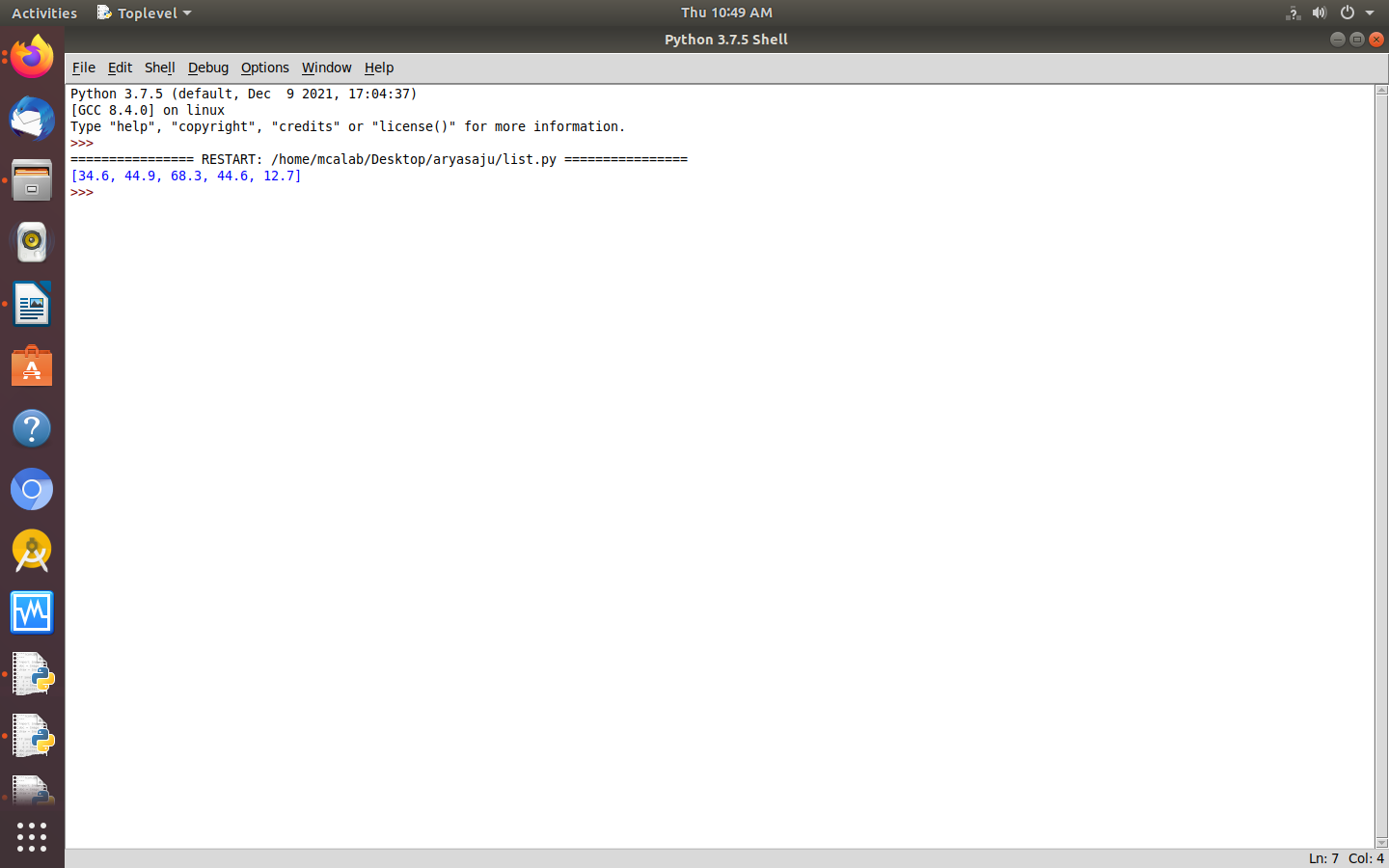

(b). SQR OF N NUMBERS

print("enter the limit")
n=int(input())
square=[i*i for i in range(n)]
print("sequence of n numbers\n",square)

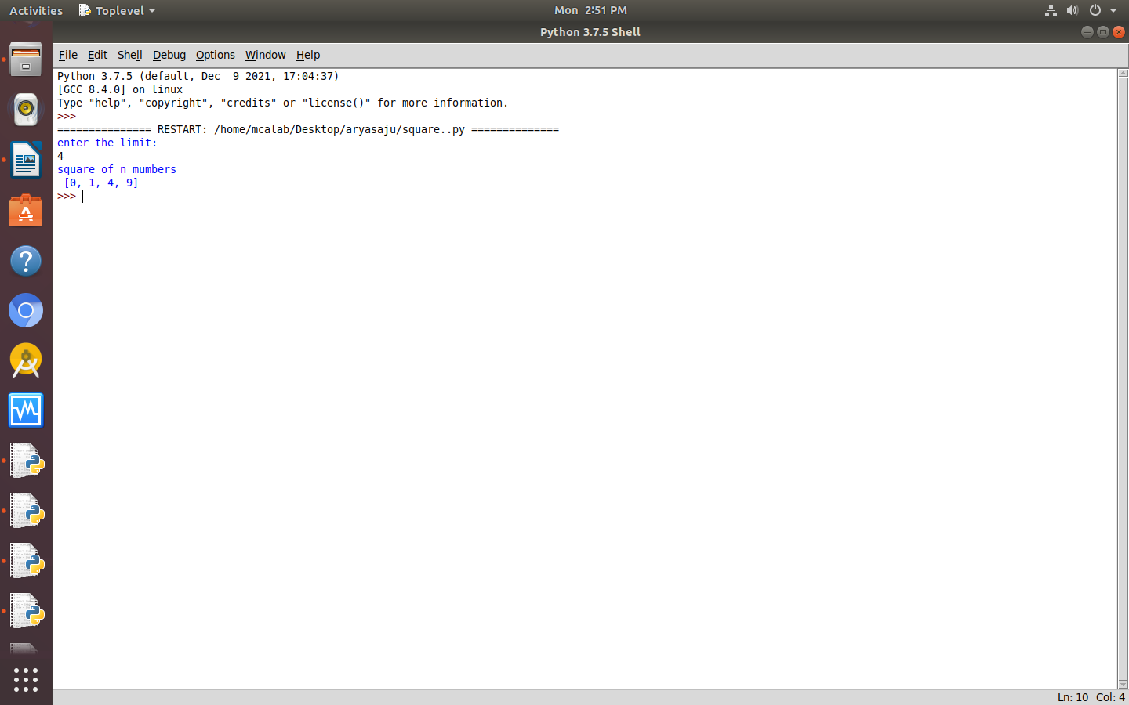
op

(c). VOWELS

word=input("enter the sentence \n")
vowels=['a','e','i','o','u',]
vow=[let for let in word if let in vowels]
print(vow)
word=input("enter the sentence\n")
vowels=['a','e','i','o','u']
vow=[let for let in word if let in vowels]
print((vow))

op

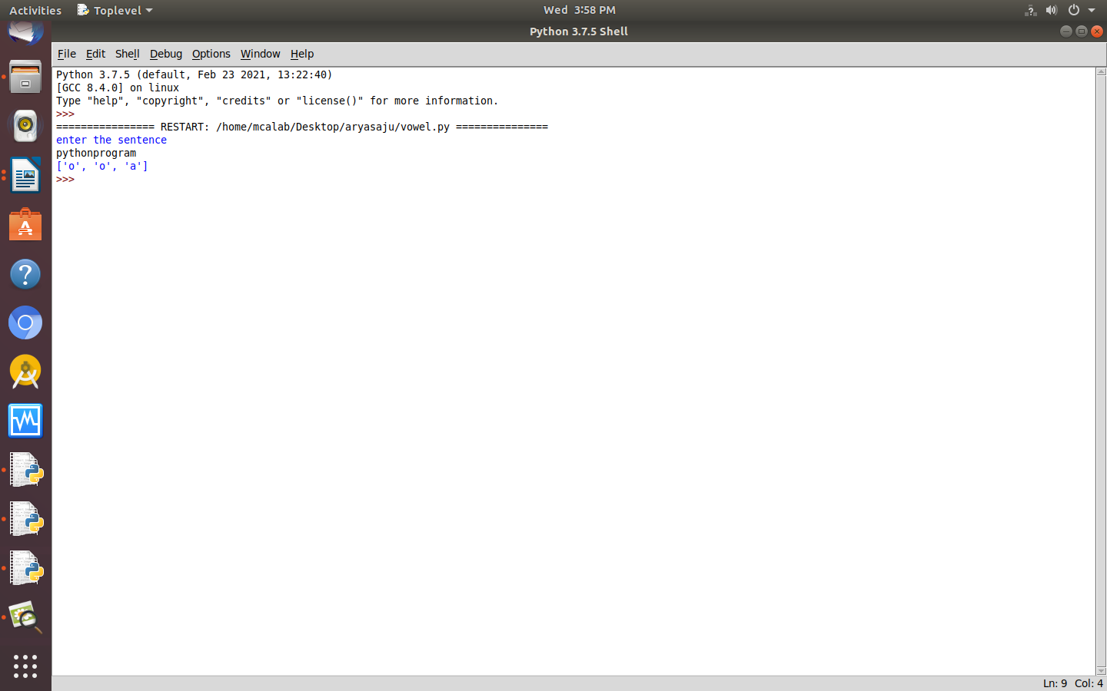

(d). ORDINAL VALUES

list1=['aravind','aparna']
print("the original list:\n"+str(list1))
res=[ord(ele) for sub in list1 for ele in sub]
print("the ASCII list is:\0n" +str(res))

op
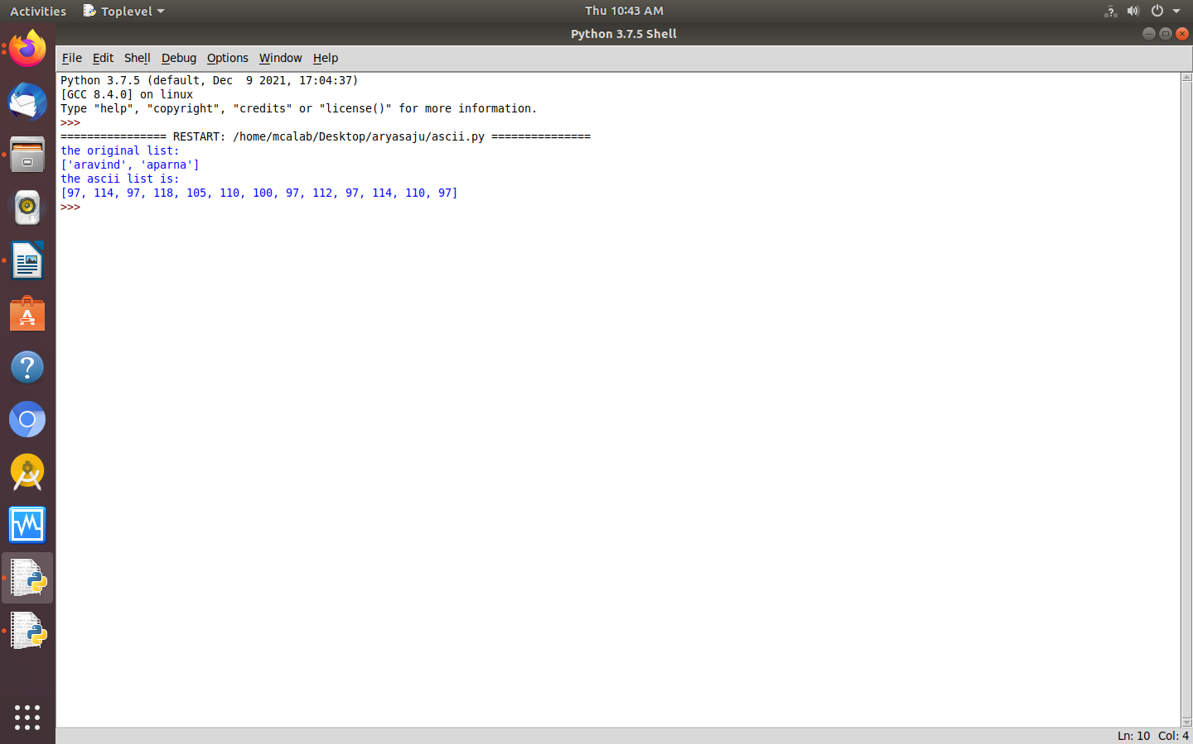

4.COUNT OF OCCURANCE

line=input("enter the line:")
count={}
sentence= line.split()
for word in sentence:
if word in count:
count[word]+=1
else:
count[word]=1
for k,v in count.items():
print(k,v)

op
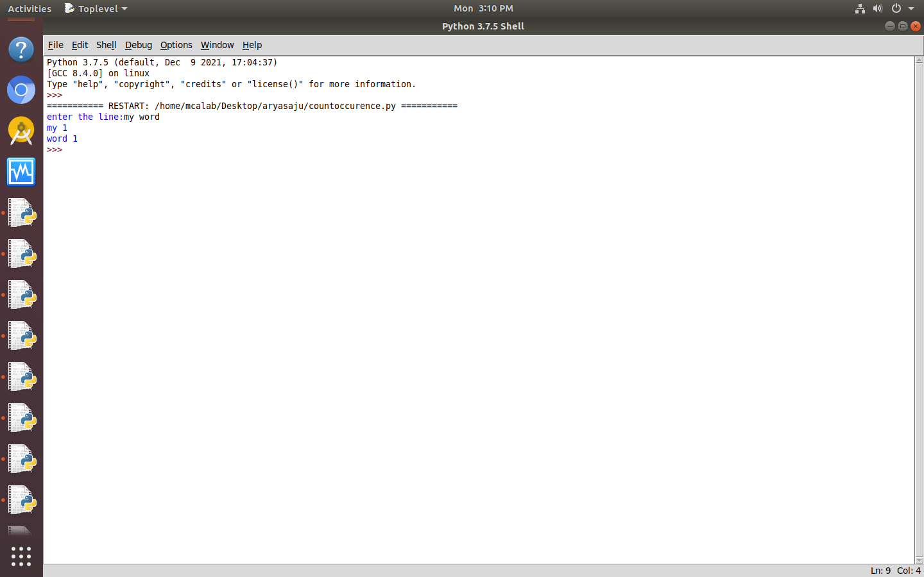

5. LIST OF INT GRTRTHN 100

list=[10,20,50,70,140]
result=[]
for i in list:
if i>100:
result.append('over')
else:
result.append(i)
print(result)

op
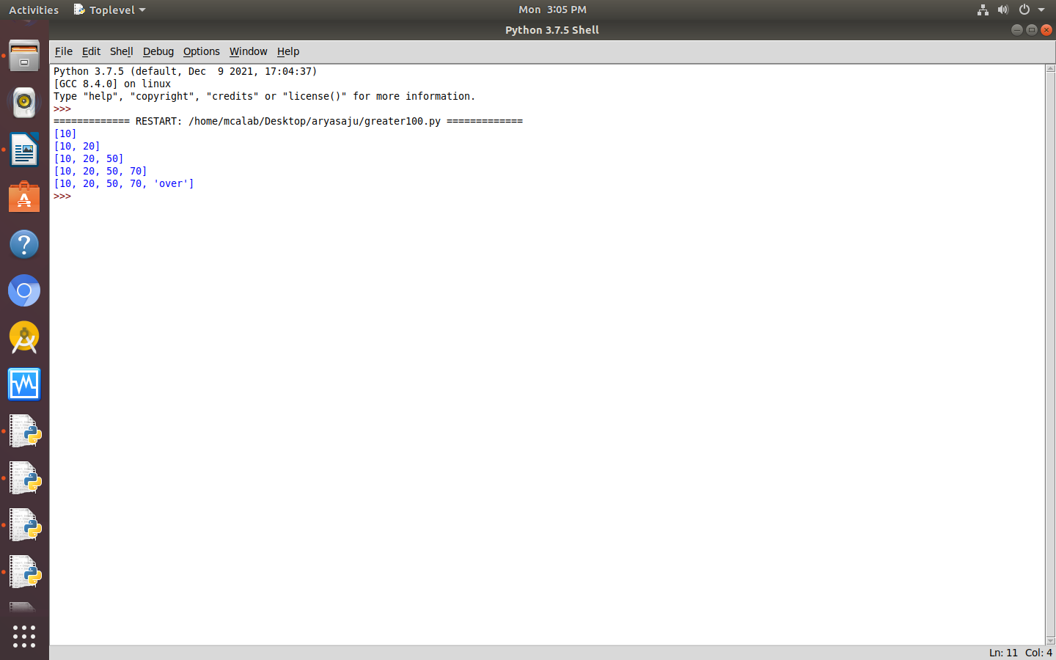

6. LIST OF NAMES

astr=input("enter the string\n")
char=input("enter the character \n")
print("given string:\n",astr)
print("given character:\n",char)
res=0
for i in range(len(astr)):
if(astr[i]==char):
res=res+1
print("number of time character is presnt in string:\n",res)

op
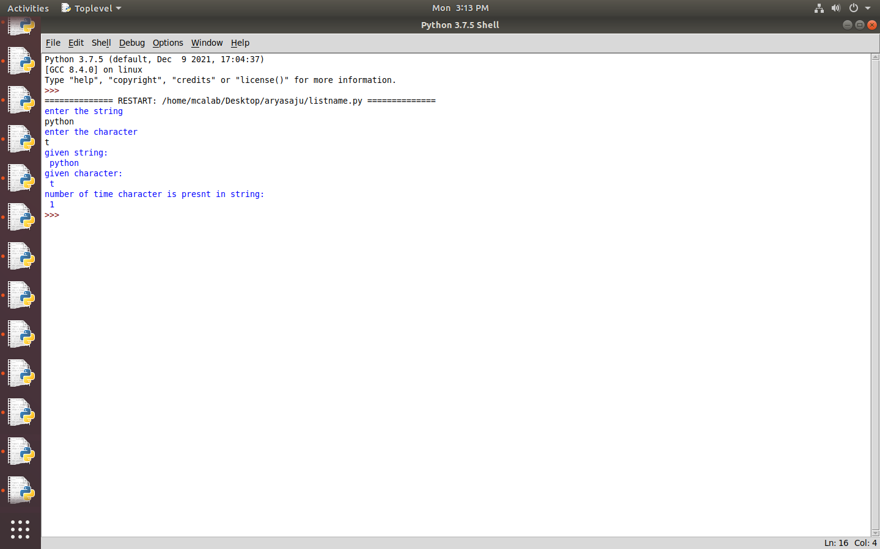

8. REPLACE

str1=input("enter a string")
char=str1[0]
str1=str1.replace(char,'$')
str1=char+str1[1:]
print("replaced string",str1)

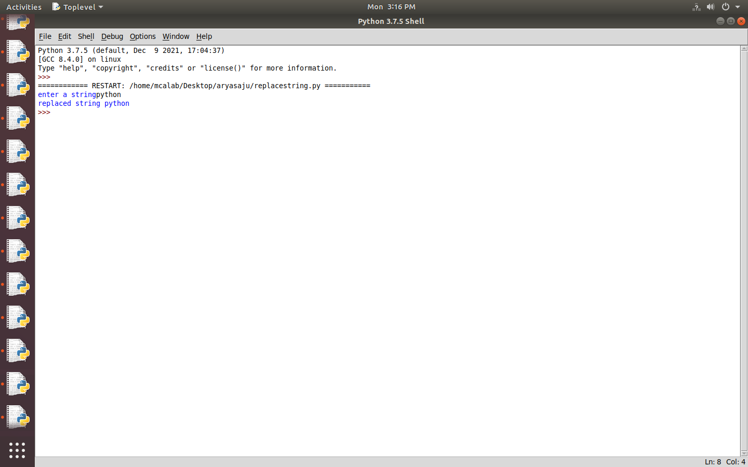
op

9.STRING EXHAUSTED
str1=input("enter a string")
print("string after swapping first and last character",str1[-1]+str1[1:-1]+str1[0])

OP
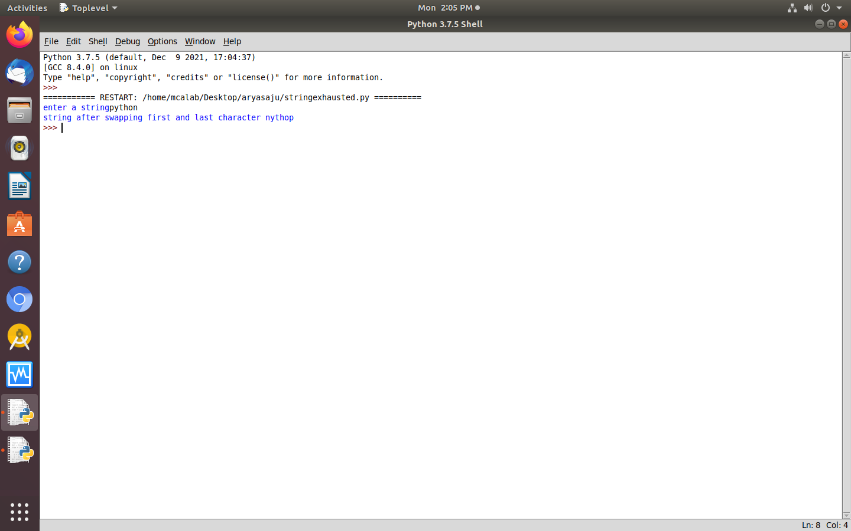

10, RADIUS OF CRCL

import math
r=float(input("enter the radius of the circle: "))
area=math.pi* r * r
print("%.2f" %area)

op
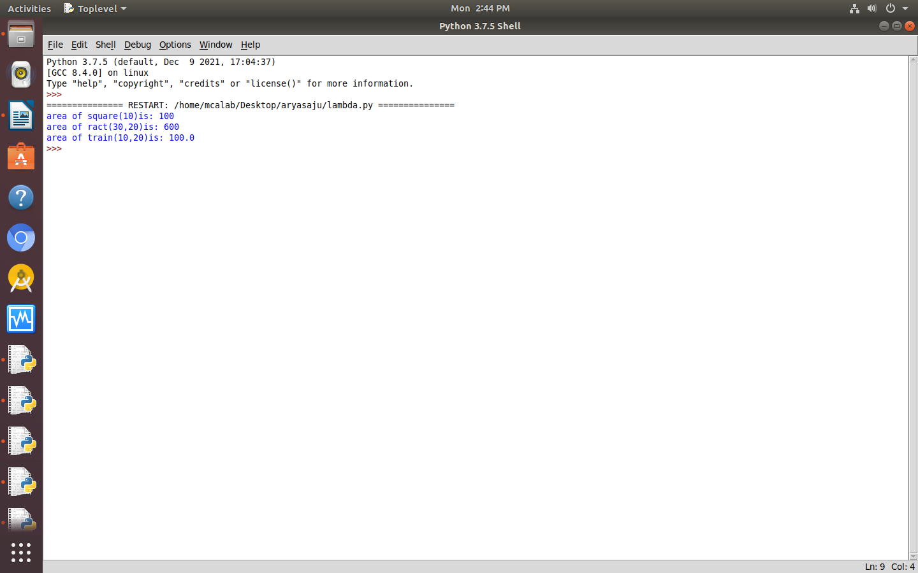

11. BIGGEST OF 3 NUM

a=10
b=14
c=12
print(max(a, b, c))

op
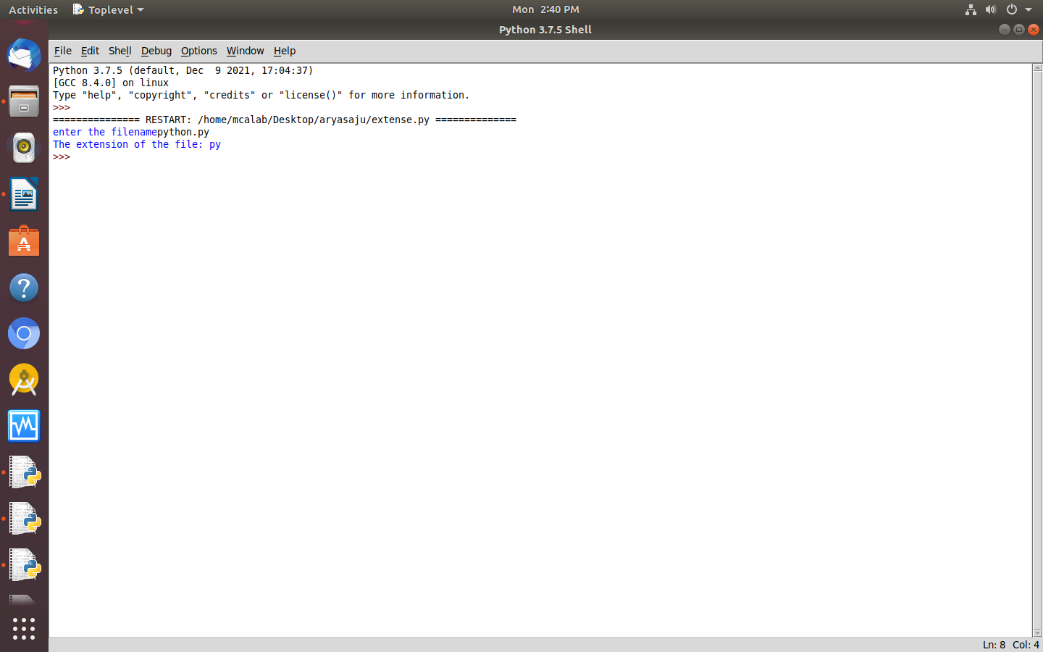

12. EXTENTION

filename=input("enter the filename:")
f_extns=filename.split(".")
print("the extension of the file is:",f_extns[-1])

op

13. COLOR

color=input("enter colors(space between colors):")
color_list=color.split(" ")
print(color_list)
print("the first color of the list is:",color_list[0],"and the last color is:",color_list[-1])

op
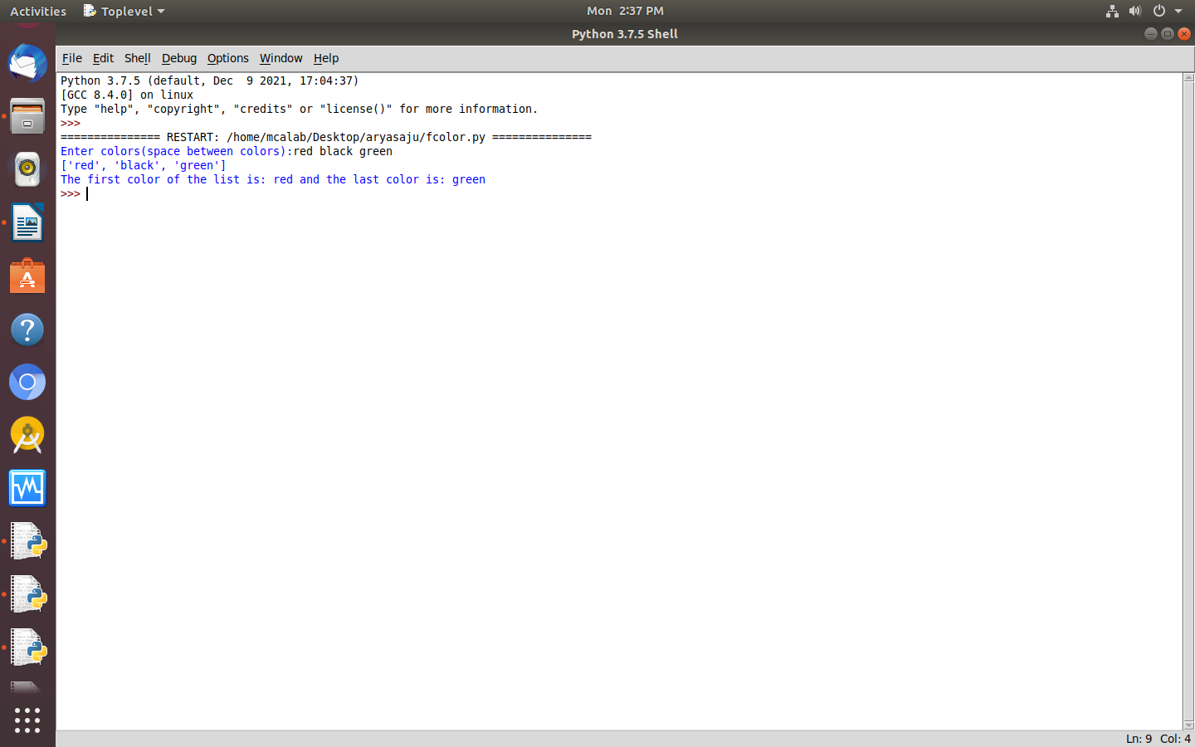

14. COMPUTE N

a=int(input("enter an integer:"))
n1=int("%s" %a)
n2=int("%s%s" %(a,a))
n3=int("%s%s%s" %(a,a,a))
print(n1," ",n2," ",n3)
print("sum=",(n1+n2+n3))

op

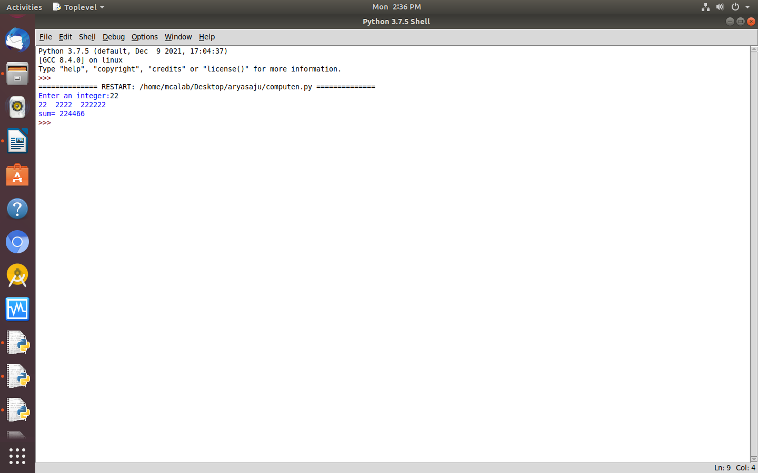

15. PRINT COLOR

color1=input("enter a set of colors(space seperated):")
color2=input("enter a set of colors(space seperated):")
c1=set(color1.split())
c2=set(color2.split())
print("the difference between",c1,"and",c2,"is",c1.difference(c2))

op
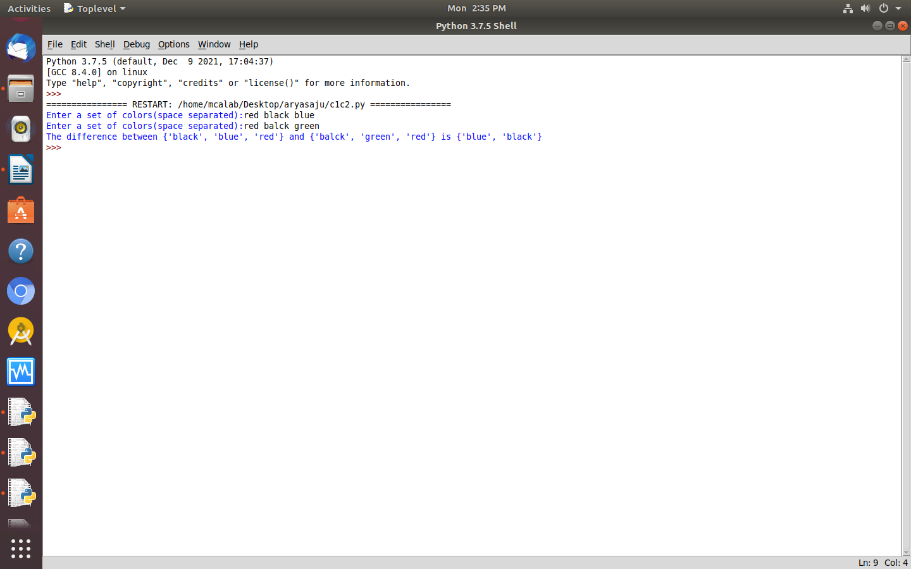

16. STRINGS

str1=input("enter the first string:")
str2=input("enter the second string:")
new_a=str2[:1]+str1[1:]
new_b=str1[:1]+str2[1:]
print("the new string after swapping first two characters of both string:",(new_a+''+new_b))

op
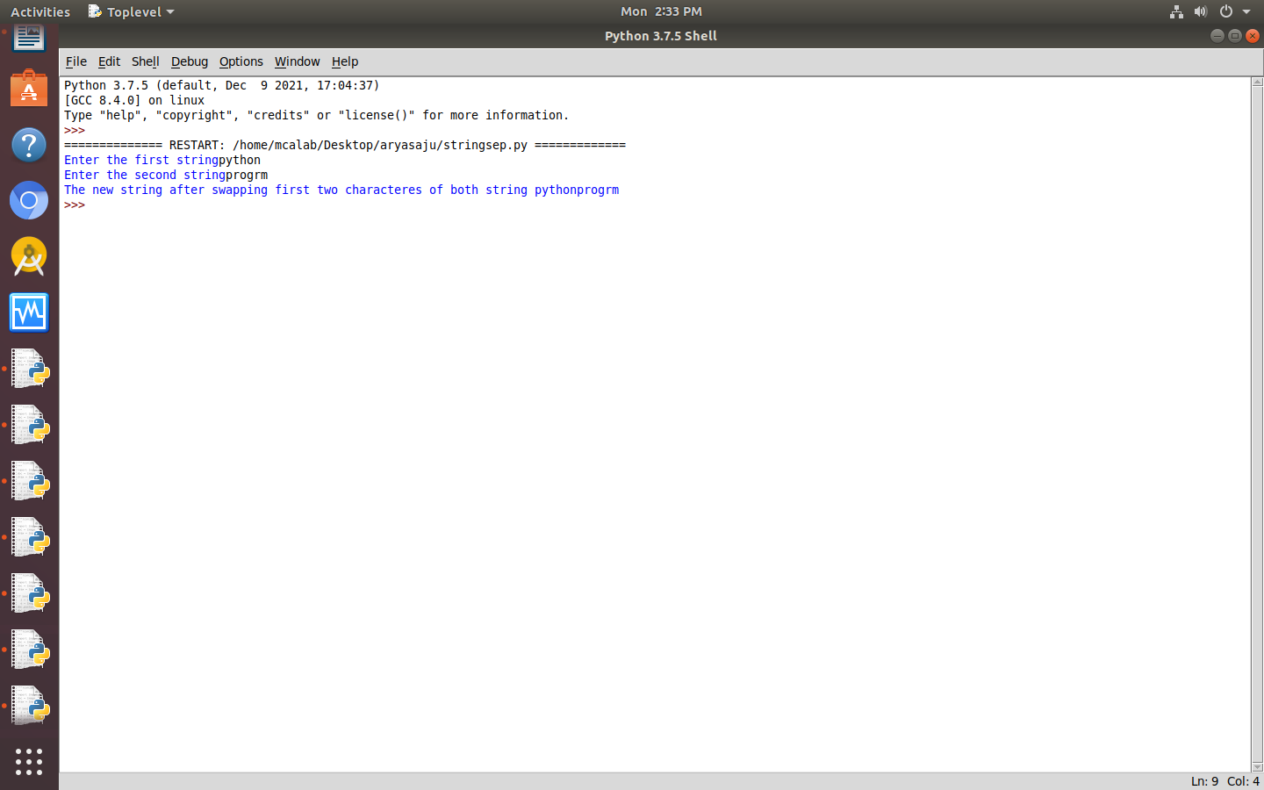

17. DICTIONARY

import operator
d={1:2,3:4,3:2,2:1,0:0}
print("original dictionary:",d)
sorted_d=sorted(d.items(),key=operator.itemgetter(1))
print("Dictionary is ascending order by value:",sorted_d)
sorted_d=sorted(d.items(),key=operator.itemgetter(1),reverse=True)
print("Dictionary in descending order by value:",sorted_d)

op
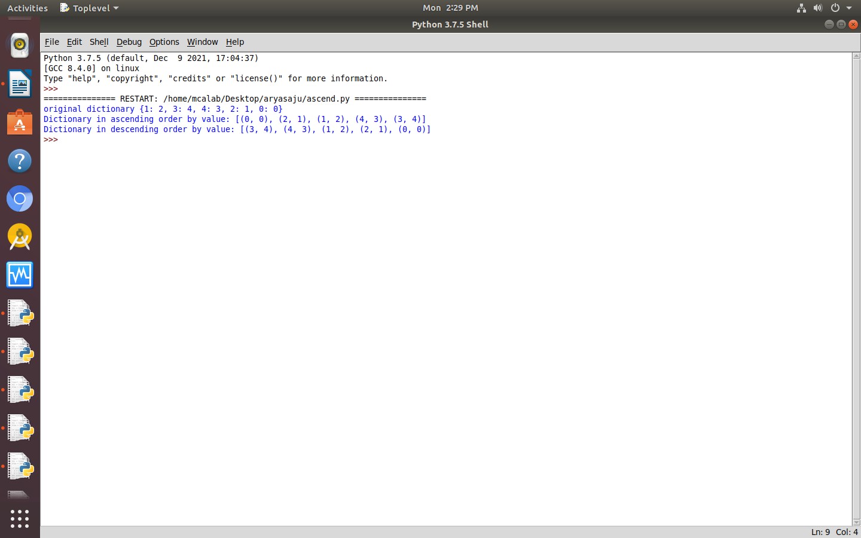

18. MERGE

d1={'a':100,'b':200}
d2={'x':300,'y':200}
print("Dictionary 1:",d1)
print("Dictionary 2:",d2)
d=d1.copy()
d.update(d2)
print("merged Dictionary:",d)

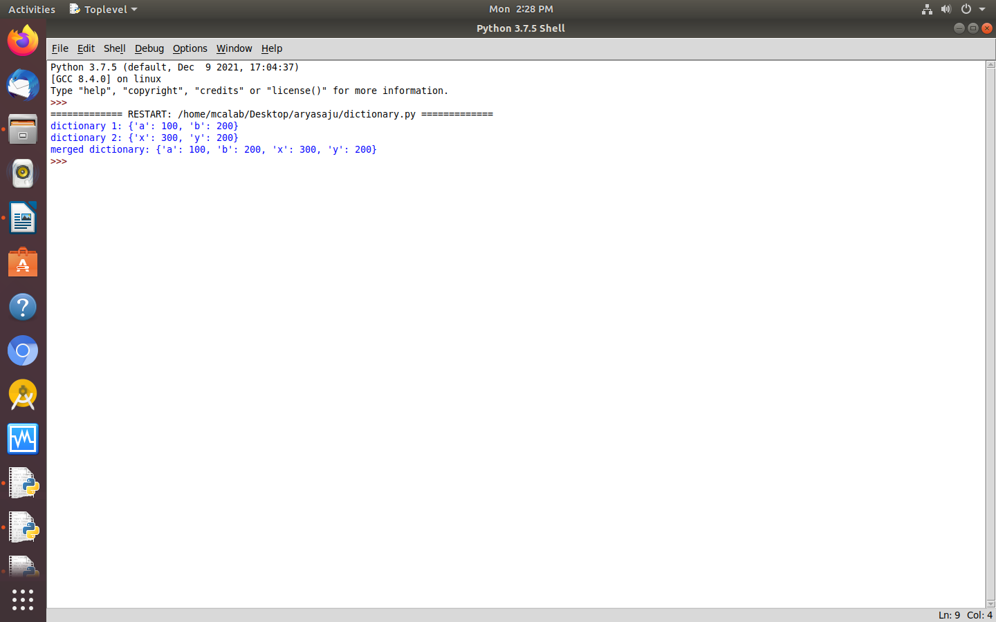
op

19. GCD

a=int(input("enter first number:"))
b=int(input("enter second number"))
for i in range(1,min(a,b)+1):
if(a%i==0 and b%i==0):
gcd=i
print("GCD of",a,"and",b,"is",gcd)

op
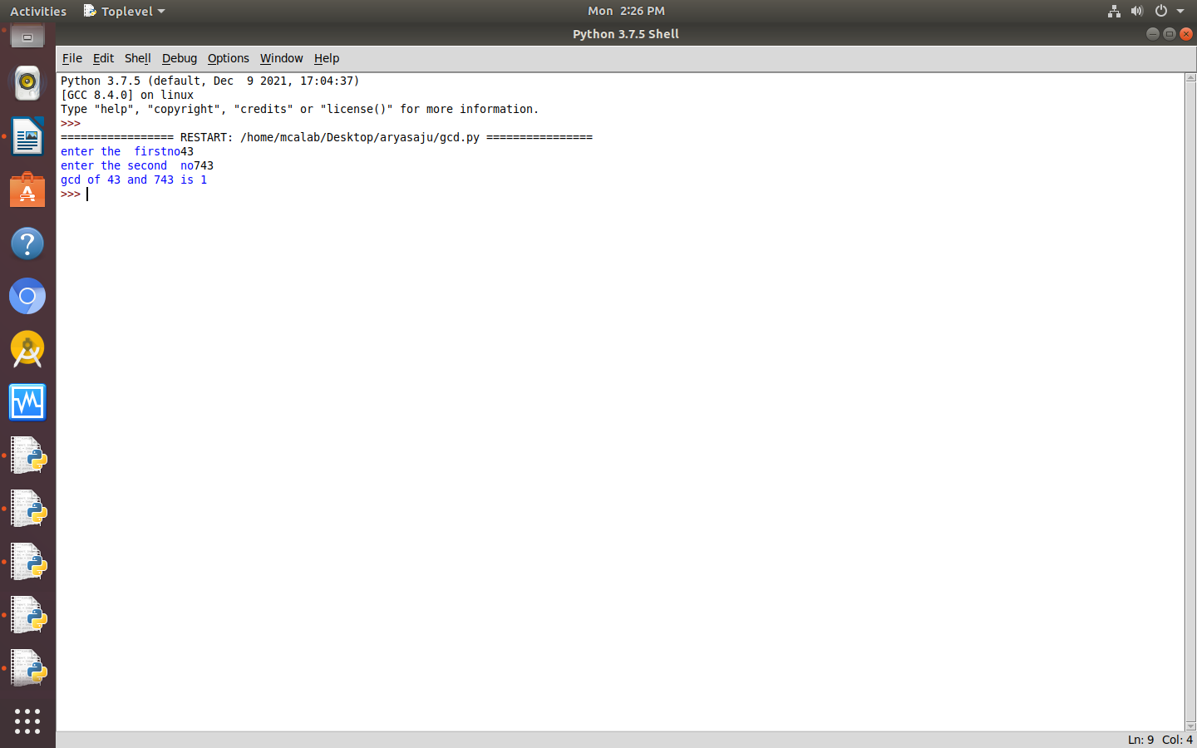

20. EVEN

num1=input("Enter an integer list(space separated):")
num=list(map(int,num1.split()))
num=[x for x in num if x%2!=0]
print("List after removing even numbers:",end='')
print(num)

op
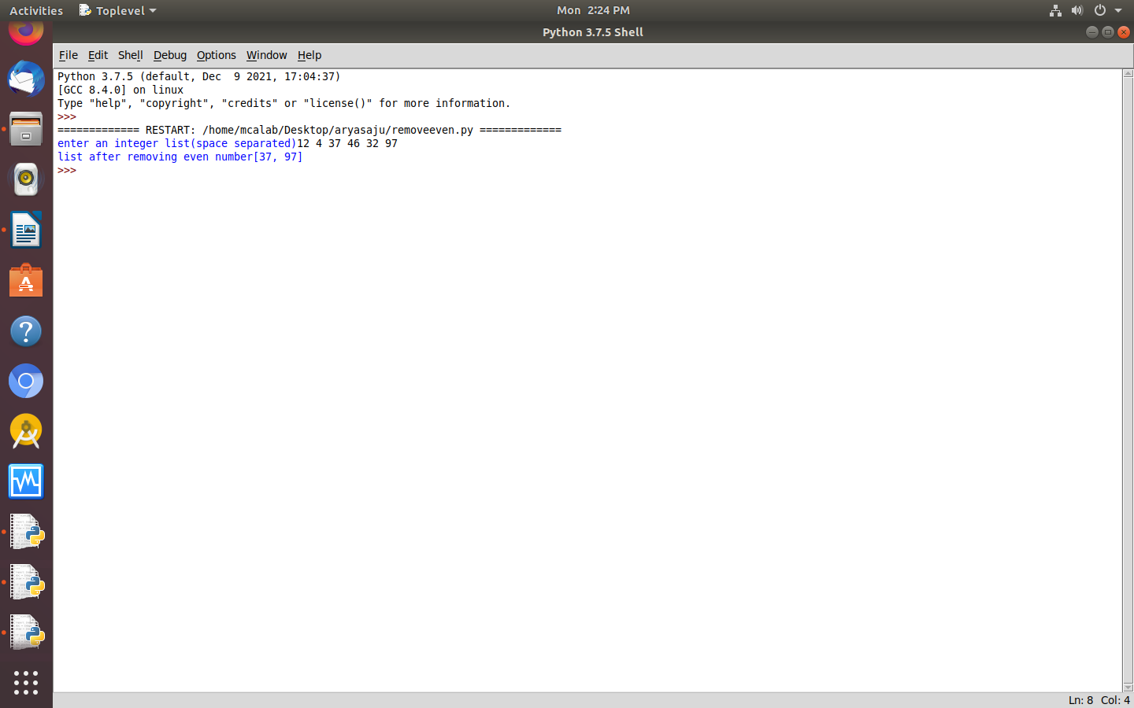

21. FACTORIAL

a=int(input("Enter the number:"))
fact=1
for i in range(1,a+1):
fact=fact*i
print("Factorial of",a,"is",fact)

op
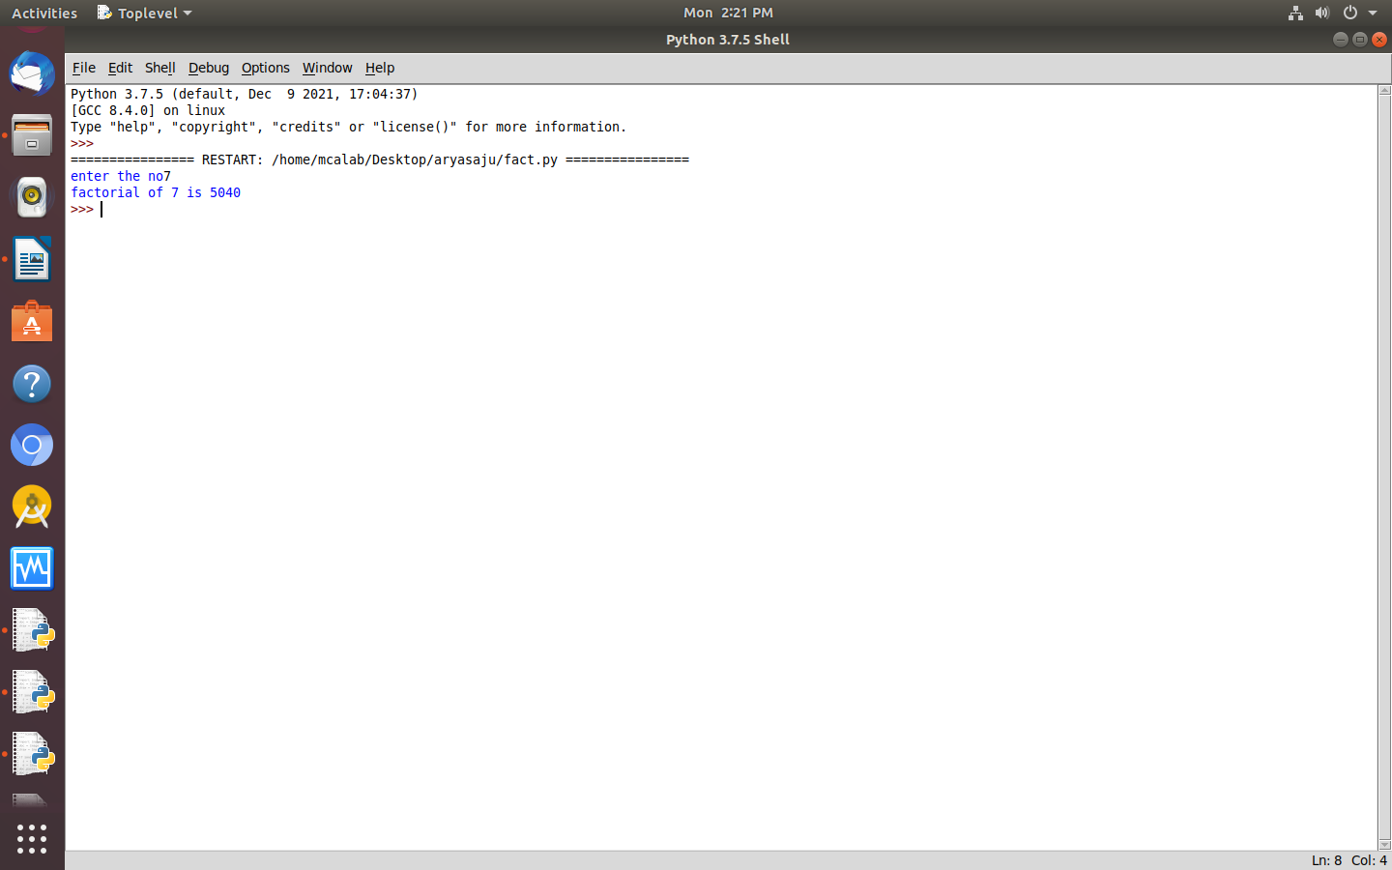

22.FIbanocci

n=int(input("Enter the number of terms:"))
f1,f2=0,1
f3=f1+f2
print("Fibonacci series of the first",n,"terms is:")
print(f1)
print(f2)
for i in range (3,n+1):
print(f3)
f1=f2
f2=f3
f3=f1+f2

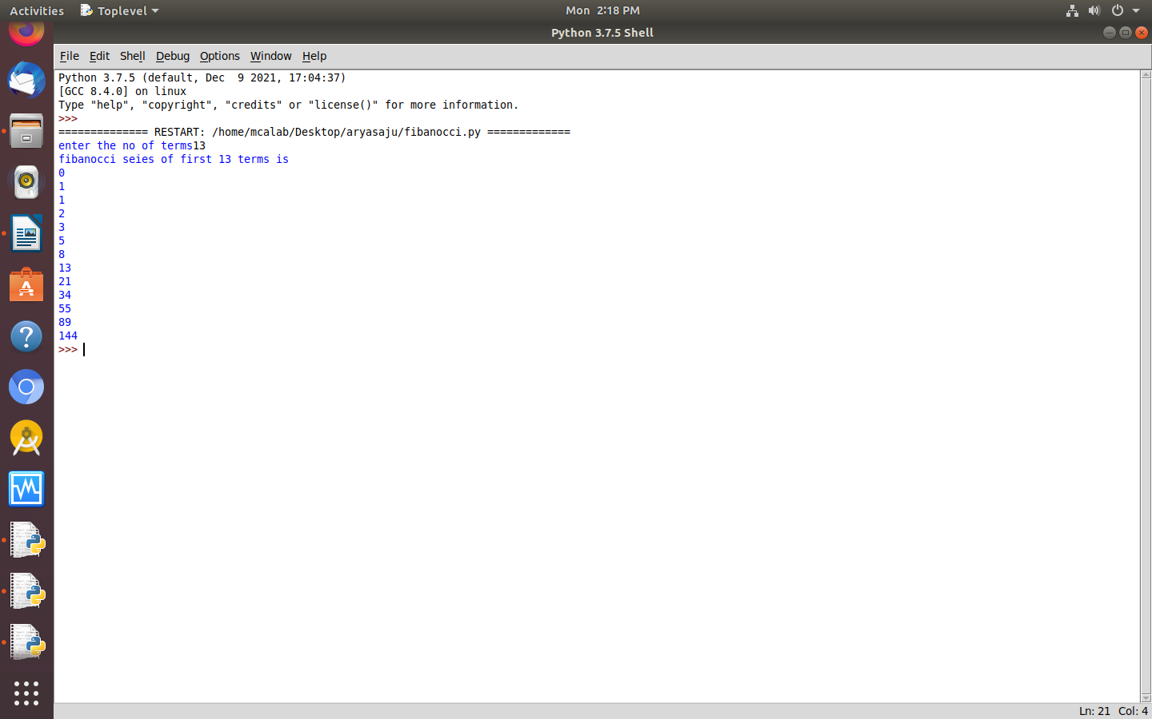
op

23. SUM OF LIST

list=input("Enter a list:")
list1=map(int,list.split())
sum=0
for i in list1:sum+=i
print("The sum of all items in list",list,"is",sum)

op
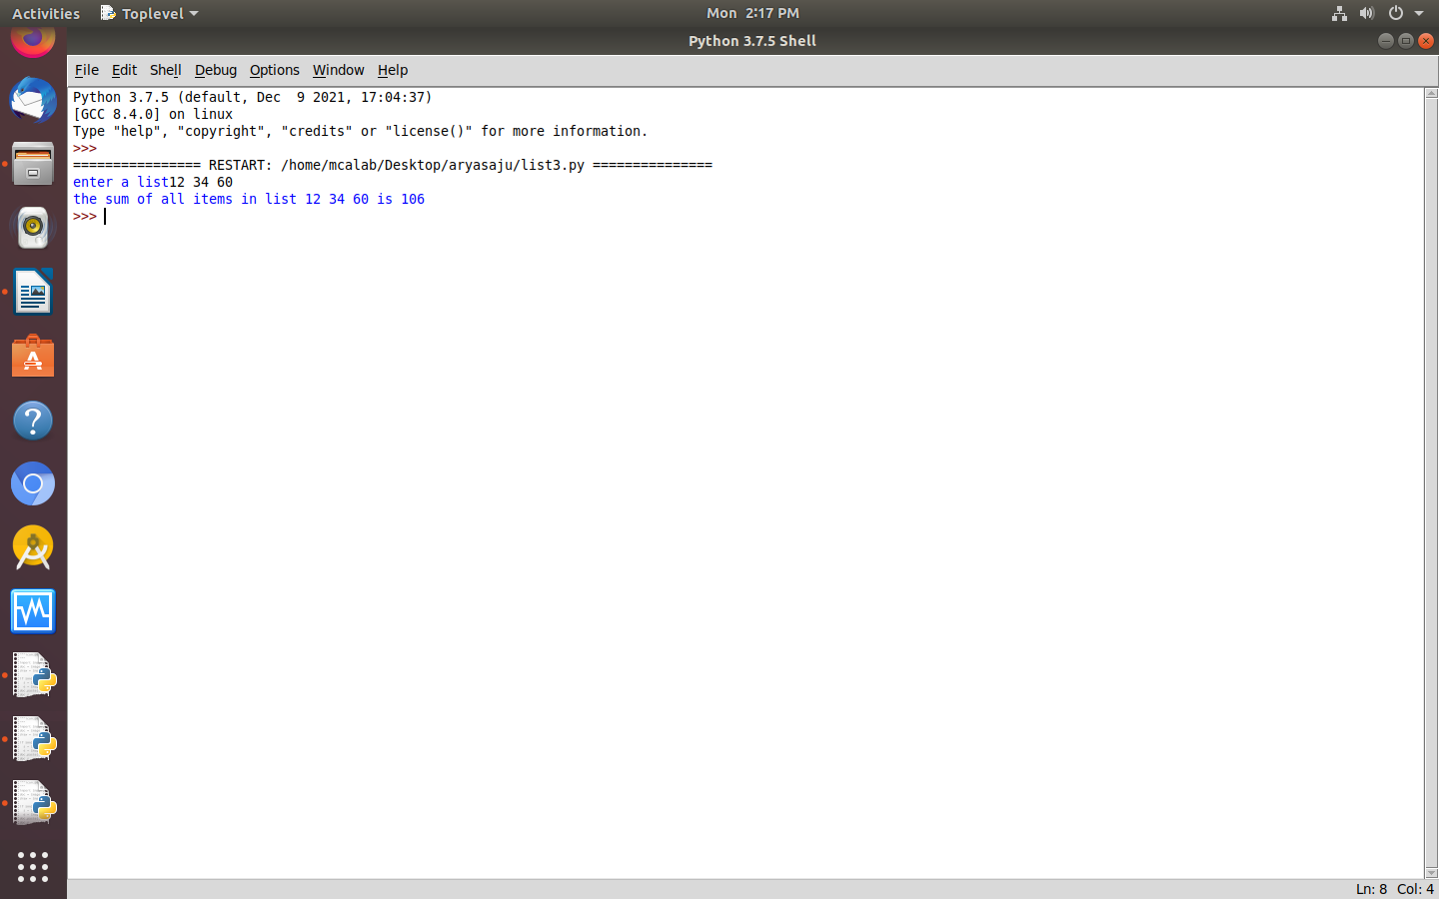

24. PERFECT SQR

import math
for i in range(1000,10000):
num=int(math.sqrt(i))
if num*num==i:
n=i
while n!=0:
r=n%10
n=n//10
if r%2!=0: break
else:print(i)

op

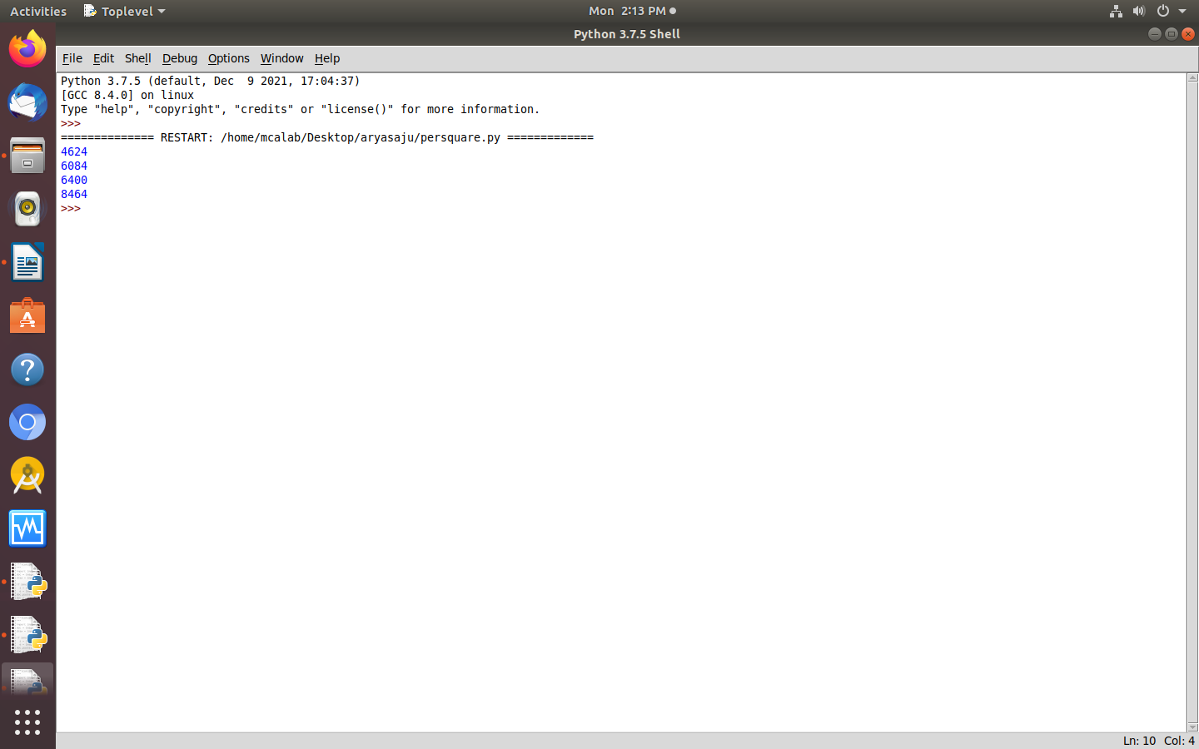

25. PYRMD NMBR

#program for pyramid
n=int(input("enter the step size:"))
for i in range(1,n+1):
k=1
for j in range(1,i+1):
print(k,end=' ')
k+=i
print()

op
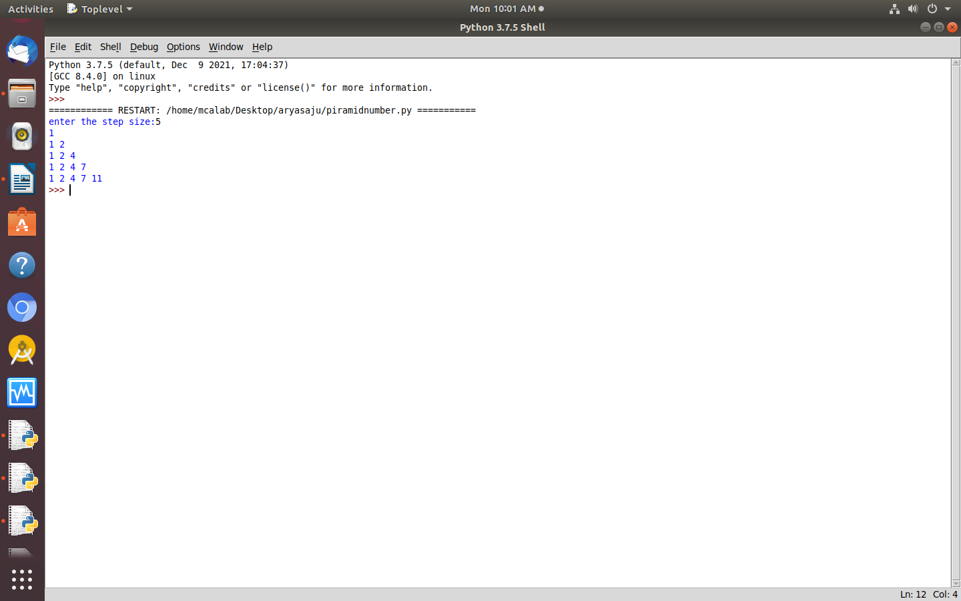

26. COUNT NO OF CHAR

dict={}
str1=input("Enter a string:")
for n in str1:
if n in dict:
dict[n]+=1
else:
dict[n]=1
print("Character frequency")
for k,v in dict.items():
print(k,v)

op

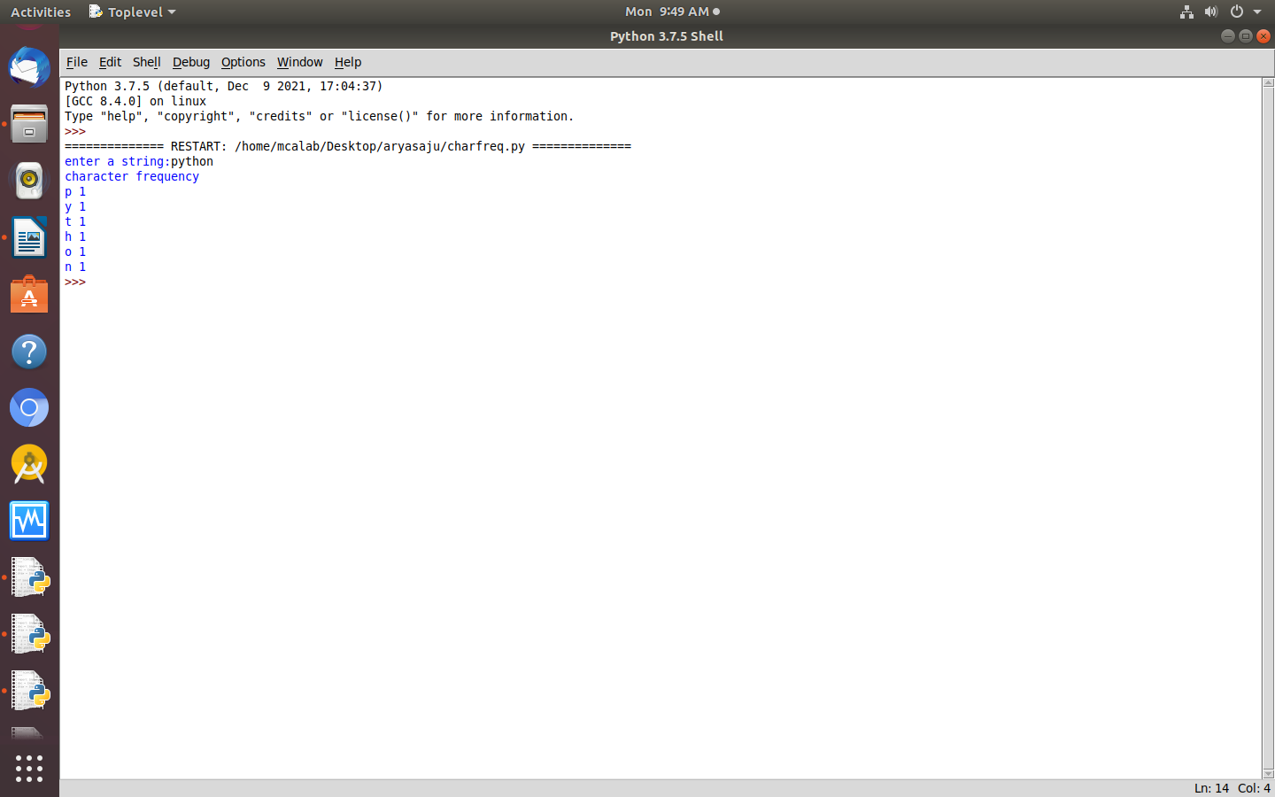

27. ING

def add_string(str1):
length=len(str1)
if length>2:
if str1[-3:]=='ing':
str1+='1y'
else:
str1+='ing'
return str1
print(add_string('ab'))
print(add_string('abc'))
print(add_string('string'))

op

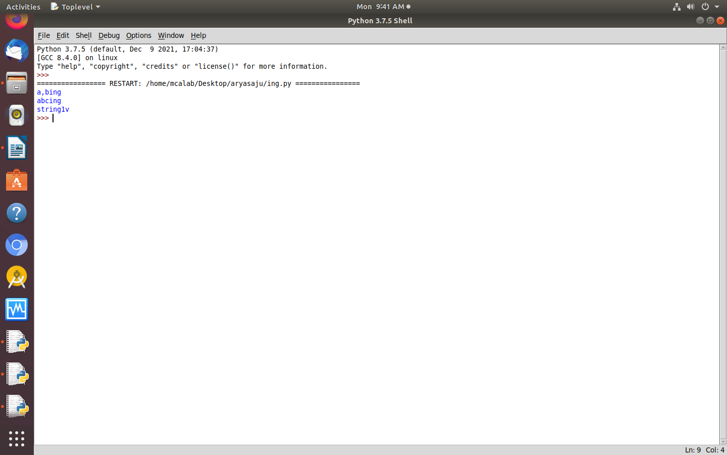

28. PATTERN

n=5
for i in range(n):
for j in range(i):
print("*",end="")
print('')
for i in range(n,0,-1):
for j in range(i):
print('*',end="")
print('')

op
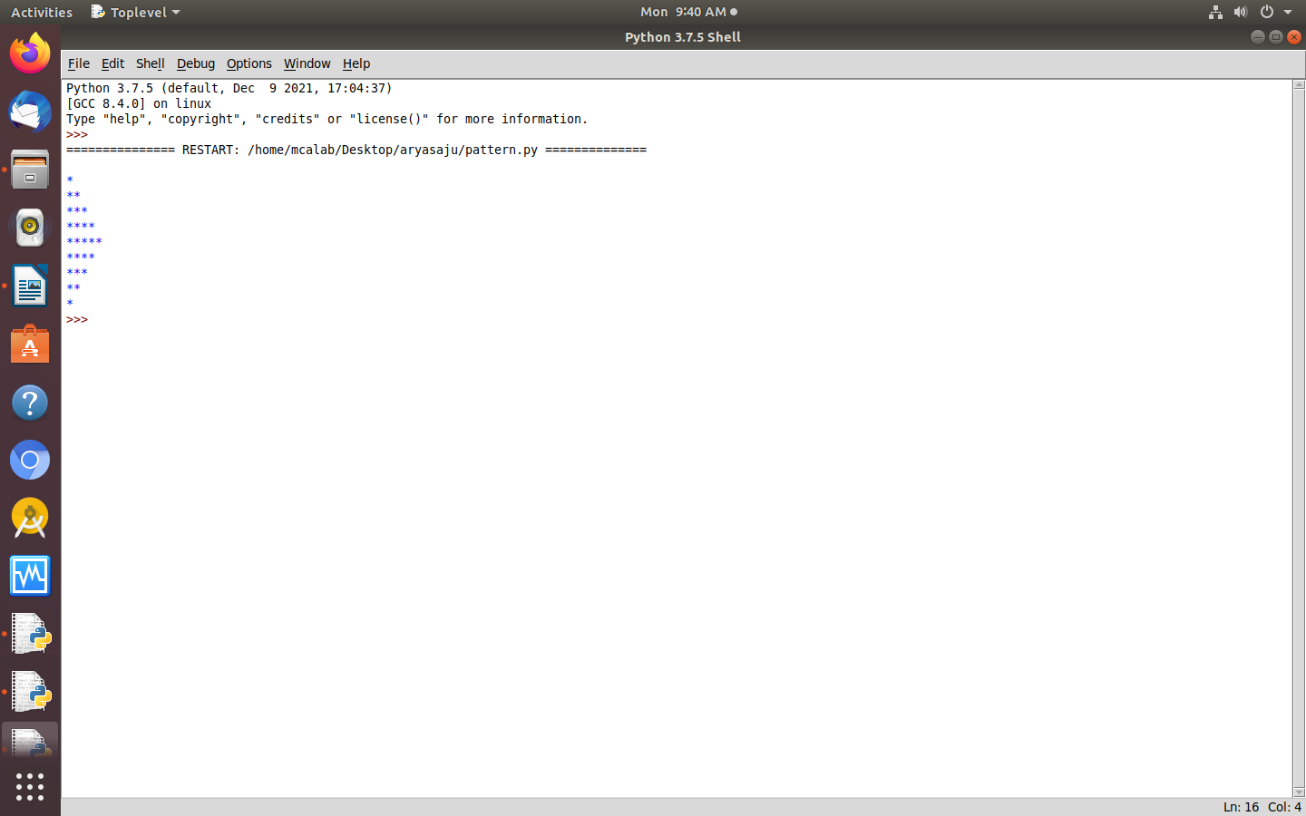

29. LENGTH OF WORD

def longestLength(a):
max1=len(a[0])
temp=a[0]
for i in a:
if(len(i)>max1):
max1=len(i)
temp=i

print("the word with the longest length is:", temp, "and length is", max1)
a=["one","two","three"]
longestLength(a)

op
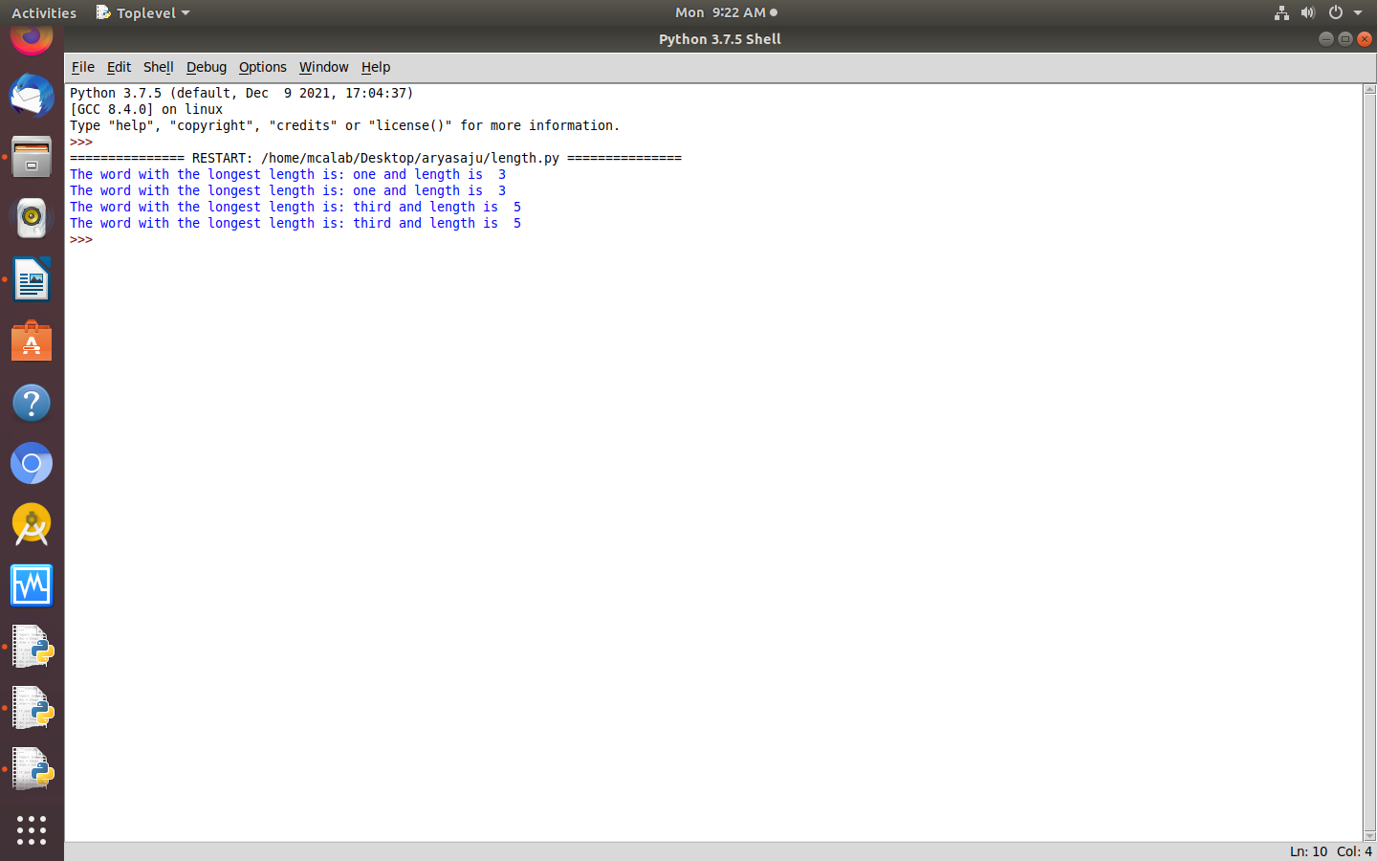

30. FACTORS

def print_factors(x):
print("the factors of",x,"are:")
for i in range(1,x+1):
if x % i ==0:
print(i)
num=320
print_factors(num)

op

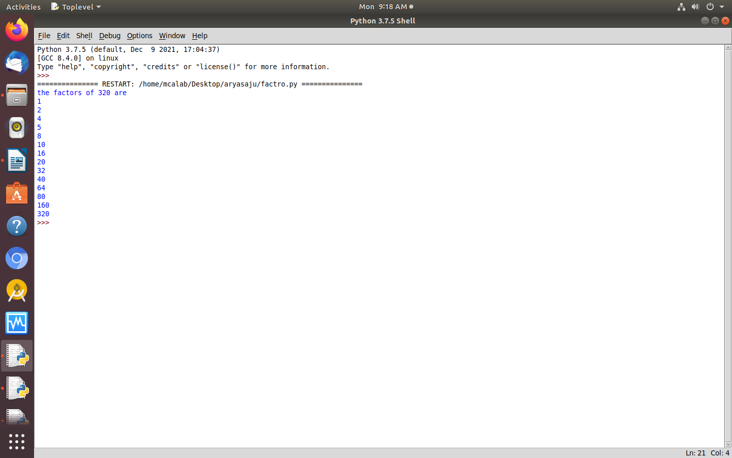

31. AREA USING LAMBDA

import math
s_area=lambda a:a**2
r_area=lambda len,ht:len*ht
t_area=lambda b,h:(1/2)*b*h
print("area of square(10) is:",s_area(10))
print("area of rectangle(30,20)is:",r_area(30,20))
print("area of triangle(10,20) is:",t_area(10,20))

op

