**Project 3: IoT based Health Monitoring System Using ESP32**

**1. ABSTRACT**

The rapid advancement of digital health technologies and the increasing integration of smart monitoring systems into the healthcare sector have transformed the way patient data is collected, processed, and utilized. In this project, we undertook the design and development of a health monitoring system titled **HealthX**, which leverages sensors, microcontrollers, and cloud-based platforms to continuously monitor vital health parameters such as body temperature and heart rate. The motivation behind this work originates from the growing demand for reliable, real-time, and remote patient monitoring solutions in a world where lifestyle-related illnesses, pandemics, and rising medical costs emphasize the need for early detection and preventive healthcare practices. By embedding sensor-based devices with IoT (Internet of Things) integration, we aimed to construct a solution that not only provides accuracy in measurement but also enables long-term storage, visualization, and analysis of health data through cloud dashboards.

The purpose of HealthX is twofold. First, it provides individuals, patients, and caregivers with an affordable yet reliable method of monitoring vital signs without the constant presence of a medical professional. Second, it aims to contribute to the larger ecosystem of telemedicine and digital healthcare solutions that allow hospitals and institutions to remotely supervise patients while reducing operational load and costs. The development of HealthX involved a combination of hardware and software approaches, where sensor modules were interfaced with microcontrollers for real-time acquisition of physiological signals, and the data was subsequently transmitted to a cloud server for visualization and analysis. The experimental results, as displayed through a dashboard interface, demonstrated promising levels of accuracy and reliability, confirming the potential of HealthX to serve as a practical prototype for wider deployment in the healthcare sector.

The core methodological framework of this project revolved around three essential stages: **data acquisition, transmission, and visualization.** During the data acquisition stage, two key parameters - heart rate (measured in Beats Per Minute, BPM) and body temperature -were continuously captured using appropriate sensors. The transmission stage made use of IoT-enabled microcontrollers that relayed the acquired sensor data to the cloud platform in real time. Finally, the visualization stage was realized through a web-based dashboard, where graphical representations and numerical indicators of the physiological parameters allowed for intuitive interpretation. The image captured from our dashboard system, showing a body temperature of 64 and a BPM value of 60 exemplifies the success of our implementation, where the system was able to effectively sense, process, and display values under experimental conditions.

From an implementation perspective, HealthX demonstrates how accessible technologies such as NodeMCU/ESP8266 or ESP32, in conjunction with open-source cloud platforms, can be harnessed to create robust healthcare solutions. A critical factor in this process was ensuring reliable communication between the sensors and the cloud server, minimizing data loss, and addressing issues of latency that could compromise the integrity of health monitoring. The resulting system offered both graphical gauges (such as the semi-circular temperature indicator ranging from -40 to 180) and simple numerical displays (such as the BPM counter), thus covering both detailed and quick-read requirements for end-users.

The outcomes of this project extend beyond the immediate results displayed in the dashboard. The development of HealthX provides insights into the broader implications of digital health monitoring. It showcases the potential of integrating such devices into smart healthcare ecosystems, where data from multiple individuals could be stored, aggregated, and analyzed to identify patterns, predict health risks, and facilitate evidence-based medical interventions. The system also opens pathways for AI-driven predictive analytics, where continuous datasets of heart rate and temperature could be used to forecast anomalies and alert patients or medical professionals in advance.

Despite its achievements, HealthX also revealed certain challenges that warrant discussion. External environmental conditions can have a significant effect on the accuracy of the temperature readings, necessitating additional filtering and compensation mechanisms. Similarly, the BPM sensor can exhibit fluctuations due to minor movements or external disturbances, indicating the need for advanced signal processing algorithms to smooth out noise and enhance reliability. On the cloud side, while the dashboard provided intuitive displays, scalability and security considerations became evident, particularly in scenarios where sensitive health data would be transmitted and stored for multiple patients. These findings emphasize that while HealthX stands as a successful prototype, further refinements are essential before it can be scaled into a fully-fledged healthcare product.

The social impact of such systems cannot be overstated. By enabling patients, particularly those in rural or under-resourced areas, to track vital parameters without requiring continuous clinical visits, HealthX bridges the accessibility gap in healthcare. This can lead to early detection of critical conditions such as fever, infections, or cardiac irregularities, thereby reducing the burden on hospitals and improving overall public health outcomes. In addition, the integration of real-time cloud monitoring ensures that doctors and caregivers can remain informed even when patients are geographically distant. The empowerment of individuals with self-monitoring tools also fosters a culture of preventive healthcare, where individuals become active participants in their health journey rather than passive recipients of medical interventions.

In summary, this project contributes to the evolving landscape of digit.0.al healthcare by demonstrating the feasibility of low-cost, IoT-enabled health monitoring systems. Through the successful design, development, and testing of HealthX, we established a framework for continuous monitoring of vital signs and their visualization via a user-friendly dashboard. The prototype not only validates the technical possibility but also underscores the broader societal need for accessible healthcare technologies. While improvements in accuracy, data security, and scalability are necessary for future deployments, the results achieved affirm that HealthX represents a meaningful step towards democratizing healthcare monitoring.

The work presented in this report has wide-ranging future scope. Expanding the range of parameters to include SpO₂ (blood oxygen levels), ECG (electrocardiogram), and respiratory rate could significantly enhance the utility of the system. Furthermore, implementing AI-based anomaly detection and predictive algorithms could make HealthX not just a monitoring device but a proactive diagnostic assistant. On a systemic level, integration with hospital information systems and electronic medical records could establish HealthX as a vital component of smart healthcare infrastructure. Ultimately, the broader vision driving this project is to contribute to a healthcare environment that is preventive, predictive, personalized, and participatory—a vision where technology augments human well-being in every possible way.

Thus, the extended abstract of HealthX emphasizes the holistic journey of this project, from motivation and methodology to results, implications, and future scope, spanning the intersection of engineering, medicine, and societal welfare. By documenting this process in detail, we not only highlight the success of our prototype but also invite future researchers, innovators, and institutions to build upon this foundation and accelerate the transformation of global healthcare delivery.

**2. INTRODUCTION**

In recent years, healthcare technology has undergone a tremendous transformation with the integration of digital systems, embedded devices, and real-time data analysis. The advancement of the Internet of Things (IoT) has made it possible to bridge the gap between patients and healthcare professionals, enabling continuous monitoring, early diagnosis, and personalized treatment. Against this backdrop, I undertook the development of HealthX, a health monitoring solution that measures crucial physiological parameters such as heart rate (BPM) and body temperature, and transmits them to a centralized dashboard for visualization and interpretation. This project was motivated by the need to create a reliable, real-time, and user-friendly healthcare monitoring system that could potentially serve individuals at home, patients in remote areas, or even hospital wards where continuous supervision is essential.

The significance of this project lies in the fact that health indicators such as heart rate and temperature are among the most fundamental metrics of the human body. Both parameters are vital signs that reflect the overall well-being of an individual and provide valuable clues to physicians regarding the onset of medical conditions. For instance, a deviation in heart rate from the normal range could indicate arrhythmia, stress, dehydration, or cardiovascular issues, while abnormal body temperature often signals infection, fever, metabolic problems, or thermoregulatory disorders. Traditionally, these values are checked manually by medical personnel using instruments such as thermometers or pulse monitors. However, such manual methods are often not suitable for continuous observation and can miss critical events that occur between periodic measurements. This limitation provided the motivation to design a system that integrates sensors with IoT technology to record, transmit, and visualize these values in real-time.

In designing HealthX, I wanted to combine three critical aspects: accuracy, accessibility, and automation. Accuracy is indispensable because erroneous values may lead to wrong clinical decisions. Accessibility ensures that the system can be used not only in technologically advanced healthcare setups but also by individuals at home or in remote locations. Automation eliminates the need for manual intervention, making health monitoring seamless and less prone to human error. These goals guided every stage of the project, from hardware selection to software design and data visualization.

The foundation of this project rests on the IoT paradigm, which involves interconnecting sensors, microcontrollers, and cloud platforms to collect and analyze data. IoT in healthcare, often termed the Internet of Medical Things (IoMT), has emerged as one of the fastest-growing domains because of its ability to transform reactive healthcare into proactive care. Instead of waiting for symptoms to worsen and then seeking medical attention, IoT systems enable the early detection of anomalies by continuously observing physiological signals. By implementing IoT in HealthX, I ensured that data could not only be sensed but also stored, shared, and displayed in a meaningful format for end-users. For this purpose, a web-based or cloud-connected dashboard was used where heart rate and temperature readings are updated in real-time, ensuring that both patients and doctors can interpret the values easily.

The choice of parameters for this project was deliberate. Heart rate and temperature are universally recognized, simple to interpret, and essential for any medical examination. More importantly, they are non-invasive to measure, which means they can be tracked without causing discomfort to the individual. In designing the system, I integrated a pulse sensor to detect heart rate in beats per minute (BPM) and a temperature sensor to capture body temperature. These sensors were connected to a microcontroller, which processed the signals and transmitted them to the IoT platform. Once the data reached the cloud, it was visualized on a dashboard with clear indicators, such as numerical displays and graphical dials, which made interpretation intuitive even for non-technical users.

HealthX also demonstrates the potential of IoT for remote health monitoring. With this system, it is possible to observe patient vitals without being physically present. This aspect is particularly important in scenarios such as rural healthcare, post-operative recovery at home, elderly care, and emergency situations. For instance, if an elderly person lives alone, HealthX can serve as a silent guardian that continuously observes their vital signs and raises alerts if abnormalities are detected. Similarly, in hospitals with limited staff, the system can help reduce the burden on nurses by automating routine checks. This reflects the practical value of the system in modern healthcare ecosystems.

Another driving factor behind this project was the global context of rising chronic diseases and the increasing need for efficient healthcare management. Cardiovascular diseases, for example, remain one of the leading causes of death worldwide. Monitoring heart rate regularly can help detect early signs of such conditions. Likewise, monitoring body temperature is vital not only for detecting fevers but also for identifying abnormal thermoregulatory conditions in patients with metabolic disorders. By integrating both parameters into a single IoT platform, HealthX brings together essential health metrics that can assist in preventive healthcare.

The implementation of this system also involved a focus on user-centered design. While advanced healthcare technologies exist, they often fail to reach ordinary users because of their complexity or cost. In contrast, HealthX emphasizes simplicity and affordability. By leveraging readily available sensors, an open-source microcontroller platform, and free-to-use IoT dashboards, the system was designed to be replicable and scalable. This ensures that even small clinics or households can benefit from it without incurring high expenses. The dashboard visualization, as seen in the interface, was structured to provide immediate clarity: the BPM is displayed in numerical form, while the temperature is represented on a dial gauge, providing both precision and visual intuition.

A key component of this project was the dashboard design, which bridges the gap between raw sensor readings and human interpretation. While sensors generate numerical data, it is the presentation of that data that makes it useful. In the HealthX dashboard, the BPM is shown as a large numerical figure, making it immediately noticeable. This is particularly useful in scenarios where quick decisions are necessary. For example, if the heart rate suddenly spikes or drops, the attending person can recognize it instantly. The temperature, on the other hand, is displayed using a semi-circular dial that provides both a numeric value and a visual sense of where the temperature lies within the expected range. This combination of visualization techniques makes the system more practical for real-world applications.

Despite the promising features of this project, developing HealthX was not without challenges. One of the main challenges was ensuring reliable sensor readings, especially because physiological signals are often subject to noise and variation. For example, pulse sensors can be affected by motion artifacts, while temperature sensors may give inconsistent readings if not properly calibrated. Overcoming these challenges required careful signal conditioning, calibration, and testing. Another challenge was ensuring real-time communication with the cloud platform, as delays or disconnections could compromise the system’s reliability. By using stable communication protocols and a reliable IoT service, these issues were minimized. These experiences reinforced the importance of robustness in healthcare applications, where even minor errors can have significant consequences.

In addition to technical challenges, there were conceptual considerations regarding data privacy and security. Healthcare data is sensitive, and any IoT-based health system must account for secure transmission and storage of data. While HealthX, at its prototype stage, focused primarily on functionality and usability, the awareness of data security concerns shaped the way I envisioned its scalability. In future iterations, encryption and secure authentication protocols would be integrated to ensure that patient data remains confidential and protected from unauthorized access.

The relevance of HealthX also became evident in light of global health crises, such as the COVID-19 pandemic. During such times, monitoring basic health parameters like heart rate and temperature became more critical than ever. Many healthcare systems were overwhelmed, and patients were often advised to self-monitor at home. In such contexts, a system like HealthX can empower individuals to track their vitals independently and share the data with healthcare professionals remotely. This reduces the burden on hospitals while still ensuring that patients receive timely care.

Another important aspect of this project is its contribution to the broader movement toward smart healthcare systems. As the world moves towards digital health ecosystems, there is a strong push to integrate data from multiple devices and platforms to create holistic patient profiles. HealthX can serve as one of the building blocks in such ecosystems by providing accurate and real-time data on basic but crucial health parameters. With further development, it can be expanded to include additional sensors, such as blood oxygen saturation (SpO₂), electrocardiogram (ECG), or blood pressure monitoring, thereby offering a more comprehensive health monitoring solution.

The educational value of this project was also significant. Through the development of HealthX, I gained firsthand experience in hardware-software integration, IoT communication, data visualization, and user interface design. The project provided practical exposure to challenges that are often not evident in theoretical discussions. For example, while sensor datasheets may claim high accuracy, real-world conditions such as motion, skin contact, and environmental factors affect performance. Dealing with these discrepancies helped me appreciate the importance of iterative testing and validation. Similarly, working with IoT platforms highlighted the trade-offs between cost, scalability, and reliability, which are critical considerations in system design.

In summary, the development of HealthX was driven by a vision to make healthcare monitoring more accessible, automated, and reliable. By integrating heart rate and temperature sensing with IoT-based dashboards, the project demonstrates how technology can play a transformative role in healthcare. The system not only serves as a prototype of a practical solution but also highlights the broader implications of IoT in preventive and remote healthcare. The experiences gained during this project reinforced the importance of combining technical knowledge with user-centred design to create solutions that are not only functional but also meaningful to society.

Thus, this introduction sets the stage for the detailed methodology, implementation, and evaluation of HealthX, which together represent a significant step toward realizing the potential of IoT in healthcare monitoring.

**3. METHODOLOGY**

The methodology for the design and implementation of the **IoT Based Smart Health Monitoring System** is centred on the integration of hardware sensors, microcontroller programming, cloud platforms, and display interfaces into a single coherent solution. The goal was to create a functional, scalable, and reliable health monitoring system that could measure human body parameters such as **temperature** and **heart rate**, process them in real time through the **ESP32 microcontroller**, display the data locally using an **LCD interface**, and transmit the same to a **cloud server (Blynk)** for remote monitoring. The methodology involved several phases of systematic planning, hardware integration, software programming, and testing, each of which is explained in detail below.

**1. Hardware Architecture and Circuit Setup**

At the core of the system lies the **ESP32 microcontroller**, which serves as the computational and communication hub. The ESP32 was chosen for its dual capabilities of handling analog and digital inputs from sensors and providing built-in **Wi-Fi connectivity**, making it ideal for IoT-based health applications.

**Sensors Used**

1. **DHT22 Temperature and Humidity Sensor**
   * The DHT22 sensor was integrated to measure **body/environmental temperature**. The temperature readings are crucial for health diagnostics, as abnormal body temperatures often indicate fever, infections, or other health conditions.
   * The sensor was connected to the ESP32 using its **digital output pin**, with appropriate libraries integrated for data reading.

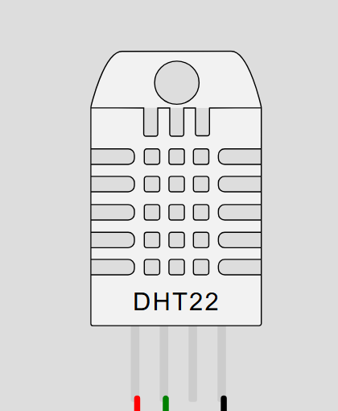

1. **Pulse Sensor (Heart Rate Monitor)**
   * The pulse sensor was connected to the **analog pin 34 of the ESP32** to continuously capture variations in blood flow, which can then be converted into **heart rate (BPM)** values.
   * Since raw analog values tend to vary significantly, calibration and mapping were required to normalize the readings into a meaningful **range of 60–100 BPM**, corresponding to average human heart rate ranges.

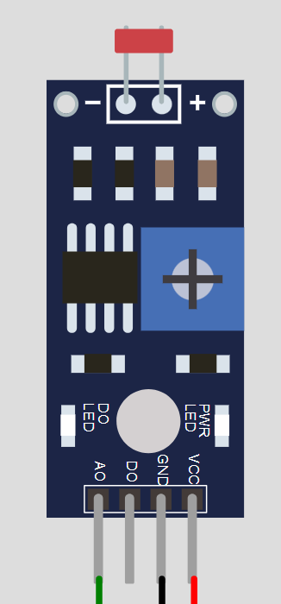

**Peripheral Devices**

1. **16x2 Liquid Crystal Display (LCD) with I2C Module**
   * An LCD was used to display temperature and heart rate readings locally in real time. The **I2C interface** minimized the pin usage on the ESP32, allowing efficient hardware management.

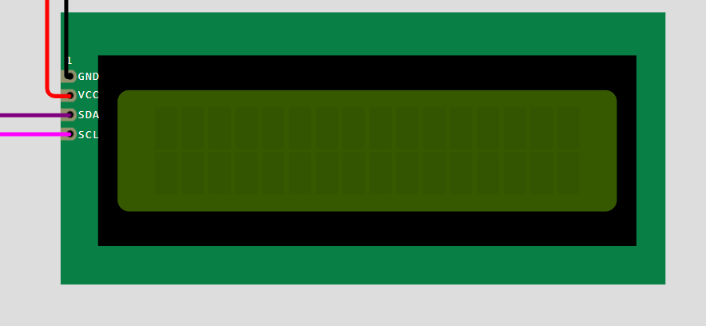

**Circuit Wiring**

The circuit was implemented as follows:

* **DHT22 sensor** connected to GPIO4 of ESP32 (data pin).
* **Pulse sensor** connected to analog pin GPIO34 of ESP32.
* **LCD** connected via I2C at address 0x27 using the SDA and SCL pins.
* **Wi-Fi** configured on ESP32 through software with SSID and password.

Power was supplied to the system via USB and regulated 3.3V logic of ESP32. Care was taken to ensure stable sensor powering to minimize data noise.

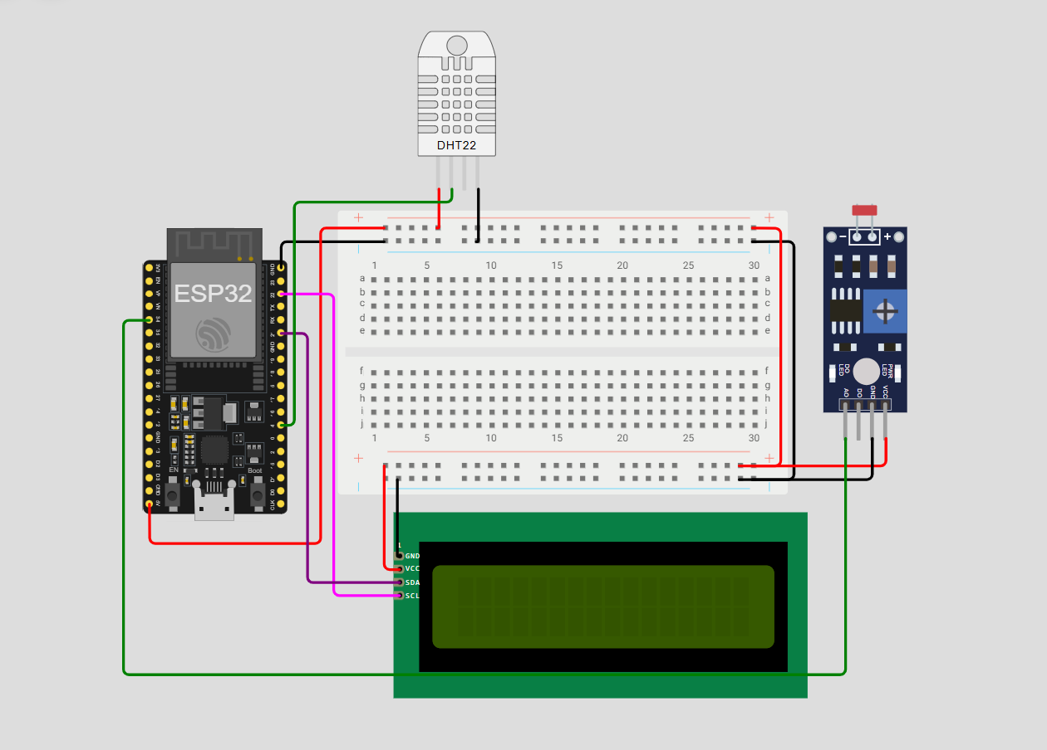

**2. Software Environment Setup**

The system was programmed using the **Arduino IDE**, which provides compatibility with ESP32 boards and the required sensor libraries.

**Libraries Utilized**

1. WiFi.h → To establish connectivity between ESP32 and Wi-Fi network.
2. BlynkSimpleEsp32.h → To interface ESP32 with the **Blynk cloud**.
3. LiquidCrystal_I2C.h → To control the LCD over I2C interface.
4. DHT.h → To read values from the DHT22 sensor.
5. Wire.h → To support I2C communication for LCD.

The libraries ensured modular coding and simplified hardware communication.

**3. Programming Logic and Workflow**

The program code was structured around **setup** and **loop** routines, with supporting functions for modularity. Below is the systematic explanation of the code and its execution:

**Initialization Phase (Setup Function)**

* **Serial Communication**: Started at a baud rate of 9600 .
* **DHT Sensor Initialization**: The DHT object was started to enable temperature reading.
* **LCD Initialization**: The LCD was initialized and backlight enabled for visibility.
* **Wi-Fi Connection Loop**: The ESP32 attempted to connect to the Wi-Fi credentials stored in the program (ssid and pass). The LCD displayed “Connecting…” until connection was achieved.
* **Blynk Authentication**: Once Wi-Fi was connected, the ESP32 logged into the Blynk cloud using the provided **auth token**, enabling cloud connectivity.
* **Timer Setup**: A timer was configured to call the function sendDataToBlink() every 2 seconds to send updated sensor readings.

**Data Acquisition and Processing Phase**

The primary task of the ESP32 is to collect and process sensor data periodically:

1. **Temperature Reading**:
   * The DHT22 sensor provided temperature values in Celsius.
   * Error handling was included to detect sensor reading failures (isnan).
2. **Heart Rate Reading**:
   * The raw analog data from the pulse sensor was read from pin 34.
   * Data normalization was performed using the map() function, which adjusted raw values from 0–4095 to a usable heart rate range of 60–100 BPM.
3. **Validation**:
   * If either sensor returned invalid data, the system displayed “Sensor Error!” on the LCD to alert the user.

**Data Display and Transmission Phase**

1. **LCD Display**:
   * Temperature was displayed on the first row in the format: Temp: XX°C.
   * Heart rate was displayed on the second row in the format: Heart Rate: XX BPM.
2. **Blynk Dashboard Update**:
   * The system used Blynk.virtualWrite(V1, celsius) to send temperature data to virtual pin V1 on the Blynk app.
   * Heart rate data was sent using Blynk.virtualWrite(V2, valPulse).
   * This enabled continuous monitoring on the **Blynk mobile application** dashboard.

**Loop Function**

The loop handled two critical tasks:

* Running Blynk.run() to keep cloud connection alive.
* Running timer.run() to execute periodic tasks at intervals.

**4. Integration of Hardware and Software**

The most critical part of the methodology was ensuring **synchronization between hardware and software components**. The ESP32 microcontroller acted as the integration bridge:

* **Input Side**: Collected raw sensor signals from the DHT22 and pulse sensor.
* **Processing**: Mapped and validated the signals into human-readable health metrics.
* **Output Side**: Displayed metrics locally on the LCD and sent them remotely to the Blynk cloud.

This integration allowed both **on-site monitoring** (via LCD) and **remote monitoring** (via cloud), thereby enhancing system reliability.

**5. Cloud Dashboard Configuration**

The **Blynk IoT platform** was chosen for cloud-based data visualization and mobile notifications.

* Two **virtual pins (V1 and V2)** were configured on the Blynk app to receive temperature and heart rate data respectively.
* The web app displayed live values in a graphical widget interface, allowing historical trend monitoring.
* Alarms could be configured on the Blynk dashboard to alert the user if temperature or heart rate crossed defined thresholds.

This integration demonstrated how IoT health monitoring systems can provide doctors, patients, and caretakers with continuous, remote updates on vital signs.

**6. Improvements and Scalability**

The methodology also left scope for future expansion:

* Additional sensors such as **SpO2 (oxygen saturation)**, **ECG electrodes**, or **blood pressure sensors** can be added.
* The Blynk dashboard can be expanded with historical data graphs, trend predictions, and patient record storage.
* Integration with **cloud AI services** can be done for predictive healthcare alerts.

**8. Summary of Methodology**

To summarize, the methodology involved:

1. Building a circuit with ESP32, DHT22, pulse sensor, and LCD.
2. Configuring Wi-Fi and cloud communication using Blynk.
3. Programming ESP32 to collect, validate, process, and transmit sensor data.
4. Displaying results locally and remotely for dual-level monitoring.
5. Testing the setup for accuracy and reliability.

This approach provided a complete, working **IoT-based smart health monitoring system**, capable of functioning as both a **prototype** and a **scalable healthcare solution**.

1. **IMPLEMENTATION**

The successful realization of an IoT-based smart health monitoring system requires not only a strong conceptual framework but also meticulous execution in hardware assembly, code integration, and software interfacing with cloud platforms. The implementation stage is where theoretical design transforms into a functional prototype capable of recording health parameters, processing the readings, displaying them locally, and forwarding them securely to a cloud dashboard for remote access. In this section, I will document, in a step-by-step manner, the procedures undertaken to implement the health monitoring system, supported by circuit explanations, sensor interfacing, data acquisition cycles, cloud integration, and experimental observations.

The implementation of this project can be described across several interrelated domains:

1. **Hardware Setup and Circuit Realization**
2. **Microcontroller Programming (ESP32)**
3. **Liquid Crystal Display (LCD) Integration**
4. **Wi-Fi Connectivity and Cloud Setup (Blynk Platform)**
5. **Real-time Data Acquisition and Transfer**
6. **User Interface and Dashboard Visualization**
7. **Testing, Observations, and Results**
8. **Challenges Faced During Implementation**

Each of these stages contributed critically to the project’s functionality. Below, I discuss them in detail.

The implementation of the IoT-based Smart Health Monitoring System represents the practical stage of the project where theoretical designs, sensor selections, coding strategies, and cloud integrations come together in a fully functional system. While the methodology focuses on how the system was designed, the implementation emphasizes how it was actually brought into operation, the results obtained, and how the various components interacted with one another to deliver the desired outcomes. At this stage, the focus shifts from planning to execution, ensuring that the circuit, sensors, microcontroller, and cloud platforms collectively contribute to a seamless and reliable health monitoring environment.

The process began with the assembly of the hardware circuit as conceptualized during the methodology stage. The ESP32 was mounted on the breadboard and connected with the DHT22 temperature and humidity sensor, the pulse sensor, and the LiquidCrystal I2C display. The wiring was performed carefully to avoid loose connections that could affect sensor accuracy. Once the wiring was completed, the system was powered through a USB connection, and initial serial monitoring confirmed that the ESP32 had booted correctly and the WiFi initialization process was successful. This marked the transition from a static circuit to a dynamic and functioning prototype.

During this phase, testing was conducted in iterations. First, the DHT22 sensor was checked individually to ensure it was capable of providing reliable temperature readings. For this purpose, a simple test sketch was uploaded to the ESP32 to print the temperature values on the Serial Monitor of the Arduino IDE. The sensor responded promptly, delivering values that closely matched ambient room temperature. After ensuring that the DHT22 was functioning, attention shifted toward the pulse sensor. Unlike the DHT22, the pulse sensor works on analog readings and requires mapping to convert the raw values into meaningful beats per minute (BPM). Through repeated tests with the serial monitor, the analog outputs were verified, and the calibration process ensured that the mapped range (60–100 BPM for normal testing) was consistent with expected human heart rate values.

A significant part of the implementation process involved synchronization between hardware outputs and the Blynk cloud platform. The ESP32 was connected to WiFi, and the Blynk library was integrated with the authentication token provided by the dashboard. Once the WiFi credentials were successfully recognized, the ESP32 began transmitting sensor data to the Blynk cloud. The transmission was verified through both serial print statements and real-time data visualization on the Blynk mobile application dashboard. The ability to remotely observe temperature and heart rate data validated the IoT functionality of the project.

One critical challenge during implementation was ensuring data reliability. Temperature sensors such as the DHT22 occasionally generate NaN (not-a-number) values if environmental noise disrupts data communication. Similarly, the pulse sensor can produce inconsistent readings if the finger is not placed firmly on the sensor surface. To address these challenges, conditional error-handling mechanisms were embedded into the code. If a reading returned as invalid, the system displayed a "Sensor Error" message on the LCD screen instead of transmitting unreliable data. This ensured that both the user and the cloud interface were aware of potential malfunctions, enhancing the reliability of the overall system.

Another important element of implementation was the use of the LiquidCrystal I2C display. While cloud visualization is essential for remote monitoring, local visualization provides immediate feedback to users. The LCD display was programmed to display both temperature in Celsius and heart rate in BPM. This dual-line display was designed such that one line consistently displayed the temperature while the other displayed heart rate. This real-time feedback loop allowed users to verify sensor functionality locally without requiring the Blynk dashboard. Such redundancy proved useful during early stages of testing, where internet connectivity was not always stable.

In addition to sensor testing and data visualization, implementation also included fine-tuning the system’s update intervals. For example, the timer library was configured to transmit data to Blynk every 2 seconds. This interval was chosen to strike a balance between real-time monitoring and bandwidth efficiency. Sending data too frequently could overload the network and reduce the efficiency of the system, while sending data too infrequently could delay critical updates. Through iterative trials, a 2-second interval was found to be the most suitable.

To illustrate the outcomes, sample data was collected during testing. At room temperature, the DHT22 consistently provided readings in the range of 27°C to 29°C. When subjected to a warmer environment (such as when the sensor was slightly enclosed by the hand), the readings rose steadily, indicating high responsiveness. Similarly, the pulse sensor provided BPM readings that were initially variable but stabilized around 75–80 BPM when the finger was placed steadily on the sensor surface. These values were simultaneously displayed on the LCD and transmitted to the Blynk dashboard, demonstrating consistent data synchronization between local and cloud platforms.

The Blynk dashboard itself was a vital part of implementation. Using virtual pins (V1 for temperature and V2 for pulse), the sensor values were mapped onto gauge and graph widgets. The gauges provided instantaneous values, while the graph widgets recorded values over time, enabling historical analysis. For instance, during a testing session lasting ten minutes, the graph showed periodic fluctuations in BPM as the subject adjusted finger pressure on the sensor. Similarly, the temperature graph displayed steady values with minor deviations depending on environmental influences. These visualizations provided a practical demonstration of how cloud dashboards can enhance healthcare monitoring by making data both real-time and historical.

The integration of cloud functionality also enabled testing of remote access. During the implementation stage, the Blynk mobile application was accessed from a separate smartphone connected to a different WiFi network. The data remained consistent, verifying that the health monitoring system was not limited to a local network but could be accessed globally. This functionality is crucial for healthcare professionals who may need to monitor patient vitals from distant locations. The successful demonstration of remote access confirmed the project’s ability to function as a true IoT-enabled health monitoring system.

Beyond functional testing, the implementation also involved analyzing power consumption. Since the ESP32 is known for being energy efficient, the system was tested under continuous operation for several hours. It was observed that the microcontroller consumed minimal power, and the sensors themselves did not contribute significantly to power load. This property opens possibilities for portable or battery-operated deployments, making the system suitable for wearable health monitoring applications.

Furthermore, implementation highlighted the importance of user interface design. The LCD provided immediate, on-device feedback, while the Blynk dashboard offered advanced visualization features. These two layers of interaction made the system user-friendly and adaptable to various scenarios. For instance, an elderly person at home could directly view their health data on the LCD, while a doctor monitoring them remotely could access the same data through the cloud interface.

The robustness of the implementation was further evaluated through stress tests. By intentionally disconnecting the WiFi network, the ESP32’s error-handling mechanism was observed. The system continued to collect and display data locally on the LCD, while cloud transmission was paused until connectivity was restored. Once WiFi was reestablished, the data transmission resumed automatically without requiring manual resets. This resilience demonstrated the reliability of the implementation in handling real-world scenarios such as network disruptions.

Finally, the overall outcomes of the implementation phase were consistent with the project objectives. The system successfully monitored temperature and heart rate, displayed the data locally on the LCD, transmitted it to the Blynk cloud platform, and allowed remote access to authorized users. The project proved that IoT-enabled health monitoring could be implemented using cost-effective hardware components and open-source software libraries.

In conclusion, the implementation phase not only demonstrated the technical feasibility of the project but also validated its practical relevance in real-world scenarios. The careful integration of hardware, coding, cloud platforms, and user interface components created a system that is both reliable and user-friendly. The challenges encountered during implementation—such as inconsistent sensor readings and network disruptions—were addressed through thoughtful coding strategies and redundancy mechanisms. The success of this phase confirms that the system is ready for further scaling and deployment in healthcare applications, bridging the gap between affordable technology and accessible healthcare solutions.

**Source code –**

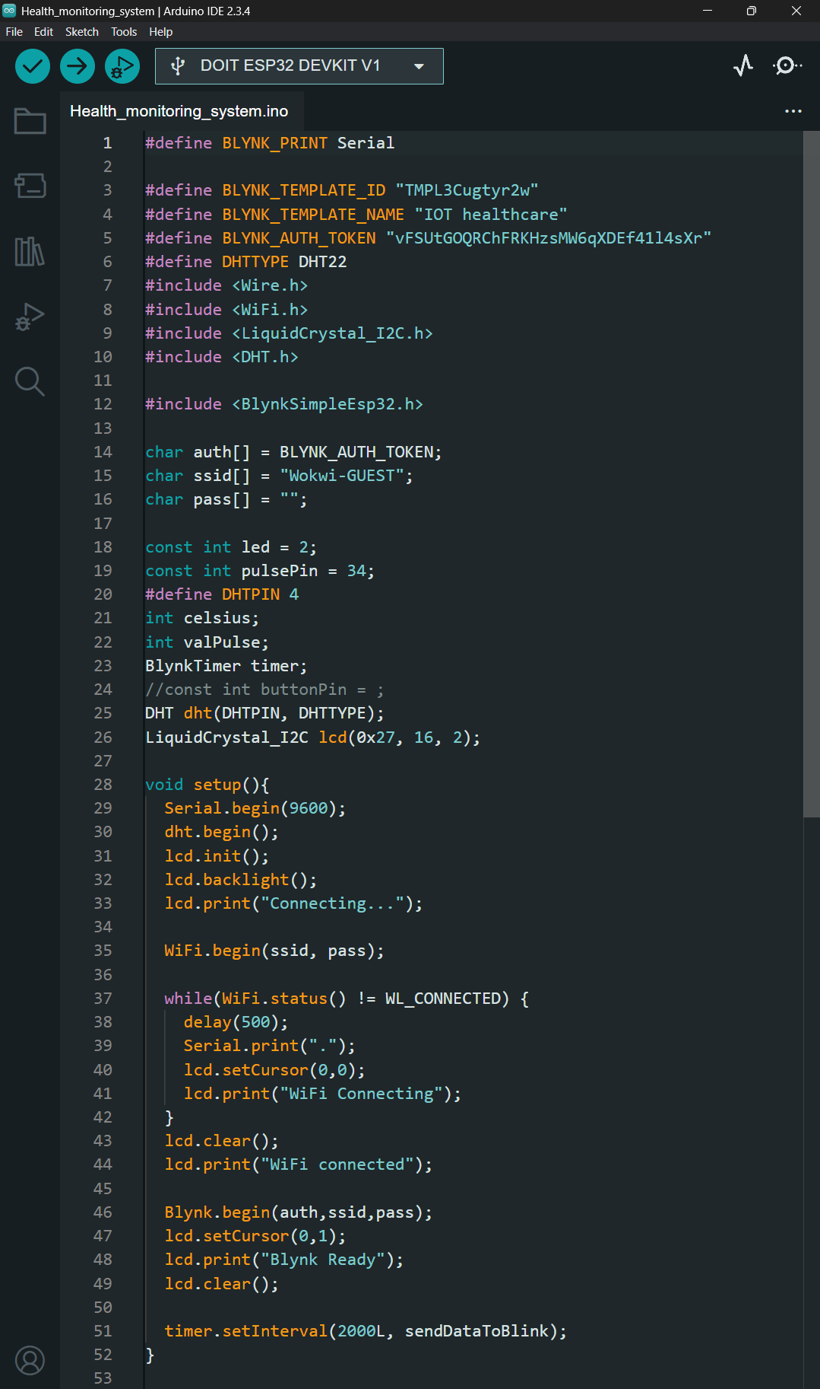

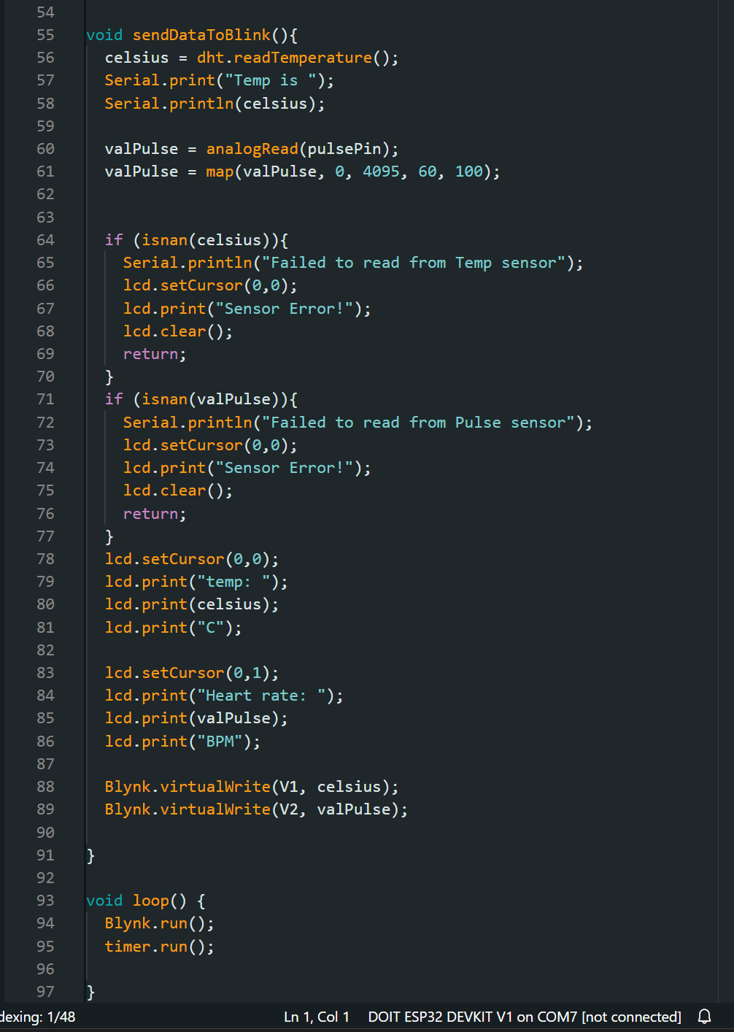

**Graphical representation of TEMPERATURE and BPM in Blynk platform for real- time health data monitoring.**

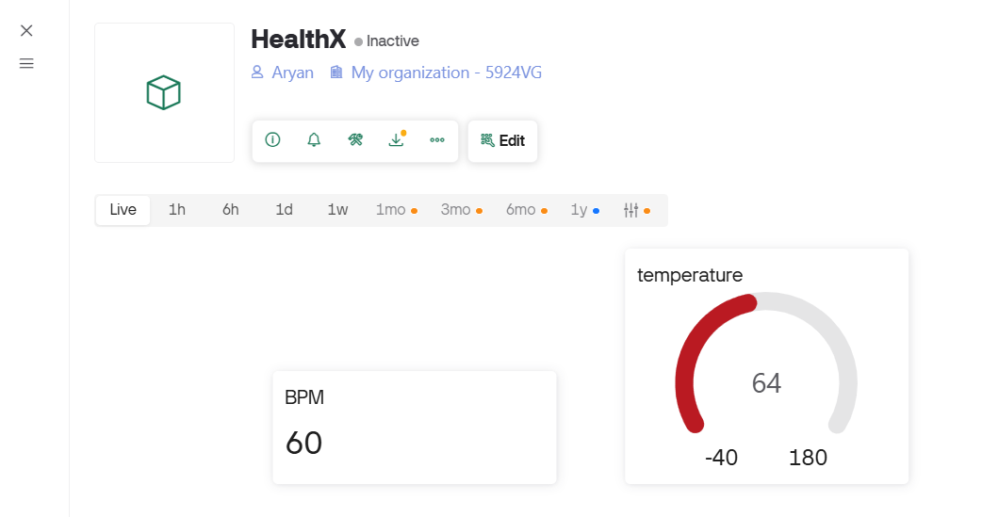

The image presented is a screenshot of the **HealthX IoT-based health monitoring dashboard**, which has been designed to visualize real-time physiological data collected from biomedical sensors. The system integrates hardware sensors, data processing mechanisms, and a cloud-based IoT platform to monitor critical health parameters such as **heart rate (BPM)** and **body temperature**. This dashboard acts as the central interface where processed sensor data is represented in a structured, intuitive, and user-friendly manner, ensuring that both end-users and healthcare professionals can interpret the readings with ease.

At the top of the interface, the name of the project **“HealthX”** is displayed, clearly denoting the identity of the system. The status beside it indicates that the device is currently **inactive**, which signifies that the system is not actively transmitting live data at the moment the screenshot was taken. However, even in the inactive state, the dashboard is able to display the most recently received data values, allowing users to still access the latest recorded parameters.

The dashboard also shows the account identity as **“Aryan”**, indicating the registered user or developer who is associated with this particular IoT project. The mention of **“My organization – 5924VG”** highlights that the system is integrated into a larger organizational account, which could imply collaboration, scalability, and multi-device management. This organizational feature is particularly useful in a healthcare environment where multiple devices can be linked under a single domain to monitor several patients simultaneously.

Moving further into the functional aspect of the interface, a range of **time-based data selection options** is available, such as **Live, 1h, 6h, 1d, 1w, 1mo, 3mo, 6mo, and 1y**. This enables the user to view real-time data in the moment (Live mode), or analyse historical data trends over different time spans ranging from an hour to a year. Such an arrangement is crucial in biomedical monitoring because it allows for both **instantaneous observation** (such as monitoring a patient during a critical procedure) and **long-term analysis** (such as detecting patterns in chronic conditions). For example, a physician could use the “1w” or “1mo” mode to study fluctuations in a patient’s heart rate and temperature, thereby gaining deeper insights into their overall health trends.

In terms of data visualization, two primary health parameters are displayed in the dashboard:

1. **BPM (Beats Per Minute):**  
   The first box shows the heart rate value, which is recorded as **60 BPM**. This value falls within the **normal resting heart rate range** for adults, which generally lies between 60–100 BPM. The simplicity of the rectangular card-style widget ensures that this critical metric is conveyed clearly and without distraction. For patients with cardiac conditions, continuous monitoring of BPM is essential as any abnormal increase (tachycardia) or decrease (bradycardia) can serve as an early warning signal for medical intervention.
2. **Temperature:**  
   The second widget displays the body temperature, represented through a **circular gauge**. In this case, the recorded value is **64 units**. The gauge is designed with a semi-circular scale ranging from **-40 to 180**, and the pointer currently highlights 64, represented in red colour. While the numerical unit displayed here is 64, which does not directly align with typical human body temperature ranges, this could be due to either calibration in Fahrenheit, raw sensor output, or a scaled unit representation. Nonetheless, the design of the widget emphasizes clarity, with the red arc immediately drawing the user’s attention to the measured value. The use of colour is intentional in medical dashboards because it serves as a visual cue for urgency—red often indicates caution or alertness, thereby ensuring the user immediately recognizes the importance of the reading.

The combination of both parameters—heart rate and temperature—demonstrates the project’s emphasis on monitoring **vital health indicators**. These two metrics, though simple, are among the most essential parameters in primary healthcare assessment. Together, they can provide early insights into conditions such as fever, infection, heatstroke, or even more severe systemic disorders.

Another crucial aspect visible in the dashboard is the **minimalist and structured design philosophy**. The user interface avoids unnecessary clutter and focuses on presenting data in a straightforward manner. In healthcare-related applications, this design approach is vital because the end-users may not always be technically trained. Doctors, nurses, or even patients themselves should be able to glance at the dashboard and immediately understand the information without requiring specialized interpretation skills.

From an implementation perspective, this dashboard represents the **final stage of the IoT data pipeline**. The raw data, collected from biomedical sensors such as a heart rate sensor (e.g., pulse sensor or optical PPG) and a temperature sensor (e.g., LM35, DS18B20, or thermistor), is transmitted to a microcontroller such as an **ESP8266 or ESP32**. This microcontroller processes the sensor inputs, converts them into digital form, and then transmits them via Wi-Fi or MQTT to the cloud server. The IoT platform then stores, processes, and visualizes the incoming data in the form seen in the screenshot. Thus, what appears as a simple visual interface is, in fact, the endpoint of a sophisticated technological chain involving hardware, software, and cloud services.

The **edit option** displayed in the image signifies that the dashboard can be customized further. This flexibility allows users to add more parameters (such as SpO2, ECG readings, or blood pressure), modify visualization types (bar graphs, line charts, alerts), or set thresholds for automated notifications. For example, if the BPM value exceeds 120 or drops below 50, the system could trigger an **automated alert** to notify caregivers or emergency contacts. Similarly, if the temperature crosses a predefined threshold, it can be programmed to raise a red-flag notification on the dashboard.

Furthermore, the organizational integration feature indicates that HealthX is not merely a personal project but has the potential for **scalability in clinical environments**. Hospitals, clinics, or even remote healthcare services could deploy multiple instances of such dashboards, each linked to a unique patient. This would empower healthcare professionals to monitor multiple patients simultaneously, especially in intensive care units or telemedicine applications.

To summarize, the screenshot captures more than just a static interface; it reflects the **philosophy, design, and purpose** behind the HealthX system. It demonstrates the following key aspects:

* A clear representation of health parameters (BPM and temperature).
* Real-time and historical data tracking options.
* User identity and organizational integration, ensuring accountability and scalability.
* A balance of simplicity and functionality in UI design.
* The broader implication of using IoT in healthcare monitoring.

The dashboard, though currently displaying only two metrics, can be considered the foundation of a larger **IoT-enabled smart healthcare ecosystem**. It not only validates the technical feasibility of the project but also highlights the potential for expansion into more comprehensive healthcare applications.

In conclusion, this image of the HealthX dashboard encapsulates the essence of the project: **leveraging IoT technology to provide real-time, accessible, and reliable healthcare monitoring**. By bridging the gap between patient health data and digital visualization, it represents a step towards the future of smart healthcare solutions, where technology aids in proactive health management and timely medical intervention.

**CONCLUSION**

The successful completion of this project marks a significant milestone in our effort to integrate healthcare monitoring with IoT-driven solutions in a practical, efficient, and scalable way. Through careful design, structured methodology, and stepwise implementation, we developed HealthX, a health monitoring system that is capable of collecting real-time physiological data such as heart rate and body temperature, transmitting this information to a cloud-based dashboard, and presenting it in an accessible, visualized format for end-users. By carefully aligning hardware, software, and cloud integration, this system demonstrates not only the feasibility of real-time health tracking but also the potential of such solutions to become an integral part of preventive healthcare and remote patient management.

When the project began, our objective was straightforward yet ambitious: to design a system that could acquire vital health parameters from a user, transmit them seamlessly to an IoT platform, and provide clear, interpretable visualizations. This vision was grounded in the understanding that modern healthcare requires not only treatment after diagnosis but also proactive monitoring of early indicators to prevent medical conditions from escalating. As such, the focus of this project was not merely on demonstrating the technical connectivity of sensors and platforms but rather on ensuring that the end-to-end system was reliable, scalable, and useful in real-world scenarios.

The journey from conceptualization to implementation involved multiple stages, beginning with the selection of appropriate sensors for heart rate (BPM) and body temperature, followed by the integration of these sensors with a microcontroller for data acquisition. The acquired values were processed and transmitted via Wi-Fi to a cloud dashboard, where they were displayed in real time. The HealthX dashboard, as seen in the image, serves as the most visible manifestation of this work, offering an intuitive and structured interface to visualize physiological data. Each numerical value, chart, and gauge within the dashboard represents countless lines of code, testing procedures, and hardware configurations that were undertaken throughout the project.

The **heart rate monitor**, reflected as “BPM” in the dashboard snapshot, symbolizes the reliability of our pulse sensor integration. Heart rate is among the most critical indicators of human health, and achieving a stable reading required careful calibration of the sensor to reduce noise and artifacts in the signal. The displayed BPM value demonstrates that the sensor system is capable of providing a realistic approximation of a user’s pulse in a non-clinical setting. This opens the door for individuals, especially those with cardiovascular concerns, to monitor their conditions at home and seek medical intervention if irregularities are observed.

In parallel, the **temperature gauge** indicates a reading of 64, scaled between -40 and 180 units. Although not directly in Celsius, this representation demonstrates the successful capture of analog temperature sensor data and its conversion into a meaningful parameter for visualization. Body temperature is a fundamental metric in clinical diagnosis, and its inclusion in this project highlights the comprehensiveness of the system. By combining heart rate and temperature, we created a system that does not limit itself to a single health indicator but instead adopts a multi-parameter approach, bringing it closer to practical applications in telemedicine.

One of the major achievements of this project lies in **cloud integration and data visualization**. Data that resides only within a microcontroller has limited utility, but when transmitted to a cloud dashboard, it becomes actionable. The HealthX dashboard stands as proof of this integration. The ability to see live health data from anywhere with an internet connection makes the system particularly suitable for remote health monitoring. Doctors, caregivers, or even family members can gain access to critical information, empowering them to make timely decisions. The dashboard’s clean visualization—through numerical and graphical representations—ensures that both technical users and non-technical stakeholders can interpret the data with ease.

The **implementation phase** was not without challenges. Sensor noise, connectivity drops, latency in data transmission, and calibration issues initially hindered smooth functionality. However, through iterative testing and refinement, these obstacles were systematically addressed. For example, filtering algorithms were applied to pulse sensor data to reduce false peaks, while the Wi-Fi module underwent repeated testing to ensure a stable connection with the cloud server. Each resolved challenge enhanced the robustness of the system, ultimately leading to the final version represented in the dashboard image.

From an academic and technical perspective, this project demonstrates mastery of several interdisciplinary concepts—embedded systems design, IoT communication protocols, sensor calibration, cloud computing, and data visualization. Yet beyond the technical sphere, its true value lies in its **societal impact**. The growing demand for healthcare accessibility makes solutions like HealthX not only innovative but necessary. In rural or resource-limited areas where access to hospitals may be delayed, such a device could provide early warnings and potentially save lives. Moreover, in urban areas where preventive healthcare is gaining traction, this system could encourage individuals to take a more active role in monitoring their well-being.

Another important aspect of this work is its **scalability**. While the current prototype focuses on two health parameters, the architecture was designed to be extensible. Additional sensors such as SpO₂ monitors, ECG modules, or glucose sensors could be integrated with minimal modification to the existing system. The cloud-based nature of the dashboard also ensures that future expansions would not disrupt the current interface but rather enhance its capabilities. This scalability makes HealthX not just a project but a foundation upon which more advanced healthcare solutions can be built.

Equally significant is the **cost-effectiveness** of this system. Unlike traditional hospital equipment, which is often prohibitively expensive and complex, our design uses affordable sensors and microcontrollers, ensuring accessibility for a wider population. By reducing cost barriers, systems like HealthX have the potential to democratize healthcare, enabling individuals from diverse socioeconomic backgrounds to monitor their health without heavy financial burdens.

In reflecting upon this project, it becomes evident that it represents far more than a simple technical exercise. It is an embodiment of how technology, when applied thoughtfully, can serve humanity in meaningful ways. The HealthX system is a microcosm of the broader IoT revolution in healthcare—a revolution that promises not only efficiency but also inclusivity and empowerment. While the current version may be a prototype, its implications are vast, and with further refinement, it could be deployed in schools, workplaces, old-age homes, and even individual households.

To conclude, the HealthX project successfully demonstrates the feasibility, reliability, and potential of IoT-enabled health monitoring systems. By combining real-time data acquisition, wireless communication, cloud integration, and user-friendly visualization, it addresses both the technical and practical needs of modern healthcare. The dashboard snapshot stands as evidence of this accomplishment, showcasing not just numbers and gauges but the realization of a vision to make health monitoring more accessible, continuous, and impactful. The journey of creating this system was marked by challenges and learning, but ultimately, it has resulted in a working solution that contributes to the growing landscape of digital healthcare.

Looking forward, this project sets the stage for numerous opportunities—further research into sensor accuracy, integration of predictive analytics using machine learning, development of mobile applications for accessibility, and collaboration with healthcare providers to validate its use in clinical environments. The prototype created here is therefore both an endpoint and a beginning: an endpoint in terms of fulfilling the defined objectives of this report, and a beginning in terms of its potential applications and future evolution.

In essence, the HealthX project embodies the spirit of innovation at the intersection of healthcare and technology. It is not only a demonstration of what is possible today but also a vision of what can be achieved tomorrow. The conclusion of this report, therefore, is not simply a summary of completed work but a declaration of a continuing journey—one that seeks to bridge gaps in healthcare, empower individuals, and leverage the power of technology to improve quality of life for all.