# Lab: ASP.Net WEB API

Problems for exercises and homework for the ["Back-End Technologies Basics"](https://softuni.bg/trainings/4398/back-end-technologies-basics-january-2024) course @ SoftUni.

In this part of the lab, you will familiarize yourself with the **ASP.NET Web API** **application**, learn how to run it in **Visual Studio**, and **connect it to a database** using **Microsoft SQL Server Management Studio** (SSMS)..

## Requirements

* Visual Studio with ASP.NET
* Microsoft SQL Server Management Studio (SSMS)
* Local SQL Server instance

## Exploring the Application

* **Launch Visual Studio** and open the provided ASP.NET Web API project.
* **Project Structure Overview:** Explore the solution's structure. Pay attention to the **Controllers** folder, **appsettings.json**, and **Program.cs**, as they play crucial roles in the application

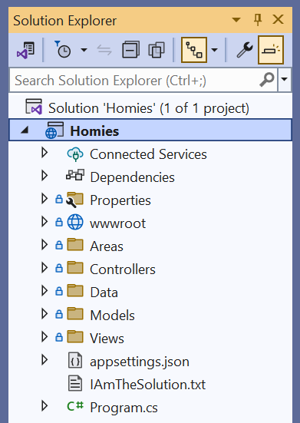

## Running the Application

* **Build and Run:** In Visual Studio, build the project by selecting **Build** > **Build Solution**. Then, run the application by clicking the **IIS Express** button

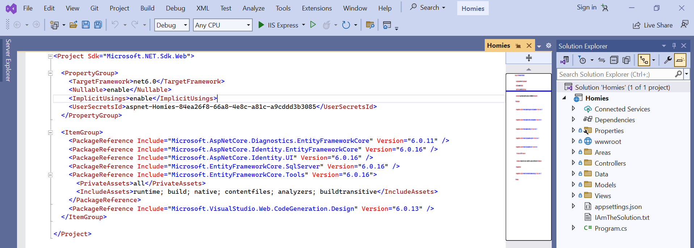

* **Verify the Application:** Once the application starts, your default web browser should open. If you see a **welcome page**, the application is running correctly.

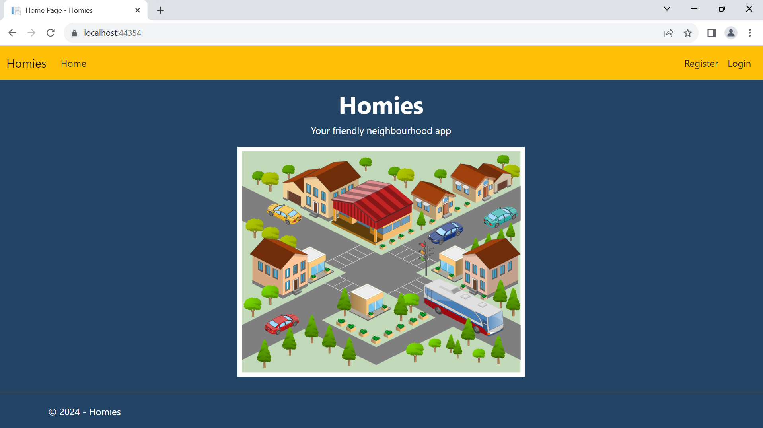

## Setting Up SSMS and Database Connection

* **Install SSMS:** If not already installed, [download](https://learn.microsoft.com/en-us/sql/ssms/download-sql-server-management-studio-ssms?view=sql-server-ver16#download-ssms) and install **Microsoft SQL Server Management Studio** from the **official Microsoft website**.
* **Connect to SQL Server:** Open SSMS and connect to your **local SQL Server instance**. Use the **default settings**

## Configuring the Database Connection

* **Locate the Connection String:** In the **ASP.NET project**, open **appsettings.json**. Find the ConnectionString section:

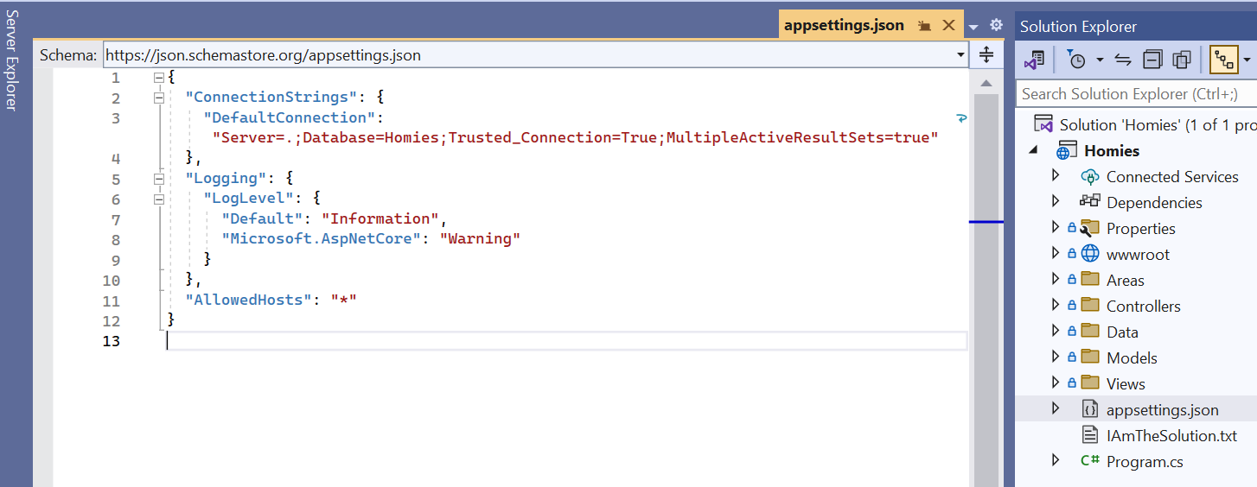

* **Modify the Connection String if Needed:** Replace the existing connection string with the one that points to your local SQL Server instance. **Save the changes**.

## Updating the Database

* **Apply Migrations:** In the **Package Manager Console** within Visual Studio, **run Update-Database** to apply migrations to your database.

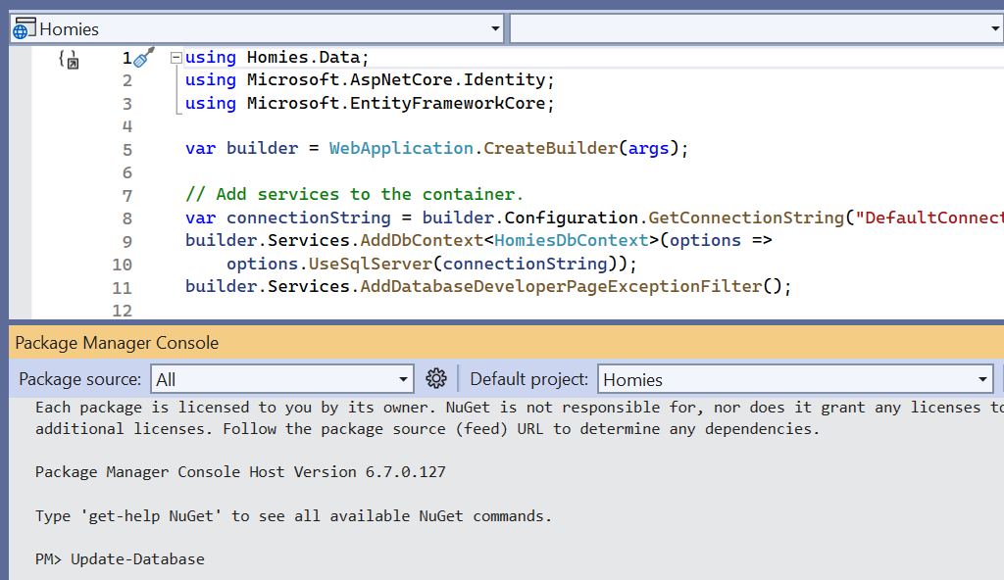

## Verifying Database Creation in SQL Server Management Studio (SSMS)

* **Locate the Database:** In the Object Explorer pane of **SSMS**, expand the **'Databases'** folder. You should see a list of all databases on the server.

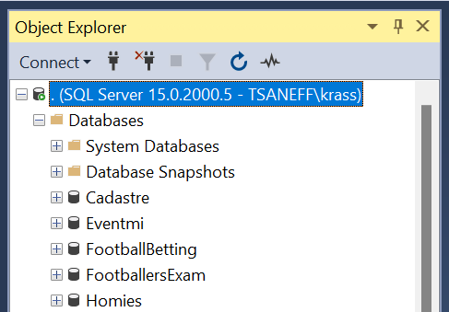

* **Check for the New Database:** Look for the database name that matches the one specified in your ASP.NET project's connection string. If the **Update-Database command executed successfully**, your database should be listed here.

## Interacting with the Application's Front End and Observing Database Changes

* **Access the Front End:** Open the front end of your application, a web page in your browser.
* **User Registration:** Before you start interacting with the CRUD operations of the application, it is important to understand and use the user authentication features provided by ASP.NET Identity. You will first **register** **a new user** and then **log in to the application**.
* **Access the Registration View:** Navigate to the registration page in your application's front end.
* **Fill Out the Registration Form:** Enter the required information in the registration form. This typically includes details like username, **email**, and **password**.

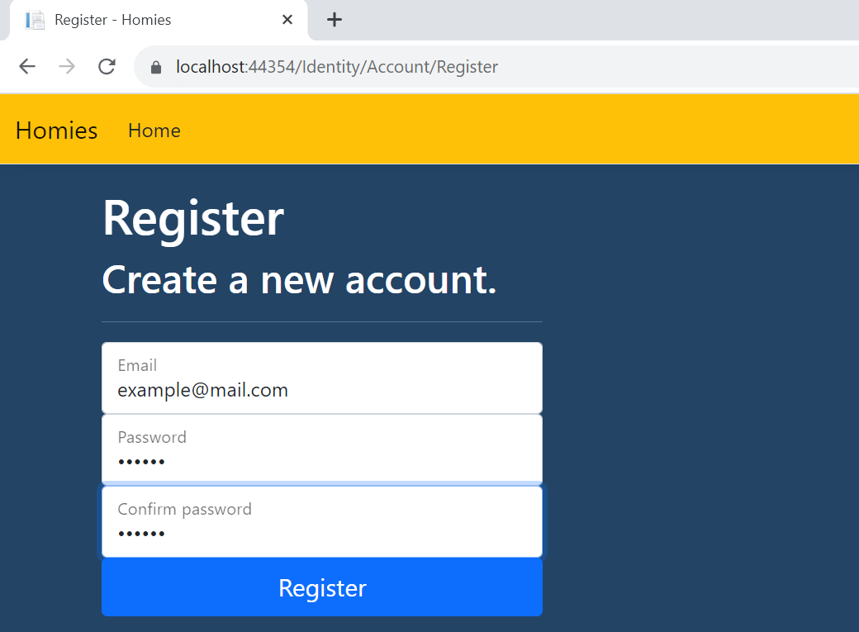

* **Submit the Form:** After filling out the form, submit it to **create a new user account**.
* **Verify Account Creation in Database:** 
  + Go back to SSMS and refresh the database view.
  + Navigate to the users table (often named AspNetUsers in ASP.NET Identity).
  + Verify that your new user account is listed in the table.
* **User Login:**
  + **Access the Login View:** Navigate to the login page in your application.
  + **Enter Login Credentials:** Input username and password you used to register in the previous step.
  + **Submit Login Form:** Submit the form to log in. Upon successful login, you should be redirected to a new page.

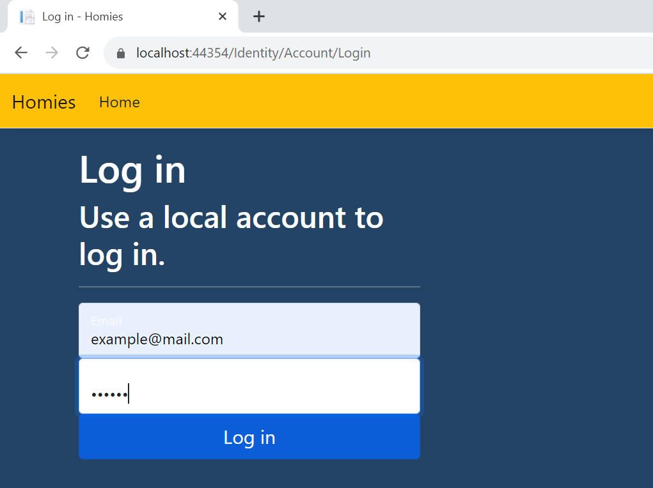

## Proceed with CRUD Operations

* Now that you are logged in, you are ready to perform **CRUD operations** as an authenticated user. This reflects a more realistic use-case scenario where user authentication is required for data manipulation.