# Lab: Mutation Testing

Lab problems for the ["Back-End Technologies Basics"](https://softuni.bg/trainings/4398/back-end-technologies-basics-january-2024) Course @ SoftUni.

## Project

You are given a Class Library project named ArrayTools.

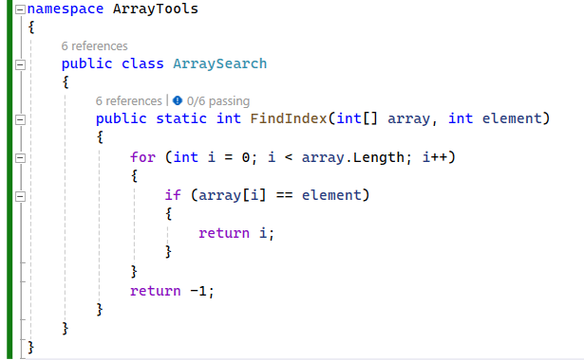

## Test Project

You also have a Test Project, with one test prepared for you. Run the test to ensure that it passes   
and the setup is correct.

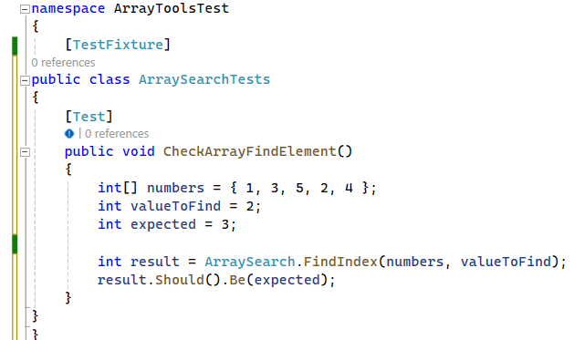

## Install Stryker

From the Console Manager Console run the following command and install Stryker

**dotnet tool install --global dotnet-stryker**

## Run Stryker

**dotnet-stryker**

5. Analize the Report

Observe the Report that Stryker created. Think of more tests to achieve 100 % Mutation Score.

Hint:

FindIndex_ElementNotPresent_ReturnsNegativeOne

FindIndex_EmptyArray_ReturnsNegativeOne

FindIndex_ElementAtStart_ReturnsZero

FindIndex_ElementAtEnd_ReturnsLastIndex

FindIndex_DuplicateElements_ReturnsFirstIndex

6. Visit Stryker Playground  
<https://stryker-mutator.io/stryker-playground/>   
Explore the interactive example. Think of other tests to achieve 100% Mutation Score  
  
If you have further interest in mutation testing, visit:

## Robo Coasters

<https://stryker-mutator.io/robo-coasters-example/>   
Visit Robo Bar – an example page for Stryker.

## Try Robo Coasters Example by yourself

<https://stryker-mutator.io/docs/General/example/>   
Following the tutorial, try the Robo Bar Example by yourself. You'll need node.js and git.