**LAB-3 SERVING FONT**

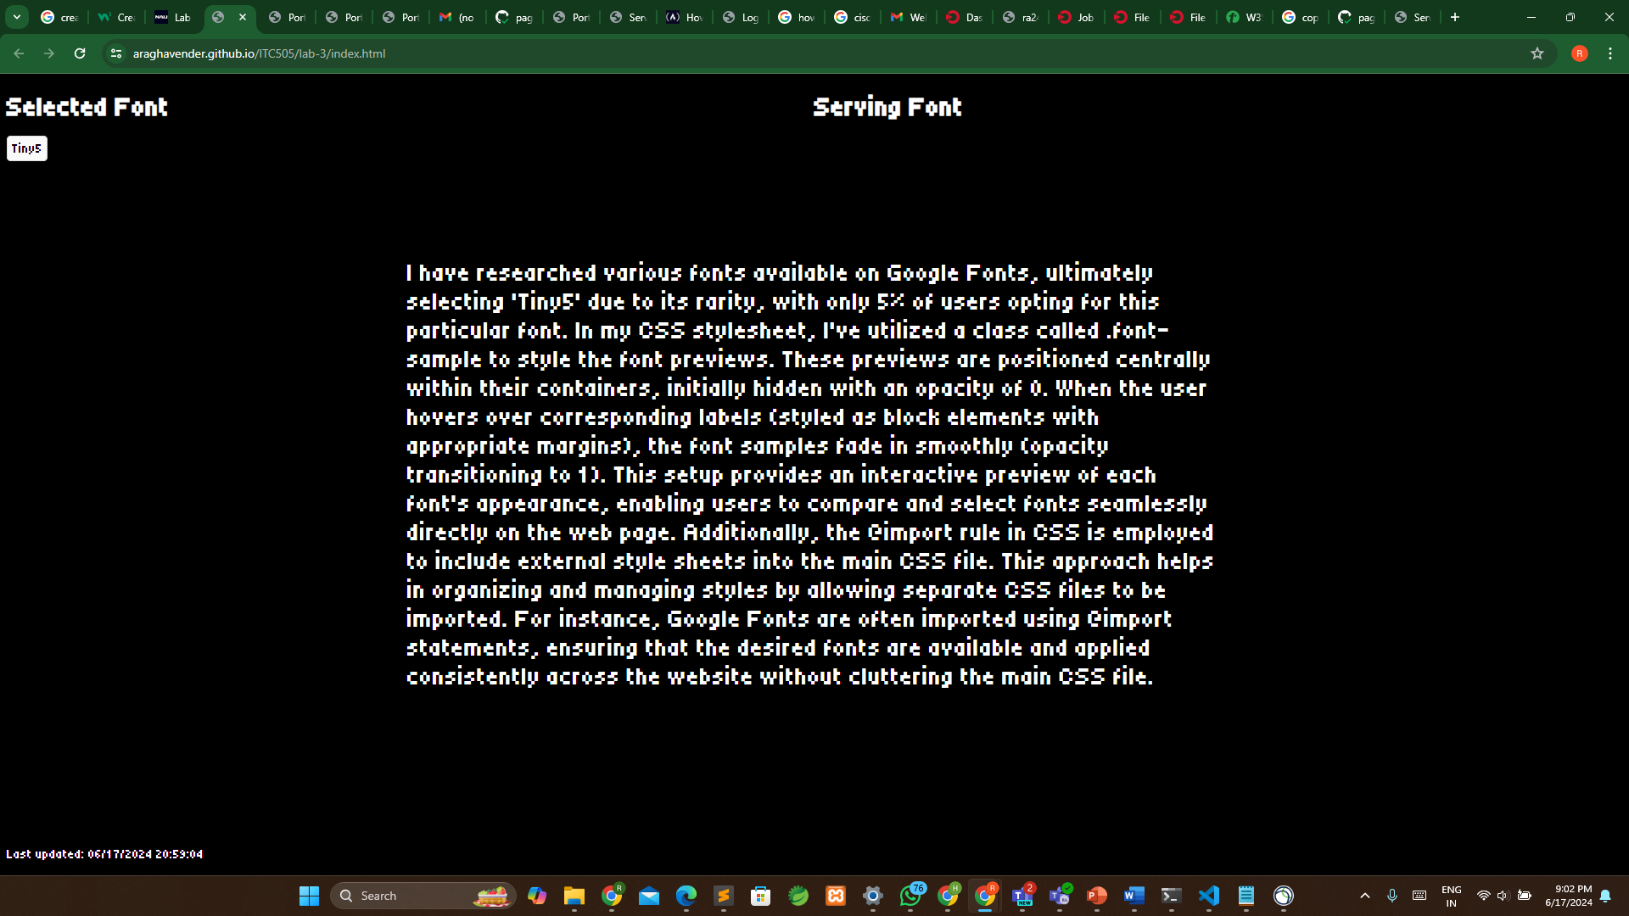

**Website Link:** [**https://araghavender.github.io/ITC505/lab-3/index.html**](https://araghavender.github.io/ITC505/lab-3/index.html)