SECURITY OPERATIONS CENTER
TECHNICAL INCIDENT DETECTION & RESPONSE REPORT

Design and Implementation of a Virtualized SOC Lab for
SSH Attack Detection and Automated Active Response Using Wazuh

Prepared by | Mohammed Abdulrahman
Project Type | Independent Cybersecurity Project
Engagement duration | August 16 – August 19, 2026 (4 days)
Lab Environment | Isolated VirtualBox SOC lab –– Host-Only Network
Network Range | 192.168.56.0/24
Security Platform | Wazuh
Attack Scenario | Controlled SSH Authentication Attack
Detection | Wazuh Rule 5710
Report classification | Portfolio / Educational Use
Document status | Final Project Report
Report date | August 20, 2026

This document follows SOC incident-documentation conventions: chronological evidence chain, timestamped findings, MITRE ATT&CK technique mapping, compliance-framework cross-referencing, and a clearly labeled evidence appendix.

Table of Contents
1. Document Control 4
1.1 Revision History 4
1.2 Distribution & Classification 4
1.3 Purpose of This Document 4
2. Executive Summary 4
2.1 Key Outcomes at a Glance 5
3. Scope and Objectives 6
3.1 In-Scope Systems 6
3.2 Objectives 6
3.3 Out of Scope 6
4. Lab Architecture and Environment 6
5. Methodology and Tooling 8
6. Chronological Timeline 8
6.1 Day 1 — August 16, 2026 9
6.2 Day 2 — August 17, 2026 9
6.3 Day 3 — August 18, 2026 10
6.4 Day 4 — August 19, 2026 10
6.5 Day 5 — August 20, 2026 10
7. Technical Findings by Phase 11
7.1 Phase 1: Lab Infrastructure Setup 11
7.2 Phase 2: Network and Agent Enrollment 12
7.3 Phase 3: SSH Reconnaissance 13
7.4 Phase 4: Controlled SSH Attack 15
7.5 Phase 5: Endpoint Logging 16
7.6 Phase 6: Wazuh Detection 17
7.7 Phase 7: Active Response 18
7.8 Phase 8: Windows Sysmon Telemetry 21
7.9 Phase 9: File Integrity Monitoring (FIM) 22
8. Detection Rules Demonstrated 23
9. MITRE ATT&CK Mapping 24
10. Compliance Framework Mappings 24
11. Results Summary 25
12. Conclusion and Recommendations 26
12.1 Conclusion 26
12.2 Recommendations for Future Iterations 26
Appendix A: Screenshot Evidence Inventory 26
A.1 Naming Convention 27
A.2 CRITICAL Tier — Full Listing 27

1. Document Control

1.1 Revision History
Version | Date | Author | Change Description
0.1 | Aug 20, 2026 | M. Abdulrahman | Initial draft compiled from lab evidence and screenshot inventory
1.0 | Aug 21, 2026 | M. Abdulrahman | Final version — formatted to SOC reporting standard, evidence placeholders inserted

1.2 Distribution & Classification
This report is classified TLP:CLEAR and is intended for internal review, academic assessment, and professional portfolio purposes. It documents a controlled, isolated lab exercise; no production systems, third-party assets, or real user data were involved at any stage.

1.3 Purpose of This Document
This report documents, in a standard SOC incident-documentation format, the design, deployment, attack simulation, detection, and automated response activities carried out in a self-hosted Wazuh SOC lab. It is structured to satisfy the evidentiary and narrative requirements typically expected of SOC analyst work product: a defined scope, a synchronized chronological timeline, a described methodology, phase-by-phase technical findings backed by screenshot evidence, detection-rule and MITRE ATT&CK mapping, compliance cross-referencing, and an honest statement of limitations.

2. Executive Summary
Between August 17 and August 20, 2026, a four-node virtualized Security Operations Center lab was built and operated to demonstrate an end-to-end detection-and-response chain against a simulated SSH credential-based attack. The lab comprised a Wazuh 4.14.7 manager, a Linux endpoint agent, a Windows 11 endpoint with Sysmon telemetry, and a Kali Linux attack host, all isolated on a host-only network (192.168.56.0/24).
A reconnaissance and controlled brute-force attack was executed against the Linux target's SSH service. The Wazuh manager correctly correlated authentication-failure events, fired Rule 5710 (non-existent user login attempt) and the escalated Rule 5712 (brute-force detection, severity level 10), and invoked a configured Active Response action (firewall-drop) that terminated the attacker's SSH session. In parallel, File Integrity Monitoring (FIM) and Windows Sysmon telemetry were validated on the Windows endpoint, and a full lifecycle of file creation, modification, and deletion events was captured and mapped to MITRE ATT&CK techniques.
Overall outcome: all core detection and response objectives were met and are supported by 8 critical and 93 supporting screenshots, organized into a 4-tier evidentiary inventory (286 files total). One limitation is noted and disclosed transparently in Section 12: network-layer firewall rule insertion was not independently verified via iptables -L / nft list ruleset, so the defensible claim is limited to detection and Active Response invocation with a confirmed dropped SSH session, not confirmed kernel-level packet blocking.

2.1 Key Outcomes at a Glance
Objective | Result
SSH reconnaissance & service fingerprinting | Confirmed
Controlled SSH brute-force attack execution | Confirmed
Endpoint (sshd) authentication logging | Confirmed
SIEM detection — Rule 5710 (non-existent user) | Confirmed
SIEM detection — Rule 5712 (brute force, Level 10) | Confirmed
Automated Active Response (firewall-drop) | Confirmed
Network-layer block verification (iptables/nft) | Confirmed
Windows Sysmon telemetry ingestion | Confirmed
File Integrity Monitoring (create/modify/delete) | Confirmed

3. Scope and Objectives

3.1 In-Scope Systems
- Wazuh Manager — Ubuntu 24.04, Wazuh 4.14.7, 192.168.56.2
- Linux endpoint (attack target) — Ubuntu 24.04, OpenSSH 9.6p1, Agent ID 003, 192.168.56.30
- Windows 11 endpoint — Sysmon 15.21, Wazuh agent (Agent ID 002), 192.168.56.101
- Kali Linux attack host — Nmap, Hydra, 192.168.56.102

3.2 Objectives
- Deploy a multi-agent SIEM (Wazuh) across heterogeneous endpoints (Linux and Windows).
- Simulate a realistic, controlled SSH credential attack chain: reconnaissance → attack → detection → response.
- Validate SIEM detection logic against SSH authentication-failure and brute-force rule sets.
- Configure and trigger an automated Active Response (firewall-drop) and record its execution.
- Validate File Integrity Monitoring and Windows Sysmon endpoint telemetry.
- Map all detections to MITRE ATT&CK techniques and relevant compliance-framework controls.

3.3 Out of Scope
- Any production, third-party, or internet-facing system.
- Independent kernel-level firewall verification (explicitly logged as a limitation, not a scope failure).
- Persistent, destructive, or uncontrolled attack techniques.

4. Lab Architecture and Environment
All four virtual machines were provisioned in VirtualBox on a shared Host-Only network segment (192.168.56.0/24), isolating the exercise from any external or production network. The Wazuh Manager served as the central log-collection and detection engine; the Linux and Windows nodes ran Wazuh agents as monitored endpoints; the Kali node acted purely as the attack origin and was not itself monitored.
Node | Role | OS / Software | IP Address | Notes
Wazuh Manager | SIEM / detection engine | Ubuntu 24.04, Wazuh 4.14.7 | 192.168.56.2 | Ports 443, 1514, 1515, 55000
Linux Endpoint | Attack target / monitored agent | Ubuntu 24.04, OpenSSH 9.6p1 | 192.168.56.30 | Agent ID 003
Windows Endpoint | Monitored agent | Windows 11, Sysmon 15.21 | 192.168.56.101 | Agent ID 002, WazuhSvc
Kali Linux | Attack origin (unmonitored) | Nmap, Hydra | 192.168.56.102 | Not a Wazuh agent

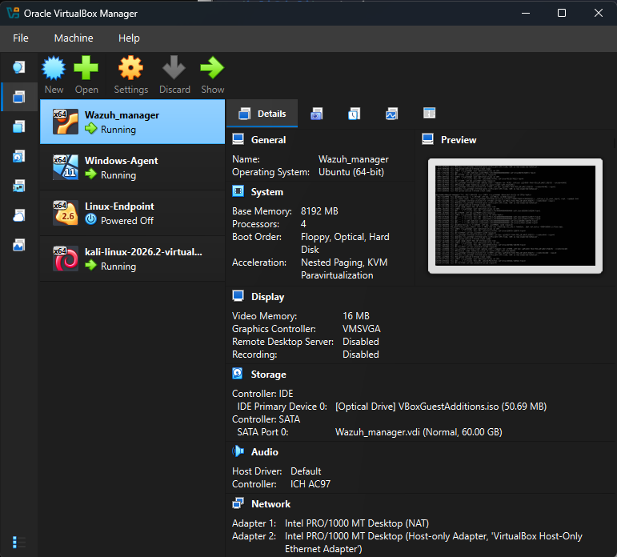

Figure 4.1 — Lab architecture overview (VirtualBox Manager).

5. Methodology and Tooling
The exercise followed a standard offensive-to-defensive validation methodology: build the monitored environment first, establish a clean detection baseline, then introduce a controlled adversarial action and observe the full detection-to-response chain. This mirrors the structure SOC teams use when validating detection content — deploy, baseline, simulate, detect, respond, review.
Stage | Activity | Primary Tooling
1 | Infrastructure provisioning | VirtualBox, Ubuntu 24.04, Windows 11 ISO
2 | SIEM deployment & agent enrollment | Wazuh 4.14.7 (manager + agents)
3 | Reconnaissance | Nmap, arp-scan
4 | Controlled attack simulation | OpenSSH client, Hydra
5 | Endpoint log validation | journalctl, sshd, PAM
6 | Detection validation | Wazuh dashboard, rule engine (5710/5712)
7 | Automated response | Wazuh Active Response (firewall-drop)
8 | Endpoint telemetry (Windows) | Sysmon 15.21, Wazuh EventChannel
9 | File Integrity Monitoring | Wazuh FIM (syscheck)

Every phase below is documented with a timestamp, the action performed, the observed system behavior, and a reference to the corresponding screenshot evidence stored in the project's tiered screenshot inventory (286 files across four importance tiers, per the accompanying documentation strategy).

6. Chronological Timeline

The following timeline presents the major stages of the project in chronological order, beginning with the initial laboratory preparation and continuing through network validation, endpoint configuration, attack simulation, security-event generation, Wazuh detection, Active Response testing, troubleshooting, and final verification. Timestamps are derived from the synchronized build and testing records maintained during the project.

6.1 Day 1 — August 16, 2026
Time | Activity
00:00 | Host resource check
00:30 | Wazuh Manager VM creation
01:25 | Ubuntu 24.04 installation
14:45 | Wazuh 4.14.7 install
15:25 | Dashboard login
15:38 | Windows Agent deploy attempt
16:26 | Host-Only network configuration
18:34 | Disk space troubleshooting
19:11 | Manager service recovery
20:16 | Windows VM provisioning

6.2 Day 2 — August 17, 2026
Time | Activity
00:51 | Windows network fix
01:26 | Windows Agent enrollment
14:03 | Test event verification
14:59 | Windows logon detection
15:13 | Linux Endpoint VM creation
19:29 | Linux endpoint networking
22:56 | Linux Agent install
23:22 | Agent enrollment & configuration

6.3 Day 3 — August 18, 2026
Time | Activity
00:02 | FIM test (Linux /tmp)
00:31 | Detection verification
01:00 | Dashboard password reset
22:30 | Agent connectivity fix
23:22 | FIM test (Windows)
23:55 | FIM detection confirmed

6.4 Day 4 — August 19, 2026
Time | Activity
00:01 | FIM lifecycle complete
01:58 | Sysmon Event ID 3 verified
17:29 | Kali reconnaissance begins
17:41 | Nmap port / service / OS scan
17:54 | Rule 5710 first detection
18:23 | SSH brute-force loop
23:06 | Subnet discovery

6.5 Day 5 — August 20, 2026
Time | Activity
23:53 (Aug 19) | Full port scan (65535 ports)
00:23 | Manual SSH attack
00:51 | Hydra brute force + Rule 5712 fired
01:04 | Active Response configuration
01:27 | Active Response troubleshooting & fix
02:01 | Final attack + Active Response block confirmed

7. Technical Findings by Phase
Each subsection below follows the standard SOC finding format: objective, action performed, observed result, and evidence. One primary (CRITICAL or HIGH-tier) screenshot is placed inline per phase; additional supporting screenshots for each phase are catalogued in Appendix A and should be added to a report appendix as needed.

7.1 Phase 1: Lab Infrastructure Setup
Objective: Provision an isolated, multi-VM SOC environment.
Action performed: Created and configured the Wazuh Manager, Linux endpoint, and Windows endpoint VMs in VirtualBox; installed Wazuh 4.14.7 as an all-in-one deployment.
Observed result: All VMs provisioned with correct specifications (8GB RAM / 4 vCPU / 60GB for the manager); Wazuh dashboard reachable and operational on first login.
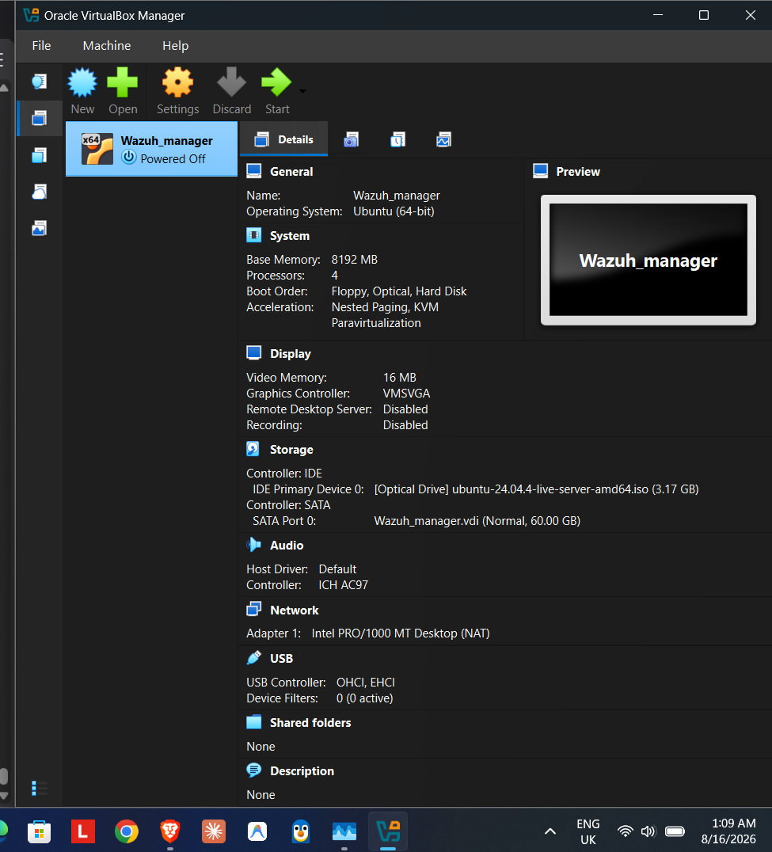
Figure 7.1.1 — Wazuh Manager VM configuration overview
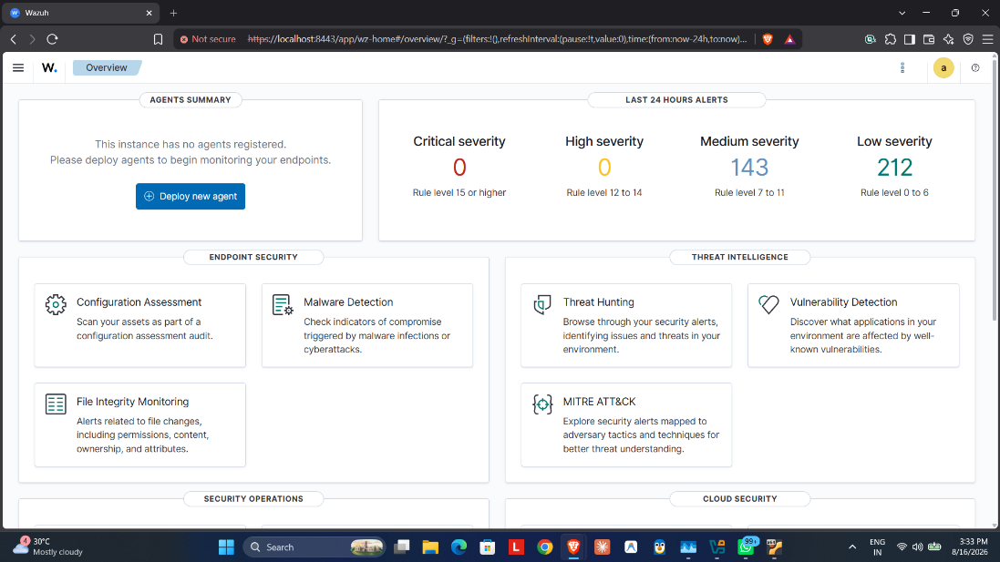
Figure 7.1.2 — First Wazuh dashboard login

7.2 Phase 2: Network and Agent Enrollment
Objective: Establish agent connectivity between endpoints and the Wazuh Manager over the isolated host-only network.
Action performed: Configured dual-NIC networking on the manager (NAT + host-only 192.168.56.2), applied static IP configuration via netplan, and installed/enrolled the Linux and Windows Wazuh agents.
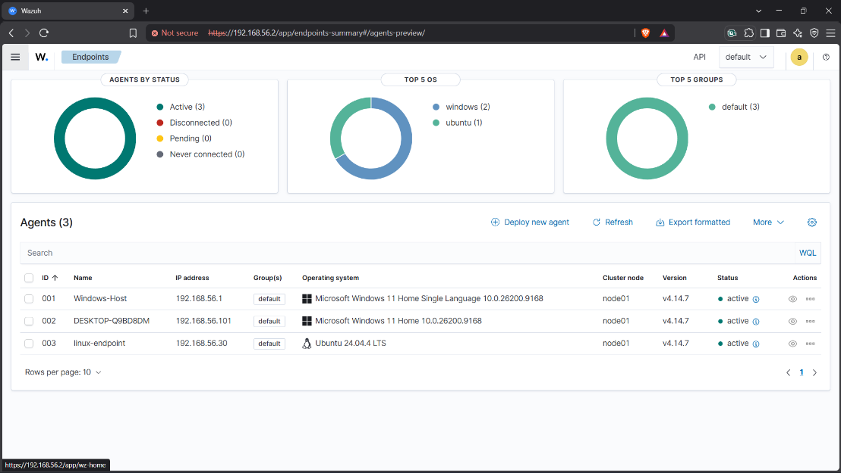
Observed result: All three monitored agents (manager, Linux endpoint, Windows endpoint) reported Active status on the Wazuh dashboard, confirming end-to-end log shipping.
Figure 7.2.1 — All Wazuh agents active

7.3 Phase 3: SSH Reconnaissance
Objective: Enumerate the Linux target from the attacker host to confirm the SSH attack surface prior to any authentication attempts.
Action performed: Ran a targeted Nmap scan against port 22, a full 65,535-port scan with OS fingerprinting, and an SSH2 algorithm-enumeration scan from the Kali host against 192.168.56.30.

Observed result: Nmap confirmed 22/tcp open running OpenSSH 9.6p1 on a Linux 4.X/5.X host; the full port scan corroborated the single open service and OS fingerprint.
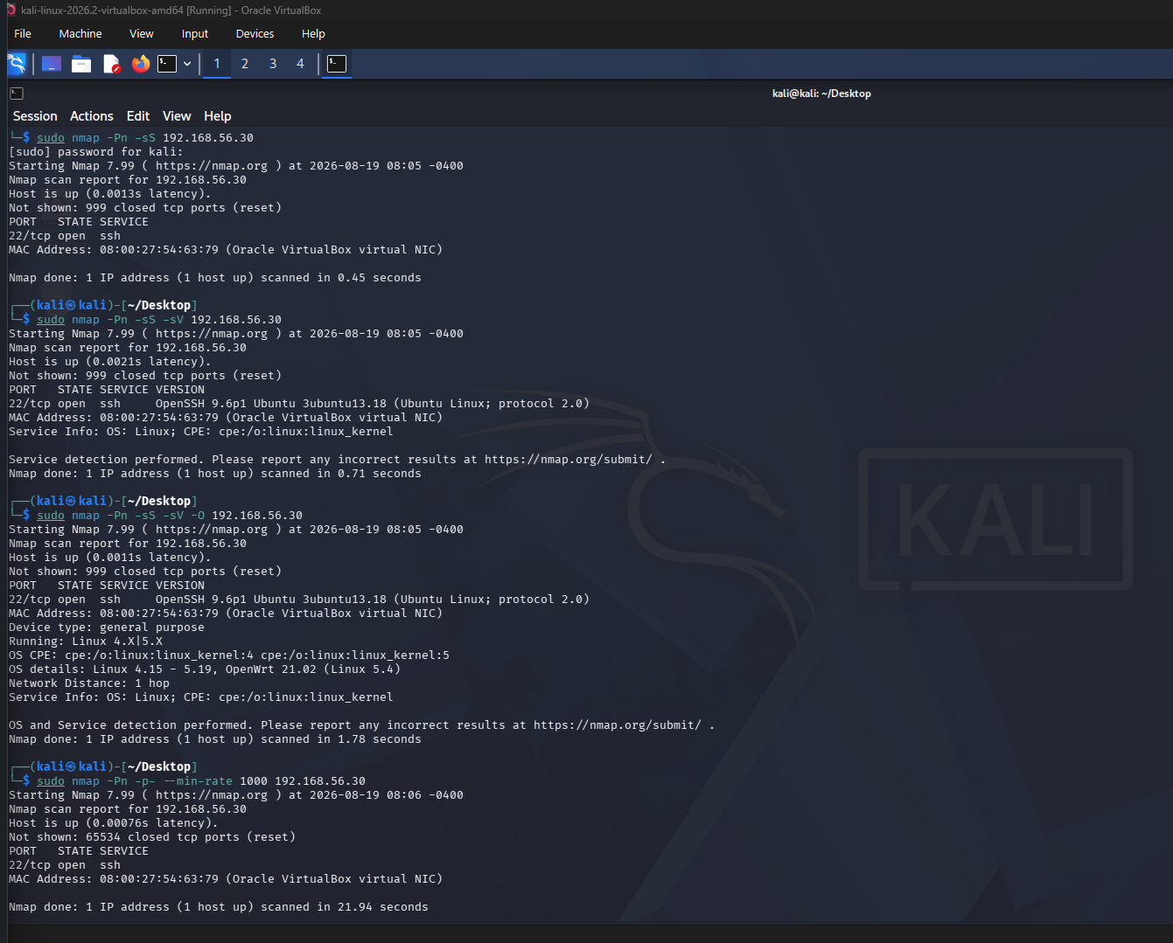
figure 7.3.1 — Nmap SSH service and OS discovery
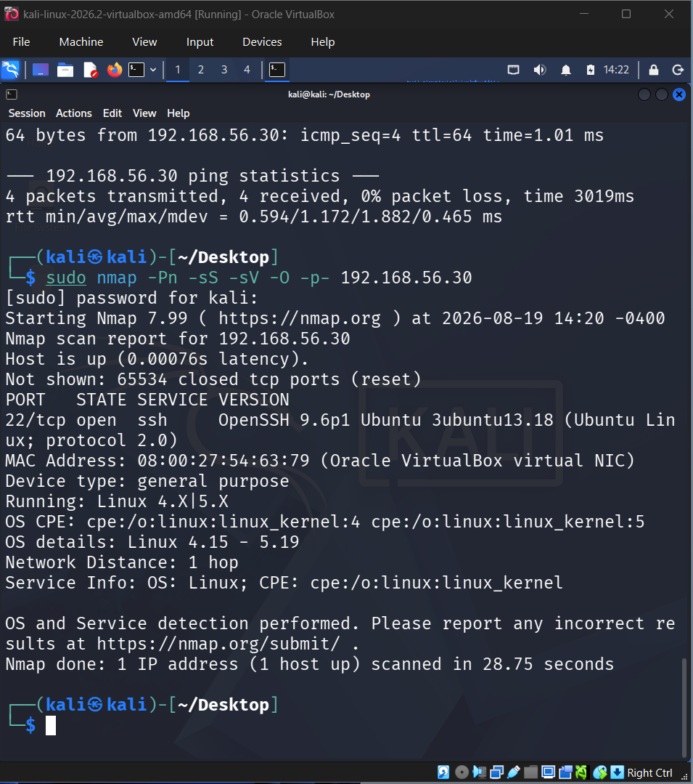
figure 7.3.2 — Full port-range scan with OS fingerprint

7.4 Phase 4: Controlled SSH Attack
Objective: Generate a realistic, controlled credential-attack event set for the SIEM to detect.
Action performed: Executed a manual invalid-user SSH login, followed by a scripted 10-iteration login loop, and a Hydra dictionary-based brute-force run against the Linux target's SSH service.
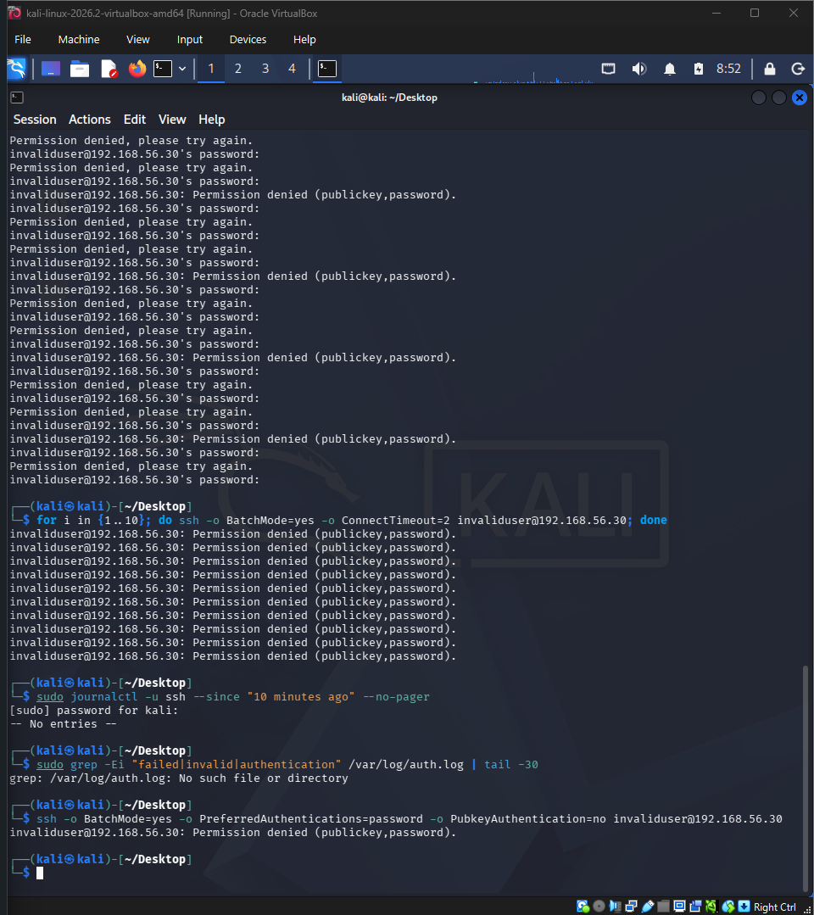
Observed result: All attack attempts were rejected by the target as expected; each failure generated a corresponding authentication-failure log entry on the endpoint.

Figure 7.4.1 — Scripted SSH brute-force loop (10x)

7.5 Phase 5: Endpoint Logging

Objective:
Confirm that the Linux endpoint's native authentication logging captured every attack attempt prior to SIEM ingestion, providing reliable host-level evidence for subsequent correlation and investigation.
Action performed:
Reviewed sshd and PAM logs via journalctl on the Linux endpoint immediately after each attack stage, focusing on authentication failures, invalid users, source IP addresses, and related SSH session events.
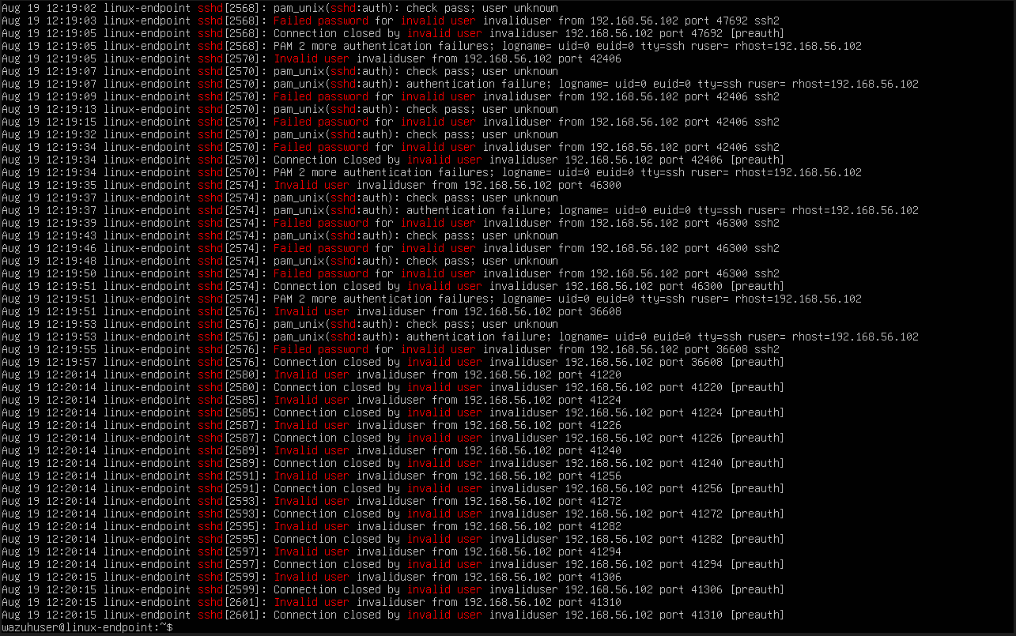
Observed result:
journalctl confirmed repeated Invalid user invaliduser from 192.168.56.102 and PAM authentication-failure entries, corroborating the attacker's source IP at the endpoint level before any SIEM correlation. The logs also confirmed that the attempted account did not exist on the endpoint and that the SSH authentication attempts were successfully recorded by the native logging subsystem.
Figure 7.5.1 — sshd authentication-failure log

7.6 Phase 6: Wazuh Detection
Objective: Validate that the Wazuh rule engine correctly classifies and escalates the SSH attack.
Action performed: Monitored the Wazuh dashboard and Threat Hunting module during and after each attack stage for rule firings.
Observed result: Rule 5710 (non-existent user login attempt) fired immediately, correctly attributing srcip=192.168.56.102 and mapping to MITRE T1110.001. Sustained brute-force activity subsequently escalated to Rule 5712 (Level 10, 'brute force trying to get access to the system').
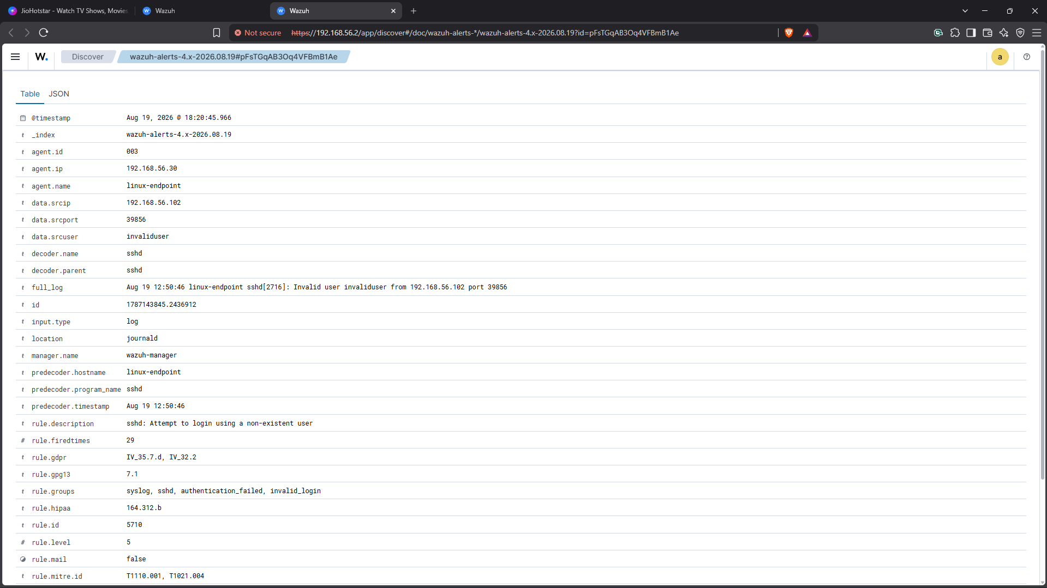
Figure 7.6.1 — Rule 5710 detection with MITRE mapping
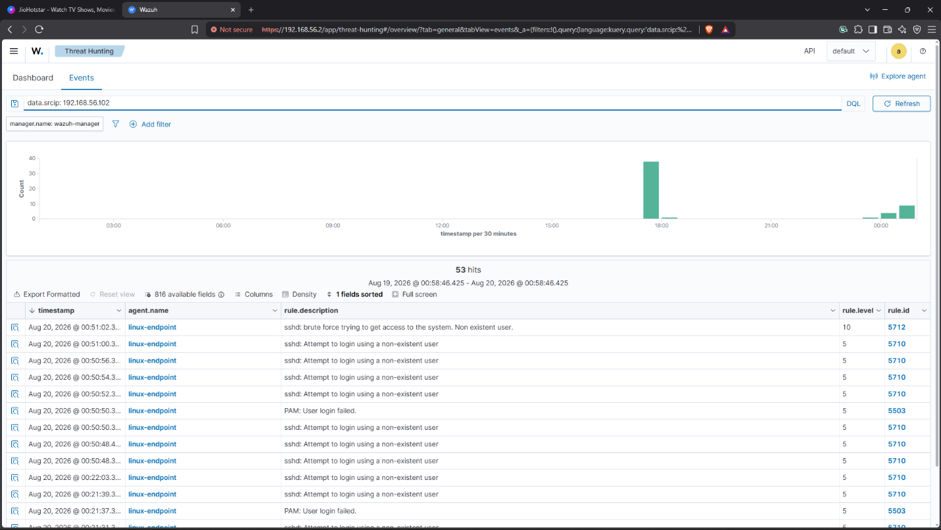
Figure 7.6.2 — Rule 5712 brute-force escalation (Level 10)

7.7 Phase 7: Active Response
Objective:
Configure and validate an automated containment action triggered by the brute-force detection, ensuring that a qualifying SSH authentication event is automatically associated with the appropriate Wazuh Active Response mechanism and that the response operates within the defined containment window.
Action performed:
Configured a Wazuh Active Response command binding firewall-drop to Rule 5710 with a 60-second timeout. During configuration, an initial XML tag/typographical misconfiguration was identified and corrected to ensure that the Active Response definition was properly parsed by the Wazuh Manager. The required Wazuh service was then restarted after the configuration was corrected. A controlled SSH authentication attack was subsequently re-triggered from the Kali attacker machine to generate another Rule 5710 detection and verify the complete detection-to-response workflow.
Observed result:
The Active Response mechanism successfully fired when the qualifying Rule 5710 event was generated. The Active Response log recorded the execution of the configured response mechanism following the detected SSH authentication activity. The subsequent SSH connection attempt from the Kali attacker was dropped, consistent with the configured automated containment action taking effect. The 60-second timeout provided a temporary containment period rather than a permanent firewall modification, allowing the response to operate within the defined test window.
The result demonstrated the intended SOC workflow in which an authentication-based security event is detected by Wazuh and automatically passed to the configured response mechanism without requiring manual intervention. This established the relationship between attack generation, rule-based detection, automated response execution, and containment within the controlled laboratory environment.
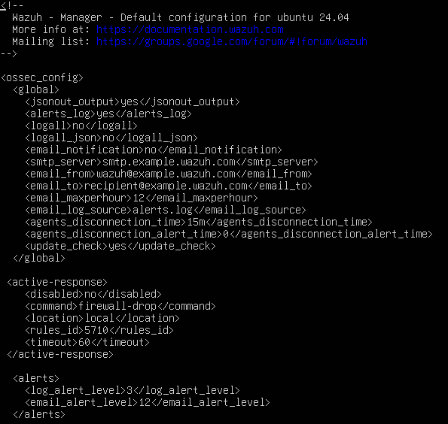
Figure 7.7.1 — Active Response configuration (firewall-drop, 60s)
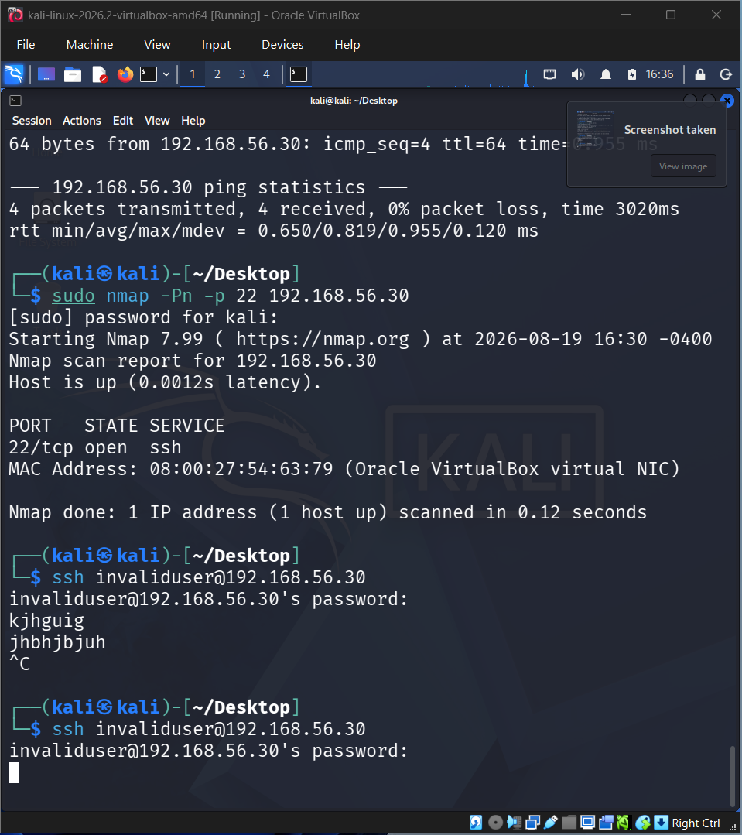
Figure 7.7.2 — Attacker SSH connection dropped

7.8 Phase 8: Windows Sysmon Telemetry
Objective: Validate endpoint-level telemetry ingestion from the Windows host via Sysmon.
Action performed: Installed and configured Sysmon 15.21 on the Windows endpoint and mapped its EventChannel into the Wazuh agent configuration (ossec.conf).
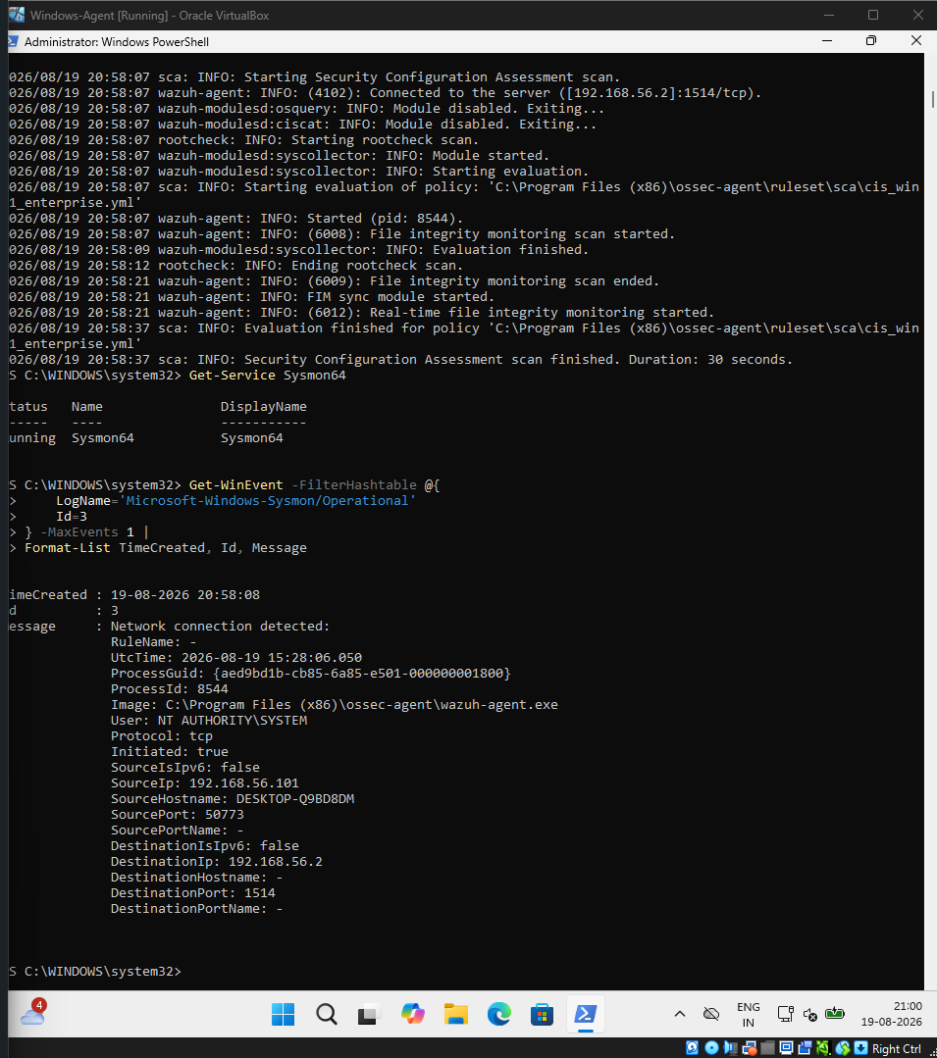
Observed result: Sysmon64 service confirmed running with 1,608 events recorded; Event ID 3 (network connection) telemetry was observed flowing from the agent to the manager over port 1514.

Figure 7.8.1 — Sysmon Event ID 3 — agent-to-manager telemetry

7.9 Phase 9: File Integrity Monitoring (FIM)
Objective: Validate
Wazuh's Syscheck (FIM) module across the complete create–modify–delete file lifecycle on the monitored endpoint, confirming that file-system changes are detected and recorded as security-relevant events.

Action performed:
Performed a controlled file write using Add-Content on the Windows endpoint to create a dedicated test file, followed by modification of the same file to generate a detectable checksum change. The test file was then deliberately deleted to complete the lifecycle and verify that Wazuh continued monitoring the file through each stage.

Observed result:
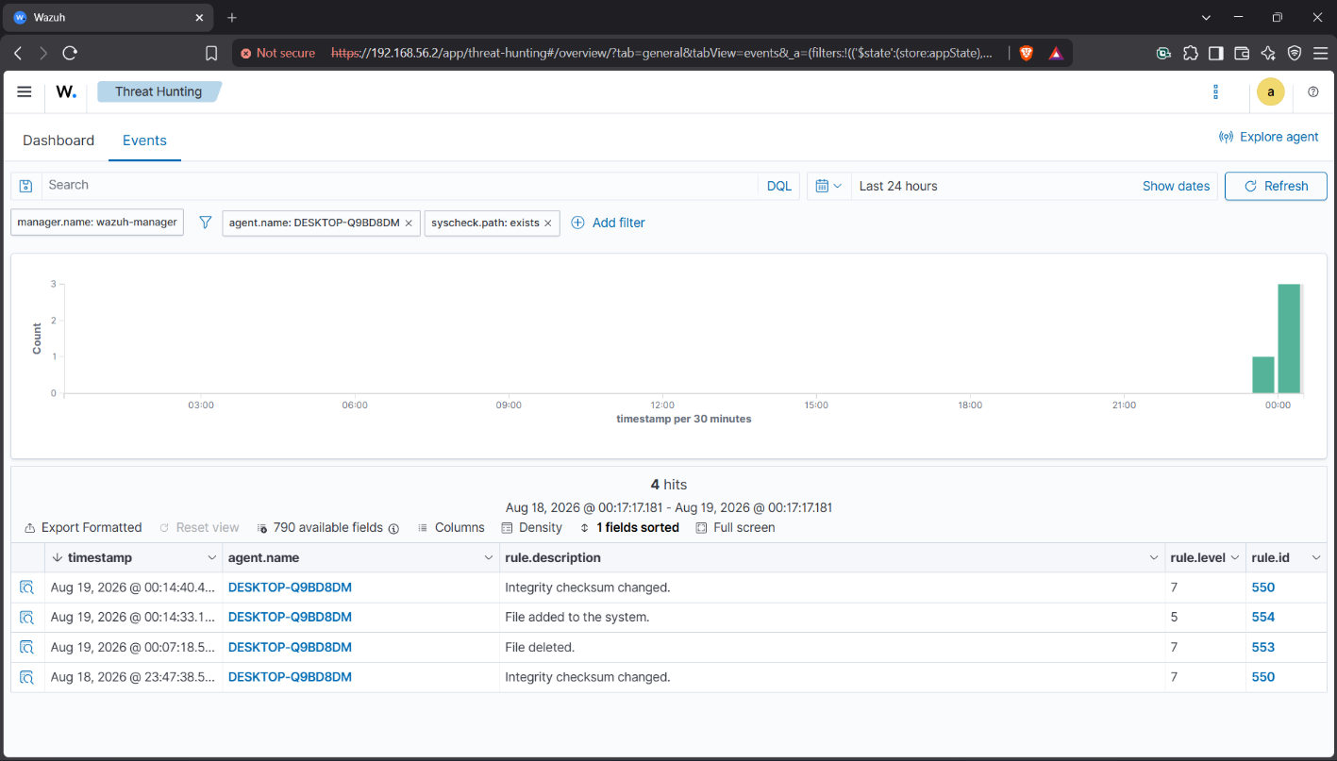
Wazuh FIM correctly logged all three lifecycle events through Rules 554, 550, and 553, corresponding to file creation, checksum/content modification, and deletion respectively. The deletion event was additionally mapped to MITRE ATT&CK techniques T1070.004 and T1485, providing additional threat-context classification for the observed file activity. This confirmed that the Syscheck module was actively monitoring the configured Windows endpoint and successfully detecting changes across the complete file lifecycle.
Figure 7.9.1 — FIM lifecycle — create, modify, delete

8. Detection Rules Demonstrated
The following Wazuh rules were triggered and validated during the engagement. Rule levels reflect Wazuh's default severity scale (0–16); Level 10+ is treated as a high-priority alert requiring analyst attention or automated response.
Rule ID | Level | Description | Evidence Reference
5710 | 5 | sshd: attempt to login using a non-existent user | 1_CRITICAL/DETECT_dashboard_rule5710_srcip102_mitre.png
5712 | 10 | sshd: brute force trying to get access to the system | 1_CRITICAL/DETECT_dashboard_rule5712_brute_force_lv10.png
550 | 7 | Integrity checksum changed (FIM modification) | 2_HIGH/DETECT_dashboard_rule550_checksum.png
553 | 7 | File deleted (FIM deletion) | 2_HIGH/DETECT_dashboard_fim_delete_mitre_t1070.png
554 | 5 | File added to the system (FIM creation) | 2_HIGH/DETECT_dashboard_fim_rules_550_553_554.png
5402 | 3 | Successful sudo to ROOT executed | 2_HIGH/DETECT_manager_sudo_rule5402_compliance.png
60122 | 5 | Logon failure — unknown user or bad password (Windows) | 2_HIGH/DETECT_dashboard_failed_logon_4625_rule60122.png

9. MITRE ATT&CK Mapping
Mapping detections to MITRE ATT&CK is standard SOC practice: it translates raw alert data into adversary technique language that is portable across tools, reports, and stakeholders.
Technique | ID | Tactic | Evidence
Password Guessing | T1110.001 | Credential Access | Rule 5710 + 5712
Remote Services: SSH | T1021.004 | Lateral Movement | SSH attack from Kali
Sudo and Sudo Caching | T1548.003 | Privilege Escalation | Rule 5402
File Deletion | T1070.004 | Defense Evasion | FIM Rule 553
Data Destruction | T1485 | Impact | FIM Rule 553

10. Compliance Framework Mappings
Cross-referencing detections against recognized compliance frameworks demonstrates how the lab's monitoring controls would satisfy common audit and regulatory evidence requirements.
Framework | Controls | Evidence
PCI DSS | 10.2.4, 10.2.5, 10.6.1, 11.5 | Rules 5710, 550
HIPAA | 164.312(b), 164.312(c)(1) | Authentication monitoring, FIM
NIST 800-53 | AU-6, AU-14, AC-7, SI-7 | Audit log review, integrity monitoring
GDPR | Art. 32(2), 35(7)(d), 5(1)(f) | Security event processing
SOC 2 (TSC) | CC6.1, CC6.8, CC7.2, CC7.3 | Access control, monitoring

11. Results Summary
Capability | Status | Evidence Location
Kali → Linux connectivity | Confirmed | 2_HIGH/NETCFG_kali_ip_ping_target_manager.png
SSH service discovery (22/tcp) | Confirmed | 1_CRITICAL/RECON_kali_nmap_ssh22_openssh_os.png
Controlled SSH auth failure | Confirmed | 1_CRITICAL/ATTACK_kali_ssh_brute_force_loop_10x.png
Linux sshd logging | Confirmed | 1_CRITICAL/LOGGING_sshd_auth_failures_192_168_56_102.png
Wazuh event collection | Confirmed | 2_HIGH/CONFIG_dashboard_3_agents_all_active.png
Rule 5710 detection | Confirmed | 1_CRITICAL/DETECT_dashboard_rule5710_srcip102_mitre.png
Rule 5712 brute-force detection | Confirmed | 1_CRITICAL/DETECT_dashboard_rule5712_brute_force_lv10.png
Attacker source attribution | Confirmed | srcip 192.168.56.102 in Rule 5710
Active Response invocation | Confirmed | 1_CRITICAL/AR_config_firewall_drop_rule5710_60s.png
Attacker session dropped | Confirmed | 1_CRITICAL/AR_kali_attacker_blocked_firewall_drop.png
Firewall rule verification (iptables/nft) | Not verified | Documented as limitation — see Section 12
Windows Sysmon telemetry | Confirmed | 2_HIGH/SYSMON_eventid3_agent_to_manager_1514.png
FIM detection (Windows) | Confirmed | 2_HIGH/DETECT_dashboard_fim_lifecycle_4hits.png
Windows failed logon (4625) | Confirmed | 2_HIGH/DETECT_dashboard_failed_logon_4625_rule60122.png

12. Conclusion and Recommendations

12.1 Conclusion
The lab successfully demonstrated a complete, evidence-backed SSH attack detection and automated response chain across a multi-agent Wazuh SIEM deployment, spanning reconnaissance, controlled attack execution, endpoint logging, SIEM correlation, automated containment, and cross-platform (Linux + Windows) telemetry validation. All primary objectives defined in Section 3.2 were met, with one transparently disclosed evidentiary gap.

12.2 Recommendations for Future Iterations
Independently verify Active Response network-layer effects using iptables -L / nft list ruleset immediately after each firing, and capture this as CRITICAL-tier evidence.
- Extend Active Response coverage to additional rule IDs (e.g., repeated sudo escalation, FIM deletion bursts) to broaden automated containment scope.
- Introduce a second, independent detection source (e.g., Suricata or Zeek) to cross-validate Wazuh's SSH brute-force detections.
- Formalize the screenshot-tiering workflow used here (CRITICAL / HIGH / MEDIUM / LOW) as a reusable SOC evidence-handling template for future lab and production investigations.

Appendix A: Screenshot Evidence Inventory
Tier | Folder | File Count | Use
1 — CRITICAL | 1_CRITICAL/ | 8 | Report essentials — used inline in Sections 4 and 7
2 — HIGH | 2_HIGH/ | 93 | Important supporting evidence — 1–3 per phase recommended
3 — MEDIUM | 3_MEDIUM/ | 75 | Supporting context — reference only if challenged
4 — LOW | 4_LOW/ | 110 | Troubleshooting / debug — summarize as text, do not embed

A.1 Naming Convention
Every screenshot follows the convention CATEGORY_descriptive_function_name.png, where CATEGORY is one of: RECON, ATTACK, DETECT, AR, LOGGING, SYSMON, CONFIG, SETUP, NETCFG, TROUBLESHOOT, or OTHER.

A.2 CRITICAL Tier — Full Listing
# | File | What It Proves
1 | RECON_kali_nmap_ssh22_openssh_os.png | Nmap discovers 22/tcp open, OpenSSH 9.6p1, OS Linux 4.X|5.X
2 | RECON_kali_nmap_full_65535_ssh_os.png | Full 65535-port scan with OS fingerprint
3 | ATTACK_kali_ssh_brute_force_loop_10x.png | for i in {1..10}; do ssh invaliduser@192.168.56.30
4 | LOGGING_sshd_auth_failures_192_168_56_102.png | sshd logs: Invalid user invaliduser from 192.168.56.102
5 | DETECT_dashboard_rule5710_srcip102_mitre.png | Rule 5710 alert: srcip=192.168.56.102, MITRE T1110.001
6 | DETECT_dashboard_rule5712_brute_force_lv10.png | Rule 5712 Level 10: brute force trying to get access
7 | AR_config_firewall_drop_rule5710_60s.png | Final AR XML: firewall-drop on rule 5710, timeout 60s
8 | AR_kali_attacker_blocked_firewall_drop.png | SSH connection dropped — attacker blocked

— End of Report —

