Alexandra Ralevski

Nov. 29, 2020

Foundations of Python

Assignment 07

https://github.com/ARalevski/ITFnd100-Mod07

Pickling and Exception Handling in Python

# Introduction

In Module07 I will be learning about pickling and error handling in Python, and the proper ways to use them.

# Pickling

Pickling allows a user to convert their data into a binary file (using 0’s and 1’s) on the computer. To begin, you must ‘import pickle’ at the beginning of the document, in order to use the built-in pickling functions that python provides. Then, you can read, write, or append to a document and convert the data to binary.

# Exception Handling

Exception handling allows you to ‘catch’ certain errors that a user may make and give them more ‘user friendly’ error messages rather than the built in ones that come with Python. You set up the code using a ‘try/except’ block that will catch any specific or non-specific errors (depending on how you write the code).

# Writing Code using Pickling and Error Handling

I wrote a script to create a list of users pet’s and their names using pickling and error handling. The output of the code running in the Terminal is shown in Fig. 1

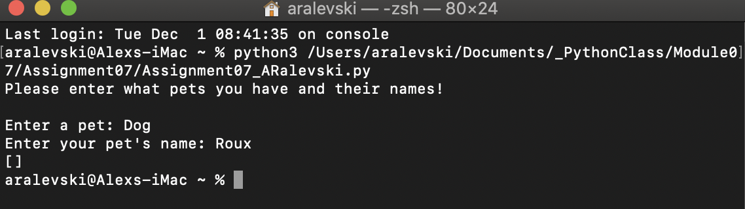

***Figure 1: Module07 Script running the terminal***

# Summary

In summary, I learned about pickling and error handling in Python, and have written a code that demonstrates the two. The code allows users to make a list of all their pets and their names, and stores it in a binary file. If a user makes an error while entering the data, the try/except block will catch it and present an error message.