Alexandra Ralevski

Nov. 20, 2020

Foundations of Python

Assignment 06

https://github.com/ARalevski/IntroToProg-Python-Mod06

Functions in Python

# Introduction

In Module06 I will be learning about how to create functions in Python, and when to use arguments and parameters to define and call functions. I will also learn about using functions and classes to better organize code.

# Functions

A function is a named set of one or more statements. Because functions must have a name, you can use that name to call a particular function throughout your code. Because they group statements together, functions help you to organize your code, especially in the ‘Processing’ and ‘Presentation’ sections. You can use parameters to pass values into the function for processing. When you call the function, the parameters you pass into it are called arguments.

# Classes

Classes are groupings of functions, variables, and constants. They help you to organize your code into the different parts (processing and input/output), to make it easier to read and use.

# Writing Code using Functions

I wrote a script to create a ‘ToDo list’ of household tasks and their priority level using functions and classes. The output of the code running in the Terminal is shown in Fig. 1.

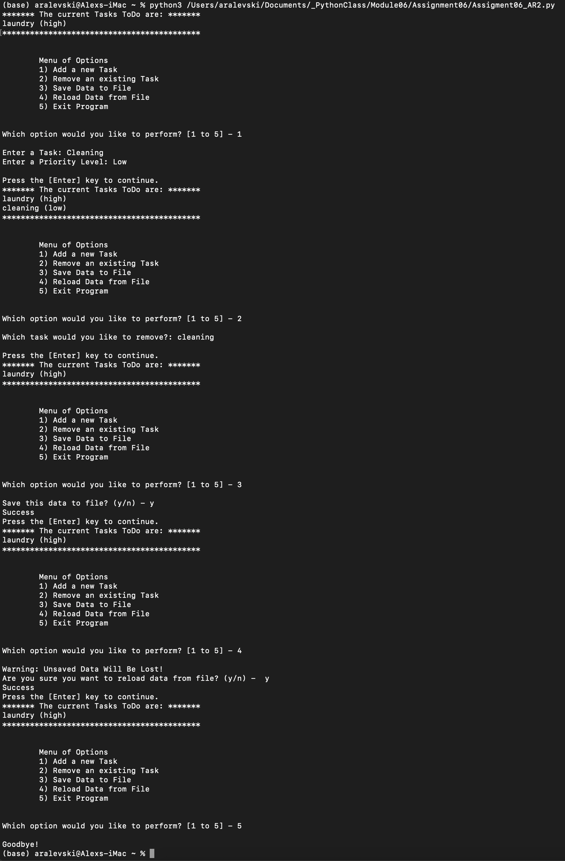

***Figure 1: Module06 Script running the terminal***

# Summary

In summary, I have written a script that creates a ‘ToDo list’ of household tasks and their priority level using classes and functions. I learned the value of using both of these tools to better write and organize my code, to make it more functional and readable for myself and others.