**Trimester March/April, 2025**

**CSE6224 SOFTWARE REQUIREMENTS ENGINEERING**

**Project Part 1**

**Topic: Campus Ride-Sharing Platform with**

**Parking System Integration**

**Context Objects Documentation**

|  |  |  |
| --- | --- | --- |
| Name | Student ID | Course |
| Chee Rui | 1211112287 | Bachelor of Computer Science |
| Teh Li Wei | 1211109581 | Bachelor of Computer Science |
| Sow Chien Yee | 1211210800 | Bachelor of Computer Science |
| Lai Zi Xuan | 1211109451 | Bachelor of Computer Science |

Context Objects and Requirements Sources

1.1 System Environment Overview

Our Campus Ride-Sharing Platform with Parking Integration system will operate within the MMU Cyberjaya campus environment and will be accessible via the pre-existing MMU mobile app. It is intended to extend the app’s current functionalities and address parking-related issues while leveraging existing campus systems such as user authentication databases and car detail records.

The environment includes:

* Existing Mobile App Platform: Users will be much more familiar with it and prevents the creation of another mobile app.
* User devices: Mobile phones, offering convenience for users interacting with the system while in their vehicles.
* Authentication system: Integration with MMU's student/staff ID database for login
* Car Details system: Integration with the current Car Sticker protocol, ensuring stricter and more controlled vehicle access within the campus.
* Administrator backend access: Restricted access panel for authorized personnel to view and manage parking reports

1.2 Stakeholder Identification

|  |  |  |
| --- | --- | --- |
| **Stakeholder** | **Role** | **Interest / Responsibility** |
| Students | Primary users | Use the app to find parking, claim parking space, report issues, and book rides; expect convenience and speed. |
| Faculty & Staff | Secondary users | Similar to students; usage of ride function may be less or negligible |
| System Administrators | Admin users | Manage reports, review user-submitted data, and maintain system integrity. |
| University Security Staff | Admin users | Check reports, verify reports and remove resolved reports |
| University IT Department | Technical support | Provide infrastructure, handle API maintenance with existing databases (login, car info). |
| Developers | System implementers | Use elicited requirements to design, develop, and test the application. |

1.3 Context Diagram

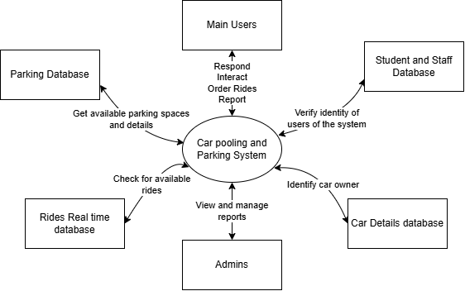

The context diagram above shows the high-level interactions between the proposed parking and transportation system and its external entities. These entities include students and faculty/staff as users, system administrators, internal systems like the real time rides database and external systems such as MMU's authentication and car sticker databases. The diagram describes the system's boundaries and the main data flows.

1.4 Sources of Requirements

The requirements for our system are gathered from the following sources:

* End Users (Students and Staff): Provide insight into daily parking issues, feature expectations, and user experience needs.
* System Administrators: Offer requirements related to managing reports and verifying car details.
* University IT Department: Define technical constraints, API details for database, and infrastructure capabilities.
* Existing Campus Policies and Procedures: Inform functional boundaries, such as parking regulations and transport access rules.
* Elicitation Techniques: Data collected via interviews, questionnaires and prototyping with stakeholders.