

**Trimester March/April, 2025**

**CSE6224 SOFTWARE REQUIREMENTS ENGINEERING**

**Project Part 1**

**Topic: Campus Ride-Sharing Platform with**

**Parking System Integration**

**Kano Model Documentation**

|  |  |  |
| --- | --- | --- |
| Name | Student ID | Course |
| Chee Rui | 1211112287 | Bachelor of Computer Science |
| Teh Li Wei | 1211109581 | Bachelor of Computer Science |
| Sow Chien Yee | 1211210800 | Bachelor of Computer Science |
| Lai Zi Xuan | 1211109451 | Bachelor of Computer Science |

Table of Contents

1 Elicitation Strategy 3

1.1 Justification for Using the Kano Model Elicitation Strategy Overview 3

1.2 Classification of Requirements Using Kano Model 3

2 Elicitation Execution and Findings 3

2.1 Categorized Requirements (Based on Kano) 3

3 Appendices 4

3.1 References 4

1 Elicitation Strategy

1.1 Justification for Using the Kano Model Elicitation Strategy Overview

• Why kano

1.2 Classification of Requirements Using Kano Model

Define the categories: Dissatisfiers, Satisfiers, Delighters   
Talk about what are they  
How are we going to sort (There’s methods)

2 Elicitation Execution and Findings

2.1 Categorized Requirements (Based on Kano)

Define the categories: Dissatisfiers, Satisfiers, Delighters   
Sort the requirements into those categories above then create the kano model  
  
example

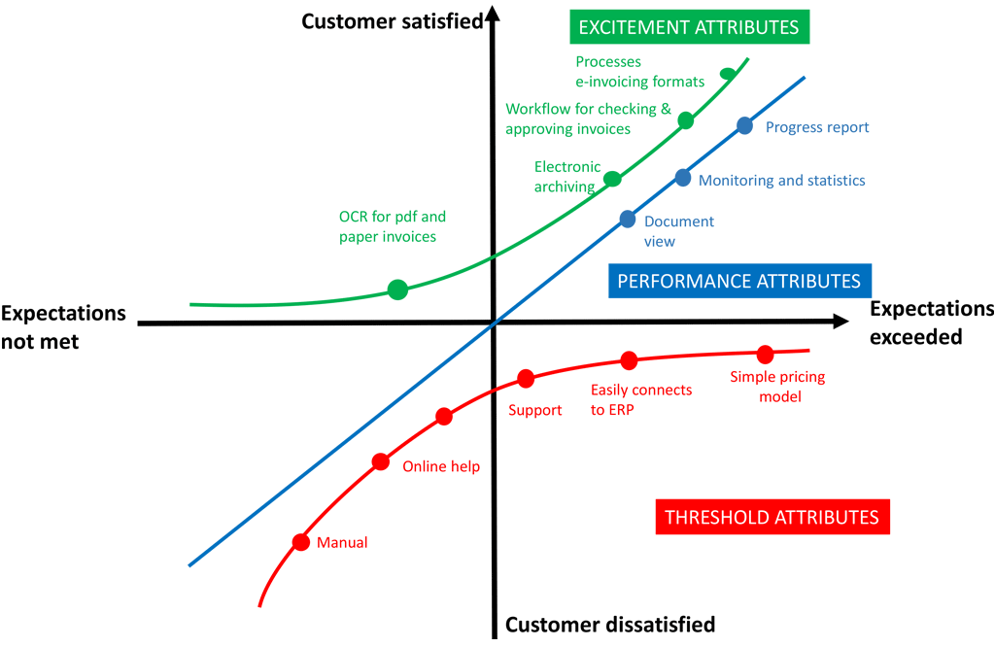

3 Appendices

3.1 References

fsdfsddf