

**Trimester March/April, 2025**

**CSE6224 SOFTWARE REQUIREMENTS ENGINEERING**

**Project Part 1**

**Topic: Campus Ride-Sharing Platform with**

**Parking System Integration**

**Requirements Elicitation Report**

|  |  |  |
| --- | --- | --- |
| Name | Student ID | Course |
| Chee Rui | 1211112287 | Bachelor of Computer Science |
| Teh Li Wei | 1211109581 | Bachelor of Computer Science |
| Sow Chien Yee | 1211210800 | Bachelor of Computer Science |
| Lai Zi Xuan | 1211109451 | Bachelor of Computer Science |

Table of Contents

1 Introduction 3

1.1 Purpose of the Document 3

1.2 Document Scope 3

1.3 Intended Audience 3

1.4 Overview 3

2 Context Objects and Requirements Sources 3

2.1 System Environment Overview 3

2.2 Stakeholder Identification 3

2.3 Context Diagram 4

2.4 Sources of Requirements 4

3 Requirements Elicitation Plan Using the Kano Model 5

3.1 Selected Elicitation Techniques 5

3.2 Justification for Using the Kano Model Elicitation Strategy Overview 5

3.3 Classification of Requirements Justification for Using the Kano Model 6

3.4 Classification of Requirements Using Kano Model 6

4 Elicitation Execution and Findings 6

4.1 Summary of Elicitation Sessions 6

4.2 Categorized Requirements (Based on Kano) 6

4.3 Observations and Notes 7

5 Appendices 7

5.1 Raw Notes or Transcripts 7

5.2 Survey Results or Interview Templates 8

5.3 References 8

1 Introduction

1.1 Purpose of the Document

(What is this document for)

1.2 Document Scope

(What will this document cover? Just metniond its for elicitation and what to expect from it)

1.3 Intended Audience

(List stakeholders who should read this) etc Developer/client

1.4 Overview

Brief summary of what’s in section 2 3 4 basically the other sections (Probably leave till last)

2 Context Objects and Requirements Sources

2.1 System Environment Overview

(Describe why we use this system this way in a high-level system context. Like why python why use app instead of website etc)

Mention any constraints (e.g., web app, mobile, regulated industry, etc.)

2.2 Stakeholder Identification

| **Stakeholder** | **Role** | **Interest/Influence** |
| --- | --- | --- |
| End User | Uses the app | High |
| Client | Pays for system | Very High |
| IT Admin | Maintains system | Medium |

(Table example..)  
But ofc talk more about the role  
  
and in the end add a short paragraph as a conclusion

2.3 Context Diagram

( A diagram showing how the system interacts with external actors or systems. Example below:)  
  
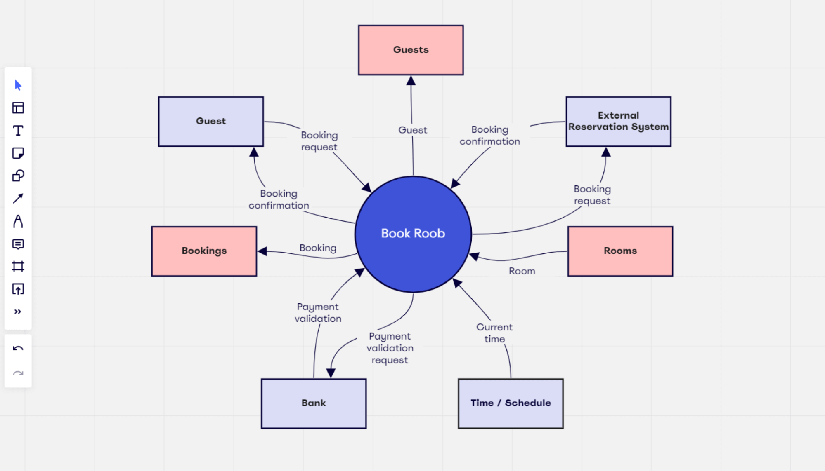

2.4 Sources of Requirements

Read Week 3 Lecture Slides Elicitation 7-37   
  
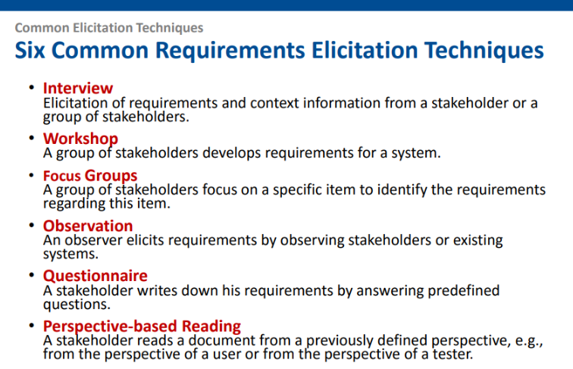  
  
(Need to ask lec if prototyping counts, also if not wrong pick 3)

3 Requirements Elicitation Plan Using the Kano Model

3.1 Selected Elicitation Techniques

Say what techniques we used  
Why we choose those, aka benefits and limitations but why we still choose it

3.2 Justification for Using the Kano Model Elicitation Strategy Overview

• Summarize how requirements are gathered (e.g., interviews, surveys, task analysis).

• Describe team roles (who did what).

3.3 Classification of Requirements Justification for Using the Kano Model

Why we choose kano model preferbally bullet point form

3.4 Classification of Requirements Using Kano Model

Define the categories: Dissatisfiers, Satisfiers, Delighters   
Talk about what are they  
How are we going to sort (There’s methods)

4 Elicitation Execution and Findings

4.1 Summary of Elicitation Sessions

(provides an overview or summary of the elicitation activities you’ve conducted, typically includes a summary of what was discussed, the main points or insights gathered, and any key takeaways from those sessions. It is more about describing the process, context, and the outcomes from the sessions themselves, without delving into the specifics of the requirements.)

4.2 Categorized Requirements (Based on Kano)

Define the categories: Dissatisfiers, Satisfiers, Delighters   
Sort the requirements into those categories above then create the kano model  
  
example

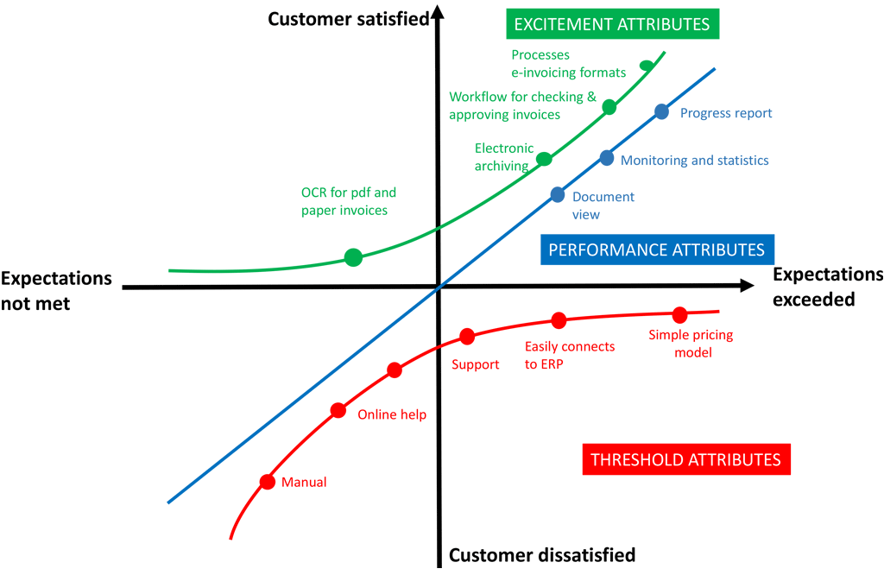

4.3 Observations and Notes

* General findings and interesting things noticed.
* Conflicting or ambiguous feedback.
* Anything that impacted what made it into the SRS.

5 Appendices

5.1 Raw Notes or Transcripts

fsdfsddf

5.2 Survey Results or Interview Templates

fsdfsddf

5.3 References

fsdfsddf