

**Trimester March/April, 2025**

**CSE6224 SOFTWARE REQUIREMENTS ENGINEERING**

**Project Part 1**

**Topic: Campus Ride-Sharing Platform with**

**Parking System Integration**

**Requirements Elicitation Report**

|  |  |  |
| --- | --- | --- |
| Name | Student ID | Course |
| Chee Rui | 1211112287 | Bachelor of Computer Science |
| Teh Li Wei | 1211109581 | Bachelor of Computer Science |
| Sow Chien Yee | 1211210800 | Bachelor of Computer Science |
| Lai Zi Xuan | 1211109451 | Bachelor of Computer Science |

Table of Contents

1 Requirements Elicitation Plan 3

1.1 Selected Elicitation Techniques 3

1.2 Tools Used 3

2 Elicitation Execution and Findings 4

2.1 Summary of Elicitation Sessions 4

2.2 Categorized Requirements (Based on Kano) 4

2.3 Observations and Notes 4

3 Appendices 4

3.1 Raw Notes or Transcripts 4

3.2 Survey Results or Interview Templates 4

3.3 References 5

1 Requirements Elicitation Plan

1.1 Selected Elicitation Techniques

Out of the many elicitation techniques, we decided to pick 3 of the most crucial to effectively gather key specifications and user expectations for the proposed system from our stakeholders.

1. Questionnaire

This technique helps to collect general opinions and preferences regarding parking and ride sharing features.

* Cost-effective and time-efficient
* Reaches a large number of respondents quickly
* Useful for identifying common issues and feature expectations

2. Interview

One-on-one interviews were conducted with selected stakeholders, including students, system administrators, and university IT staff to share thoughts and explore specific requirements in detail.

* Allows follow-up questions and clarification
* Provides detailed, context-rich insights
* Helps understand workflows, exceptions, and stakeholder goals

3. Prototyping

Figma prototypes were developed to demonstrate possible layouts and overall of the system. These were shown to users for feedback and confirmation.

* Helps validate assumptions before implementation
* Encourages stakeholders to express preferences and UI concerns
* Useful in discovering hidden usability or feature gaps

## 1.2 Tools Used

2 Elicitation Execution and Findings

2.1 Summary of Elicitation Sessions

(provides an overview or summary of the elicitation activities you’ve conducted, typically includes a summary of what was discussed, the main points or insights gathered, and any key takeaways from those sessions. It is more about describing the process, context, and the outcomes from the sessions themselves, without delving into the specifics of the requirements.)

2.1.1 Questionnaire Session

2.1.2 Interview Sessions

Two interviews were conducted with students representing both key user groups of the system:

1. **Driver Interview**: Conducted with Sow Chien Yee, a student who regularly drives to campus
2. **Rider Interview**: Conducted with Ng Zai Kit, a student who doesn't own a car

The interviews followed a structured format with questions categorized according to the Kano model (Dissatisfiers, Satisfiers, and Delighters) to effectively identify and prioritize requirements. Each interview lasted approximately 5-10 minutes and explored both ride-sharing and parking system features.

**Summary of Key Findings:**

1. Drivers prioritize safety and prefer manual control over rider selection with gender filters
2. Riders value convenience and automatic matching with basic verification
3. Both groups are motivated by rewards and would use reporting features
4. Privacy concerns exist regarding sharing personal information in parking systems
5. Real-time parking information is highly valued by all users

2.1.3 Prototype Session

Authentication system

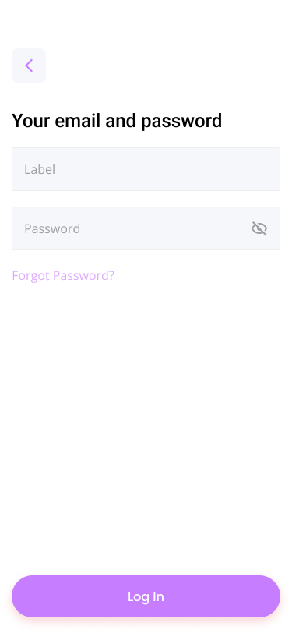

This is a prototype of a simple authentication system for the whole application, it included a simple form of register as a user and login form for normal users, drivers and even administrators. The third image provided shows a form of a normal user register as a driver. The driver registration form needs to be detailed to let administrators to register the user as a driver.

Car-pooling system/Campus Ride-Sharing system (normal user side)

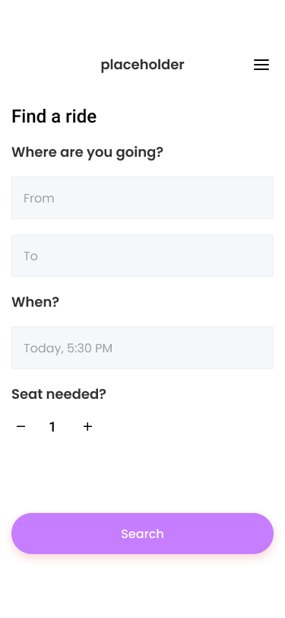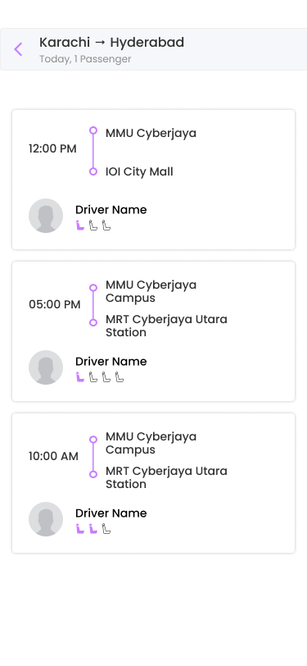

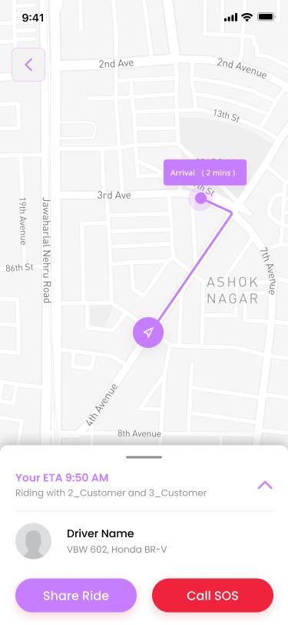(map is sample only, not final product)

This system shows the normal users’ side of carpooling/campus ride-sharing system. The system allows normal users to book/request a ride. Apart from other carpooling/ride-sharing system which auto find driver for customers, this system lets normal users choose their appropriated route to optimize best routes for both drivers and customers.

Car-pooling system/Campus Ride-Sharing system (driver’s side)

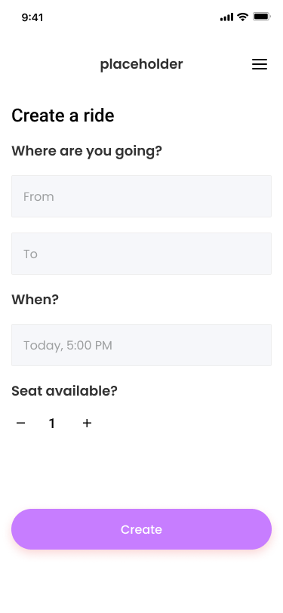

This one shows the driver’s side of the carpooling/campus ride-sharing system. Drivers can create ride for customers to join ride, as from earlier normal users can choose ride. The purpose of the driver to create ride is to let driver to go to their own destination after the ride and to let normal riders to join without interrupting the driver’s route.

Parking System

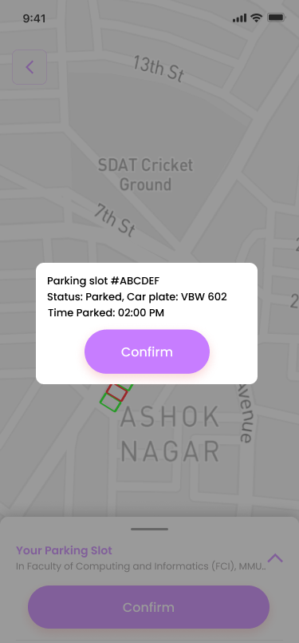  
(map is sample only, not final product)

This parking system is made for normal users (mostly students) to find a parking slot inside campus. The system features an automatic parking finding system and a manual parking booking system to let users to book a parking instantly (for automatic parking searching system) and for users to book a parking for a certain time slot (for manual parking booking system). Users and admins can view parking info if the slot is taken according to image 3.

Administrative system

This is the administrative system for the prototype application. The system can let administrators to view driver details for car-pooling/ride-sharing system and parking information for parking system. The purpose of the administration is to ensure that drivers are being approved manually for application of car-pooling/ride-sharing system, and also to view and update the availability of the parking of the parking system.

2.2 Categorized Requirements (Based on Kano)

Define the categories: Dissatisfiers, Satisfiers, Delighters   
Sort the requirements into those categories above then create the kano model

2.2.1 Questionnaire Session

2.2.2 Interview Session

**Dissatisfiers (Must-Have Requirements)**

These are basic expectations that cause dissatisfaction when not met:

1. **Ride Information Fundamentals**
   * Time of departure
   * Pick-up location and destination
   * Driver details (including picture)
   * Number of available seats
   * Cost/price information
2. **Safety and Verification**
   * University verification system for all users
   * Basic security measures
3. **Parking Information**
   * Real-time parking availability count
   * Map location of parking spots

**Satisfiers (Performance Requirements)**

These features increase satisfaction when provided and implemented well:

1. **Ride Approval and Matching**
   * Options for both manual approval (preferred by drivers) and automatic matching (preferred by riders)
   * Filters for gender and faculty (particularly important for female drivers)
   * Recurring ride booking capability
2. **Parking System Enhancement**
   * Best parking lot suggestions based on destination
   * Partial identification of vehicles in parking spots (opinions varied on privacy concerns)

**Delighters (Excitement Requirements)**

These are unexpected features that create high satisfaction:

1. **Incentive Systems**
   * Fuel savings and carbon footprint reduction metrics
   * Reward system (fuel compensation or redeemable points)
2. **Safety and Convenience Enhancements**
   * Location sharing with friends during rides
   * Rating system (particularly star ratings)
   * Illegitimate parking reporting with photo evidence

2.2.3 Prototype Session  
example

2.3 Observations and Notes

* General findings and interesting things noticed.
* Conflicting or ambiguous feedback.
* Anything that impacted what made it into the SRS.

2.3.1 Questionnaire Session

2.3.2 Interview Session

* **Gender-based Safety Concerns**: Female drivers expressed significant preference for same-gender riders, suggesting safety filters are essential rather than optional.
* **Privacy vs. Accountability Balance**: Differing opinions regarding the sharing of personal information in the parking system highlight the need for careful consideration of privacy implications.
* **Verification Importance**: University verification appears to be a key trust factor that enables users to feel comfortable with the ride-sharing concept.
* **Economic Incentives**: Both interviewed users expressed that monetary incentives or rewards would significantly increase their motivation to use the platform.
* **Automatic vs. Manual Preferences**: There was a clear preference difference between drivers (preferring manual approval) and riders (preferring automatic matching), indicating a need for a hybrid approach.
* **Illegitimate Parking Concerns**: Both participants expressed strong interest in a reporting mechanism for parking violations, suggesting this is a common pain point on campus.

2.3.3 Prototype Session

3 Appendices

3.1 Raw Notes or Transcripts

Transcript 1

|  |
| --- |
| Teh Li wei (Interviewer): Okay, I'm Li Wei and I'm currently working on a software requirements project. So the title is about a ride sharing and parking system. The goal of this interview is to gather your thoughts on how the system should work and what details matter to you as a user. So can you introduce yourself before we start the interview?  Interviewee: Sure. My name is Sow Chien Yee and I am a student in MMU. I usually drive to school when i have class.  Teh Li wei (Interviewer): Alright. So our question is, what information do you think must be required when offering a ride?  Interviewee: I think the information that must be required is about the time to depart from the location and the destination of the location.  Teh Li wei (Interviewer): Alright, so would you feel safe letting someone you don't know to join your car if they are a verified student? And tell me why or why not?  Interviewee: Actually, I don't really feel safe if I'm a male stranger because I usually drive alone and then I usually prefer my rider is girl.  Teh Li Wei (Interviewer): Even iff he is verified user?  Interviewee: Yeah.  Teh Li Wei (Interviewer): So would you prefer to manually approve a rider or let the system match you automatically and tell me why?  Interviewee: I will prefer to manually approve them because I think this is more convenient and also efficient.  Teh Li Wei (Interviewer): Alright, so what kind of filters would be helpful when matching with a rider like gender, faculty, race?  Interviewee: I think gender and faculty because like I mentioned just now, if female is, I can feel more safety because usually girls with girls are more comfortable.  Teh Li Wei (Interviewer): So if the system could show you your estimated fuel safe or carbon footprint reduction, so would that motivate you to offer more rides?  Interviewee: Yes, that will motivate me.  Teh Li Wei (Interviewer): So if you could earn a small profit, or rewards like fuel compensation or redeemable points for the campus perks for each ride you offer, would that make you more motivated to use the platform?  Interviewee: Yeah for sure, that will motivate me too.  Teh Li Wei (Interviewer): Okay, so the continue questions are about the parking system to see the empty parking slot. So what do you expect when viewing the parking availability like real-time count and location?  Interviewee: I will expect them to have real-time count. Because sometimes this can let us know on the next second if the parking spot got empty spaces  Teh Li Wei (Interviewer): OK. So would it help if the app could suggest the best parking lot based on your destination?  Interwiewee: Yes it will help.  Teh Li Wei (Interviewer): Alright, so would you prefer to view claim parking spot along with the name or plate number of the person who claimed it? Why or why not?  Interviewee: I would prefer to view parking spot along with the name and plate number because sometimes if anything happen we can contact them immediately.  Teh Li Wei (Interviewer): Alright, so if there was a report illegitimate parking feature with the photo upload. Would you use it? Why or why not?  Interviewee: Yes, definitely I will use it because we can report any illegal parking. Because this illegal parking is a very common issue. It's a very big issue nowadays. So I think the feature with photo uploads is very helpful to make sure that this report is real.  Teh Li Wei (Interviewer): Okay, alright. Thank you for the interview.  Interviewee: Thank you. |

Transcript 2

|  |
| --- |
| Teh Li Wei (Interviewer): So I'm Li Wei and I'm currently working on a software requirements project. So the title is about a ride sharing and parking system. The goal of this interview is to gather your thoughts on how the system should work and what details matter to you as a user. So can you introduce yourself before we start the interview?  Interviewee: My name is Ng Zai Kit and I'm a student of MMU.  Teh Li Wei (Interviewer): Okay, so there's the question. You are the riders (role of this system), because you don't have car right?  Interviewee: Yes.  Teh Li Wei (Interviewer): Okay, so first question. When requesting a ride, what details do you expect to see before confirming?  Interviewee: I think I will need to know the picture of the drivers and how many seats they have and did they have any other customer. The most important is the price.  Teh Li Wei (Interviewer): Ah, the price. Would you feel comfortable getting into a car with someone you don't know if they are verified by the university system?  Interviewee: It's okay for me because I think it is verified by the university and I think it will be safe.  Teh Li Wei (Interviewer): Alright, so would you like the system to allow recurring ride bookings?  Interviewee: Yeah, because it's more convenient for us to booking a car like one day before and you don't have to book at the...time so rush.  Teh Li Wei (Interviewer): So when booking a ride, would you prefer to choose the driver manually or let the system automatically match one for you based on location and destination and why?  Interviewee: Yeah it have to be automatically because like, if I choose it (manually), it waste my time and lot of thing to do if automatically can do all the things for me, is will be the best.  Teh Li Wei (Interviewer): Alright. So if you could rate the review each ride experience, would you actually use the feature?  Interviewee: Not for writing but I will give the starring rating.  Teh Li Wei (Interviewer): Okay. So would you use a feature where your friends can see your live location during the ride?  Interviewee: Yeah, I think it's okay for me because if my friend can see my location I think it's more safety if I have anything happen my friend can know in the first time (instantly).  Teh Li Wei (Interviewer): Alright so the continual question is about the parking system. So what do you expect when viewing the parking availability like real time count and map location?  Interviewee: Yeah it's a great feature because it's more convenient for other people to finding parking if there are no parking in that spot, so the person don't have to find it so hard.  Teh Li Wei (Interviewer): Okay, does it help if the app could suggest the best parking lot based on your destination?  Interviewee: Yeah. If the features is like this, it is a good features because now I don't see any apps got this kind of features. So I think it's a good try.  Teh Li Wei (Interviewer): Would you prefer to view claim parking spots along with the name or plate number of the person who claimed it? Why or why not?  Interviewee: I wouldn't recommend this because it's some privacy issues. For me, I think we just need to know about the plate number is okay. If we know about the person name or other details, I think it's not very good like this.  Teh Li Wei (Interviewer): If there was a report illegitimate parking feature with photo upload, would you use it? Why or why not?  Interviewee: Yes, I will use it because for me, I really hate other people parking illegally and I think this is a better way to let other people know about the properly parking is very important.  Teh Li Wei (Interviewer): Okay, thank you for the interview. |

Two interview transcripts were collected:

1. Interview with Sow Chien Yee (Driver perspective)
2. Interview with Ng Zai Kit (Rider perspective)

The complete transcripts contain detailed responses to questions about ride-sharing preferences, safety concerns, matching preferences, parking system requirements, and feature priorities.

3.2 Survey Results or Interview Templates

**Interview Structure and Templates**

The interviews followed a structured format using questions categorized according to the Kano model. Two separate interview templates were created for the different user groups:

**Driver Interview Template:**

*Dissatisfiers (Must-Have Features):*

1. What information do you think must be required when offering a ride? (time/destination)
2. Would you feel safe letting someone you don't know join your car if they are a verified student? Why or why not?

*Satisfiers (Performance Features):*

1. Would you prefer to manually approve riders, or let the system match you automatically? Why?
2. What kind of filters would be helpful when matching with a rider? (gender/faculty/race)

*Delighters (Excitement Features):*

1. If the system could show you your estimated fuel saved or carbon footprint reduction, would that motivate you to offer more rides?
2. If you could earn a small profit or reward (fuel compensation/redeemable points for campus perks) for each ride you offer, would that make you more motivated to use the platform?

**Rider Interview Template:**

*Dissatisfiers (Must-Have Features):*

1. When requesting a ride, what details do you expect to see before confirming (driver name, student ID, car model, plate number)?
2. Would you feel comfortable getting into a car with someone you don't know if they are verified by the university system? Why or why not?

*Satisfiers (Performance Features):*

1. Would you like the system to allow recurring ride bookings? (max one day before)
2. When booking a ride, would you prefer to choose the driver manually, or let the system automatically match one for you based on location and destination? Why?

*Delighters (Excitement Features):*

1. If you could rate and review each ride experience, would you actually use that feature?
2. Would you use a feature where your friends can see your live location during the ride (optional)?

**Both User Groups Template:**

*Dissatisfiers (Must-Have Features):*

1. What do you expect when viewing the parking availability (real-time count, map location)?

*Satisfiers (Performance Features):*

1. Would it help if the app could suggest the best parking lot based on your destination?
2. Would you prefer to view claimed parking spots along with the name or plate number of the person who claimed it? Why or why not?

*Delighters (Excitement Features):*

1. If there was an "Report Illegitimate Parking" feature with photo upload, would you use it? Why or why not?

**Interview Summary Results**

The following tables summarize the key findings from the interviews:

**Driver Responses (Sow Chien Yee):**

|  |  |
| --- | --- |
| **Question Category** | **Key Response** |
| Essential Ride Information | Time of departure and destination location |
| Safety with Unknown Riders | Not fully comfortable, prefers female riders even with verification |
| Matching Preference | Prefers manual approval for convenience and efficiency |
| Filter Preferences | Gender and faculty filters preferred for safety |
| Fuel/Carbon Tracking | Would be motivated by this feature |
| Reward System | Confirmed this would increase motivation |
| Parking Information | Expects real-time count for immediate availability |
| Parking Suggestions | Found this feature helpful |
| Viewing Parking Claims | Prefers seeing name and plate number for contact purposes |
| Illegitimate Parking Reports | Would definitely use this feature to report common issues |

**Rider Responses (Ng Zai Kit):**

|  |  |
| --- | --- |
| **Question Category** | **Key Response** |
| Expected Ride Details | Driver picture, available seats, passenger count, and price |
| Comfort with Verified Drivers | Comfortable due to university verification |
| Recurring Bookings | Prefers this feature for convenience and avoiding rush |
| Matching Preference | Prefers automatic matching to save time |
| Rating Feature | Would use star ratings but not written reviews |
| Location Sharing | Would use for safety reasons |
| Parking Information | Values real-time information for convenience |
| Parking Suggestions | Sees this as a valuable and unique feature |
| Viewing Parking Claims | Prefers only plate number due to privacy concerns |
| Illegitimate Parking Reports | Would use to discourage illegal parking |

3.3 References

1. GeeksforGeeks (2025 April 2) Requirements Elicitation – Software Engineering , <https://www.geeksforgeeks.org/software-engineering-requirements-elicitation/>
2. ResearchGate (2016 April) The Elicitation Interview Technique: Capturing People’s Experiences of Data Representations  
   <https://www.researchgate.net/publication/287995118_The_Elicitation_Interview_Technique_Capturing_People's_Experiences_of_Data_Representations>