Twitteranalyser User Documentation

Contents

Terms and meanings 2

Versions 2

Overview 3

Use of the application 3

The events table view 3

Adding an event 4

Editing an event 5

Deleting an event 5

The tweets table view 5

# Terms and meanings

In this section, important terms and what they mean in the context of the application are discussed.

|  |  |
| --- | --- |
| Term | Meaning |
| Event | a single, real world event which can be searched for by one or more tags, and for which an analysis of sentiments is desired |
| Twitter-Tweet | a single tweet of some person, with the message text as main property |
| Sentiment-Analysis | analysis of sentiments present in tweets (based on word comparisons) |

# Versions

|  |  |  |
| --- | --- | --- |
| Version | Date of publish | Author |
| Sprint 1 | 9.4.2014 | Max Kesselbacher |
| Sprint 2 | 30.4.2014 | Max Kesselbacher |

# Overview

Sentiment Grinder is an application operated through a web GUI which makes it possible to produce an analysis of sentiments for events, based on twitter tweet messages.

Several events can be tracked at the same time – each event is configured with its own set of keywords upon which tweets are gathered, stored and their sentiment is rated.

For the stored tweets of an event, the application can perform a sentiment analysis based on counting and weighting the positive and negative connotated words in the tweet messages to produce a graphical overview and a time trend of the sentiments present in the twitter messages.

The gathered tweets and the sentiment analysis results can also be exported.

# Use of the application

The application is operated through a web GUI. Currently, the newest version of the Mozilla Firefox browser is supported.  
So in order to use the application, the newest version of the Mozilla Firefox browser has to be installed (older versions are not guaranteed to work), and a working network connection to the application main site has to be established. With these requirements met, the application can be properly used. Following is a discussion of the use cases that can be handled by the application.

## The events table view

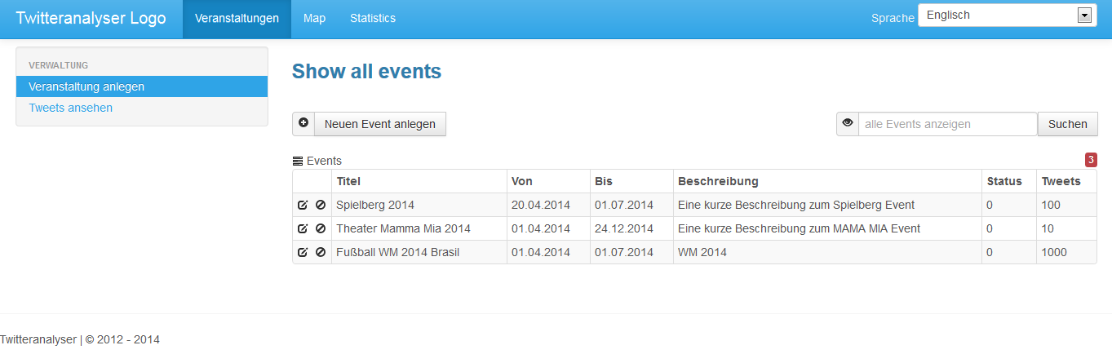When navigating to the application site in the browser, the main application site is loaded, which consists of a table of already created events and various buttons which are used to maintain this table of events. On initial startup, this table will be empty. When events are configured, the following information is displayed in the table view:

* Name
* From / To dates of data analysis
* Description
* Status of the tweet fetching
* Number of already fetched tweets
* Number of displayed events

The following functions can be performed on this main application site:

* Adding a new event (with the global “Add Event” button)
* Editing an existing event (with the “Edit” button of the event to be edited), editing also opens the detail view of the event
* Deleting an existing event (with the “Delete” button of the event to be deleted)
* Searching for specific events by names

Switching between the events table and the tweets table can be done by the navigation elements at the left of the site.

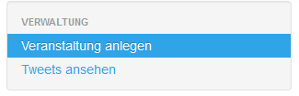

Moreover, a dropdown menu to change the working language the GUI is displayed in is already available. Currently, the following languages are supported:

* English
* German

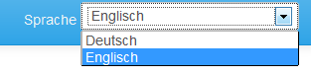

### Adding an event

Before the sentiment analysis can be started, a new event has to be added to the system. To accomplish this, the global “Add event” button in the events table view has to be pressed. Upon doing so, a new form will be shown where the information about an event has to be entered. Mandatory information that has to be entered:

* Name of the event
* Description why the event shall be analyzed
* List of tags for which the twitter tweets shall be fetched
* Time frame (from and to date) of the data fetching, only tweets between the two points are fetched and can be analyzed

Optional information that can also be filled:

* Minimum number of tweets that shall be fetched before a notification shall occur (not yet supported)

After entering the required information, the event can be saved and added to the system. As there are not yet any tweets linked to this event, no analysis is possible. The main events table view is loaded, with the newly created event also in the table.

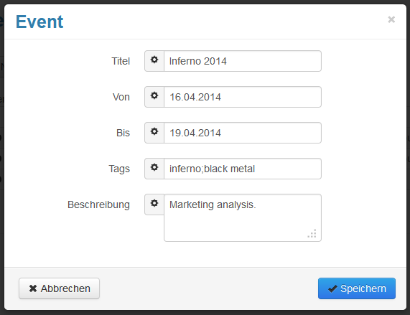

### Editing an event

The properties of existing events that are configured when adding those can later be edited. To accomplish this, the “Edit” button of the corresponding event to be added has to be clicked. Upon doing so, the details view of the event will be loaded. In this view, the configured properties that are currently defined are shown. These properties can be edited and filled with new values. If the new values are valid ones and all mandatory properties are filled, the changes to the event can be saved. If the time frame is changed, possibly new tweets for the event will be fetched.

The details view where the properties of the event can be changed is the same form as for adding an event.

### Deleting an event

When an event is not needed anymore in the system, it can be deleted. To accomplish this, the “Delete” button for the corresponding event to be deleted has to be pressed in the events table view. Upon doing so, a confirmation dialog shows up, requesting confirmation to the deletion of the selected event. When this confirmation is granted, the event will be deleted from the system.

## The tweets table view

Content follows.