# TECHNICAL DOCUMENTATION

## Architecture

The structure of the project is a classic MVC architecture, realised with Zend framework (version 1).

The start of the application calls the index.php file which loads the Zend bootloader for the primary initialization of the project. All requests that are received via the web site are forwarded to the appropriate controller by the Zend framework. The controller is determined by the subfolder the application is currently in. All main menu items have a corresponding controller (e.g. map controller for [http://twitteranalyser.local/m](http://twitteranalyser.local/index)ap) The standard controller is the index controller (<http://twitteranalyser.local/index>).   
All menu subitems are actions in the corresponding controller. Every click on a subitem calls another action in the controller. The IndexAction is called whenever the controller is called.

The application uses Twitter-Bootstrap. This is significantly responsible for the design of the graphical user interface and the presentation (e.g. of the date selection)

### controllers

The controller logic is split into five controllers:

* Index controller (main controller)
* Error controller
* API controller: This controller handles dialogs (e.g. creating of events) and multilingualism (translation of texts for the dialogs) via JSON strings
* Map controller
* Statistics controller

### C:\Users\Corinna\Downloads\MVC.jpg

### views

The phtml-files in „views“ are used for the displaying of the web page. They contain, besides the html code, also php code for the dynamic aspects of the page.  
All user interactions call an action in the controller that the view belongs to. For the views „analysis“, „event“ and „tweets“ it is the API controller.  
The view „event“ generates a list as an overvies of all currently existing events. Possible user interaction are:

* Edit an existing event
* Create a new event
* Search for an event in the list
* Delete an event

The view “tweets“ generates a list of all collected tweets. Possible interactions are:

* Display tweets for a certain event
* Create a new filter
* Use a filter for a list of tweets of an event
* Start analysis
* Search for tweets containing certain words

For the view of the map and the statistics, Google Maps and Google Visualisation are used for the presentation of the map and charts.

### apimanagement The dialogs are managed by the file „apimanagement.js“. All dialogs of the web application are generated by using EJS code that is loaded and displayed dynamically via JQuery (see „public“ folder; the EJS dialogs can be found in the „tpl“ folder). The api management sends JSON requests to the API controller. The controller sends responses or validation errors.

### languages

The csv-files contain the texts that are displayed on the webpage.

### models For each database table exists a corresponding model.

## Control flow

### Events

Events can be created via a dialog.

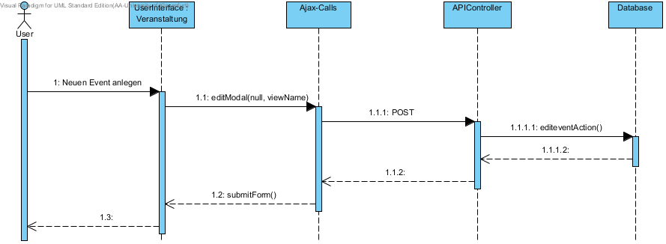

Existing events can be edited. The same dialog is used as for creating an event.

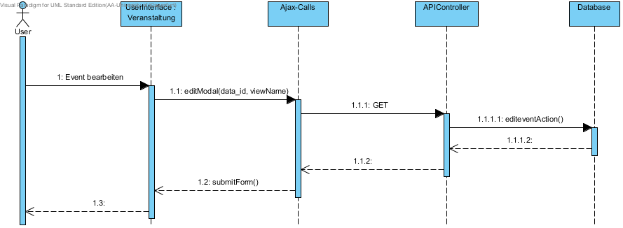

A certain event can be searched in the list of events.

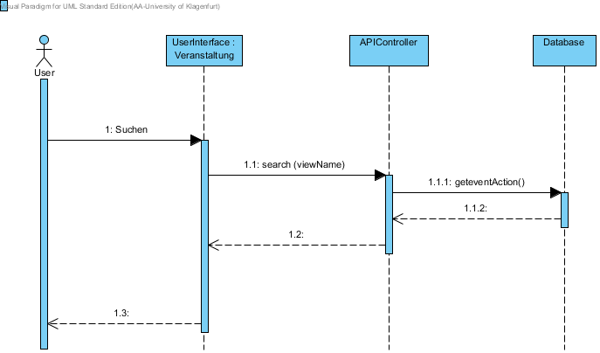

### Tweets

The collected tweets are shown in a list. The list can be restricted by only displaying the tweets for a certain event.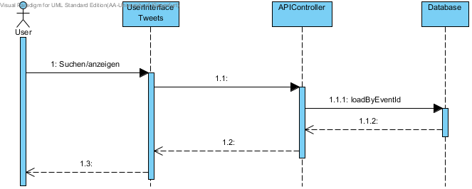

The tweet list for an event can be filtered by applying an existing filter.

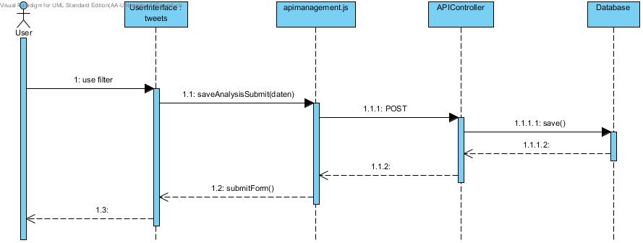

New filters can be created via a dialog.

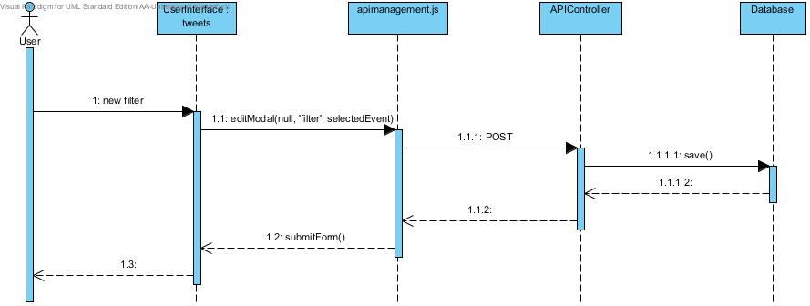

## Database

### Entity Relationship Diagram

The following Entity Relationship Diagram shows all tables of the database.

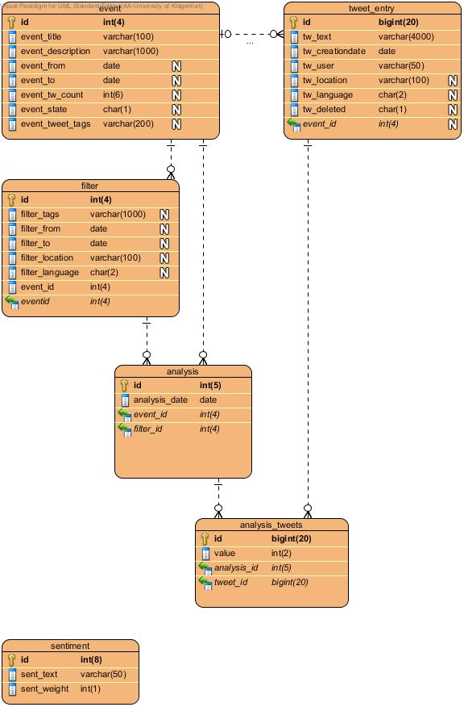

The table tweets_entry contains all tweets that were collected for a certain event. These can be restricted by defining a filter. The table analysis_tweets marks the subset of all collected tweets that are used in a certain analysis. It also contains the results of the sentiment analysis for each tweet.

The table sentiment contains keywords that determine if the text of a certain tweet has a positive or negative connotation.

### Description of the tables

The table event contains the information needed for each created event.

|  |  |  |
| --- | --- | --- |
| table event | details | description |
| id | AUTO_INCREMENT | primary key |
| event_title |  | title of the event |
| event_description |  | short description of the event |
| event_from | DEFAULT NULL | date to specify the beginning of the tweet collection |
| event_to | DEFAULT NULL | date to specify the ending of the tweet collection |
| event_tw_count | DEFAULT NULL | specifies the number of tweets to collect |
| event_state | DEFAULT '0' | 0: initial state  1: collection in progress  2: collection finished |
| event_tweet_tags | DEFAULT NULL | all tweet tags which should be considered, separated with a special delimiter |

The table tweet_entry holds all collected tweets and their relevant information. Each tweet is assigned to an event because each collection of tweets is started for a certain event.

|  |  |  |
| --- | --- | --- |
| table tweet_entry | details | description |
| id | AUTO_INCREMENT | primary key |
| tw_text |  | content/text of the tweet |
| tw_creationdate |  | creation date of the tweet |
| tw_user |  | user/author of the tweet |
| tw_location | DEFAULT NULL | Location of the user/author |
| tw_language | DEFAULT NULL | language of the tweet text |
| tw_deleted | DEFAULT '0' | marks the tweet as deleted |
| event_id |  | foreign key, each tweet is assigned to a certain event |

The table filter contains attributes of tweets to restrict the tweets of a certain events that should be used in an analysis.

|  |  |  |
| --- | --- | --- |
| table filter | details | description |
| id | AUTO_INCREMENT | primary key |
| filter_tags | DEFAULT NULL | tags that should be contained in the tweet text |
| filter_from | DEFAULT NULL | only tweets that where created after that date will be considered |
| filter_to | DEFAULT NULL | only tweets that where created before that date will be considered |
| filter_location | DEFAULT NULL | only tweets with this location will be considered |
| filter_language | DEFAULT NULL | only tweets with this location will be considered |

The table analysis contains informations about all performed analysis.

|  |  |  |
| --- | --- | --- |
| table analysis | details | description |
| id | AUTO_INCREMENT | primary key |
| analysis_date |  | creation date of the analysis |
| event_id |  | foreign key, id of the event the analysis belongs to |
| filter_id |  | foreign key, id of the used filter |

The entries in the table analysis_tweets marks which of the collected tweets should be considered in the analysis. It also contains the results of the sentiment analysis.

|  |  |  |
| --- | --- | --- |
| table analysis_tweets | details | description |
| id | AUTO_INCREMENT | primary key |
| tweet_id |  | foreign key, id of the considered tweet |
| analysis_id |  | foreign key, id of the analysis the tweet belongs to |
| value |  | Degree of sentiment assigned to the tweets |

The table sentiment contains keywords that are used for the sentiment analysis. Each keyword is weighted concerning their influence on the grade of sentiment of a tweet.

|  |  |  |
| --- | --- | --- |
| table sentiment | details | description |
| id | AUTO_INCREMENT | primary key |
| sent_text |  | keyword for sentiment analysis |
| sent_weight |  | weight of the keyword  range: [-5;5]  (-5 … negative, 5 … positive) |