ELEE 4680 Computer Networking
Final Networking Project

1.
INTRODUCTION 3
2. INITIAL PLAN 3
2.1 PRELININARY DESIGN PROPOSAL 3
3. HARDWARE 7
4. REVISIONS MADE 8
5. DIFFICULTIES 8
6. LIMITATIONS 9
7. Code analysis 10
8. CODE 13
9.Possible ImProvments 8
10. CONCLUSION 16
11. USER MANUAL 17
12. APPENDIX 24

- INTRODUCTION
Virtual Network Computing (VNC) is a common system used by professionals to remotely control computers over a network connection. Keyboard and mouse commands are sent from the sender to the receiving computer while a graphical interface relays back the operating window of the receiving computer. While VNC’s have proven to be invaluable to the traveling professional, one fatal flaw arises from this system in that one is not able to control over the computer itself when a VNC crashes. In this state, the sender has no method of communication with the receiving computer, short of physically visiting the receiving computer. An Arduino based HTTP server remotely connecting to the computer can solve these types of problems when a VNC fails.

- INITIAL PLAN
  - PRELININARY DESIGN PROPOSAL
Context Analysis:
Problem Statement: The purpose of this project is to design a way for an Arduino connected to a router to display an HTTP server that allows a user to select a link on the web page. This will then cause a signal to be sent from this Arduino to another remote Arduino connected directly to the motherboard of the receiving computer.
Technical Environment: This project is a laboratory design project undertaken over the course of half of a single semester. Several critical technical subsystems need not be developed as these are provided and thus constitute a specified technical framework. These include the Arduino board, language, XBee interfaces, etc. General analog and digital test and analysis equipment are available, as is expert technical assistance provided by the Professor.
Economic Environment: The time to finish is approximately 5 weeks; finances are covered by the department.

Functional Specification:
The project should be capable of:
- Producing an HTTP server that displays an html page that is able to be accessed from around the world.
- Displaying an HTML page that can be accessed on any device regardless of OS.
- Performing a soft startup or shutdown of a computer simulating pressing the power/shutdown button.
- Resetting the computer in the event of a BSOD or overclocking failure.
- Providing a low digital signal that allows a user to turn on a second power supply if needed.
Design Constraints:
- Use DFRobot X-Board V2
- Use XBee S1
- Low to no budget
- Programmed in C

3 SYSTEMATIC DESIGNS AND HARDWARE
3.1 SYSTEMATIC DESIGN
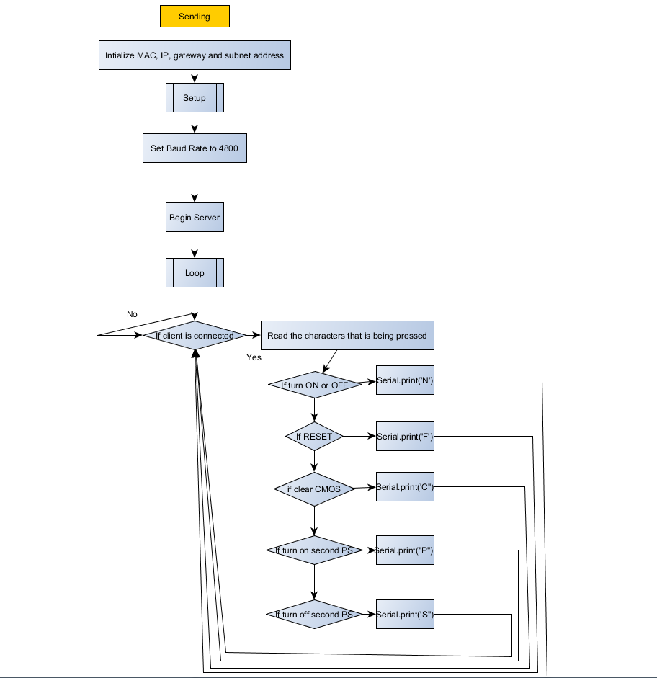

Figure 1: General State Diagram for the Sending Xboard

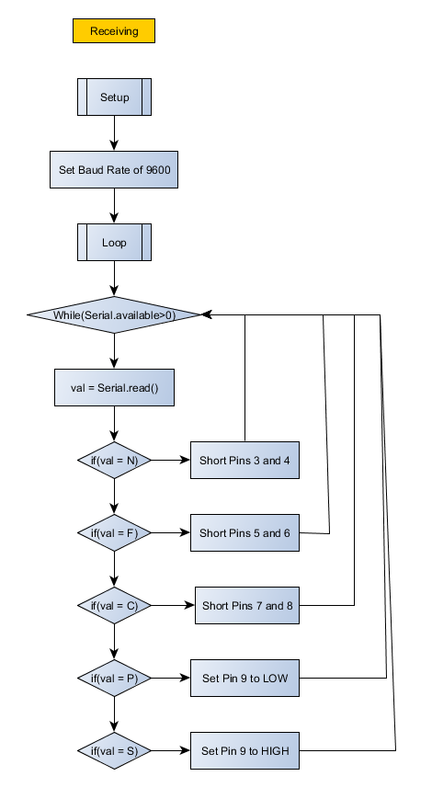
Figure 2: General State Diagram for the Receiving Xboard

3.2 HARDWARE
3.2.1 XBOARD V2
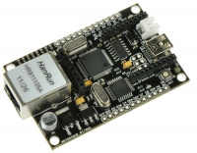
Figure 3: Xboard V2

Two Xboards were used in this project. One on the sending end and one of the receiving end. The Xboard is a variant of the Arduino that runs the Atmega328P MCU. It has an Ethernet port and an XBee socket, and is essentially an Ethernet shield for an Arduino all in one. For this project, all 8 of the digital pins on the Xboard were used on the receiving side.

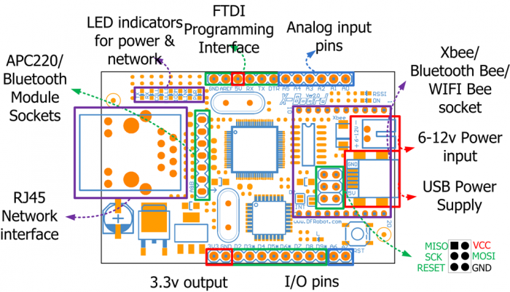
Figure 4: Xboard Pinout

3.2.2 XBee 1mW Wire Antenna
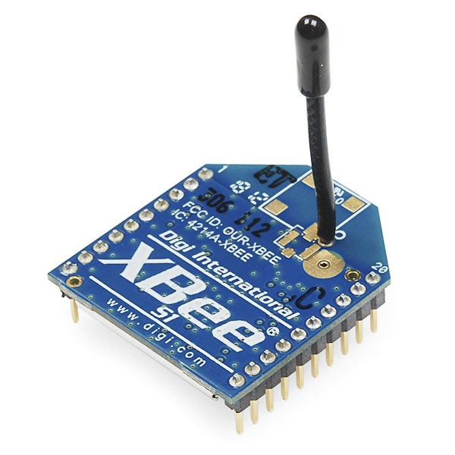
Figure 5: XBee Module

Two XBee modules were used in this project, with one being mounted on top of each Xboard. They operate at a frequency of 2.4GHz and use the IEEE 802.15.14 standard for transmitting. The XBee were the hardware for which each Xboard was communication with each other. Each Xboard would transmit data via serial connection which would then be transmitted over to the XBee on the receiving Xboard.

4. REVISIONS MADE

Several changes were made throughout the life of the project:
- One Xboard to two - At first, one Xboard was going to be used, however, it was deemed that sometimes the computer that one would want to control is not close to a router. Thus, another Xboard was added to the project.
- Functionality - The initial plan was to have the Xboard simply turn a computer on and off, however, with 8 digital pins available for use, it was best to fully utilize as many pins as possible. Thus, several other functionalities were added: reset the computer, clear the CMOS, and control a second power supply

5. DIFFICULTIES

Several difficulties were encountered while working on this project:
- Having the 2 Xboards communicate with each other - by using the XBee it was determined that the two Xboards could be allowed to communicate with each other. However, initially it was not realized that these XBee modules had not been paired properly. To pair them properly, the "address" of the receiving XBee had to be put into the destination address of the sending XBee. One other problem that arose was setting the correct baud rates on the two Xboards. The baud rate is the data rate in bits per second for a serial transmission. For 2 devices to communicate with each other they have to have baud rates that are synchronized but not necessarily the same. In this instance, it was determined that a baud rate of 4800 on the sender side and a baud rate of 9600 on the receiving side allowed for effective communication.
- Having the HTTP server configured properly - several parameters are required for the HTTP server to run properly. The first is the IP address of the device, the mac address, the gateway, and the subnet. It is important to note that when migrating this project from router to router all the settings can stay the same except for the gateway address. Different routers can default to different values, thus before connecting simply check the gateway address to see if it matches the current Arduino code.

6. LIMITATIONS

Several limitations of this project come into play.
1) The Arduino on the receiving side must have a power source nearby. Powering it from a USB connected to the computer it is controlling is insufficient. When you shut down the computer, it stops power from being supplied to the Arduino.
2) The maximum distance between the sender and receiver Xboards found during testing is 100-150 feet with several walls in between. To alleviate this problem, more powerful XBee’s can be used.
3) Network failures. This project inherently depends on the sending Xboard having an internet connection and being able to access the HTTP server on the Arduino from the outside. This makes the project susceptible to network failures caused by ISP or electrical problems, strict firewalls, or other forces outside of one’s control.

7. CODE ANALYSIS

6.1 Sending Xboard
#include <Ethernet.h>
#include <SPI.h>

byte mac[] = { 0x00, 0xAD, 0xBE, 0xEF, 0xFE, 0xED }; //physical mac address
byte ip[] = { 192, 168, 0, 102 }; // ip in lan
byte gateway[] = { 192, 168, 0, 1 }; // internet access via router
byte subnet[] = { 255, 255, 255, 0 }; //subnet mask
EthernetServer server(84); //server port

String readString;
Include the required Ethernet library, set the correct parameters for the Ethernet server, and initialize readString as string.

void setup(){

Ethernet.begin(mac, ip, gateway, subnet);//start the ethernet connections
server.begin(); //Tells the server to begin listening for incoming connections.

//enable serial data print
Serial.begin(4800);

}
In the setup, the program starts the Ethernet connection, starts the server, and sets the baud rate.

void loop(){
// Create a client connection
EthernetClient client = server.available();
if (client) {
while (client.connected()) {
if (client.available()) {
char c = client.read(); //Read the next byte received from the server the client is connected to (after the last call to read()).

//read char by char HTTP request
if (readString.length() < 100) {

//store characters to string
readString += c;
//Serial.print(c); testing
}
In the main loop of the program a client connection is created, and if a client is there, the initial parameters are set to read the characters.

//if HTTP request has ended
if (c == '\n') {

//Serial.println(readString); //print to serial monitor for debuging

//now output HTML data header
if(readString.indexOf('?') >=0) { //don't send new page
client.println("HTTP/1.1 204 ERROR");
client.println();
client.println();
}
else {
client.println("HTTP/1.1 200 OK"); //send new page
client.println("Content-Type: text/html");
client.println();

client.println("<HTML>");
client.println("<HEAD>");
client.println("<TITLE>Control your computer</TITLE>");
client.println("</HEAD>");
client.println("<BODY>");

client.println("<H1>Ameer</H1>");

client.println("<a href=\"/?Q\" target=\"inlineframe\">Turn Computer ON or OFF</a>");
client.println("<a href=\"/?X\" target=\"inlineframe\">Hard Reset Computer</a>");
client.println("<a href=\"/?L\" target=\"inlineframe\">Clear CMOS</a>");
client.println("<a href=\"/?R\" target=\"inlineframe\">Turn ON Second Power Supply</a>");
client.println("<a href=\"/?B\" target=\"inlineframe\">Turn OFF Second Power Supply</a>");

client.println("<IFRAME name=inlineframe style=\"display:none\" >");
client.println("</IFRAME>");

client.println("</BODY>");
client.println("</HTML>");
}

delay(1);
//stopping client
client.stop();

Code for displaying the HTTP server properly

///////////////////// control arduino pin
if(readString.indexOf("Q") >0)//checks for on
{
Serial.print('N');
}
if(readString.indexOf("X") >0)//checks for reset
{
Serial.print('F');
}
if(readString.indexOf("L") >0)//Checks for clear CMOS
{
Serial.print('C');
}
if(readString.indexOf("R") >0)//Checks for Turn on second PS
{
Serial.print('P');
}
if(readString.indexOf("B") >0)//Checks for Turn off second PS
{
Serial.print('S');
}
//clearing string for next read
readString="";

readString contains the letter that corresponds to the link that is pressed linked to each command. There are multiple if statements that check which letter is pressed and then performs a serial print of a character over XBee.

6.2 Receiving Xboard
char val;
void setup(){

//enable serial data print
Serial.begin(9600);

}
Initializes val as a character and sets the baud rate to 9600.

void loop() {
//Connect PINS 3 and 4 to the Power pins on motherboard, connect PINS 5 and 6 to Reset pins on motherboard, connect PINS 7 and 8 to Clear CMOS pins on motherboard, connect PIN 9 to the green power pin on a power supply
while(Serial.available() > 0) {
val = Serial.read();
if (val == 'N'){ //turn computer ON or OFF
//changes both pins to output, writes low and then switches back to input. This is done because simply changing the pin to output occasionally causes the intended action to be performed
pinMode(3, OUTPUT);
delay(500);
digitalWrite(3, LOW);
delay(500);
pinMode(3, INPUT);
delay(100);
pinMode(4, OUTPUT);
delay(500);
digitalWrite(4, LOW);
delay(500);
pinMode(4, INPUT);
}
if (val == 'F'){ //reset computer
pinMode(5, OUTPUT);
delay(500);
digitalWrite(5, LOW);
delay(500);
pinMode(5, INPUT);
delay(100);
pinMode(6, OUTPUT);
delay(500);
digitalWrite(6, LOW);
delay(500);
pinMode(6, INPUT);
}
if (val == 'C'){ //clear cmos
pinMode(7, OUTPUT);
delay(500);
digitalWrite(7, LOW);
delay(500);
pinMode(7, INPUT);
delay(100);
pinMode(8, OUTPUT);
delay(500);
digitalWrite(8, LOW);
delay(500);
pinMode(8, INPUT);
}
if (val == 'P'){ //Turn on power supply
pinMode(9, OUTPUT);
delay(500);
digitalWrite(9, LOW);
}
if (val == 'S'){ //Turn on power supply
pinMode(9, OUTPUT);
delay(500);
digitalWrite(9, HIGH);
}

}
The receiving Xboard checks for available serial data and then checks to see if that data corresponds to the correct if statements.

8. CODE
Please refer to the Appendix for the code.

9. POSSIBLE IMPROVEMENTS

- Enclosure can be made for the receiving Xboard. A computer case has a metal bottom, thus it is not possible to place the Xboard directly onto the bottom. A small enclosure would fix this problem.
- XBee S2. Using a stronger XBee allows for a farther distance between the two Xboards.
- Temperature sensors and probes. Monitor the ambient temperature using a sensor and CPU Northbridge and Southbridge temperature using probes, and outputting this data to the HTML web page.
10. CONCLUSION

It was challenging and very interesting to work on this project. Overall, the project consisted of two Xboards communicating wirelessly via XBee's, with one serving as an HTTP server and the other controlling a computer. First, a single Xboard was used both as an HTTP server and communicator with the computer. However, this was deemed to be insufficient for the scope of the project and a second Xboard was added. XBee's were used to communicate between the two, and separate code had to be written for each of them to communicate properly. Several obstacles were faced during the building of this project. One was determining the correct XBee baud rate between the two. The other was setting up the HTTP server to run properly. I found this project to be one of the most enjoyable projects in my educational career as it was one of the few times I was allowed to determine the project.

11. USER MANUAL
Both Xboards must be powered using miniusb cables and have the proper XBee’s connected. One Xboard is labeled as a sender which has an Ethernet port. An Ethernet cable is used to connect this Xboard to a router. The receiving Xboard is placed in a position inside the receiving computer that allows it to have the proper access to the pins it needs on the motherboard. Pins 3 and 4 must be connected to the power pins on the front panel I/O. Pins 5 and 6 must be connected to the reset pins, with pins 7 and 8 being connected to the clear CMOS pins. If a second power supply is needed to be powered, pin 9 of the Xboard it can be connected to the green cable of the power supply. The sending Xboard can be accessed via http://192.168.0.102:84 or the global IP address of the network with the correct port. At this address, an HTML page is displayed that presents the several different functions. Simply clicking on the link will perform the intended action.

12. APPENDIX
Code:
xboard_ethernet_code_XBee
//address= http://192.168.0.102:84

#include <Ethernet.h>

byte mac[] = { 0x00, 0xAD, 0xBE, 0xEF, 0xFE, 0xED }; //physical mac address
byte ip[] = { 192, 168, 0, 102 }; // ip in lan
byte gateway[] = { 192, 168, 0, 1 }; // internet access via router
byte subnet[] = { 255, 255, 255, 0 }; //subnet mask
EthernetServer server(84); //server port

String readString;

//////////////////////

void setup(){

Ethernet.begin(mac, ip, gateway, subnet);//start the ethernet connections
server.begin(); //Tells the server to begin listening for incoming connections.

//enable serial data print
Serial.begin(4800);

}

void loop(){
// Create a client connection
EthernetClient client = server.available();
if (client) {
while (client.connected()) {
if (client.available()) {
char c = client.read(); //Read the next byte received from the server the client is connected to (after the last call to read()).

//read char by char HTTP request
if (readString.length() < 100) {

//store characters to string
readString += c;
//Serial.print(c); testing
}

//if HTTP request has ended
if (c == '\n') {

//Serial.println(readString); //print to serial monitor for debugging

//now output HTML data header
if(readString.indexOf('?') >=0) { //don't send new page
client.println("HTTP/1.1 204 ERROR");
client.println();
client.println();
}
else {
client.println("HTTP/1.1 200 OK"); //send new page
client.println("Content-Type: text/html");
client.println();

client.println("<HTML>");
client.println("<HEAD>");
client.println("<TITLE>Control your computer</TITLE>");
client.println("</HEAD>");
client.println("<BODY>");

client.println("<H1>Ameer</H1>");

client.println("<a href=\"/?Q\" target=\"inlineframe\">Turn Computer ON or OFF</a>");
client.println("<a href=\"/?X\" target=\"inlineframe\">Hard Reset Computer</a>");
client.println("<a href=\"/?L\" target=\"inlineframe\">Clear CMOS</a>");
client.println("<a href=\"/?R\" target=\"inlineframe\">Turn ON Second Power Supply</a>");
client.println("<a href=\"/?B\" target=\"inlineframe\">Turn OFF Second Power Supply</a>");

client.println("<IFRAME name=inlineframe style=\"display:none\" >");
client.println("</IFRAME>");

client.println("</BODY>");
client.println("</HTML>");
}

delay(1);
//stopping client
client.stop();

///////////////////// control arduino pin
if(readString.indexOf("Q") >0)//checks for on
{
Serial.print('N');
}
if(readString.indexOf("X") >0)//checks for reset
{
Serial.print('F');
}
if(readString.indexOf("L") >0)//Checks for clear CMOS
{
Serial.print('C');
}
if(readString.indexOf("R") >0)//Checks for Turn on second PS
{
Serial.print('P');
}
if(readString.indexOf("B") >0)//Checks for Turn off second PS
{
Serial.print('S');
}
//clearing string for next read
readString="";

}
}
}
}
}

xboard_ethernet_code_XBee_recieverside
char val;
void setup(){

//enable serial data print
Serial.begin(9600);

}

void loop() {
//Connect PINS 3 and 4 to the Power pins on motherboard, connect PINS 5 and 6 to Reset pins on motherboard, connect PINS 7 and 8 to Clear CMOS pins on motherboard, connect PIN 9 to the green power pin on a power supply
while(Serial.available() > 0) {
val = Serial.read();
if (val == 'N'){ //turn computer ON or OFF
//changes both pins to output, writes low and then switches back to input. This is done because simply changing the pin to output occasionally causes the intended action to be performed
pinMode(3, OUTPUT);
delay(500);
digitalWrite(3, LOW);
delay(500);
pinMode(3, INPUT);
delay(100);
pinMode(4, OUTPUT);
delay(500);
digitalWrite(4, LOW);
delay(500);
pinMode(4, INPUT);
}
if (val == 'F'){ //reset computer
pinMode(5, OUTPUT);
delay(500);
digitalWrite(5, LOW);
delay(500);
pinMode(5, INPUT);
delay(100);
pinMode(6, OUTPUT);
delay(500);
digitalWrite(6, LOW);
delay(500);
pinMode(6, INPUT);
}
if (val == 'C'){ //clear cmos
pinMode(7, OUTPUT);
delay(500);
digitalWrite(7, LOW);
delay(500);
pinMode(7, INPUT);
delay(100);
pinMode(8, OUTPUT);
delay(500);
digitalWrite(8, LOW);
delay(500);
pinMode(8, INPUT);
}
if (val == 'P'){ //Turn on power supply
pinMode(9, OUTPUT);
delay(500);
digitalWrite(9, LOW);
}
if (val == 'S'){ //Turn on power supply
pinMode(9, OUTPUT);
delay(500);
digitalWrite(9, HIGH);
}

}
}

