RemoteXY
- Connection testing
  - Access https://remotexy.com, create an account
  - Download remoteXY apps using your OS app store.
  - Click “editor”
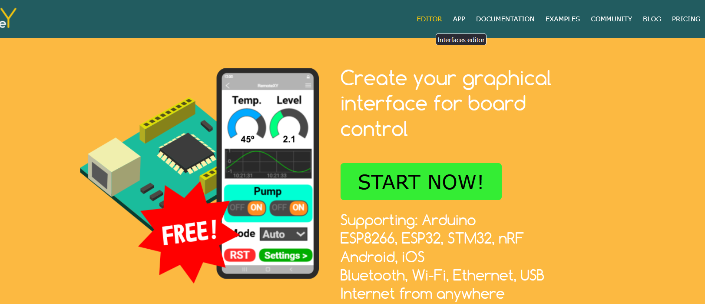
  - Drag n drop a button
  - Using right panel, configure apps as the example then click apply
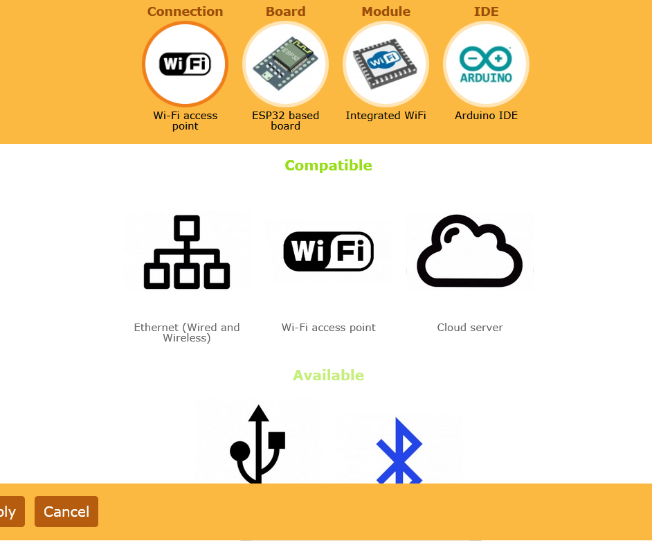
Note: “Apply” button will remain grey (disable) if one or more configuration elements not configured.
  - Leave the rest as it is.
  - Click “Get Source Code”
  - Copy and paste the entire code to the Arduino IDE.
  - Click “+” sign on RemoteXY apps.
  - Select Wi-Fi point and select for “RemoteXY” SSID, and PASSWORD “12345678”
  - If everything works as expected, your design should appear on apps.
  - Now try to add an LED indication on the ESP32 using the built-in LED.
  - Try for BLE connection
- PWM
Drag and drop a slider into the desktop worksheet.
Configure as point A.
Insert code lines below
const int ledPin = 16; //declaration
pinMode(ledPin, OUTPUT); // setup

// slider event
int pwmValue = map(RemoteXY.slider_01, 0, 100, 0, 255);
analogWrite(ledPin, pwmValue);
Or you can use ledc function instead
// declaration
const int ledPin = 16; // 16 corresponds to GPIO16
const int freq = 5000;
const int resolution = 8
const int ledPin = 16;

ledcAttach(ledPin, freq, resolution); //setup
// slider event
int pwmValue = map(RemoteXY.slider_01, 0, 100, 0, 255);
ledcWrite(ledPin, pwmValue);

- Four LEDS
Drag n drop 4 LED as shown below
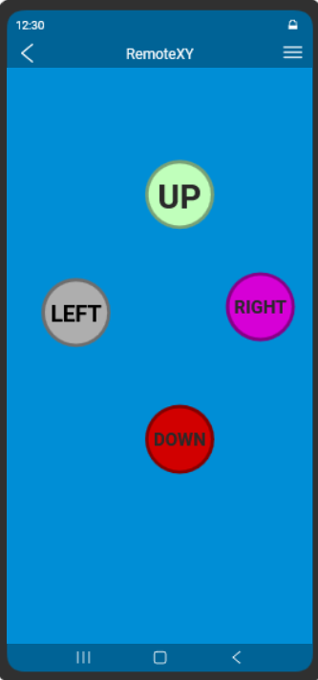
Below is an example of remoteXY read button state using event
void RemoteXY_button_left_event() {

if (RemoteXY.button_left != 0) {
digitalWrite(LED, HIGH);
} else {
digitalWrite(LED, LOW);
}
// TODO: RemoteXY.button_left was changed
}

Can you identify the differences between using an event handler and without an event handler?.
How do you think if we simply put
digitalWrite(LED, (RemoteXY.button_left==0)?LOW:HIGH);

- Control over cloud
Control over the cloud is achievable only if already registered.
Simply click my token to create a new token and get the server address

The example of a generated token is shown below
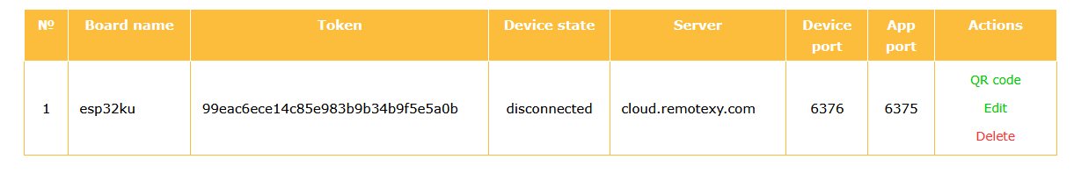
The server address and token are also required in the RemoteXY apps.
If everything works as expected, the ESP32 could be controlled everywhere over the internet.

