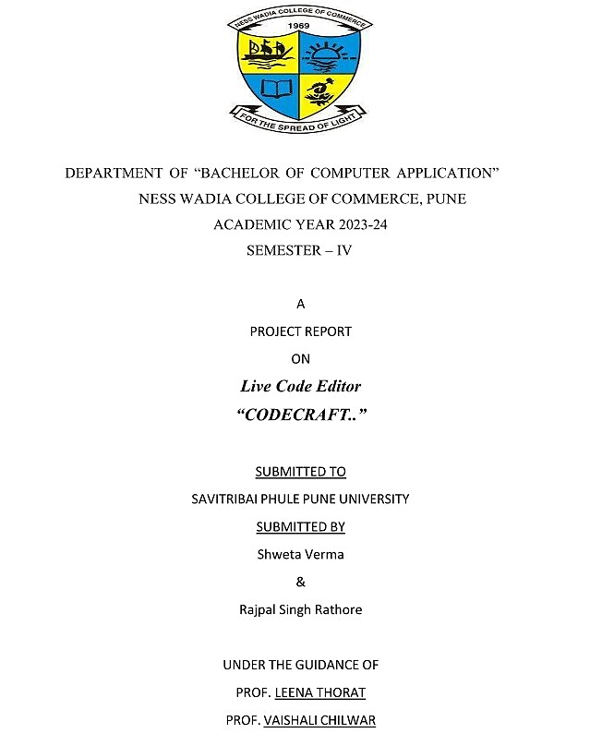DEPARTMENT OF

“BACHELOR OF COMPUTER APPLICATION”

NESS WADIA COLLEGE OF COMMERCE, PUNE

ACADEMIC YEAR 2023-24

SEMESTER – IV

A Project on

**BuildMaster**

Submitted To

SAVITRIBAI PHULE PUNE UNIVERSITY

Submitted By

Yash Padwal (30)

&

Abhijeet Raskar (38)

UNDER THE GUIDANCE OF

PROF. VAISHALI CHILWAR

**Abstract**

The BuildMaster website is a comprehensive platform designed to cater to the needs of PC enthusiasts and beginners alike, providing a one-stop solution for custom PC building, pre-built systems, high-quality components, and in-depth tutorials. With a focus on quality, performance, and customer satisfaction, BuildMaster aims to empower users to create their dream machines tailored to their preferences and requirements. The platform offers a range of features, including customizable PC builds, step-by-step tutorials, and a vibrant community for sharing knowledge and experiences. Through intuitive user interfaces, extensive product listings, and expert guidance, BuildMaster simplifies the PC building process, making it accessible to users of all skill levels. By combining innovative technology, reliable performance, and user-friendly design, BuildMaster strives to revolutionize the PC building experience, enabling users to unleash their creativity and achieve unparalleled results.

**ACKNOWLEDGEMENT**

I would wish to thank all the people who have helped to make this project possible. A project for a student is an experience, in the course of which he/she realizes the real-world problems that one has to undergo during the development of any project. Hence without the help and guidance of our teachers, this project wouldn't have been successful. We are grateful to them for supporting us throughout the Design, Implementation and Evaluation phase of the project.

We extend our heartfelt gratitude to our guides, YouTube tutorials, and ChatGPT for their invaluable assistance throughout the development of this project. Their insightful guidance and support have been instrumental in navigating the various challenges encountered along the way.

We extend our heartfelt gratitude to Professor Vaishali Chilwar for her invaluable guidance, unwavering support, and insightful ideas throughout the duration of this project. Professor Vaishali Chilwar’s expertise, encouragement, and constructive feedback have been instrumental in shaping our understanding and approach towards developing the live code editor.

Yours Sincerely,

Abhijeet Raskar & Yash Padwal

**Index:**

|  |  |  |  |
| --- | --- | --- | --- |
| **No.** |  | **Title** | **Page No.** |
| **1.** |  | **Introduction**  Problem Statement    Purpose or goals    Project scope and Limitations | **5** |
| **2.** |  | **System Analysis**    Existing System  Drawbacks of existing system  Features | **6** |
| **3.** |  | **Feasibility Study** | **7** |
| **4.** |  | **Implementation Details** Software Requirements  Hardware Requirements | **8** |
| **5.** |  | **System Design**    Entity Relationship Diagram  DFD(Data Flow Diagram)  Data Dictionary | **9-17** |
| **6.** |  | **Screenshots** |  |
| **7.** |  | **Conclusions** |  |
| **8.** |  | **Bibliography** | **19** |

**1. Introduction**

With the increasing popularity of custom PC building, there is a growing demand for centralized resources and guidance to assist enthusiasts in creating their dream machines.

BuildMaster aims to fill this gap by providing comprehensive support and information tailored to the needs of PC builders.

1. **Problem Statement:**

* PC building can be daunting for beginners due to the complexity of hardware compatibility, component selection, and assembly. Existing resources are scattered and often lack detailed guidance, leading to confusion and frustration among enthusiasts.

1. **Purpose/Objective and Goals:**

* The primary purpose of BuildMaster is to empower PC builders with the knowledge, tools, and resources they need to successfully plan, assemble, and optimize their custom PCs. Our goals include:
  + Providing step-by-step tutorials and guides for every stage of the PC building process.
  + Offering a curated selection of components, reviews, and recommendations to simplify the purchasing process.
  + Creating a community platform for users to share their builds, seek advice, and collaborate with fellow enthusiasts.
  + Offering a user-friendly interface.

1. **Project Scope and Limitations:**

* BuildMaster will focus on guiding users through the PC building process, offering tutorials, component recommendations, and community features. However, it will not provide direct sales of components or offer technical support beyond general advice and troubleshooting tips.

**2. System Analysis**

1. **Existing Systems:**

* Websites like BitKart and Tom's Hardware offer valuable resources for PC builders, but they lack comprehensive tutorials and community features.

1. **Limitations of Existing Systems:**

* While existing systems excel in component compatibility checking and product reviews, they often lack detailed assembly guides and community engagement features.

1. **Project Perspective, Features:**

* BuildMaster will differentiate itself by offering a user-friendly interface, comprehensive tutorials, curated component recommendations, and an active community platform.
* Create an interactive and responsive user interface for ease of use.
* Ensure security measures to protect user data.

1. **Component Recommendations:**

* Provide categorized lists of PC components such as CPU, GPU, motherboard, etc.
* Allow users to view detailed information, reviews, and ratings for each component.

1. **Tutorials and Guides:**

* Offer a comprehensive library of tutorials and guides for PC building, customization, and maintenance.
* Organize tutorials into categories and provide search functionality.

1. **Stakeholders:**

* Stakeholders in the BuildMaster project include PC enthusiasts, hardware manufacturers, developers, and online retailers.

1. **Requirements Analysis:**

* Functional requirements include user registration, tutorial navigation, component database management, and community forum integration.
* Performance requirements include fast page load times and responsive user interfaces.
* Security requirements include user authentication, data encryption, and secure payment processing.

**3. Feasibility Study**

A feasibility study is an essential step before starting any software development project. It helps you assess whether the project is viable, considering various aspects such as technical, economic, legal, operational, and scheduling factors. Here's a brief outline of a feasibility study for your code editor project:

**1. Project Scope:**

- Define the scope of your code editor. What features do you want to include? For example, syntax highlighting, code autocompletion, error checking, etc.

2. Market Analysis:

- Research existing code editors in the market. Identify their strengths and weaknesses.

- Analyse your target audience and determine if there is a demand for a new code editor.

3. Technical Feasibility:

- Assess the technical requirements for your project. Can you achieve the desired features using HTML, CSS, and JavaScript?

- Evaluate the compatibility with different browsers and operating systems.

4. Resource Assessment:

- Estimate the resources needed for development, including manpower, Technology and tools.

5. Timeframe:

- Create a realistic timeline for the development process. Consider potential delays and allocate time for testing and debugging.

6. Cost Estimation:

- Calculate the cost associated with the development, including software and hardware expenses, personnel costs, and any other relevant expenses.

7. Legal and Compliance:

- Ensure that your project complies with legal requirements and licenses associated with using third-party libraries or tools.

8. Risks and Mitigation:

- Identify potential risks such as technical challenges, resource constraints, or market changes. Develop strategies to mitigate these risks.

**4. Implementation Details**

**Security Requirements:**

FRONT END: - HTML, CSS, PHP.

BACKEND: - PHP, SQL.

PLATFORM: - WINDOWS 10, VISUAL STUDIO, NOTEPAD, GOOGLE CHROME,MICROSOFT EDGE.

HARDWARE REQUIREMENTS

The minimum requirements of hardware are as follows:-

RAM: 2GB.

Processor: Intel(R) Core(TM) i5-4200U CPU @ 2.50GHz 2.710 GHz.

HDD: 512GB and above.

SDD: 128GB (optional).

Monitor.

Internet connection.

**Software/Hardware Specifications:**

* BuildMaster is built using HTML, CSS, JavaScript, PHP, and MySQL.
* It runs on a web server with Apache, PHP, and MySQL support.

**5. System Design**

Requirement Gathering

1. **Functional Requirements:**

**User Registration:**

* Users should be able to register accounts with a valid email address and password.
* Registration form should include validation checks for email format, password strength, and unique username.

**Authentication:**

* Registered users should be able to log in securely using their email and password.
* Passwords should be securely hashed and stored in the database.

**User Profile Management:**

* Users should be able to update their profile information, including name, email, and password.
* Option to upload profile pictures and customize settings.

1. **Database Requirements:**

**User Data:**

* Store user information such as name, email, hashed password.

**Component Database:**

* Maintain a database of PC components with attributes such as name, description, price, ratings, and compatibility details.

1. **Performance and Scalability:**

* Responsive Pages.
* Quick execution.

1. **Language and Frameworks:**

**Backend:**

* Choose a suitable backend programming language and framework such as PHP & JS.

**Frontend:**

* Utilize modern frontend frameworks like HTML5 & CSS3 for dynamic user interfaces.

1. **Compatibility and Accessibility:**

**Cross-Browser Compatibility:**

* Ensure the website functions correctly across different web browsers such as Chrome, Firefox, Safari, and Edge.

**Responsive Design:**

* Implement responsive design principles to ensure the website is accessible and user-friendly on various devices, including desktops, laptops, tablets, and smartphones.

**ER DIAGRAM**

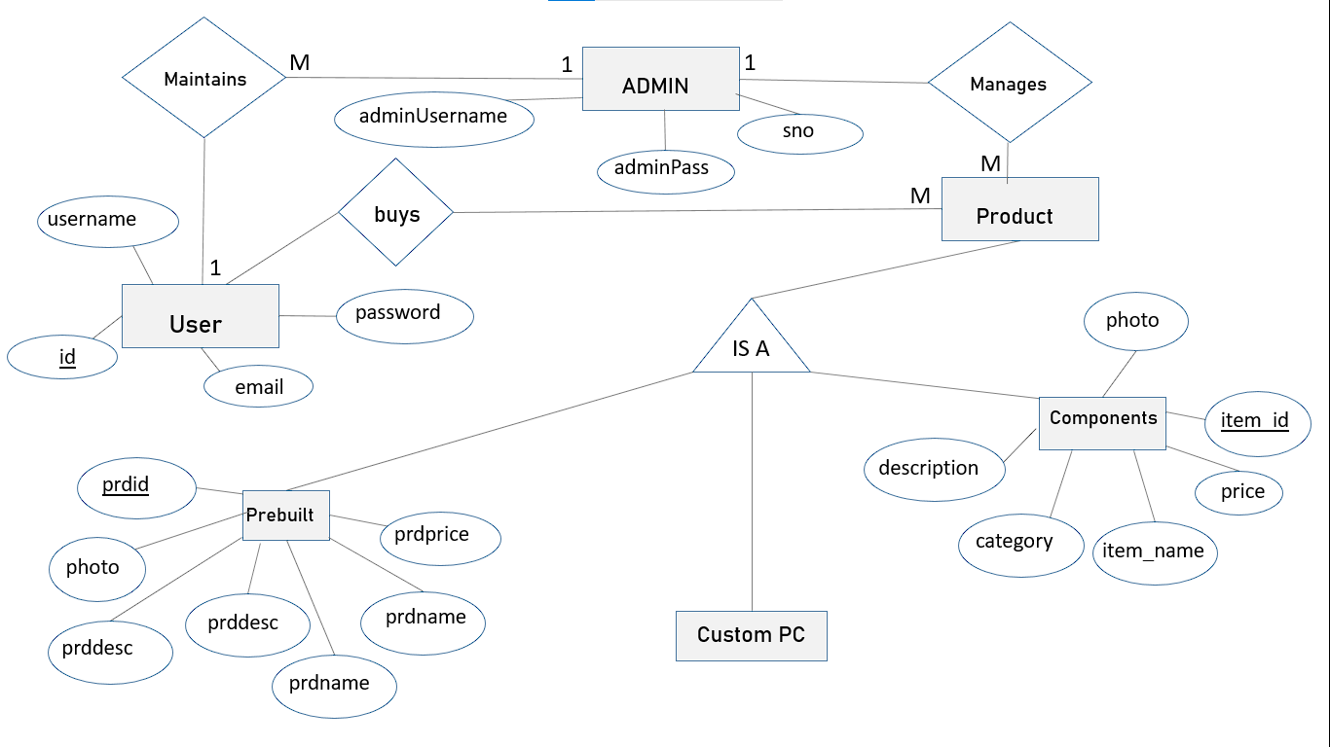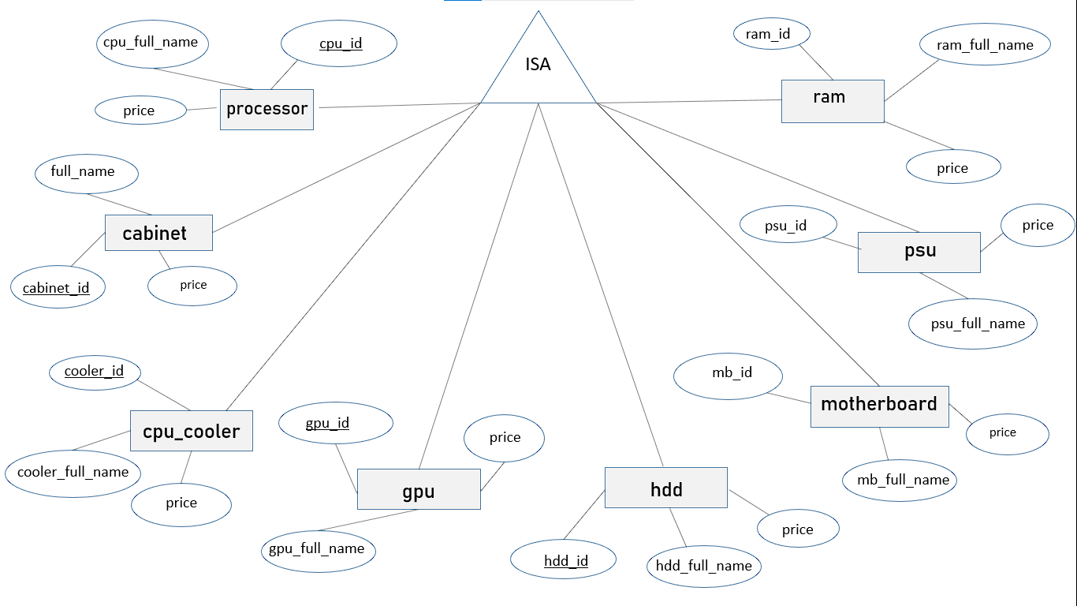

**Data Flow Diagram**

**0th  LEVEL (CONTEXT LEVEL DFD)**



**login info login info**

0.0

BuildMaster

**Item details**

ADMIN

USER

1.0

Registration

USER

USER

ADMIN

Admin

ADMIN

USER

USER

2.0

Login

3.0

Products

USER

USER

ADMIN

Admin

4.0

Cart

USER

USER

ADMIN

Admin

5.0

Bill

USER

USER

ADMIN

Admin

6.0

Reports

USER

USER

ADMIN

Admin

**DATA DICTIONARY**

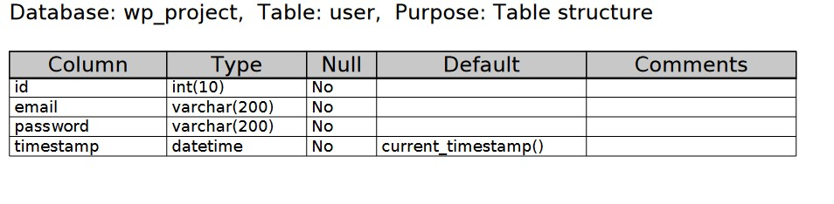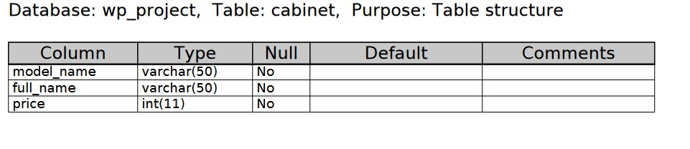

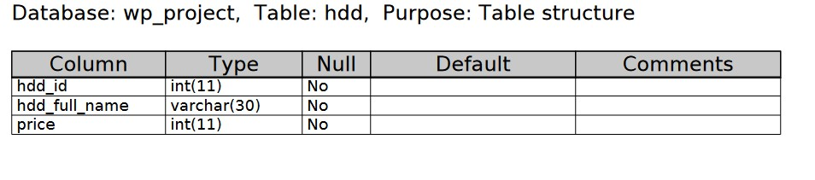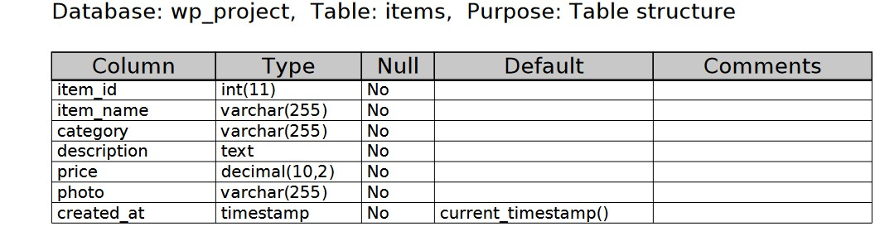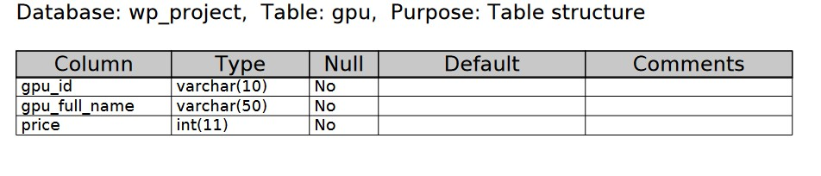

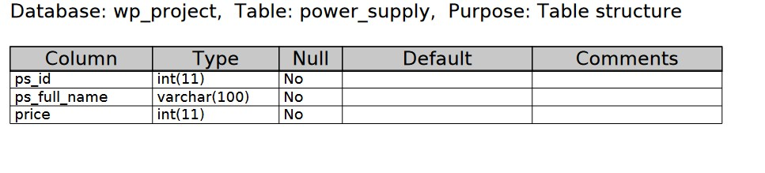

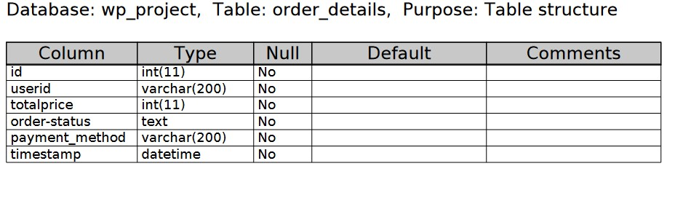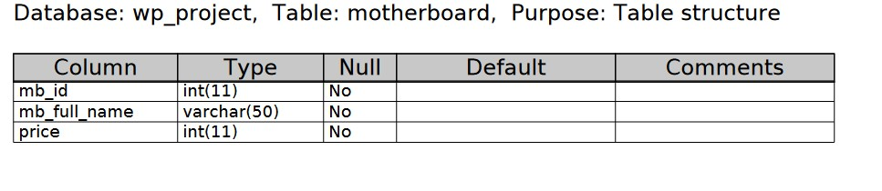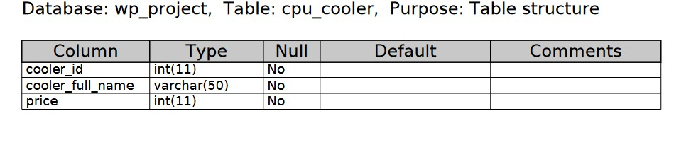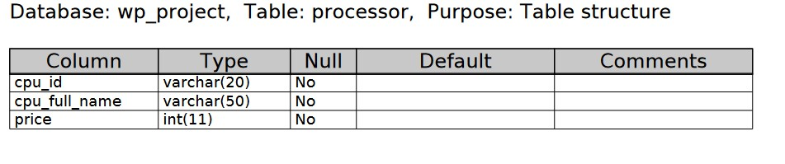

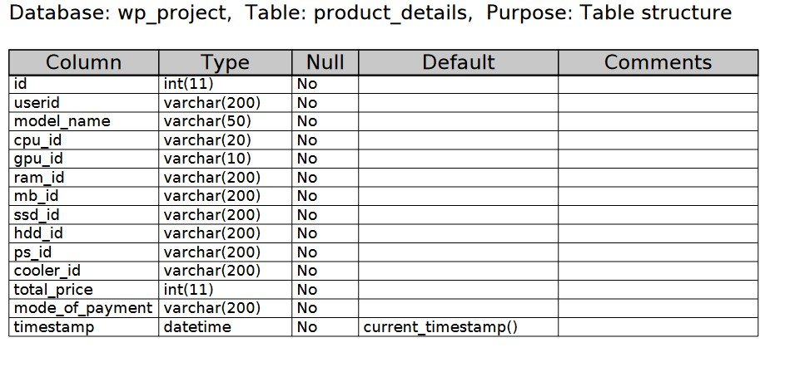



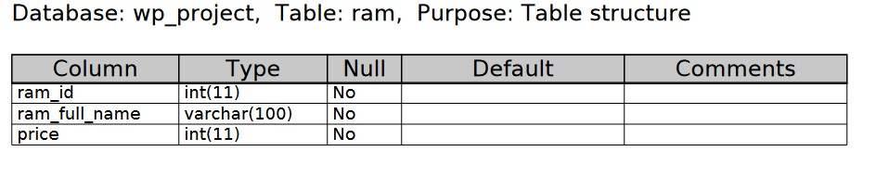

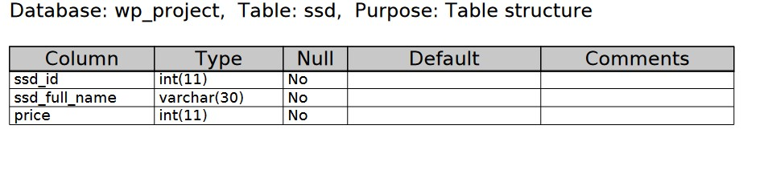

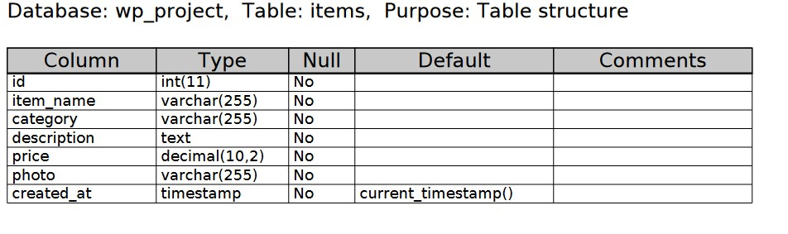

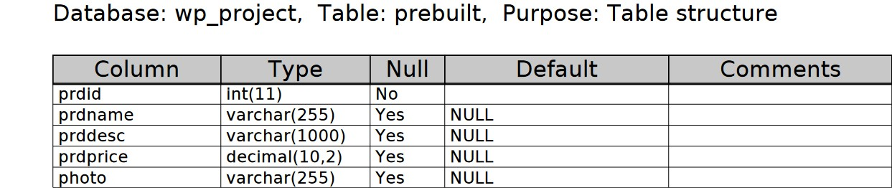

**7.Conclusion and Recommendations**

**Conclusion:**

BuildMaster provides a comprehensive platform for PC builders to access tutorials, recommendations, and community support, streamlining the PC building process and empowering users to create their ideal systems.

**Recommendations**: To further improve BuildMaster, we recommend implementing user feedback mechanisms, expanding tutorial content, and enhancing community engagement features.

**8.Bibliography and References**

BitKart. (https://bitkart.com/)

Tom's Hardware. (<https://www.tomshardware.com/>)

Newegg.com

Youtube.com

Chatgpt.com

Bard.google.com

Geekforgeeks.com