IPL Dashboard

User-Guide

# Who can use this?

* Primarily, coaches to evaluate performance of various players. Players can introspect themselves about their strengths and weaknesses.
* Team management, to see trends about the performance of various teams.
* Those who take part in auctions to inspect the performance of players.
* Cricket analysts to ease their analysis of single players or single teams.
* Cricket enthusiasts to satisfy their curiosity.

# Components

* **Batsman Stats:** Shows the performance of each batsman year-wise, opposition-wise, venue-wise, phase-wise (powerplay, middle overs or death overs).
* **Bowler Stats:** Shows the performance of each bowler year-wise, opposition-wise, venue-wise, phase-wise (powerplay, middle overs or death overs). Also, shows player rivalries.
* **Venue Stats:** Shows various toss insights, average batting total, win distribution by toss-decisions.

# Description

## Batsman Stats

**Level of details:**

* Year
* Batting Team
* Phase-wise run rate
* Matches by venue
* Runs by venue
* Dismissal type
* Matches by opposition
* Runs by opposition
* Most runs (will add highest S/R, most 4s, most 6s in later update)

See the following screenshot for reference.

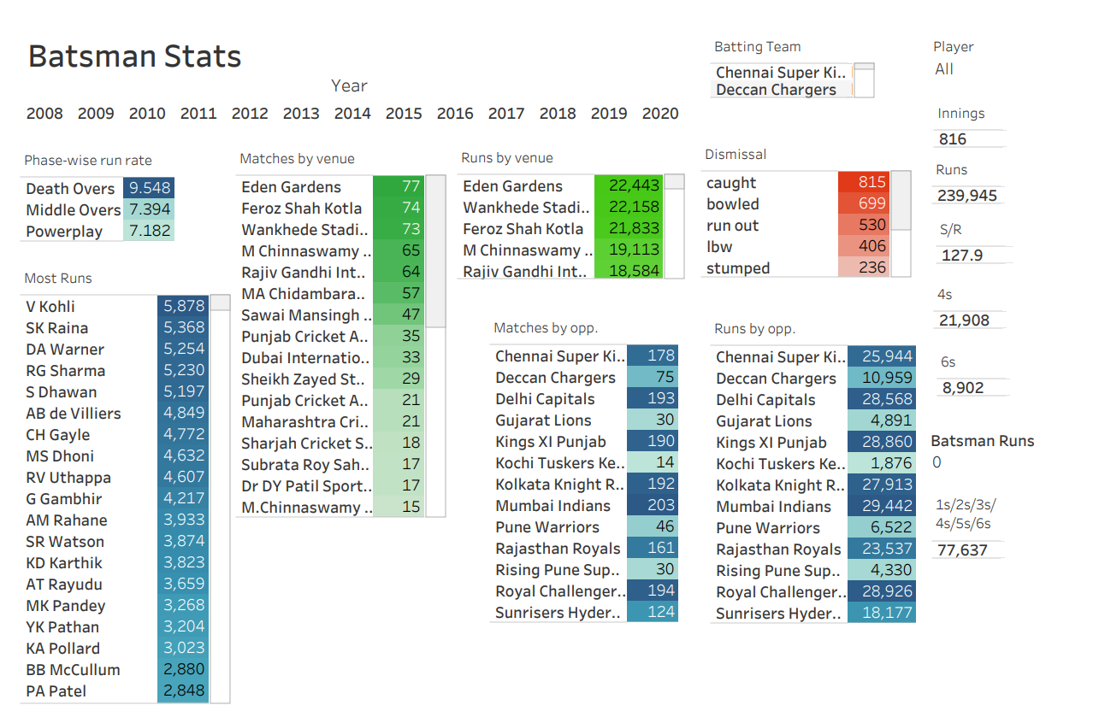

Few examples of use-cases.

1. Check the overall performance of any team by clicking at batting team (scrollable). After clicking at batting team, click at any of the level of detail to get further info. Let’s say, a specific venue is clicked, all the stats will be then limited to that venue only. You can click as much of level of details as you want.
2. Check the individual performance of players. Just select or search player from player filter and all the stats will be displayed and you can have all level of details just by clicking at any level of detail.

## Bowler Stats

**Level of details:**

* Year
* Bowling Team
* Phase-wise wickets
* Matches by venue
* Wickets by venue
* Dismissal type
* Matches by opposition
* Wickets by opposition
* Most wickets (will add lowest economy, lowest average, lowest S/R in later update)

See the following screenshot for reference.

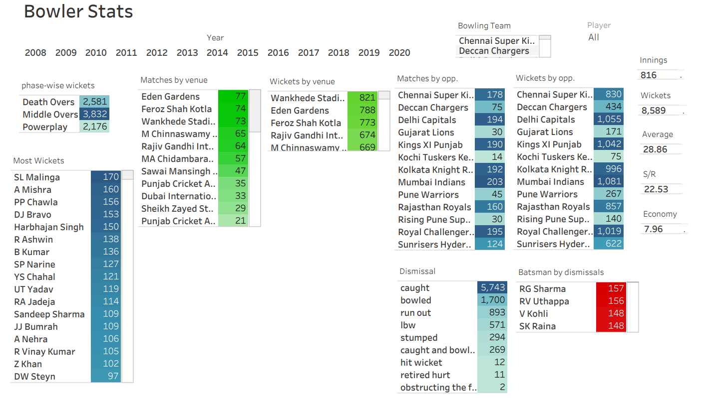

Has same functionality as batsman stats.

# Venue Stats

**Level of details:**

* Year
* Venue
* Toss-decision
* Highest 1st inning avg. total

Refer to the screenshot on the next page.

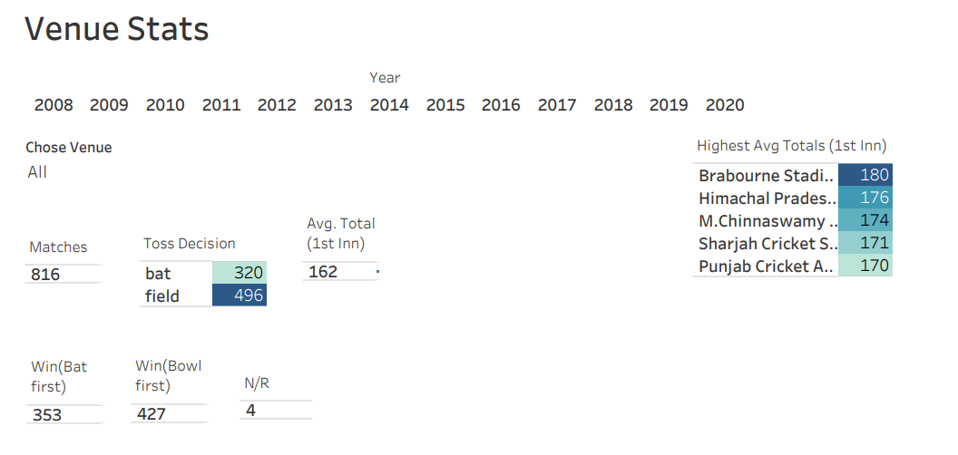

Few examples of use-cases.

* Check the toss statistics by venue, year.
* Check the avg. total (1st inning) by venue.
* No. of wins by Toss-decisions.

Click at any level of detail to get more detailed info.