WEEK 5 INTERNSHIP REPORT
Fashion-MNIST Image Classification
Using Deep Learning
Baseline Neural Network, CNN, Statistical Comparison,
Calibration and Deep Error Analysis

Prepared by | Rishi Raj
Project | Fashion_MNIST_Deep_Learning_Project
Week | 5 – Deep Learning
Repository | github.com/ARraj14/Fashion_MNIST_Deep_Learning_Project
Prepared as a comprehensive technical report documenting dataset exploration, model development, evaluation, comparison, and original error analysis.

Abstract
This report presents a complete deep-learning image-classification workflow using the Fashion-MNIST dataset. The work begins with structured dataset exploration and preprocessing, then develops a fully connected neural-network baseline and a convolutional neural network (CNN). The models are evaluated not only through overall accuracy but also through class-level precision, recall and F1-score, confusion matrices, confidence behavior, calibration, paired prediction analysis, statistical significance testing and targeted error analysis.
Fashion-MNIST contains 70,000 grayscale images across 10 balanced clothing categories. The baseline dense network achieved 88.11% test accuracy with 1,189 errors. The CNN achieved 93.34% test accuracy with 666 errors, producing an absolute gain of 5.23 percentage points and a 43.99% relative reduction in classification errors. The largest class-level improvements were observed for Pullover (+13.90 percentage points), Coat (+10.30) and Shirt (+8.00). A paired McNemar exact test showed that the change in predictions was statistically significant (p < 0.001).
The analysis also identifies important limitations. Shirt remained the hardest class at 78.30% accuracy, and most mistakes occurred among visually similar upper-body garments. Although the CNN was more accurate and more confident on correct predictions, its Expected Calibration Error increased from 0.0104 to 0.0202, demonstrating that higher classification accuracy did not automatically yield better-calibrated probabilities. These results provide a specific, evidence-based assessment of model behavior rather than relying on a single headline accuracy value.

Contents
- 1. Introduction
- 2. Dataset and Technology Stack
- 3. Methodology and Experimental Design
- 4. Exploratory Data Analysis
- 5. Baseline Neural Network
- 6. Convolutional Neural Network
- 7. Model Comparison and Statistical Analysis
- 8. Confidence and Calibration Analysis
- 9. Deep Error Analysis
- 10. Discussion
- 11. Challenges Encountered and Solutions
- 12. Conclusion
- References
- Appendix A – Key Code Extracts
- Appendix B – Reproducibility and Project Structure

1. Introduction

1.1 Background
Image classification is a supervised-learning task in which a model learns to assign an input image to one of several predefined categories. Fashion-MNIST provides a compact but non-trivial benchmark for this task because several clothing classes share similar shapes, silhouettes and pixel patterns. The dataset is therefore suitable for comparing a standard dense neural network against a model that explicitly learns spatial features through convolution.

1.2 Project Objective
The primary objective of Week 5 was to design, train and evaluate a deep-learning classifier for Fashion-MNIST and to demonstrate why convolutional architectures are generally more suitable than fully connected networks for image data. A second objective was to perform detailed analysis beyond overall accuracy so that the report documents model behavior, failure modes and uncertainty with concrete evidence.

1.3 Scope
- Explore dataset structure, quality, balance and pixel statistics.
- Normalize image data and prepare it for neural-network training.
- Train a dense neural-network baseline.
- Train a CNN with convolution, pooling, batch normalization and dropout.
- Compare models overall and at class level.
- Perform paired prediction analysis and a McNemar exact test.
- Study prediction confidence, calibration and prediction margins.
- Identify recurring misclassification patterns and limitations.
- Save trained models, figures and machine-readable metrics for reproducibility.

2. Dataset and Technology Stack

2.1 Fashion-MNIST Dataset
Property | Value
Training images | 60,000
Test images | 10,000
Total images | 70,000
Image resolution | 28 × 28 pixels
Channels | 1 (grayscale)
Classes | 10
Train images per class | 6,000
Test images per class | 1,000
Original pixel range | 0 to 255
Missing values | 0

The dataset is perfectly balanced: each class contributes exactly 10% of the training and test sets. This is important because overall accuracy is not being inflated by a dominant class, and no resampling or class-weight correction is required.
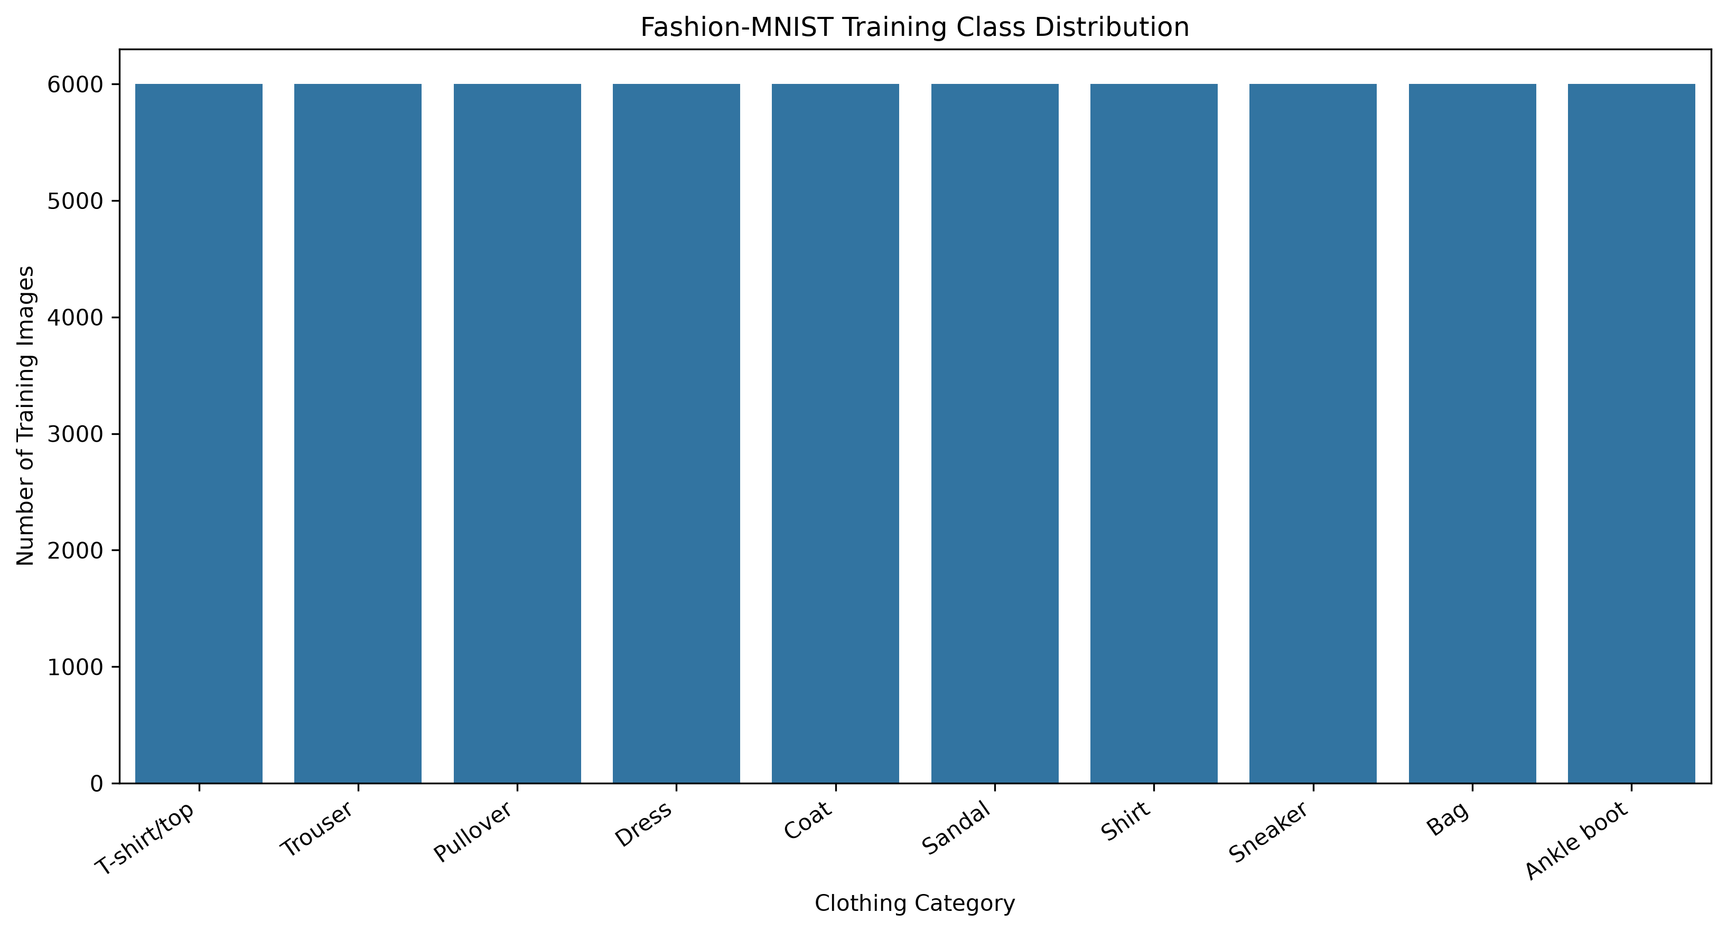
Figure 1. Fashion-MNIST training class distribution.

2.2 Class Labels
ID | Class | Train | Test
0 | T-shirt/top | 6,000 | 1,000
1 | Trouser | 6,000 | 1,000
2 | Pullover | 6,000 | 1,000
3 | Dress | 6,000 | 1,000
4 | Coat | 6,000 | 1,000
5 | Sandal | 6,000 | 1,000
6 | Shirt | 6,000 | 1,000
7 | Sneaker | 6,000 | 1,000
8 | Bag | 6,000 | 1,000
9 | Ankle boot | 6,000 | 1,000

2.3 Technology Stack
Technology | Purpose
Python 3.12 | Programming environment
TensorFlow / Keras | Deep-learning model construction and training
NumPy | Array operations and image preprocessing
Pandas | Tabular metrics and analysis outputs
Matplotlib | Visualization of training and evaluation results
Seaborn | Heatmaps and analytical visualization in project scripts
Scikit-learn | Classification metrics and confusion matrices
SciPy | Statistical testing
uv | Environment and dependency management
Git / GitHub | Version control and project submission

3. Methodology and Experimental Design

3.1 End-to-End Workflow
- Load Fashion-MNIST using the TensorFlow/Keras dataset interface.
- Inspect shapes, labels, missing values, class balance and pixel statistics.
- Normalize pixel values from 0–255 to 0–1.
- Train a dense neural-network baseline using a validation split.
- Train a CNN on the same training/test partitions.
- Generate predictions for the fixed 10,000-image test set.
- Calculate accuracy, precision, recall, F1-score, confusion matrices and class-level accuracy.
- Compare predictions image-by-image and apply a McNemar exact test.
- Measure confidence behavior, Expected Calibration Error and prediction margins.
- Perform targeted misclassification analysis and save all outputs. All figures embedded in this report are taken directly from the project-generated files under outputs/figures rather than recreated separately for the report.

3.2 Preprocessing
Pixel values were converted to float32 and divided by 255.0. This maps the raw grayscale intensity range [0, 255] to [0, 1], improving numerical stability and making gradient-based optimization more consistent. The CNN input was additionally expanded from shape (28, 28) to (28, 28, 1) to provide an explicit channel dimension.
Code Extract 1. Image normalization and CNN shape preparation
x_train = x_train.astype('float32') / 255.0
x_test = x_test.astype('float32') / 255.0
# Additional channel dimension for CNN
x_train = np.expand_dims(x_train, axis=-1)
x_test = np.expand_dims(x_test, axis=-1)

3.3 Evaluation Strategy
Both models were evaluated on the same 10,000-image test set. Because the dataset is balanced, overall accuracy is directly interpretable; however, per-class precision, recall, F1-score and confusion matrices were also examined to expose class-specific weaknesses. Confidence and calibration analysis were added because a classifier can be accurate while still producing unreliable probability estimates.

4. Exploratory Data Analysis

4.1 Dataset Quality
No missing values were detected in either the training or test image arrays. The training labels and test labels contained all class IDs from 0 to 9. The training set mean pixel value was 72.9404 with a standard deviation of 90.0212; the observed pixel range was 0–255.

4.2 Per-Class Pixel Statistics
Class | Mean pixel | Pixel std.
T-shirt/top | 83.03 | 89.44
Trouser | 56.84 | 87.60
Pullover | 96.06 | 91.46
Dress | 66.02 | 90.33
Coat | 98.26 | 95.96
Sandal | 34.87 | 67.09
Shirt | 84.61 | 86.52
Sneaker | 42.76 | 75.17
Bag | 90.16 | 93.14
Ankle boot | 76.81 | 94.49

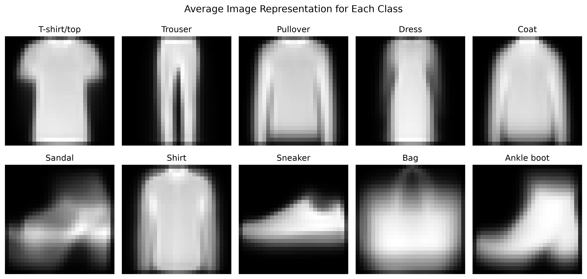
Figure 2. average image representation for each Fashion-MNIST class.
The mean-image visualizations complement the numerical pixel statistics. Upper-body categories retain broad torso and sleeve silhouettes, whereas footwear categories concentrate most non-background pixels toward the lower part of the 28×28 canvas. Bag forms a compact, centered shape. Numerically, Coat and Pullover have the highest mean pixel intensities, while Sandal and Sneaker have much lower means because a larger proportion of their image area is background. Together, the visual and numerical summaries show that the classes differ in both spatial structure and overall intensity distribution.

5. Baseline Neural Network

5.1 Architecture
Layer | Output | Parameters / Setting
Flatten | 784 | 28×28 image flattened
Dense | 128 | ReLU, 100,480 parameters
Dropout | 128 | 0.30
Dense | 64 | ReLU, 8,256 parameters
Dropout | 64 | 0.20
Dense output | 10 | Softmax, 650 parameters

The baseline contains 109,386 trainable parameters. Flattening the image converts its two-dimensional spatial structure into a one-dimensional vector; therefore, neighboring-pixel relationships are not explicitly preserved.
Code Extract 2. Baseline dense network
model = Sequential([
Input(shape=(28, 28)),
Flatten(),
Dense(128, activation='relu'),
Dropout(0.30),
Dense(64, activation='relu'),
Dropout(0.20),
Dense(10, activation='softmax')
])

5.2 Training Behavior
The baseline was trained for 20 epochs with a batch size of 128 and a 20% validation split. Early stopping monitored validation loss and restored the best model weights. The lowest validation loss occurred at epoch 19 (0.3062), so the final evaluation used the epoch-19 weights.
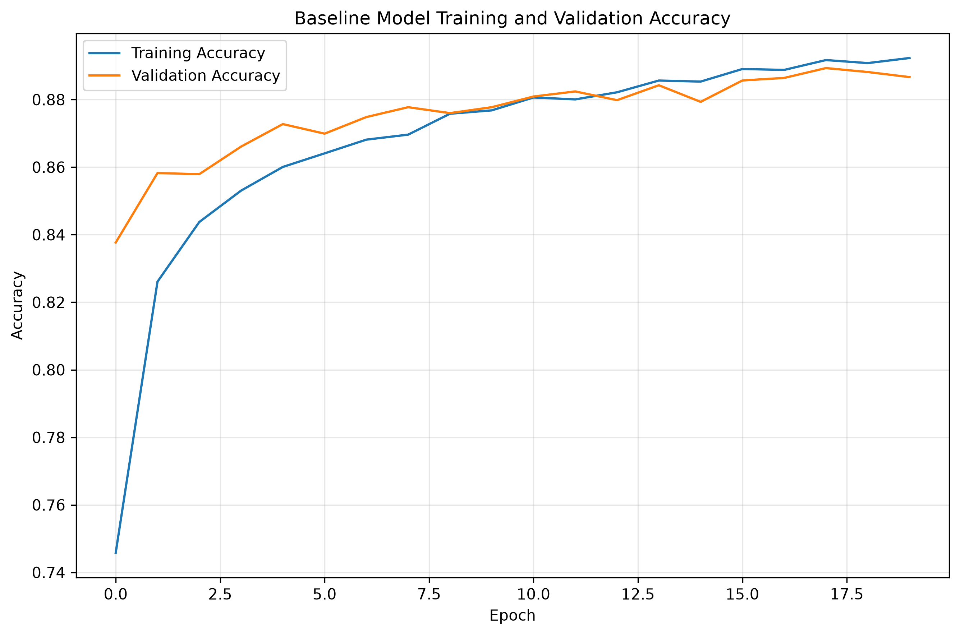
Figure 3. baseline training and validation accuracy across 20 epochs.
Training accuracy increased steadily from 74.58% to 89.23%. Validation accuracy reached approximately 88.9% and remained close to training accuracy, indicating only a modest generalization gap.

5.3 Baseline Test Results
Metric | Result
Test loss | 0.332044
Test accuracy | 88.11%
Correct predictions | 8,811
Incorrect predictions | 1,189
Mean confidence – correct | 0.9182
Mean confidence – incorrect | 0.6442

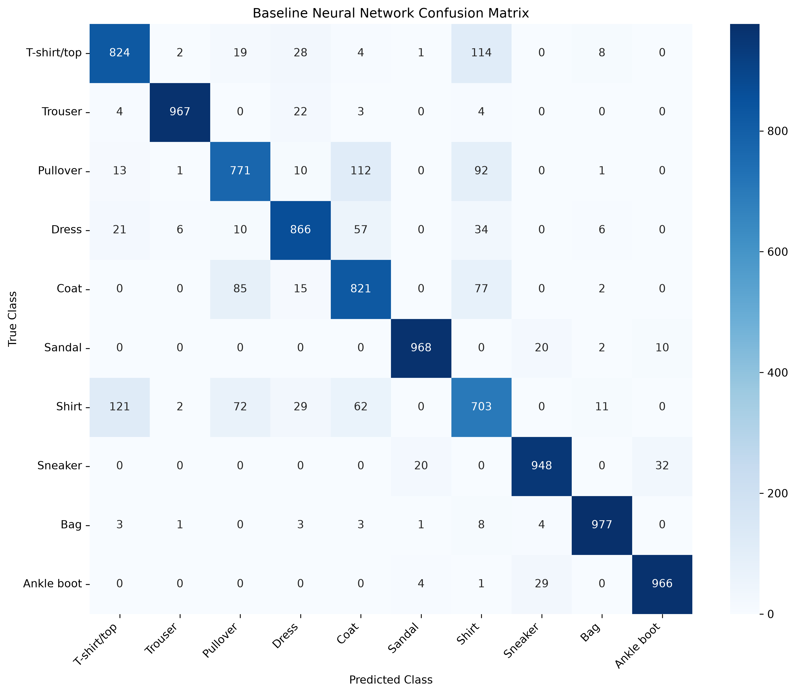
Figure 4. baseline confusion matrix on 10,000 test images.
The baseline performs very strongly on Bag, Trouser, Sandal and Ankle boot, but struggles with visually overlapping upper-body classes. Shirt is the weakest baseline category at 70.30% accuracy. For example, 121 Shirt images were predicted as T-shirt/top and 72 were predicted as Pullover.

6. Convolutional Neural Network

6.1 CNN Architecture
Layer | Output shape | Parameters
Conv2D 32 | 28×28×32 | 320
Batch Normalization | 28×28×32 | 128
Conv2D 32 | 28×28×32 | 9,248
MaxPooling2D | 14×14×32 | 0
Dropout | 14×14×32 | 0.25
Conv2D 64 | 14×14×64 | 18,496
Batch Normalization | 14×14×64 | 256
Conv2D 64 | 14×14×64 | 36,928
MaxPooling2D | 7×7×64 | 0
Dropout | 7×7×64 | 0.30
Flatten | 3,136 | 0
Dense | 128 | 401,536
Dropout | 128 | 0.40
Output | 10 | 1,290

The CNN contains 468,202 parameters in total, of which 468,010 are trainable and 192 are non-trainable batch-normalization parameters. Convolutional filters preserve local spatial structure and can learn edges, textures and progressively more complex clothing patterns.
Code Extract 3. Main CNN feature-extraction and classification stack
Conv2D(32, (3,3), padding='same', activation='relu')
BatchNormalization()
Conv2D(32, (3,3), padding='same', activation='relu')
MaxPooling2D((2,2))
Dropout(0.25)
Conv2D(64, (3,3), padding='same', activation='relu')
BatchNormalization()
Conv2D(64, (3,3), padding='same', activation='relu')
MaxPooling2D((2,2))
Dropout(0.30)
Flatten()
Dense(128, activation='relu')
Dropout(0.40)
Dense(10, activation='softmax')

6.2 Training Configuration
The CNN was trained for a maximum of 25 epochs using Adam with an initial learning rate of 0.001. EarlyStopping used patience 4 and restored the best validation-loss weights. ReduceLROnPlateau reduced the learning rate by a factor of 0.5 when validation loss stopped improving. Learning-rate reductions occurred at epochs 10, 16 and 23. Training finished after epoch 25, and the best weights from epoch 21 were restored.
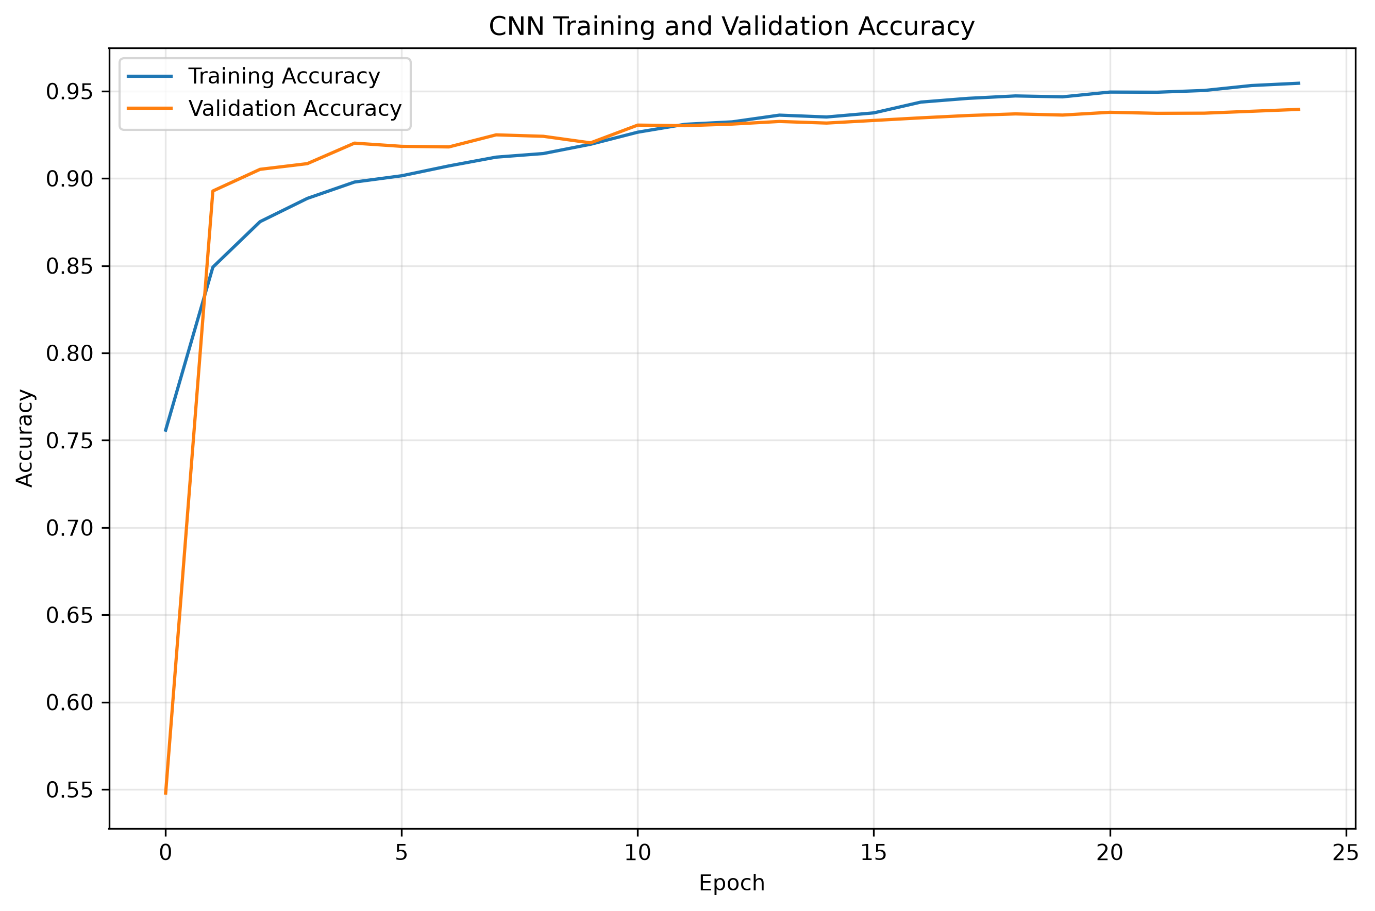
Figure 5. CNN training and validation accuracy across 25 epochs.
The CNN initially showed low validation accuracy at epoch 1 (54.78%), but rapidly improved to 89.28% by epoch 2 and exceeded 93% validation accuracy by epoch 11. Final training accuracy reached 95.45%, while validation accuracy reached 93.95%. The validation curve remained stable despite continued training improvement, suggesting moderate but controlled overfitting.

6.3 CNN Test Results
Metric | Result
Test loss | 0.206340
Test accuracy | 93.34%
Correct predictions | 9,334
Incorrect predictions | 666
Macro F1 | 0.9333
Mean confidence – correct | 0.9692
Mean confidence – incorrect | 0.7340

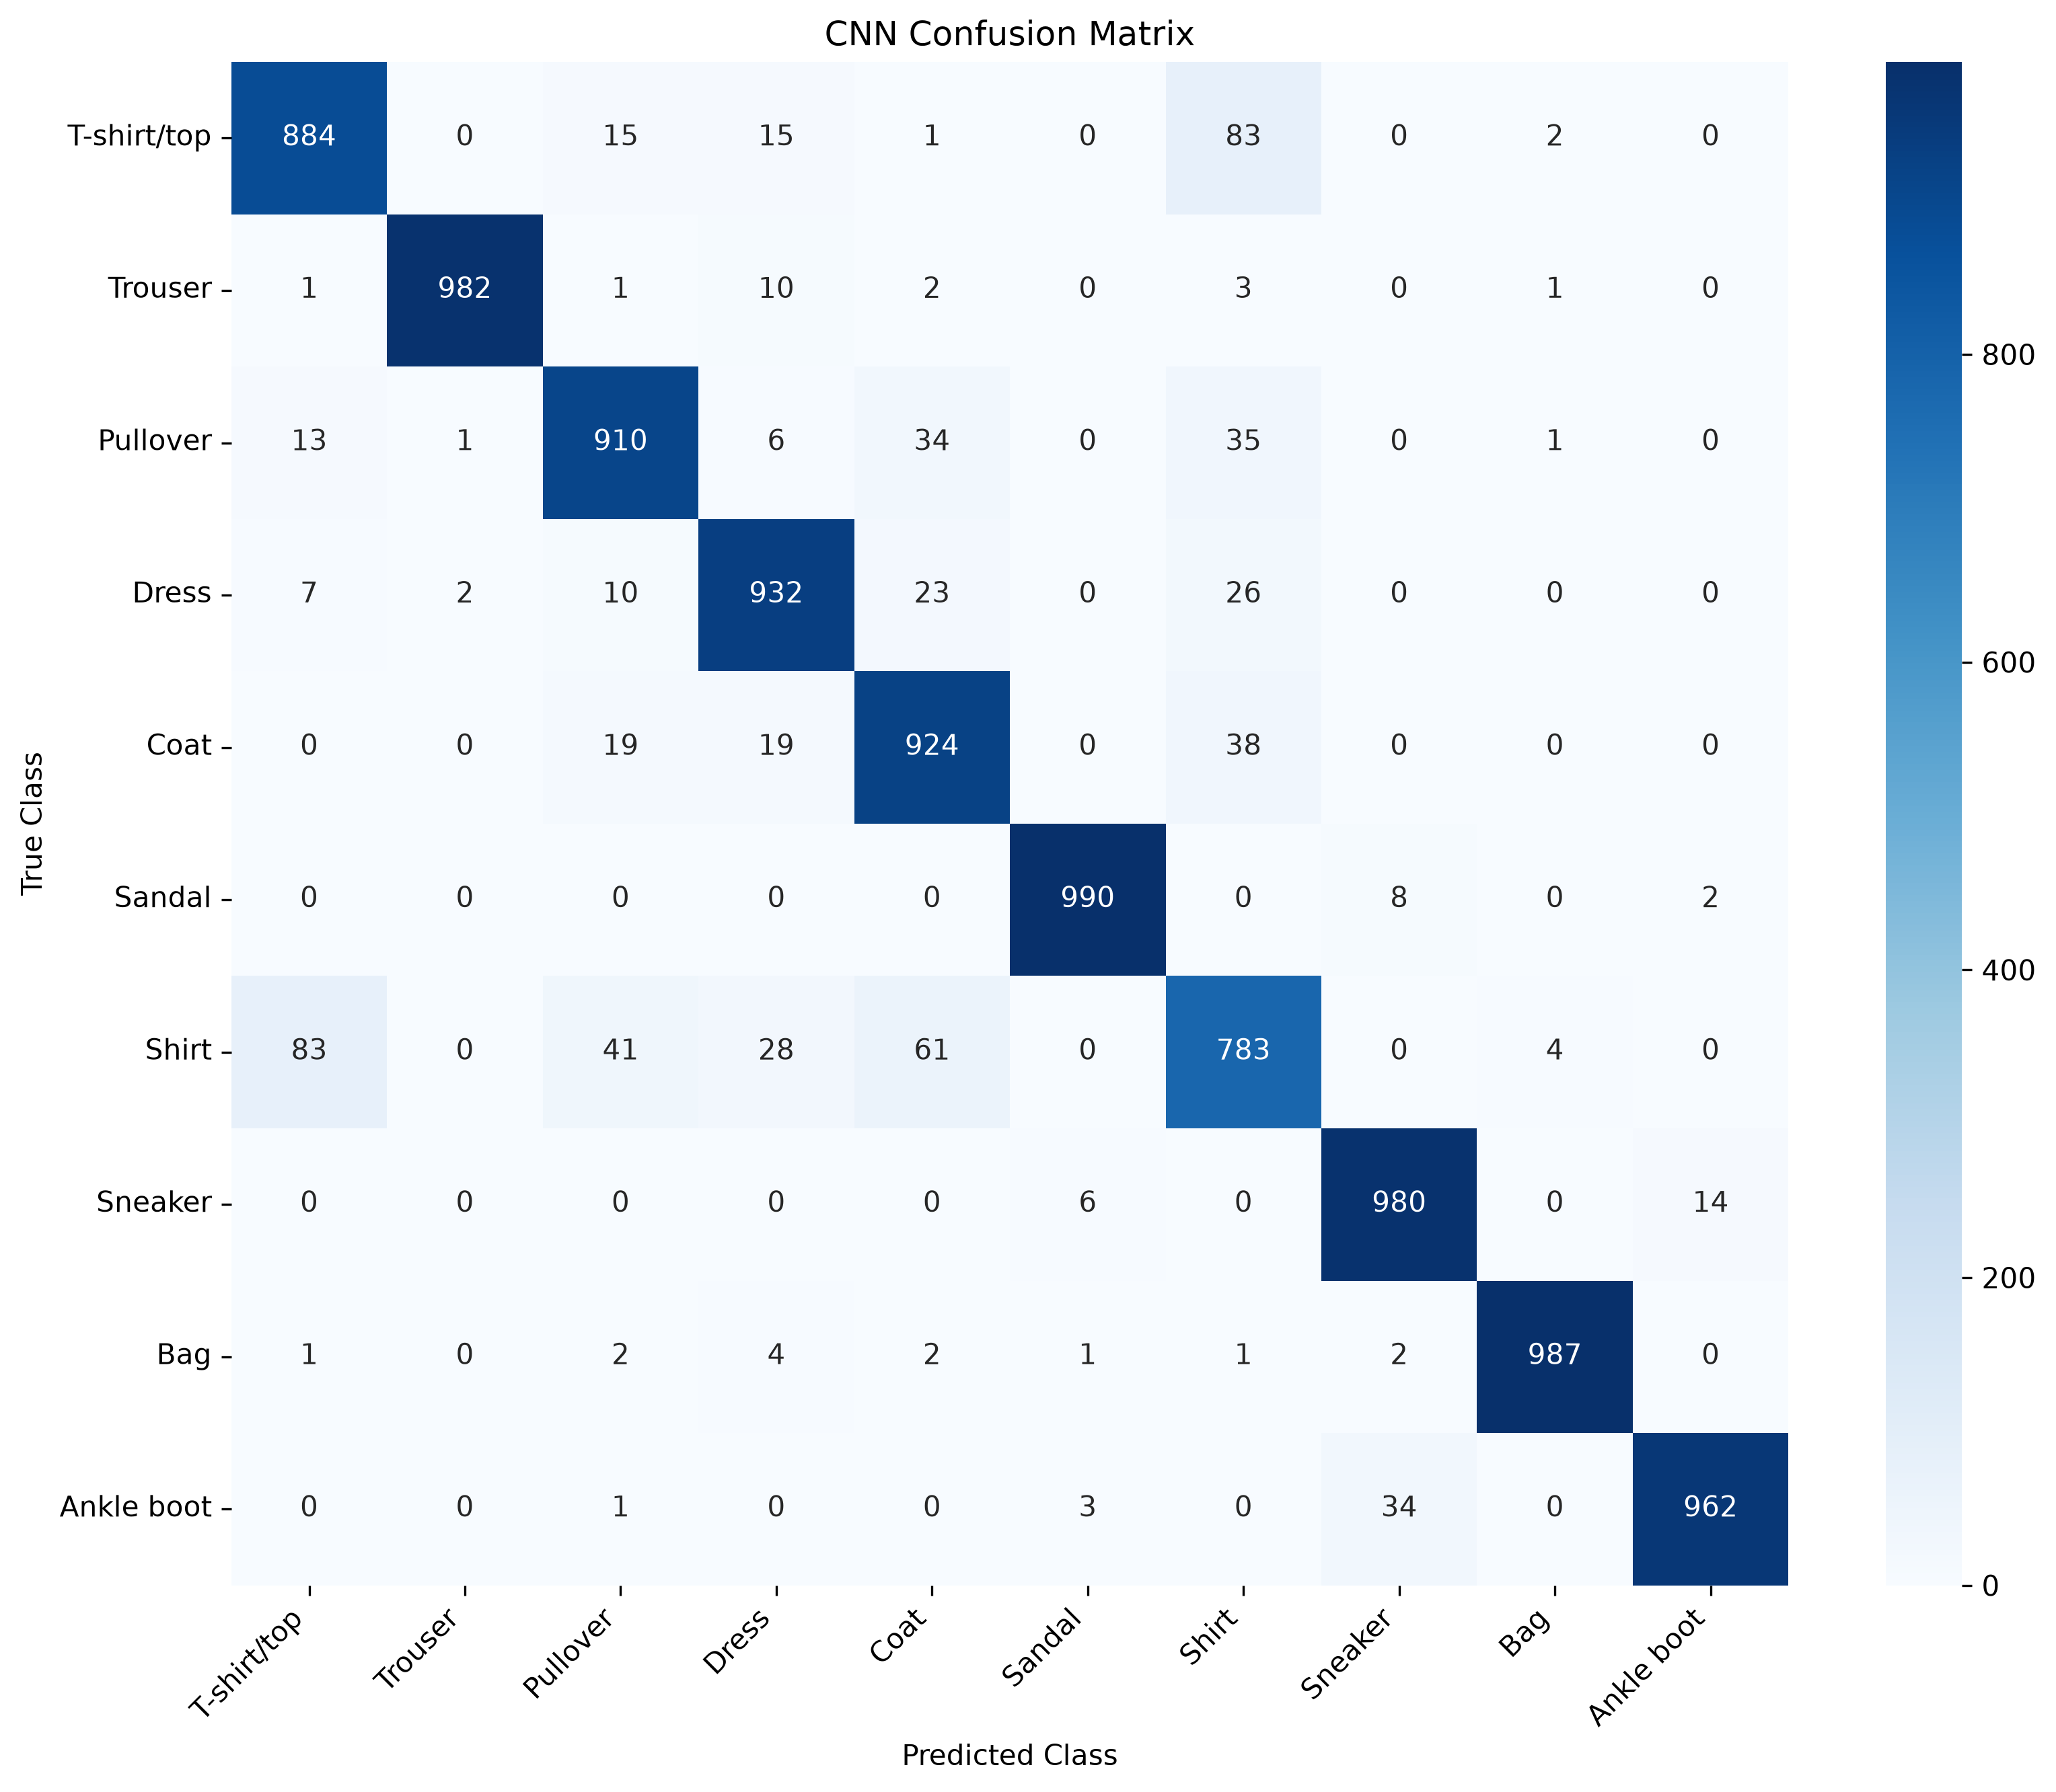
Figure 6. CNN confusion matrix on the same 10,000-image test set.

6.4 CNN Per-Class Classification Metrics
Class | Precision | Recall | F1-score
T-shirt/top | 0.8938 | 0.8840 | 0.8889
Trouser | 0.9970 | 0.9820 | 0.9894
Pullover | 0.9109 | 0.9100 | 0.9105
Dress | 0.9191 | 0.9320 | 0.9255
Coat | 0.8825 | 0.9240 | 0.9028
Sandal | 0.9900 | 0.9900 | 0.9900
Shirt | 0.8080 | 0.7830 | 0.7953
Sneaker | 0.9570 | 0.9800 | 0.9684
Bag | 0.9920 | 0.9870 | 0.9895
Ankle boot | 0.9836 | 0.9620 | 0.9727

The macro-average precision, recall and F1-score are all approximately 0.933, consistent with the balanced class distribution. Shirt has the lowest F1-score (0.7953), while Bag, Trouser and Sandal are close to 0.99.

7. Model Comparison and Statistical Analysis

7.1 Overall Performance
Metric | Baseline NN | CNN | Change
Test accuracy | 88.11% | 93.34% | +5.23 pp
Test loss | 0.332044 | 0.206340 | −37.86%
Correct predictions | 8,811 | 9,334 | +523
Incorrect predictions | 1,189 | 666 | −523
Relative error reduction | — | 43.99% | —

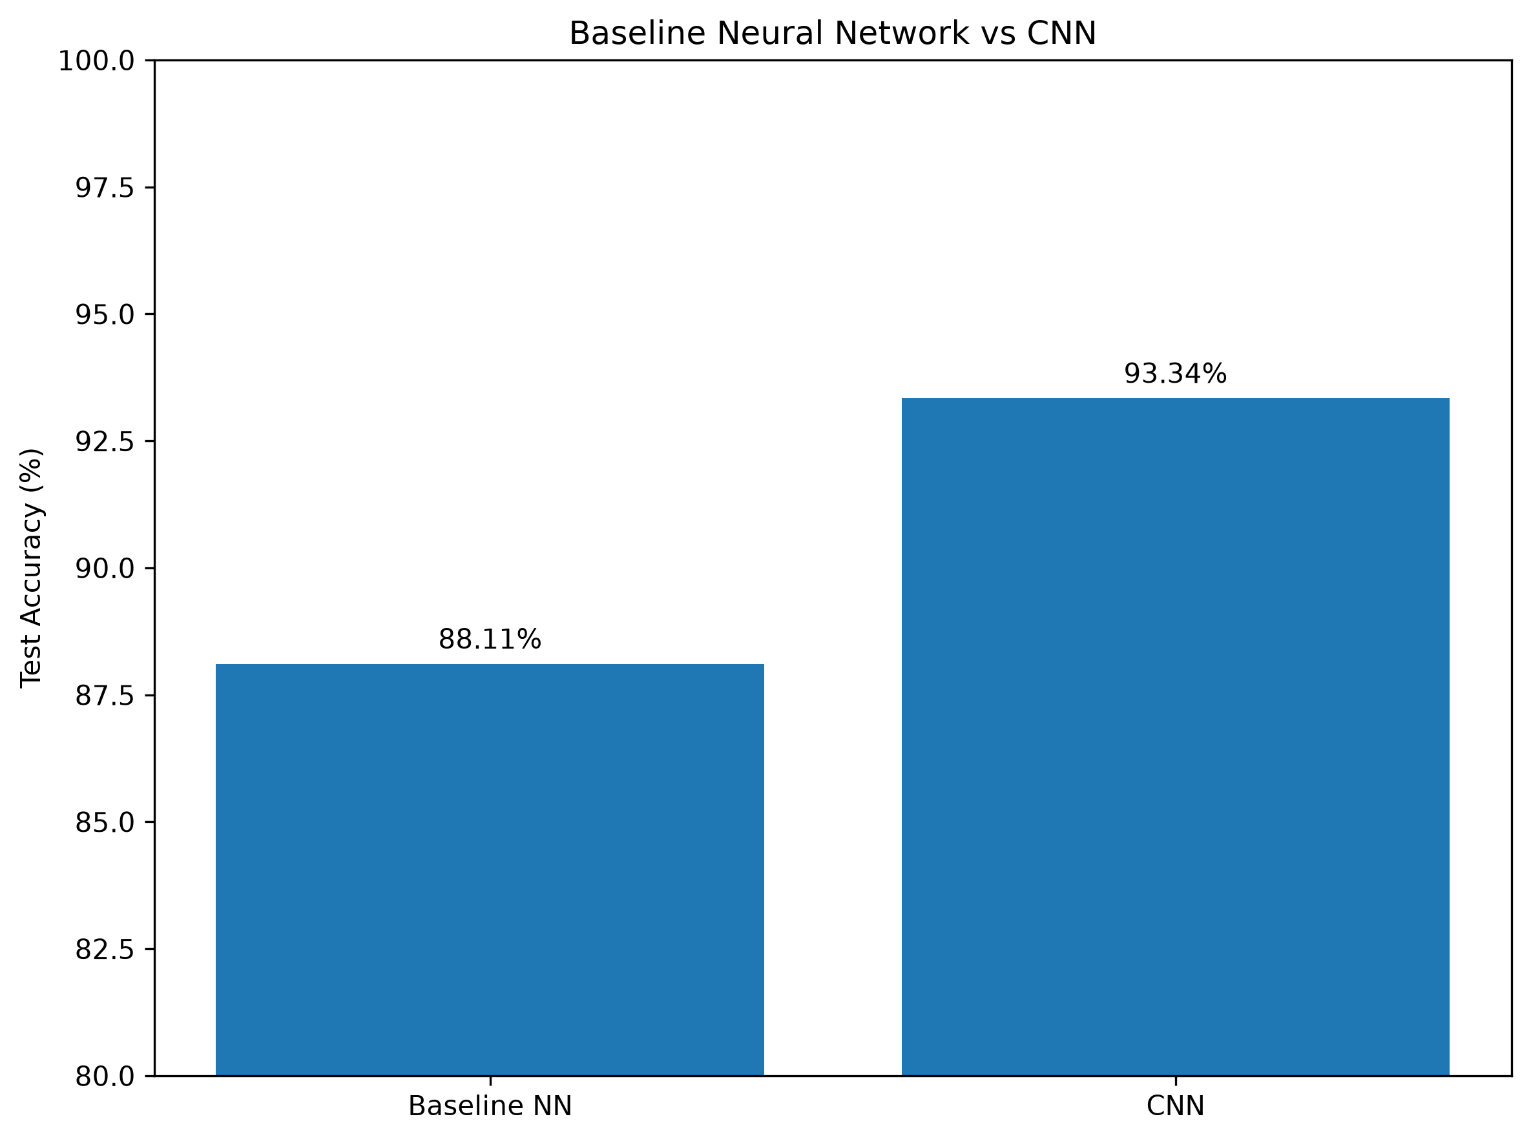
Figure 7. overall test accuracy comparison between the baseline neural network and CNN.

7.2 Worked Improvement Calculation
The error reduction is not stated only as a percentage; it can be reproduced directly from the observed predictions:
Worked Example 1. Relative reduction in classification errors
Baseline errors = 1,189
CNN errors = 666
Errors removed = 1,189 − 666 = 523
Relative error reduction = 523 / 1,189 × 100 = 43.99%
Thus, the CNN removed nearly 44% of the errors made by the baseline on the same test set.

7.3 Per-Class Comparison
Class | Baseline | CNN | Change (pp)
T-shirt/top | 82.40% | 88.40% | +6.00
Trouser | 96.70% | 98.20% | +1.50
Pullover | 77.10% | 91.00% | +13.90
Dress | 86.60% | 93.20% | +6.60
Coat | 82.10% | 92.40% | +10.30
Sandal | 96.80% | 99.00% | +2.20
Shirt | 70.30% | 78.30% | +8.00
Sneaker | 94.80% | 98.00% | +3.20
Bag | 97.70% | 98.70% | +1.00
Ankle boot | 96.60% | 96.20% | -0.40

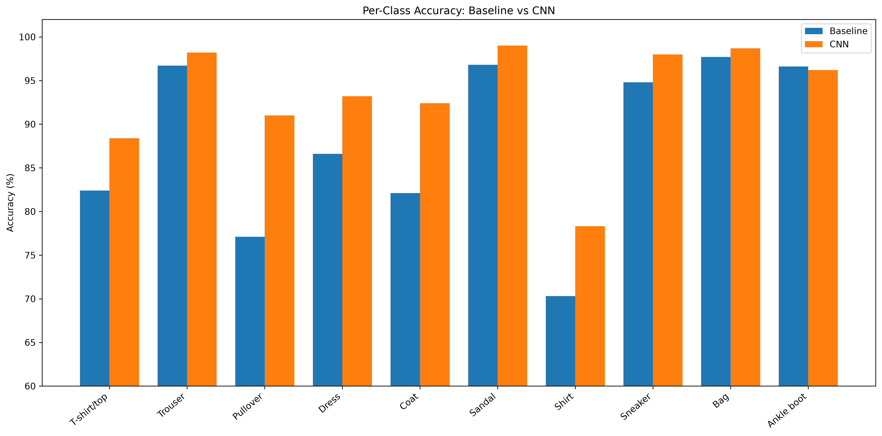
Figure 8. class-by-class accuracy comparison.
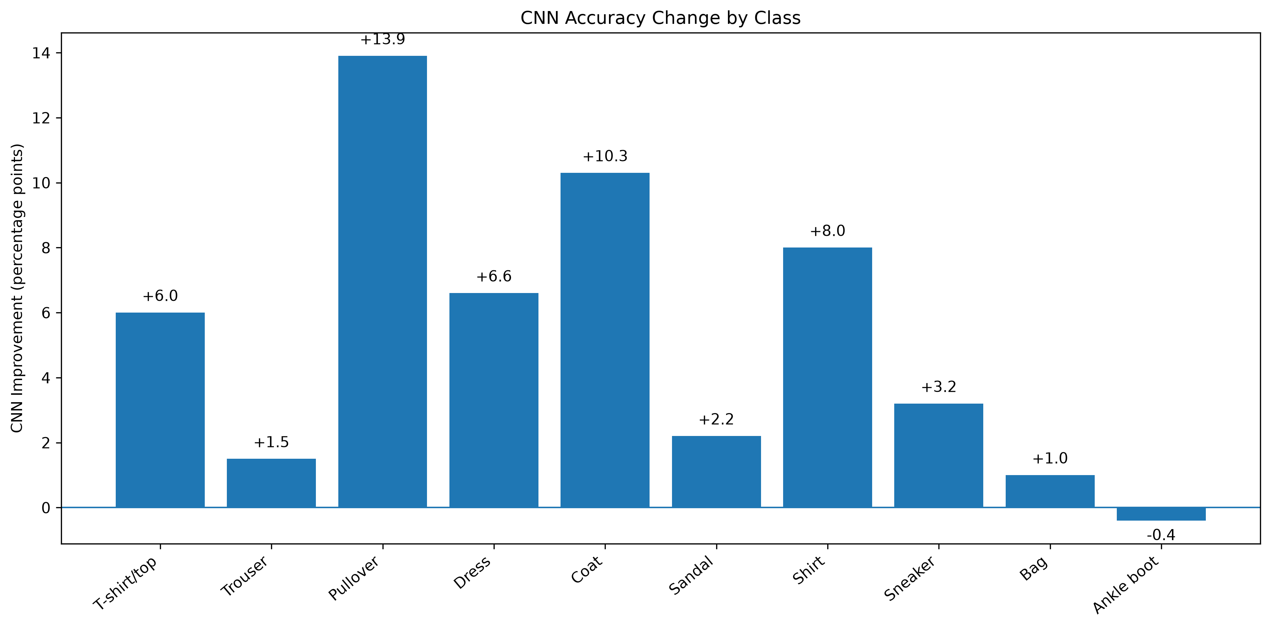
Figure 9. absolute CNN accuracy change for each class.
Pullover improved the most, from 77.10% to 91.00% (+13.90 percentage points). Coat improved by 10.30 points and Shirt by 8.00 points. These are precisely the categories where preserving local spatial information is especially useful. Ankle boot was the only class with a small decrease (−0.40 points), illustrating that an overall improvement does not require every class to improve individually.

7.4 Paired Prediction Analysis
Outcome | Images
Both models correct | 8,619
Both models wrong | 474
CNN corrected a baseline error | 715
CNN introduced a new error | 192

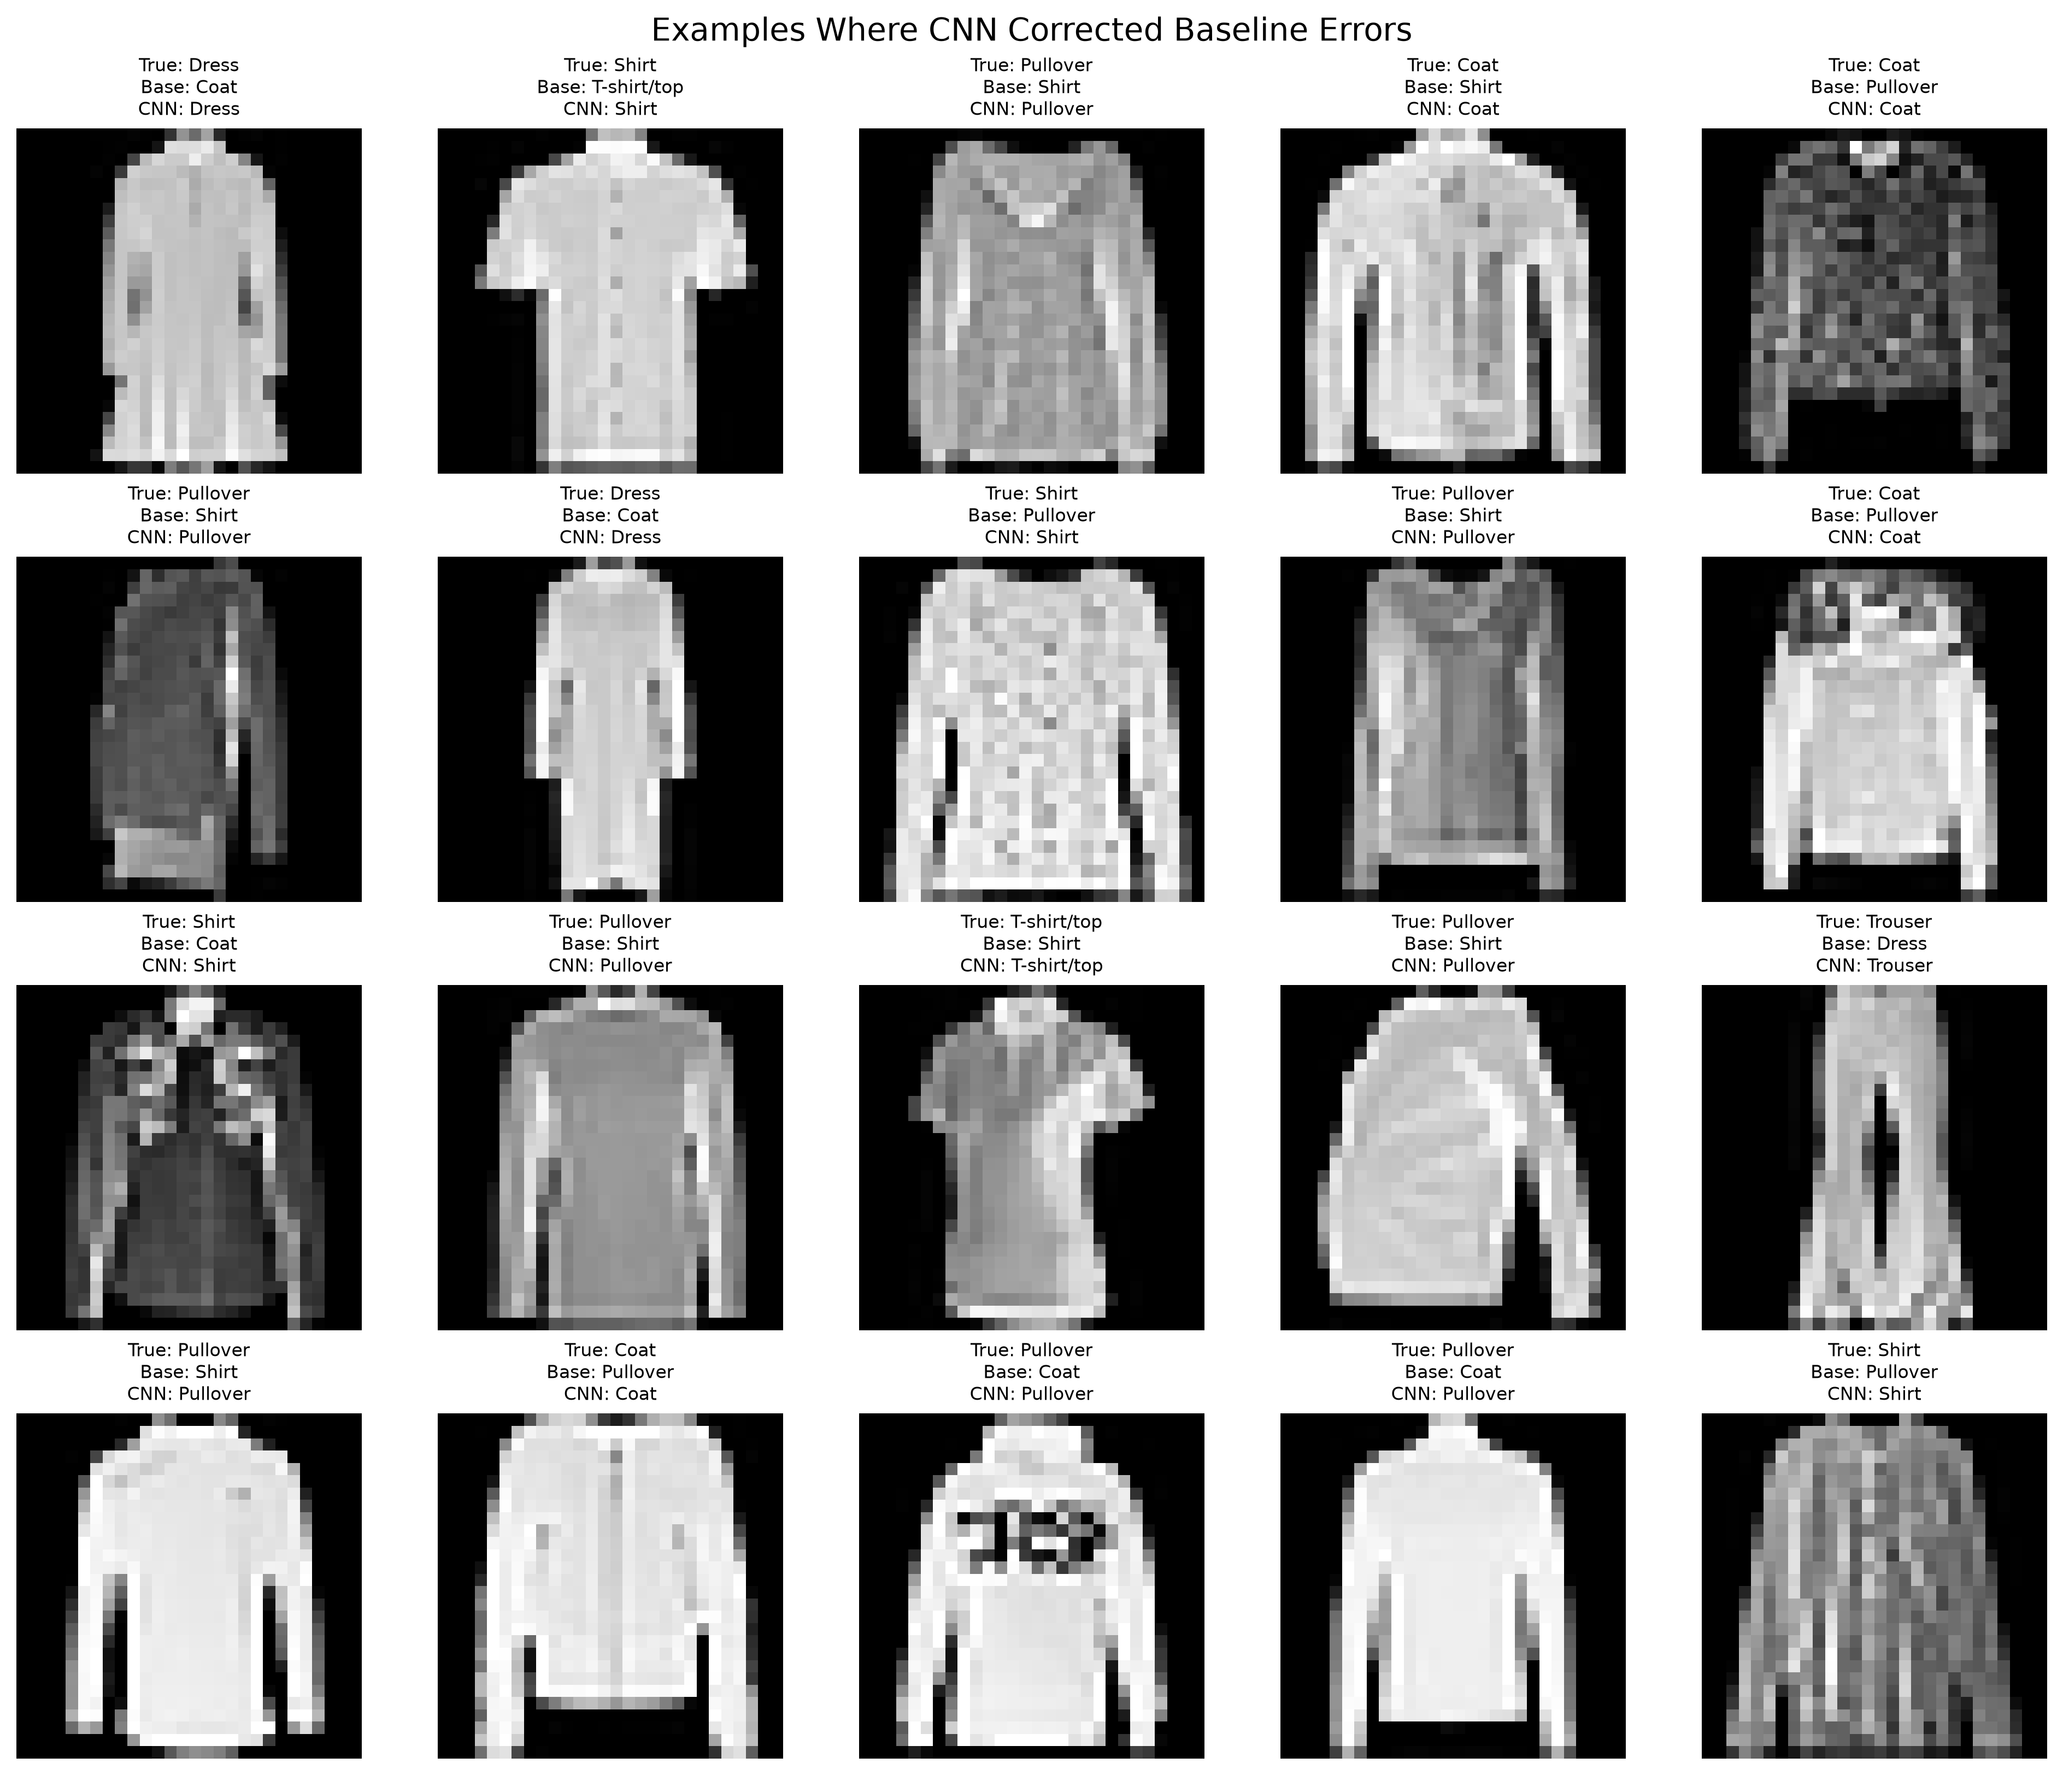
Figure 10. examples where the CNN corrected errors made by the baseline model.
The paired counts show that the CNN corrected 715 images that the baseline misclassified, whereas the baseline was correct on only 192 images that the CNN missed. Figure 10 provides concrete examples of those corrected cases rather than only an aggregate bar chart. This makes the improvement inspectable at image level and explains the net gain of 523 correct predictions.

7.5 Statistical Significance
Because the two classifiers were evaluated on the same images, their predictions are paired. A McNemar exact test was applied to the discordant cases (715 baseline-wrong/CNN-correct versus 192 baseline-correct/CNN-wrong). The computed p-value was extremely small and is reported as p < 0.001. Therefore, the difference in paired predictions is statistically significant at α = 0.05.
The statistical result complements the accuracy increase: it indicates that the observed improvement is systematic on this test set rather than being driven by a small number of random label changes.

8. Confidence and Calibration Analysis

8.1 Prediction Confidence
Model | Correct mean confidence | Incorrect mean confidence
Baseline | 0.9182 | 0.6442
CNN | 0.9692 | 0.7340

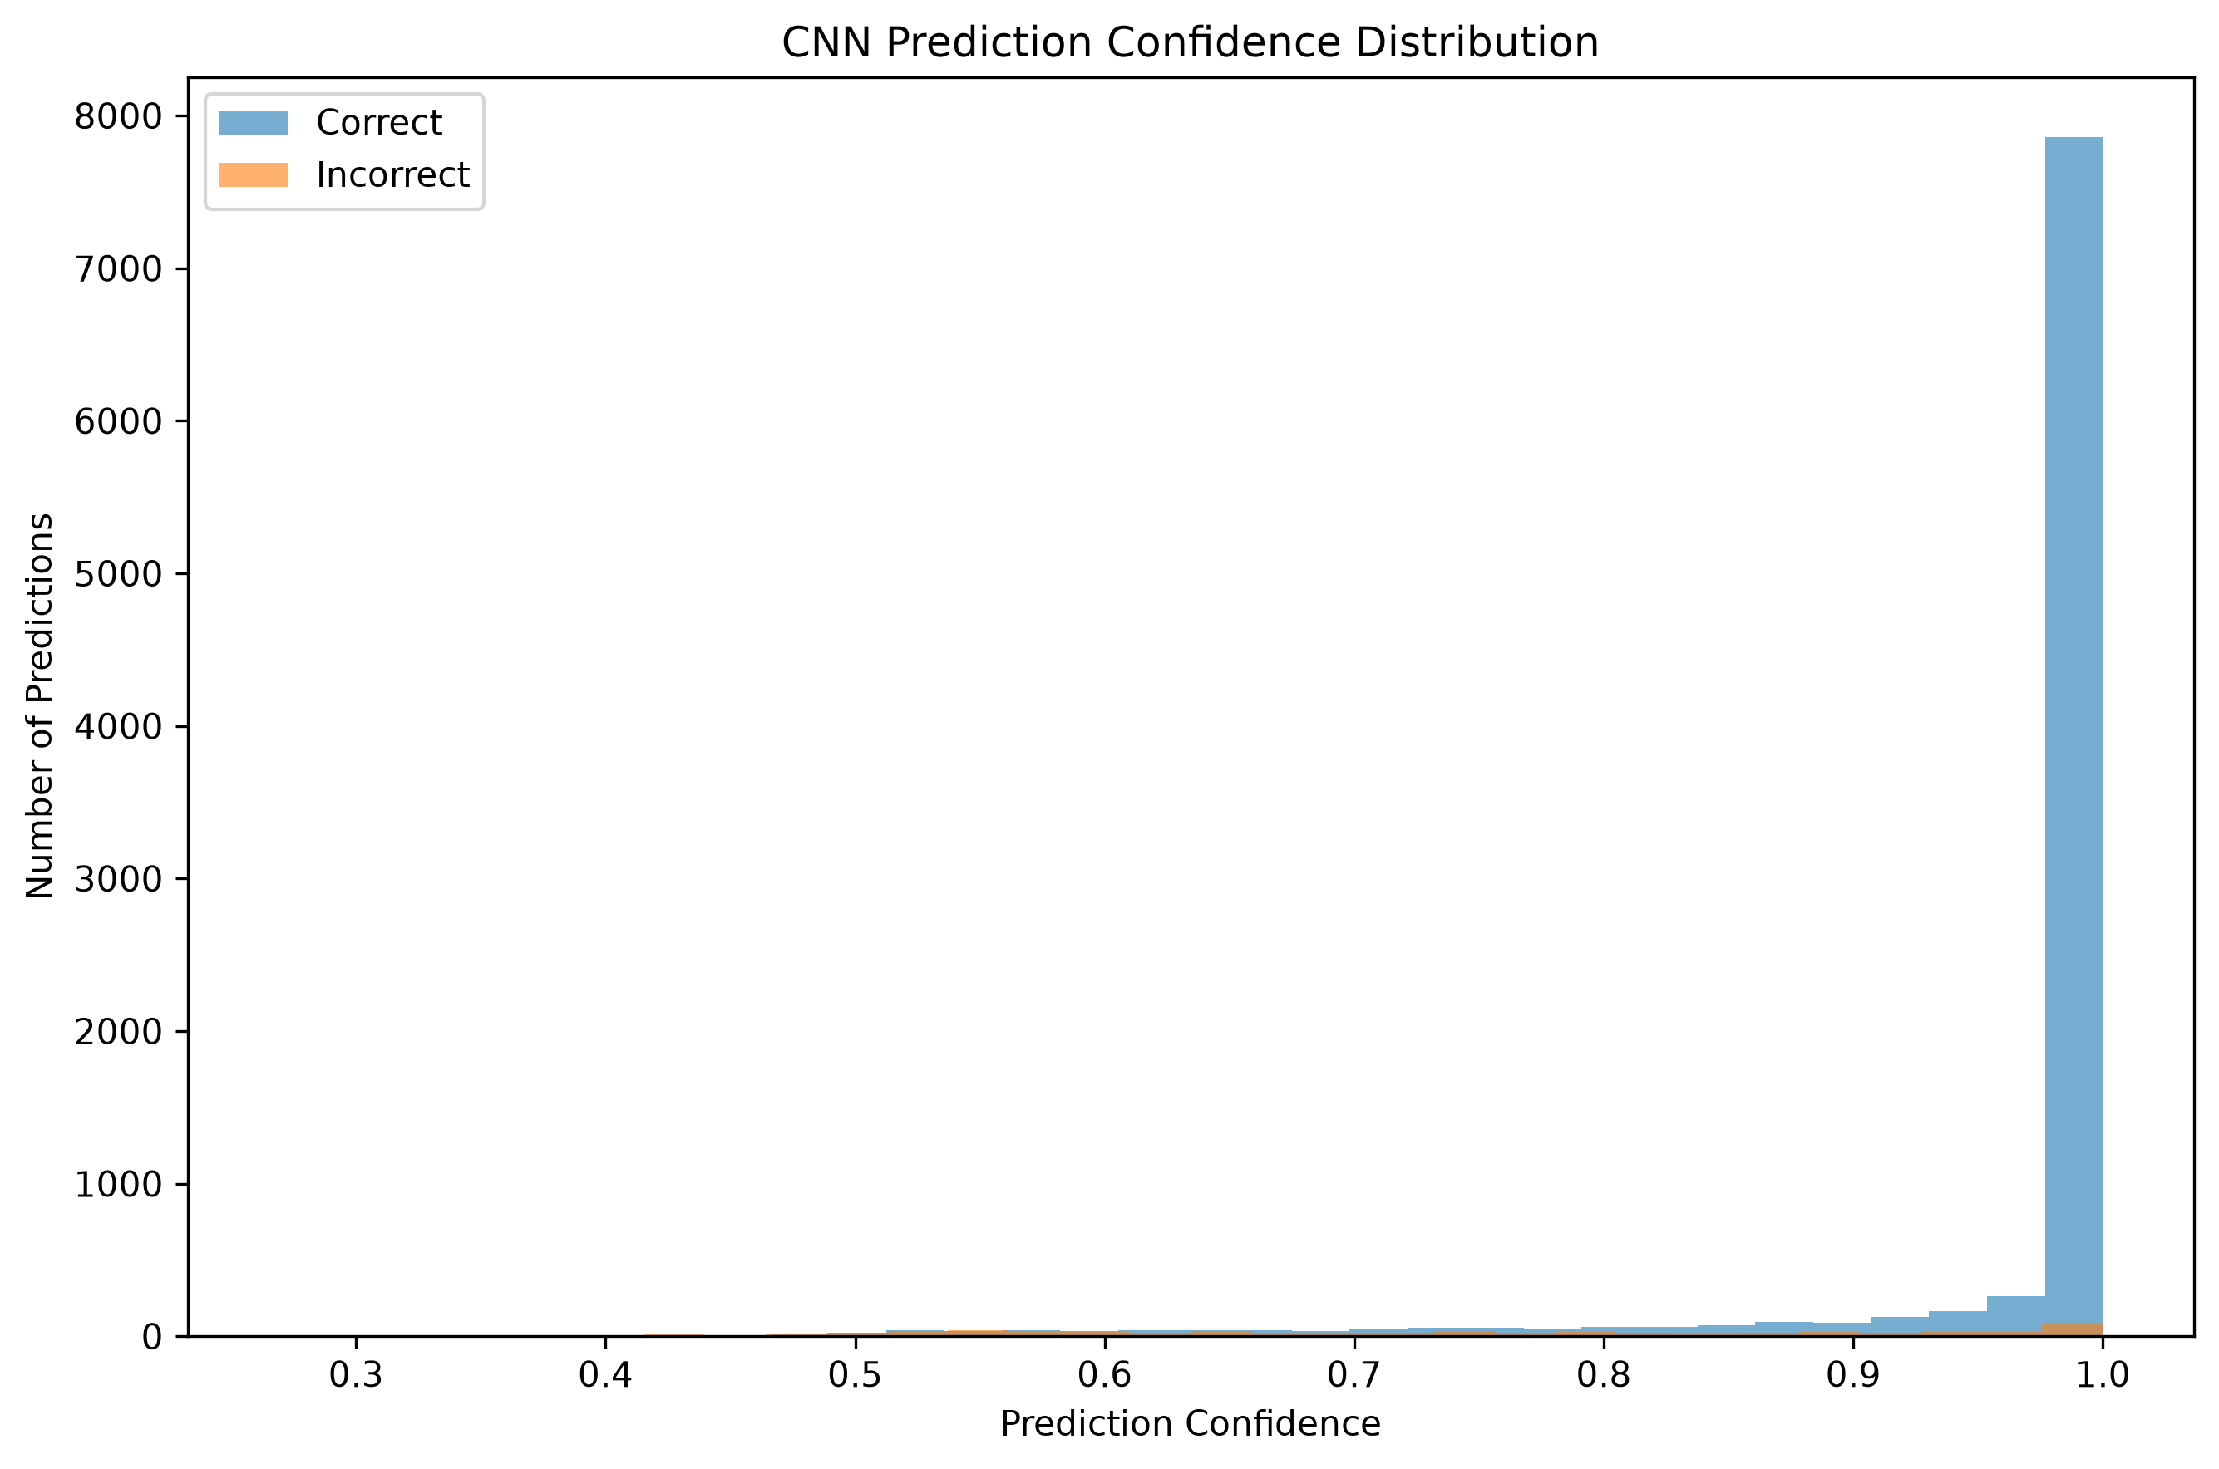
Figure 11. CNN prediction-confidence distribution for correct and incorrect test predictions.
The CNN is more confident than the baseline on both correct and incorrect predictions. Figure 11 shows the CNN confidence distribution directly: correct predictions are heavily concentrated near confidence 1.0, while incorrect predictions occupy a broader and lower-confidence range. The higher confidence on correct predictions is useful, but the presence of confident errors shows why softmax confidence should not be treated as guaranteed certainty.

8.2 Expected Calibration Error
Model | ECE
Baseline | 0.0104
CNN | 0.0202

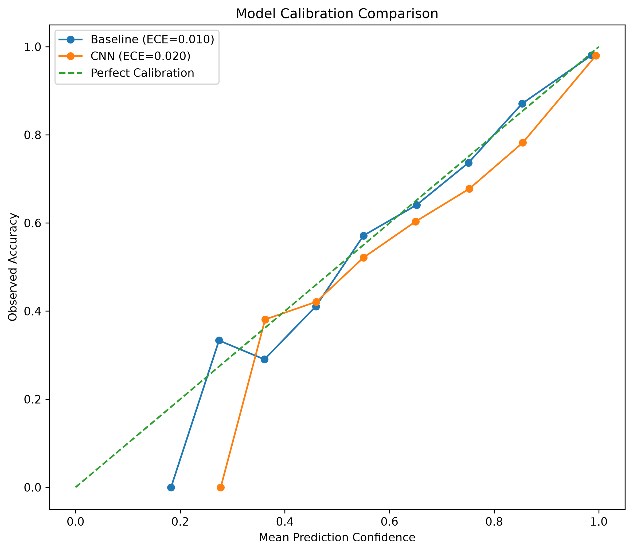
Figure 12. reliability/calibration comparison between the baseline model and CNN.
The CNN achieved higher classification accuracy but a larger calibration error. Its ECE increased from 0.0104 to 0.0202. Figure 12 plots the observed calibration curves for both models against the perfect-calibration diagonal, making the difference visible rather than relying only on the ECE values. This demonstrates that accuracy and probability calibration measure different aspects of model quality.

9. Deep Error Analysis

9.1 Per-Class Error Rates
Class | Correct | Errors | Accuracy | Error rate
T-shirt/top | 884 | 116 | 88.40% | 11.60%
Trouser | 982 | 18 | 98.20% | 1.80%
Pullover | 910 | 90 | 91.00% | 9.00%
Dress | 932 | 68 | 93.20% | 6.80%
Coat | 924 | 76 | 92.40% | 7.60%
Sandal | 990 | 10 | 99.00% | 1.00%
Shirt | 783 | 217 | 78.30% | 21.70%
Sneaker | 980 | 20 | 98.00% | 2.00%
Bag | 987 | 13 | 98.70% | 1.30%
Ankle boot | 962 | 38 | 96.20% | 3.80%

Shirt remains the hardest class. The CNN correctly classified 783 of 1,000 Shirt images, leaving 217 errors and a 21.70% error rate. By contrast, Sandal reached 99.00% accuracy with only 10 errors.

9.2 Frequent Error Pairs
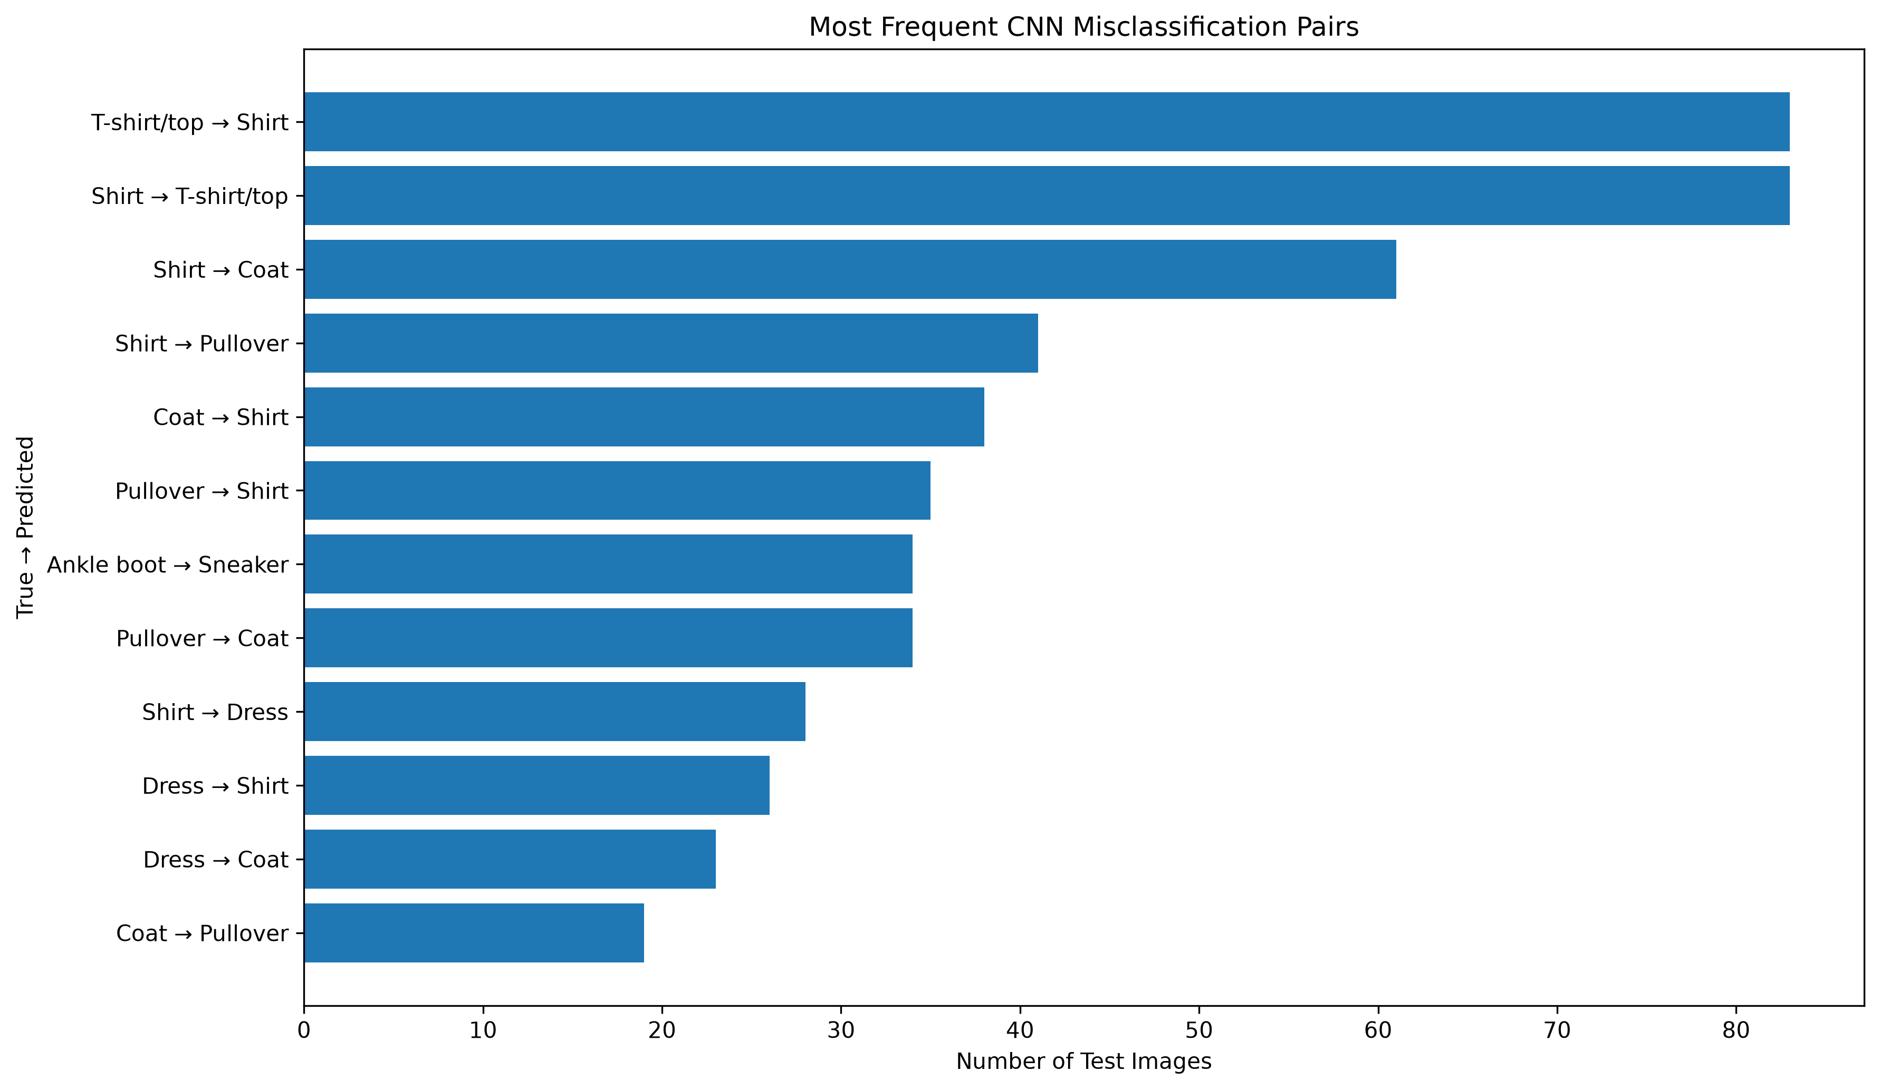
Figure 13. most frequent directional CNN misclassification pairs.
The two most frequent errors are symmetric: T-shirt/top → Shirt and Shirt → T-shirt/top both occur 83 times. Other major confusions include Shirt → Coat (61), Shirt → Pullover (41), Coat → Shirt (38), Pullover → Shirt (35), and Pullover → Coat (34). These results show that the remaining errors are concentrated in visually similar upper-body garments rather than spread uniformly across all classes.

9.3 Prediction Margin
The prediction margin was defined as the difference between the highest and second-highest predicted probabilities. A large margin means the model strongly separates its first choice from the nearest alternative.
Prediction group | Mean margin
Correct predictions | 0.9423
Incorrect predictions | 0.5173

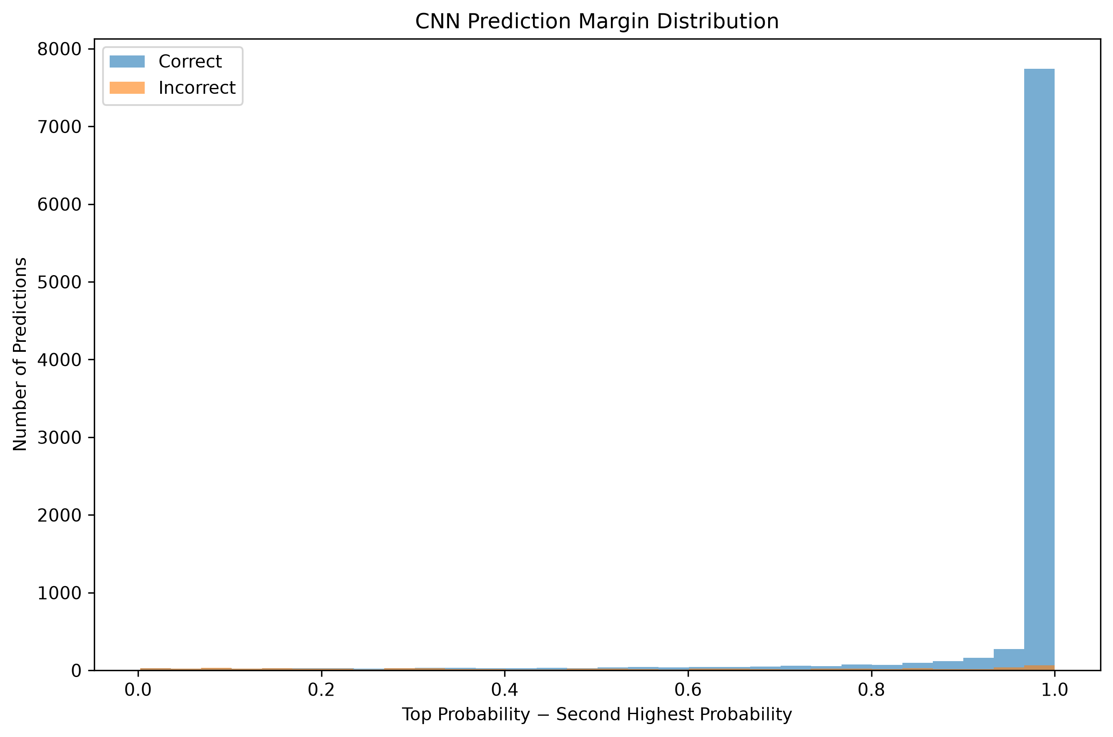
Figure 14. CNN prediction-margin distribution for correct and incorrect predictions.
The mean prediction margin was 0.9423 for correct predictions and 0.5173 for incorrect predictions. Figure 14 shows the full distribution rather than only those averages: correct predictions are strongly concentrated at large margins, whereas errors are more dispersed toward smaller margins. This provides additional evidence that incorrect predictions are typically more ambiguous, while also retaining the important observation that a small number of errors can still be made with high confidence.

10. Discussion

10.1 Why the CNN Improved Performance
The dense baseline converts every image into 784 unrelated input positions before classification. It can learn useful global patterns, but it does not explicitly model local neighborhoods. The CNN instead applies shared convolutional filters over nearby pixels. This makes it better suited to features such as edges, sleeves, collars, shoe contours and localized textures. Max pooling further summarizes local activations while reducing spatial dimensions, and batch normalization stabilizes training.

10.2 Where the CNN Helped Most
The greatest improvements occurred for Pullover, Coat and Shirt. These classes are visually similar, so fine spatial structure is particularly important. Pullover accuracy increased by 13.90 points and Coat by 10.30 points. Even Shirt, which remained the hardest class, improved from 70.30% to 78.30%. This pattern is consistent with the CNN learning more useful shape information than the flattened baseline.

10.3 Remaining Limitations
- Shirt remains difficult because its silhouette overlaps with T-shirt/top, Pullover, Coat and Dress.
- The 28×28 grayscale resolution removes color and fine texture information that could distinguish similar garments.
- Several incorrect predictions are highly confident, so raw softmax probabilities should not be interpreted as calibrated certainty.
- The experiment uses the standard Fashion-MNIST split only; robustness to distribution shift, image corruption or external fashion datasets was not tested.
- The CNN is more computationally expensive than the baseline and contains over four times as many parameters.

11. Challenges Encountered and Solutions
Challenge | Observed issue | Resolution
TensorFlow on native Windows | TensorFlow reported that CUDA GPU acceleration is unavailable on native Windows for current versions. | Training was completed correctly on CPU; this did not affect functional correctness.
TensorFlow startup logging | oneDNN and TensorFlow startup messages made terminal output noisy. | Logging was suppressed without changing the final model logic or reported metrics.
uv project packaging | uv initially expected src/fashion_mnist_deep_learning_project/__init__.py when adding SciPy. | The repository is a script-based data-science project, so tool.uv.package = false was configured and the obsolete project script entry was removed.
Model comparison quality | Overall accuracy alone would not explain where the CNN improved. | Paired predictions, class-level changes, calibration, confidence, margins and error pairs were added.
Reproducibility | Deep-learning runs can vary slightly due to floating-point and initialization effects. | Python, NumPy and TensorFlow random seeds were fixed at 42 and artifacts were saved.

12. Conclusion
The Week 5 project successfully developed and evaluated two neural-network approaches for Fashion-MNIST image classification. The dense baseline achieved 88.11% test accuracy, while the CNN reached 93.34%. The improvement corresponds to 523 fewer errors and a 43.99% relative reduction in mistakes on the fixed 10,000-image test set.
The CNN produced its strongest gains on categories that depend heavily on spatial structure: Pullover improved by 13.90 percentage points, Coat by 10.30 and Shirt by 8.00. Paired prediction analysis showed that the CNN corrected 715 baseline errors while introducing 192 new errors, and a McNemar exact test indicated that the difference was statistically significant (p < 0.001).
The deeper analysis also identified limitations that would be hidden by overall accuracy alone. Shirt remained the hardest category, common errors were concentrated among similar upper-body garments, and the CNN had a larger Expected Calibration Error than the baseline despite higher accuracy. Correct predictions also had a much larger prediction margin than incorrect predictions. Overall, the project demonstrates both the effectiveness of convolutional networks for image classification and the importance of evaluating model reliability and failure patterns in addition to headline accuracy.

References
1. Xiao, H., Rasul, K., & Vollgraf, R. (2017). Fashion-MNIST: a Novel Image Dataset for Benchmarking Machine Learning Algorithms. arXiv:1708.07747.
2. TensorFlow / Keras. Fashion-MNIST dataset loader and deep-learning framework documentation.
3. Scikit-learn. Classification metrics and confusion-matrix utilities.
4. SciPy. Statistical functions used for paired exact testing.
5. Project repository: https://github.com/ARraj14/Fashion_MNIST_Deep_Learning_Project

Appendix A – Key Code Extracts

A.1 Early Stopping and Learning-Rate Control
early_stopping = EarlyStopping(
monitor='val_loss', patience=4,
restore_best_weights=True
)
reduce_lr = ReduceLROnPlateau(
monitor='val_loss', factor=0.5,
patience=2, min_lr=1e-6
)

A.2 Per-Class Accuracy
for class_id, class_name in enumerate(CLASS_NAMES):
mask = y_test == class_id
class_accuracy = (y_pred[mask] == y_test[mask]).mean()
print(f'{class_name}: {class_accuracy * 100:.2f}%')

A.3 Paired Prediction Counts
both_correct = (baseline_correct & cnn_correct).sum()
both_wrong = ((~baseline_correct) & (~cnn_correct)).sum()
cnn_fixed_baseline = ((~baseline_correct) & cnn_correct).sum()
baseline_better = (baseline_correct & (~cnn_correct)).sum()

A.4 McNemar Exact Test
discordant = cnn_fixed_baseline + baseline_better
mcnemar_result = binomtest(
k=min(cnn_fixed_baseline, baseline_better),
n=discordant,
p=0.5,
alternative='two-sided'
)

A.5 Error-Pair Counting
for index in incorrect_indices:
true_name = CLASS_NAMES[y_test[index]]
predicted_name = CLASS_NAMES[y_pred[index]]
pair = f'{true_name} -> {predicted_name}'
misclassification_pairs[pair] = misclassification_pairs.get(pair, 0) + 1

Appendix B – Reproducibility and Project Structure

B.1 Repository Structure
Fashion_MNIST_Deep_Learning_Project/
├── models/
│ ├── fashion_mnist_baseline.keras
│ └── fashion_mnist_cnn.keras
├── outputs/
│ ├── figures/
│ └── metrics/
├── src/
│ ├── explore.py
│ ├── train_baseline.py
│ ├── train_cnn.py
│ ├── evaluate.py
│ └── error_analysis.py
├── README.md
├── requirements.txt
├── pyproject.toml
└── uv.lock

B.2 Reproduction Commands
uv sync
uv run python src/explore.py
uv run python src/train_baseline.py
uv run python src/train_cnn.py
uv run python src/evaluate.py
uv run python src/error_analysis.py

B.3 Main Generated Artifacts
The repository includes trained baseline and CNN .keras models, 25 analytical figures, CSV/JSON metrics, classification reports, confusion matrices, calibration outputs and detailed error-analysis files. Keeping these artifacts in the repository allows the evaluator to verify that the report is based on concrete model outputs rather than generic descriptions.

