TELCO CUSTOMER CHURN
End-to-End Data Science Capstone
Week 6 Internship Report

Prepared by: Rishi Raj
Repository: ARraj14/Telco_Customer_Churn_Capstone

Predictive modeling • Probability calibration • Customer segmentation • Retention prioritization
Final automated validation: 26 / 26 checks passed

Executive Summary
This report presents a complete end-to-end customer churn and retention-prioritization system built on the IBM Telco Customer Churn dataset. The project progresses from data validation and exploratory analysis to leakage-safe supervised learning, probability calibration, threshold optimization, customer segmentation, independent holdout validation, customer-level risk scoring, and reusable inference for previously unseen customers.
The final cleaned dataset contains 7,043 customers with an overall churn rate of 26.54%. A hidden data-quality issue was identified in TotalCharges: 11 blank text values became missing only after numerical conversion. Because all 11 belonged to zero-tenure customers, they were logically assigned 0.0 rather than removed.
Model-family and hyperparameter selection were performed using only the 5,634-customer training partition. Logistic Regression achieved the highest 5-fold GridSearch ROC-AUC at 0.8464 and was locked before the 1,409-customer holdout set was evaluated. Its independent holdout ROC-AUC was 0.8407. Sigmoid probability calibration reduced training out-of-fold Brier Score from 0.16524 to 0.13519, while the holdout Brier Score was 0.13875.
A recall-oriented F2 threshold of 0.16 was selected using training-only out-of-fold probabilities. On the independent holdout set, this operating point achieved 91.18% recall and detected 341 of 374 churners, with 33 false negatives. The threshold is treated as an operational retention setting rather than a universally optimal decision boundary.
K-Means segmentation was also made leakage-safe: preprocessing, K selection, PCA, and K-Means fitting were performed on training customers only, and the frozen model was then applied to holdout customers. K=3 produced a training silhouette score of 0.2995 and a mean Adjusted Rand Index of 1.0000 across tested random seeds. Segment labels were derived from training profiles and independently validated on holdout data.
The final combined retention policy shows strong out-of-sample separation. Holdout churn declines monotonically from 67.56% for Critical-priority customers to 32.18% High, 18.55% Medium, and 5.13% Low. This provides independent evidence that calibrated prediction and training-defined behavioral segmentation work together to concentrate churn risk.
Key Result | Value | Key Result | Value
Customers analyzed | 7,043 | Overall churn | 26.54%
Selected classifier | Logistic Regression | Training CV ROC-AUC | 0.8464
Holdout ROC-AUC | 0.8407 | Holdout Brier Score | 0.1387
Retention threshold | 0.16 | Holdout recall | 91.18%
Selected K | 3 | Mean stability ARI | 1.0000
Figures generated | 36 | Automated validation | 26 / 26 PASS

Contents
1. Introduction and Business Problem
2. Dataset Description and Validation
3. Data Cleaning and Feature Engineering
4. Exploratory Data Analysis
5. Correlation and Multivariable Analysis
6. Supervised Learning and Model Selection
7. Probability Calibration, Threshold Optimization and Error Analysis
8. Leakage-Safe Customer Segmentation
9. Independent Business Segment Validation
10. Final Customer Risk and Retention System
11. New-Customer Inference and Deployment Artifacts
12. Business Recommendations
13. Challenges and Technical Improvements
14. Limitations and Further Analysis
15. Reproducibility and Final Validation
16. Conclusion
Appendix A. Selected Detailed Results
References

1. Introduction and Business Problem
Customer churn is an important business problem for subscription-based telecommunications companies because losing established customers can reduce recurring revenue and increase the pressure to acquire replacements. A useful churn system should therefore do more than generate a binary prediction: it should identify where churn is concentrated, estimate risk reliably, expose model errors, group customers into interpretable behavioral segments, and translate analytical outputs into prioritization rules that can support retention decisions.
The objective of this Week 6 capstone is to build a reproducible analytical pipeline that converts raw customer records into validated insights and actionable retention priorities while maintaining strict separation between training decisions and independent evaluation.

1.1 Project Objectives
- Validate the source dataset and detect hidden data-quality issues.
- Clean and engineer features without unnecessarily discarding customers.
- Perform detailed EDA with concrete subgroup and multivariable churn rates.
- Compare multiple classifiers using training-only cross-validation.
- Calibrate model probabilities and optimize a recall-oriented retention threshold.
- Analyze false positives, false negatives, and subgroup recall.
- Build customer segments without using the churn target as a clustering input.
- Validate segment behavior on an unseen holdout partition.
- Combine calibrated probability and segment context into retention priorities.
- Provide a reusable inference script for completely new customers.

1.2 End-to-End Workflow
Raw data → validation → cleaning → feature engineering → EDA → training/holdout split → training-only model selection → probability calibration → threshold optimization → error analysis → training-fitted K-Means → frozen segment naming → independent segment validation → independent priority validation → full cross-fitted risk register → deployment model → new-customer inference.

2. Dataset Description and Validation
The project uses the IBM Telco Customer Churn sample dataset, containing demographic, service, contract, billing, tenure, and churn information for 7,043 customers. The target column Churn contains Yes/No outcomes; 1,869 customers churned and 5,174 remained.
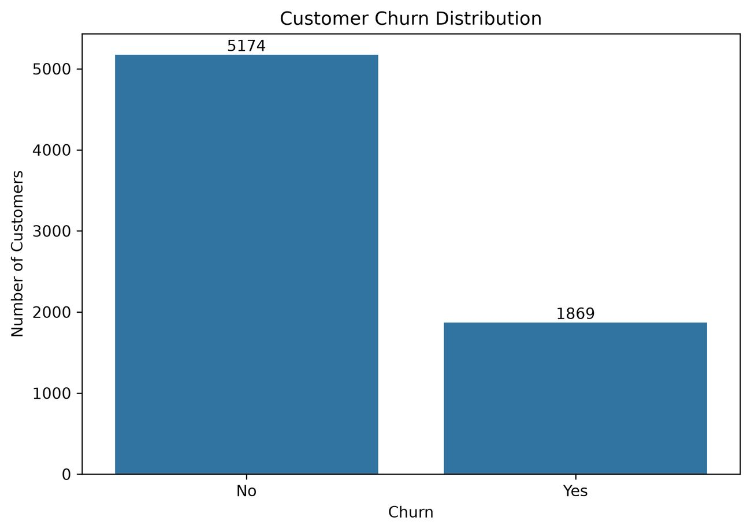
Figure 1. Churn target distribution in the 7,043-customer dataset. [Source figure: 01_churn_distribution.png]
Validation Item | Observed Value
Rows | 7,043
Original columns | 21
Churned customers | 1,869
Retained customers | 5,174
Overall churn rate | 26.54%
Duplicate rows | 0
Duplicate customer IDs | 0
Hidden invalid TotalCharges values after numeric conversion | 11

2.1 Hidden TotalCharges Issue
A normal missing-value check initially reported no nulls because TotalCharges was stored as text. Numeric coercion exposed 11 blank values. Inspection showed that every affected customer had tenure = 0, which is consistent with newly activated accounts that had not yet accumulated historical charges. The records were retained and TotalCharges was assigned 0.0.

3. Data Cleaning and Feature Engineering
String values were normalized, TotalCharges was converted to numeric, the 11 zero-tenure blanks were imputed with 0.0, and integrity checks confirmed zero missing values and zero duplicate customer records in the cleaned dataset. The final cleaned dataset contains 7,043 rows and 27 columns.
Engineered Feature | Definition / Analytical Purpose
ChurnValue | Binary target: No = 0, Yes = 1.
TenureGroup | Six tenure bands from 0–12 to 61–72 months.
NumServices | Count of active service indicators.
HasInternetService | 1 when InternetService is not No; otherwise 0.
ContractValue | Month-to-month = 0, One year = 1, Two year = 2.
AutomaticPayment | 1 for automatic bank transfer or automatic credit-card payment.

The original human-readable fields were retained alongside engineered variables so that the same cleaned dataset could support business analysis, model training, clustering, and final customer-level reporting.

4. Exploratory Data Analysis
EDA was designed to quantify churn differences rather than only display distributions. Fifteen dedicated EDA figures and multiple supporting tables were generated. The largest churn gaps appear across tenure, contract, internet service, payment method, senior-citizen status, and payment automation.

4.1 Tenure and Customer Maturity
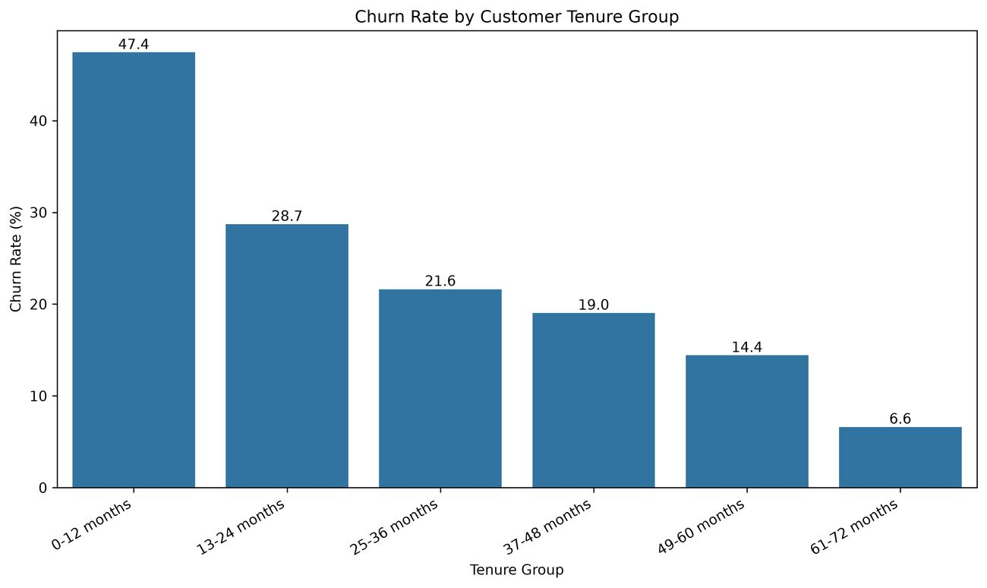
Figure 2. Churn rate declines strongly as customer tenure increases. [Source figure: 05_tenure_group_churn_rate.png]
Tenure Group | Customers | Churned | Churn Rate
0-12 months | 2186 | 1037 | 47.44%
13-24 months | 1024 | 294 | 28.71%
25-36 months | 832 | 180 | 21.63%
37-48 months | 762 | 145 | 19.03%
49-60 months | 832 | 120 | 14.42%
61-72 months | 1407 | 93 | 6.61%

Customers in the first 12 months churn at 47.44%, compared with only 6.61% among customers with 61–72 months of tenure. The earliest-tenure group therefore has approximately 7.2 times the churn rate of the longest-tenure group.

4.2 Contract, Internet Service and Payment Method
Characteristic | Highest-Risk Category | Churn Rate | Lowest-Risk Category | Churn Rate
Contract | Month-to-month | 42.71% | Two year | 2.83%
Internet service | Fiber optic | 41.89% | No internet | 7.40%
Payment method | Electronic check | 45.29% | Credit card (automatic) | 15.24%

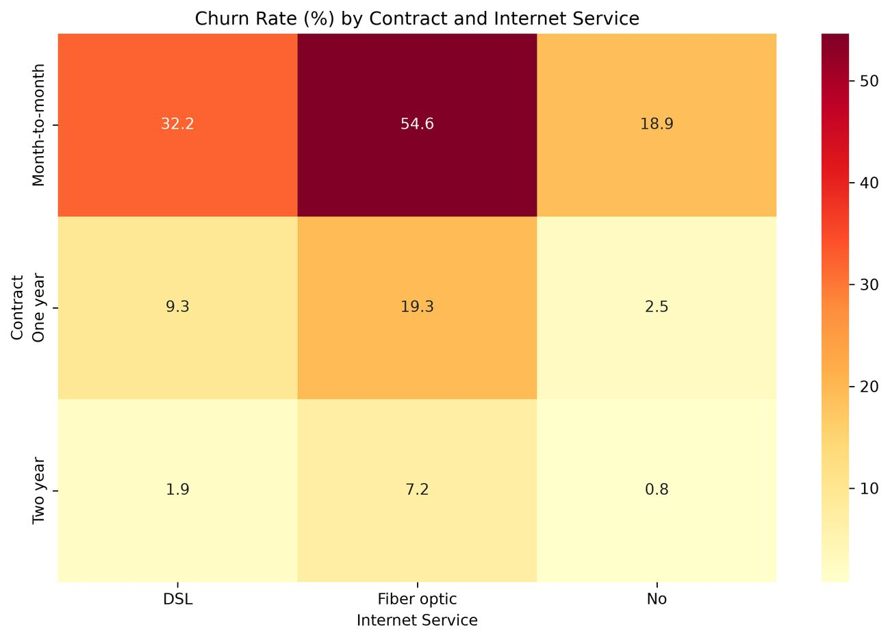
Figure 3. Churn interaction between contract type and internet service. [Source figure: 13_contract_internet_heatmap.png]
Multivariable analysis shows that contract and internet service interact strongly. Month-to-month fiber-optic customers have a 54.61% churn rate, while two-year fiber customers are far lower. A three-variable grouping further identified Month-to-month + Fiber optic + Electronic check as the highest-risk meaningful combination: 1,307 customers, 789 churners, and 60.37% churn.

5. Correlation and Multivariable Analysis
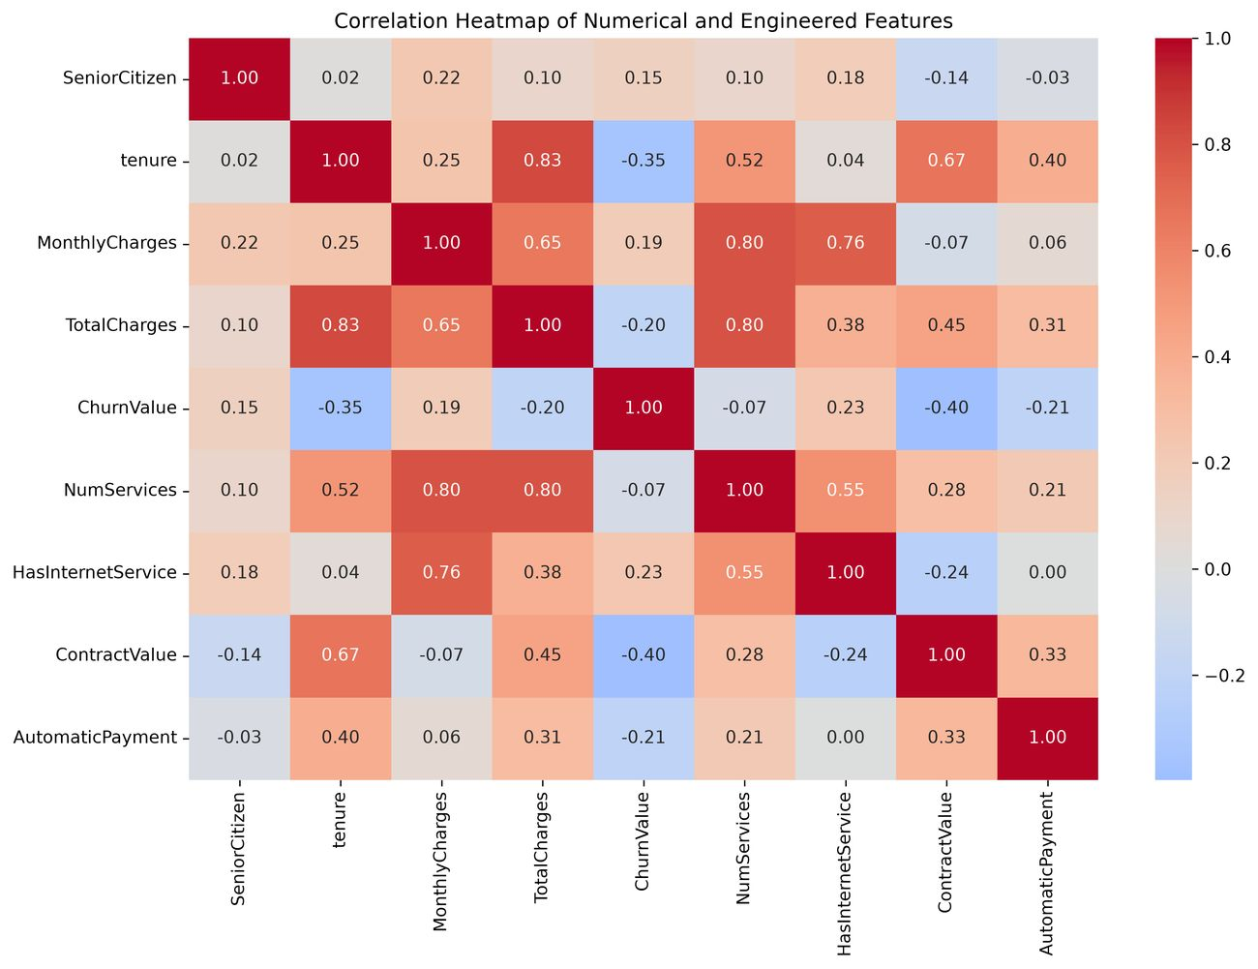
Figure 4. Correlation heatmap for numerical and engineered variables. [Source figure: 15_correlation_heatmap.png]
Feature | Correlation with ChurnValue | Interpretation
ContractValue | -0.397 | Lower values associated with higher churn
tenure | -0.352 | Lower values associated with higher churn
HasInternetService | +0.228 | Higher values associated with higher churn
AutomaticPayment | -0.210 | Lower values associated with higher churn
TotalCharges | -0.198 | Lower values associated with higher churn
MonthlyCharges | +0.193 | Higher values associated with higher churn
SeniorCitizen | +0.151 | Higher values associated with higher churn

ContractValue (-0.397) and tenure (-0.352) show the strongest negative relationships with churn. HasInternetService (+0.228), MonthlyCharges (+0.193), and SeniorCitizen (+0.151) are positively associated with churn. Strong relationships also exist among predictors, including tenure ↔ TotalCharges (0.826), MonthlyCharges ↔ NumServices (0.802), and TotalCharges ↔ NumServices (0.796). These are associations, not causal claims.

6. Supervised Learning and Model Selection
The supervised stage uses 22 input variables: eight numerical/engineered features and fourteen categorical features. Numerical variables are median-imputed and standardized; categorical variables are most-frequent imputed and one-hot encoded. All preprocessing is contained inside scikit-learn pipelines.
The dataset is split once into 5,634 training customers and 1,409 independent holdout customers using stratification and random_state = 42. Crucially, the holdout set is not used to select the model family or hyperparameters.

6.1 Training-Only Model Comparison
Model | CV ROC-AUC | OOF ROC-AUC | OOF Recall | OOF F1 | Selected
Logistic Regression | 0.8464 | 0.8458 | 0.8000 | 0.6278 | Yes
Random Forest | 0.8462 | 0.8455 | 0.7873 | 0.6319 | No
Decision Tree | 0.8298 | 0.8286 | 0.7806 | 0.6168 | No

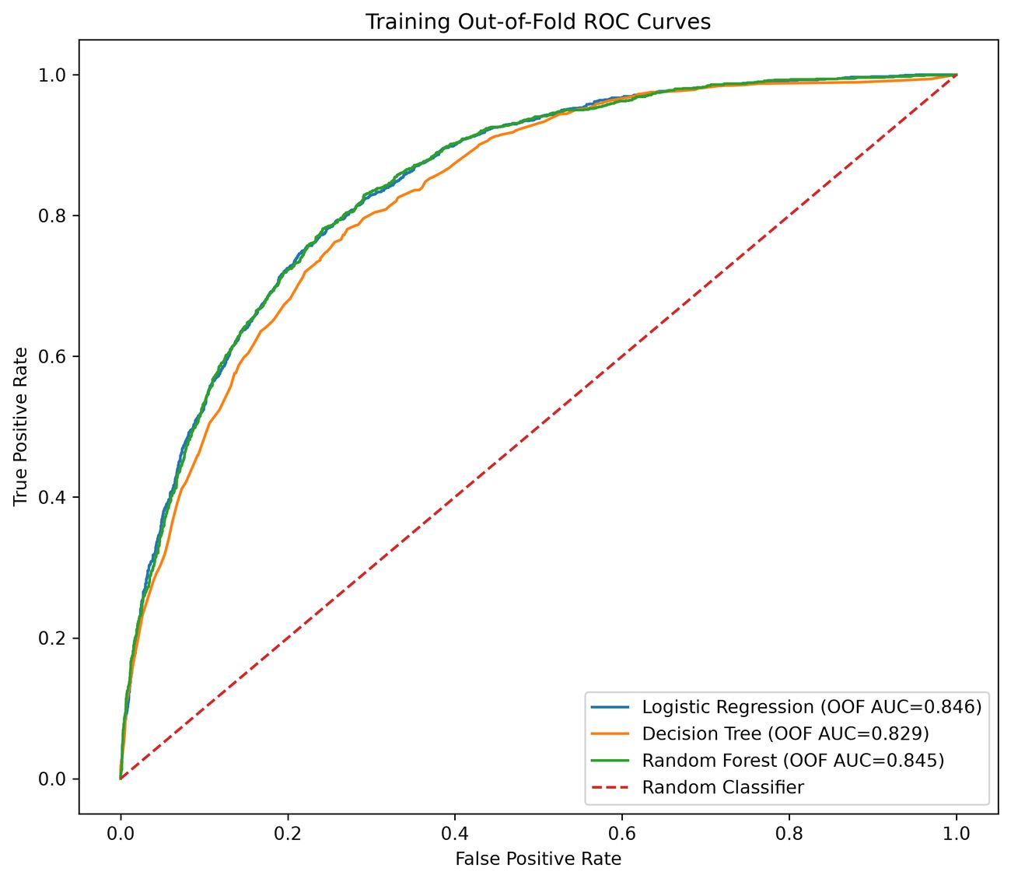
Figure 5. Training out-of-fold ROC curves for the three candidate classifiers. [Source figure: 17_model_roc_curves.png]
Logistic Regression achieved the highest GridSearch CV ROC-AUC at 0.8464, narrowly above Random Forest at 0.8462. Because the selection criterion was predefined as training cross-validation ROC-AUC, Logistic Regression was selected before any holdout performance was considered.
comparison_df = comparison_df.sort_values(
["GridSearch_CV_ROC_AUC", "OOF_ROC_AUC"],
ascending=False,
).reset_index(drop=True)
best_model_name = comparison_df.loc[0, "Model"]

Code Evidence 1. Model-family selection uses training cross-validation metrics only.

6.2 Independent Holdout Evaluation
Metric | Result | Metric | Result
ROC-AUC | 0.8407 | Accuracy | 0.7388
Balanced Accuracy | 0.7531 | Precision | 0.5052
Recall | 0.7834 | F1 | 0.6143

The independent holdout ROC-AUC of 0.8407 is close to the training CV ROC-AUC of 0.8464, indicating stable ranking performance on unseen customers. The holdout evaluation is now genuinely independent of model-family selection.

7. Probability Calibration, Threshold Optimization and Error Analysis
A model can rank customers correctly while still producing unreliable absolute probabilities. Because the selected Logistic Regression uses class_weight = balanced, raw probability quality was explicitly tested using training-only out-of-fold predictions.

7.1 Probability Calibration
Probability Model | ROC-AUC | Brier Score | Log Loss | Mean Predicted Risk
Raw selected classifier | 0.84580 | 0.16524 | 0.49049 | 41.37%
Sigmoid calibrated classifier | 0.84579 | 0.13519 | 0.41660 | 26.60%

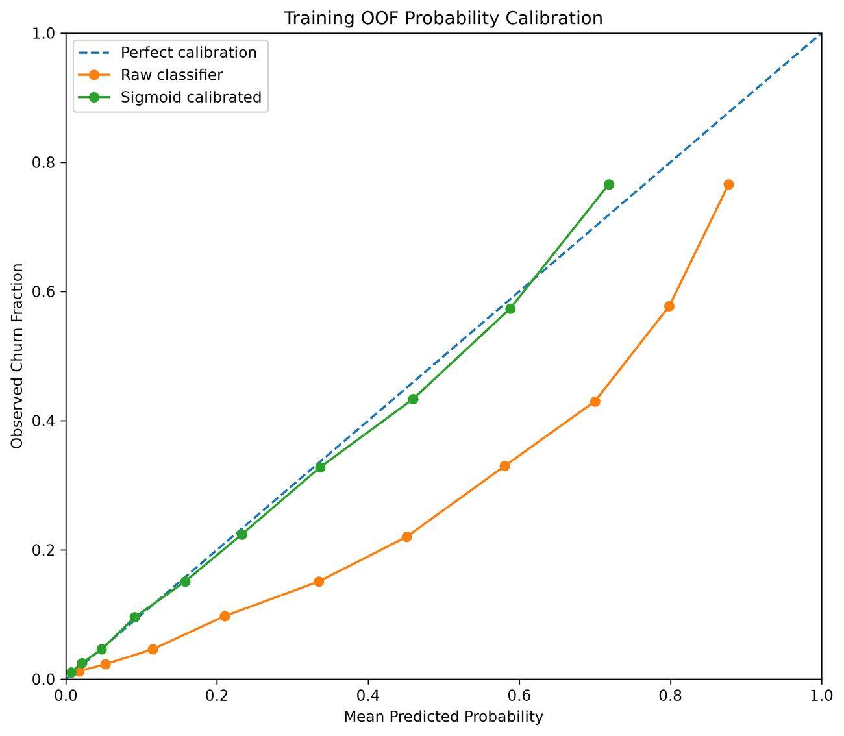
Figure 6. Training out-of-fold calibration: raw versus sigmoid-calibrated probabilities. [Source figure: 36_probability_calibration_curve.png]
Sigmoid calibration reduced Brier Score from 0.16524 to 0.13519 and Log Loss from 0.49049 to 0.41660 while preserving ROC-AUC. On holdout customers, mean predicted risk was 26.80% versus an observed churn rate of 26.54%, with Brier Score 0.13875.
if calibrated_probability_metrics["Brier_Score"] < raw_probability_metrics["Brier_Score"]:
selected_probability_model = CalibratedClassifierCV(
estimator=clone(base_model), method="sigmoid", cv=5
)

Code Evidence 2. Calibration is selected using training OOF Brier Score.

7.2 F2-Oriented Threshold Optimization
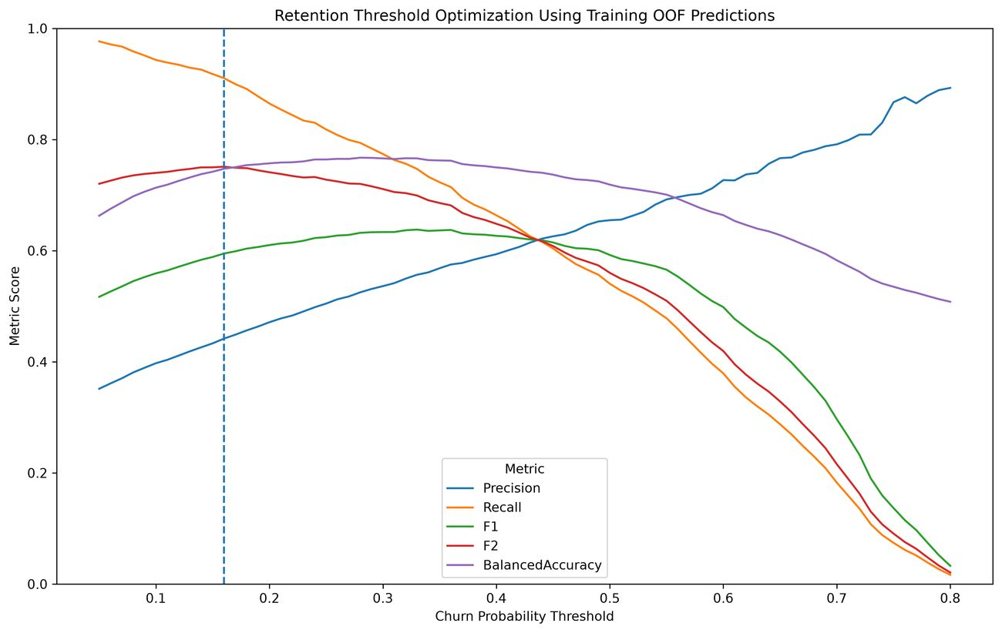
Figure 7. Training out-of-fold threshold optimization across precision, recall, F1, F2 and balanced accuracy. [Source figure: 20_threshold_optimization.png]
Strategy | Threshold | Precision | Recall | F1 | F2
Default threshold 0.50 | 0.50 | 0.6603 | 0.5561 | 0.6038 | 0.5743
Optimized F2 threshold | 0.16 | 0.4452 | 0.9118 | 0.5982 | 0.7538

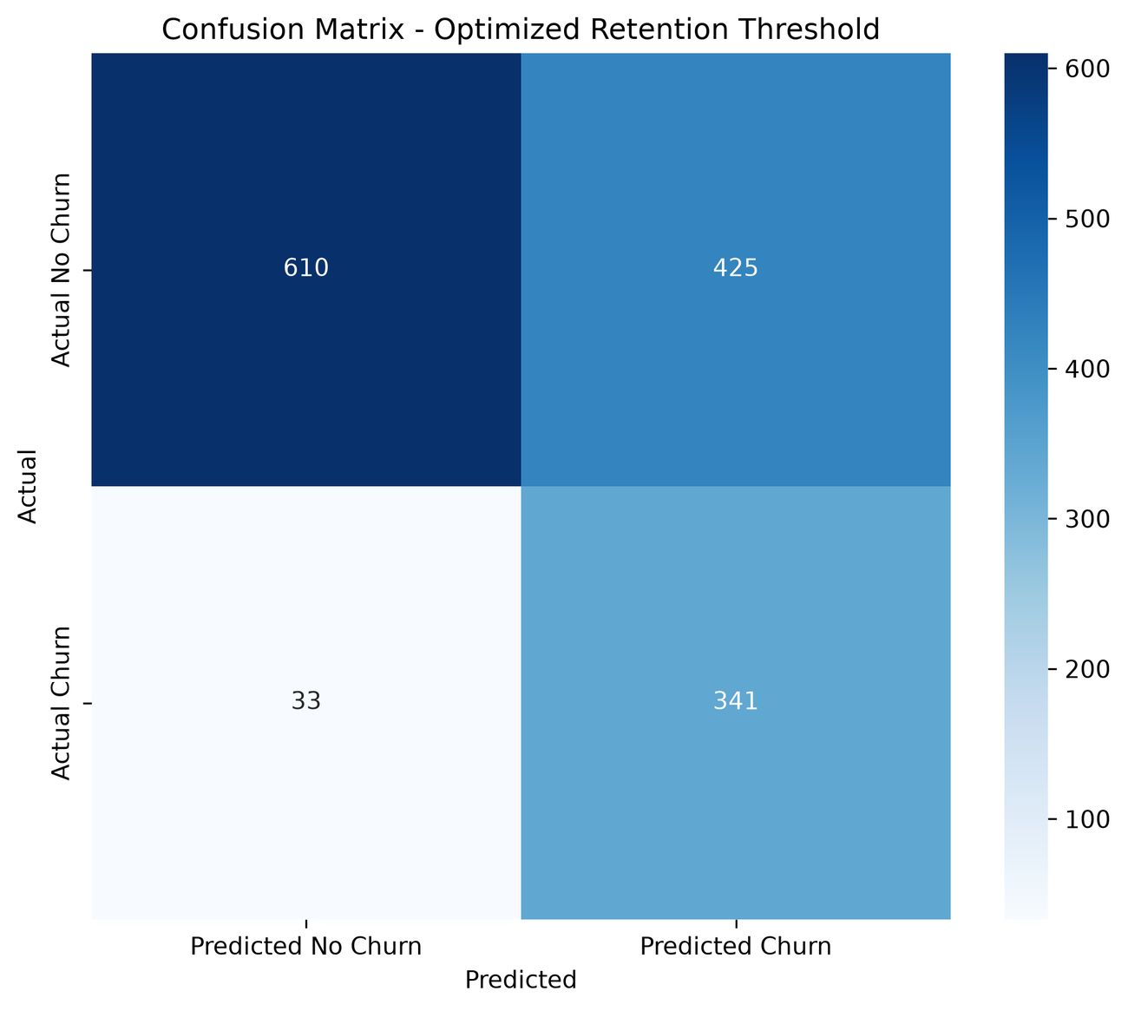
Figure 8. Independent holdout confusion matrix at the selected 0.16 retention threshold. [Source figure: 21_optimized_threshold_confusion_matrix.png]
The 0.16 threshold detects 341 of 374 holdout churners and misses only 33, producing 91.18% recall and F2 = 0.7538. The trade-off is 425 false positives and precision of 44.52%. This threshold is appropriate when broad retention outreach is economically acceptable; a higher threshold can be used when contact capacity is constrained.

7.3 Subgroup Error Analysis
Subgroup | Customers | Actual Churners | Recall | Avg Predicted Risk
Month-to-month | 773 | 329 | 97.26% | 42.90%
One year | 300 | 36 | 58.33% | 11.80%
Two year | 336 | 9 | 0.00% | 3.13%
Female | 687 | 193 | 89.64% | 26.68%
Male | 722 | 181 | 92.82% | 26.90%

Subgroup results expose an important limitation: two-year-contract recall is 0% because only nine holdout churners belong to that group. This is not evidence that all two-year customers are safe; rather, the subgroup contains very few positive cases and its recall estimate is unstable.

8. Leakage-Safe Customer Segmentation
Customer segmentation is independent of the churn target. Churn and ChurnValue are not clustering inputs. The clustering feature set includes tenure, MonthlyCharges, TotalCharges, NumServices, Contract, InternetService, PaymentMethod, OnlineSecurity, TechSupport, and PaperlessBilling.
To prevent leakage into later business validation, preprocessing, K selection, PCA, and final K-Means fitting are performed on training customers only. The frozen pipeline then assigns clusters to the holdout customers.

8.1 Selecting K
K | Silhouette | Davies-Bouldin | Calinski-Harabasz
2 | 0.2812 | 1.3986 | 2628.54
3 | 0.2995 | 1.2698 | 2675.17
4 | 0.2663 | 1.4961 | 2263.55
5 | 0.2510 | 1.6521 | 2007.40
6 | 0.2383 | 1.5721 | 1810.68
7 | 0.2274 | 1.5357 | 1706.79
8 | 0.2226 | 1.5573 | 1579.49

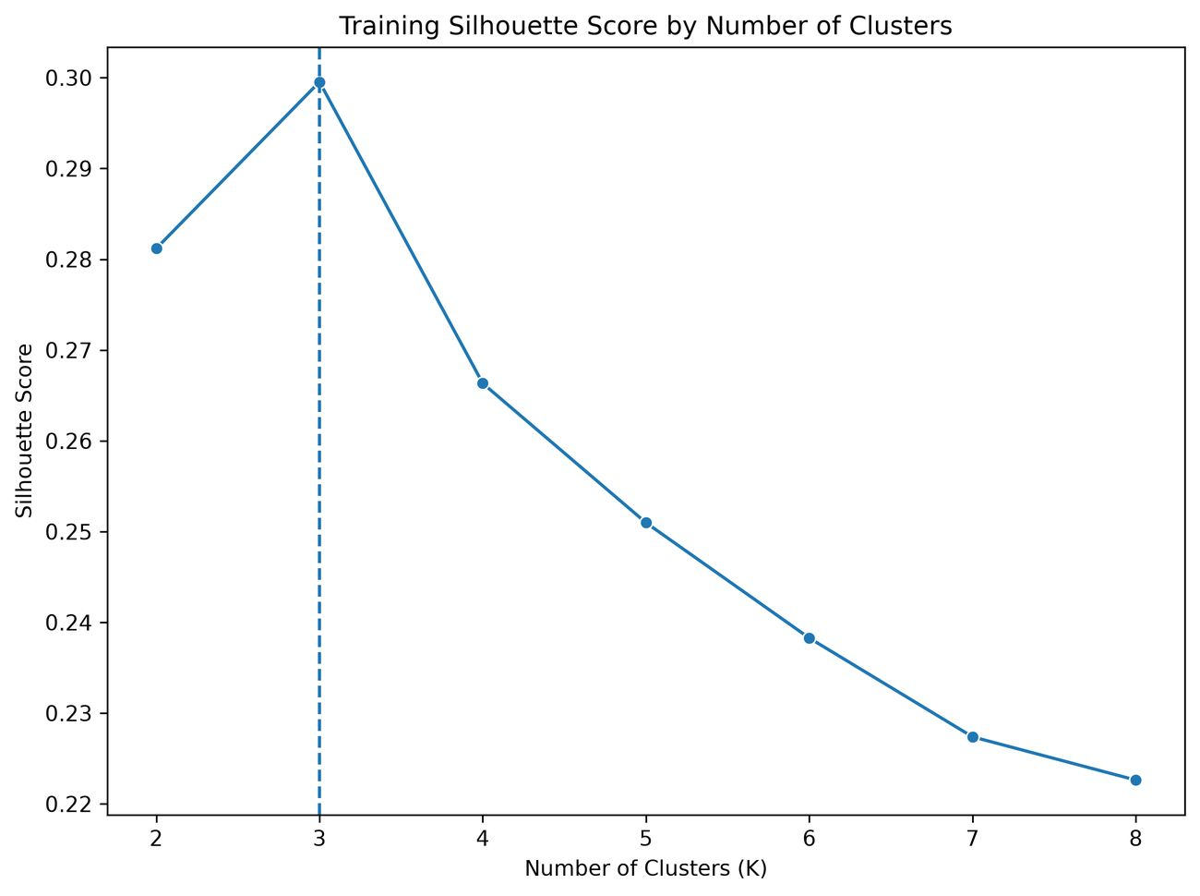
Figure 9. Training silhouette score for K = 2 through K = 8. [Source figure: 25_kmeans_silhouette_scores.png]
K=3 provides the strongest training solution: silhouette 0.2995, Davies-Bouldin 1.2698, and Calinski-Harabasz 2675.17. The silhouette value indicates moderate, not perfect, separation; the clusters are therefore interpreted as useful behavioral groupings rather than naturally isolated populations.

8.2 Stability and PCA
Random State | Adjusted Rand Index
7 | 1.0000
21 | 1.0000
42 | 1.0000
99 | 1.0000
123 | 1.0000
Mean | 1.0000

The K=3 solution is completely stable across the tested random seeds, with ARI = 1.0000 for every run. PCA is used only for visualization; PC1 explains 43.83% and PC2 explains 20.54%, for 64.37% total two-dimensional variance.
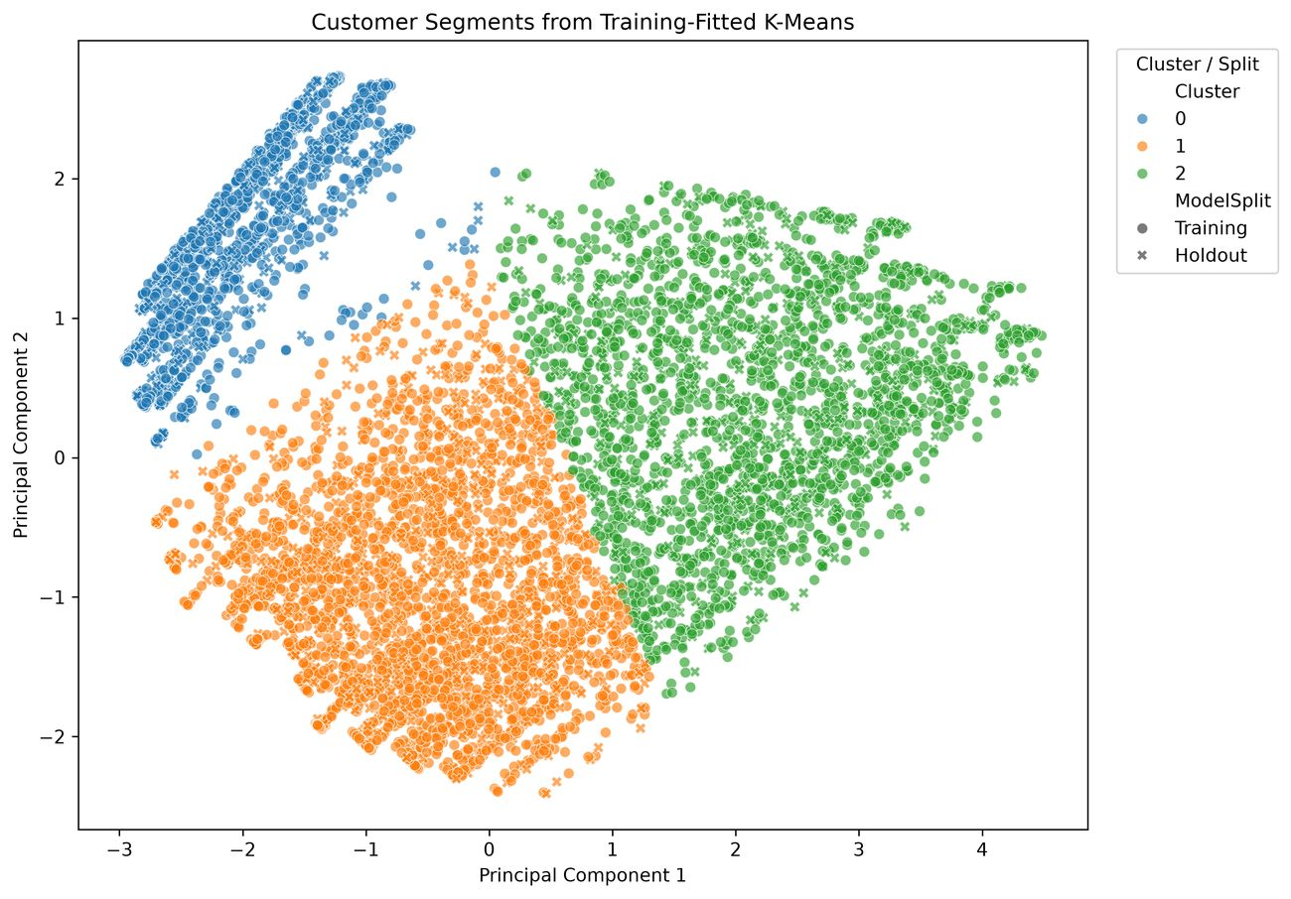
Figure 10. Customer clusters projected into two PCA dimensions; clusters were formed in the full preprocessed feature space. [Source figure: 26_customer_segments_pca.png]

9. Independent Business Segment Validation
Segment names are derived from training profiles before holdout churn outcomes are examined. Cluster 0 is labeled Low-Cost Stable Customers, Cluster 1 High-Risk Short-Tenure Customers, and Cluster 2 High-Spend Loyal Customers. “High-Spend” is used instead of “High-Value” because the dataset measures charges but not profitability or customer lifetime value.
Segment | Training Churn | Holdout Churn | Difference | Holdout Avg Tenure | Holdout Avg Monthly
Low-Cost Stable Customers | 7.22% | 7.89% | +0.67 pp | 32.18 | 21.20
High-Risk Short-Tenure Customers | 44.67% | 43.95% | -0.72 pp | 15.82 | 68.27
High-Spend Loyal Customers | 14.95% | 13.00% | -1.95 pp | 57.18 | 89.63

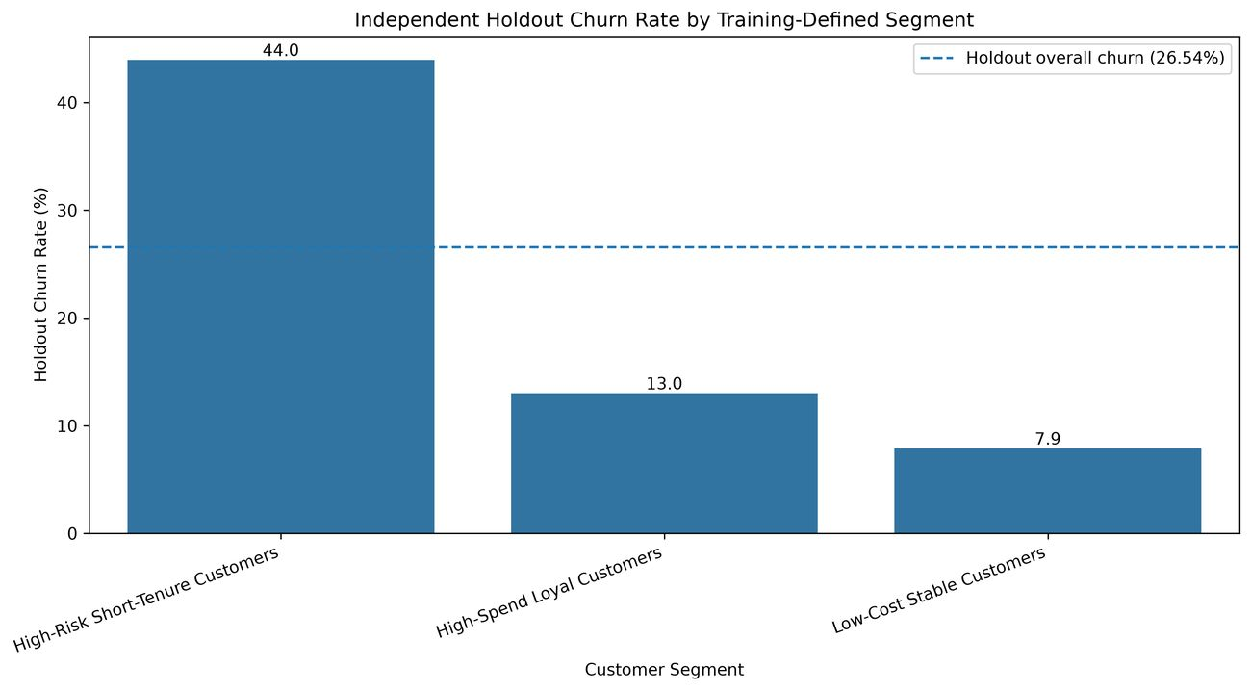
Figure 11. Independent holdout churn rate by training-defined business segment. [Source figure: 30_business_segment_churn_rate.png]
The training-defined segment behavior generalizes well. High-Risk Short-Tenure churn changes only from 44.67% in training to 43.95% on holdout; Low-Cost Stable changes from 7.22% to 7.89%; and High-Spend Loyal changes from 14.95% to 13.00%. On holdout data, the high-risk segment has 1.66 times the overall churn rate and 5.57 times the churn rate of the Low-Cost Stable segment.

10. Final Customer Risk and Retention System
The final decision layer combines three components that were fixed without using holdout outcomes: the calibrated churn probability, the training-selected 0.16 retention threshold, and the frozen training-defined business segment. The combined policy is then evaluated on the independent holdout set.

10.1 Independent Risk-Band Validation
Risk Band | Customers | Actual Churners | Actual Churn Rate | Avg Predicted Risk
Below Retention Threshold | 643 | 33 | 5.13% | 5.25%
High Risk | 315 | 208 | 66.03% | 63.69%
Retention Candidate | 451 | 133 | 29.49% | 31.75%

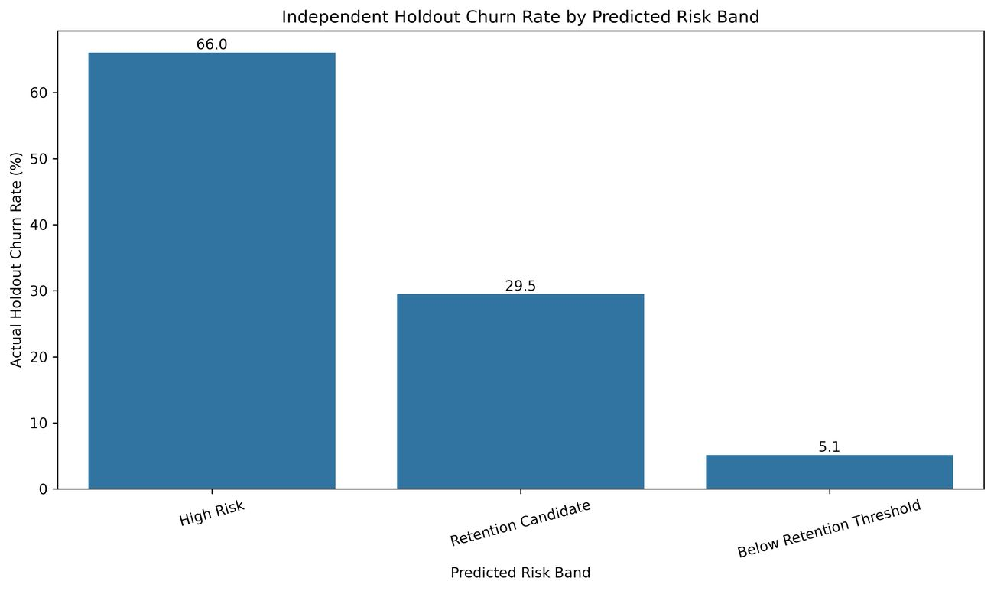
Figure 12. Independent holdout churn rate by calibrated risk band. [Source figure: 33_actual_churn_by_risk_band.png]
Observed churn increases sharply and monotonically across the risk bands: 5.13% below the retention threshold, 29.49% for Retention Candidates, and 66.03% for High Risk. Average predicted risk is also close to the observed rate in each group, supporting both discrimination and calibration.

10.2 Independent Retention-Priority Validation
Priority | Customers | Actual Churners | Actual Churn Rate | Avg Predicted Risk
Critical | 299 | 202 | 67.56% | 64.09%
High | 289 | 93 | 32.18% | 35.98%
Medium | 275 | 51 | 18.55% | 20.52%
Low | 546 | 28 | 5.13% | 4.68%

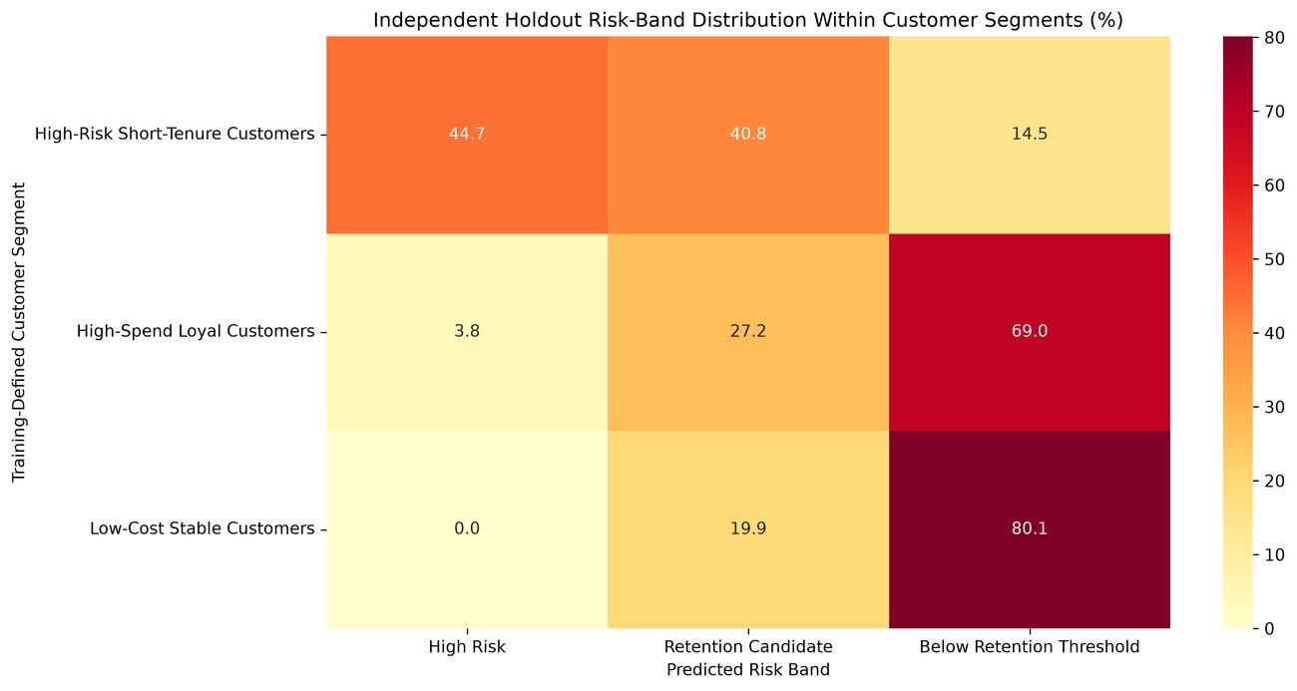
Figure 13. Independent holdout distribution of calibrated risk bands within training-defined segments. [Source figure: 35_segment_risk_heatmap.png]
The combined policy produces a clear priority gradient on unseen customers: Critical 67.56%, High 32.18%, Medium 18.55%, and Low 5.13% actual churn. This monotonic ordering is the strongest evidence that prediction, calibration, segmentation, and business decision logic work together rather than only in isolation.

10.3 Full Cross-Fitted Customer Risk Register
After independent validation was complete, 5-fold cross-fitted calibrated probabilities were generated for all 7,043 customers to create the analytical risk register. Full cross-fitted performance is ROC-AUC 0.8450, Brier Score 0.1357, and Log Loss 0.4175. These full-dataset outputs support operational ranking, while the holdout analysis remains the primary evidence of generalization.
Full Priority | Customers | Actual Churn Rate | Avg Predicted Risk
Critical | 1448 | 66.64% | 64.14%
High | 1423 | 33.59% | 35.88%
Medium | 1404 | 20.87% | 21.41%
Low | 2768 | 4.80% | 4.68%

11. New-Customer Inference and Deployment Artifacts
The project now supports end-to-end inference for a completely new customer. The inference script performs the same feature engineering used during training, loads the final calibrated classifier, applies the frozen clustering preprocessor and K-Means model, assigns the frozen business segment, applies the validated threshold, and returns a risk band, retention priority, and recommended action.
result = predict_customer(customer)
# Output includes:
# ChurnProbability, Cluster, Segment,
# RiskBand, RetentionPriority, RecommendedAction

Code Evidence 3. Reusable end-to-end inference entry point.
Demo Inference Field | Result
Calibrated churn probability | 75.50%
Cluster | 1
Business segment | High-Risk Short-Tenure Customers
Risk band | High Risk
Retention priority | Critical
Recommended action | Immediate retention outreach with support and personalized incentive

11.1 Serialized Artifacts
Artifact | Role
best_churn_model.joblib | Training-selected base Logistic Regression pipeline.
retention_churn_model.joblib | Training-fitted sigmoid-calibrated probability model.
customer_segmentation_pipeline.joblib | Frozen preprocessing, K-Means, PCA and segment mapping.
final_churn_model_full.joblib | Final calibrated deployment model refitted after independent evaluation.

12. Business Recommendations

12.1 High-Risk Short-Tenure Customers
- Prioritize proactive retention outreach during the first year, especially for customers with high calibrated risk.
- Improve onboarding and early technical-support experiences.
- Offer appropriate incentives to move from month-to-month to longer contracts.
- Promote automatic payment, particularly among electronic-check customers.
- Monitor fiber-service quality and investigate service issues before offering generic discounts.

12.2 High-Spend Loyal Customers
- Protect long-tenure, high-spend relationships through loyalty benefits and priority support.
- Use personalized rather than generic offers.
- Monitor service-quality or billing disruptions because losing these customers can materially reduce recurring charges.

12.3 Low-Cost Stable Customers
- Maintain affordability and reliable service.
- Avoid expensive retention interventions for customers with low predicted risk.
- Use selective cross-sell opportunities where they improve customer fit rather than simply increasing service count.

12.4 Campaign Operating Principle
The 0.16 threshold is suitable when retention outreach is relatively inexpensive compared with an undetected churn event. If campaign capacity is limited, the High Risk or Critical groups provide narrower, higher-yield targets. The appropriate production threshold should ultimately incorporate contact cost, offer cost, customer lifetime value, and measured campaign response.

13. Challenges and Technical Improvements
Challenge | Resolution
Hidden TotalCharges blanks | Numeric coercion exposed 11 zero-tenure blanks; retained records and set TotalCharges = 0.0.
Class imbalance | Used stratification, balanced class weights, ROC-AUC, balanced accuracy, recall, F1 and F2.
Test-set selection risk | Model family and hyperparameters are now selected using training-only CV.
Poor raw probability calibration | Compared raw vs sigmoid probabilities using OOF Brier Score and selected calibration.
Default threshold misses churners | Selected a training-OOF F2 threshold of 0.16; holdout recall reached 91.18%.
Circular segment validation | Fit and named clusters using training customers, then validated frozen segments on holdout.
Deployment gap | Saved the segmentation bundle and added a new-customer inference script.
Clustering robustness | Measured stability across random seeds using ARI; mean ARI = 1.0000.

These changes are methodological rather than cosmetic. They directly improve the credibility of the reported holdout results and make the final project reproducible from raw data through new-customer inference.

14. Limitations and Further Analysis
The dataset is a static public sample rather than a temporal production stream. Real-world performance may change as customer behavior, products, pricing, and service quality evolve. Model and calibration drift should therefore be monitored if the system is deployed.
The 0.16 threshold is optimized for F2, not for economic value. The dataset does not contain contact costs, retention-offer costs, customer lifetime value, profitability, or intervention-response outcomes. A production decision rule should incorporate these quantities.
K-Means is a practical baseline for mixed customer data after scaling numerical variables and one-hot encoding categorical variables, but Euclidean distance is not ideal for every mixed-data setting. K-Prototypes, Gower-distance clustering, or model-based segmentation could be compared in future analysis.
Observed relationships remain associational rather than causal. For example, longer contracts correlate with lower churn, but the analysis does not prove that moving a particular customer to a longer contract will itself prevent churn. The strongest next production step would be an A/B test of targeted retention interventions.

15. Reproducibility and Final Validation
The repository is organized as a deterministic staged pipeline. Each script writes its own tables, figures, or serialized models; later scripts consume those outputs. The complete analysis can be regenerated using uv and Python 3.12-compatible dependencies.
uv sync
uv run python src\01_validate_data.py
uv run python src\02_clean_data.py
uv run python src\03_eda.py
uv run python src\04_train_models.py
uv run python src\05_threshold_error_analysis.py
uv run python src\06_customer_segmentation.py
uv run python src\07_segment_business_analysis.py
uv run python src\08_final_risk_scoring.py
uv run python src\09_final_validation.py
uv run python src\10_predict_customer.py --demo

Reproducibility commands. Scripts are executed in pipeline order.
Validation Item | Result
Cleaned customers | 7,043
Missing values | 0
Duplicate rows | 0
Duplicate customer IDs | 0
Selected model | Logistic Regression
Training CV ROC-AUC | 0.8464
Independent holdout ROC-AUC | 0.8407
Independent holdout Brier Score | 0.1387
Independent holdout recall | 0.9118
Selected K | 3
Mean stability ARI | 1.0000
Figures generated | 36
Risk-register customers | 7,043
New-customer inference | PASS
Automated validation checks | 26 / 26 PASS
Final validation | PASSED

Repository: https://github.com/ARraj14/Telco_Customer_Churn_Capstone

16. Conclusion
This capstone demonstrates a complete transition from raw customer data to an independently validated retention framework. The project first establishes a trustworthy data foundation, then quantifies churn patterns through detailed EDA and multivariable analysis. Supervised modeling is evaluated with a strict training/holdout design, and the selected Logistic Regression is calibrated before its probabilities are used operationally.
The unsupervised component adds a complementary behavioral view. Training-fitted K-Means produces three stable and interpretable groups, and the segment churn patterns remain consistent on holdout customers. Most importantly, the combined retention policy is validated independently: Critical, High, Medium, and Low priorities show 67.56%, 32.18%, 18.55%, and 5.13% holdout churn respectively.
The final result therefore goes beyond a standalone churn classifier. It provides reproducible preprocessing, detailed exploratory evidence, calibrated probabilities, threshold trade-offs, subgroup error analysis, stable customer segmentation, independent business validation, a complete customer risk register, and reusable new-customer inference. The automated final validation passes all 26 checks.

Appendix A. Selected Detailed Results

A.1 Full Risk Bands (Cross-Fitted Analytical Register)
Risk Band | Customers | Actual Churn Rate | Average Predicted Risk | Share
Below Retention Threshold | 3184 | 5.24% | 5.25% | 45.21%
High Risk | 1550 | 66.06% | 63.68% | 22.01%
Retention Candidate | 2309 | 29.36% | 30.97% | 32.78%

A.2 Full Segment Risk Profile
Segment | Customers | Actual Churn | Avg Predicted Risk | Retention Candidate Rate
High-Risk Short-Tenure Customers | 3185 | 44.52% | 44.54% | 86.94%
High-Spend Loyal Customers | 2309 | 14.60% | 14.60% | 33.26%
Low-Cost Stable Customers | 1549 | 7.36% | 7.34% | 20.79%

A.3 Figure Inventory
The repository contains 36 analytical figures. This report embeds selected figures directly from outputs/figures; all remaining figures remain available in the repository for detailed inspection. The included visuals are compressed only for document size and are not recreated or numerically altered.

References
1. IBM Samples Team. “Telco customer churn (11.1.3+).” IBM Community, 11 July 2019. https://community.ibm.com/community/user/blogs/steven-macko/2019/07/11/telco-customer-churn-1113 (accessed 5 October 2026).
2. Scikit-learn documentation: https://scikit-learn.org/stable/ — preprocessing, pipelines, GridSearchCV, probability calibration, classification metrics, K-Means, PCA, and model persistence (accessed 5 October 2026).
3. Project repository: https://github.com/ARraj14/Telco_Customer_Churn_Capstone
4. Project-generated tables and figures under outputs/tables and outputs/figures; final automated validation recorded 26 / 26 checks passed.

